- Create three files file1.txt, file2.txt, file3.txt using a loop. Then write a separate for loop that renames each to newfile1.txt, new-file2.txt, new-file3.txt using mv.
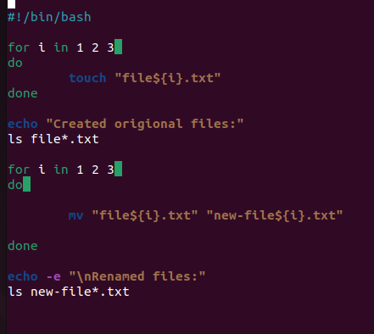
OUTPUT:
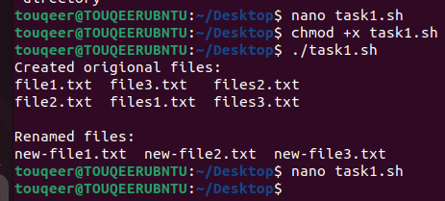

- Write a script that stores your bio-data (name, roll number, department, semester) in an indexed array, then prints it as a neatly labeled block using a for loop over the array.’
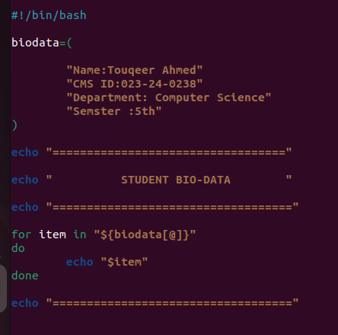
OUTPUT:
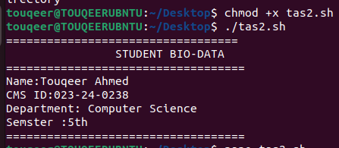
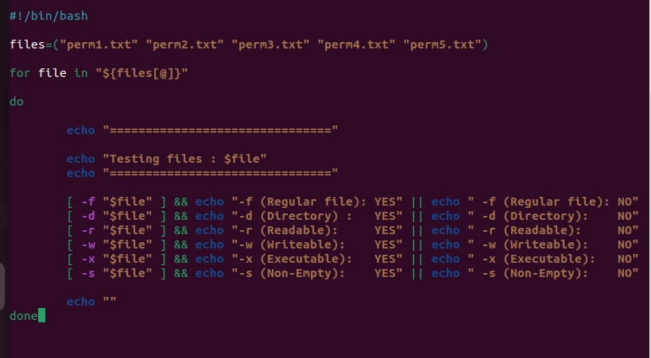
- Create 5 files with 5 different permission combinations (using chmod). Write a script that loops over all 5 files and, for each one, applies every file test condition (-f, -d, -r, -w, -x, -s) and prints the result of each.

OUTPUT
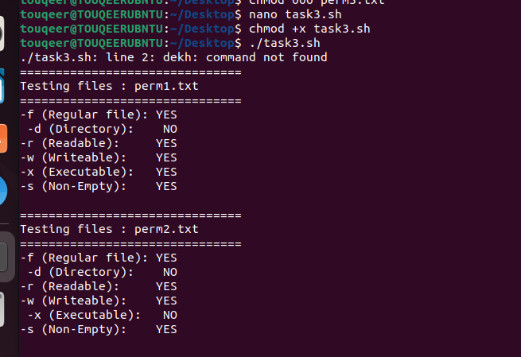
S
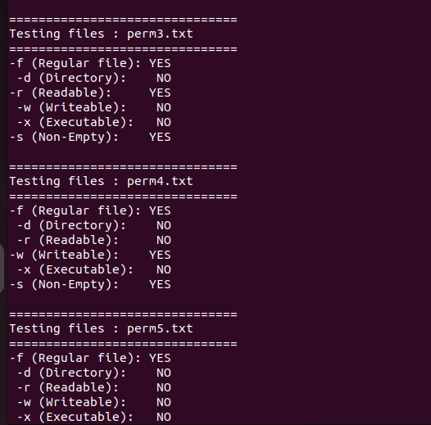
- Write a script using case that prompts the user for a number 1–10 and prints its Roman numeral equivalent. If the number is outside that range, print an error message instead.

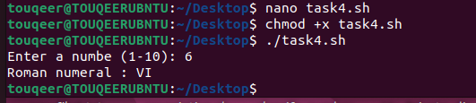
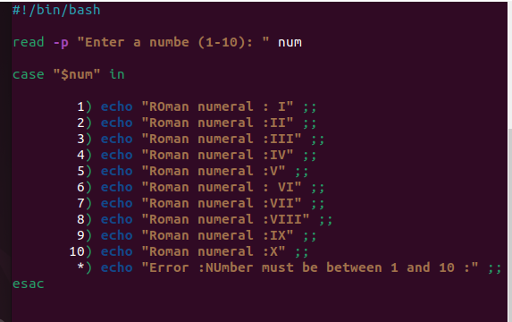

OUTPUT:

- You burn 4.2 calories per minute on a treadmill. Write a script using a while loop that prints the calories burned after 10, 15, 20, 25, and 30 minutes.
Code:
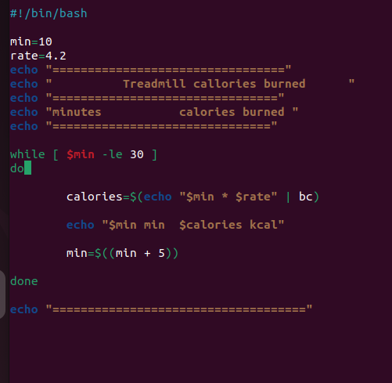
Output:
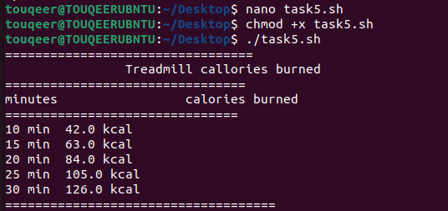

- Write a function that crawls the current directory and prints every file with a .txt extension. Call it from a script and show it working in a directory with a mix of .txt and non-.txt files.
Code:
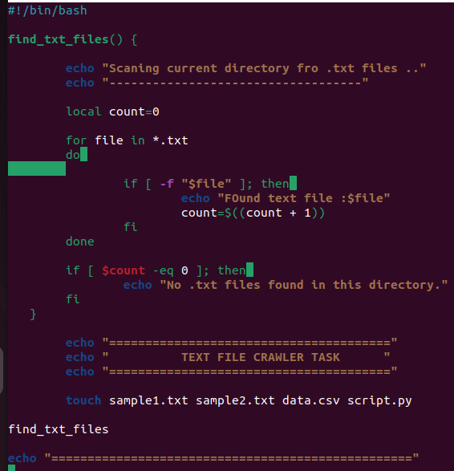
Output:
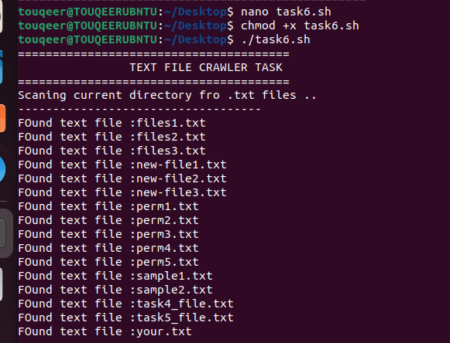

- Using an associative array, store at least 4 students' names as keys and their letter grades as values. Loop over the array and print each student's result as "NAME: GRADE".
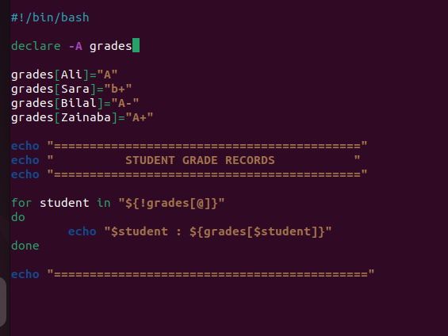
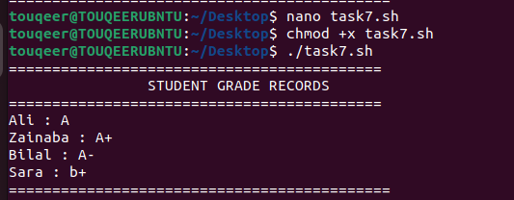
- Write a script using a C-style for loop that prints the multiplication table (1 through 10) for a number the user provides.
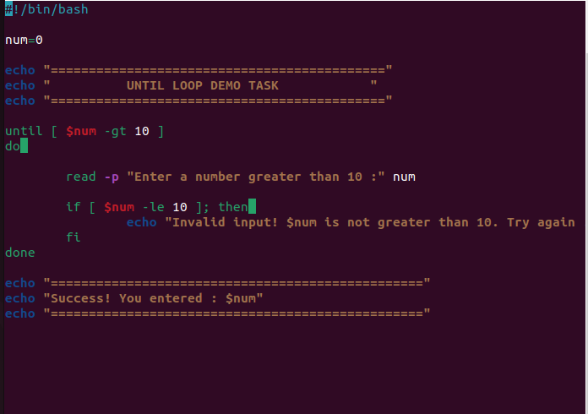
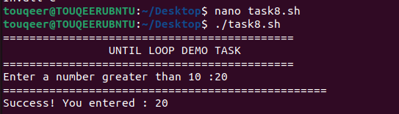

- Write a function called double_it that takes one number and returns double its value using echo and command substitution (not return). Call it from your script and print the result for at least three different inputs.
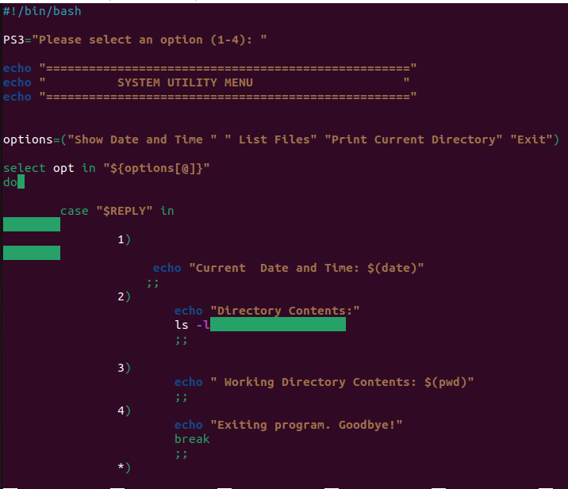

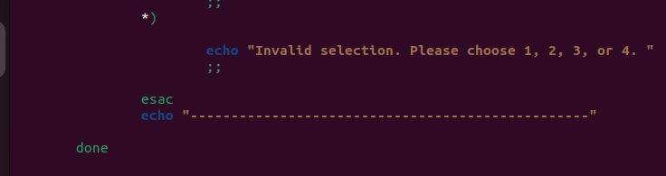

Output :
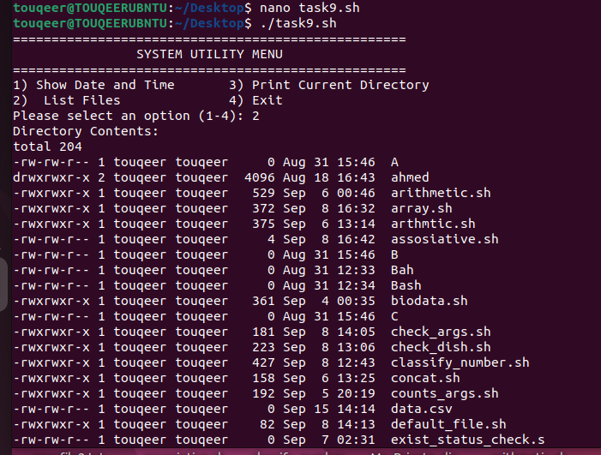

Continue output –9
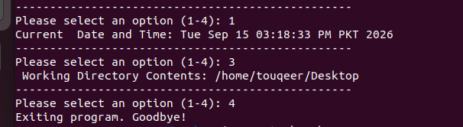

10.Write a function that deliberately omits local on an internal variable that shares a name with a script-level variable, and show the resulting bug (the script-level value getting overwritten). Then fix it with local and show the corrected output — include both versions
OUTPUT :
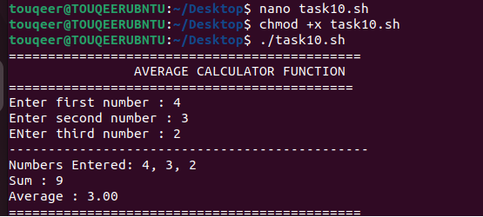

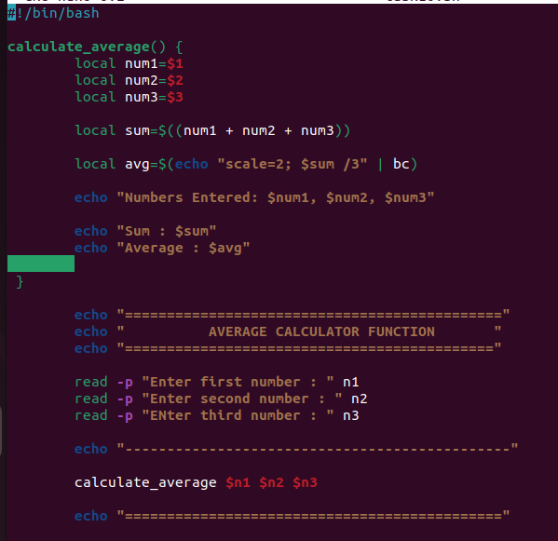

11.Write a script that loops from 1 to 100: use continue to skip every multiple of 3, and use break to stop completely the first time it reaches a multiple of 17. Print every number it doesn't skip along the way.
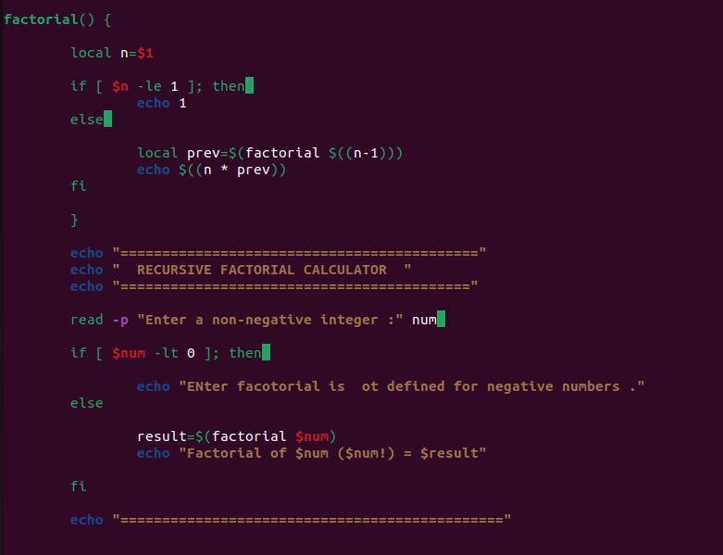
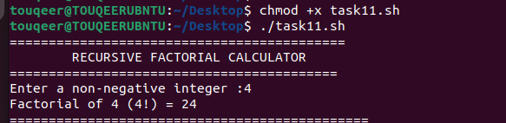

12.Write a one-line script (no if statement) using && and || that attempts to cd into a directory given as $1, lists its contents if successful, or prints "Directory not found" if it isn't.
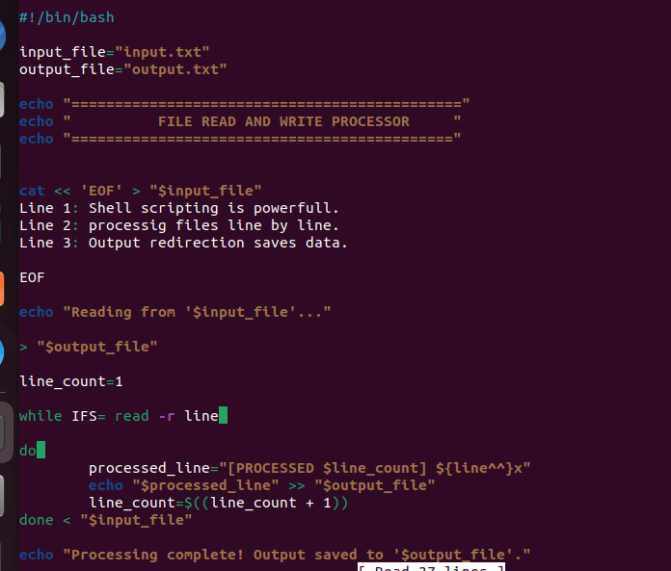

Output :
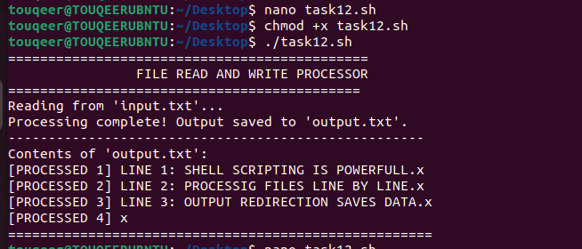

13.Store a mix of existing and non-existing file/directory paths in an array. Loop through the array and, for each entry, use the file test operators to categorize it as "file", "directory", or "missing", printing one labeled line per entry.
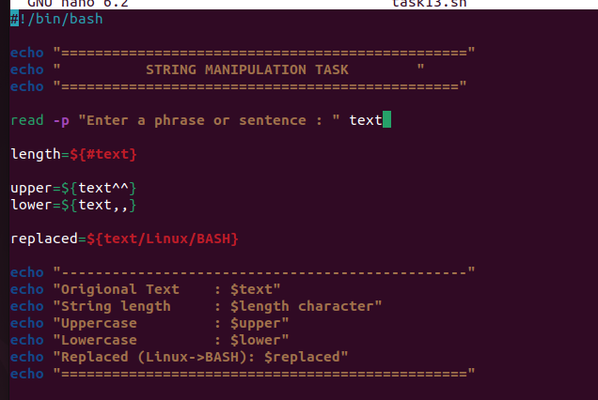
OUTPUT :

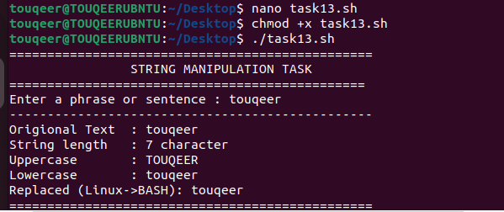
14.Write a script using until that repeatedly asks the user to enter a positive number, and only stops asking once they do — printing "That's not positive, try again" on every invalid attempt.
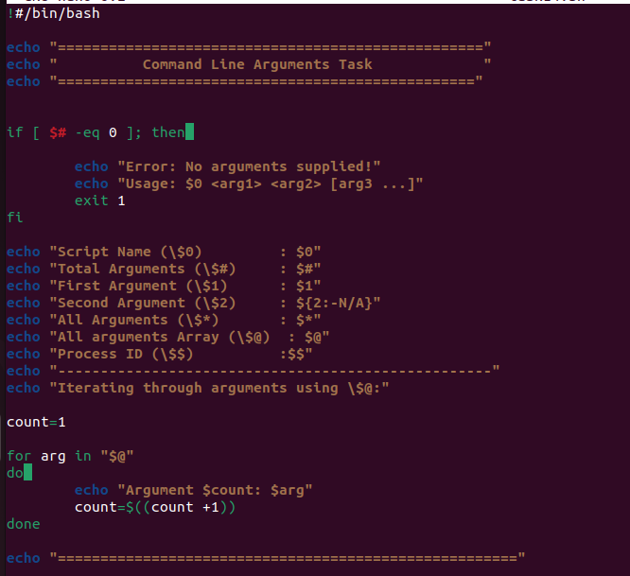

15.Write a script with a menu (using select) offering "Create file", "List files", "Delete a file", and "Quit". Use case inside the loop to run the right action for each choice, and break only when the user picks Quit.

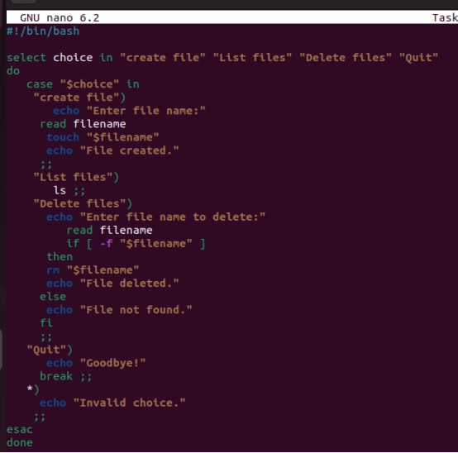

16.Write a script that accepts options -n (a name) and -c (a count, requires a value) using getopts, then prints the name that many times. Show it working both with flags in order (-n Ali -c 3) and out of order (-c 3 -n Ali).
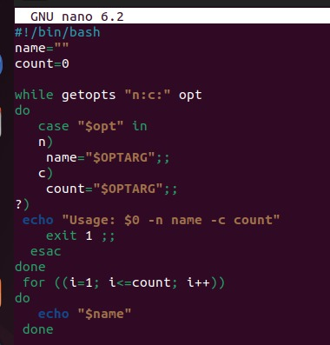

17.Create a file lines.txt with at least 6 lines of text. Use mapfile -t to load it directly into an array, then print the total number of lines and the 3rd line specifically, without using any manual while read loop.
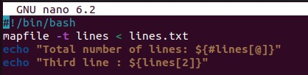

18.Write a script with a nested loop that prints pairs (i, j) for i and j both from 1 to 5, but uses break 2 to exit both loops entirely the moment the product i*j exceeds 15. Print each pair as it's checked, including the one that t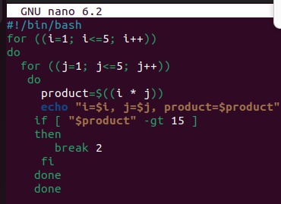riggers the break.

