GIT-HUB LINK :
- List the five categories of system calls from Section 4, and give one additional real Linux system call example for each, not already used in this lab.

- Process Control: Controls processes. Example: waitpid() waits for a child process to finish.
2. File Management: Performs file operations. Example: stat() gets information about a file
3. Device Management: Controls devices. Example: ioctl() sends device-specific commands.
4. Information Maintenance: Gets system/user information. Example: getuid() returns the user ID.
5. Communication: Allows processes to communicate. Example: pipe() creates a communication channel between processes.

- Explain, in your own words, the difference between a system call and an interrupt (Section 5), including how the two are related rather than fully separate concepts.
A system call is a request made by a user program to obtain a service from the operating system kernel while an interrupt is a mechanism that transfers CPU control to a handler when an event occurs. They are related because traditional system calls on x86 could use a software interrupt such as int 0x80 to enter the kern

- Assemble and run the syscall demo from Section 6 against your own myfile containing your name. Confirm it prints the expected text, and in one sentence explain what int 0x80 is doing compared to the modern syscall instruction mentioned in the note below it.

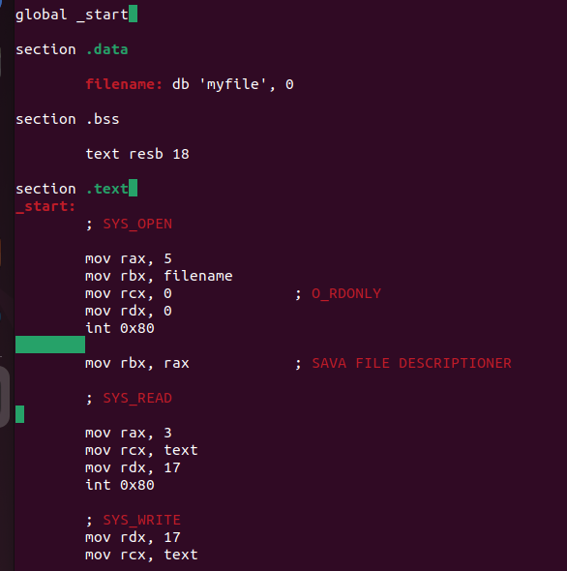

OUTPUT:
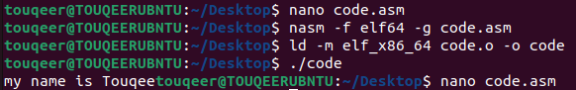
- Write and run the C program from Section 7 using open, read, write, and close directly (no printf/fopen). Then rewrite it using only printf and fopen/fread instead, and use strace on both — do they end up making the same underlying system calls?
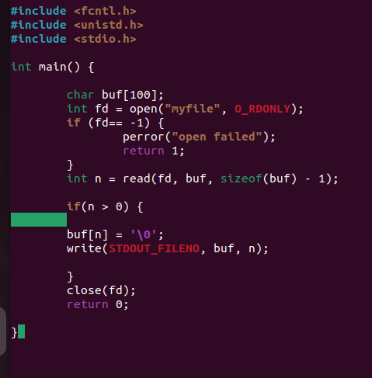
OUTPUT:
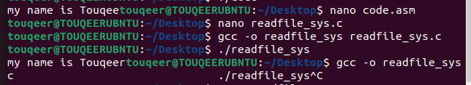

- Write and run the dup2 redirection program from Section 8. Then use strace on it and find the dup2 call in the output, confirming which file descriptor numbers it's operating on.
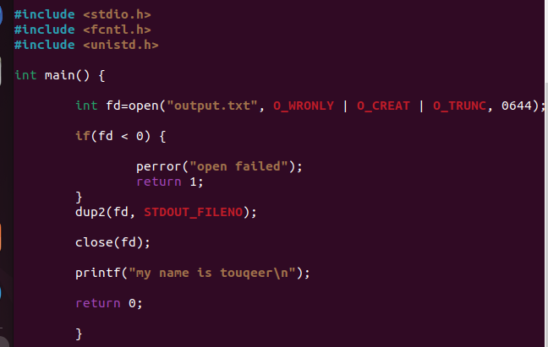
OUTPUT:
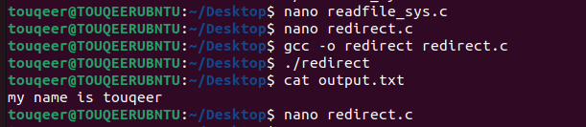

- Modify the Section 8 program to use dup instead of dup2 to achieve the same redirection. Explain in 1–2 sentences why dup alone requires an extra step that dup2 doesn't.
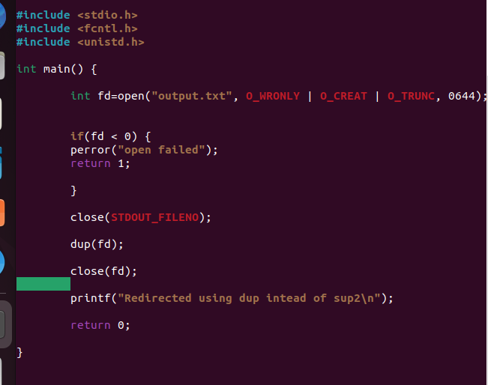

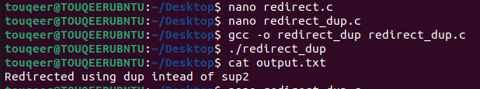
dup(oldfd) automated tareeqe se sab se lowest available (free) file descriptor number assign karta hai. Redirection ke liye file descriptor 1 (stdout) free hona lazmi hai, isliye pehle close(1) karna padta hai.
Jabki dup2(oldfd, newfd) mein hum specific descriptor number khud specify karte hain (newfd = 1), aur agar wo pehle se open ho toh dup2 usko khud hi pehle close kar deta hai.

7.Create a folder containing two files, file1.txt and file2.txt. Run strace ls inside it and list every system call you can identify in the output, with a one-line description of what each does.
OUTPUT:
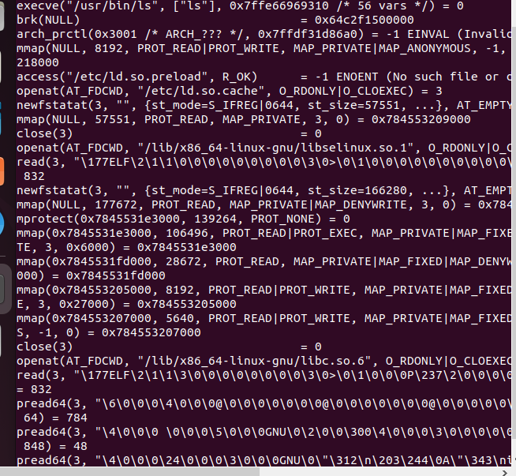

System call | Purpose
execve() | ls program start/execute karta hai
brk() | Process heap manage karta hai
mmap() | Memory map karta hai
openat() | Directory/files open karta hai
newfstatat() / statx() | File/directory information leta hai
getdents64() | Directory entries read karta hai
close() | File descriptor close karta hai
read() | Data read karta hai
write() | Output terminal par likhta hai
fstat() | File descriptor ki information leta hai
access() | File access/availability check karta hai
arch_prctl() | Architecture/thread-related setup
set_tid_address() | Thread/process setup
set_robust_list() | Robust futex list setup
rseq() | Restartable sequences setup
prlimit64() | Process resource limits check karta hai
getrandom() | Random data obtain karta hai
ioctl() | Terminal/device information/control

- Run strace -c on any command of your choice (e.g. cat, grep, or your own compiled program) and report which system call took the most total time, and which was called the most times.
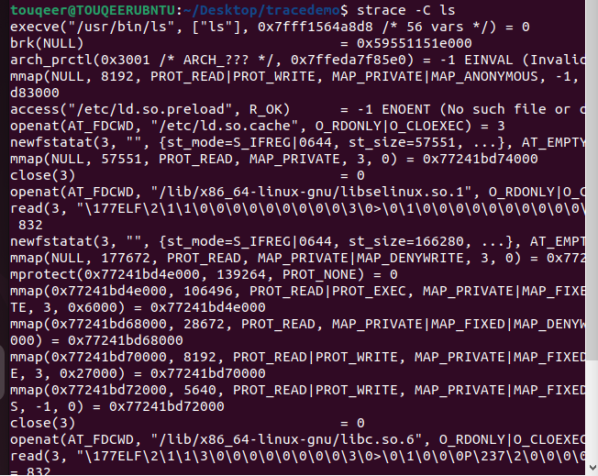
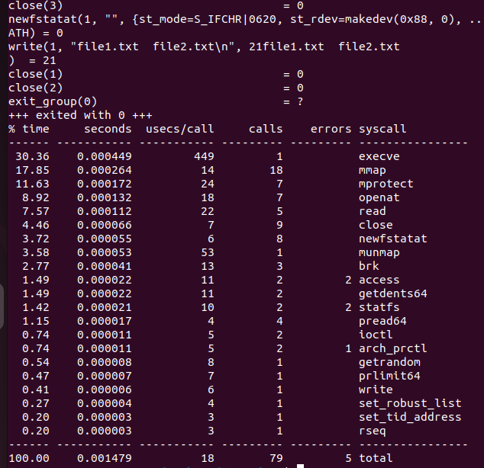

System Call taking the most total time: mmap (ya execve)
System Call called the most times: mmap (ya close)

- Open two terminals. In one, run cat > abcd; in the other, find its PID with pidof and attach to it with strace -p. Type a few characters in the first terminal and report the system calls you observe appearing in the second.
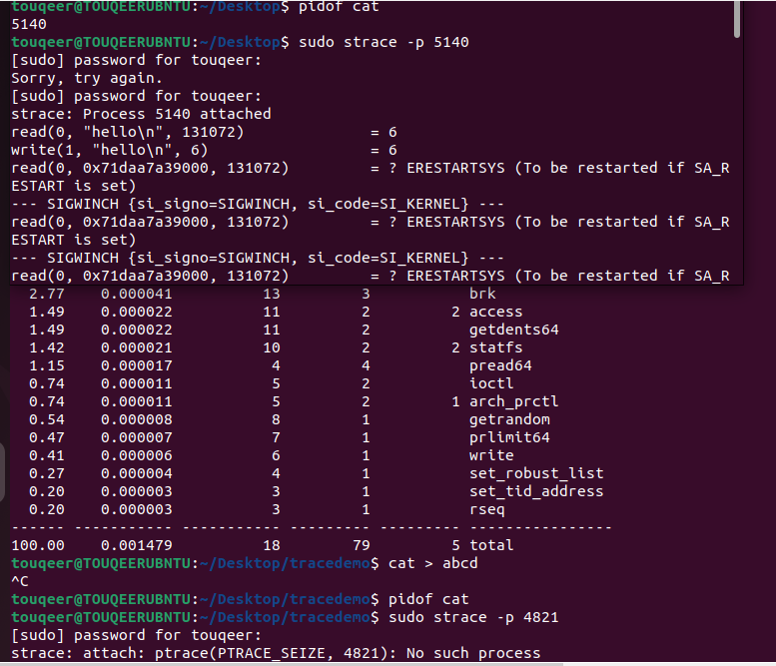

THE END

