LAB -03 :->
Name: Touqeer Ahmed
CMS -ID :023-24-0238
BS CS -V “G”

- Write a script that asks for and prints your name, roll number, and department (bio-data), using read and echo

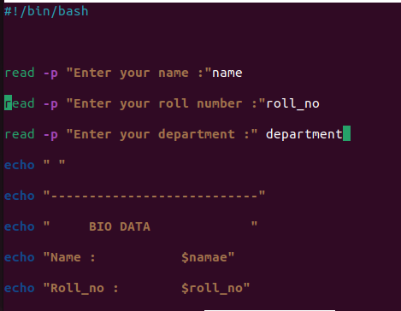
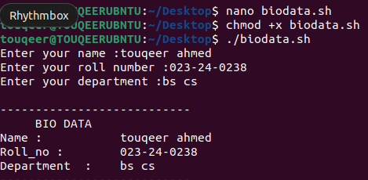

- Write a script that prints the number of command-line arguments it was given and then lists each one on its own line.
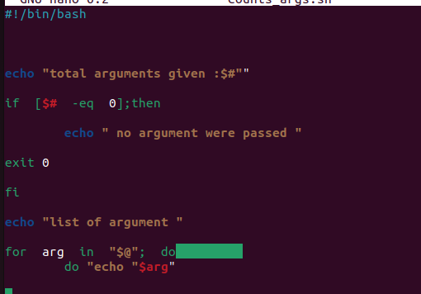
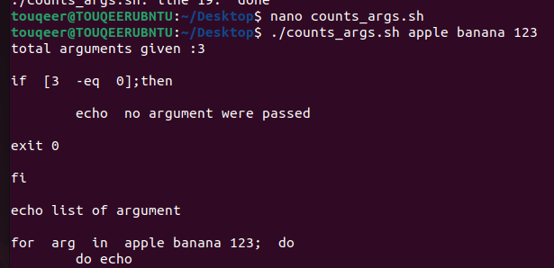

- Write a script that takes two numbers from the user and prints the result of all five arithmetic operations (+, -, *, /, %), using $((...)) rather than expr.
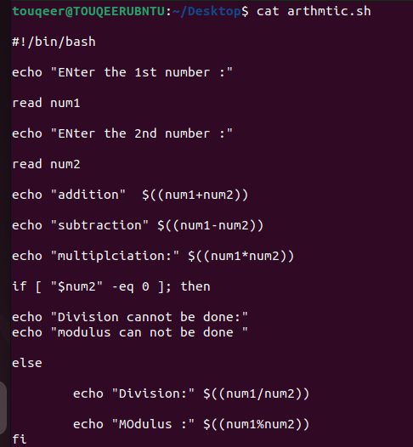
OUTPUT:
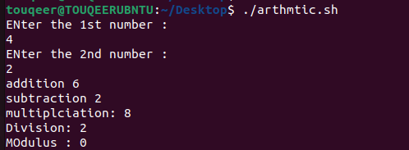

- Write a script that takes two strings from the user and prints their concatenation.
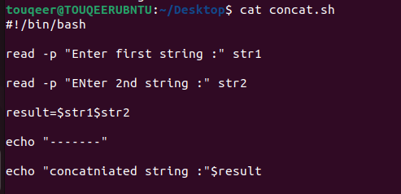
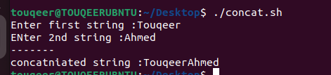

- Write a script that takes two strings from the user and reports whether they're equal, and which one is empty (if either is), using the string operators from Section 10.2
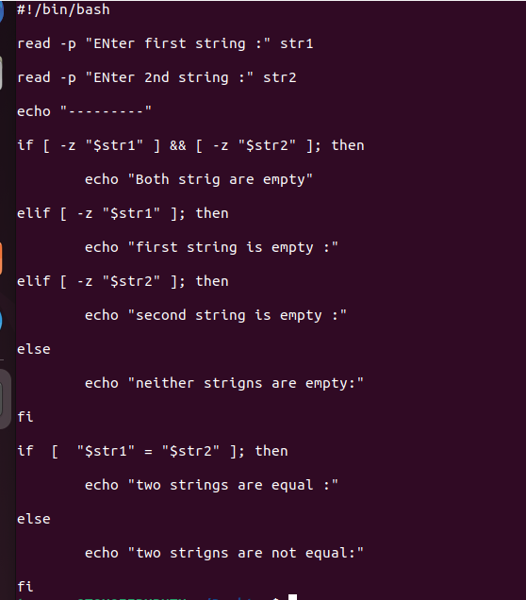
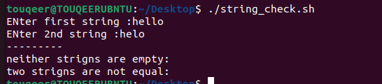
Output :1:

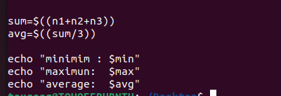
- Write a script that takes three numbers from the user and prints the minimum, maximum, and average, using if/elif/else. 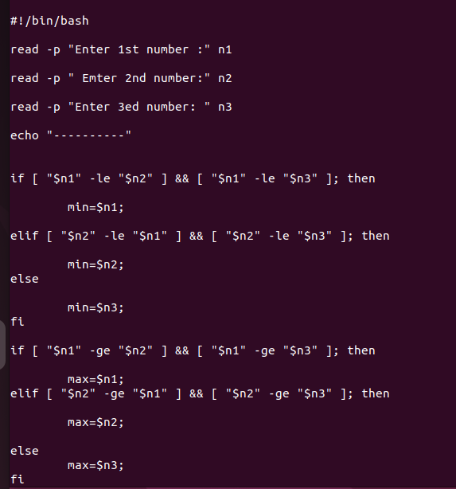

Output :
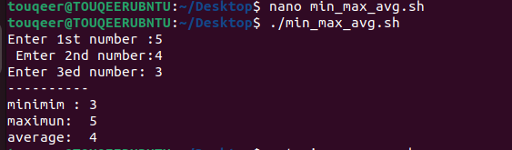
7. Write a script that creates a directory, then uses chmod to set permissions so that only the owner can enter and execute inside it (recall Lab 2) — verify the result with ls -l.
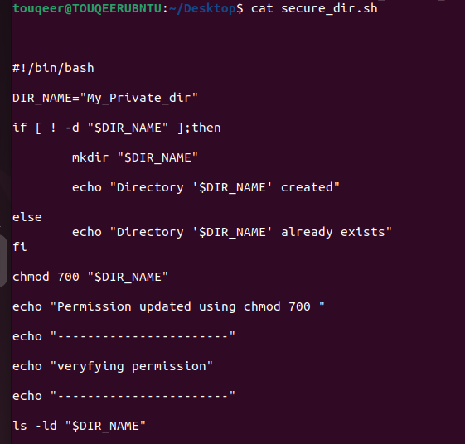
OUTPUT : 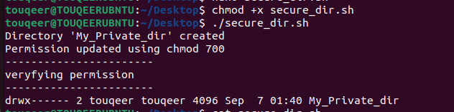

8.Write a script that prints the current date in the format DD-MM-YYYY using the date command and command substitution.

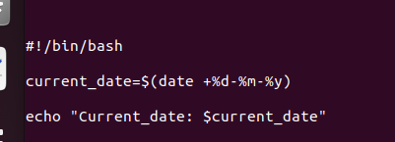
OUTPUT:
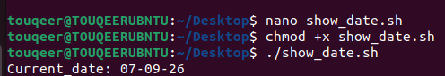

9. Write a script that asks the user for a filename and creates that file using touch, then asks for a new name and renames it using mv, printing a confirmation message at each step.
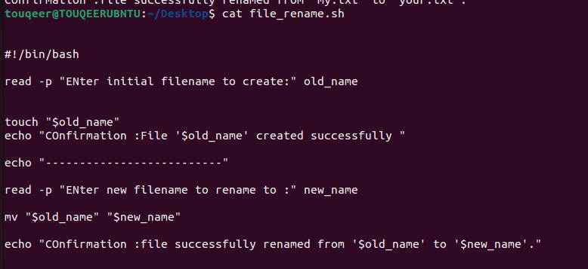
OUTPUT:
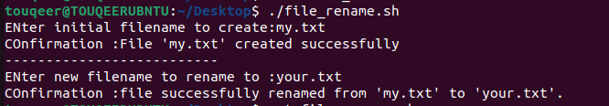
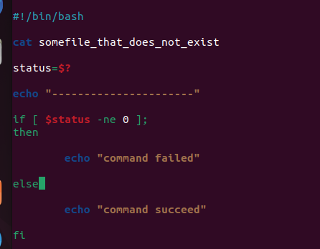
10.Write a script that deliberately tries to open a file that doesn't exist (cat somefile_that_does_not_exist), then immediately checks $? and prints "Command failed" if it's non-zero, "Command succeeded" otherwise

OUTPUT:
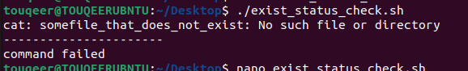

11.Write a script that classifies a number entered by the user as positive, negative, or zero, and separately whether it's even or odd — using a single if/elif chain with the -a (AND) operator to combine both checks into a single sentence, e.g. "The number is positive and even."
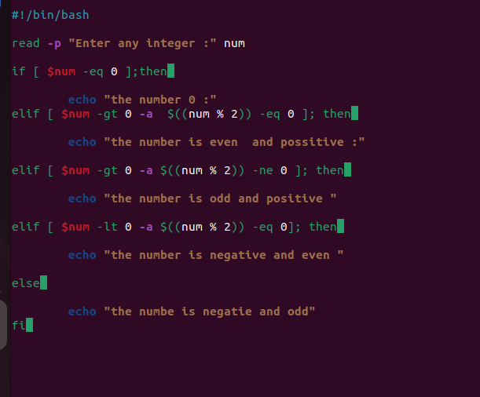

OUTPUT:
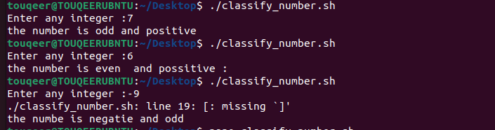

12.Write a script that checks how full your root filesystem is (hint: df -h /, then extract the percentage with awk or cut) and prints a warning message if usage is 80% or higher, or "Disk space OK" otherwise.
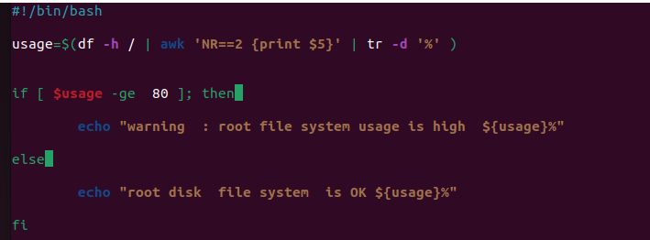

13.Write a script that expects exactly 2 arguments. If it's run with the wrong number of arguments, it should print a usage message (e.g. Usage: ./script.sh ) and exit 1 without doing anything else; otherwise it should proceed normally and exit 0.
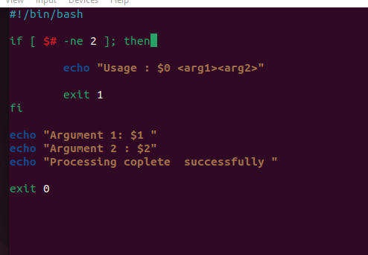
OUTPUT :
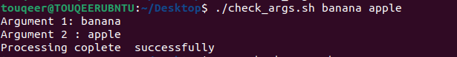

14.Write a script that takes a path as its argument and, using the file test operators from Section 10.5, reports whether it's a file, a directory, or doesn't exist — and if it's a file, also reports whether it's readable, writable, and/or executable.
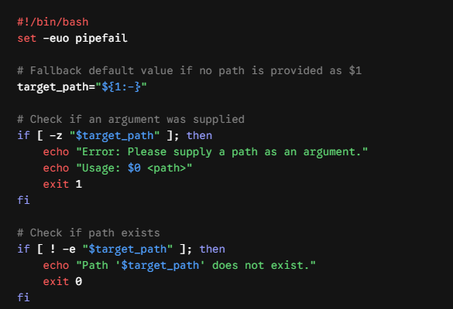
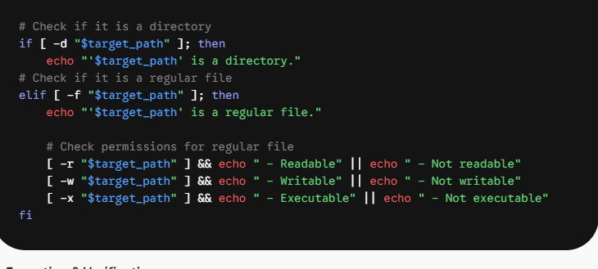
15.Write a script that takes a filename as an optional argument, using ${1:-default.txt} to fall back to a default name if none is given. Test it both with and without an argument

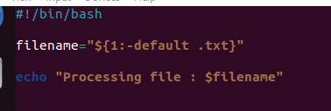

16.Take any script from this lab that uses a positional parameter, add set -euo pipefail right after the shebang, then deliberately trigger a failure (e.g. reference an unset variable, or run a command on a nonexistent file). Report exactly how the script's behavior differs with and without strict mode
