
National University of Computer & Emerging Science
Islamabad Campus

CY2002
Digital Forensics- Final Project

BitLocker Key
Finder and Extractor

Submitted by: Ahmed Umar Rehman,
Roll number: i221580
Date: November 19, 2024

Table of Contents
• Introduction 2
• Details and Steps 2
• Summary 2
• References 2

Introduction
In this project, we have compiled a tool to simulate the process of extracting and finding the key for the BitLocker encrypted drive.

Details and Steps

README
We have included a python code which is the main program, winpmem_mini_x64_rc2.exe for capturing image of the live RAM, and a .bat file for installing the required dependencies. In order to use our tool, you have to install the latest version of python for your Windows system yourself from Python. Also you need to install Git for Windows from Git Download These are all the requirements for our program.

User Guide
The first step is to run the python file after uncommenting the line #22 in the python code. It will call the BAT file which will automatically install the dependencies. Do comment on that line after the first run, otherwise it will keep running the installation scripts for the dependencies already installed. And run vs code as administrator for betterment.
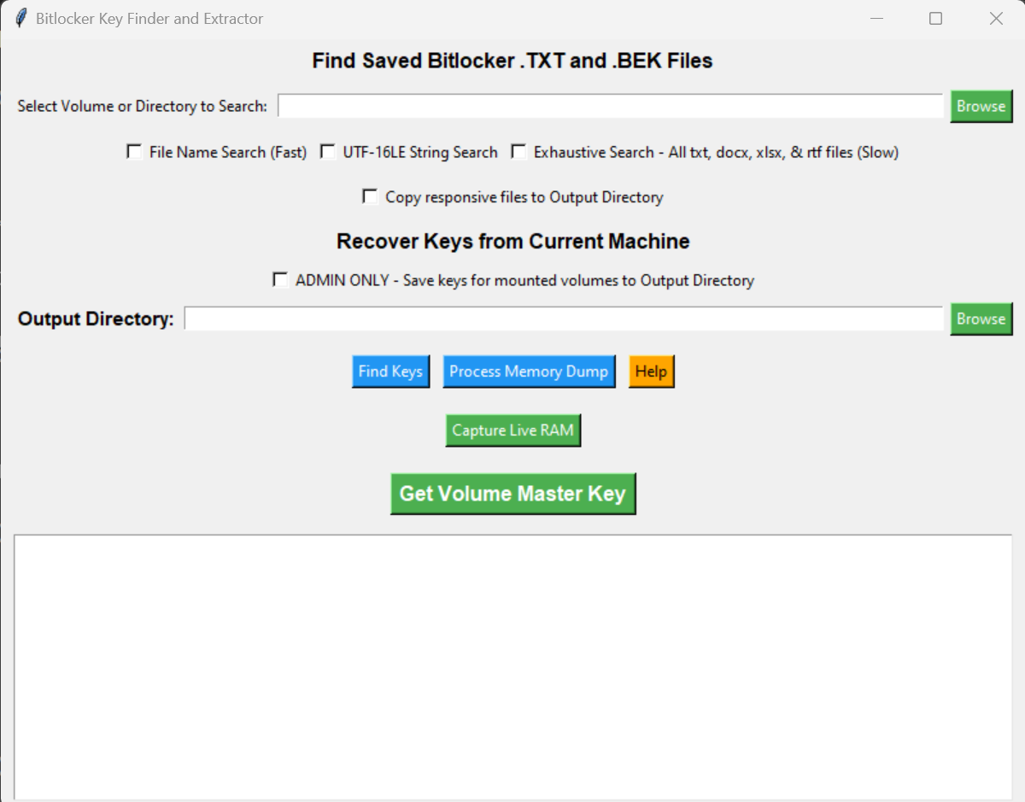
This is the interface you will see after successfully running the program. It shows multiple options including:
1) In order to find the Recovery key saved in partition, 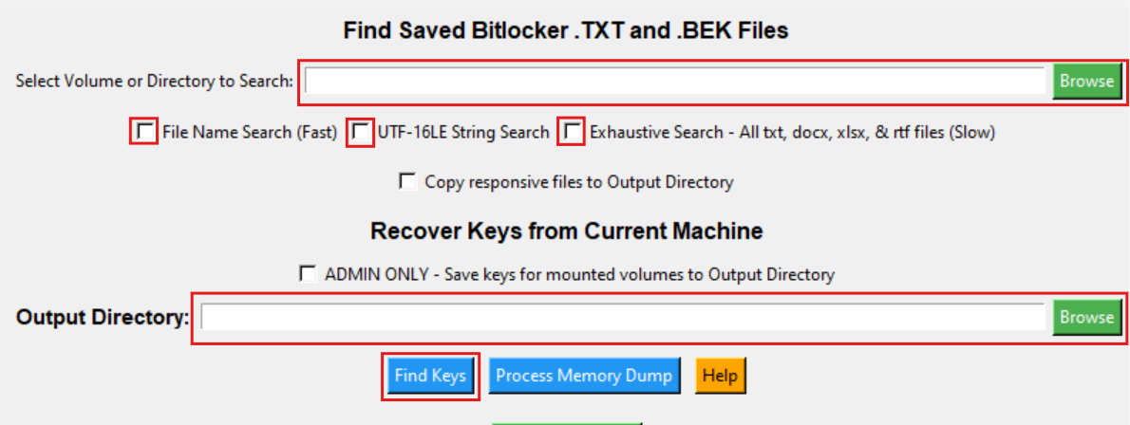
You will first select the partition in the above browse button and select the methods of searches from the given checkboxes. In the second browse button at the bottom, you will select the output directory where you want to store the key. 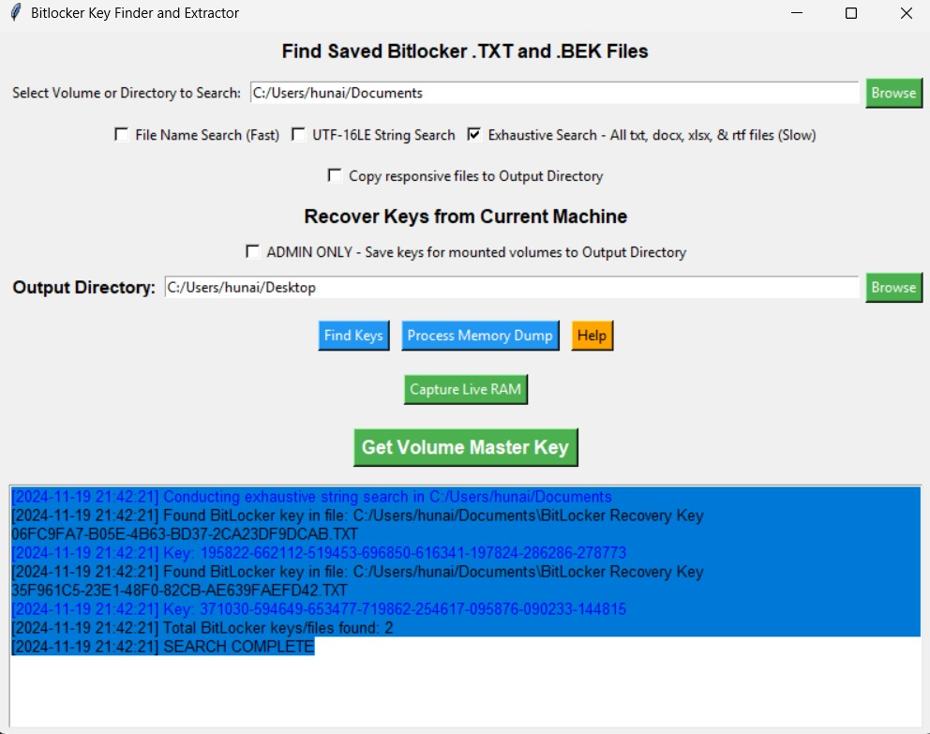
Here you can see the output of your search.
2). The “Process Memory Dump” button allows you to select the image of the live RAM (if already available) for searching the key OR you can press the “Capture Live RAM” button in order to create a new image of the RAM.
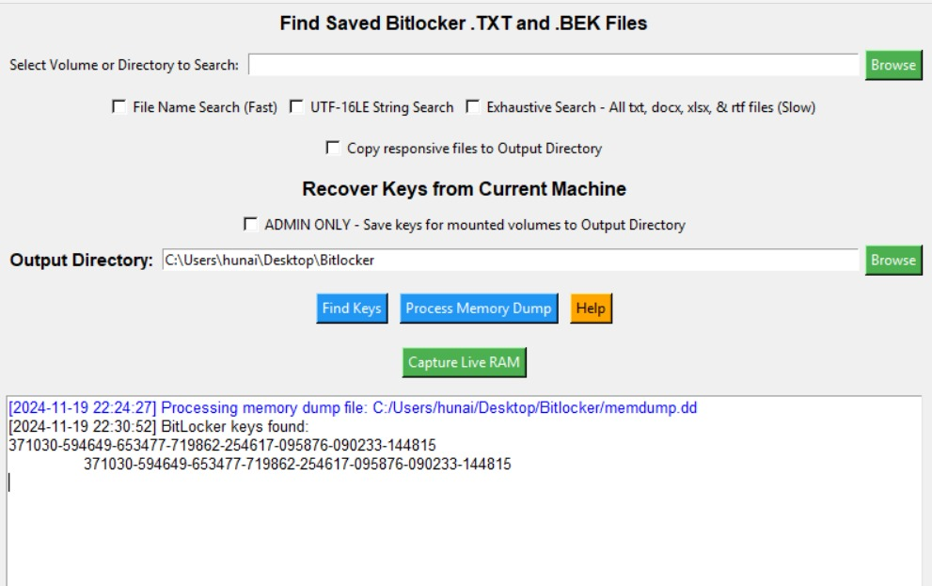
3). The “Get Volume Master Key” button will initiate the Elcomsoft Forensic Disk Decrypter software.
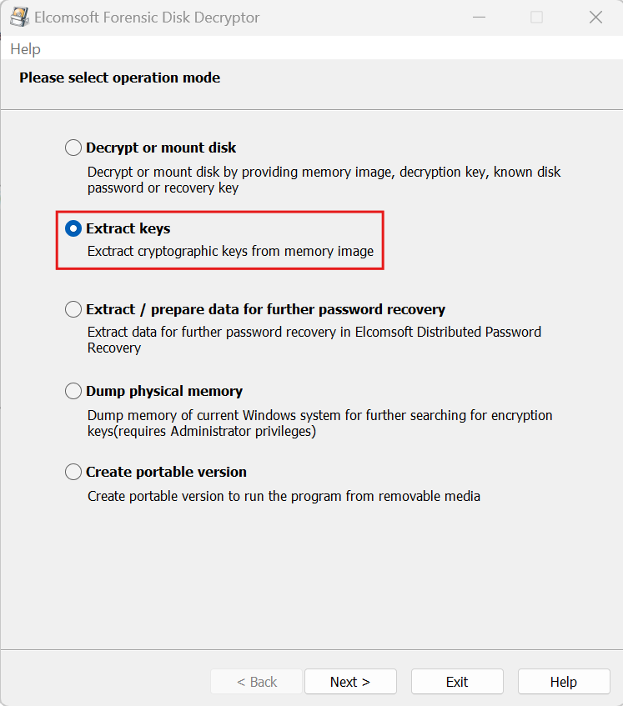
Here, you will select the “Extract Keys” option.
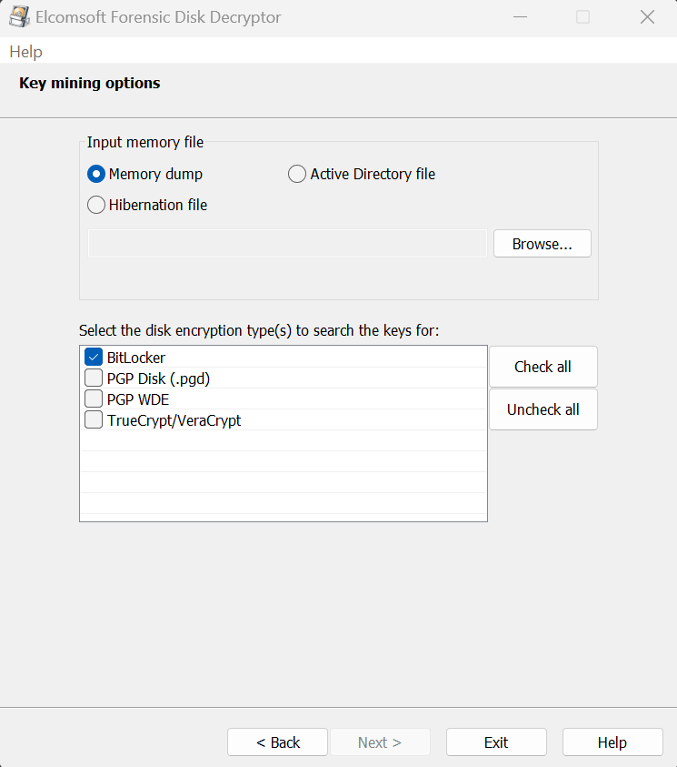
You will select the memory dump in the input selection and browse for the RAM image created and then select BitLocker in the disk encryption types.
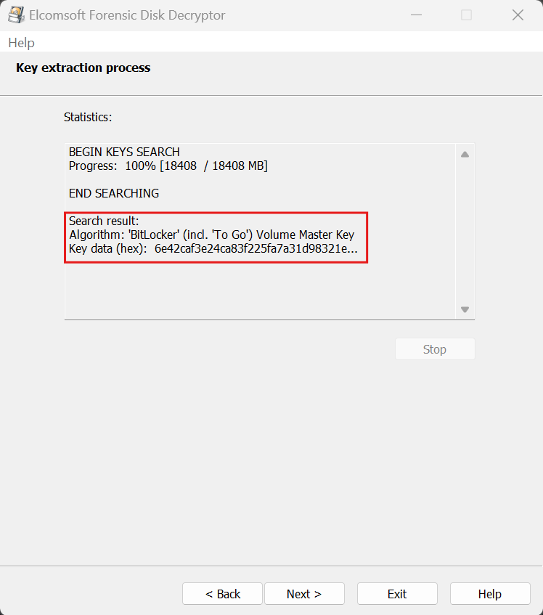
Once the VMK is found, you can save it in the form of an .evk file at any place.
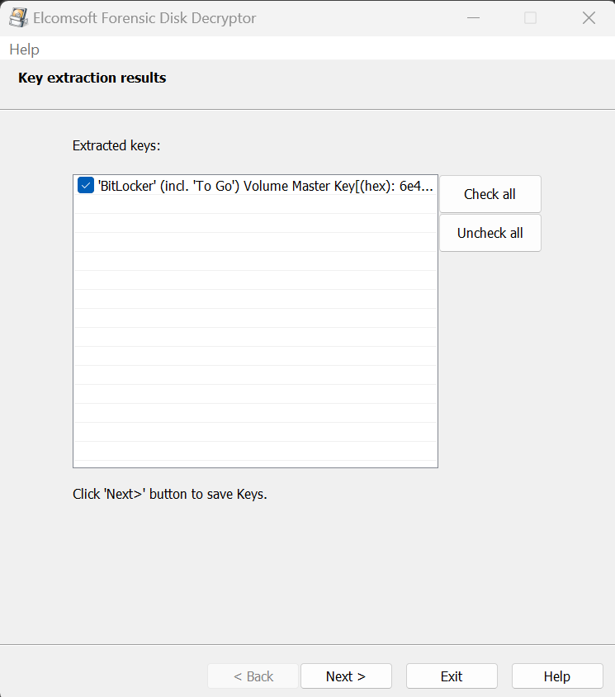

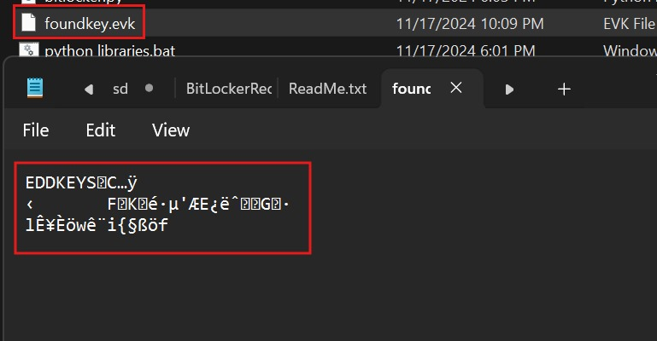

This is the VMK given by Elcomsoft.
4). 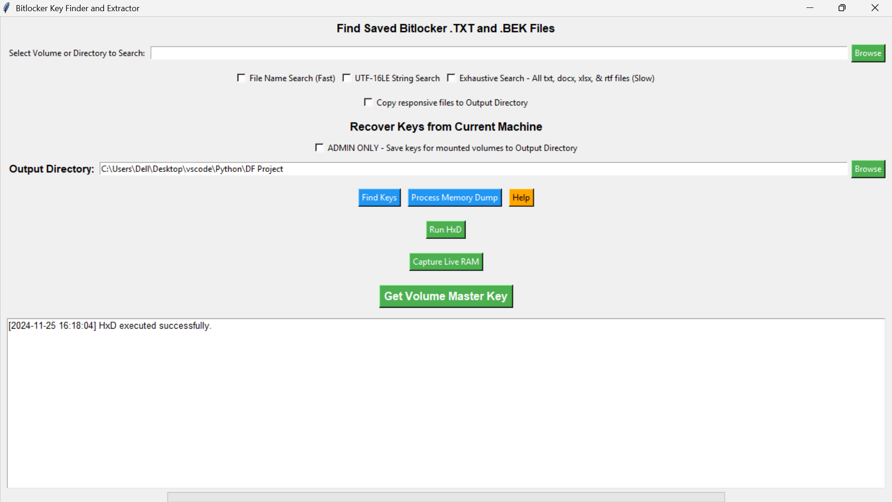
We have also added the button for winhex software to view the hex value of any file.
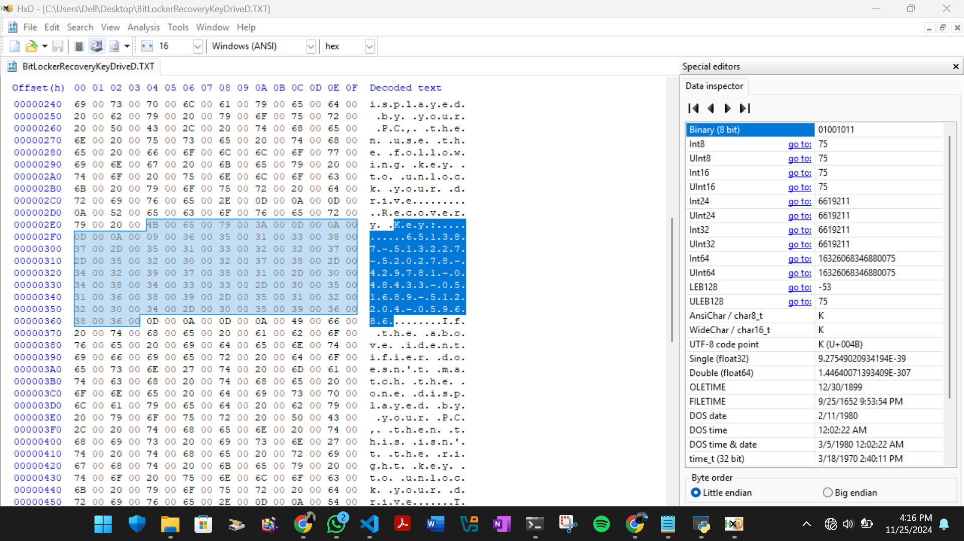
You can view any file using Winhex

Summary

The BitLocker Key Finder and Extractor project focuses on creating a tool to simulate the process of extracting and finding keys for BitLocker-encrypted drives. The solution integrates a Python program, a memory acquisition tool (`winpmem_mini_x64_rc2.exe`), and a batch file for dependency installation. Users are guided to set up Python and utilize an interface with options for key recovery, memory dump processing, and volume master key extraction via Elcomsoft Forensic Disk Decrypter. The tool allows capturing live RAM images or using existing ones to locate keys efficiently. The project aims to simplify the forensic process of decrypting BitLocker-encrypted volumes, offering step-by-step usability for investigators.

References
BitLocker Key Finder v3.3.0
Winpmem

