Software Requirements Specification

for

V-Elect

**Version 1.1 approved**

**Prepared by:**

**Ahmed Wael 900183285**

**Menna Ghalwash 900181104**

**Mariam Daabis 900182265**

**Mostafa Elsharkawy 900182569**

**The American University in Cairo**

**School of Sciences and Engineering**

**5/11/2020**

**Table of Contents**

1. Introduction 1

1.1 Purpose 1

1.2 Document Conventions 1

1.3 Intended Audience and Reading Suggestions 1

1.4 Product Scope 2

1.5 References 3

2. Overall Description 3

2.1 Product Perspective 3

2.2 Product Functions 5

2.3 User Classes and Characteristics 13

2.4 Operating Environment 15

2.5 Design and Implementation Constraints 16

2.6 User Documentation 18

2.7 Assumptions and Dependencies 19

3. External Interface Requirements 20

3.1 User Interfaces 20

3.2 Hardware Interfaces 25

3.3 Software Interfaces 26

3.4 Communications Interfaces 27

4. System Features 28

4.1 User Registers an account for V-Elect 28

4.2 User Registration Process Decision (eKYC) 30

4.3 User Registration Process Decision (Manually) 32

4.4 User Logs in to V-Elect 33

4.5 User Votes for a Candidate 34

4.6 User Views Results and Statistics 36

4.7 User Searches for Campaign Content or Discussion Threads (All users allowed, including guests) 38

4.8 User Views Discussion Threads (Guests allowed) 40

4.9 User Participates in Discussion Threads (Guests not allowed) 42

4.10 User Creates Campaign Content (Campaigners and Candidates) 45

4.11 User Views Campaign Content (All users including guests) 47

4.12 User Pays for VEI-Tool 50

4.13 User uses VEI-Tool 51

4.14 User Requests/Joins Live Talk 53

4.15 User Moderates Discussions (Admin/Campaigners/Candidates) 55

4.16 User Edits Own Profile (Limited to password and username) 56

4.17 Administrator Edits Profile (Adding, Muting, and Removing) 58

4.18 User Reports Bug (All users allowed) 60

4.19 Candidate/Campaigner adds a Campaigner 61

5. Other Nonfunctional Requirements 62

5.1 Performance Requirements 62

5.2 Safety Requirements 62

5.3 Security Requirements 63

5.4 Software Quality Attributes 64

5.5 Business Rules 65

Appendix A: Glossary

Appendix B: Analysis Models

Appendix C: To Be Determined List

**Revision History**

|  |  |  |  |
| --- | --- | --- | --- |
| **Name** | **Date** | **Reason For Changes** | **Version** |
| Initial SRS Document | 11/5/2020 | N/A | 1.0.0 |
| Final SRS Document | 11/7/202 | Revised with Format Adjustments | 1.1.0 |

# Introduction

## Purpose

This document will describe V-Elect (*Version 1.1.0*), which is intended for Virtual Elections Inc. The product is a mobile application and website that aspires to lead a unique development for a system capable of handling various services for elections. The system will manage the streamlining of campaigns, hosting debates, and the actual elections and voting processes. V-Elect itself does not perform any necessary actions other than the campaigning and voting processes themselves, meaning that results of a particular vote are not binding unless a government or entity agrees to a contract with VEI, thereby enforcing the results of the vote.

## Document Conventions

The document has few conventions to aid the audience in the readability of certain sections (like section 4 for instance). This includes the following:

* Button names will be *italicized*
  + Examples:
    - *Submit Documents*
    - *Register Account*

* **TBD**s will be written in **bold**, and will be followed by a “-” as well as a code to link that TBD to the list in Appendix C
  + Example:
    - **TBD-1.2.1**

* Acronyms that are unknown to readers without tech-heavy backgrounds can be found in Appendix A, with a definition and occasionally a reference to where it was mentioned.

## Intended Audience and Reading Suggestions

This document is intended for the VEI stakeholders and everyone directly involved in the development of V-Elect. It serves the purpose of being an initial proposal/outline for an online platform (website and mobile application) that hosts and encompasses everything related to the elections from handling campaigns to handling the actual voting process. This document will also serve as a guide for the software developers of V-Elect to follow as it will provide different types of specifications and constraints. This software requirement specification (SRS) will contain different Use Case diagrams as well as simple diagrams that will show the major components of V-Elect.

Document audience:

* VEI stakeholders.
* Government officials.
* V-Elect software developers.
* V-Elect project managers.
* Testers.

Users include:

* General community (voters)
* Campaigners
* Candidates
* Administrators

## Product Scope

V-Elect is an online system that will manage election processes in a given country, in accordance with local authorities and government, available to users as both a mobile application and a website. V-Elect will be an all-encompassing platform for candidates to present their ideologies and strategies and engage in debate with other candidates; for campaigners to lobby for their respective candidates and showcase the candidate’s plan and program; and for voters to get a full understanding of all candidates and to make an informed decision with their vote.

V-Elect will allow candidates and their team of campaigners to publish content relating to their campaign and to the candidate’s stance on different socio-political and economic topics. The system will support different forms of content, including but not limited to articles, videos, and audio clippings.

In the duration prior to the voting period, voters will have opportunities to engage in discussion with candidates, campaigners and one another. The mobile application and website will support discussions over the content published by candidates and campaigners. Users will also be able to create discussion threads dedicated to discussing particular topics with candidates, campaigners and one another. Only **registered** voters will be allowed to participate in discussions, and other guest users will only be allowed to view the discussions. Registration and authorization will be performed through the online system, or at voting centers for users who prefer this approach.

During the voting period, registered voters will be allowed to cast their votes using the mobile application or the website. Alternatively, voters who prefer to visit voting centers will be allowed to do so, where they will be directed to sign into the system from the center’s devices.

V-Elect’s voting process will be characterized by its security, reliability and anonymity of voters. Additionally, V-Elect aims to replace the traditional ballot-voting system, which has become outdated due to its slow speed and frequency of lost votes.

## References

All information has been provided in designated sections, and we decided to incorporate all designs, diagrams, and information into this SRS.

The tools used for this SRS involve the following:

* Visual Paradigm - Standard Edition

* + <https://www.visual-paradigm.com/>
* Lucidchart

* + <https://www.lucidchart.com/pages/>
* Wireframe.cc

* + <https://wireframe.cc/>
* MySQL

* + <https://www.mysql.com/>

# Overall Description

## Product Perspective

V-Elect’s goal is to replace voting systems that exist worldwide today. Instead of traditional counting and manual approaches, it aspires to achieve an effective method of online voting which will prove more efficient in vote counting and efficiency. It will also provide exact statistics of certain voting results, and can be applied to any entity which requires voting.

The system itself will involve a website and an application, which are connected to multiple servers for a broader reach of users. There is also a centralized database to hold the information of all the users of the app, which will mainly include voter information that will be explained in depth in section 2.3. In addition, there will be a blockchain peer-to-peer network between all users of the application, which will mainly keep track of a ledger of candidates and votes for those specific candidates, to ensure reliability and authenticity during the voting process.

In addition, our product will be using available centers with computers to allow voters without access to our product. These centers will be moderated and will be accessing the same servers as the original product, to ensure that all votes will be counted using our system.

This will not be a follow-on member of a product family, and will behave as a stand-alone system that will be introduced to societies, but it can be described as a component of the whole election process within a country. V-Elect does not determine who the candidates are, which excludes this from our requirements. It is up to the nation’s government to approve suitable candidates, and V-Elect’s administrators will promptly add those candidates to the system for the voters to use. V-Elect also does not perform any actions after the results are in. The government that agrees to use the software will perform the necessary actions and transitions based on the results of the vote. The software itself acts as an intermediary between selection of candidates and the actions performed afterwards (changing government positions, for instance).

System Integration:

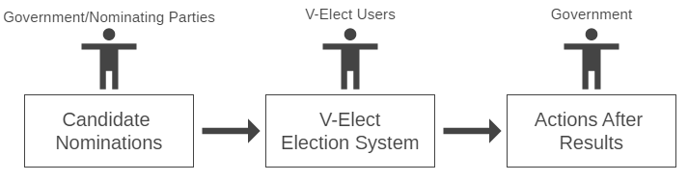

*Figure 2.1.1*

General Structure of V-Elect:

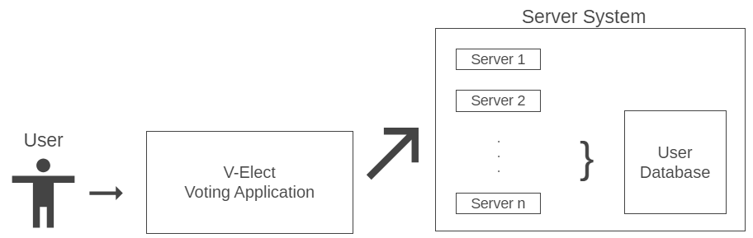

*Figure 2.1.2*

## Product Functions

Note to Readers:

* We would advise you to familiarize yourself with the various user classes found in section **2.3** before taking a look at the following functions. This will help clarify the differences between certain users and the actions they are allowed to take.

General Overview of Product Functions:

User/Voter:

1. Enter as a Guest
   1. Guest mode can view most of the features the website/application offer:
      1. View results
      2. Watch content

1. Enter by an Account
   1. Create an account (free feature) by entering:

(Verify manually or by checking eKYC)

* + 1. Full Name
    2. Email address
    3. Mobile number
    4. Home address
    5. ID number (passport/National ID)
       1. + scan a document of it
    6. Recent photo (within 6 months)
    7. Security question with answer
    8. Password

Password has to be 8 characters or more that includes uppercase, lowercase, digits and special characters

* 1. Login by entering:
     1. ID/Mobile Number
     2. Password
     3. Answer to Security Question
  2. Report a bug
  3. Edit their profiles:
     1. Editing their username
     2. Editing their password
  4. Participate in Q/As and moderated discussions
  5. Receive notifications of updates or live talks.
  6. View Results and Statistics
  7. Watch Content
  8. Vote online using application or website
  9. Vote in existing centers with PCs connected to website
  10. Create dedicated forums for certain topics

Campaigners:

1. Can be added to a list by either the candidate or another accepted campaigner
2. Possess icon/symbol next to their accounts on the app/website to verify that they are campaigners.
3. Allowed to upload content by using VEI too or other free host service:
4. Allowed to moderate discussions:
   1. Text:
      1. Q/A discussions
   2. Audio/Video
      1. Live
      2. Recorded
5. Request Live scheduled talks
6. Can Vote online or in centers

Candidates:

1. Includes all Campaigner options
   1. Verified as candidate
   2. Allowed to enter video talks and discussions
   3. Can vote online and in centers

Administrators:

1. Moderate and mute reported accounts
2. Edit profiles
   * 1. Adding, Removing, and Muting
3. Verify Live Talk Requests

General Overview of Voter Use Case:

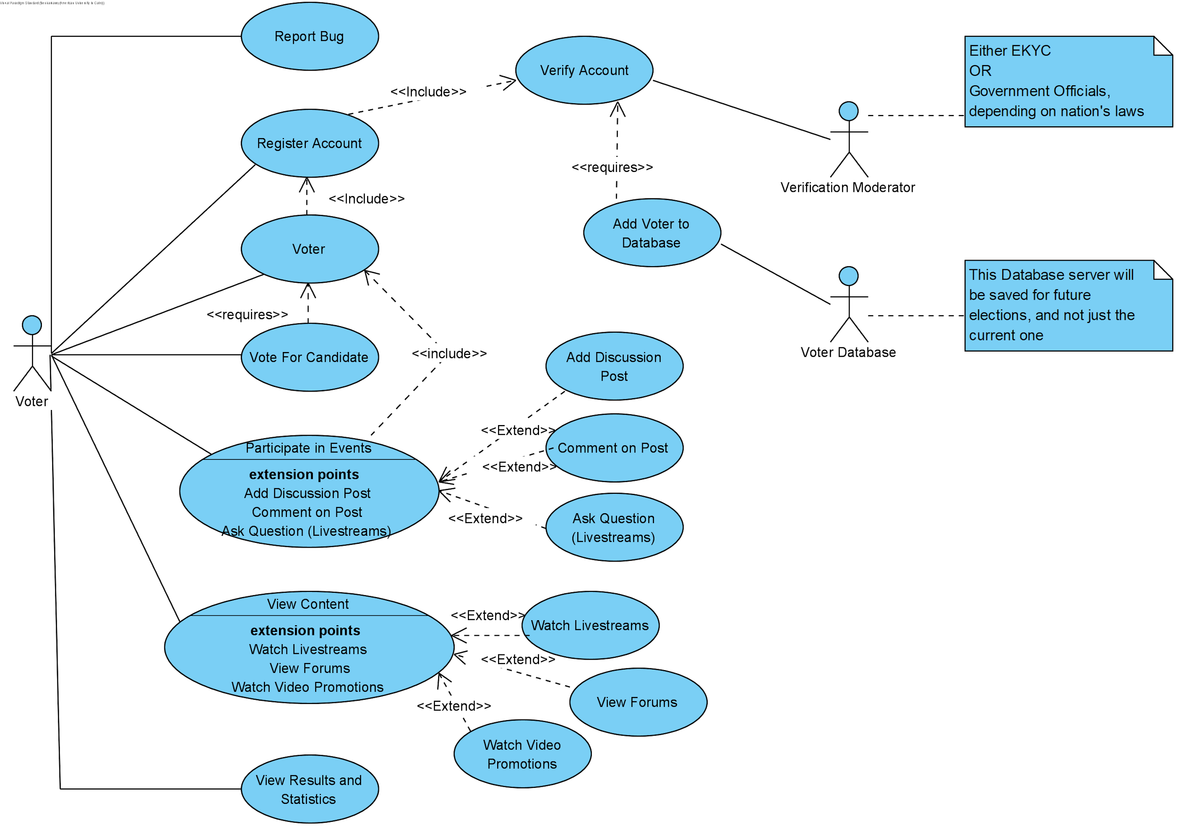

*Figure 2.2.1*

For Figure 2.2.1, textual descriptions and more details regarding the functional requirements can be found in the following sections:

* **4.1 - 4.9**
  + Registering
  + Logging In
  + Participating
  + Voting
  + Viewing Results and statistics
* **4.11** 
  + Viewing general content
* **4.18** 
  + Reporting a Bug

The following activity diagram specifically mentions the flow of a Voter who is logging in to vote for a specific candidate. (See section **4.5** for more details on activity)

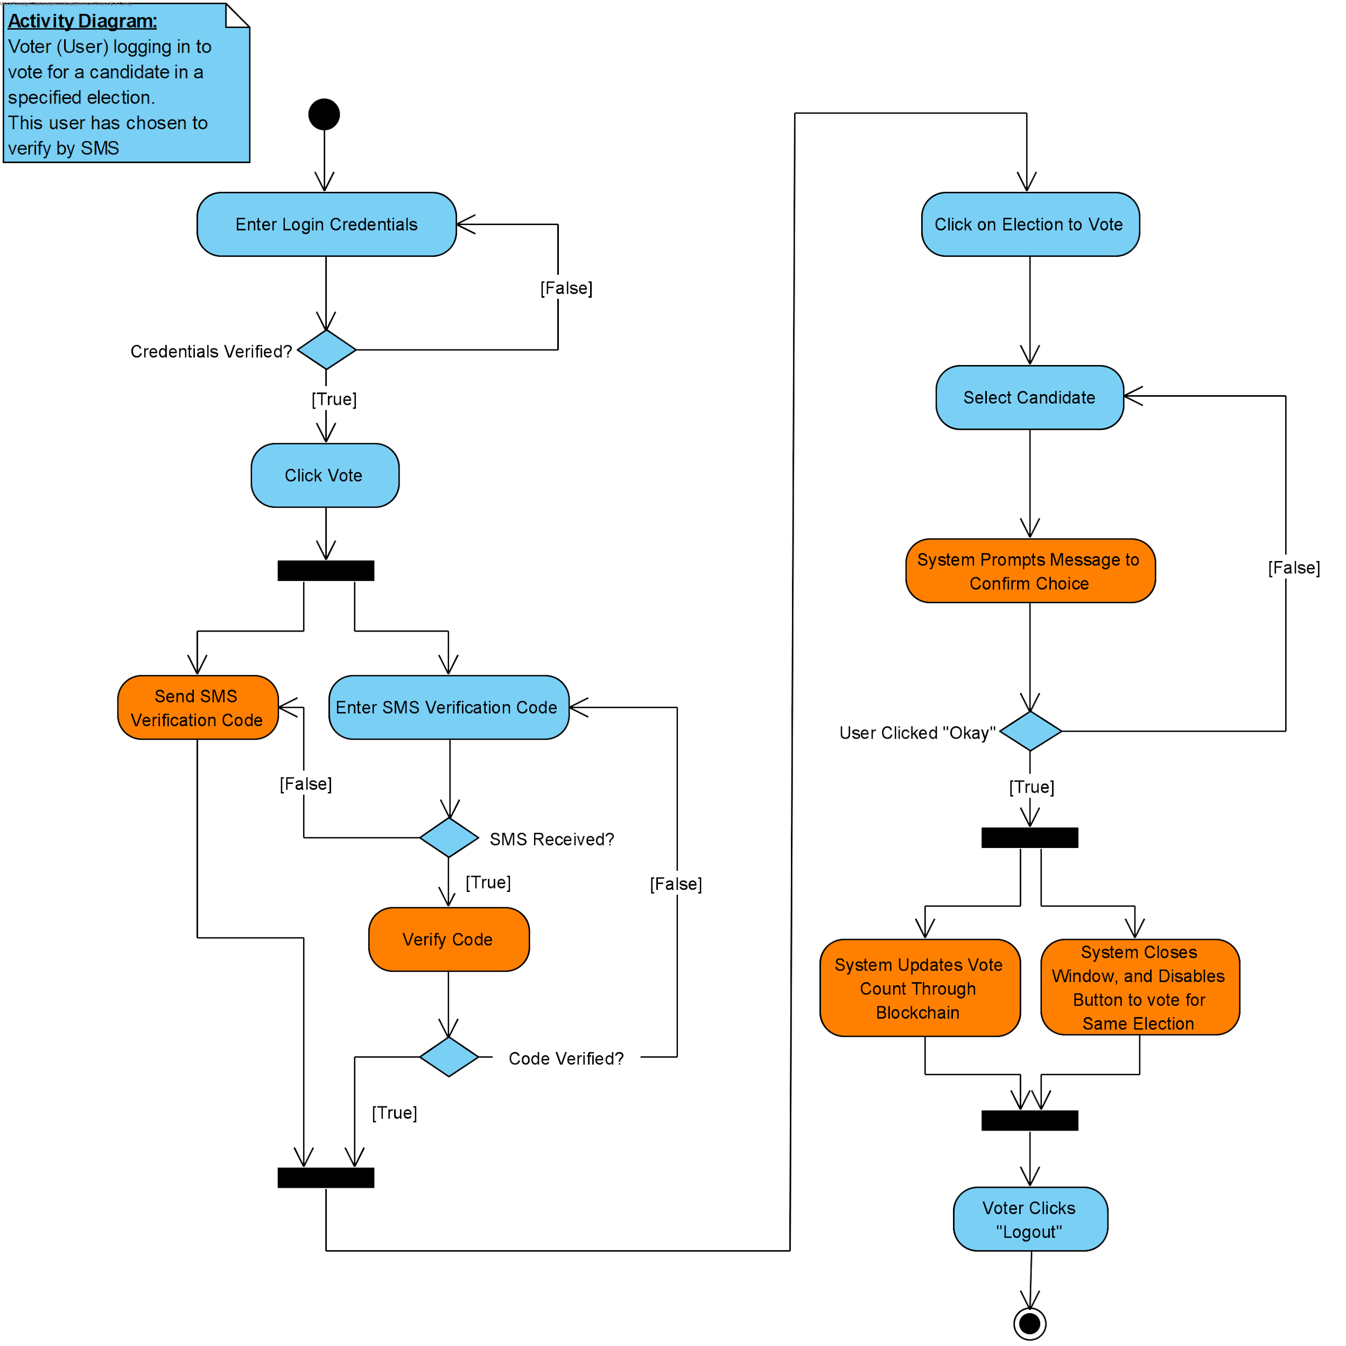

*Figure 2.2.2*

*Note that Orange bubbles specify system activities, while Blue bubbles specify user activities

General overview of Campaigner/Candidate/Administrator Use Case:

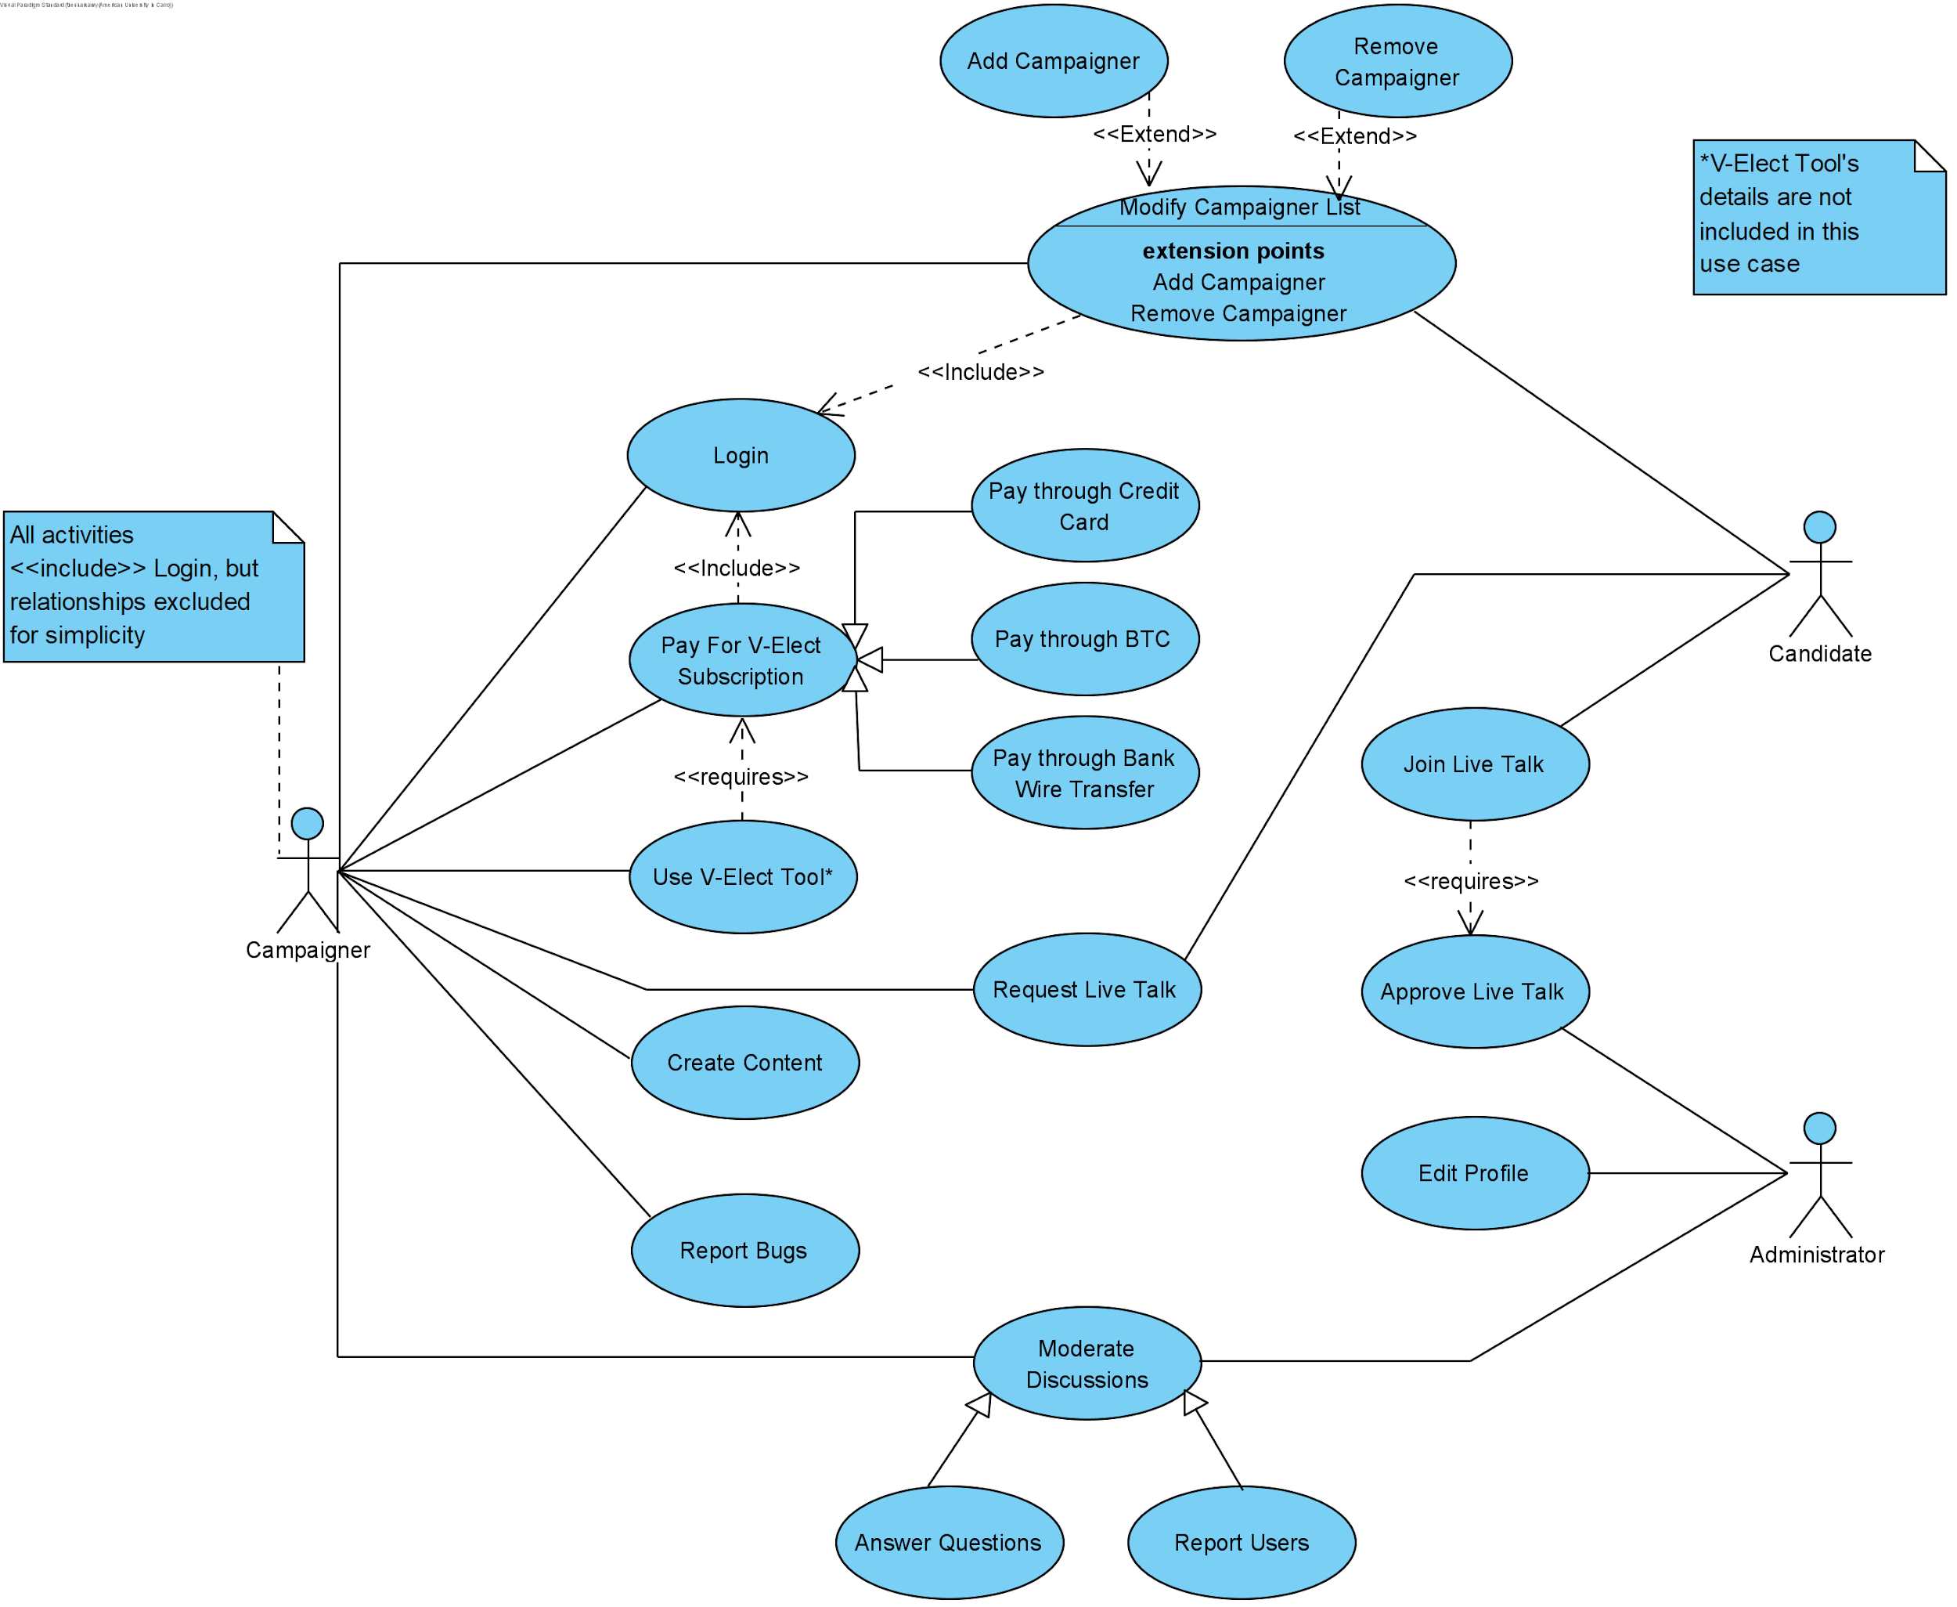

*Figure 2.2.3*

Figure 2.2.3 provides a general overview of the functions performed by a campaigner. It also includes brief use cases for administrators and candidates, but a better view on the difference between these user classes can be found in section **2.3**. Textual descriptions and detailed functional requirements can be found in the following sections:

* **4.11 - 4.15:**
  + Paying and Using V-Elect Tool
  + Creating content
  + Requesting/Joining Live Talk
  + Moderating Discussions
* **4.17- 4.19**
  + Administrator Edits Profile
  + User adds Campaigner
  + User Reports Bug

The following diagram specifically describes the flow of a Candidate who is logging in to perform certain functions, and then promptly log out. See above sections for more details.

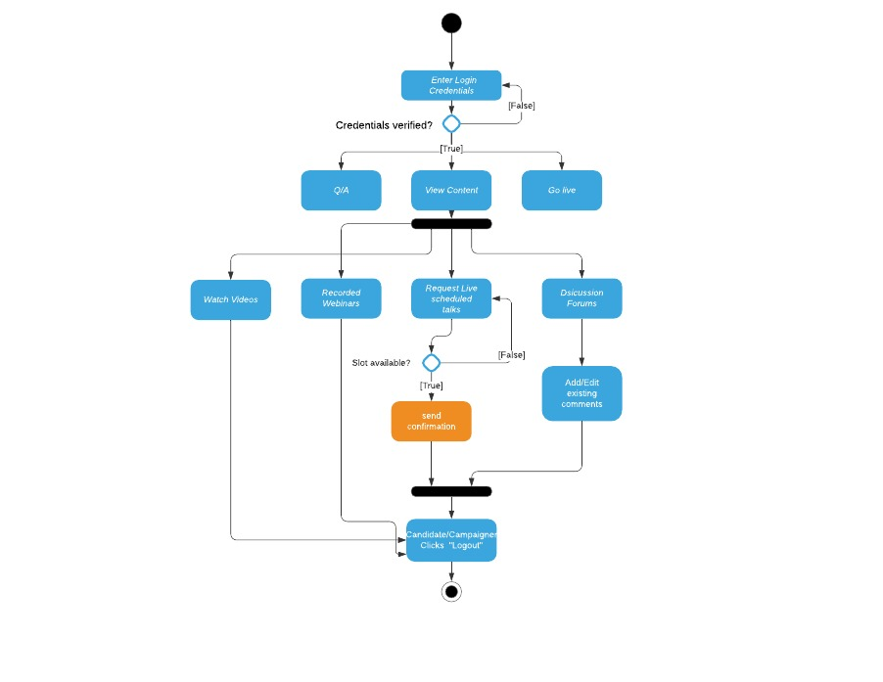

*Figure 2.2.4*

General Activity Diagram for User to Report Author:

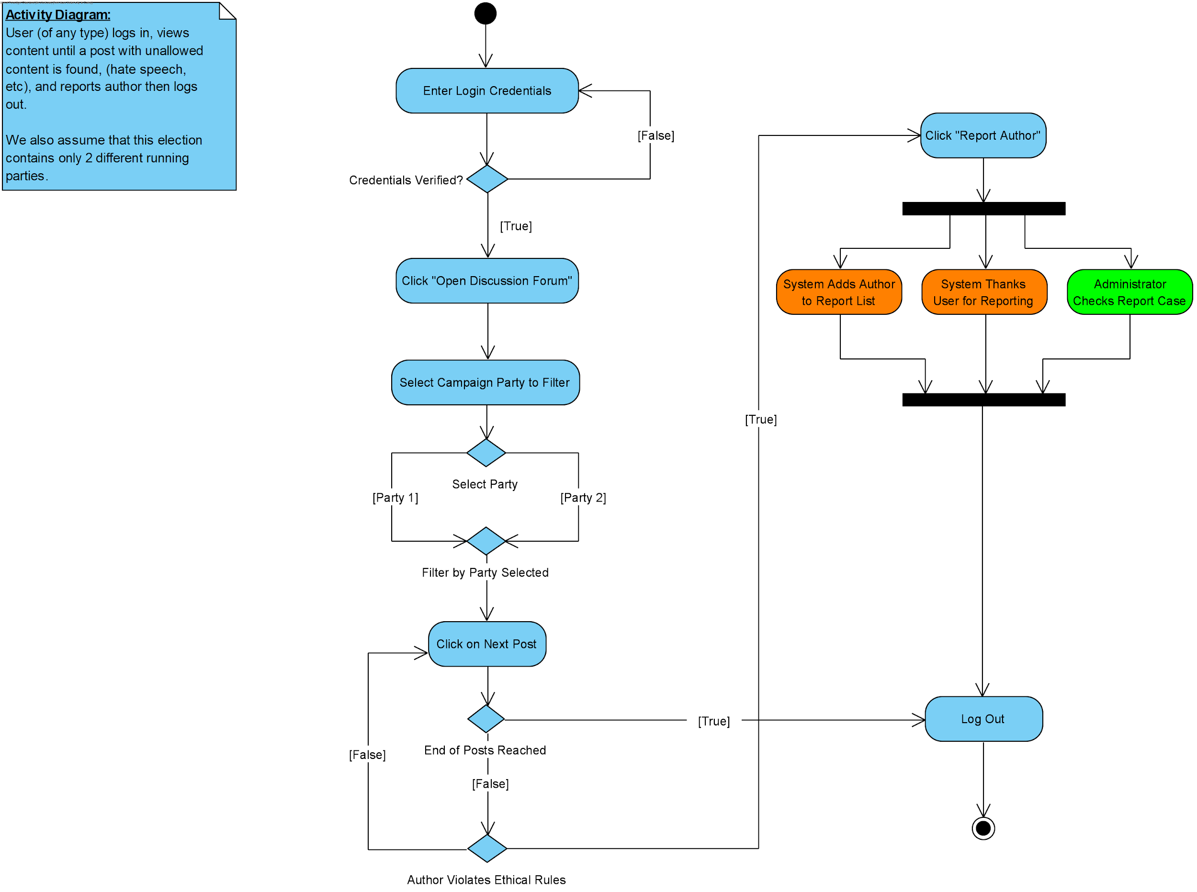

*Figure 2.2.5*

Figure 2.2.5 is a specific activity diagram, but it still illustrates the important process of being able to report an author in V-Elect. Blue bubbles represent user actions, Orange represent system, and green represent administrator actions. This activity involves an obsessive user who constantly searches for unethical authors of a certain party. This user can also be described as a moderator for a certain campaign, who will help maintain the integrity of the online discussion forums.

## 

## User Classes and Characteristics

In terms of end-users, the following diagram illustrates the overall structure:

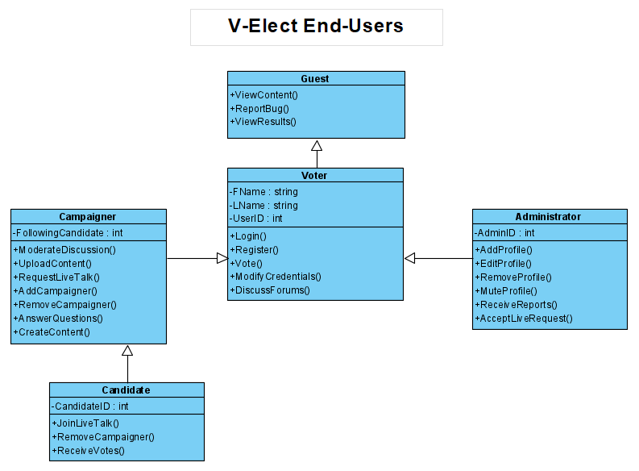*Figure 2.3.1*

* Guest:
  + Views content, results, and can report technical issues
  + **Consists of:**
    - General public, particularly users who are ineligible to vote
      * Like those who are underage
    - Users who wish to view campaign and results without the right to vote
* Voter:
  + Inherits from **Guest**
  + Has an account, and can vote, while also participating in discussions
  + **Consists of:**
    - General public, particularly users who are eligible to vote
      * Users with IDs, and above the voting age requirement
* Administrator:
  + Inherits from **Voter**
  + Adds, Edits, and Removes Profiles
  + Moderates reports, and can accept live requests from candidates/campaigners
  + **Consists of:**
    - IT committees of VEI
      * Including general moderators for discussions and events
    - Specific members of country’s government (to verify candidates)
      * Selected by VEI as candidates
* Campaigner:
  + Inherits from **Voter**
  + Represents certain candidate, and can perform a variety of actions:
    - Moderating discussions while answering questions
    - Adding/Removing other campaigners
    - Creating content through V-Elect Tools
  + **Consists of:**
    - Candidate’s team of campaigners, to be selected by the candidate him/herself, or by another campaigner.
    - Usually marketing and promotion teams, as well as educated members for publishing content and answering questions regarding campaigns.
* Candidate:
  + Inherits from **Campaigner**
  + Joins live talks, full control over removing campaigners, and receives votes
  + **Consists of:**
    - Approved candidates by the government, which are added to V-Elect prior to the election process.

## Operating Environment

The design goal is to allow all operating systems and versions that go back until 2015, because not all voters might have access to the latest versions of software. If successful, V-Elect plans on supporting even older versions, in order to minimize the number of citizens who cannot vote due to lack of access to later versions. This will include the consideration of centers with old PCs for voting as well.

Subsequently, our general compatibility outline is as follows:

The application should be compatible with Android and iOS environments:

* iOS 9 or later
* Android version 6 (Marshmallow) or later

Website compatible with and will operate on most (if not all) modern web browsers, especially the following:

* Chrome (version 41 or later)
* Internet Explorer (11)
* Microsoft Edge (version 25 or later)
* Safari (version 6.2.8 or later)
* Firefox (version 43.0 or later)

Notice that our browsers are primarily supporting the versions that have been released since 2015, as that’s as far as our legacy programming will be concerned with, in order to focus on the content of the newer versions.

In terms of operating systems for laptops and PCs, they should support the listed browser versions, so V-Elect can focus primarily on optimizing the website for the browsers. Obviously the important operating systems should include Windows, Linux, and Mac OS.

## Design and Implementation Constraints

**2.5.1 National Legislations**

**2.5.1.1 Becoming a Candidate**

The process of applying to become a candidate differs from one election to another and from one country to another. Due to the existence of multiple national legislations and offices that specify how anyone can become a candidate, the application and approval of candidates will be handled through the procedures outlined by the government. Afterwards, V-Elect administrators will add to the system any candidates who have received government approval to run for office.

**2.5.1.2 Usage of e-KYC**

In some countries, there exist governmental regulations which prohibit the use of e-KYC verification. Therefore, in these countries, we will need to integrate a few manual processes to authenticate voters before giving them authorization to vote and engage with content and discussion threads. Voters will still upload their pictures and national IDs to the V-Elect, and administrators will manually review registration applications and provide authorization to users which meet registration requirements.

**2.5.1.3 Payment using cryptocurrency**

The VEI-tool for content sharing comes with a fee. Different payment options will be available for candidates and their campaigns to choose from. However, in countries where cryptocurrency transactions are prohibited by law, this payment option will not be available. This restricts the number of payment options which can be offered by V-Elect for the VEI-tool in said countries.

**2.5.2 User Experience Ethical Considerations**

In order to uphold election process ethics and moral standards, V-Elect will not utilize algorithms that tailor content to the user from one campaign over another. Instead, users will be presented with all content from all campaigns, and they will be able to filter which campaigns’ content they would like to view, over a time period that they specify. Users will also be able to sort the content based on different criteria, such as most interacted with and newest. Additionally, users can search for specific content that they want to find.

**2.5.3 Graphic User Interface (GUI) Limitations**

The GUI on different mobile phones and on the website will be as consistent as possible; however, it is inevitable that elements will be designed differently between one platform and another. This is due to the fundamental differences between the different mobile phones with one another and with desktop browsers, such as differences in screen dimensions and supported plug-ins.

**2.5.4 Security Constraints**

As previously indicated, the security of the voting process is a defining characteristic of V-Elect. Security standards and protocols will be upheld to the maximum degree; thorough testing will be conducted; and regular extensive maintenance will be performed. We will only be restricted by the fact that the system’s security will be bounded by the latest advancements in security technology and protocols.

## User Documentation

The following tools will be provided by the development team to aid users in the understanding of V-Elect’s voting process:

1. Help button in website and application that includes:
   1. How the user can access and use the software
      1. This can be achieved by handling different online tutorials of how to access different information.
   2. The different features of the software
      1. ex: handling debates, Q/A,...etc
   3. Tips and tricks of software
      1. Quick shortcuts or buttons to access certain features
   4. FAQs with people that had previous resolved problems
   5. ‘Report a problem’ button that people can send out a long text of their problem or concern for our system’s technical support to help them.
2. Printed manuals that can be distributed in regions where V-Elect performs elections
3. Online video tutorials on how to use the website and application
4. IT Support team to aid any users in confusion regarding V-Elect

## Assumptions and Dependencies

The following factors are assumptions that were made in regards to the SRS, and many decisions made throughout the document rely on these assumptions.

The processes of applying to become a candidate and receiving approval will occur independently from V-Elect, due to extensive and restraining national legislation.

Administration privilege access level is pre-determined by VEI, particularly which administrators are citizens in which the election is to take place and are thus also eligible voters, as opposed to technical administrators who may or may not be eligible to vote.

The software developers are experienced and knowledgeable enough to determine which search and sorting algorithms to utilize.

Blockchain network is implemented by developers who will participate in V-Elect development, and will consist of a large peer-to-peer network of our users, in order to minimize and effectively eliminate any tampering or duplication of votes. The blockchain ledger will contain the list of candidates, and the votes that they have received, with information on regions (in the case of an electoral vote being taken place).

Design Assumptions:

1. Our app/website will support English and Arabic languages, with plans to expand internationally
2. User runs an operating system which supports internet browsing (internet connection is required)
3. No ads will be inserted
4. Our app/website will not be violating any internet ethnic rules

# External Interface Requirements

## User Interfaces

First either the application or the website, the user will land on the login page, if they don't have an account they will have 2 options. Either they will be required to sign up in order to login to their account (which they will have full access to voting participating and requesting sessions) or to login as a guest mode (which they will not be able to neither vote nor participate in anything, guest mode can online view content). User interface is an important component of this software; therefore, as they login to their account they will find a help button that will make it easier for the interaction between the software and the user. In addition, there will be a button to change the language from english to arabic or vice versa. Other icons of different features will be available on the screen, including a profile button that will include all the user’s information, like their username, email address, home address, mobile number,...etc

Prototype for user:

*Figure 3.1.1 Figure 3.1.2*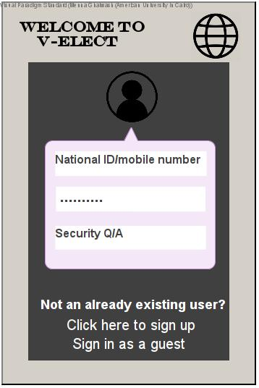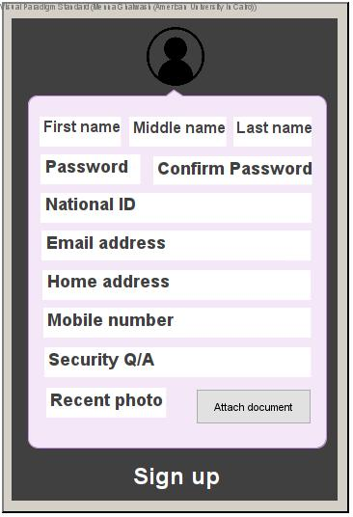

When logged in:

Before the voting period there will be a menu (figure 3.1.3) which contains a help button (figure 3.1.4) at the top left corner and a profile button at the top right corner (figure 3.1.5 ). On one hand, the profile button will direct the user to a page where they will find all their information that was used using the sign up in addition to a few documents that they will be required to upload. On the other hand the help button eases the user’s experience in the application by providing multiple services that will help them. for example, reporting a problem for any technical issues they faced, a tutorial of how to access some features and how to use them, a list of features and a list of frequently asked questions.

In addition, the menu includes 3 other buttons; the first one is for any questions which the users would like to ask the candidates (figure 3.1.6), the second button is for all the content the candidates share including videos, discussion forums, recorded webinars and for requesting any live sessions (figure 3.1.7). Finally, the third button is for live videos (it will contain multiple liver videos and the user will choose which one he would like to participate in.

*Figure 3.1.3 Figure 3.1.4*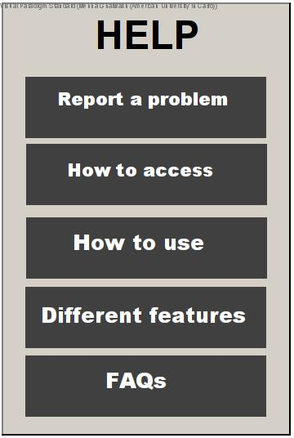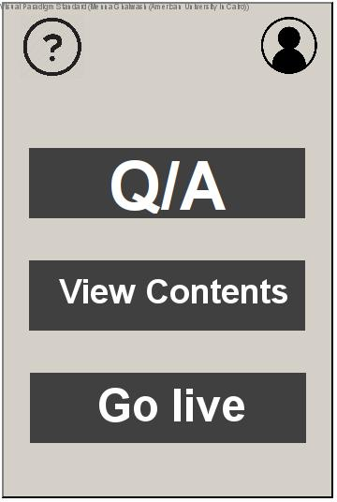

Figure 3.1.5 shows the page the user will be directed to when they click on the icon in the top right corner of the menu, it includes all the user’s information.

*Figure 3.1.5 Figure 3.1.6*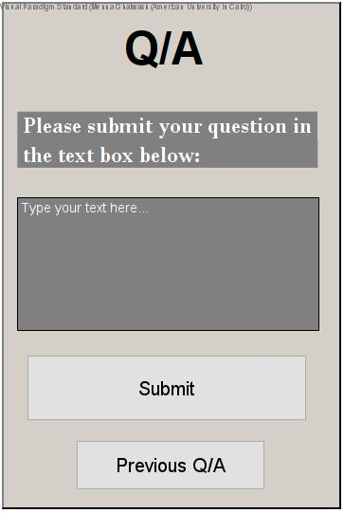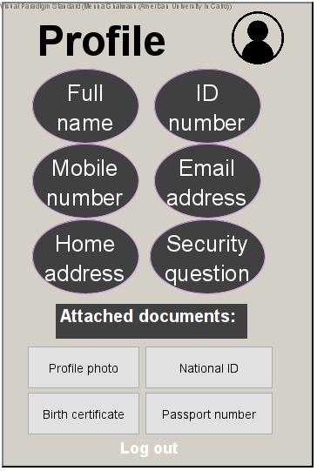

Figure 3.1.6 shows the Q/A page where the users will be able to submit their questions to the candidates. there will be an extra feature of sharing the question and the candidate's answer anonymously for other users to view.

Figure 3.1.7 shows the content which will be available for the user to participate in. Either watch videos of the candidates, send out discussion forums or participate in discussion threads, watch recorded webinars of zoom meetings with the candidates or the campaigners. In addition to having a button where the user can request a live talk with the candidate.

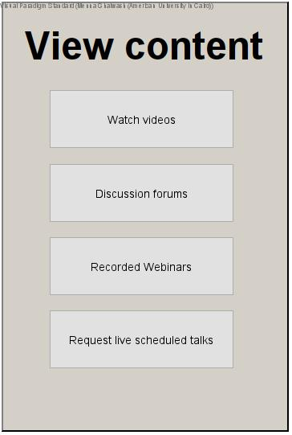

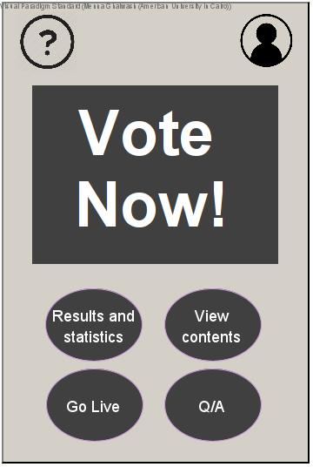

*Figure 3.1.7 Figure 3.1.8*

During the voting period:

Figure 3.1.8 shows the menu during the voting period where the user will be able to vote by clicking on the button ‘vote now!’ and it will direct him to a page where it contains all the elections that are currently open. Afterwards, the user will select an election, and the page will redirect them to a list of candidates for that election, which the user will have to select from either one of the candidates’ names or an abstain for their vote. The user will click on their option and the application will ask them to confirm their choice and then they won’t be able to vote again.

Moreover, there will be a button that shows results and statistics; in other words, the percentage of votes for each candidate.

## Hardware Interfaces

As mentioned in section **2.4**:

Mobile Application Versions:

* iOS 9 or later
* Android version 6 (Marshmallow) or later

Web Browser Supported versions:

* Chrome (version 41 or later)
* Internet Explorer (11)
* Microsoft Edge (version 25 or later)
* Safari (version 6.2.8 or later)
* Firefox (version 43.0 or later)

Supported Operating Systems:

* macOS 10.11 or later (El Capitan)
* Windows 7 or later
* Most modern Linux distributions, including:
  + Ubuntu 15.0 or later
  + Fedora 23 or later
  + Mint 17.2 or later
  + Arch 4.2.5 or later
  + Or any distros supporting web browsers listed above

## Software Interfaces

**3.3.1 Database**

As mentioned previously, specifically the Product Perspective section (2.1), a centralized database will be used to store our user’s information (encrypted over traffic). This information will include the information input by the user (thoroughly detailed in section 4.1.2), but will exclude passwords, as those will be stored using a hash function to prevent plaintext sniffing and password attacks.

The database itself will be hosted using the latest version of MySQL, and the servers will either be outsourced or developed through VEI, depending on their choice and budget. This information will be regarded as **TBD-3.3.1.**

The MySQL database will also be stored on backup servers, to minimize a critical point of failure in the system, and the same goes for the other servers that will keep our website and application running.

**3.3.2 Blockchain Network**

Unlike the database servers mentioned above, voting will require a blockchain network of peer-to-peer users that all contain a ledger with an updated vote count. This will minimize and possibly eliminate any tampering with vote counts, and will supply secure results, as well as efficient and accurate statistics regarding the votes tallied.

General Overview of Blockchain:

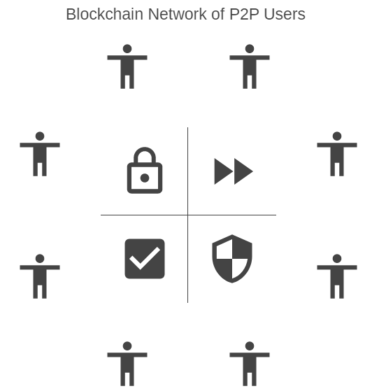

*Figure 3.3.2.1*

Consider each “person” in the diagram above to be a user, which can also be represented by a block in the blockchain. The users are essentially connected, and we will have set a timer limit on the amount of blocks that can be added per hour (standard is 6 per hour, once every ten minutes). This will help guarantee to users that our system is secure. The optimal way to achieve anonymity in voting will involve removing users from their votes, when they are tallied. Unlike bitcoin blockchains, the ledgers that will be spread throughout the chain will only contain the candidate and the number of votes, eliminating any traceability back to the user.

## Communications Interfaces

The following protocols will be required in the development of V-Elect:

* Generally, HTTP protocol will be used for the interaction between user’s devices and website/application.
* AES should be the standard for encryption, or any encryption algorithm that can match its security.
* bcrypt should be the standard for the hash functions used to store users’ passwords, or any modern hash function that does not have available exploits.
* Any APIs used must not be called using plaintext, and developers should ensure encryption whenever possible, to minimize the opportunity for sniffers like Wireshark to acquire passwords.

# System Features

## User Registers an account for V-Elect

4.1.1 Description and Priority

This feature must be available to all users who use the application or website, and changes the access type of a user from a Guest to a Voter. Voters have more access in terms of participation and actually voting for a candidate, which is the reason for the necessity of this feature. The option of registering requires proof of certain documents to validate identity, regardless of whether eKYC is used, or manual verification from the administrators.

Priority: High

4.1.2 Stimulus/Response Sequences

Pre-conditions:

The user should have downloaded the V-Elect application for iOS and Android OR have the website open in a browser.

The user should be connected to the internet.

The user should have access to a working mobile phone.

**Stimulus:** The user opens V-Elect (regardless of website or application)

**Response:** The home page is displayed on the screen

**Stimulus:** The user clicks on the *Register Account* button

**Response:** The sign up form is displayed, as well as a *Submit* button

**Stimulus:** The user fills in information on his/her identity

Information includes:

* Full Name
* National ID
* Birth Date
* Home Address
* Email Address (Optional)
* Mobile Number
* Password (twice for verification)
* Security Question with Correct Answer

**Response:** The form stays idle, and awaits the uploading of scanned documents

**Stimulus:** The user clicks *Upload Documents* button

**Response:** A new pop-up opens, with the option of uploading PDFs or PNGs

System also requests access to photos and data

**Stimulus:** The user accepts system’s access to local files, and uploads documents

Documents depend on nation’s laws, and can include:

* Birth Certificate
* National ID
* Passport
* Recent Photo

**Response:** Pop-up window closes, and form is re-shown

**Stimulus:** The user clicks *Submit*

**Response:** System sends verification code to mobile, and email if inputted

**Stimulus:** The user clicks verification link in email (if inputted)

**Response:** Window opens, thanking user for email verification

System requests user to input code from mobile (verification)

**Stimulus:** User enters correct code from mobile

**Response:** System outputs message, thanking user for verification, and asks user to await approval

Post-Conditions:

User is redirected to home page, and no access privileges levels are changed

4.1.3 Functional Requirements

REQ-1: Verify User Information

* System should ensure unique National ID, Mobile Number, (and email if input) with V-Elect Database
* System should ensure password is of at least 16 characters, with at least 1 capital letter, lowercase letter, number, and special character
* System should ensure validity with Birthdate, specifically if user is of age to vote in current nation

REQ-2: Send Mobile Verification Code

* System should call API to send SMS with unique verification code of 8 capital letters or numbers, and code must be verified within 15 minutes, or re-sent

REQ-3: Send Email Verification Link

* System should call API to send email with a unique link to be clicked by user within 20 minutes, or re-sent

REQ-4: Add User to Register Database

* System must send user information to database, to await approval depending on nation’s methods

## User Registration Process Decision (eKYC)

* + 1. Description and Priority

This feature is available only in countries where the usage of eKYC verification is legal. In countries where that is not the case, feature 4.3 replaces this feature. The system uses eKYC’s authentication and verification of applicants to determine whether to accept or reject an applicant.

Priority: High

* + 1. Stimulus/Response Sequences

Pre-condition: User applies to become a registered voter as in 4.1

**Stimulus**: Third party eKYC system authenticates and verifies applicant

**Response**: Applicant is added to the voter database. Applicant is notified of their acceptance by an SMS to the phone number they have provided in 4.1 (and by an email if they provided one in 4.1)

**Stimulus**: Third party eKYC system rejects applicant

**Response**: Applicant is notified of their rejection and reason for rejection (if provided by eKYC third party)

Post-condition: User is notified whether or not they can now login to the system as a registered voter

* + 1. Functional Requirements

REQ-1: Add Verified User to Database

* System should create a new entry for the accepted user to its user database
* System should ensure that all documents and details provided by the user are securely stored in the database
* System should now allow the user to participate in discussion threads, and vote during voting period

REQ-2: Notify Applicant of their Application Status

* System should fetch user’s phone number (and possibly email) and send users notifying them whether or not they have been accepted
* System should include (in the SMS [and email]) reasons for rejection of application (if any) as communicated by third party eKYC system

## User Registration Process Decision (Manually)

* + 1. Description and Priority

This feature is available only in countries where the usage of eKYC verification is prohibited by governmental regulations. In countries where eKYC is legal, feature 4.2 replaces this feature. Under 4.3, the system depends on government-approved VEI administrators to manually process applicant files, and determine whether or not they should be allowed to vote.

Priority: High

* + 1. Stimulus/Response Sequences

Pre-condition: User applies to become a registered voter as in 4.1

**Stimulus**: Government-approved administrators authenticate and verify applicant

**Response**: Applicant is added to the voter database. Applicant is notified of their acceptance by an SMS to the phone number they have provided in 4.1 (and by an email if they provided one in 4.1)

**Stimulus**: Government-approved administrators reject applicant

**Response**: Applicant is notified of their rejection and reason for rejection (if provided by eKYC third party)

Post-condition: User is notified whether or not they can now login to the system as a registered voter

* + 1. Function Requirements

REQ-1: Add Verified User to Database

* System should create a new entry for the accepted user to its user database
* System should ensure that all documents and details provided by the user are securely stored in the database
* System should now allow the user to participate in discussion threads, and vote during voting period

REQ-2: Notify Applicant of their Application Status

* System should fetch user’s phone number (and possibly email) and send users notifying them whether or not they have been accepted
* System should include (in the SMS [and email]) reasons for rejection of application (if any) as communicated by government-approved administrators

## User Logs in to V-Elect

* + 1. Description and Priority

This feature should only be available to verified users, who have been verified through either 4.2 or 4.3, and will throw error messages if the user does not exist within the database. It essentially opens the options of voting and participating in online events to the current user, and converts the user from a Guest to a Voter.

Priority: High

* + 1. Stimulus/Response Sequences

Pre-conditions:

User is registered and accepted via 4.2 or 4.3

User has Home Page open in browser or mobile app, or any page with *Login* option

**Stimulus:** User clicks *Login* button

**Response:** System pops up a form to accept user credentials

**Stimulus:** User enters National ID, phone number, and password

**Response:** System validates data, and pops up specified user’s security question

**Stimulus:** User answers security question

**Response:** If the answer is correct (regardless of case-sensitivity) the system logs in the user and opens the homepage with new options. If answer is incorrect, then system asks for another trial, or offers verification by email or phone number

Post-conditions:

User has home page open, with option to Vote (if voting allowed)

User has option to open discussion forms and participate

4.4.3 Functional Requirements

REQ-1: System Verifies User Information

* System uses a hash function and sends encrypted data over to be verified by the server with the database. Encryption ensures no traffic sniffing through the process.
* Server returns a success signal with a key if the system is validated.
* If information is incorrect, the system prompts an error message to the user, and asks to try again.

REQ-2: System allows user access to Voter privileges

* System opens sessions for logged in users, and allows the option of voting or participating in discussions and events, as well as previous allowed options.

## User Votes for a Candidate

* + 1. Description and Priority

This feature allows Voters (or those with higher access levels - See section 2.3), to select a candidate and mark them as voted during an election process. The feature makes use of blockchain technology, as well as advanced encryption processes to ensure anonymity and reliability of votes.

Priority: High

4.5.2 Stimulus/Response Sequences

Pre-conditions:

User is logged in as a Voter or higher access

Administrators allow voting (During voting period)

User has not previously voted for this election

**Stimulus:** User clicks *Vote* button

**Response:** System opens new page, with verification options for user before voting

**Stimulus:** User clicks on one of the verification options (mobile or email)

**Response:** System sends verification code depending on user’s option, and awaits code input

**Stimulus:** User enters verification code

**Response:** Assuming correct, system opens new page with available elections to vote in

**Stimulus:** User clicks on one of the election options

**Response:** System opens new page with candidates for the specified election

**Stimulus:** User clicks on one of the candidate buttons

**Response:** System pops up message asking if user wants to confirm choice

**Stimulus:** User clicks on choice by clicking *I Confirm*

**Response:** System opens home page, with vote option no longer available to user

System also adds vote to tally, to be elaborate in the functional requirements

System also sends verification SMS and email (if registered) to confirm user’s vote, without specifying candidate voted for

Post-conditions:

Verification email/SMS is sent to user’s email/mobile

Count for specified candidate is updated through the blockchain

4.5.3 Functional Requirements

REQ-1: Allow voting for election

* System should enable voting on specified dates to be determined by administrators and government officials (based on nation laws)
* *Vote* button should appear on days of voting

REQ-2: Verify User

* Similar to verification for Login (4.4), the system should send similar SMS or email verification links to be confirmed by the user.
* This must be verified within 10 minutes of voting

REQ-3: Display Election/Candidate options

* System should have menus confirmed by government officials, and available to users once the Vote button is clicked, and the user is verified.
* When a user clicks on a candidate to vote, the system should display a popup message asking the user to click *Okay* to confirm voting for selected candidate (to avoid accidental voting).

REQ-4: Add vote to candidate’s existing votes

* System utilizes blockchain and peer-to-peer network to update the number of votes for the selected candidate.
* System should validate change in votes, by checking if change was reflected in the majority of peer-to-peer network, in order to avoid tampering data.
* System should update the count without any trace of the identification of the user who has just voted, to allow for anonymous voting.
  + However, the system may trace address in the case of an electoral vote depending on region, but nothing more than the region/state specified.

## User Views Results and Statistics

* + 1. Description and Priority

This feature allows users of all types to view the results of a certain election, and any statistics involving the percentage of voters. No login is required, as even guests can view results.

Priority Level: High

* + 1. Stimulus/Response Sequences

Pre-conditions:

User has website/application open

Election has finished, and voting period is over

Result button is available on screen

**Stimulus:** User clicks on *Results and Statistics*

**Response:** System opens new page, with a variety of elements.

Page contains:

* Number of votes for each party
* Optional pie chart, or graph of percentages
* Any additional statistics involving the election

Post-conditions:

V-Elect displays correct results based on vote tally

* + 1. Functional Requirements

REQ-1: Calculate Results

* System should be able to access the blockchain network to acquire the number of votes for each candidate.
* Simple counting algorithm to add all the votes should be implemented (Popular vote)
* Other algorithms should be added in the case of other types of votes (parliamentary/electoral).

REQ-2: Display Results

* System should display results on screen when button is clicked
* System should only allow access to this button on specified days by administrators (specifically government officials).
* Results should be available for a set period of time, then placed in archives or removed.

## User Searches for Campaign Content or Discussion Threads

* + 1. Description and Priority

This feature must be available to all users, regardless of whether they are guests or registered voters (including campaigners, campaigners and administrators). This feature allows users to search for discussion forums for certain topics that they are interested in or specific campaign content.

Priority: Medium-High

* + 1. Stimulus/Response Sequences

Pre-condition: User is logged in to the system

**Stimulus**: User clicks on the search tab icon

**Response**: The system prompts the user to select between searching campaign content or discussion threads

**Stimulus**: User chooses search category

**Response**: The system prompts the user to input search keywords

**Stimulus**: User inputs search keywords

**Response**: None

**Stimulus**: User clicks on the search icon

**Response**: The system presents the Headers of all entries (in the specified search category) which include the keywords inputted by the user

**Stimulus**: User clicks on the filter / sort icon

**Response**: The system prompts the user to choose between filter / sort categories

**Stimulus**: User specifies which filter / sort category they want to modify

**Response**: The system prompts the user to choose between the different options within the filtering / sorting category

**Stimulus**: User specifies the specific filtering / sorting criteria

**Response**: The search results are refreshed to meet the criteria specified by the user

Post-condition:

User is presented with Headers of campaign content / discussion threads that satisfy their keyword search and meet the filtering and sorting criteria they specified

* + 1. Functional Requirements

REQ-1: Determine which Database to Search From

* System should decide whether the search will be conducted over the campaign content database or discussion threads database

REQ-2: Search by Keywords

* System should be able to efficiently search the specified database for the keyword specified by the user
* System should be able to return entries with exact matches as well as entries with partial matches
* System should prioritize entries with exact matches over entries with partial matches (provided no filtering or sorting criteria are specified)

REQ-3: Sorting Results

* System should accept sorting criteria for data of creation, number of comments, current voting rating, number of interactions (number of downvotes + upvotes + comments)
* System should be able to efficiently sort the results based on the criteria specified by the user

REQ-4: Filtering Results

* System should accept filtering criteria for specified range for date of creation, exact matches only or all matches, which categories to accept keywords for (title, body, author), and which campaign’s content to search (only when searching campaign content)
* System should eliminate all entries which do not specify all the filtering criteria

## User Views Discussion Threads

* + 1. Description and Priority

This feature must be available to all users, regardless of whether they are guests or registered voters (including campaigners, campaigners and administrators). Viewing discussion threads entails accessing any discussion thread and viewing the interaction on said thread.

Priority: High

* + 1. Stimulus / Response Sequences

Pre-conditions:

Users must be signed-in with any account type.

Users must have either searched for discussion threads or be on the tab / page for discussion threads.

**Stimulus**: User clicks on the header of a discussion thread (title, date, author)

**Response**: The system redirects the user to the particular discussion thread

**Stimulus**: User clicks on drop down menu icon next to thread title / comment

**Response**: The system presents the user with the options to Star, Hide or Report thread / comment

**Stimulus**: User clicks on Star thread / comment

**Response**: The system saves the thread / comment to the user preference database and flags the thread / comment as starred. The system shows a star icon next to the thread / comment.

**Stimulus**: User clicks on Hide thread / comment

**Response**: The system saves the thread / comment to the user preference database and flags the thread / comment as hidden. The system obscures the thread / comment from the user.

**Stimulus**: User clicks on Report thread / comment

**Response**: The system pushes the thread / comment to the reported database. The system will prompt the user to Hide the thread / comment.

Post-condition:

Thread with comments is displayed to the user. If the user hides the thread, they are redirected back to the page they were previously at.

* + 1. Functional Requirements

REQ-1: Fetching Discussion Thread from Header

* System should be able to retrieve thread content and comments by searching its thread database using title, date and author provided in the header

REQ-2: Star Thread / Comment

* System should save the thread / comment to the user’s database of preferences and flag it as starred
* System should display a star icon next to the thread / comment

REQ-3: Hide Thread

* System should save the thread to the user’s database of preferences and flag it as hidden
* System should redirect the user back to the search page or general the discussion forum page

REQ-4: Hide Comment

* System should save the comment to the user’s database of preferences and flag it as hidden
* System should remove the comment from the user screen
* System should re-organize screen elements to occupy the now-empty area

## User Participates in Discussion Threads

* + 1. Description and Priority

This feature must be available to all users except guest users. Participating in discussion threads includes creating discussion threads, commenting, and upvoting or downvoting threads / comment. Discussion threads can be conducted using text, video, voice, or avatar based interactions.

Priority: High

* + 1. Stimulus/Response Sequences

Pre-condition:

The user must be logged into the system as a registered voter, campaigner or candidate.

**Stimulus**: User clicks *Create New Discussion Thread*

**Response**: The system prompts the user to choose between timed or indefinite discussion.

**Stimulus**: User chooses one of timed or indefinite discussion

**Response**: The system prompts the user to choose between text, video, voice, or avatar-based discussions.

**Stimulus**: User chooses timed discussion

**Response**: System prompts user to specify duration for discussion

**Stimulus**: User clicks on *Text* as the desired medium of discussion

**Response**: The system prompts the user with two input text boxes (title and body)

**Stimulus**: User clicks on *Video* as the desired medium of discussion

**Response**: The system prompts the user with an input text box (title), a window with their live recording, and video recording setting buttons (*mute/unmute, turn camera on/off, etc.)*

**Stimulus**: User clicks on *Audio* as the desired medium of discussion

**Response**: The system prompts the user with an input text box (title), wave forms of their sound and speech, and *mate/unmute* buttons

**Stimulus**: User clicks on *Avatar-based* as the desired medium of discussion

**Response**: The system prompts the user with an input text box (title), a screen to customize their avatar, wave forms of their sound and speech, and *mate/unmute* buttons

**Stimulus**: User clicks on *Take Part in Discussion* when viewing the thread

**Response**: The system prompts the user with an appropriate configuration of input mediums that are identical to the thread’s medium of discussion

**Stimulus**: User clicks the upvote or downvote icon next to a thread / comment

**Response**: The system increments or decrements the thread / comment vote counter.

**Stimulus**: Timer runs out for timed discussions

**Response**: All participants are stopped from continuing discussion, and the *Take Part in Discussion* disappears.

Post-condition:

User views the thread which they created or continues to view the thread they were viewing before participating in it.

* + 1. Functional Requirements

REQ-1: Create New Discussion Thread

* System should push a new entry to its database of discussion threads, with its time and duration (infinity for indefinite) as well as all other relevant data and metadata
* System should create a Header (title, date, author, type, duration) for the Discussion Thread to be used for search and to appear in the Discussion Thread tab / page
* System should set the thread’s upvote/downvote counter to 0
* System should direct the posting user to be the first participant in the discussion by prompting them with input fields that fit the discussion medium they specified

REQ-2: Prompt New Comment

* System should provide the user with a button to *Take Part in Discussion*
* System should force comments / participations to be of the same medium as the post

REQ-3: Add Comment

* System should update the corresponding thread’s entry in the database to account for the comment
* System should display the comment to the user and to all other users and guests viewing the same tab / page
* System should set the thread’s upvote/downvote counter to 0

REQ-4: Upvote or Downvote Thread / Comment

* System should visually show the incrementation or decrementation to the thread / comment vote count
* System should reflect the change to the corresponding thread entry in its thread database

## User Creates Campaign Content

4.10.1 Description and Priority

This feature is available to candidates and campaigners only. They can create, upload and edit campaign content.

Priority: High

4.10.2 Stimulus/Response Sequences

Pre-conditions:

The user must be signed in from a verified candidate/campaigner account.

The user must be connected to a stable internet connection.

**Stimulus:** The user clicks *Live* button

**Response:** System requests access to camera and microphone.

**Stimulus:** User clicks on *Grant Access* button

**Response:** System begins the live video and assigns the verified candidate or campaigner to be host.

**Stimulus:** User clicks *Assign Co-host*

**Response:** System displays list of all members of the campaign and a search bar to search for specific campaign members

**Stimulus:** The user clicks *Upload Content*  button

**Response:** The system prompts the user to choose between already existing content or using the VEI-tool.

**Stimulus:** The user chooses *Upload Existing Content*

**Response:** The system requests access to the user’s files and allows the user to upload web-links, images, videos, documents, presentations, sheets.

**Stimulus:** The user chooses *Use VEI-Tool*

**Response:** The system redirects the user to the VEI-Tool page.

**Stimulus:** The user clicks *Edit* button

**Response:** The system presents the same page with the content now with *select* option where they can then delete/rename/reorder the already existing content. The system also provides them with a ‘hidden content’ option.

Post-conditions:

Updated content page is presented to the user or user is redirected to VEI-Tool page.

4.10.3 Functional Requirements

REQ-1: Going Live

* System should provide the user with co-host assignment options.
* System should provide the host/co-host with the option to start and end live.
* System should allow hosts to view and scroll through incoming comments

REQ-2: Upload Content

* System should provide the user with different format options to upload
* System should provide the user with *submit*/*cancel* option
* System should provide the user with *view as user* feature after submitting

REQ-3: Edit Content

* System should allow user to remove an attachment from a post
* System should allow user to add an additional attachment to the same post

## User Views Campaign Content

4.11.1 Description and Priority

This feature must be available to all users, regardless of whether they are guests or registered voters (including campaigners, campaigners and administrators).

Priority: High

4.11.2 Stimulus/Response Sequences

Pre-condition:

User must be signed-in with any account type.

The user must have either searched for campaign content or be on the tab / page for campaign content.

**Stimulus:** User clicks on the header of the content they want to view

**Response:** System loads a page with the content and the comments on the content.

**Stimulus:** User clicks on *View Edit History* button

**Response:** System loads a pop-up with all the changes to the post

**Stimulus**: User clicks on drop down menu icon next to content title / comment

**Response**: The system presents the user with the options to Star, Hide or Report content / comment

**Stimulus**: User clicks on Star content / comment

**Response**: The system saves the content / comment to the user preference database and flags the content / comment as starred. The system shows a star icon next to the content / comment.

**Stimulus**: User clicks on Hide content / comment

**Response**: The system saves the content / comment to the user preference database and flags the content / comment as hidden. The system obscures the content / comment from the user.

**Stimulus**: User clicks on Report content / comment

**Response**: The system pushes the content / comment to the reported database. The system will prompt the user to Hide the content / comment.

Post-condition:

Campaign content with comments is displayed to the user. If the user hides the content, they are redirected back to the page they were previously at.

4.11.3 Functional Requirements

REQ-1: Fetching Discussion Content from Header

* System should be able to retrieve campaign content and comments by searching its campaign database using title, date and author provided in the header

REQ-2: View Edit History

* System should check the corresponding campaign content entry in the campaign content database and return all change history
* System should include old version and new version for every change as well as date of change

REQ-3: Star Content / Comment

* System should save the content / comment to the user’s database of preferences and flag it as starred
* System should display a star icon next to the content / comment

REQ-4: Hide Content

* System should save the content to the user’s database of preferences and flag it as hidden
* System should redirect the user back to the search page or general the discussion forum page

REQ-5: Hide Comment

* System should save the comment to the user’s database of preferences and flag it as hidden
* System should remove the comment from the user screen
* System should re-organize screen elements to occupy the now-empty area

## User Pays for VEI-Tool

* + 1. Description and Priority

This feature is available to candidates and campaigners only. The feature utilises a 3rd party application to process payment.

Priority: Medium

* + 1. Stimulus/Response Sequences

Pre-conditions:

User’s (candidate or campaigner only) campaign has not purchased the VEI-Tool AND user has either clicked the menu option to purchase access to the tool or was redirected to this page when attempting to use VEI-tool

**Stimulus:** User clicks *Proceed to Payment*

**Response:** System redirects user to third party payment processor

**Stimulus:** Third party payment processor sends the system that the payment was successful

**Response:** User and all members of the campaign that the user is part of are granted access to VEI-Tool

**Stimulus:** Third party payment processor sends the system that the payment was unsuccessful for a set of reasons

**Response:** System notifies the user that the payment was rejected for the reasons specified by the third party payment processor, and prompts the user to retry to *Proceed to Payment*

Post-conditions: User is redirected to VEI-Tool or prompted to repeat payment procedure in case of failure

* + 1. Functional Requirements

REQ-1: Direct User to Payment Processor

* System should be able to send the requested price to the payment processor
* System should redirect user to an the payment processor’s page as an embedded within the page / tab of V-Elect

REQ-2: Receive Transaction Details from Payment Processor

* System should be able to receive details about the success/failure of the transaction
* System should be able to receive details about the transaction including date, sender, and other details commonly associated with transactions

REQ-3: Communicate with User about the success or failure of the transaction

* System should display a pop-up to the user indicating whether their payment was accepted or rejected

REQ-4: Grant campaign access to VEI-Tool

* On acceptance of payment, system should fetch (from the user database table) the campaign details of the user who initiated the payment
* System should then filter all users who have the same campaign credentials (including the paying user) and grant them VEI-Tool access
* System should redirect the paying user to the VEI-Tool

REQ-5: Deny multiple payments

* Before clicking on the *Proceed to Payment* button, system should check if the user belongs to a campaign that has already purchased access to the VEI-Tool
* If true, system should notify the user that they already have access to the VEI-Tool
* If true, system should also redirect the user to the VEI-Tool

## User uses VEI-Tool

* + 1. Description and Priority

This feature is available to candidates and campaigners only. For a fee (see 4.12), candidates and campaigners may use the VEI-Tool to create campaign content, such as videos, audio files, documents, presentations, etc. This is the feature by which V-Elect generates income. This feature depends on a third party multimedia customization service.

Priority: Medium

* + 1. Stimulus/Response Sequences

Pre-conditions: User belongs to a campaign which has purchased the ability to access and utilize the VEI-Tool

**Stimulus:** User clicks *Create Campaign Content* button

**Response:** System redirects user to the third party multimedia customization service which is embedded in the V-Elect page / tab

**Stimulus:** Third party multimedia customization service attempts to export content to V-Elect

**Response:** V-Elect system accepts the finalized content and displays it to the user with two buttons *Submit* and *Cancel*

**Stimulus:** User clicks *Submit*

**Response:** System publishes the content and pushes it to its database of campaign content. System also prompts the user to choose between returning to the Home Screen, creating new content, or viewing the published content.

**Stimulus:** User clicks *Discard*

**Response:** All progress on the content is discarded.

**Stimulus:** User clicks *Continue Editing*

**Response:** System prompts user to return to the third party service to continue editing.

Post-conditions: User starts creating new content, views published content, or returns to the Home Screen

* + 1. Functional Requirements

REQ-1: Direct User to Multimedia Customization Service

* System should redirect user to the multimedia customization service’s page as an embedded within the page / tab of V-Elect
* If available (in the case of more editing to be carried), system should be able to transfer the to-be-modified content to the multimedia customization service

REQ-2: Receive Finalized Content from Multimedia Customization Service

* System should be able to receive the content (video, audio, text, etc.) created by the multimedia customization service

REQ-3: Publish Content

* System should publish the campaign content after creating a header for it
* System should push the entry to the campaign content database

REQ-4: Verify Campaign Access

* System should check if the user is a candidate or campaigner who belongs to a campaign that has purchased access to the VEI-Tool
* In case of failure, system should redirect the user to the Home Screen

## User Requests/Joins Live Talk

4.14.1 Description and Priority

This feature is available to candidates and campaigners only. The candidate can join live talks as well as request to start them. Campaigners can also start/end the live talks as they are co-hosts with the candidates.

Priority: High

4.14.2 Stimulus/Response Sequences

Pre-condition:

User must be signed-in with a verified candidate or campaigner account.

The user must be connected to a stable internet connection.

**Stimulus:** User clicks on the *schedule live* Button

**Response:** System prompts the user to enter exact date and time for the meeting

**Stimulus:** User clicks on the *Live* Button

**Response:** System requests camera to camera and microphone.

**Stimulus:** User clicks on *Grant Access* button

**Response:** System begins the live video and assigns the verified candidate or campaigner to be host.

**Stimulus:** User clicks *Assign Co-host*

**Response:** System displays list of all members of the campaign and a search bar to search for specific campaign members

Post-condition: Live talks will take place with candidates being hosts and campaigners being co-hosts.

4.14.3 Functional Requirements

REQ-1: Going Live

* System should provide the user with co-host assignment options.
* System should provide the host/co-host with the option to start and end live.
* System should allow hosts to view and scroll through incoming comments.

REQ-2: Scheduling Live Sessions:

* System should check availability of date and time chosen by the user.
* System should prompt user to re-enter another date and time if the already entered date is not available.
* System should send a confirmation email to the candidate/campaigners who requested the meeting.

## User Moderates Discussions

* + 1. Description and Priority

This feature is available for all users including the campaigners and candidates. The admins and campaigner are responsible for moderating the thread itself on the system for the users.Guests are not allowed in this feature.

Priority: Medium-High

* + 1. Stimulus/Response Sequences

Pre-condition:

User must be logged in to their account in order to participate in the discussions

**Stimulus**: User clicks on *view content* from menu

**Response**: A new page will pop up that includes 4 buttons (o of them is labeled discussions forums)

**Stimulus**: User clicks on *discussion forums*

**Response**: A new page will pop up that contains 2 labels

**Stimulus**: User will have the option of either participating in an existing thread by the candidate or a campaigner or starting a new thread

**Response**: The user will choose whatever they please

**Stimulus**: If the user clicks on an existing thread

**Response**: a new pop up page will appear with all the existing discussion threads available.

**Stimulus**: If the choice is starting a new thread.

**Response**: A new pop up page will appear which includes a textbox that users are required to write their concerns in it.

**Stimulus**: The users will start a new thread

**Response**: A notification will be sent to the admin first in order to verify its appropriateness of submitting it

**Stimulus**: After the new thread is verified

**Response**: A notification will be sent to campaigners and candidates to moderate the discussion

Post-condition:

Discussions will take place either an existing one or a new thread by the user after verifying it with the administrator.

* + 1. Functional Requirements

REQ-1: creating a thread

* System prompts user to type in the textbox the new thread

REQ-2: Verification

* System should send to the administrators in order to verify the new thread

## User Edits Own Profile

* + 1. Description and Priority

This feature is available for all the users who use the application or the website and want to change anything in their profile with the limitation of their username and password. As explained previously the guest user does not have an actual account; therefore, this feature is for all users except users registered in guest mode.

Priority: Medium-High

* + 1. Stimulus/Response Sequences

Pre-condition: The user must be logged in in order to verify that they are not a guest user and to be able to change their profile information

**Stimulus**: The user will click on the *profile* button which exists in the top right corner of the menu.

**Response**: The profile page will open with all their information stated

**Stimulus**: The user clicks on the text box where the information they want to change exists.

**Response**: The system will require them to re enter their ID number and account password in order to verify.

**Stimulus**: The user will enter their ID number and account password

**Response**: The system will send a verification code to their mobile number

**Stimulus**: The user will enter the verification code

**Response**: The system will give access to user to change in the profile information

Post-condition:

The user will be able to edit in their profile anything

* + 1. Functional Requirements

REQ-1: Sign in

* Text box will appear and user will be prompted to enter their ID number and account password

REQ-2: Verification

* Another text box will be displayed in order to allow the user to enter the verification code

REQ-3: Editing

* The user will have access to change / edit their information

## Administrator Edits Profile (Adding, Muting, and Removing)

* + 1. Description and Priority

This feature is only available to administrators who are logged in, and will allow them to add, mute, or remove profiles from the V-Elect system.

Priority Level: Medium-High

* + 1. Stimulus/Response Sequences

Pre-conditions:

Administrator is logged in

Administrator has opened *Admin* page

**Stimulus:** Admin clicks on *Mute User*

**Response:** System displays popup asking for ID input of user, and time to be muted

**Stimulus:** Admin enters User ID (to be muted), and duration of mute

**Response:** System removes User access to creating posts and commenting for that duration.

**Stimulus:** Admin clicks on *Remove User*

**Response:** System displays popup asking for ID input of user

**Stimulus:** Admin enters User ID (to be removed)

**Response:** System displays popup verifying that admin wants to remove this user

**Stimulus:** Admin clicks *Verify* (to be removed)

**Response:** System removes user from V-Elect database, and logs out all instances of user

**Stimulus:** Admin clicks *Add User*

**Response:** System displays list of registered accounts that are not yet verified.

**Stimulus:** Admin clicks on specific User ID

**Response:** System displays User information, included uploaded documents

System also displays *Verify* and *Remove* buttons for admin to select

**Stimulus:** Admin clicks *Verify* (to be added)

**Response:** System adds User to V-Elect Database, and notifies user of registration approval

**Stimulus:** Admin clicks *Remove* (to be added)

**Response:** System rejects User application, and registration is no longer valid.

System also asks the admin the reason for rejection.

**Stimulus:** Admin enters reason for rejection

**Response:** System notifies user of rejection, and attaches admin message.

Post-condition:

V-Elect Database is update properly, according to Admin controls

* + 1. Functional Requirements

REQ-1: Edit V-Elect Database:

* System should provide the proper functions for INSERT, UPDATE, and DELETE functions in the MySQL database. It should also attach these functions to the buttons that the Admin will have access to.
* System should use the same encryption methods for sending calls to and from the server.

## User Reports Bug

4.18.1 Description and Priority

This feature must be available to all users, regardless of whether they are guests or registered voters (including campaigners, campaigners and administrators).

Priority: High

4.18.2 Stimulus/Response Sequences

Pre-condition:

User has the application open.

**Stimulus:** User clicks *Help* button in home page

**Response:** A new pop-up menu appears with multiple options.

**Stimulus:** User clicks *Report a Bug* button in Help menu.

**Response:** A text box appears for the user to submit their report.

Post-condition:

User is done reporting a bug.

4.18.3 Functional Requirements

REQ-1: Reporting a Bug:

* System should provide the user with a text box to write the complaint in.
* System should provide the user with a *submit changes* button and then update the report database.

## Candidate/Campaigner adds a Campaigner

* + 1. Description and Priority

This feature is available to Candidates and Campaigners, who wish to add another user to the list of campaigners for a certain candidate.

Priority Level: Medium

* + 1. Stimulus/Response Sequences

Pre-conditions:

User must be logged in as a Campaigner or Candidate

If Campaigner, then user must be registered to at least one candidate

**Stimulus:** User clicks on *Add Campaigner*

**Response:** System opens new window, with text box requesting ID of new campaigner.

**Stimulus:** User inputs new campaigner ID

**Response:** System asks for verification of new campaigner

System sends an SMS to new campaigner, with verification code

**Stimulus:** User enters verification code

**Response:** If code is correct, then system adds new campaigner to list of campaigners for the selected candidate

* + 1. Functional Requirements

REQ-1: List of Campaigners

* System should provide a mechanism of keeping track of the campaigners for each candidate, specifically through the database that V-Elect uses.
* System should also provide a mechanism to append a new ID to the list of campaigners, using the basic INSERT function in MySQL.
* System should also use similar SMS verification as mentioned in previous sections.

# Other Nonfunctional Requirements

## Performance Requirements

**5.1.1 Speed with regards to legacy systems**

Website and application should not only support older systems (for third-world country voters, but should also perform near optimally on these systems, by limiting the use of extensive reactive applications and animations and keeping the application bare. The application can look fancy and friendly in design, but developers should keep in mind to not over-rely on features that are available to newer versions.

**5.1.2 WiFi and network reliability**

The website and the application should not contain many images or videos in the *Vote* section, as to keep the required packets minimal for users with slow or unstable internet connections. This primarily applies to third-world countries without proper network infrastructure.

## Safety Requirements

**5.2.1 Encryption**

When dealing with data over servers or peer-to-peer blockchain networks, all data must be encrypted, to prevent sniffers like Wireshark from accessing data in plaintext. Recommend using AES when encrypting data, or any modern data encryption algorithms when implementing and setting up server base.

**5.2.2 Backup Servers**

To prevent loss of data due to critical point of failure, or server malfunctions, multiple backup servers should exist in different locations. Servers should only be used when other servers malfunction or are down for maintenance, which will also accomplish reliability when discussing future non-functional requirements.

**5.2.3 Compliance with State Laws**

Software should comply with any/all required nation laws, to prevent lawsuits and any violations within a nation. Developers are encouraged to check IEEE standards, as well as local nation networking laws prior to the launch of V-Elect in a new nation.

## Security Requirements

**5.3.1 Two-Step Verification**

As mentioned in the System Features section, users who log in will have to answer a security question, or verify their identity by mobile SMS code, or an email verification link. Verification will also be required once more during voting days, in order to ensure to the best of our ability, that the intended user casts his/her intended vote.

**5.3.2** **Anonymity**

Per VEI’s request, users’ votes cannot be traced back to them by the system, to ensure no access to intended votes. The blockchain network can only keep track of the regions of voters, in the case of regional votes (like parliamentary or electoral votes).

**5.3.3 Privilege Level Access**

Certain functions can only be accessed by certain users with allowed access. For example, only administrators have the option to mute or delete profiles from a system, and this authority cannot be passed down to regular Voter accounts. Developers should maintain access levels in order to minimize any tampering with the web app’s functionalities.

**5.3.4 Penetration Testing**

Developers should mind the current programming practices to maximize security in application, while also hiring a pen-testing team to help search for flaws or exploits within the system. This team should constantly be looking for errors or noticeable concerns that need to be brought to the attention of the development team throughout the election process. The quicker an issue is dealt with, the less impact it will have. Optimistically, major flaws should have been dealt with prior to launch, or at least prior to the election phases.

## Software Quality Attributes

This section will primarily be used to express non-functional requirements that have not been mentioned in any of the subsections of section **5**. For instance, security and safety requirements have already been mentioned in **5.2** and **5.3**, which is why they will no longer be mentioned in this section.

**5.4.1 Reliability**

The system should be reliable, in terms of secure voting and minimal down times. It should not be allowed to fail longer than 2 minutes during a voting period, and must make use of as many backup servers as needed to ensure this. In terms of voting reliability, the results should be accurate down to the vote, meaning that developers should accurately test the algorithms and mechanisms for counting before launching the product for a certain region.

**5.4.2 Availability**

Depending on the region where V-Elect will be launched, VEI should ensure that the majority of citizens of that region will have access to the application or website. For those who won’t have access, VEI should accommodate the proper voting centers necessary in order to reach the number of citizens required for a vote to remain valid (depending on nation and vote). The application and website should also be available for use on all of the supported systems mentioned in section **3.2**

**5.4.3 Reusability and Adaptability**

By reusability, we specifically are implying that the software developed should be easily applied to any region when necessary. Slight changes may need to be adjusted in order to accommodate for different state and region laws, but no heavy changes should be required to the software (in terms of infrastructure or design approaches), when launching to a new region. This also implies adaptability, in the way that software should adapt to new changes as smoothly as possible, without requiring much effort to integrate new features.

**5.4.4 Maintainability**

Software should be easily maintainable by members of the development team (specifically maintenance engineers), and system maintenance should only be allowed outside of voting periods, unless flaws or issues in the system are found. Maintenance regarding servers should not exceed 30 minutes, unless no election or voting process is being held, then that time may be extended due to the lack of need for V-Elect at that period in time.

**5.4.5 Flexibility and Scalability**

Software should be written cleanly, and in a manner that will easily accept new changes, especially when/if VEI decides to expand to broader regions (like the United Nations, for example). This applies to both flexibility and scalability, in that the software must be able to change easily in response to new requirements, and that the software must be scalable and remain stable when new features are added. This requirement is not easily quantifiable, which is why VEI and the V-Elect team should try to screen their developers to ensure cleaner code.

**5.4.6 Ease of Use**

An extremely important non-functional requirement, as users around a nation must be able to easily comprehend the application/website in order to properly vote. This can be achieved through providing manuals, online videos, and the *Help* button mentioned in previous sections, such as **2.6.** Users must be able to have access to these tutorials in advance, in preparation for upcoming elections, and an online Help team should be provided by VEI or V-Elect to aid any customers facing confusion in understanding the application. Sometimes, a human touch can be more effective than an online video.

## Business Rules

For every election, campaigning and discussion features will be available indefinitely. Voting features will be available only during the voting period, as specified by local authorities. Features relating to viewing statistics will be made available according to decisions taken by local authorities (for example: start of voting period, after voting ends, etc.)

**Appendix A: Glossary**

* **Admin:**
  + Administrator, or account with highest access in the V-Elect application/website
* **AES:**
  + Advanced Encryption Standard, which is a modern encryption algorithm that helps secure data being transferred over networks.
* **bcrypt:** 
  + A password-hashing function, which is known to be secure and one of the best for modern website password hashing. Hashing itself is the process of converting a password into a random series of characters based on the given hash function, which helps with identifying whether an input password is correct, without storing the password in plaintext.
* **Distro:**
  + Computer software distribution package, primarily a Linux distribution that entails certain features.
* **eKYC:**
  + electronic Know Your Customer, which is an automated third-party system that can provide validation in user identity, which will relieve a lot of manual verification if implemented.
* **MySQL:**
  + My Structured Query Language, a relational database management system used to create web databases.
* **OS:**
  + Operating system, a system software that manages computer hardware, software resources, and provides services for various programs.
* **SMS:**
  + Short Message Service, which is a popular text-messaging system used on most (if not all) mobile phones.
* **VEI:**
  + Virtual Elections Inc, the name of the company that has hired us to create V-Elect
* **Wireshark:**
  + A popular network packet analyzer that can acquire packets over a certain network. If packets are sent using plaintext, programs like Wireshark can allow other users to see passwords being sent to and from a server.

**Appendix B: Analysis Models**

All models used in this SRS have been placed in their designated sections, and they include general diagrams, use case diagrams, class diagrams, and activity diagrams.

**Appendix C: To Be Determined List**

* **TBD-1.2.1**:
  + Example TBD to help readers understand how our TBD system works
* **TBD-3.3.1:**
  + VEI must determine whether servers will be outsourced or developed internally, depending on budget and time constraints, as well as regions where V-Elect will be offered.