Final-Three Runtime Behaviour Analysis
After the wider portfolio study had reduced the candidate space, the retained algorithms were examined as a separate runtime behaviour problem. The purpose of this analysis was to explain the structure of the final three-class selection task rather than only report aggregate model accuracy. The study therefore recomputes the fastest label from the measured runtimes of introsort, heapsort, and timsort, then relates these labels to structural features, prediction success, failure type, and regret.
The analysis uses 303,223 labelled arrays from the existing training dataset. The virtual best solver total runtime is 6.623571 seconds, while the single best solver total runtime is 8.495169 seconds using heapsort. The remaining SBS-to-VBS gap is 22.03 percent, which means that the final three algorithms still contain meaningful room for per-instance selection.
Winner Distribution Inside the Final Portfolio
Algorithm | Fastest cases | Share
introsort | 15,434 | 5.09%
heapsort | 46,711 | 15.40%
timsort | 241,078 | 79.51%

The winner distribution is not balanced. Timsort is the dominant fastest algorithm, but heapsort and introsort still form non-trivial regions of the empirical space. This confirms that the final task is not a simple fixed-algorithm problem: the majority class is strong, but using only the majority class would leave measurable runtime regret in the regions where the other algorithms are faster.
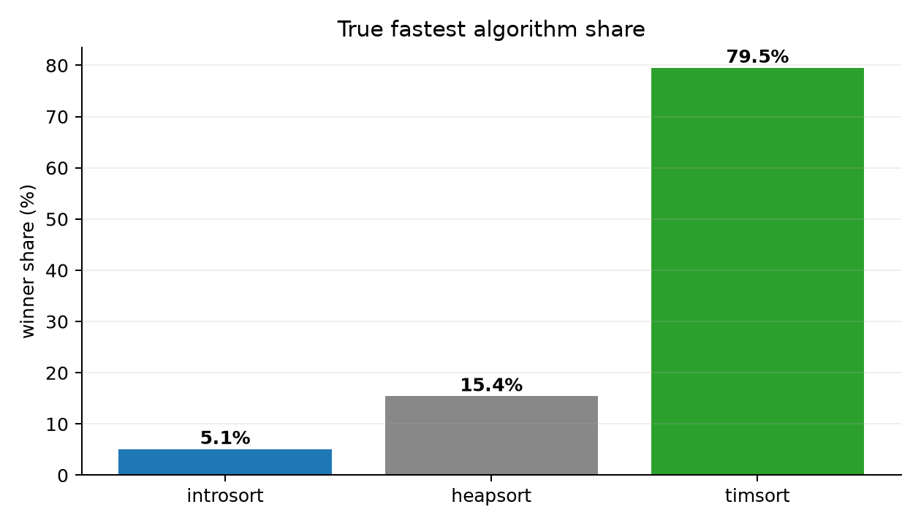
Figure X. Fastest-algorithm share inside the final three-algorithm portfolio.
Domain-Level Behaviour
Domain | Rows | Dominant | Dominant share | Prediction success | Mean regret (us)
Crypto | 100,000 | timsort | 85.1% | 88.62% | 0.32
Stock | 100,000 | timsort | 82.2% | 89.57% | 0.45
Earthquake | 100,003 | timsort | 72.6% | 86.60% | 0.20
Weather | 3,220 | heapsort | 39.4% | 65.47% | 5.22

The final portfolio behaves differently across the data sources. Crypto, Stock, and Earthquake are dominated by timsort, while Weather is more mixed and has lower success. This does not mean that element count alone determines regret. The harder cases are created by the combination of source structure, timing margin, and the algorithm selected by the classifier.
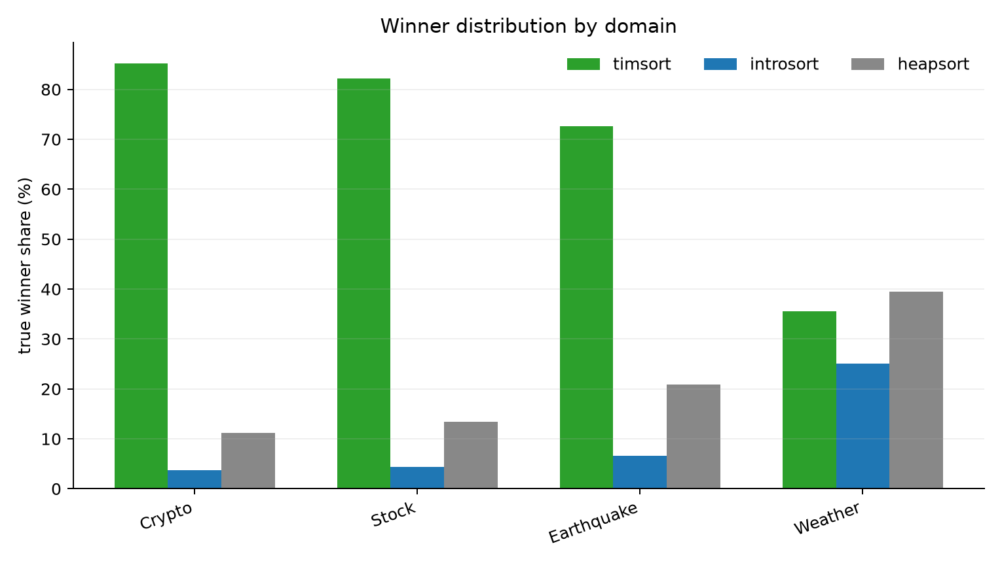
Figure X. Winner distribution by domain for the final three algorithms.
Structural Conditions Behind Correct Prediction
Correct prediction is strongest when the measured runtime winner is supported by clear structural evidence. High sortedness, low inversion ratio, and consistent run structure create regions where timsort dominates almost completely. In these regions the model is not merely learning a label frequency; it is detecting the same structural pattern that makes the runtime measurement favour timsort.
True class | Feature | Region | Success | Median margin (us)
heapsort | top5_freq_ratio | 0.8477 to 1 | 95.8% | 0.13
heapsort | mad_norm | 0.02041 to 0.02041 | 95.0% | 0.21
heapsort | duplicate_ratio | 0.954 to 0.9706 | 94.8% | 0.17
heapsort | duplicate_ratio | 0.9706 to 0.9837 | 94.6% | 0.21
introsort | n_elements | 1.338e+04 to 1.841e+05 | 85.0% | 2.25
introsort | length_norm | 0.07269 to 1 | 85.0% | 2.25
introsort | duplicate_ratio | 0.9922 to 0.9999 | 76.0% | 0.90
introsort | longest_run_ratio | 4.345e-05 to 0.0008703 | 71.8% | 1.63
timsort | adj_sorted_ratio | 0.9053 to 0.9095 | 99.8% | 9.17
timsort | inversion_ratio | 0.05952 to 0.06598 | 99.8% | 11.58
timsort | runs_ratio | 0.176 to 0.1832 | 99.8% | 13.46
timsort | top5_freq_ratio | 0.02 to 0.02497 | 99.4% | 0.79

Heapsort success is linked with high duplicate and frequency concentration, especially top-5 frequency and duplicate-ratio regions. Introsort appears in larger and less cleanly ordered cases, but because it is the smallest true winner class, its decision boundary is less stable. This explains why per-class behaviour is more informative than one aggregate accuracy number.
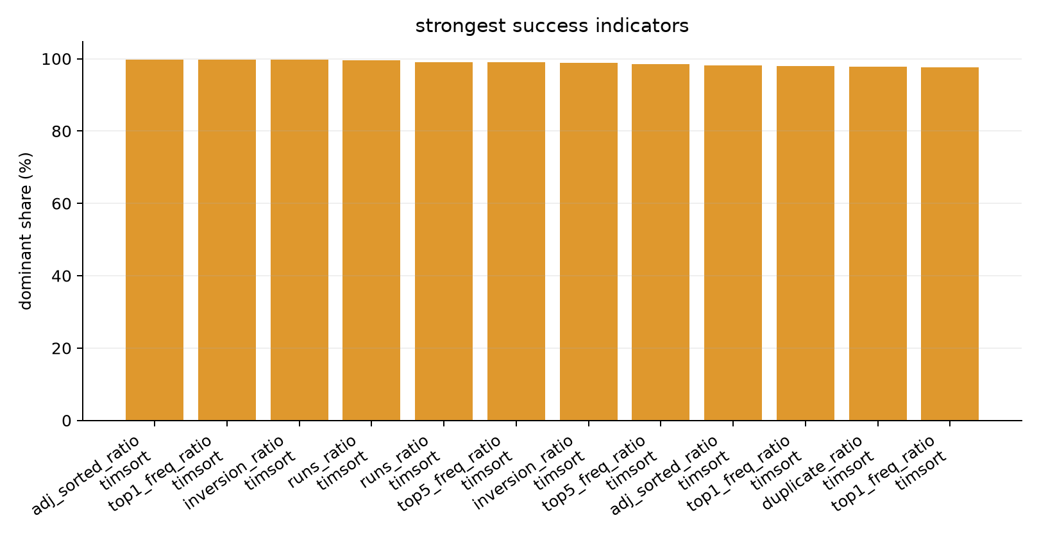
Figure X. Strongest structural regions behind successful predictions.
Failure Structure and Regret
Failure pair | Cases | Mean regret (us) | Median regret (us) | P95 regret (us)
timsort_to_heapsort | 13,482 | 3.16 | 1.85 | 9.04
introsort_to_heapsort | 8,227 | 0.94 | 0.12 | 3.42
heapsort_to_introsort | 4,745 | 3.84 | 0.87 | 11.00
timsort_to_introsort | 4,721 | 8.15 | 4.88 | 27.71
heapsort_to_timsort | 3,378 | 1.28 | 0.21 | 4.71
introsort_to_timsort | 1,779 | 1.49 | 0.29 | 6.02

The failure analysis separates label error from runtime damage. There were 36,332 failed predictions, but 19,806 of them had regret at or below one microsecond. These cases are near-boundary decisions where two algorithms are practically tied. The important part of the error distribution is therefore the high-regret subset, not every incorrect label equally.
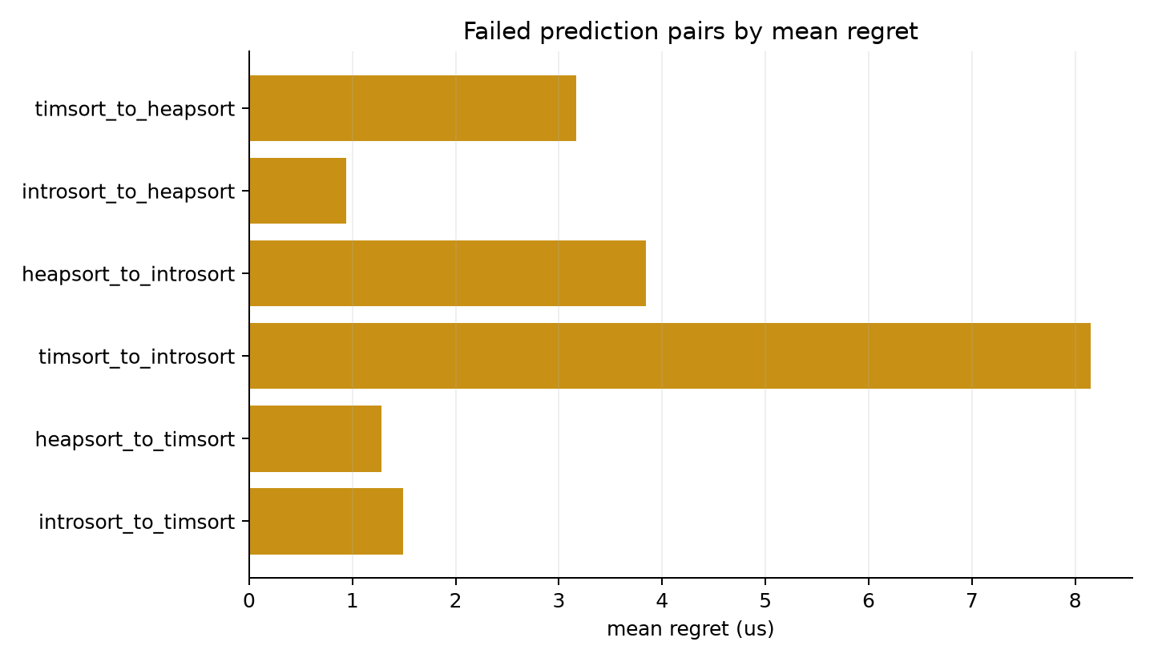
Figure X. Failed prediction pairs ordered by mean regret.
Worst-Failure Anatomy
Failure pair | Cases | Mean regret (us) | Median n | Median margin (us)
timsort_to_introsort | 253 | 53.56 | 13321 | 36.63
heapsort_to_introsort | 103 | 86.71 | 184103 | 46.92
timsort_to_heapsort | 75 | 36.94 | 8606 | 31.83
introsort_to_heapsort | 34 | 66.64 | 13518 | 43.60
heapsort_to_timsort | 22 | 49.62 | 2998 | 2.02
introsort_to_timsort | 13 | 47.00 | 3464 | 0.54

The worst 500 failures have a distinct profile. Their median array size is 13,320.5 compared with 2,500 for all failures and 501 for the full dataset. They also show weaker longest-run structure, higher inversion ratio, and much lower duplicate/frequency concentration than ordinary failures. This indicates that the highest regret cases are not random noise; they are concentrated in structurally difficult regions where the class boundary is expensive when crossed incorrectly.
Feature | Worst failures | All failures | All data
n_elements | 1.332e+04 | 2500 | 501
adj_sorted_ratio | 0.5102 | 0.519 | 0.5302
inversion_ratio | 0.4949 | 0.4865 | 0.4686
runs_ratio | 0.421 | 0.623 | 0.5054
longest_run_ratio | 0.001862 | 0.005 | 0.02
duplicate_ratio | 0.07401 | 0.4184 | 0.01285
top5_freq_ratio | 0.003811 | 0.1594 | 0.02
entropy_ratio | 0.7835 | 0.6463 | 0.7573

Interpretation
This final-three behaviour study supports the same conclusion as the wider algorithm portfolio reduction, but at a more detailed level. The retained algorithms are not interchangeable labels. Timsort captures ordered and run-adaptive structure, heapsort captures duplicate-heavy and frequency-concentrated regions, and introsort appears in a smaller but still meaningful part of the structural space. The selector succeeds when those structural signals are clear and fails mainly near boundaries or in larger high-regret regions where the wrong class carries measurable runtime cost.
The analysis also explains why the thesis evaluates runtime value rather than classification accuracy alone. A failed label can be harmless when two algorithms are tied, while a smaller number of errors can dominate regret if the selected algorithm is far from the oracle runtime. The practical question is therefore not only whether the classifier predicts the fastest label, but whether its mistakes preserve most of the SBS-to-VBS runtime gap.

