Final-Three Sorting Behavior Knowledge Report
Baseline Runtime Landscape
Rows analyzed: 303,223.
SBS algorithm: heapsort.
VBS total: 6.623571s; SBS total: 8.495169s; VBS/SBS gap: 22.03%.
Winner share: introsort 5.09%, heapsort 15.40%, timsort 79.51%
Meaning: this is the raw runtime landscape before explaining success or failure.
Structural Regions Where Each Algorithm Wins
Each structural feature was bucketed into quantile regions.
For each region, the loop measured which of timsort/introsort/heapsort is the dominant runtime winner.
Strongest regions found:
adj_sorted_ratio 0.9039 to 0.9078: timsort dominates with 99.6% over 30,322 arrays; median winner margin 13.33 us.
inversion_ratio 0.06146 to 0.07016: timsort dominates with 99.5% over 30,322 arrays; median winner margin 11.92 us.
runs_ratio 0.155 to 0.1791: timsort dominates with 99.0% over 30,322 arrays; median winner margin 4.46 us.
runs_ratio 0.1791 to 0.2034: timsort dominates with 98.5% over 30,322 arrays; median winner margin 8.25 us.
inversion_ratio 0 to 0.06146: timsort dominates with 98.1% over 30,323 arrays; median winner margin 3.96 us.
adj_sorted_ratio 0.9078 to 1: timsort dominates with 97.2% over 30,323 arrays; median winner margin 3.21 us.
top5_freq_ratio 0.02 to 0.032: timsort dominates with 96.8% over 30,322 arrays; median winner margin 0.92 us.
top1_freq_ratio 0.004 to 0.00431: timsort dominates with 96.3% over 30,323 arrays; median winner margin 0.75 us.
top5_freq_ratio 0.01 to 0.014: timsort dominates with 95.6% over 30,322 arrays; median winner margin 1.54 us.
top5_freq_ratio 0.014 to 0.02: timsort dominates with 95.5% over 30,323 arrays; median winner margin 0.87 us.
duplicate_ratio 0: timsort dominates with 95.4% over 30,323 arrays; median winner margin 1.58 us.
longest_run_ratio 0.12 to 1: timsort dominates with 95.4% over 30,323 arrays; median winner margin 1.79 us.
Why Correct Predictions Are Correct
Successful predictions: 266,891 (88.02%).
Highest success indicators are regions where the true fastest class is structurally clear and the runtime margin is usually not tiny.
adj_sorted_ratio 0.9048 to 0.9088: correct timsort region, 99.7% dominance, n=26,689, median margin=11.83 us.
top1_freq_ratio 0.004 to 0.004024: correct timsort region, 99.7% dominance, n=26,689, median margin=0.75 us.
inversion_ratio 0.06046 to 0.06737: correct timsort region, 99.7% dominance, n=26,689, median margin=12.62 us.
runs_ratio 0.1779 to 0.1873: correct timsort region, 99.6% dominance, n=26,689, median margin=11.00 us.
runs_ratio 0.15 to 0.1779: correct timsort region, 99.0% dominance, n=26,689, median margin=4.29 us.
top5_freq_ratio 0.02 to 0.02762: correct timsort region, 99.0% dominance, n=26,689, median margin=0.87 us.
inversion_ratio 0 to 0.06046: correct timsort region, 98.8% dominance, n=26,690, median margin=3.71 us.
top5_freq_ratio 0.014 to 0.02: correct timsort region, 98.6% dominance, n=26,689, median margin=0.96 us.
adj_sorted_ratio 0.9088 to 1: correct timsort region, 98.2% dominance, n=26,689, median margin=2.83 us.
top1_freq_ratio 0.001594 to 0.002: correct timsort region, 97.9% dominance, n=26,689, median margin=2.21 us.
duplicate_ratio 0: correct timsort region, 97.8% dominance, n=26,690, median margin=1.63 us.
top1_freq_ratio 0.004024 to 0.007968: correct timsort region, 97.5% dominance, n=26,689, median margin=1.25 us.
Why Failed Predictions Fail
Failed predictions: 36,332 (11.98%).
Low-regret failures <=1 us: 19,806; high-regret failures >1 us: 16,526.
Main failed class-pairs:
timsort_to_heapsort: n=13,482, mean regret=3.16 us, p95=9.04 us.
introsort_to_heapsort: n=8,227, mean regret=0.94 us, p95=3.42 us.
heapsort_to_introsort: n=4,745, mean regret=3.84 us, p95=11.00 us.
timsort_to_introsort: n=4,721, mean regret=8.15 us, p95=27.71 us.
heapsort_to_timsort: n=3,378, mean regret=1.28 us, p95=4.71 us.
introsort_to_timsort: n=1,779, mean regret=1.49 us, p95=6.02 us.
Strong high-regret feature regions:
longest_run_ratio 0.002333 to 0.0024: timsort_to_heapsort dominates failures with 80.2%, n=1,653.
n_elements 2999 to 3000: timsort_to_heapsort dominates failures with 78.8%, n=1,653.
length_norm 0.01629 to 0.0163: timsort_to_heapsort dominates failures with 78.8%, n=1,653.
dispersion_ratio 0.05035 to 0.06621: timsort_to_heapsort dominates failures with 73.7%, n=1,653.
mad_norm 0.02144 to 0.02868: timsort_to_heapsort dominates failures with 71.1%, n=1,652.
longest_run_ratio 0.002001 to 0.002333: timsort_to_heapsort dominates failures with 70.6%, n=1,652.
n_elements 3000 to 3483: timsort_to_heapsort dominates failures with 68.0%, n=1,652.
length_norm 0.0163 to 0.01892: timsort_to_heapsort dominates failures with 68.0%, n=1,652.
mean_abs_diff_norm 0.04876 to 0.06389: timsort_to_heapsort dominates failures with 67.9%, n=1,652.
longest_run_ratio 0.002786 to 0.002807: timsort_to_heapsort dominates failures with 67.3%, n=1,653.
iqr_norm 0.05024 to 0.06591: timsort_to_heapsort dominates failures with 66.8%, n=1,652.
n_elements 2500 to 2513: timsort_to_heapsort dominates failures with 66.5%, n=1,653.
Representative Examples
Representative cases exported to tables/representative_cases.csv.
Weather n=52,585: true=introsort, pred=introsort, regret=0.00 us, margin=496.96 us, file=weather_Singapore_2015_2020_wind_rolling_24h_std_REV.csv.
Crypto n=17,361: true=heapsort, pred=heapsort, regret=0.00 us, margin=361.92 us, file=crypto_LTC-USD_2y_1h_rolling_5d_std_SHUF.csv.
Weather n=184,104: true=timsort, pred=timsort, regret=0.00 us, margin=4380.29 us, file=weather_Singapore_2000_2020_precip_cumsum.csv.
Earthquake n=63: true=introsort, pred=timsort, regret=0.00 us, margin=0.00 us, file=quake_japan_global_M5plus_20200101_20201231_latitude_REV.csv.
Weather n=184,081: true=timsort, pred=introsort, regret=659.25 us, margin=659.25 us, file=weather_Havana_2000_2020_temp_rolling_24h_mean_PSORT10.csv.
Domain-Level Behavior Patterns
Domain split tests whether global pattern hides different behavior per source.
Domain winner and success patterns:
Crypto: n=100,000, dominant=timsort 85.1%, tim=85.1%, intro=3.7%, heap=11.1%, success=88.62%, mean regret=0.32 us.
Stock: n=100,000, dominant=timsort 82.2%, tim=82.2%, intro=4.3%, heap=13.4%, success=89.57%, mean regret=0.45 us.
Earthquake: n=100,003, dominant=timsort 72.6%, tim=72.6%, intro=6.6%, heap=20.9%, success=86.60%, mean regret=0.20 us.
Weather: n=3,220, dominant=heapsort 39.4%, tim=35.5%, intro=25.0%, heap=39.4%, success=65.47%, mean regret=5.22 us.
Size and Structure Interaction Patterns
Interaction test checks whether one feature still matters after size changes.
Strongest size x structure regions:
n_elements x inversion_ratio size 250 to 500, feature 0 to 0.07016: timsort 99.9%, n=10,389, success=99.8%, p95 regret=0.00 us.
n_elements x adj_sorted_ratio size 250 to 500, feature 0.9039 to 1: timsort 99.8%, n=10,067, success=99.6%, p95 regret=0.00 us.
n_elements x inversion_ratio size 50 to 250, feature 0 to 0.07016: timsort 99.7%, n=11,514, success=99.6%, p95 regret=0.00 us.
n_elements x inversion_ratio size 500 to 1000, feature 0 to 0.07016: timsort 99.7%, n=11,679, success=99.7%, p95 regret=0.00 us.
n_elements x inversion_ratio size 1000 to 2513, feature 0 to 0.07016: timsort 99.6%, n=12,500, success=99.5%, p95 regret=0.00 us.
n_elements x adj_sorted_ratio size 500 to 1000, feature 0.9039 to 1: timsort 99.4%, n=11,323, success=99.5%, p95 regret=0.00 us.
n_elements x runs_ratio size 250 to 500, feature 5.432e-06 to 0.1791: timsort 99.3%, n=11,345, success=99.1%, p95 regret=0.00 us.
n_elements x adj_sorted_ratio size 50 to 250, feature 0.9039 to 1: timsort 99.2%, n=12,007, success=99.3%, p95 regret=0.00 us.
n_elements x runs_ratio size 50 to 250, feature 5.432e-06 to 0.1791: timsort 99.1%, n=12,745, success=99.1%, p95 regret=0.00 us.
n_elements x adj_sorted_ratio size 1000 to 2513, feature 0.9039 to 1: timsort 99.1%, n=12,728, success=99.2%, p95 regret=0.00 us.
n_elements x duplicate_ratio size 50 to 250, feature 0 to 0.002309: timsort 98.5%, n=10,956, success=98.6%, p95 regret=0.00 us.
n_elements x top5_freq_ratio size 50 to 250, feature 0.032 to 0.372: timsort 98.5%, n=15,190, success=98.4%, p95 regret=0.00 us.
n_elements x duplicate_ratio size 50 to 250, feature 0.002309 to 0.1202: timsort 98.4%, n=7,124, success=98.5%, p95 regret=0.00 us.
n_elements x duplicate_ratio size 250 to 500, feature 0.002309 to 0.1202: timsort 98.3%, n=12,164, success=98.4%, p95 regret=0.00 us.
Class-Specific Success Indicators
Per-class test avoids timsort dominance hiding intro/heap signals.
Best class-specific indicators:
introsort: n_elements 1.338e+04 to 1.841e+05, n=1,544, class share=10.0%, margin=2.25 us, success=85.0%.
introsort: length_norm 0.07269 to 1, n=1,544, class share=10.0%, margin=2.25 us, success=85.0%.
introsort: duplicate_ratio 0.9922 to 0.9999, n=1,544, class share=10.0%, margin=0.90 us, success=76.0%.
introsort: longest_run_ratio 4.345e-05 to 0.0008703, n=1,544, class share=10.0%, margin=1.63 us, success=71.8%.
introsort: mean_abs_diff_norm 0.0002674 to 0.01451, n=1,544, class share=10.0%, margin=0.54 us, success=68.0%.
heapsort: top5_freq_ratio 0.8477 to 1, n=4,671, class share=10.0%, margin=0.13 us, success=95.8%.
heapsort: mad_norm 0.02041 to 0.02041, n=4,671, class share=10.0%, margin=0.21 us, success=95.0%.
heapsort: duplicate_ratio 0.954 to 0.9706, n=4,670, class share=10.0%, margin=0.17 us, success=94.8%.
heapsort: duplicate_ratio 0.9706 to 0.9837, n=4,672, class share=10.0%, margin=0.21 us, success=94.6%.
heapsort: n_elements 3000 to 3631, n=4,670, class share=10.0%, margin=0.54 us, success=93.1%.
timsort: adj_sorted_ratio 0.9053 to 0.9095, n=24,108, class share=10.0%, margin=9.17 us, success=99.8%.
timsort: inversion_ratio 0.05952 to 0.06598, n=24,108, class share=10.0%, margin=11.58 us, success=99.8%.
timsort: runs_ratio 0.176 to 0.1832, n=24,108, class share=10.0%, margin=13.46 us, success=99.8%.
timsort: top5_freq_ratio 0.02 to 0.02497, n=24,108, class share=10.0%, margin=0.79 us, success=99.4%.
timsort: n_elements 1095 to 1482, n=24,108, class share=10.0%, margin=5.79 us, success=99.3%.
Worst Failure Anatomy
Worst-failure test isolates top 500 errors by regret, not by count.
Worst failure pairs:
timsort_to_introsort: n=253, mean regret=53.56 us, median n=13321, median margin=36.63 us.
heapsort_to_introsort: n=103, mean regret=86.71 us, median n=184103, median margin=46.92 us.
timsort_to_heapsort: n=75, mean regret=36.94 us, median n=8606, median margin=31.83 us.
introsort_to_heapsort: n=34, mean regret=66.64 us, median n=13518, median margin=43.60 us.
heapsort_to_timsort: n=22, mean regret=49.62 us, median n=2998, median margin=2.02 us.
introsort_to_timsort: n=13, mean regret=47.00 us, median n=3464, median margin=0.54 us.
Feature shift in worst failures:
n_elements: worst median=1.332e+04, all-failure median=2500, all-data median=501.
adj_sorted_ratio: worst median=0.5102, all-failure median=0.519, all-data median=0.5302.
inversion_ratio: worst median=0.4949, all-failure median=0.4865, all-data median=0.4686.
runs_ratio: worst median=0.421, all-failure median=0.623, all-data median=0.5054.
longest_run_ratio: worst median=0.001862, all-failure median=0.005, all-data median=0.02.
duplicate_ratio: worst median=0.07401, all-failure median=0.4184, all-data median=0.01285.
top5_freq_ratio: worst median=0.003811, all-failure median=0.1594, all-data median=0.02.
entropy_ratio: worst median=0.7835, all-failure median=0.6463, all-data median=0.7573.
Final Synthesis and Next Tests
The loop builds a behavior map for the final three algorithms only.
The main question is which structural indicators make timsort, introsort, or heapsort win.
Success analysis explains where the model sees the same structure as the timing oracle.
Failure analysis separates harmless boundary mistakes from expensive mistakes.
Prediction status: predictions generated from models/xgboost_v5/xgb_v5.json.
Next tests should target the strongest high-regret regions with controlled synthetic probes and optional fresh retiming.

Baseline Winner Share
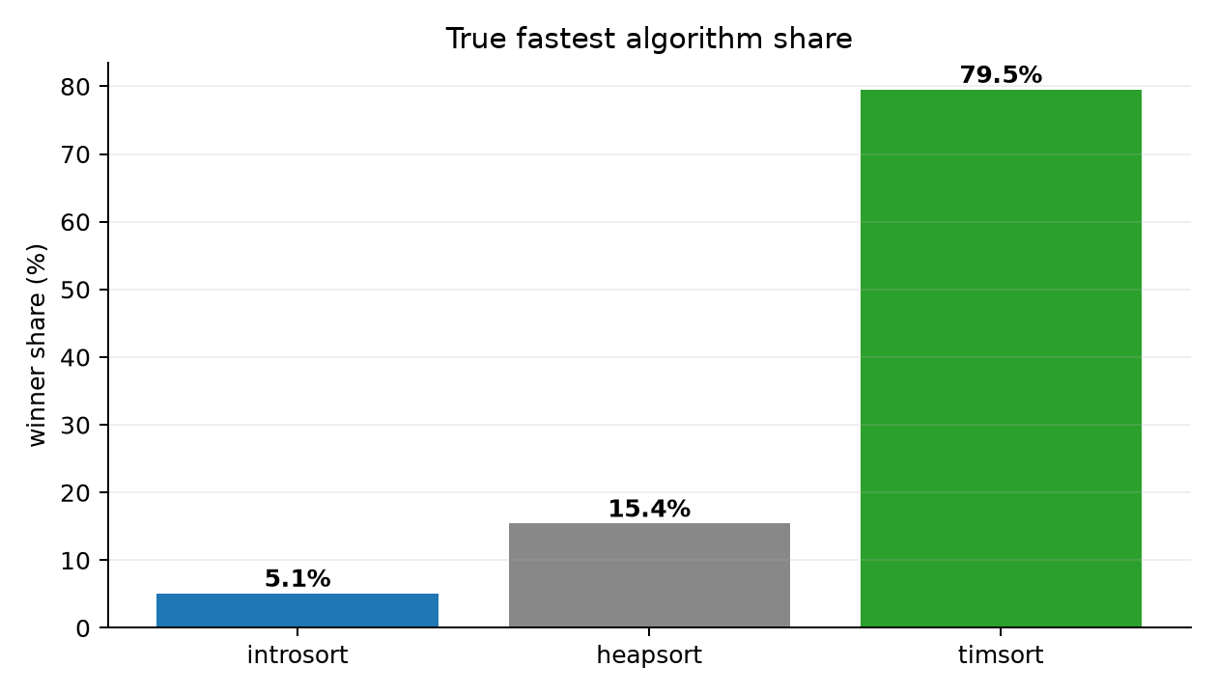

Domain Winner Patterns
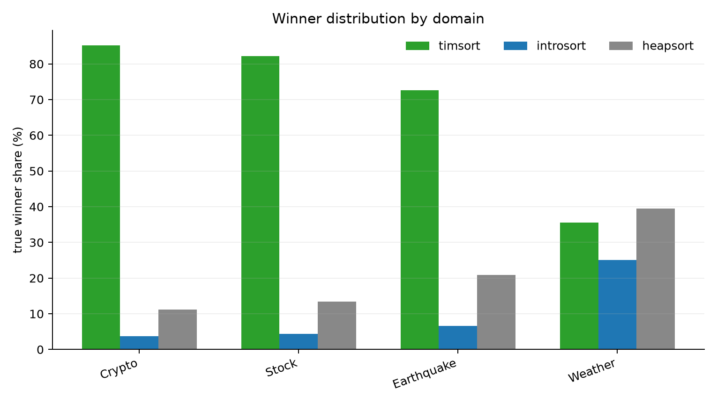

Failure Pairs Regret
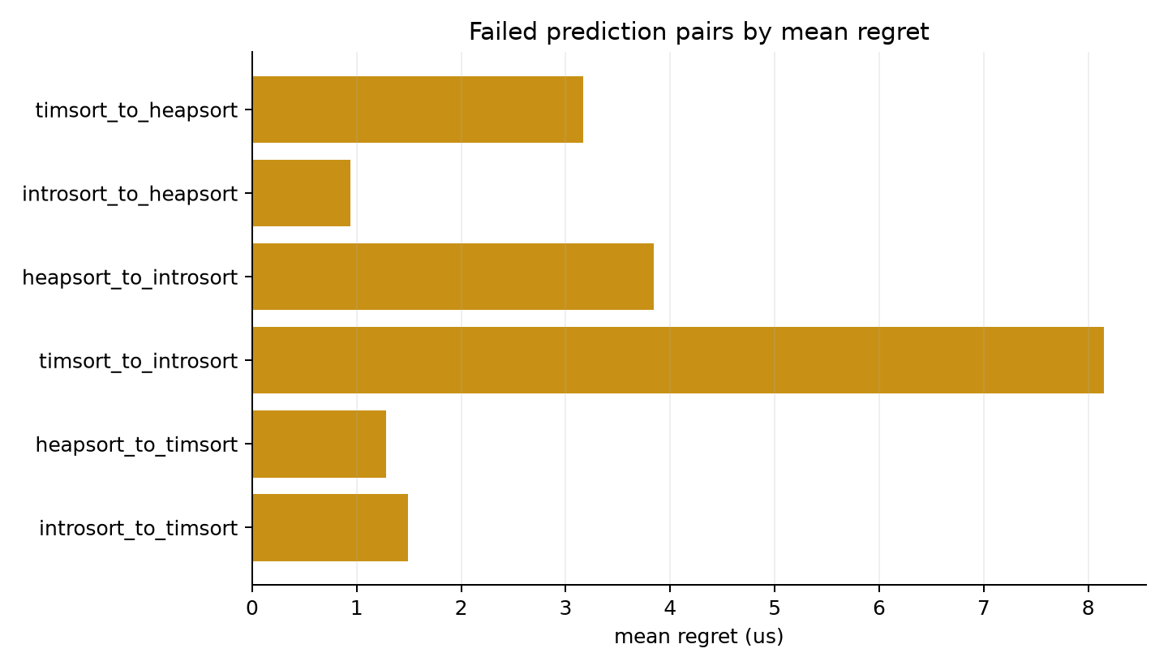

Size Feature Interaction Patterns
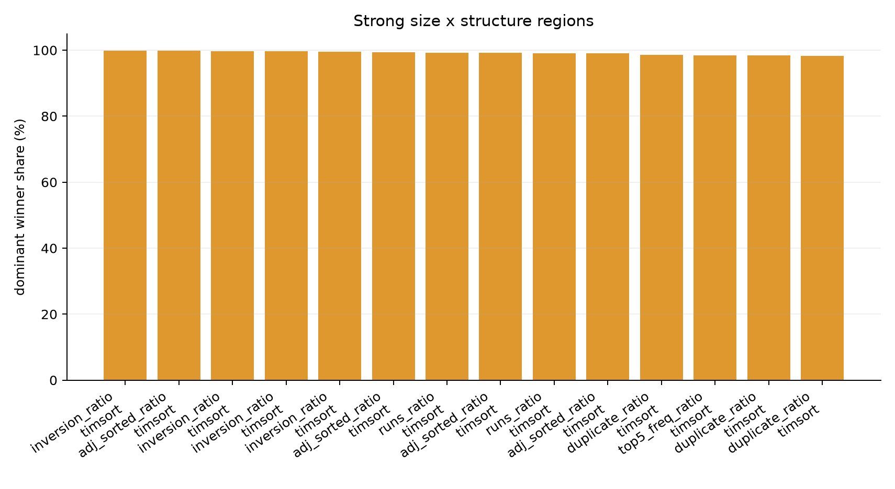

Success Top Indicators
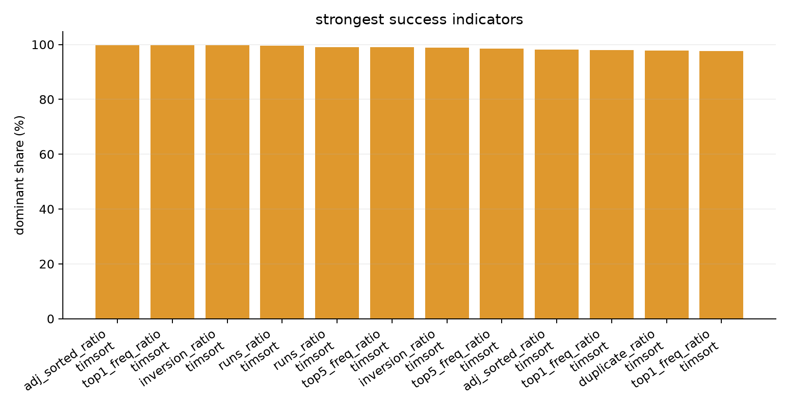

Winner Region Top Indicators
