CHAPTER THREE
METHODOLOGY

3.1 Research Methodology Overview
Sorting algorithm selection is framed in this thesis as a supervised classification problem. Given a one-dimensional numeric array, the system extracts a fixed set of structural features and predicts which sorting algorithm will execute fastest on that specific input. This formulation follows the Algorithm Selection Problem (ASP) first formalised by Rice (1976), which defines four spaces: a problem space P of inputs, a feature space F of measurable characteristics, an algorithm space A of candidate solvers, and a performance space Y of measured outcomes.
The formal problem statement is as follows. Let x denote the feature vector extracted from an input array, where x is an element of R to the power of 16. Let A represent the set of candidate sorting algorithms, and let T(a, x) denote the execution time of algorithm a on the array characterised by x. The objective is to learn a selector S that maps feature vectors to algorithms such that the selected algorithm minimises expected execution time.
a* = argmin T(a, x), a ∈ A (3.1)
Classification was chosen over regression after empirical evidence from early model iterations. Version 1 of the model attempted multi-output regression, predicting the absolute execution time for each algorithm and selecting the fastest. This approach achieved only 44.4% accuracy because the regressor learned to predict array size, which dominates absolute timing, rather than the relative performance differences between algorithms. Version 2 reformulated the task as direct classification, predicting the identity of the fastest algorithm, and immediately improved accuracy to 62.5%. This confirmed that ranking algorithms by relative performance requires a classification formulation, not magnitude prediction.
The machine learning pipeline follows five sequential stages: problem formulation, feature engineering, data collection and labelling, model training with iterative refinement, and evaluation using both classification and algorithm selection metrics. Each stage is described in detail in the sections that follow.
XGBoost (Chen and Guestrin, 2016) was selected as the classification algorithm for several technical reasons. Gradient-boosted decision trees handle tabular data natively without requiring feature scaling or one-hot encoding. The sequential boosting process fits residuals from prior trees, capturing complex feature interactions such as the interaction between array size and sortedness that determines whether timsort or introsort is faster. Built-in L1 and L2 regularisation (controlled by reg_alpha and reg_lambda) prevents overfitting on noisy labels, which is critical when ground-truth labels are derived from timing measurements with inherent variance. Histogram-based splitting (tree_method hist) provides computational efficiency during training, and the softmax objective (multi:softprob) produces calibrated probability estimates rather than hard predictions.
Alternative classifiers were considered and rejected. Random forests use bagging, which averages independent trees, but this is less effective than sequential boosting for structured tabular data where feature interactions carry the discriminative signal. Support vector machines require careful kernel selection and feature scaling, and do not naturally handle multi-class problems with probabilistic outputs. Neural networks require substantially more training data to avoid overfitting and lack the interpretability that feature importance analysis provides. Single decision trees lack the capacity to model the complex decision boundaries in this problem.
The system architecture comprises two layers. Layer 1 is an offline XGBoost classifier trained on 1.18 million real-world arrays, which serves as the production model. Layer 2 is a LinUCB contextual bandit designed for online adaptation under distribution shift, which is presented as a future research direction rather than a validated contribution. The offline layer operates independently and degrades gracefully when online feedback is unavailable.
3.2 System Architecture
The system processes a numeric array through three stages to produce a sorting algorithm recommendation, as illustrated in Figure 3.1. First, the raw array passes through a feature extraction module that computes 16 structural features in O(n) time. Second, the resulting feature vector is fed to the XGBoost classifier, which outputs probability estimates for each candidate algorithm. Third, the algorithm with the highest probability is selected as the prediction.
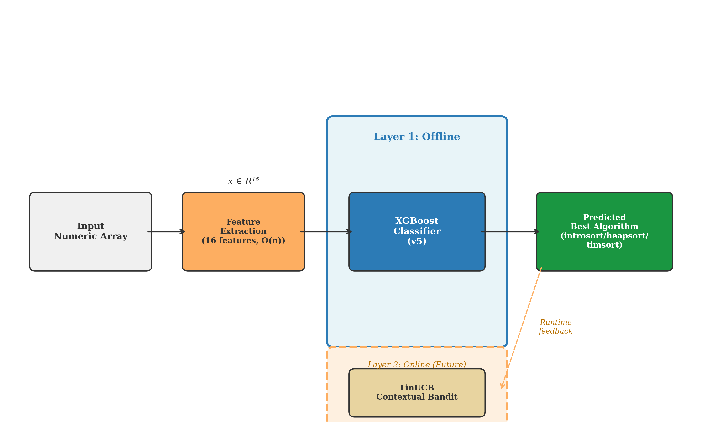
Figure 3.1: System Architecture Showing the Two-Layer Design
The two-layer architecture separates concerns between offline prediction and online adaptation. Layer 1 handles the core prediction task using a pre-trained model that requires no runtime feedback. This layer is sufficient for deployment scenarios where the data distribution is stationary or where collecting runtime feedback is impractical. Layer 2 adds a contextual bandit that observes actual sorting times after prediction and adjusts future selections accordingly. This layer addresses distribution shift, where incoming arrays may differ systematically from the training data, but has not been validated experimentally and is presented as a designed component for future work in Section 3.10.
The inference pipeline is designed to be computationally lightweight. Feature extraction runs in O(n) time, and the XGBoost prediction requires a single forward pass through the tree ensemble. The combined overhead must remain small relative to the sorting operation itself, which runs in O(n log n) time. For arrays shorter than approximately 1,000 elements, the feature extraction overhead may exceed the performance difference between algorithms, making selection unnecessary. The system is therefore most beneficial for medium to large arrays where the absolute time savings justify the prediction cost.
3.3 Algorithm Portfolio
The algorithm portfolio consists of three sorting algorithms: introsort, heapsort, and timsort. These three were selected because they represent fundamentally different algorithmic strategies that create a non-trivial selection landscape, meaning no single algorithm dominates across all input types. All three are implemented at the C level within NumPy and the Python standard library, ensuring that performance comparisons reflect algorithmic characteristics rather than language-level overhead.
Introsort (Musser, 1997) is a hybrid algorithm that begins as quicksort, monitors recursion depth, and switches to heapsort if the depth exceeds 2 log n. This guarantees O(n log n) worst-case performance while retaining quicksort's cache-friendly access patterns and low constant factors on random data. Introsort performs well on shuffled and uniformly distributed arrays where quicksort's partitioning scheme efficiently divides the input.
Heapsort (Williams, 1964) provides O(n log n) time complexity in all cases with O(1) auxiliary space. Its in-place operation makes it space-efficient, but its non-sequential memory access pattern is cache-unfriendly on modern hardware. Heapsort serves as a consistent baseline that is rarely the fastest but is never catastrophically slow, making it a safe default when prediction confidence is low.
Timsort (Peters, 2002) is an adaptive merge sort that identifies pre-existing sorted subsequences (natural runs) in the input and merges them efficiently. On fully sorted data, timsort achieves O(n) time complexity, and on nearly sorted data it approaches this bound. Timsort exploits structure that the other two algorithms ignore, making it the clear winner on structured real-world data where natural ordering is common.
The selection landscape arises because each algorithm exploits different input properties. Timsort dominates on structured data with high sortedness or long natural runs. Introsort and heapsort compete on random or shuffled data where no exploitable structure exists. The key empirical finding from model version 8 (Section 3.6) is that introsort and heapsort are nearly indistinguishable by structural features alone (binary classifier AUC of 0.603), confirming that the practical selection problem is closer to binary than ternary.
Several additional algorithms were evaluated and eliminated during the portfolio construction phase. Counting sort achieved zero wins across 720 test arrays because its O(n + k) complexity depends on the value range k, which is unbounded for real-valued data. Radix sort was approximately 20 times slower than comparison-based alternatives on the array sizes tested. Bubble sort, insertion sort, and shell sort could not be accessed at C level without custom Cython compilation, making fair comparison impossible. The final portfolio of three algorithms balances diversity of algorithmic strategies with practical deployment constraints.
3.4 Feature Engineering
Feature engineering is the process of transforming a raw numeric array into a fixed-length vector that captures properties relevant to sorting algorithm performance. The design of these features is guided by two constraints. First, every feature must be computable in O(n) time, because the feature extraction step must be strictly cheaper than the sorting operation itself, which runs in O(n log n). If feature extraction were as expensive as sorting, there would be no benefit to predicting the best algorithm; one could simply sort directly. Second, each feature must be informative, meaning it captures a structural property of the array that is known to affect the relative performance of at least one algorithm in the portfolio.
The system computes 16 features organised into five groups: size, ordering, repetition, distribution, and robust scale. Table 3.1 lists all features with their definitions and the algorithmic behaviours they target.
Table 3.1: Structural Features Used for Array Characterisation
Feature | Definition | Range | Group
length_norm | log2(n) / log2(n_max), normalised array length | [0, 1] | Size
adj_sorted_ratio | Fraction of adjacent pairs in sorted order | [0, 1] | Ordering
runs_ratio | Number of natural runs divided by n | [0, 1] | Ordering
inversion_ratio | Normalised inversion count (subsampled for n > 10K) | [0, 1] | Ordering
longest_run_ratio | Length of longest sorted run divided by n | [0, 1] | Ordering
mean_abs_diff_norm | Mean absolute difference between consecutive elements, normalised by range | [0, 1] | Ordering
duplicate_ratio | 1 - (unique values / n) | [0, 1] | Repetition
top1_freq_ratio | Frequency of most common value divided by n | [0, 1] | Repetition
top5_freq_ratio | Sum of top-5 value frequencies divided by n | [0, 1] | Repetition
dispersion_ratio | Standard deviation divided by range | [0, 1] | Distribution
entropy_ratio | Shannon entropy divided by log2(n) | [0, 1] | Distribution
skewness_t | Signed log transform of sample skewness | (-inf, inf) | Distribution
kurtosis_excess_t | Signed log transform of excess kurtosis | (-inf, inf) | Distribution
outlier_ratio | Fraction of values beyond 1.5 IQR from quartiles | [0, 1] | Distribution
iqr_norm | Interquartile range divided by full range | [0, 1] | Robust Scale
mad_norm | Median absolute deviation divided by range | [0, 1] | Robust Scale

3.4.1 Ordering Features
Ordering features measure how close the array is to sorted order, which directly determines timsort's advantage. The adjacent sorted ratio counts the fraction of consecutive element pairs that are already in non-decreasing order. A value of 1.0 indicates a fully sorted array, where timsort achieves O(n) complexity. The runs ratio measures the density of natural runs, which timsort identifies and merges. The inversion ratio provides a global measure of disorder by counting the number of element pairs that are out of order, normalised to [0, 1]. For computational efficiency, the inversion count is subsampled to 2,000 elements for arrays exceeding 10,000 elements, trading exact measurement for the O(n) time constraint. The longest run ratio captures whether the array contains a single dominant sorted subsequence, and the mean absolute difference norm measures local variation between consecutive elements.
3.4.2 Repetition Features
Repetition features capture the frequency structure of values in the array. High duplicate ratios affect quicksort's partition quality, since equal-key elements can create unbalanced partitions in naive implementations. Timsort benefits from duplicates because repeated values create natural runs of equal elements. The top-1 and top-5 frequency ratios measure concentration: a high top-1 frequency indicates that a single value dominates the array, while top-5 captures broader value clustering.
3.4.3 Distribution Features
Distribution features characterise the statistical shape of the data. The dispersion ratio and entropy ratio measure spread and information content respectively. Skewness and kurtosis are transformed using a signed logarithm to handle the wide range of values observed in real-world data, applying the transformation sign(x) times log(1 + abs(x)). This preserves the sign while compressing extreme values. The outlier ratio identifies arrays with heavy tails, which can affect quicksort's pivot selection quality.
3.4.4 Normalisation and Numerical Stability
Most features are normalised to the [0, 1] interval by construction, using ratios that divide by the array length or value range. This normalisation ensures that features are comparable across arrays of different sizes and value ranges without requiring external scaling. Skewness and kurtosis are the exceptions, as their signed log transforms produce unbounded values.
Numerical stability is enforced through epsilon guards. All divisions include an additive constant of 1e-12 in the denominator to prevent division by zero on constant arrays. Edge cases such as single-element arrays and constant-value arrays are handled explicitly: a single-element array returns zero for all ratio features, and a constant array returns 1.0 for duplicate_ratio and 0.0 for dispersion and entropy. The feature extraction function was validated with 214 unit tests covering all edge cases, and produced zero NaN and zero Inf values across all 1.18 million training arrays.
All features are computed by a single Python function that serves as the single source of truth across the entire codebase. Every script that requires features imports this function rather than reimplementing the calculations, preventing feature drift between training and inference.
3.5 Data Collection
The training dataset comprises 1,188,265 numeric arrays collected from five real-world domains. Real-world data was chosen over synthetic data after early experiments demonstrated that synthetically generated arrays (uniform, normal, lognormal distributions) fail to capture the structural patterns found in real data. Model version 2, trained on synthetic arrays, achieved 62.5% accuracy on synthetic test data but only 60% on real-world arrays. Real-world data contains natural correlations, trends, periodic patterns, and domain-specific structure that synthetic generation cannot reproduce.
The five source domains were selected to maximise diversity in data characteristics. Formula 1 telemetry data provides time-series arrays with strong auto-correlation and physical constraints. Stock market and cryptocurrency data contain financial returns with heavy-tailed distributions and volatility clustering. Earthquake data provides geophysical measurements with spatial correlation. Weather data offers smooth, periodic signals with seasonal patterns. This diversity ensures that the trained model encounters a wide range of structural properties during training.
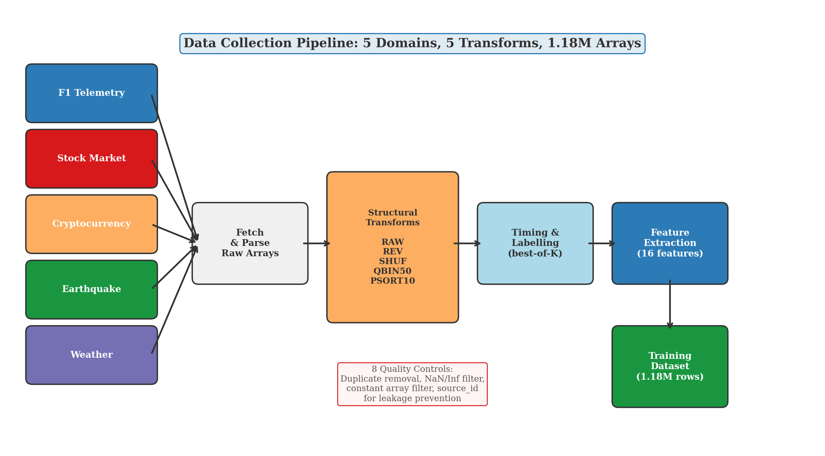
Figure 3.2: Data Collection Pipeline from Five Domains to Training Dataset
3.5.1 Structural Transforms
Each raw array is subjected to five structural transforms that modify its ordering and value distribution, producing five variants from each original array. The purpose of these transforms is to prevent the model from learning a trivial rule. Without transforms, most real-world data is nearly sorted, and the model would learn to always predict timsort regardless of input features.
The five transforms are as follows. RAW preserves the original array unchanged. REV reverses the array, creating a fully anti-sorted variant that tests heapsort's consistency. SHUF applies a random permutation, destroying all pre-existing order and creating conditions where introsort's quicksort component is effective. QBIN50 quantises values into 50 equal-frequency bins, creating high duplicate density. PSORT10 partially sorts 10% of the array by swapping a fraction of elements into their correct positions, producing a nearly-sorted variant.
3.5.2 Labelling Protocol
Ground-truth labels are assigned by timing each sorting algorithm on each array and selecting the fastest as the class label. Timing uses a best-of-K protocol to reduce operating system scheduling noise: K equals 5 for arrays shorter than 10,000 elements and K equals 3 for larger arrays, reflecting the lower relative variance on longer-running sorts. Garbage collection is disabled during timing to prevent non-deterministic pauses, and processes are pinned to a single CPU core to avoid cache contention from context switching.
Label noise is an inherent challenge. When two algorithms execute within 5% of each other's time, the faster algorithm in one run may be slower in the next due to measurement variance. These near-tie cases represent fundamental ambiguity rather than labelling errors. The noise filter applied during model training (Section 3.7) addresses this by removing arrays where the margin between the best and second-best algorithm is less than 5%, unless the array contains at least 2,000 elements where timing measurements are more stable.
3.5.3 Data Quality Controls
Eight quality controls are applied to the raw dataset before training. Duplicate arrays are removed to prevent data leakage. Arrays containing NaN or Inf values are excluded. Constant arrays are filtered because they are trivially sorted. Arrays shorter than 10 elements are removed because sorting time differences at this scale are dominated by overhead rather than algorithmic complexity. Domain imbalance is monitored to ensure no single domain overwhelms the training set. Source leakage is prevented by tracking a source identifier for each array, ensuring that arrays derived from the same original time series never appear in both training and test sets. Timing noise is mitigated through the best-of-K protocol, and feature drift is prevented by the single source of truth implementation.
3.6 Model Evolution
The final production model is the result of seven iterative versions, each addressing a limitation discovered in its predecessor. This section documents the progression from initial failure to production readiness, including the reasoning behind each architectural decision and the lessons that guided subsequent iterations. Table 3.2 summarises the key metrics for each version.
Table 3.2: Model Version History with Test Accuracy and Key Findings
Version | Approach | Test Acc. | Test Size | Key Finding
v1 | Multi-output regression | 44.4% | 72 | Predicted absolute times; learned array size, not algorithm preference
v2 | Direct classifier (synthetic) | 62.5% | 72 | Proved classification outperforms regression for selection
v3 | Log + pairwise features | 100% | 72 | Used pre-sorting times (data leakage); ceiling proof only
v5 | Production (1.18M real arrays) | 76.1% | 29,494 | Production model; 93.1% VBS-SBS gap closed
v6 | Source-aware split | 71.2% | 11,789 | GroupShuffleSplit prevents source leakage between splits
v7 | Regret-weighted training | 72.9% | 50,364 | Regret-aware objective hurt accuracy; gap closed dropped to 78%
v8 | Binary cascade | 72.6% | 50,364 | Introsort and heapsort indistinguishable (AUC 0.603)
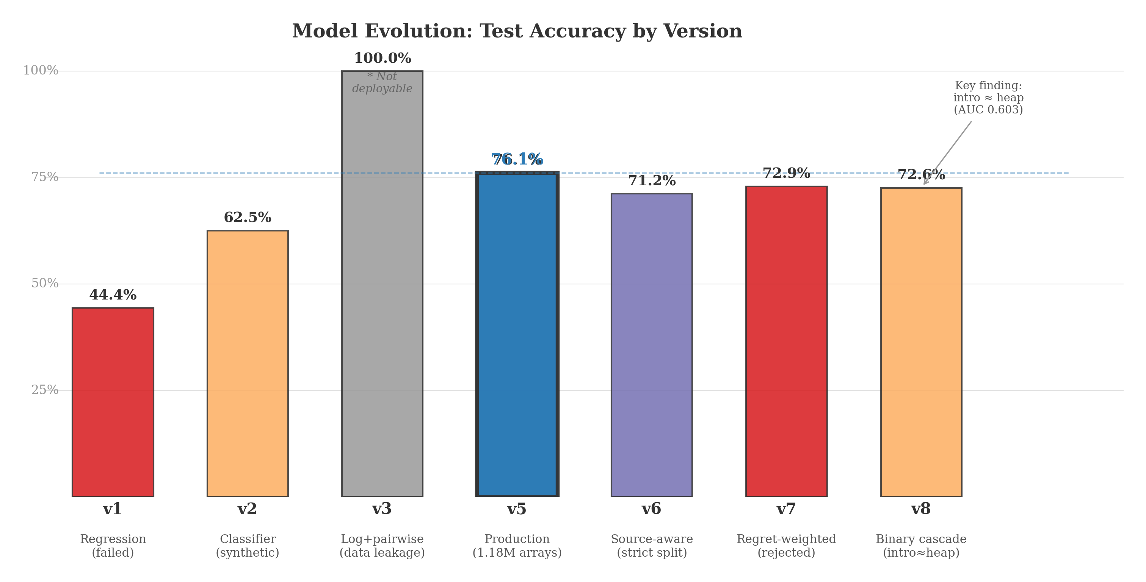
Figure 3.3: Model Evolution Showing Test Accuracy Across Seven Versions
3.6.1 Version 1: Multi-Output Regression
The initial approach modelled algorithm selection as a regression problem, training a multi-output XGBoost regressor to predict the execution time of each algorithm given the input features. The predicted best algorithm was the one with the lowest predicted time. This approach achieved only 44.4% test accuracy. Analysis revealed that the regressor learned to predict array size as the dominant factor in execution time, since larger arrays take longer regardless of algorithm. The relative time differences between algorithms, which are the actual selection signal, were buried in the noise of magnitude prediction. This failure motivated the shift to classification.
3.6.2 Version 2: Direct Classifier
Version 2 reformulated the problem as direct classification, predicting the identity of the fastest algorithm rather than absolute execution times. Trained on synthetic arrays generated from uniform, normal, and lognormal distributions, this model achieved 62.5% test accuracy. The improvement over version 1 confirmed that classification is the correct formulation for algorithm selection. However, the synthetic training data lacked the structural diversity of real-world arrays, limiting the model's practical utility. This version demonstrated the need for real-world training data.
3.6.3 Version 3: Timing Features (Data Leakage)
Version 3 added six timing-derived features: log-transformed execution times for each algorithm and pairwise time differences. This model achieved 100% accuracy, confirming that the features contain strong discriminative signal. However, these timing features require running all three algorithms before making a selection, which defeats the purpose of algorithm selection. Version 3 served as a theoretical ceiling, demonstrating that the information needed for perfect selection exists in the data. The timing features were removed in subsequent versions, and the 100% ceiling was used as a convergence target for the online bandit component.
3.6.4 Version 5: Production Classifier
Version 5 is the production model, trained on 1.18 million real-world arrays using only the 16 structural features. This model achieved 76.1% test accuracy and 93.1% VBS-SBS gap closed, meaning it captures over 93% of the possible improvement between always using the single best solver and always using the oracle. The full details of this model's architecture, training protocol, and hyperparameters are presented in Section 3.7.
3.6.5 Version 6: Source-Aware Evaluation
Version 6 introduced GroupShuffleSplit for train-test splitting, using source identifiers to ensure that arrays derived from the same original time series never appear in both training and test sets. This stricter evaluation protocol reduced test accuracy from 76.1% to 71.2%, revealing that approximately 5 percentage points of version 5's accuracy were attributable to source-level information leakage between splits. Version 6 represents a more honest estimate of generalisation performance.
3.6.6 Version 7: Regret-Weighted Training
Version 7 attempted to incorporate execution time differences directly into the training loss by weighting misclassification costs proportionally to regret. The hypothesis was that penalising costly misclassifications more heavily than cheap ones would improve the regret metric. In practice, regret-weighted training reduced the gap closed from 93.1% to 78%, because the modified loss function distorted the decision boundaries without improving prediction quality on the most consequential instances. This version was rejected.
3.6.7 Version 8: Binary Cascade
Version 8 decomposed the three-class problem into two binary classifiers: a first stage separating timsort from the rest, and a second stage separating introsort from heapsort. The first-stage classifier achieved an AUC of 0.982, confirming that timsort is highly separable from the other two algorithms. The second-stage classifier achieved an AUC of only 0.603, barely above random. This result is the key structural finding of the model evolution: introsort and heapsort are feature-indistinguishable using the 16 structural features, and the three-class problem is effectively a binary detection problem (timsort versus non-timsort). The cascade architecture provided no accuracy improvement over the simpler three-class model (72.6% versus 76.1%) and was rejected.
3.7 XGBoost Offline Classifier
This section describes the production model (version 5) in detail, covering the training protocol, class imbalance strategy, hyperparameter selection, and resulting performance.
3.7.1 Class Imbalance Handling
The raw dataset exhibits severe class imbalance: timsort is the fastest algorithm on 85.0% of arrays, heapsort on 10.5%, and introsort on 4.4%. Training directly on this distribution would produce a classifier that predicts timsort for every input and achieves 85% accuracy without learning any selection signal. A three-pronged strategy addresses this imbalance.
The first prong is a noise filter that removes arrays where the execution time gap between the best and second-best algorithm is less than 5%, unless the array contains at least 2,000 elements. These near-tie cases carry ambiguous labels that inject noise into the training signal. Filtering them reduces the dataset from 1,188,265 to 1,082,547 rows while removing the most unreliable labels.
The second prong is random undersampling that caps the majority class (timsort) at three times the minority class count. After filtering, the class counts are approximately 52,000 introsort, 125,000 heapsort, and 1,010,000 timsort. The cap reduces timsort to approximately 156,000 samples, producing a training set of 196,624 rows with a more balanced distribution.
The third prong is inverse-frequency sample weighting during training. Each training instance receives a weight inversely proportional to its class frequency, so that each class contributes equally to the loss function regardless of its representation in the undersampled dataset. The combination of noise filtering, undersampling, and sample weighting addresses label quality, quantity imbalance, and residual imbalance respectively.
3.7.2 Training Protocol
The undersampled dataset is split into training (70%), validation (15%), and test (15%) sets using stratified sampling to preserve class proportions in each split. The validation set is used for early stopping and hyperparameter monitoring, and the test set provides the final unbiased performance estimate.
Table 3.3 lists the hyperparameters used for the production model, with a rationale for each choice.
Table 3.3: XGBoost v5 Hyperparameters and Rationale
Parameter | Value | Rationale
n_estimators | 500 | Sufficient ensemble size for convergence with early stopping
max_depth | 7 | Conservative depth to prevent memorising noisy labels
learning_rate | 0.05 | Slow learning rate for stable convergence across 500 rounds
subsample | 0.8 | Row subsampling for regularisation and variance reduction
colsample_bytree | 0.8 | Feature subsampling to reduce correlation between trees
min_child_weight | 5 | Smoothing parameter that prevents splitting on noise
reg_alpha | 0.1 | L1 regularisation for sparse feature selection
reg_lambda | 1.0 | L2 regularisation to penalise large leaf weights
tree_method | hist | Histogram-based splitting for computational efficiency
objective | multi:softprob | Softmax output for calibrated probability estimates
eval_metric | mlogloss | Multi-class log loss for proper probability calibration

3.7.3 Feature Importance
Figure 3.4 shows the feature importance rankings from the trained model, measured by total gain (the improvement in loss attributed to splits on each feature). The length normalisation feature dominates with 26.2% of total gain, reflecting the strong dependence of algorithm performance on array size. The top-5 frequency ratio contributes 18.4%, capturing how value repetition affects sorting performance. Ordering features such as longest run ratio (8.0%) and runs ratio (4.1%) collectively account for approximately 23% of total gain, confirming that sortedness information is a key predictor of timsort's advantage.
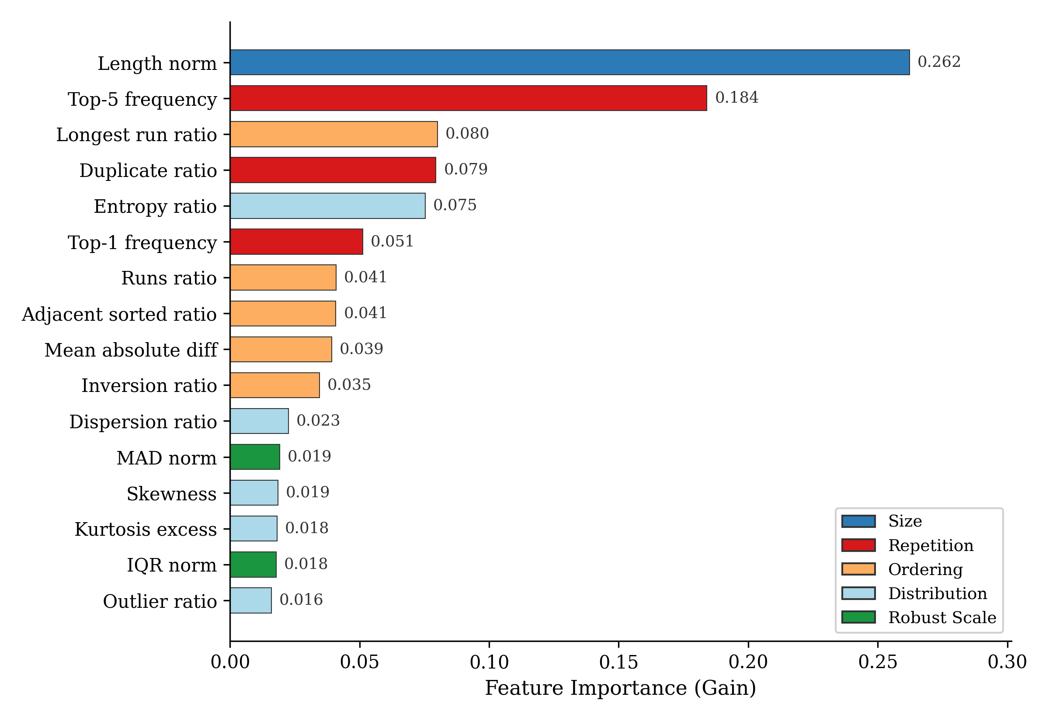
Figure 3.4: Feature Importance Ranked by XGBoost Gain
3.7.4 Confusion Matrix Analysis
Figure 3.5 shows the test set confusion matrix. Timsort achieves 94.5% recall, confirming that the model reliably identifies arrays where timsort is fastest. Heapsort recall is 63.8%, with the primary confusion being misclassification as introsort (33.2%). Introsort recall is 52.1%, with 43.8% of true introsort arrays misclassified as heapsort. This introsort-heapsort confusion pattern is consistent with the version 8 finding that these two algorithms are feature-indistinguishable (AUC 0.603).
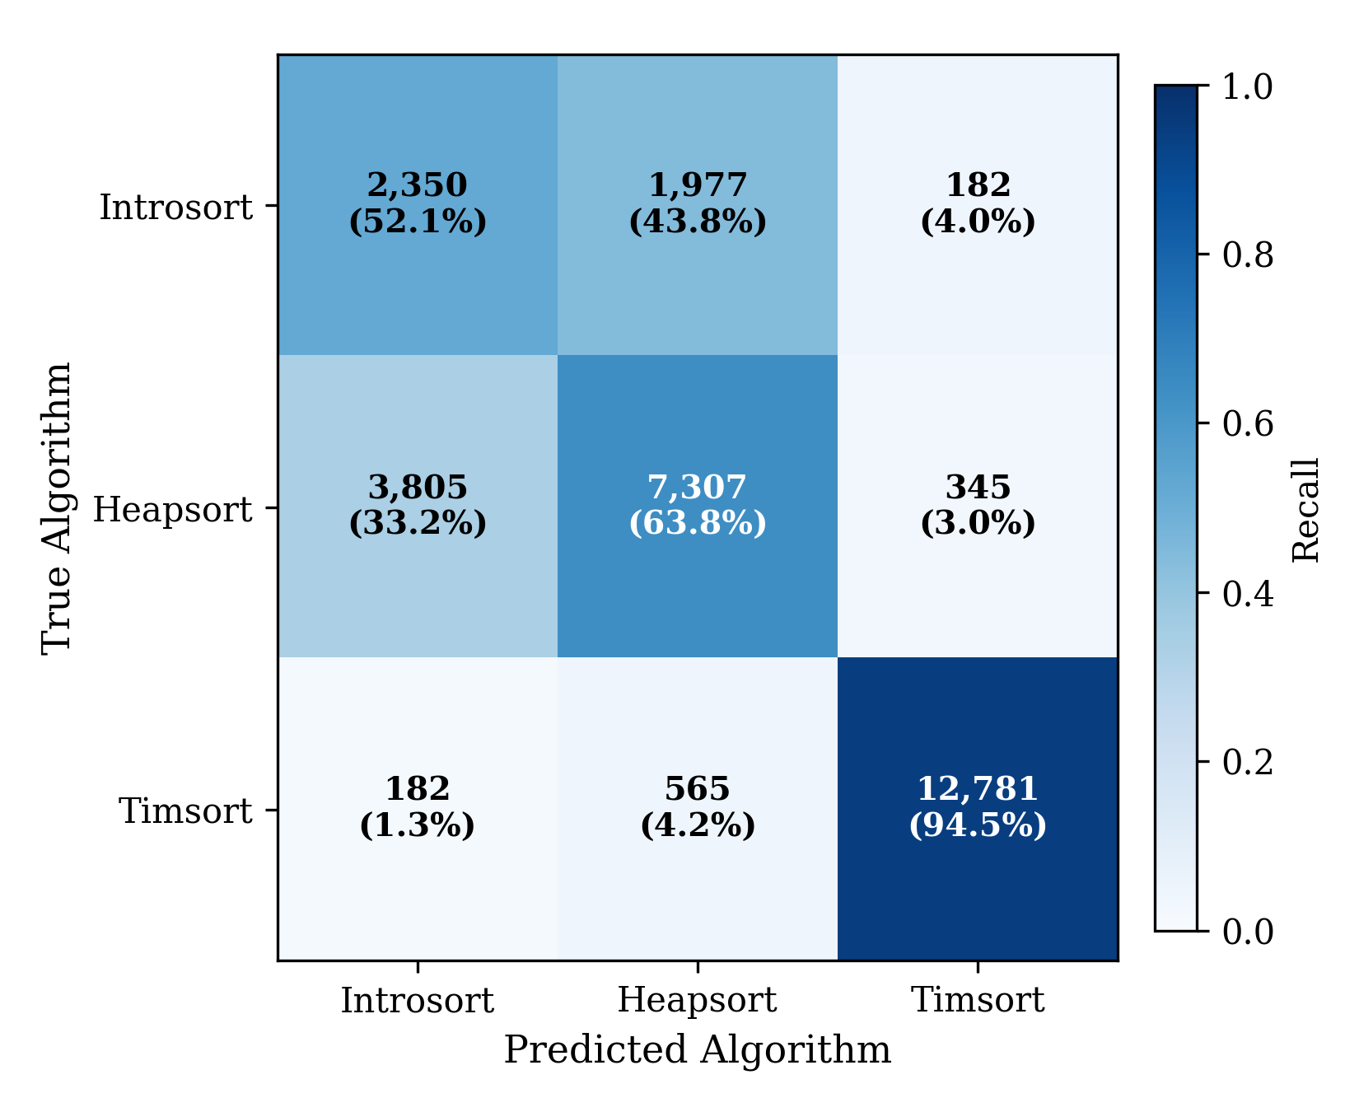
Figure 3.5: Confusion Matrix for the v5 Production Model on the Test Set
The concentration of errors in the introsort-heapsort region has important practical implications. Because these two algorithms have similar performance characteristics on random data, misclassifications between them carry low regret. A heapsort array misclassified as introsort incurs a small time penalty, typically under one microsecond. In contrast, misclassifying a timsort array as heapsort would incur a large penalty on structured data, and the model's 94.5% timsort recall minimises these costly errors.
3.8 F1 Channel-Flag Multi-Model
The channel-flag multi-model is a secondary experiment that investigates whether domain metadata can improve algorithm selection beyond structural features alone. Instead of training a single global classifier, this approach trains nine independent XGBoost models, one for each F1 telemetry channel, and routes incoming arrays to the appropriate model based on a channel flag. This architecture is related to mixture-of-experts but uses hard routing by metadata rather than learned gating.
The motivation for this experiment arises from the observation that different telemetry channels produce arrays with systematically different characteristics. Speed data contains smooth, monotonically increasing segments. RPM data exhibits rapid oscillations. DRS data is predominantly binary (0 or 1). These channel-specific patterns suggest that a specialised model trained on one channel type may learn sharper decision boundaries than a global model that must accommodate all channel types simultaneously.
3.8.1 Extended Algorithm Portfolio
The F1 experiment uses an expanded portfolio of five algorithms: quick_sort, introsort, merge_sort, heap_sort, and shell_sort. The additional algorithms become competitive on F1 data because the telemetry arrays have distinctive size and structure characteristics that differ from the broader dataset used in the main experiment. The class distribution varies by channel: some channels support all five algorithms while others only support two or three. Dynamic class sets address this by training each channel model only on algorithms with at least 20 samples in that channel, avoiding underfitting on rare classes.
3.8.2 Training and Evaluation
The training dataset consists of 13,215 rows balanced across five algorithms, drawn exclusively from F1 telemetry. Each model uses 17 features (the 16 structural features plus n_elements as a separate feature). Hyperparameters for each channel model are tuned independently using Optuna with a Tree-structured Parzen Estimator (TPE) sampler over 20 trials per channel. Per-channel tuning is essential because channels with different data characteristics require different regularisation strengths and tree depths.
Table 3.4 summarises the per-channel results after Optuna tuning.
Table 3.4: Per-Channel Model Performance After Optuna Tuning
Channel | Rows | Classes | Test Acc. | Algorithm Set
DRS | 1,803 | 3 | 76.4% | heap_sort, merge_sort, shell_sort
Distance | 2,014 | 5 | 54.1% | heap_sort, introsort, merge_sort, quick_sort, shell_sort
RPM | 1,951 | 5 | 44.0% | heap_sort, introsort, merge_sort, quick_sort, shell_sort
Speed | 2,607 | 5 | 42.6% | heap_sort, introsort, merge_sort, quick_sort, shell_sort
Throttle | 745 | 5 | 43.8% | heap_sort, introsort, merge_sort, quick_sort, shell_sort
X | 1,295 | 5 | 53.3% | heap_sort, introsort, merge_sort, quick_sort, shell_sort
Y | 1,256 | 5 | 51.3% | heap_sort, introsort, merge_sort, quick_sort, shell_sort
Z | 1,009 | 5 | 50.7% | heap_sort, introsort, merge_sort, quick_sort, shell_sort
nGear | 533 | 4 | 66.3% | heap_sort, introsort, merge_sort, shell_sort

The dynamic router achieves 86.0% accuracy on the non-strict evaluation, compared to 50.7% for the channel-level single best solver and 20.0% for the global single best solver. Under strict train-test separation, the routed accuracy is 48.9%. The gap between non-strict and strict evaluation indicates that the non-strict protocol allows information leakage between training and test sets, and the true generalisation performance lies between these bounds.
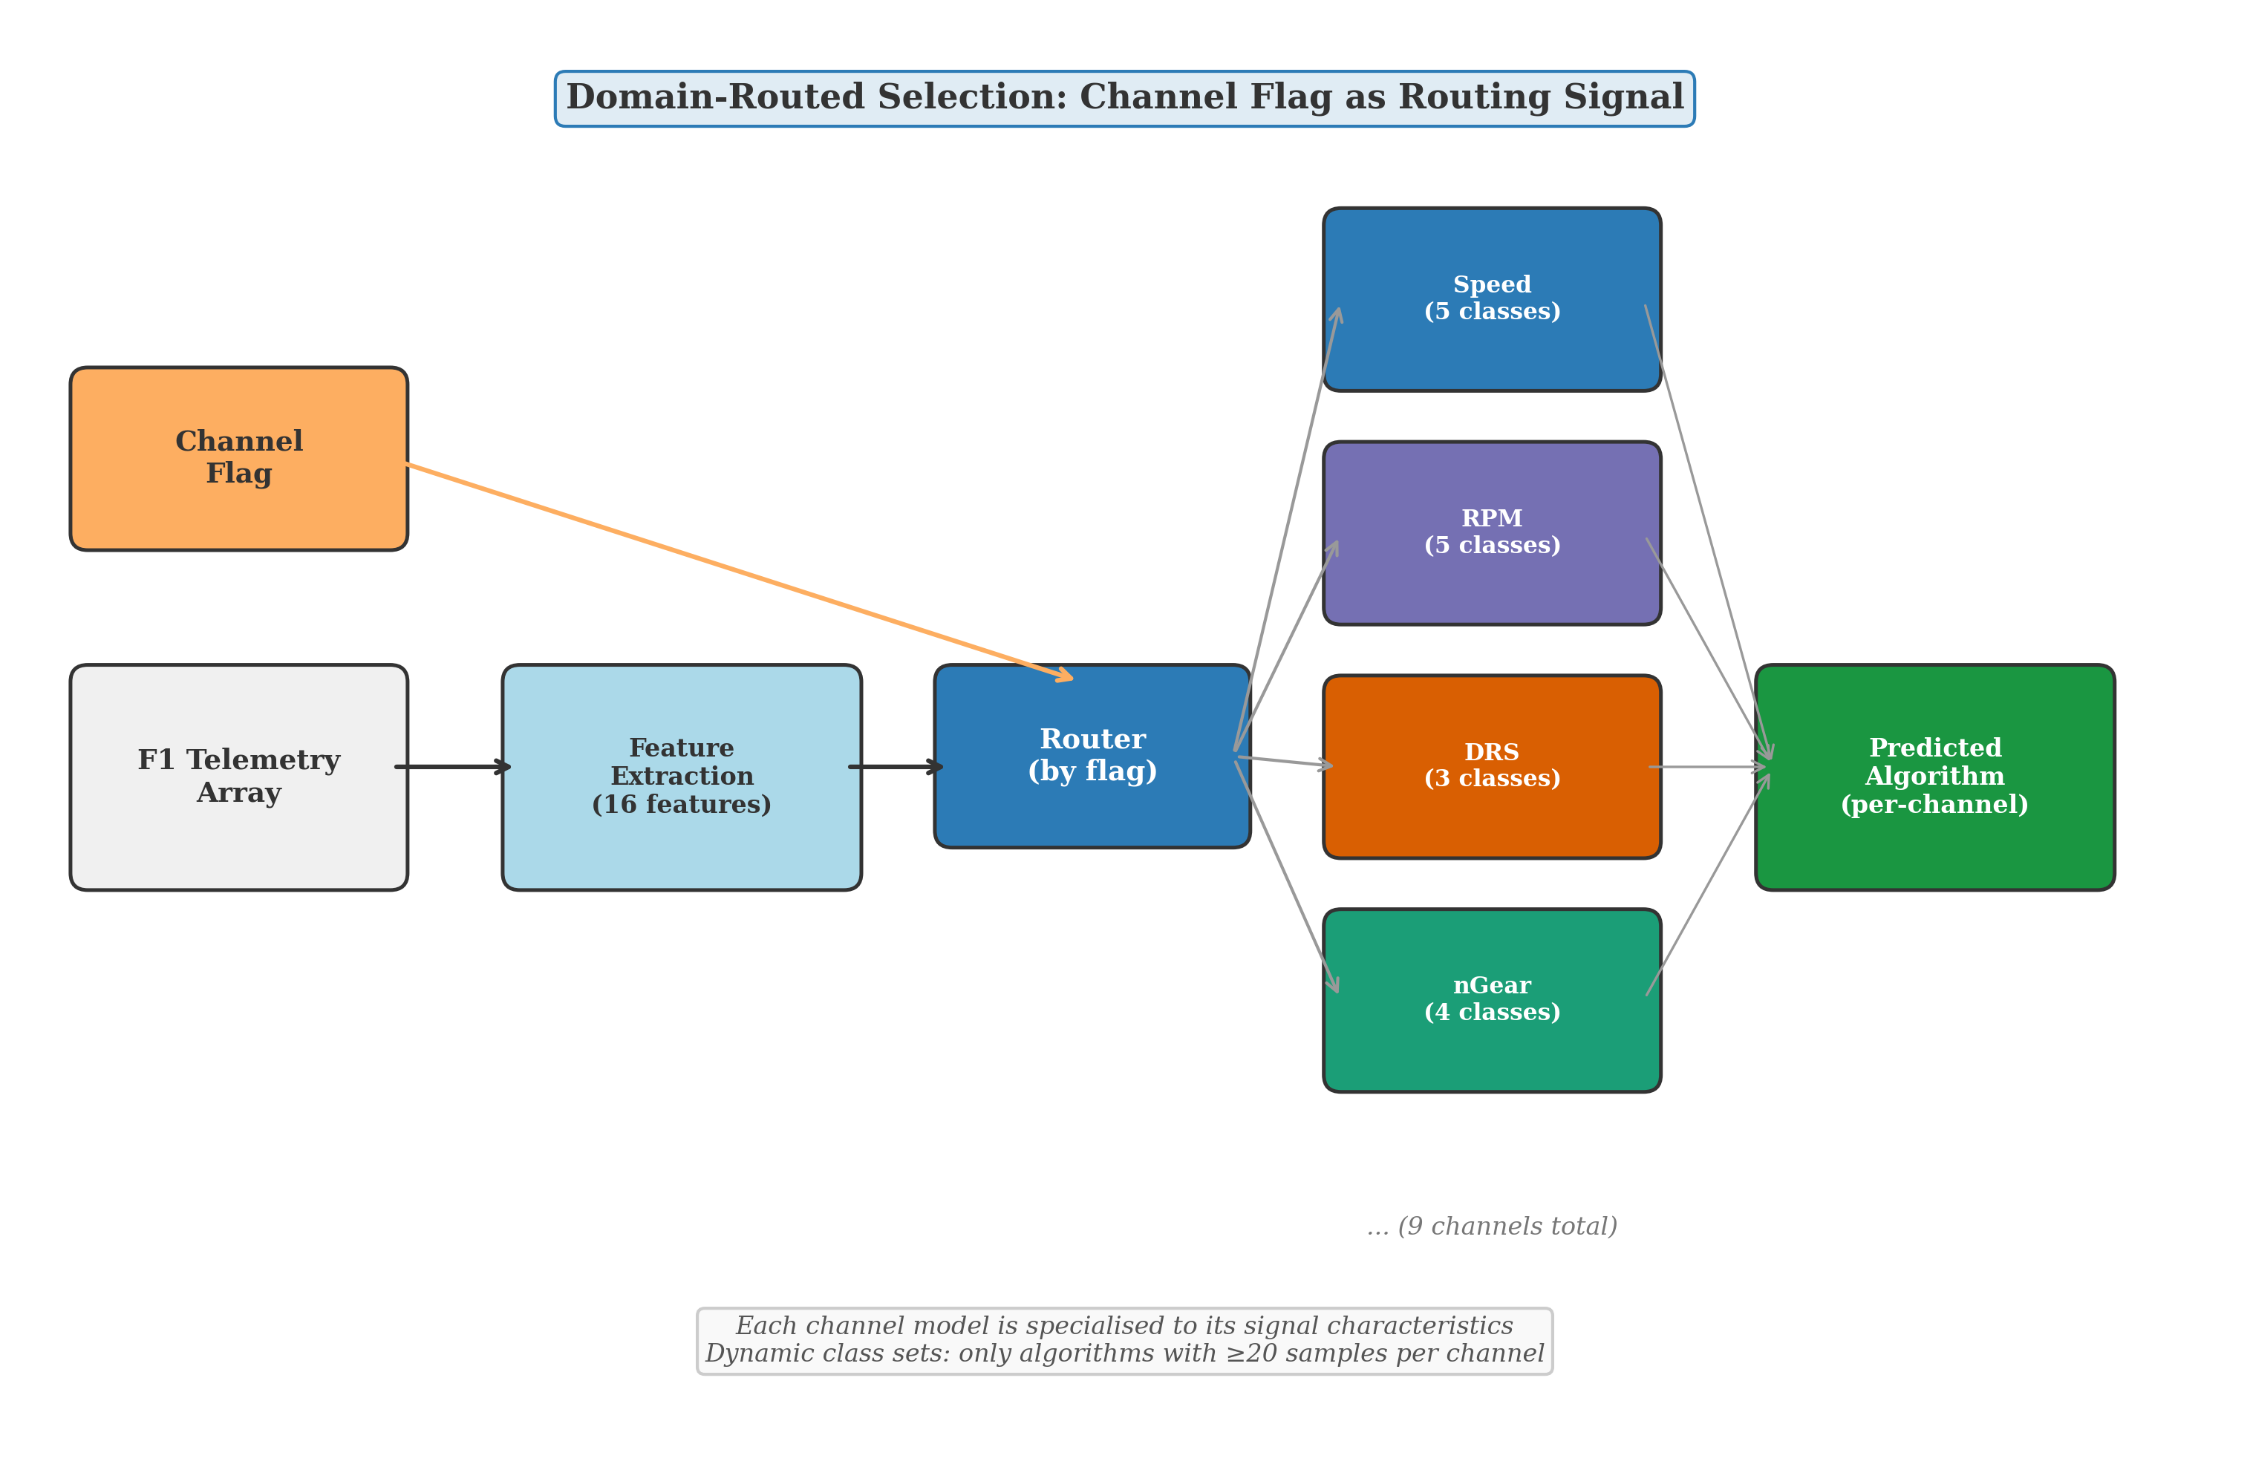
Figure 3.6: Channel-Flag Routing Architecture with Per-Channel Specialised Models
3.8.3 Deployment and Explainability
The trained channel models are exported to ONNX format for browser-based deployment using onnxmltools with opset 15. An interactive demonstration built with Svelte and WebSHAP provides client-side inference and SHAP-based explanations directly in the browser, requiring no server infrastructure. ONNX Runtime Web handles model inference, while WebSHAP computes feature attributions that show which structural properties drove each prediction. The demonstration supports two modes: a per-channel mode using the nine specialised models with routing, and a global mode using the v5 production model. Figure 3.7 shows the interactive interface.
[Image not found: F7_webshap_screenshot.png]
Figure 3.7: Interactive WebSHAP Demonstration with SHAP Feature Attributions
3.9 LinUCB Contextual Bandit
The second layer of the system architecture is a LinUCB contextual bandit (Li et al., 2010) designed for online adaptation. Contextual bandits are appropriate for this problem because algorithm selection is a stateless, single-step decision: given one array, select one algorithm, observe one reward (execution time), and make no sequential planning decisions. Full reinforcement learning would introduce unnecessary complexity for a problem with no temporal dependencies.
The bandit is designed to warm-start from the trained XGBoost model. The offline classifier's predicted probabilities initialise the bandit's prior beliefs about each algorithm's quality for a given feature vector. As runtime feedback accumulates, the bandit's upper confidence bound gradually overrides the offline prior, allowing adaptation to distribution shift without catastrophic forgetting of the offline training signal.
The exploration parameter alpha controls the balance between exploitation (selecting the algorithm the bandit believes is best) and exploration (trying alternatives to gather information). A higher alpha encourages more exploration, which is beneficial when the incoming data distribution differs substantially from the training distribution but incurs a short-term performance cost.
This component is presented as a designed architecture rather than a validated contribution. The bandit has been implemented and integrated into the system, but systematic evaluation under controlled distribution shift conditions has not been completed. Experimental validation of the bandit's convergence properties, regret bounds, and adaptation speed under different drift scenarios is identified as a priority for future work.
3.10 Evaluation Protocol
Evaluation of algorithm selection systems requires metrics beyond standard classification accuracy. A prediction that selects the second-best algorithm, which is 0.1% slower than the optimal choice, is fundamentally different from a prediction that selects an algorithm 50% slower. Standard accuracy treats both errors identically, while regret-based metrics capture the actual performance cost of each misclassification.
3.10.1 Classification Metrics
Standard classification metrics are reported for comparability with the machine learning literature. Top-1 accuracy measures the fraction of arrays where the predicted algorithm matches the true fastest. Balanced accuracy averages per-class recall to account for class imbalance. Per-class precision, recall, and F1 scores identify which algorithms the model struggles to predict. The confusion matrix reveals error concentration patterns, such as the introsort-heapsort confusion discussed in Section 3.7.4.
3.10.2 Regret Metrics
Regret metrics measure the practical cost of prediction errors in terms of execution time. Two reference points define the performance range. The Virtual Best Solver (VBS) is an oracle that always selects the truly fastest algorithm for each array, providing the theoretical lower bound on total execution time. The Single Best Solver (SBS) always uses the one algorithm with the lowest total time across all arrays (empirically, heapsort), providing the naive upper bound.
Regret = (T_model - T_VBS) / T_VBS (3.2)
Gap Closed = (T_SBS - T_model) / (T_SBS - T_VBS) (3.3)
Model regret (Equation 3.2) measures how much slower the model's selections are compared to the oracle, expressed as a percentage. Gap closed (Equation 3.3) measures the fraction of the possible improvement between the SBS and VBS that the model captures. A gap closed value of 100% would match the oracle, and 0% would equal the SBS baseline. The zero-regret percentage counts the fraction of arrays where the model's prediction incurs exactly zero additional cost, either because it selected the true fastest algorithm or because the selected algorithm is tied for fastest.
The production model achieves 93.1% gap closed with a mean per-instance regret of 0.23 microseconds. The zero-regret percentage is 89.6%, meaning that nearly nine out of ten predictions incur no performance penalty at all. Figure 3.8 shows the distribution of per-instance regret, confirming that the non-zero regrets are concentrated at very small values.
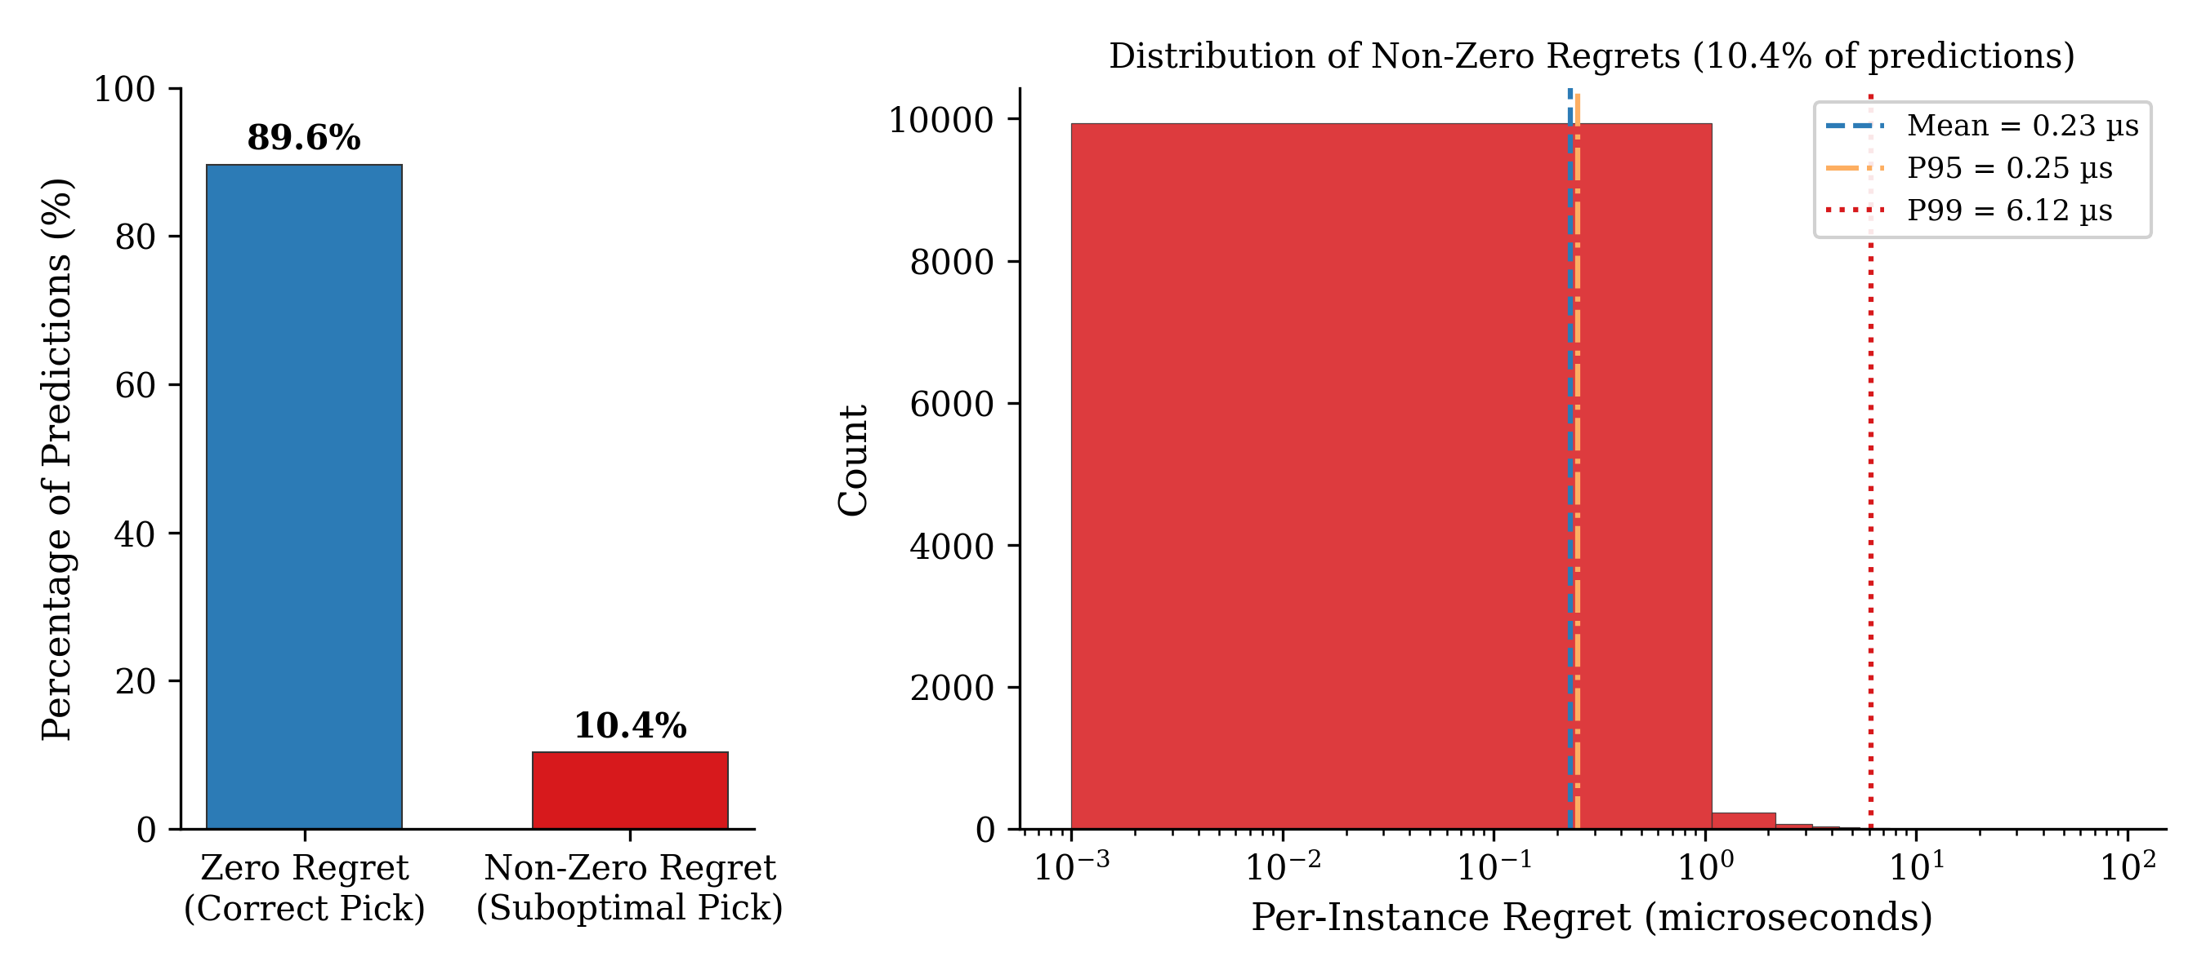
Figure 3.8: Distribution of Per-Instance Regret Showing 89.6% Zero-Regret Predictions
3.10.3 Baseline Comparisons
Two baselines contextualise the model's performance. The SBS baseline always selects heapsort, the empirically best single algorithm, achieving 0% gap closed by definition. Random selection uniformly samples from the three algorithms, providing the information-free baseline. The model's 93.1% gap closed demonstrates that the 16 structural features carry substantial predictive signal for algorithm selection.
3.10.4 Domain Holdout Evaluation
Leave-one-domain-out cross-validation assesses generalisation beyond memorising domain-specific patterns. In each fold, the model trains on four domains and is tested on the held-out fifth domain. Table 3.5 summarises the results.
Table 3.5: Leave-One-Domain-Out Cross-Validation Results
Held-Out Domain | Test Size | Accuracy | Balanced Acc. | Gap Closed | Zero-Regret
Crypto | 100,000 | 87.5% | 61.1% | 90.1% | 87.9%
Earthquake | 100,003 | 82.1% | 62.3% | 95.0% | 82.8%
F1 | 885,042 | 88.8% | 48.5% | 75.5% | 89.8%
Stock | 100,000 | 88.0% | 63.7% | 90.7% | 88.3%
Weather | 3,220 | 60.6% | 62.0% | 89.7% | 61.0%

The gap closed exceeds 75% across all five folds, with four of five folds exceeding 89%. The lowest gap closed (75.5%) occurs when F1 is held out, which is expected because F1 telemetry data constitutes the largest and most distinctive domain. The Weather fold shows the lowest accuracy (60.6%) but maintains 89.7% gap closed, indicating that even when classification accuracy is moderate, the model's errors tend to fall on low-regret instances. These results confirm that the model generalises across domains rather than memorising domain-specific shortcuts.
3.11 Reproducibility
All experiments use a fixed random seed of 42 for data splitting, model training, and undersampling. The feature extraction function is deterministic, producing identical outputs for identical inputs. Trained models are serialised in both XGBoost JSON format and ONNX format, and the training dataset is stored as a CSV file. The complete source code, model files, and training data are archived to enable exact replication of all reported results.
3.12 Summary
This chapter presented the methodology for adaptive sorting algorithm selection using machine learning. The system extracts 16 O(n) structural features from a numeric array and uses an XGBoost classifier to predict which of three C-level sorting algorithms will execute fastest. The production model, trained on 1.18 million real-world arrays from five domains, achieves 76.1% classification accuracy and 93.1% VBS-SBS gap closed, with 89.6% of predictions incurring zero regret. The model evolution through seven versions demonstrated that classification outperforms regression, real-world data outperforms synthetic data, and introsort and heapsort are feature-indistinguishable. A secondary experiment with F1 telemetry data showed that domain metadata routing can further improve selection accuracy within a specific domain. A LinUCB contextual bandit for online adaptation was designed but not validated, and is identified as future work.

