MAFIA WEB GAME
Live Audit Report
Every step played live, with screenshots · Backend audit · Sounds
Item | Detail
Prepared by | Usman (QA + DevOps), 22 October 2026
Code tested | Live design: Mafia-Frontend + Mafia-Backend (what mafia-frontend-lyart.vercel.app runs), plus this audit's fixes
Where | Local: client http://localhost:3000, server http://localhost:4000, Browser pane
GitHub | Branch Usman on ahmedxali84/Mafia-Techflix- (main not touched)
Result | 26 live steps passed · 82/82 automated tests · 3 backend bugs fixed · no role leaks

Every screen of the game was opened and used for real in the browser: the home page, menu, career, help, the lobby (including real network players joining and dropping), a full 7-player game with the Jester and the Thief from role reveal to victory, play again and leave. Each step shows the screenshot taken at that moment, what was done, what should happen and what actually happened.

1. Summary
Area | What was checked | Result
Menus | Home, Play page, wrong code, Career stats, How to play, mute, copy link | Pass
Lobby | Live player list, network join, 10 s drop, bots add/remove, role mix, start rules | Pass
Game | Role reveal, night picks + teammate marks, kill cinematic, morning report | Pass
Day | Town chat, Mafia channel, chat closed at night, voting, change vote, verdict | Pass
End | Victory screen, full roster, match timeline, play again, leave | Pass
Secrecy | Only own role + Mafia teammate + dead roles visible (live) and 2 full audited games (tests) | Pass
Robustness | Refresh mid-game keeps the seat; room deleted when only bots remain | Pass
Backend audit | 2 room bugs that broke games + 1 hardening fix | Fixed
Sounds | Kill, vote-out, save and every button click | Pass

2. Live walkthrough: menus
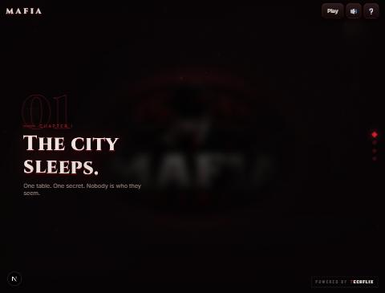 | Step 1. Home page  What I did: Opened http://localhost:3000.  Expected: The "01 · Chapter I · The city sleeps" intro with the top bar (Play, sound, help) and the Powered by TECHFLIX badge.  Result: Shown exactly like the live Vercel site. The role cards fly in as you scroll (scroll-driven animation).  ✔ PASS

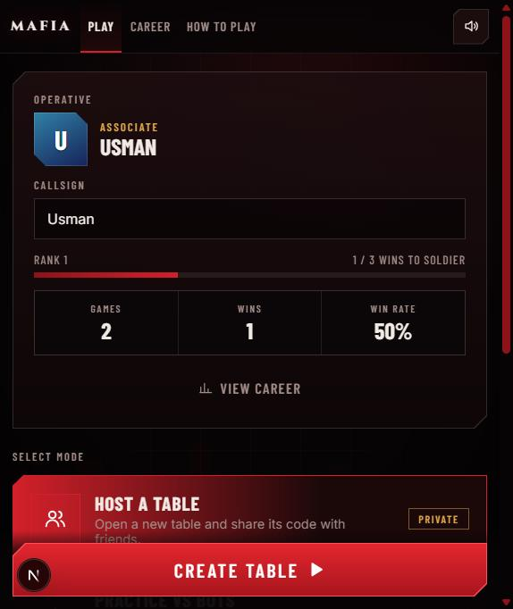 | Step 2. Play page (Operative card)  What I did: Clicked Play. The logo zooms in, then the menu opens.  Expected: Callsign, rank and stats, plus 3 modes: Host a table, Practice vs bots, Join with code.  Result: Shows USMAN, Rank 1, 2 games / 1 win / 50% kept from earlier games. Note: the zoom only finishes while the window is visible; it froze while the Claude window was hidden and continued when it came back (browser behaviour, not a bug).  ✔ PASS

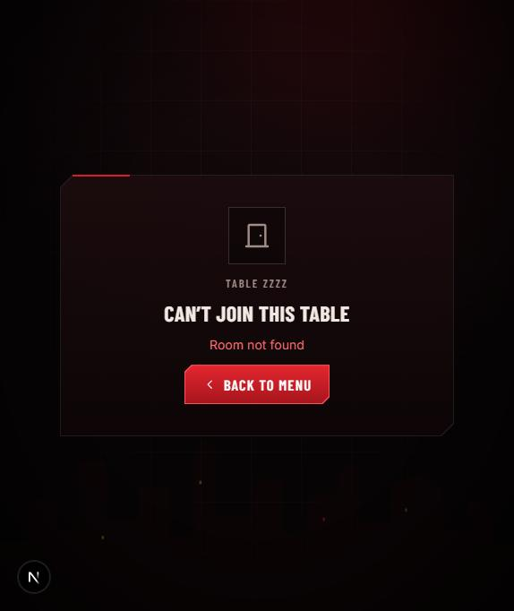 | Step 3. Join with a wrong code  What I did: Join with code → typed ZZZZ → Enter.  Expected: A clear error, not a crash or an empty room.  Result: "Can't join this table · Room not found" with a Back to menu button.  ✔ PASS

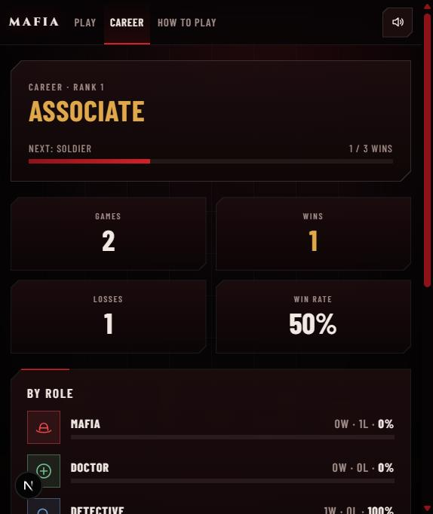 | Step 4. Career page  What I did: Opened Career from the top menu.  Expected: Rank, wins/losses and a record per role.  Result: Associate (Rank 1), 2 games, 1 win, 1 loss, 50%, per-role record (Detective 1W, Mafia 1L).  ✔ PASS

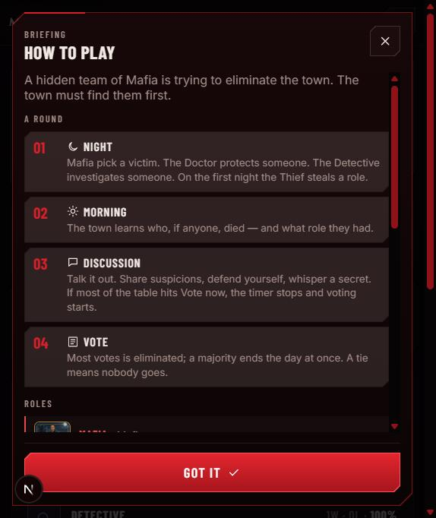 | Step 5. How to play  What I did: Clicked How to play, then Got it.  Expected: Rules for each phase and role, matching the server.  Result: Night / Morning / Discussion / Vote explained, including Vote now and the Thief stealing on the first night. Matches the backend rules.  ✔ PASS

 | Step 6. Mute button  What I did: Clicked the speaker in the top bar, then again.  Expected: Sound turns off and stays off after a refresh; second click turns it back on.  Result: Label changed to "Unmute sounds" with a crossed speaker, and mafia_muted=1 was saved. Turned back on afterwards.  ✔ PASS

3. Live walkthrough: lobby
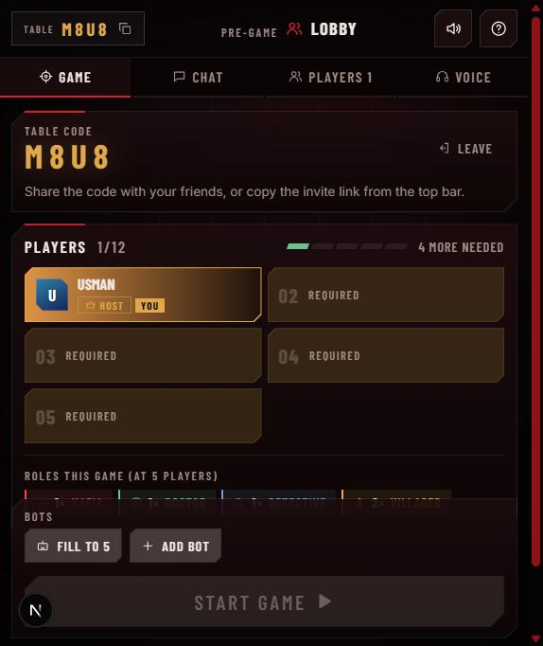 | Step 7. Host a table  What I did: Host a table → Create table.  Expected: A 4-letter code, me as host, Start blocked until 5 players.  Result: Table M8U8, Usman HOST · YOU, 1/12, "4 more needed", Start game disabled.  ✔ PASS

 | Step 8. Copy invite link  What I did: Clicked the copy icon next to the table code.  Expected: The invite link is copied and the icon confirms it.  Result: Icon turned into ✓ and the link was copied to the clipboard.  ✔ PASS

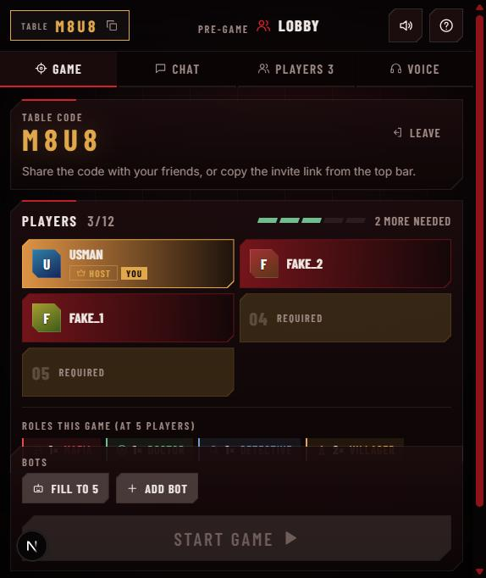 | Step 9. Real players join over the network  What I did: Ran node tests/addBots.js M8U8 2 (2 players that connect exactly like a friend's browser).  Expected: They appear in the list instantly for everyone.  Result: Fake_1 and Fake_2 joined live: 3/12, "2 more needed".  ✔ PASS

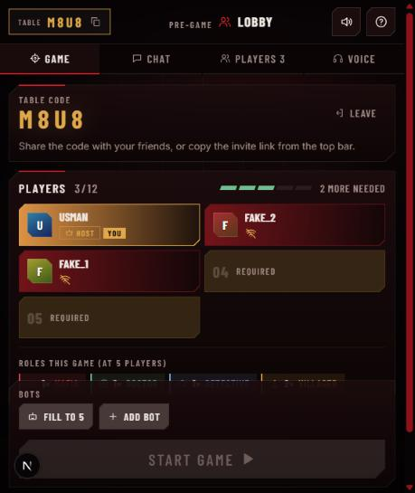 | Step 10. A player drops  What I did: Closed those 2 connections.  Expected: They show as offline first (a refresh gets the seat back).  Result: Offline icon shown on both cards.  ✔ PASS

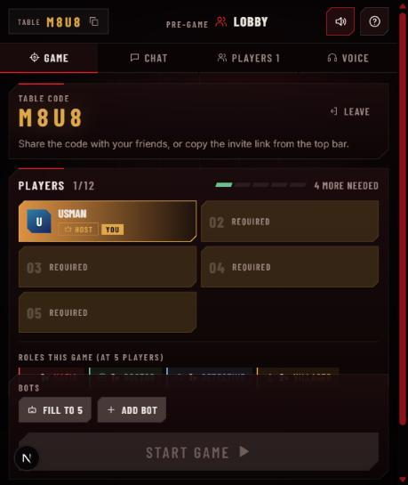 | Step 11. 10-second lobby grace  What I did: Waited 10 seconds.  Expected: Players who don't come back are removed.  Result: Both removed after ~10 s; back to 1/12.  ✔ PASS

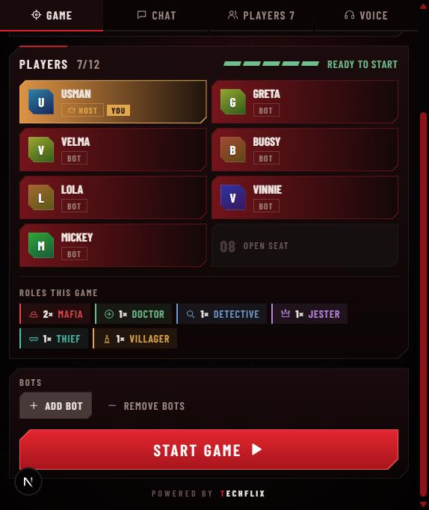 | Step 12. Bots and the role mix  What I did: Fill to 5, Add bot ×2 (and tested Remove bots in between: back to 1/12).  Expected: At 7 players the extra roles join: Jester and Thief.  Result: 7/12 "Ready to start". Roles: 2 Mafia, Doctor, Detective, Jester, Thief, 1 Villager (matches the server rules).  ✔ PASS

4. Live walkthrough: the game
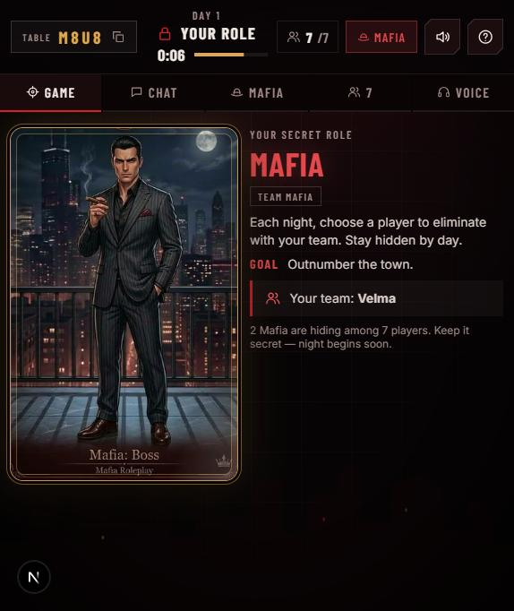 | Step 13. Role reveal  What I did: Start game.  Expected: A private role card; Mafia also see their team.  Result: MAFIA card, "Your team: Velma". A separate MAFIA chat tab appeared (2 Mafia).  ✔ PASS

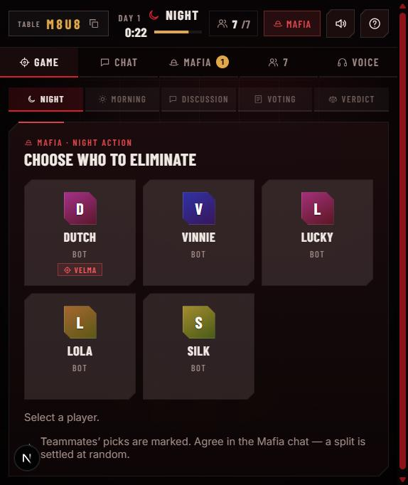 | Step 14. Night: choose who to eliminate  What I did: Opened the night screen.  Expected: Only non-Mafia targets; the teammate's pick is marked.  Result: Velma (teammate) not in the list; her pick on Dutch is marked. Picked Dutch; the night ended once everyone acted.  ✔ PASS

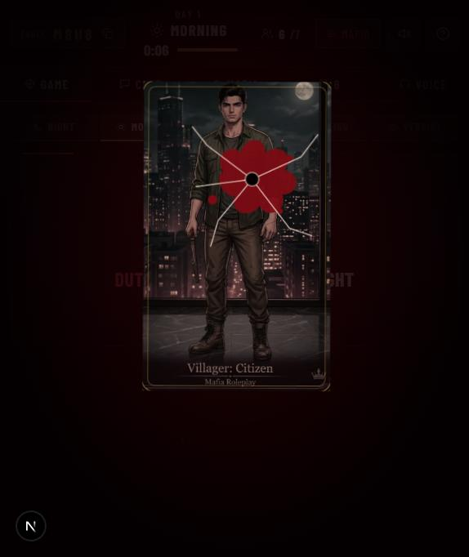 | Step 15. Kill cinematic + sounds  What I did: Watched the morning.  Expected: Card shot, cracked, torn, with sounds timed to it.  Result: Bullet hole, cracks and blood on Dutch's Villager card. Sounds measured: gunshot 0.45 s, crack 0.5 s, tear 1.05 s, bell 1.2 s.  ✔ PASS

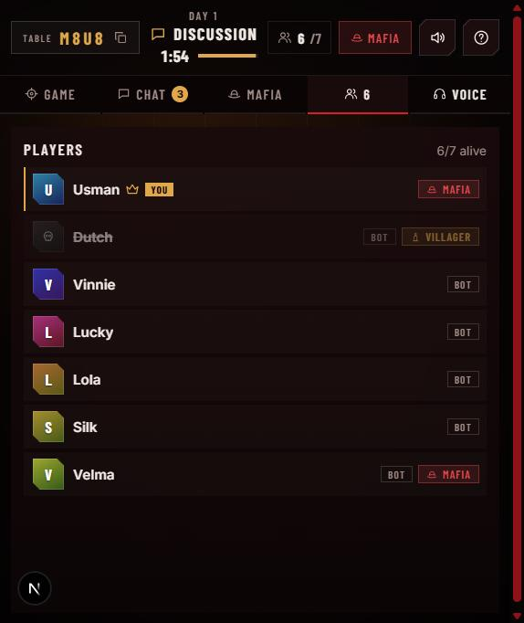 | Step 16. Who can see which role  What I did: Opened the Players tab.  Expected: Only my role, my Mafia teammate and dead players' roles.  Result: Usman MAFIA, Velma MAFIA, Dutch (dead) VILLAGER; every other living role hidden. No leak.  ✔ PASS

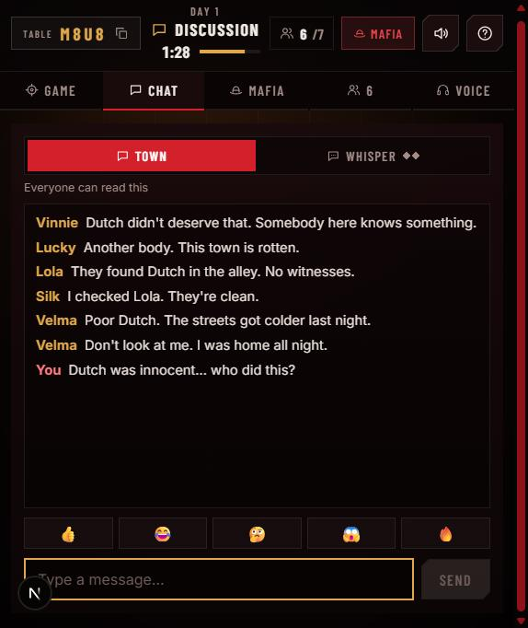 | Step 17. Town chat (day)  What I did: Sent "Dutch was innocent… who did this?".  Expected: Everyone can read it; bots react.  Result: Message shown as "You" among bot reactions (Silk claimed Detective: "I checked Lola. They're clean").  ✔ PASS

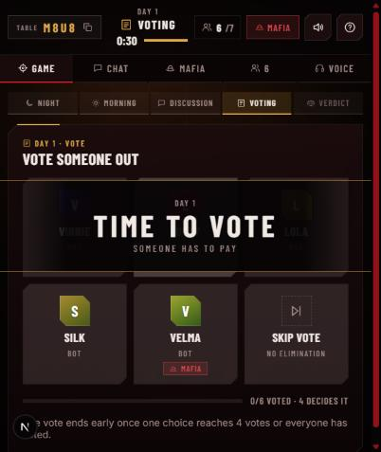 | Step 18. Voting  What I did: Discussion ended (Vote now majority) → voting.  Expected: "Time to vote" with a 30 s timer and the majority needed.  Result: Splash shown, "4 decides it", Skip vote available. Voted for Silk.  ✔ PASS

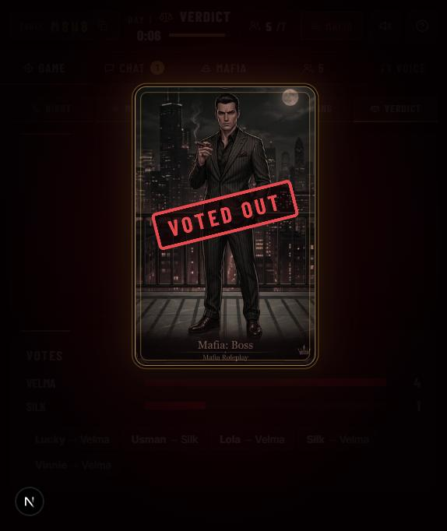 | Step 19. Verdict + voted-out cinematic  What I did: Waited for the result.  Expected: The vote ends as soon as it is decided; stamp animation.  Result: Velma voted out 4–1, the full vote log is shown, "VOTED OUT" stamp (stamp, whoosh, thud sounds).  ✔ PASS

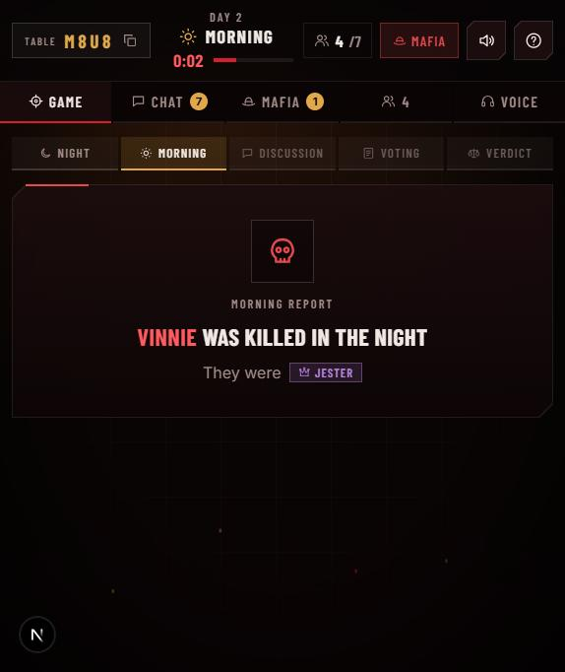 | Step 20. Refresh in the middle of the game  What I did: Reloaded the page.  Expected: Same seat, same role, chat history kept.  Result: Back in Day 2 as Mafia with all messages. Morning report: "Vinnie was killed · Jester".  ✔ PASS

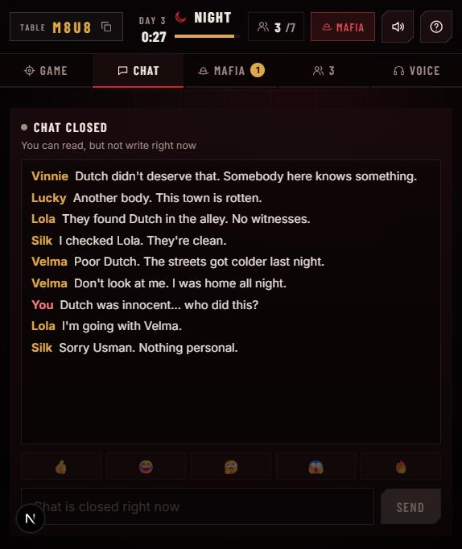 | Step 21. Town chat closed at night  What I did: Opened Chat at night.  Expected: Town chat cannot be written at night.  Result: "Chat closed · You can read, but not write right now".  ✔ PASS

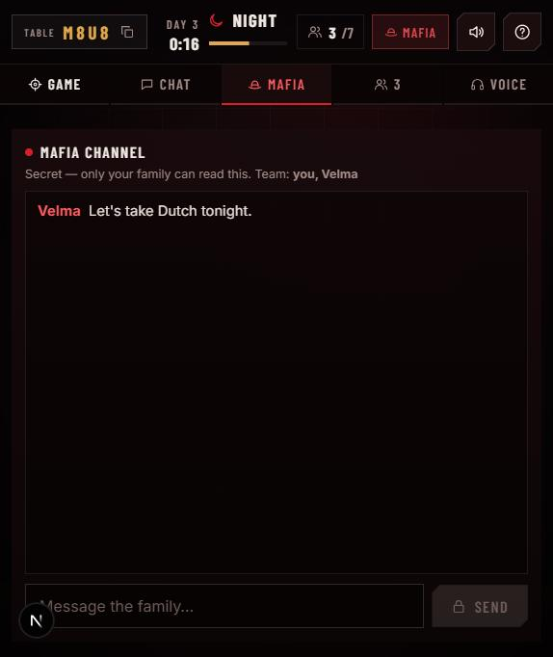 | Step 22. Mafia channel  What I did: Opened the MAFIA tab.  Expected: Secret channel for the family only.  Result: "Secret — only your family can read this. Team: you, Velma", with Velma's night message.  ✔ PASS

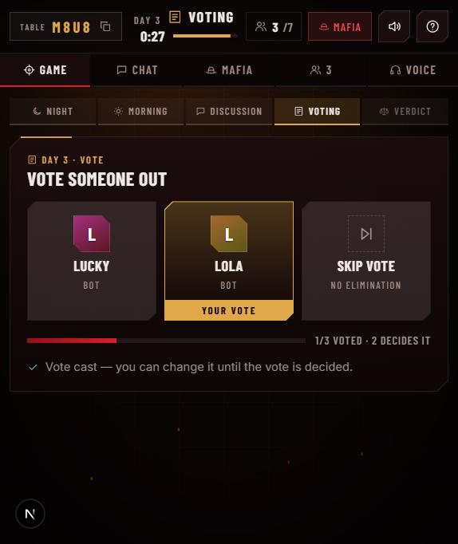 | Step 23. Change your vote  What I did: Day 3 vote, then picked a different player.  Expected: A vote can be changed until it is decided.  Result: "Vote cast — you can change it until the vote is decided"; the vote ended in a tie (nobody out).  ✔ PASS

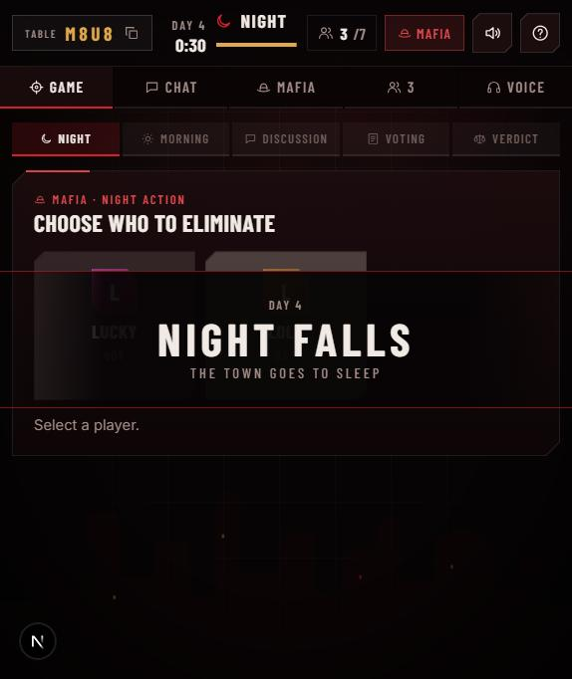 | Step 24. Night falls (day 4)  What I did: Next night.  Expected: Phase splash and the night action again.  Result: "Day 4 · Night falls". Made the last kill.  ✔ PASS

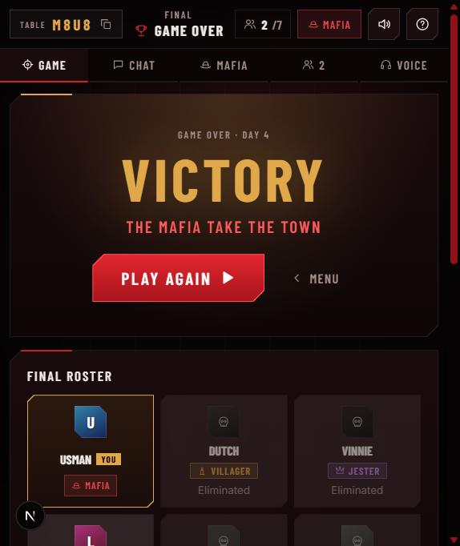 | Step 25. Game over  What I did: Waited for the morning.  Expected: Mafia equal the town → Mafia win.  Result: "VICTORY · The Mafia take the town", Play again and Menu buttons.  ✔ PASS

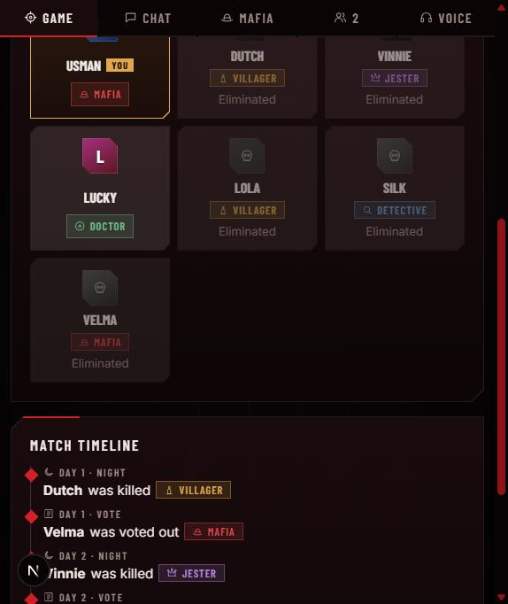 | Step 26. Final roster + match timeline  What I did: Scrolled down.  Expected: All roles revealed; the story of the game.  Result: Every role shown (Doctor, Detective, Jester, Villagers, Mafia); timeline lists each kill and vote.  ✔ PASS

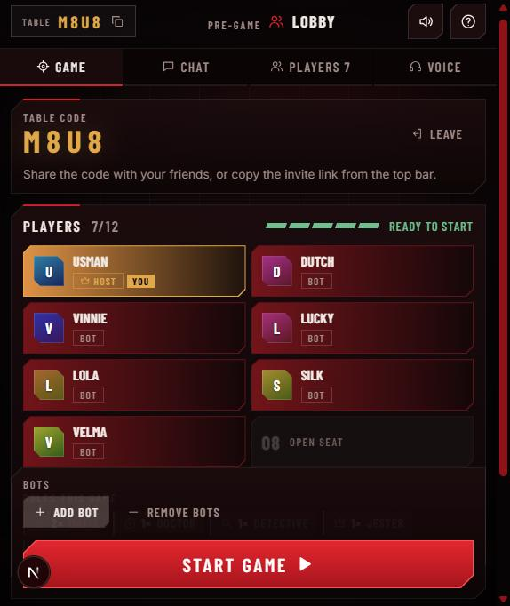 | Step 27. Play again  What I did: Clicked Play again.  Expected: Back to the lobby with the same table.  Result: 7/12 "Ready to start", roles reset.  ✔ PASS

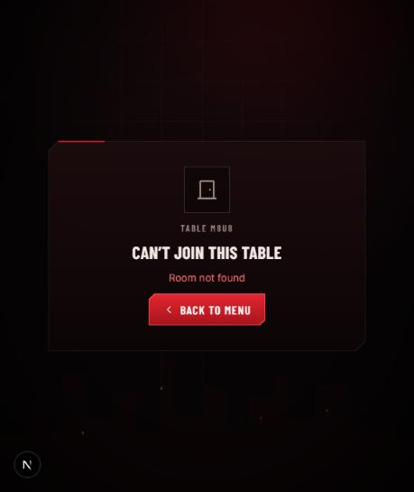 | Step 28. Leave  What I did: Leave, then opened /room/M8U8 again.  Expected: With only bots left, the room is deleted.  Result: "Can't join this table · Room not found".  ✔ PASS

5. Automated tests
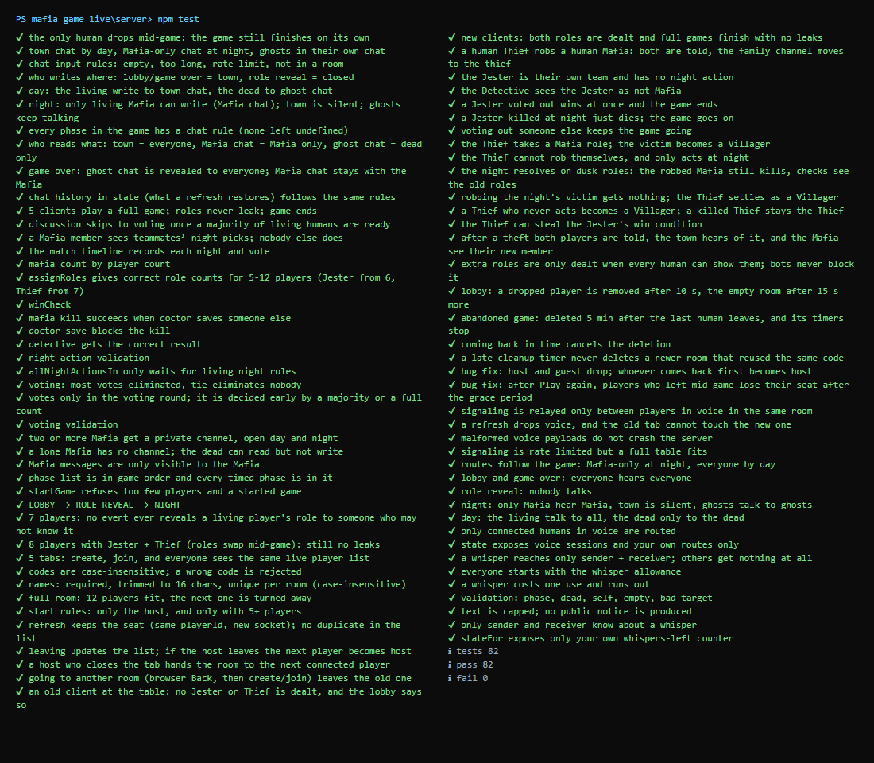
cd server && npm test: 82 tests, 82 pass, 0 fail. They include the new audit tests: timeouts.test.js, abandon.e2e.test.js, and the role-leak audit for Jester + Thief.

6. Backend audit
# | Area | Finding | Severity | Status
1 | Rooms | Host and a guest drop; the host comes back but the guest keeps the host title → nobody can Start / Play again / Add bot. Room stuck. | High | Fixed
2 | Rooms | A player who left mid-game kept the seat after Play again and was dealt a role (seen: Mafia) on autopilot. | High | Fixed
3 | Timeouts | A late cleanup timer could delete a newer room that reused the same code; rejoining didn't cancel deletion. | Low | Fixed
— | Role leaks | Every event of full games audited (classic + Jester/Thief, roles swapping mid-game). Bots only use public info. | — | Pass
— | Timeouts | Empty lobby gone after 25 s; abandoned game deleted after 5 min with timers stopped; a game whose only human leaves still finishes. | — | Pass

Not code, but important: free Render sleeps after ~15 min idle (run node tests/checkServer.js <url> before a demo), and games live in memory, so a restart or redeploy ends running games.

7. Sounds added
Moment | Sounds (timed to the animation) | Checked live
Night kill | Gunshot → glass crack → card tearing → death bell | 0.45 / 0.5 / 1.05 / 1.2 s
Voted out | Stamp → whoosh as the card drops → thud | 0.56 / 1.35 / 2.4 s
Doctor save | Shield ring + rising healing shimmer | No save happened live; same engine
Every button | Click on all buttons, tabs and menu links; no double sound | 1 tone per click, measured

8. Not shown live
- Voice chat: the microphone is blocked inside the preview pane, so it was not tested with real audio. The app correctly shows "Microphone permission was denied". Voice routing is covered by the automated voice tests.
- Whispers and ghost chat: covered by automated tests (whispers*.test.js, chat.e2e.test.js); not repeated in this walkthrough.
- Doctor save sound: no save happened in these games.

