MAFIA WEB GAME
Complete Work Record: Usman
QA + DevOps + Chat/Voice · Weeks 1–8 · 18–25 October 2026
Item | Detail
Team member | Usman (Backend: QA + DevOps + Chat/Voice)
Repository | github.com/ahmedxali84/Mafia-Techflix-
Branch | Usman (latest 95f15fd) · main untouched
Result | All 8 weeks of Usman's tasks done (deploy steps by you) · 92/92 tests · 11 bugs found, 10 fixed
Also delivered | Short video Usman_Work_Summary.mp4 (82 s) · PDF/Word audit reports · live audit PDF

This document records everything that was done: every request, what was built or fixed, how it was tested, the screenshots taken along the way, and what is still left to do.

1. Summary in numbers
What | Number
Weeks of Usman's tasks completed | 8 of 8 (deploy itself and Discord link are yours to do)
Automated tests passing | 92 / 92 (was 29 at the start)
Bugs found | 11 (10 fixed, 1 open in old client code)
New features | Discord button, feedback form, kill/save/click sounds, debug fake players, server wake-up check
Live walkthrough | 26 steps, all passed, each with a screenshot
Reports | 2 PDFs, 3 Word files, 1 video, docs/DEPLOY, TESTING_CHECKLIST, BUG_LIST

2. Usman's tasks (from the Team Task Assignment PDF)
Week | Task | Status | What was done
1 | First deployment: backend Render, frontend Vercel | By you | You deployed. Added render.yaml, docs/DEPLOY.md, tests/checkServer.js
2 | 5-tab room test + Render deploy | Done | 9 room tests (create/join, wrong code, full room 12, host hand-over, refresh); live 2-player join/drop test
3 | Check no role leaks | Done | Every event of full games audited, classic + Jester/Thief; planted leak caught
4 | Full game test, bug list, debug mode (5 fake players) | Done | tests/addBots.js, bug list, played many full games
5 | Public chat (day), Mafia chat (night), dead chat | Done | 9 chat tests; checked live: town, Mafia channel, chat closed at night, ghost chat
6 | Testing on different phones and browsers | Partly | Phone 375 px, tablet 768 px, desktop; real Chrome + Edge. Safari/Firefox need a real device
7 | Discord link button, then LiveKit/Agora voice (if time) | Done | Discord button in 4 places. LiveKit/Agora skipped: the game already has its own voice chat
8 | Feedback form, final checklist, final deployment, custom domain (optional) | Done | Feedback form + server; final launch checklist; custom-domain steps. Final redeploy is yours

3. Timeline: every request and what was done

18 Oct: start servers, Weeks 1–4
- Read the task PDF, started the game servers (backend :4000, frontend :3000).
- Wrote room tests (Week 2), the role-leak audit (Week 3), fake-player script + server check + Render/Vercel config + docs (Weeks 1–4).
- Found and fixed a room bug (one socket stuck in two rooms) and a flaky voice test.
- Made the Week 1–4 audit Word file; installed GitHub CLI, Pandoc, Poppler, LibreOffice; signed you in to GitHub.
- Pushed to a new branch Usman (PR #8 to main closed, as you asked: nothing goes to main).
- Ran a live demo (2 full games) and made the work-report PDF with screenshots.
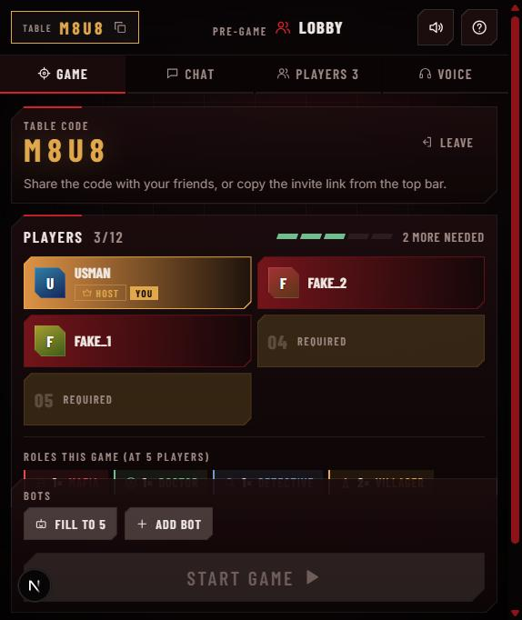  Week 2: players join live | 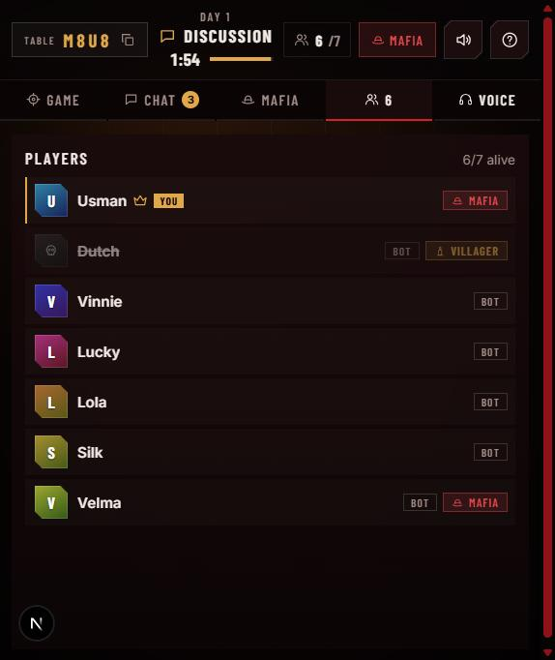  Week 3: roles hidden | 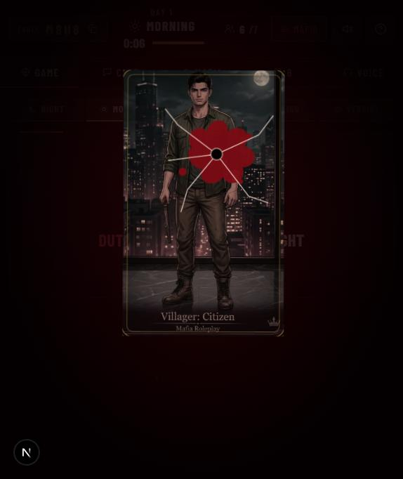  Week 4: full game

21 Oct: pull main, Week 5, live design
- Merged the new main work (Mubashir's phase list) into your branch.
- Week 5: chat tests (who can write/read each chat in every phase, refresh history, spam/length limits).
- Found the live Vercel site runs newer code (repos Mafia-Frontend + Mafia-Backend) and was pointing at localhost:4000.
- With your approval, copied the live code into a separate folder mafia game live (branch Usman-live-design), kept all QA tests, re-added 2 lost fixes. 74/74 tests.
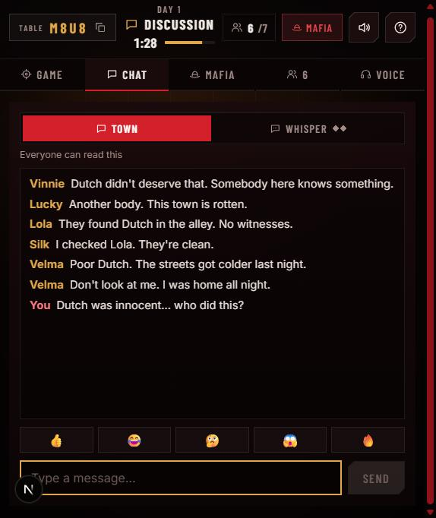  Town chat | 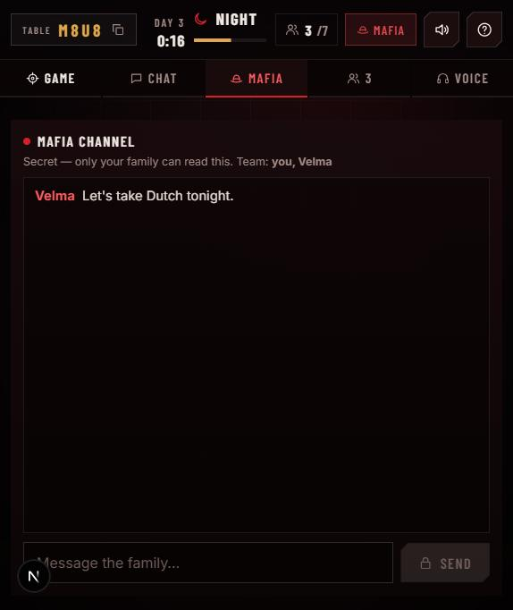  Mafia channel | 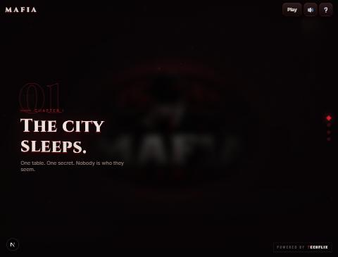  Live design locally

22 Oct: backend audit, sounds, live walkthrough
- Audited server timeouts, role leaks and room logic: fixed a stuck-host bug, a ghost-seat bug and a cleanup bug; no leaks (including Jester/Thief).
- Added sounds: kill (gunshot, crack, tear, bell), vote-out (stamp, whoosh, thud), Doctor save, every button click. Measured that each sound matches its animation.
- Walked through 26 steps live in the browser and made the live audit PDF. Pushed everything to the Usman branch.
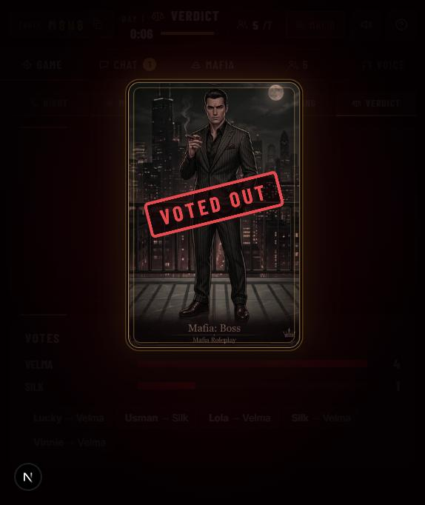  Vote-out animation + sounds | 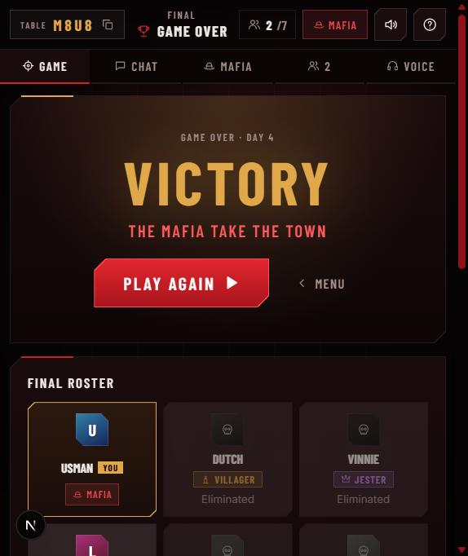  Victory | 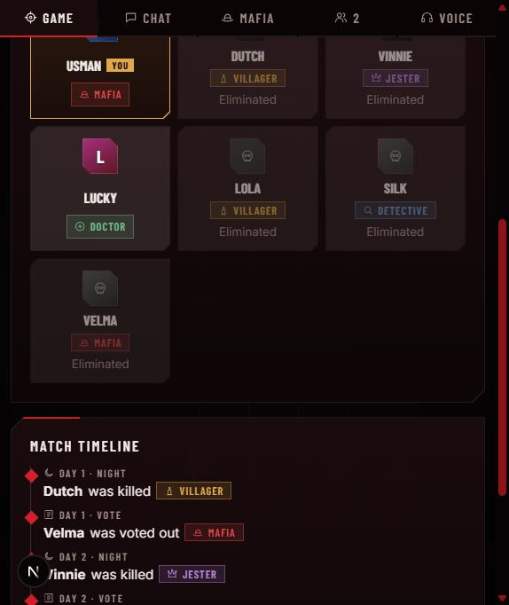  Roster + timeline

25 Oct: pull everything, Weeks 6–8, video + this file
- Pulled main, every branch and both live repos. Only Hiban's branch had unmerged work: a fix for a server crash (one bad message ended every game). Ported it onto the current code with his tests.
- Week 7: Discord button (menu, home, voice panel, game over). Link comes from NEXT_PUBLIC_DISCORD_URL; you will send it later.
- Week 8: feedback form with a protected server endpoint and spam limit.
- Week 6: phone/tablet/Chrome/Edge checks; fixed a phone menu overflow caused by the new buttons.
- Final checklist, deploy and custom-domain steps; 92/92 tests; production build passes; pushed; made this file and the video.
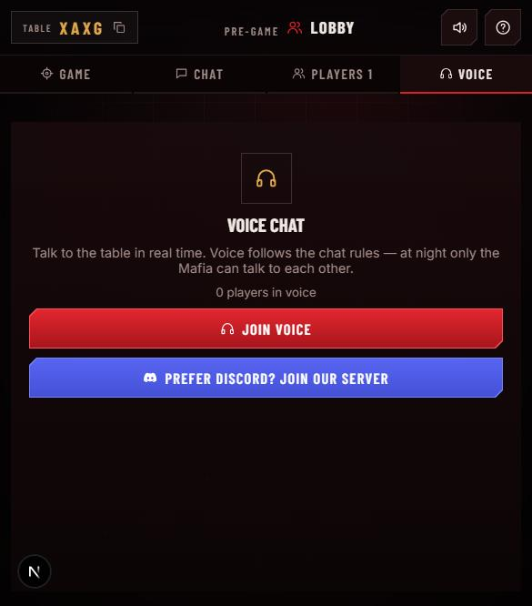  Discord button | 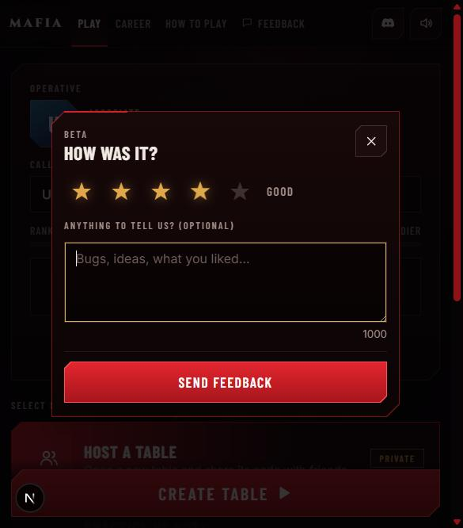  Feedback form | 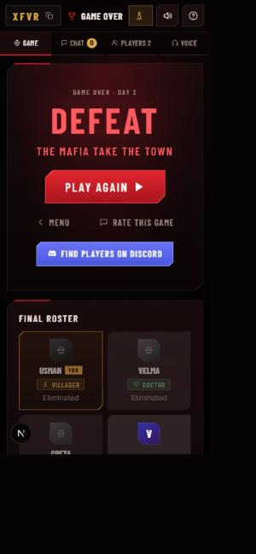  Phone: game over

4. All bugs found
# | Severity | Bug | Where | Status
1 | Low | A socket joining a second room stayed as a "ghost" host in the first | server/index.js | Fixed
2 | Low | leave_room from an old tab removed a seat a newer tab had taken | server/index.js | Fixed
3 | Medium | Voice test failed ~3 in 4 runs under load (test timing) | tests | Fixed
4 | Low | Phase splash never unmounts after a very fast phase | old client | Open
5 | Low | README wrongly said production disables bots | docs | Fixed
6 | High | Host + guest drop, host returns: room stuck without a usable host | server/rooms.js | Fixed
7 | High | Player who left kept the seat after Play again and was dealt a role | server | Fixed
8 | Low | Late cleanup timer could delete a newer room with the same code | server/rooms.js | Fixed
9 | Critical | A null payload crashed the whole server (Hiban's finding, ported) | server/index.js | Fixed
10 | Medium | Phone menu overflow after adding Feedback + Discord | client menu | Fixed
11 | Low | Feedback dialog inherited menu button styles | client | Fixed

5. New features
Feature | What it does | Where
Discord button | Opens your Discord invite in a new tab. Only real discord.gg / discord.com/invite links; hidden until the link is set | Menu, home, voice panel, game over
Feedback form | 1–5 stars + comment; 5 per visitor per 10 min; saved on the server; team reads it with FEEDBACK_TOKEN | Menu "Feedback", game over "Rate this game"
Sounds | Kill, vote-out, Doctor save, every button click; timed to the animations | All game screens
Fake players | node tests/addBots.js CODE 5 adds network players that really play | Testing
Server check | node tests/checkServer.js URL wakes the free Render server before a demo | Deploy
Crash protection | Every client event goes through a safe wrapper; bad input gets an error, not a crash | Server
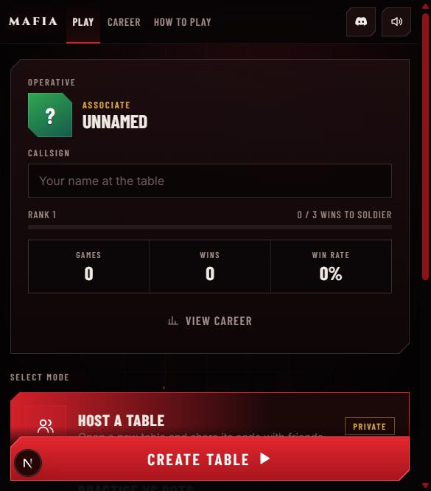  Discord icon in the menu | 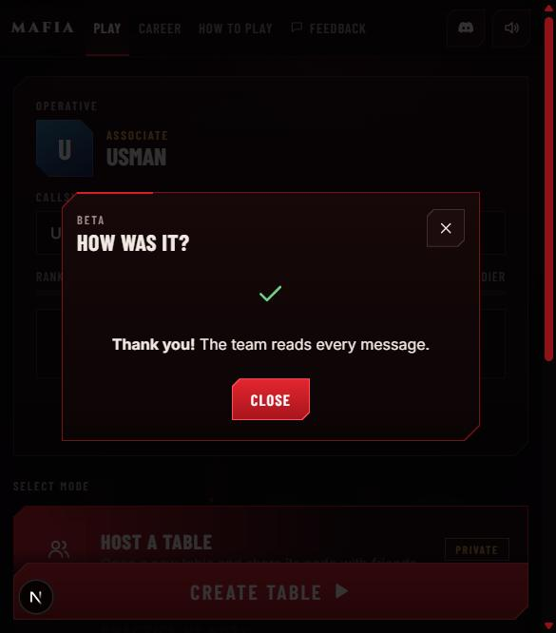  Feedback sent | 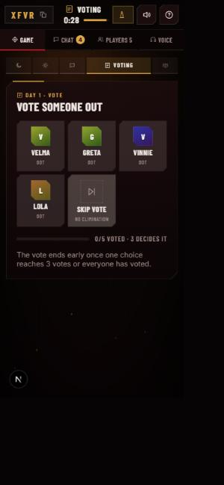  Phone: voting

6. Tests
cd server && npm test: 92 tests, 92 pass, 0 fail (25 Oct 2026). The client production build (what Vercel runs) also passes.
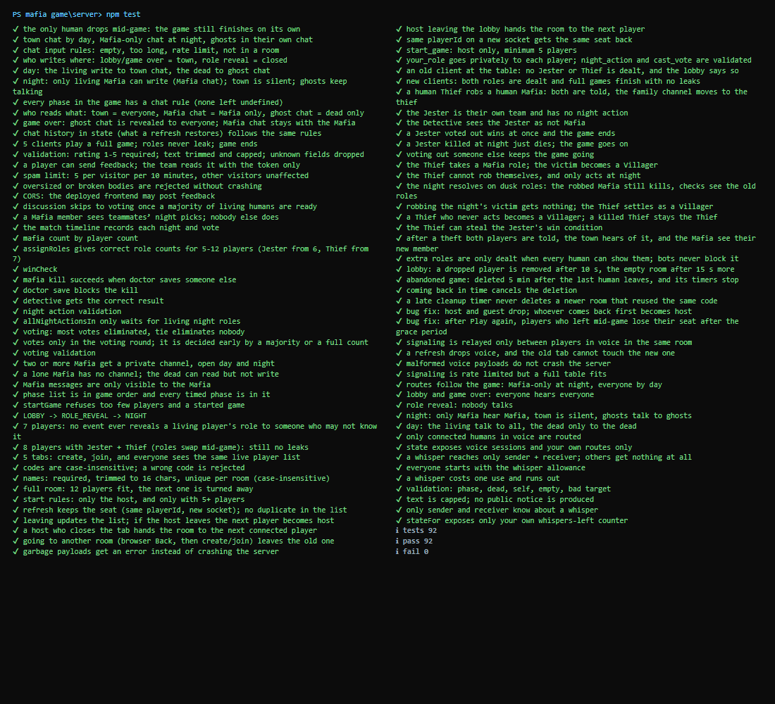
npm test: 92/92

Test file | What it proves
rooms.e2e / sockets.e2e | Join, wrong code, full room, start rules, refresh, host hand-over, bad payloads
roleleak.e2e | No role leaks in full games, also with Jester + Thief
chat / chat.e2e | Town, Mafia and ghost chat rules in every phase; history; limits
timeouts / abandon.e2e | Cleanup timers, stuck-host and ghost-seat fixes, games never hang
feedback | Validation, spam limit, token-protected reading, CORS
game, phases, special roles, voice, whispers | The team's game-logic tests

7. GitHub record
When | What | Status
18 Oct | Weeks 1–4 work; PR #8 to main opened by mistake, then closed | Closed
18 Oct | Branch feature/qa-deploy-week1-4 removed; everything on branch Usman | Deleted
21 Oct | main merged in; Week 5 chat tests | Merged
22 Oct | Live design + audit fixes + sounds + live audit report | Done
25 Oct | Hiban's branch merged (crash fix), Weeks 6–8 (95f15fd) | Merged
main was never changed. Your local folder mafia game matches GitHub.

Tools installed on this PC
- GitHub CLI (signed in as UsmanKD8), Pandoc, Poppler, LibreOffice: for PRs and the Word/PDF reports.
- FFmpeg: for the summary video.

8. What is left (for you)
- Send the Discord invite link, or put it in Vercel as NEXT_PUBLIC_DISCORD_URL and redeploy.
- Render: set FEEDBACK_TOKEN (long random secret) and CLIENT_ORIGIN; redeploy backend and frontend.
- Test once on a real iPhone (Safari) and an Android phone; Firefox/Safari are not on this PC.
- Free Render storage is wiped on redeploy: read the feedback before redeploying.
- Run npm install in client/ of your local folder before running it (new package gsap).
- Optional: custom domain (steps in docs/DEPLOY.md). Optional: LiveKit/Agora voice (not needed, voice already works).

