# Project Progress Report

**Table Of Contents**

Project Progress Report 1

Section1: 2

A. Introduction: 3

B. Problems: 3

C. Solution: 3

D. Project management methodology: 3

Section2 3

In this section, we delve into the foundational aspects of our project. 3

A. Introduction: 3

B. Project planning: 4

C. Analyse and Specifications of needs: 4

1. Le Backlog du Produit (Product Backlog): 4

2. Identification des Acteurs (Stakeholder Identification): 4

A. Super User: 5

B. Regular User: 5

C. Guest: 5

3. Spécification des Besoins Fonctionnels (Specification of Functional Requirements): 5

1. User Authentication and Authorization: 5

2. Account Management: 5

3. Cryptocurrency Transactions 5

4. Trading Functionality: 5

5. Portfolio Management: 6

6

4. Conclusion: 6

Section3: 7

1. Architecture logicielle (Software Architecture): 7

2. Environnement de développement (Development Environment): 7

We used IntelliJ IDEA as an IDE and mySQL workbench to organize the database and the project as a whole. 7

3. Choix technologiques (Technological Choices): 7

A. Frontend Application: 7

B. Backend Application: 7

C. Database Management System (DBMS): 7

4. Sprints progress: 8

Sprint Breakdown: 8

Sprint Activities: 8

5. Software presentation: 8

6. Conclusion: 8

# 

# Section1:

## Introduction:

Our project aims to develop a website called WhalesCap that is a virtual bank specializing in cryptocurrencies.

This report presents an overview of our progress and the methodologies employed in the development process.

## Problems:

We have a lot of common problems in today’s world that we encounter when using real money and transferring it. such as:

1. Transferring money over long distances
2. Long transaction timing
3. Having to go to the bank each time you have to make a transaction.

## Solution:

1. Making a secure and a safe place to transact money.
2. Can make transactions anywhere from the world. (Decentralization)
3. Quick deals that take no more than minutes to complete.
4. Ability to trade different cryptocurrencies.

## Project management methodology:

We used Discord to communicate and have a scheduled meeting every 2 weeks with all the members of the group, to see the progress and organize the tasks.

# Section2

# In this section, we delve into the foundational aspects of our project.

## Introduction:

Project planning is a critical phase in the lifecycle of any project. It involves a series of steps that ensure the project is completed on time, within budget, and to the specified quality standards. Effective project planning provides a roadmap for the project team, outlining the tasks, timelines, resources, and roles necessary to achieve the project goals. In this chapter, we will explore the essential components of project planning, including task breakdown, scheduling, role organization, and the analysis and specification of requirements.

## Project planning:

We divided the roles into the following: Frontend/Backend/Database Management

For the Frontend we had three developers: BOULHELLA Zakarya, SEGHIRI Khadidja, BOUALI Ines.

For the Backend we had three developers: GUERROUDJ Ahmed Yacine, KHALOUCHE Mohamed, BOUTAGHANE Louai Abdelmalek.

For the Database Management: BOULHELLA Zakarya, BOUTAGHANE Louai Abdelmalek

Each one of them choosed certain pages and developed it.

And whenever someone finishes their work in a certain field, he may jump to another task.

## C. Analyse and Specifications of needs:

### Le Backlog du Produit (Product Backlog):

A prioritized list of features, enhancements, and fixes required for the product. This backlog is continuously refined and reprioritized to reflect the current needs and priorities of stakeholders.

1. For instance, we can add deposit/withdraw using bank account
2. Advanced techniques for trading cryptocurrencies, not only market execution but buy/sell limits, buy/sell stops etc…
3. We can improve the website’s design even further by implementing advanced UI/UX improvements.

### 2. Identification des Acteurs (Stakeholder Identification):

Identifying all individuals and groups who have an interest in the project.

#### Super User:

This actor is unique and has access to multiple normal user information, such as: 1.

1. see user balance
2. delete cryptocurrencies.

#### Regular User:

This actor is the website’s main focus, after registering on the site,he’ll have:

1. his own wallet with what he can buy/sell different cryptocurrerncies
2. See different changes on the coins, whether it’s going up or down
3. fund his account with fiat currency and withdraw as well.

#### Guest:

This user can only browse the website mainpage, and see cryptocurrencies prices. As he can’t have the special functions the regular user has, not until he registers on the website.

### 3. Spécification des Besoins Fonctionnels (Specification of Functional Requirements):

**1. User Authentication and Authorization:**

User Registration: Users can create an account by providing their email, username, and password. They will receive a verification email to confirm their registration.

Login: Registered users can log in using their username/email and password.

**2. Account Management:**

Profile Management: Users can update their personal information and change their password.

Account Balances: Users can view their cryptocurrency balances in their account dashboard.

**3. Cryptocurrency Transactions**

Deposit Funds: Users can deposit various cryptocurrencies into their WhalesCap account by generating a unique wallet address.

Withdraw Funds: Users can withdraw funds to their external wallets.

Transfer Funds: Users can transfer funds between their WhalesCap wallets or to other users within the platform.

**4. Trading Functionality:**

Buy and Sell Orders: Users can place buy and sell orders for supported cryptocurrencies.

Trade History: Users can view their past trades and transactions.

**5. Portfolio Management:**

Dashboard Overview: Users can view an overview of their portfolio, including the current value and performance metrics.

Transaction History: Users can view their deposit, withdrawal, and trading history.

### 

## Conclusion:

In conclusion, effective project planning is essential for the success of any project. It involves clear communication, and continuous monitoring and adjustment. By breaking down the project into manageable tasks, assigning clear roles, and thoroughly analyzing requirements, we can ensure that the project progresses smoothly and meets its objectives. The following sections will build on this foundation, detailing the specific methodologies and tools used in the execution phase of the project.

# Section3:

## 1. Architecture logicielle (Software Architecture):

Describe the overall structure and organization of the software system developed for the project.

Explain how the software is designed, highlighting the main components or modules of the system and how they interact with each other.

## Environnement de développement (Development Environment):

## We used IntelliJ IDEA as an IDE and mySQL workbench to organize the database and the project as a whole.

## Choix technologiques (Technological Choices):

### Frontend Application:

We built the project using technologies: HTML, CSS, JavaScript, Without a framework.

Components include pages for user registration, login, dashboard, trading interface, transaction history, and account settings.

### Backend Application:

Components include authentication middleware, API controllers, data models, service layers, and integration modules.

We used python as a programming language and Django as a framework for the backend.

### Database Management System (DBMS):

The DBMS stores and manages user data, transaction history, cryptocurrency balances, and other relevant information.

We used mySQL for that.

## Sprints progress:

The development of WhalesCap followed the Agile SCRUM methodology, ensuring iterative progress and continuous feedback. Each sprint lasted two weeks and included the following phases: planning, development, testing, and review.

### Sprint Breakdown:

Sprint 1: User sign-up and login functionalities.

Sprint 2: Homepage

Sprint 3: Cryptocurrency deposit and withdrawal features

Sprint 4: Trading functionality (buy and sell Cryptocurrency)

Sprint 5: Wallet and Transaction history.

Sprint 6: Market section for price changes and a visual chart for each coin.

Sprint 6: Final testing and bug fixes

### Sprint Activities:

We had brief meetings to discuss progress and roadblocks in Discord for two weeks.

## Software presentation:

Here are some samples of the project pages:

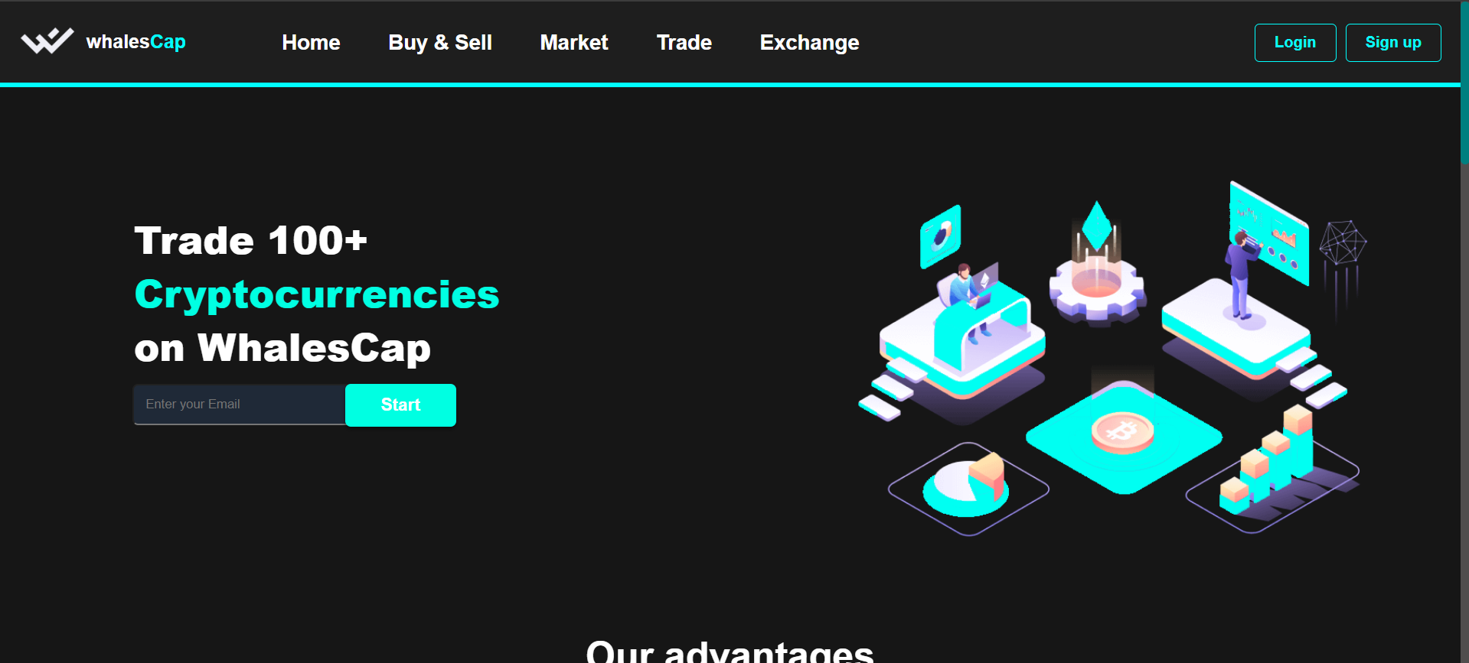

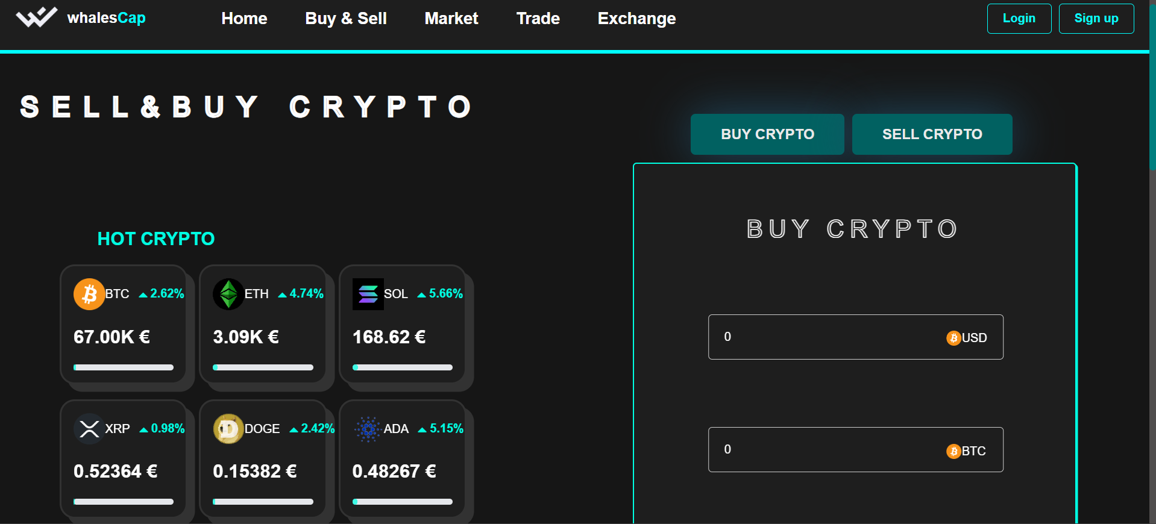

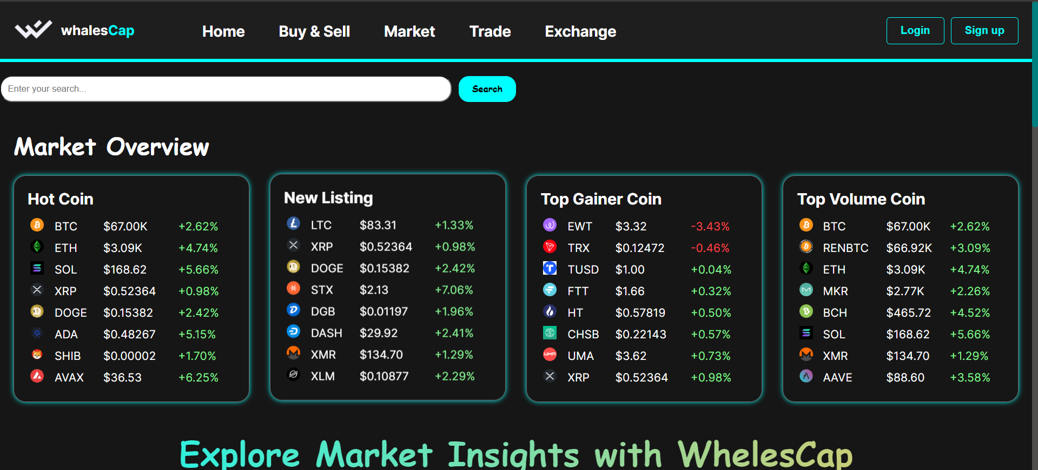

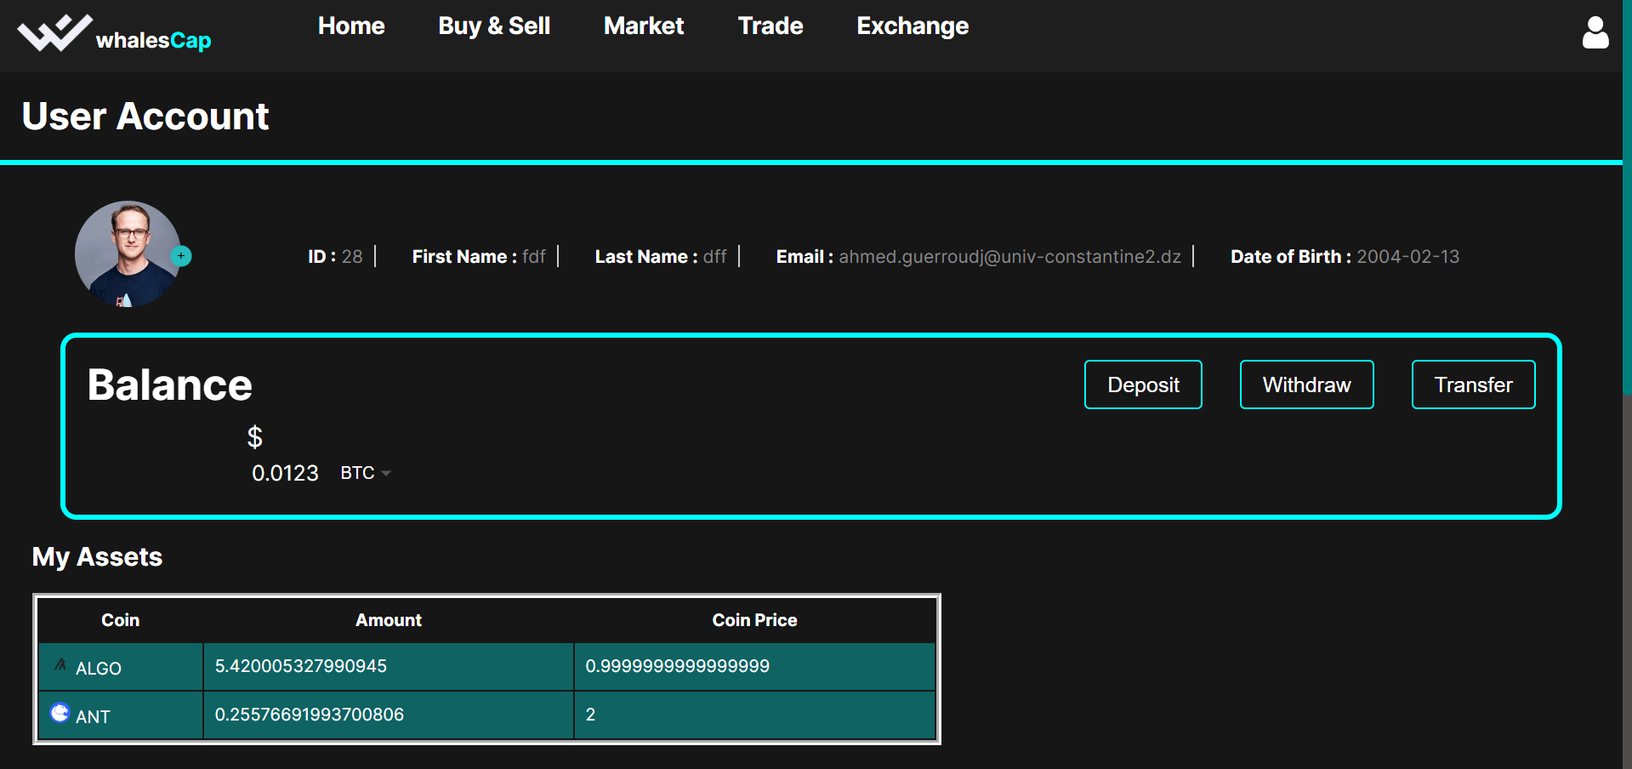

## Conclusion:

This report provides a detailed overview of our project to develop a website for WhalesCap, a virtual bank for cryptocurrencies. From project planning to implementation, we have strived to adhere to best practices and deliver a product that meets the needs of our clients. Looking ahead, we are excited about the future possibilities for WhalesCap and remain committed to its ongoing success.