

Database Design and Implementation Project

Academic Year: 2023/24

Batch 2023.

**Contents**

1 Requirement Analysis (15%) 5

1.1 Description of the three websites chosen 5

1.1.1 http://www.sainsbury.co.uk (EXAMPLE ONLY) 5

1.1.2 http://www.asda.com (EXAMPLE ONLY) 5

1.1.3 http://www.tesco.com (EXAMPLE ONLY) 5

1.2 List of data fields (Entities and their attributes) 5

1.2.1 List of data fields from website 1 6

1.2.2 List of data fields from website 2 6

1.2.3 List of data fields from website 3 6

1.3 Finalised List 6

1.3.1 The generic list(Optional) 6

2 Database design (25%) 6

2.1 Entity Relationship Modelling 6

2.1.1 Initial Entity Relationship Model 7

2.1.2 Extended Entity Relationship Model 7

2.3 Database Schema 7

3. Database implementation (10%) 8

4. SQL Queries (50%) 8

4.1 Query 1 9

4.1.1 For what purpose will this query be used in business terms? 9

4.1.2 Query in natural language 9

4.1.3 SQL Code and output 9

4.1.4 Explain the output of the data (was this what was predicted?) 9

4.2 Query 2 9

4.2.1 For what purpose will this query be used in business terms? 9

4.2.2 Query in natural language 9

4.2.3 SQL Code and output 9

4.2.4 Explain the output of the data (was this what was predicted?) 9

4.3 Query 3 9

4.3.1 For what purpose will this query be used in business terms? 9

4.3.2 Query in natural language 9

4.3.3 SQL Code and output 9

4.3.4 Explain the output of the data (was this what was predicted?) 9

4.4 Query 4 10

4.4.1 For what purpose will this query be used in business terms? 10

4.4.2 Query in natural language 10

4.4.3 SQL Code and output 10

4.4.4 Explain the output of the data (was this what was predicted?) 10

4.5 Query 5 10

4.5.1 For what purpose will this query be used in business terms? 10

4.5.2 Query in natural language 10

4.5.3 SQL Code and output 10

4.5.4 Explain the output of the data (was this what was predicted?) 10

5. References 11

# Requirement Analysis (15%)

## 1.1 Description of the three websites chosen

## 1.1(DESCRIPTION OF THREE WEBSITES)

**TELEMART(telemart.pk):**

Telemart is an online shopping platform in Pakistan that gives a wide variety of products including electronics, gadgets, fashion items, and more. It provides a user-friendly platform for purchasing via the internet, with engaging pages for searching and selecting products. Telemart requires users to fill out the fields such as shipping address, contact information, and payment details during the purchasing process.

**GUL AHMED(gulahmedshop.com):**

Gul Ahmed is one of the famous clothing brands from Pakistan that sells styles and qualities of fabrics. The Gul Ahmed Shop is an online store where customers are able to access its varieties and buy clothes, home textiles, and accessories. The purchase function on the Gul Ahmed website entails filling in details such as size selection, shipping address, payment method, and contacts. Gul Ahmed is one of the famous brands of clothing from Pakistan that sells a variety of fabrics and styles. The Gul Ahmed Shop is an e-commerce where customers can search for its styles and purchase them clothes, home textiles and accessories. The exploit of functionality in e-commerce includes filling in the sizes we want on the appointment, the address of where it will be sent, the method of payment, and our identity.

**LIBERTY BOOKS(libertybooks.com):**

Liberty Books is a premium bookstore chain in Pakistan that provides a wide selection of books and products revolving around different genres. The website allows users to shop online for different books, stationery items, and other book-related products. During the purchase process at Liberty Books’ website, the user has to provide information about the billing and shipping address, payment information, and contact information.

### 1.1.1 [https://telemart.pk](https://telemart.pk/)

### 1.1.2 [https://www.gulahmedshop.com › women › trousers](https://www.googleadservices.com/pagead/aclk?sa=L&ai=DChcSEwi7z4iN8KqGAxVxkmgJHWn0BdsYABAAGgJ3Zg&ase=2&gclid=Cj0KCQjwu8uyBhC6ARIsAKwBGpTjXscUdLKXzjvZleOvHMs84Y66-yl5huKGOyf-1XdYytaxh50uBGMaAmbQEALw_wcB&ohost=www.google.com&cid=CAESVeD28ICroUl7Z-Spt7_KtdzX--tUPU3AEL0UV_q4b1fqt1fwDrZjGnpVCHxPNy1zWKbebxY-IytNKVG56spRStw3KuswoZVxFk9YDd_rlEYF3z25tzE&sig=AOD64_2vpDZhig517jGDry8meNL08l1NnQ&q&nis=4&adurl&ved=2ahUKEwjz84KN8KqGAxViX_EDHTfgAmQQ0Qx6BAgPEAE)

### 1.1.3 [https://www.libertybooks.com](https://www.googleadservices.com/pagead/aclk?sa=L&ai=DChcSEwjki5Xh8KqGAxWmQ0ECHZNyB-4YABAAGgJ3cw&ase=2&gclid=Cj0KCQjwu8uyBhC6ARIsAKwBGpRRabHY-J23DAiLJsQZ9BbMS3hA-sh03opDEZbPdO2xdek-MYsK7VcaAmKLEALw_wcB&ohost=www.google.com&cid=CAESVeD2_jki5dq9cn8NCtSmtBsYt5llK65CGrTj_dq8AsFQSzzcd5nEkxeWZ-59u7p6gQfRISVuzYYnBs6KpXpA2Q8enN9UyP8T85l4gyO9DRu9t-xT1O0&sig=AOD64_3frd-Tfqy_f9-VzAM6mjvFXs6Hug&q&nis=4&adurl&ved=2ahUKEwiU143h8KqGAxV8BdsEHXtmA0QQ0Qx6BAgIEAE)

### 

## 1.2 List of data fields (Entities and their attributes)

### 1.2.1 List of data fields from website 1

|  |  |  |  |
| --- | --- | --- | --- |
| **Entity: Mobile and tablets** | **Entity: Gaming and computer** | **Entity: Sports items** | **Entity: Medical items** |
| Attributes | Attributes | Attributes | Attributes |
| Item id | Item id | Item id | Item id |
| Item type | Item type | Item type | Item type |
| Item price | Item price | Item price | Item price |
| Brand name | Brand name | Brand name | Brand name |
| quality | quality | quality | quality |
| **Entity: Users** | **Entity: ride on toys** | **Entity: power and light**ing | **Entity: washing machines** |
| Attributes | Attributes | Attributes | Attributes |
| User id | Item id | Item id | Item id |
| User name | Item type | Item type | Item type |
| User email | Item price | Item price | Item price |
| User password | Brand name | Power and lighting item id | Brand name |
| User address | Ride on toys item id | id | Washing machine item id |
| **Entity: Gaming sales** | **Entity: cooling and heating** | **Entity: Medical items** | **Entity: TVs** |
| Attributes | Attributes | Attributes | Attributes |
| Sales id | Item id | Item id | Item id |
| Item id | Item type | Sale id | Item type |
| Item total price | Item price | Item total price | Item price |
| Sales date | Item name | Sale date | Brand name |
| quantity | Cooling and heating item id | quantity | quality |

|  |  |  |
| --- | --- | --- |
| **Entity: Mobile sales** | **Entity: men fashion** | **Entity: fashion sales** |
| Attributes | Attributes | Attributes |
| Item id | Item id | Item id |
| Sale id | Item type | Sale id |
| Item total price | Item name | Item total price |
| Sale date | Brand name | Sale date |
| quantity | Item price | quantity |

|  |  |  |
| --- | --- | --- |
| **Entity: appliances** | **Entity: kids product** | **Entity: automotive** |
| Attributes | Attributes | Attributes |
| Item id | Item id | Item id |
| Item type | Item type | Item type |
| Item name | Item name | Item name |
| Item price | Item price | Item price |

|  |
| --- |
| **Entity: orders** |
| Attributes |
| Order id |
| User id |
| Item type |
| Item id |
| Payment method |
| Total amount |

### 1.2.2 List of data fields from website 2

|  |  |  |  |
| --- | --- | --- | --- |
| BAGS | LAWN UNSTICHED | SHOES | FRAGRANCES |
| ATTRIBUTES  PRODUCT_ID    PRICE    MATERIAL  COLOUR  MEASUREMENTS  GENDER | ATTRIBUTES  ITEM_ID  PRICE  COLOURS  PRODUCT_TYPE    PRODUCT _FABRIC  DUPPATA_FABRIC  TROUSER FABRIC | ATTRIBUTES  SHOE_ID  SIZE  MATERIAL  STYLE  GENDER  COLOUR | ATTRIBUTES  ITEM_ID  TYPE  INTENSITY  GENDER  OCCASIONS  PRICE  GENDER |

|  |  |  |  |
| --- | --- | --- | --- |
| MEN_KURTA | KIDS | IDEAS_HOME | MEN_UNSTICHED |
| ATTRIBUTES  PRODUCT_ID  FABRIC TYPE  SIZE  COLOURS  TYPE | ATTRIBUTES  PRODUCT_ID  SIZE  PRICE  COLOUR  TYPE | ATTRIBUTES  PRODUCT_ID  SIZE  COLOUR  PRICE  TYPE | ATTRIBUTES  ITEM_ID  PRICE  COLOURS  PRODUCT_TYPE    PRODUCT _FABRIC  TROUSER FABRIC |

·

### 1.2.3 List of data fields from website 3

|  |  |  |  |  |
| --- | --- | --- | --- | --- |
| Entity: fiction | Entity: Non Fiction | Entity: Urdu books | Entity: children books | Entity: games & stationary |
| Attributes | Attributes | Attributes | Attributes | Attributes |
| title | writer | title | title | title |
| writer | title | writer | writer | type |
| type | author | type | Release date | writer |
| Release date | Release date | overview | type | Release date |
| overview | Names of character | Release date | overview | overview |
| Names of character | overview | Names of character | Names of character | Names of character |
| Location | Location | Location | Location | Location |
| concepts | language | concepts | concepts | concepts |
| language | concepts | language | language | language |
| honors | honors | honors | honors | honors |
| tags | accessible | tags | tags | tags |
| accessible | tags | evaluation | accessible | accessible |
| evaluation | evaluation | accessible | evaluation | evaluation |
| author | type | author | author | author |

.

## 1.3 Finalised List

[Delete this text: include one list of the attributes you have chosen to take forward to your diagram. For better marks, consider adding self-suggested or identified hidden entities and attributes.]

# Database design (25%)

## 2.1 Entity Relationship Modelling

[Delete this text: section 2.1.1 is optional, section 2.1.2 is NOT optional. You may choose to create an initial, simpler, ERD as a rapid prototype on which to work to produce your more complex EERD.]

### 2.1.1 Initial Entity Relationship Model

### 2.1.2 Extended Entity Relationship Model

[Delete this text: for optimum marks, ensure that you include all of the extended notation. Marks for this section are awarded for the correct use of extended notations. Try to include references of all extended syntax. If necessary you may need to include additional data items.]

## 2.2 Database Schema

[Delete this text: Describe the identified tables their attributes i.e. identify which attributes are primary keys, which are foreign keys, and which may be both primary key and foreign keys. Also, choose the data types for the attributes. The database implementation should be consistent with the schema.]

The above sub sections are to help you understand the stepwise process. If you prefer, you can merge all sub sections in Section 2 and only provide one entity relation diagram that is extended, normalised and have key attributes and data types. And provide explanation of the normalisation.

# 3. Database implementation (10%)

[Delete this text: Using the software provided, build tables to represent the entities from the Table Schema. Invent data to represent stock for the tables created. Insert minimum six records into each table. Provide screen dumps of all the CREATE TABLE statements and the completed tables with data. Marks are most often lost for not including the CREATE TABLE statements. Check that you have these before submitting your assignment.]

# 4. SQL Queries (50%)

[Delete this text: queries that gain higher marks are those that use more than one table, make use of calculations, are different from each other, reflect real world queries and use SQL functions. Examples of functions and calculations can be found on the MySQL website, from lectures and through your own research (such as the module textbook).]

## 4.1 Query 1

SELECT a.item_type, wm.item_name

FROM appliances a, washing_machines wm

WHERE a.item_id = wm.item_id

GROUP BY a.item_type, wm.item_name

ORDER BY a.item_type, wm.item_name;

### 4.1.1 For what purpose will this query be used in business terms?

This query will be used to generate a report that groups and lists the types of appliances and their corresponding washing machine names. This can be useful for business purposes such as:

- Identifying which types of appliances are associated with which washing machines

- Analysing sales trends and product relationships

- Generating inventory reports

- Identifying opportunities for product bundling or cross-selling

### 4.1.2 Query in natural language

Show me a list of appliance types and their corresponding washing machine names, grouped together.

### 4.1.3 SQL Code and output

**CODE:**

SELECT a.item_type, wm.item_name

FROM appliances a, washing_machines wm

WHERE a.item_id = wm.item_id

GROUP BY a.item_type, wm.item_name

ORDER BY a.item_type, wm.item_name;

**OUTPUT :**

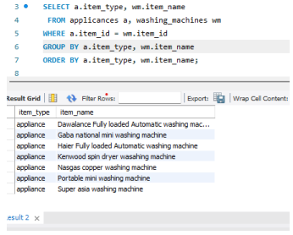

**4.1.4 Explain the output of the data (was this what was predicted?)**

The output shows a list of appliance types (item_type) and their corresponding washing machine names (item_name), grouped together. Each group represents a unique combination of appliance type and washing machine name. The output is sorted alphabetically by appliance type and then by washing machine name.

This output is likely what was predicted, as it provides a clear and organized list of appliance types and their associated washing machine names. The grouping and sorting make it easy to analyze and identify patterns or relationships between the data.

## 4.2 Query 2

SELECT item_id, item_name, item_price

FROM automotives

WHERE item_price > (SELECT AVG(item_price) FROM Tvs);

### 4.2.1 For what purpose will this query be used in business terms?

This query will be used to identify and list automotive products with prices higher than the average price of TVs. This can be useful for business purposes such as:

- Identifying premium or high-end automotive products

- Analysing pricing strategies and product positioning

- Targeting customers who are willing to spend more on automotive products

- Comparing product prices across different categories

### 4.2.2 Query in natural language

Show me a list of automotive products with prices higher than the average price of TVs.

### 4.2.3 SQL Code and output

**CODE :**

SELECT item_id, item_name, item_price

FROM automotives

WHERE item_price > (SELECT AVG(item_price) FROM Tvs);

**OUTPUT :**

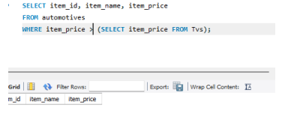

### 4.2.4 Explain the output of the data (was this what was predicted?)

The output shows a list of automotive products (item_id, item_name, item_price) with prices higher than the average price of TVs. The average price of TVs is calculated using the subquery (SELECT AVG(item_price) FROM Tvs).

This output is likely what was predicted, as it provides a list of automotive products with prices above the average TV price. The query helps identify premium or high-end automotive products, which can be useful for targeted marketing or pricing strategies.

## 4.3 Query 3

ms.sale_id,

mi.item_name,

mi.brand_name,

ms.quantity,

ms.total_price,

ms.sale_date

FROM

MedicalSales ms

INNER JOIN

MedicalItems mi ON ms.item_id = mi.item_id

WHERE

ms.sale_date BETWEEN '2024-05-01' AND '2024-05-31'

ORDER BY

ms.total_price DESC;

### 4.3.1 For what purpose will this query be used in business terms?

4.2.1 Business Purpose:

This query will be used to generate a sales report for medical items sold between a specific date range (May 1, 2024, to May 31, 2024). The report will include the sale ID, item name, brand name, quantity sold, total price, and sale date. This can be useful for business purposes such as:

- Analyzing sales trends and revenue

- Identifying top-selling medical items

- Tracking inventory and restocking needs

- Evaluating sales performance and revenue growth

### 4.3.2 Query in natural language

4.2.2 Natural Language Query:

"Show me a list of medical items sold between May 1, 2024, and May 31, 2024, including the sale ID, item name, brand name, quantity sold, total price, and sale date, sorted by total price in descending order."

### 4.3.3 SQL Code and output

**CODE:**

SELECT

ms.sale_id,

mi.item_name,

mi.brand_name,

ms.quantity,

ms.total_price,

ms.sale_date

FROM

MedicalSales ms

INNER JOIN

MedicalItems mi ON ms.item_id = mi.item_id

WHERE

ms.sale_date BETWEEN '2024-05-01' AND '2024-05-31'

ORDER BY

ms.total_price DESC;

**OUTPUT :**

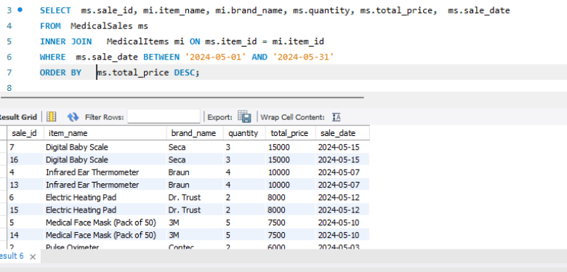

### 4.3.4 Explain the output of the data (was this what was predicted?)

The output shows a list of medical items sold between May 1, 2024, and May 31, 2024, with the specified columns. The output is sorted by total price in descending order, showing the highest revenue-generating items first.

This output is likely what was predicted, as it provides a comprehensive sales report for medical items sold within the specified date range. The query helps identify top-selling items, revenue growth, and sales trends, which can inform business decisions and strategies.

## 4.4 Query 4

SELECT gc.item_id, gc.item_name, gs.quantity AS gaming_quantity, gs.total_price AS gaming_total_price

FROM gaming_and_computer gc

LEFT JOIN GamingSales gs ON gc.item_id = gs.item_id

WHERE gc.item_id IN (1, 3, 5, 7, 9);

### 4.4.1 For what purpose will this query be used in business terms?

This query will be used to retrieve specific item information from the gaming_and_computer table and corresponding sales data from the GamingSales table for a selected list of item IDs (1, 3, 5, 7, 9). This can be useful for business purposes such as:

- Analysing sales performance for specific products

- Identifying top-selling items

- Tracking inventory and restocking needs

- Evaluating product pricing and revenue growth

### 4.4.2 Query in natural language

Show me the item name, quantity sold, and total price for the items with IDs 1, 3, 5, 7, and 9 from the gaming and computer category."

### 4.4.3 SQL Code and output

**CODE:**

SELECT gc.item_id, gc.item_name, gs.quantity AS gaming_quantity, gs.total_price AS gaming_total_price

FROM gaming_and_computer gc

LEFT JOIN GamingSales gs ON gc.item_id = gs.item_id

WHERE gc.item_id IN (1, 3, 5, 7, 9);

### 4.4.4 Explain the output of the data (was this what was predicted?)

The output shows the item ID, item name, quantity sold, and total price for the selected items from the gaming and computer category. The LEFT JOIN ensures that all items from the gaming_and_computer table are included, even if there are no corresponding sales data in the GamingSales table.

This output is likely what was predicted, as it provides the requested information for the specified item IDs. The query helps analyze sales performance, identify top-selling items, and track inventory and revenue growth for specific products in the gaming and computer category.

## 4.5 Query 5

SELECT mf.item_name, fs.total_price, fs.quantity, fs.sale_date

FROM men_fashion mf

INNER JOIN FashionSales fs ON mf.item_id = fs.item_id

ORDER BY fs.total_price DESC;

### 4.5.1 For what purpose will this query be used in business terms?

This query will be used to retrieve specific item information from the gaming_and_computer table and corresponding sales data from the GamingSales table for a selected list of item IDs (1, 3, 5, 7, 9). This can be useful for business purposes such as:

- Analyzing sales performance for specific products

- Identifying top-selling items

- Tracking inventory and restocking needs

- Evaluating product pricing and revenue growth

### 4.5.2 Query in natural language

Show me the item name, quantity sold, and total price for the items with IDs 1, 3, 5, 7, and 9 from the gaming and computer category."

### 4.5.3 SQL Code and output

**CODE:**

SELECT mf.item_name, fs.total_price, fs.quantity, fs.sale_date

FROM men_fashion mf

INNER JOIN FashionSales fs ON mf.item_id = fs.item_id

ORDER BY fs.total_price DESC;

**OUTPUT :**

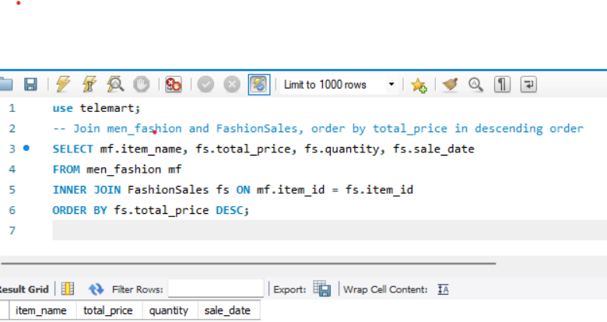

### 4.5.4 Explain the output of the data (was this what was predicted?)

The output shows the item ID, item name, quantity sold, and total price for the selected items from the gaming and computer category. The LEFT JOIN ensures that all items from the gaming_and_computer table are included, even if there are no corresponding sales data in the GamingSales table.

This output is likely what was predicted, as it provides the requested information for the specified item IDs. The query helps analyze sales performance, identify top-selling items, and track inventory and revenue growth for specific products in the gaming and computer category.

# 5. References

Sun, P. 2008. Template for DDI Assignment. Additional Supporting Materials for Chelmsford Campus. Database Design and Implementation module (EJ215004S) materials. Anglia Ruskin University.