Fruit

ninja

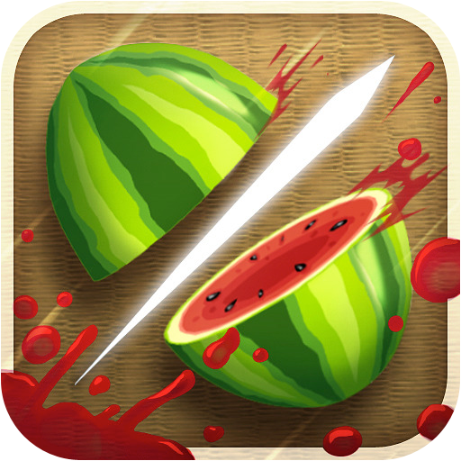

**User manual:**

when you first open the game you’ll find a screen that shows the modes of the game which are classic and arcade and there is a button which displays high scores of the last five games of classic and arcade modes. If you pressed classic you’ll be directed to a screen in order to choose which level of difficulty you’d like to play ; the levels differ in the speed of the fruits, if you pressed any of the three levels you will be sent to the main game screen that has a time showing how long you’ve been playing, the lives, pause button and the high score that has been reached in this level there are two kind of bombs ; one of them make you lose one live while the other one makes you lose the whole game and a game over screen will be shown in order to choose if you want to exit or to go to the main menu. On the other hand it you pressed arcade you’ll be sent to a screen that displays three level of difficulties then you will be directed to game screen in the arcade mode you have just 60 seconds to achieve a high score , the pause button will show you pause menu which has two buttons to control the sound also a reset button, new game button and resume button and a save button that will make you save the state of the game that you topped at before pressing pause and you’ll be able to load this game later from the first screen of the game.

**Design patterns:**

The designs that has been used are :

* MVC
* Strategy
* Singelton
* Command
* Factory

MVC:

It has been used in each GUI screen making a different controller for each screen and FXML files to contain GUI components.

Strategy:

It has been used to differentiate between classic and arcade mode.

Singelton:

It has been used in classic screen and arcade screen.

Command:

It has been used in the level screen to choose between the three levels which are easy, medium and hard.

Also it has been used to differentiate between different speeds of fruits.

Factory:

It has been used in displaying fruits on the screen in which we have a fruit factory containing all types of fruits and they are displayed on the screen randomly each time.

**Sequence diagrams:**

