Software Requirements Specification
for
Travel Advisor Website
Version 1.0
Prepared by Ahmed Hamada – Ahmed Zahran – Abdelrhman Khaled
31/3/2026
Table of Contents
Table of Contents ii
Revision History ii
1. Introduction 1
1.1 Purpose 1
1.2 Intended Audience and Reading Suggestions 1
1.3 Product Scope 1
1.4 References 1
2. Overall Description 2
2.1 Product Perspective 2
2.2 Product Functions 2
2.3 User Classes and Characteristics 2
2.4 Operating Environment 2
2.5 Design and Implementation Constraints 2
2.6 Assumptions and Dependencies 3
3. External Interface Requirements 3
3.1 User Interfaces 3
3.2 Hardware Interfaces 3
3.3 Software Interfaces 3
3.4 Communications Interfaces 3
4. System Features 4
4.1 System Feature 1 4
4.2 System Feature 2 (and so on) 4
5. Other Nonfunctional Requirements 4
5.1 Performance Requirements 4
5.2 Security Requirements 5
5.3 Business Rules 5

Revision History
Name | Date | Reason For Changes | Version

Introduction

Purpose
This Software Requirements Specification defines the requirements for the Travel Advisor Website.
The purpose of this document is to describe the functional and non-functional requirements of the web-based system that enables users to search for available flights, compare ticket prices, book flight tickets, make online payments, and see top flights destination.

Intended Audience and Reading Suggestions
The primary audience includes project managers, system analysts, software developers, UI/UX designers, and testers. It may also be useful for stakeholders such as clients and business analysts who need a clear understanding of the system requirements and expected behavior.

For effective reading, all readers are encouraged to start with the overview sections first, including Purpose, Scope, and Product Perspective, and then continue to the detailed requirements based on their responsibilities.

Product Scope
The Travel Advisor Website is a web-based system that helps users book flight tickets online. The website allows users to search for available flights, compare prices, choose suitable tickets, make payments, manage their bookings, and see top flights destinations.

The main goal of this system is to make the flight booking process easier, faster, and more convenient for users. It also helps the business by attracting more customers, improving service quality, and increasing online booking opportunities.

Our Project will divide into:
- Dashboard for admin who can see and manage what is happening in the whole system.
- Website for users who’s interested in booking flights tickets.

References
The following documents were used as references for preparing this Software Requirements Specification:

- Customer Requirements Specifications (CRS) for Travel Advisor Website.

- IEEE Recommended Practice for Software Requirements Specifications, IEEE, Version 1998, source: IEEE standards documentation.

Overall Description

Product Perspective
The Travel Advisor Website is a self-contained web-based system developed to help users search for flights, compare ticket prices, book tickets, and manage their reservations online.

This system works as a standalone website, but it also connects with some external services to complete its functions. For example, it may connect with airline or flight data sources to display available flights and with an online payment gateway to process payments securely. The website mainly includes modules such as user registration and login, flight search, booking management, and payment processing.

Product Functions
- Allow users to create an account, and log in.

- Display list of top flights destination with details such as destination name, description, images, and top places

- Display List of users reviews about their experience with booking flights using the website.

- Allow users to search for available flights by entering details such as departure location, destination, travel date, and number of passengers.

- Display a list of available flights with details such as airline name, departure time, arrival time, ticket price, and flight duration.

- Allow users to compare flight options and choose the most suitable one.

- Allow users to book flight tickets by entering passenger information.

- Allow users to make secure online payments using the available payment methods.

- Send notifications or confirmation messages to users by email or through the website.

- Allow the admin to manage bookings, and user information.

User Classes and Characteristics
The main users of the Travel Advisor Website:

- Admin: The administrator manages the website and has a higher access level than normal users. The admin can monitor bookings and manage user accounts.

- User: is the main user of the system. This user can search for flights, book tickets, and make payments.

Operating Environment
- The website should work on common operating systems such as Windows, Android, and iOS

- The system should support web browsers such as Google Chrome, Mozilla Firefox, Microsoft Edge, and Safari.

- On the server side, the system will run on a web server connected to a database server that stores all data.

- External services such as a payment gateway for online payments and an email service for sending booking confirmations and notifications.

Design and Implementation Constraints
- The system should be developed as a web-based application, so users can access it through a browser without installing special software.

- The system should use a database to store all users’ data

- The website should interface with external services such as a payment gateway and possibly a flight data source or API.

- The system should follow common web development standards and design conventions to make maintenance easier.

- The system shall include basic security considerations, especially for user login, personal data, and online payment processing.

- The project may be limited by available time, budget, and development tools.

- The website should be compatible with common browsers and normal internet-based communication.

Assumptions and Dependencies
This project assumes that users have internet access, a working web browser, and basic knowledge of using websites and online payment systems.
It also assumes that the external services used by the system, such as the flight information source, payment gateway, and email notification service, will be available and working correctly.
The website depends on the database server, hosting environment, and third-party services to function properly, so any failure or change in these components may affect the performance of the system.

External Interface Requirements

User Interfaces
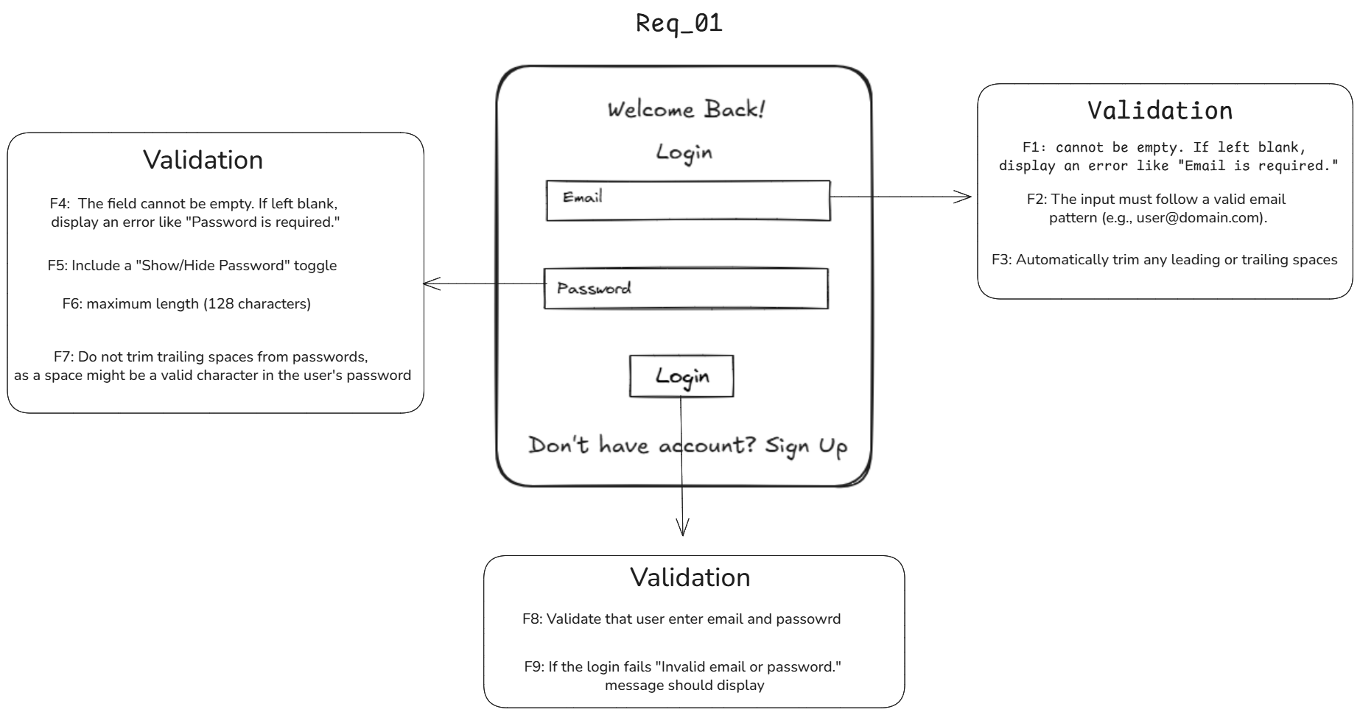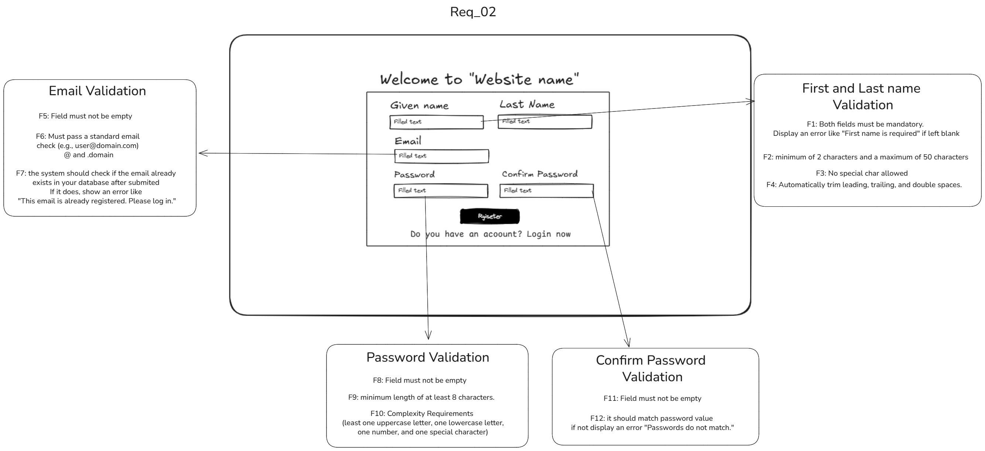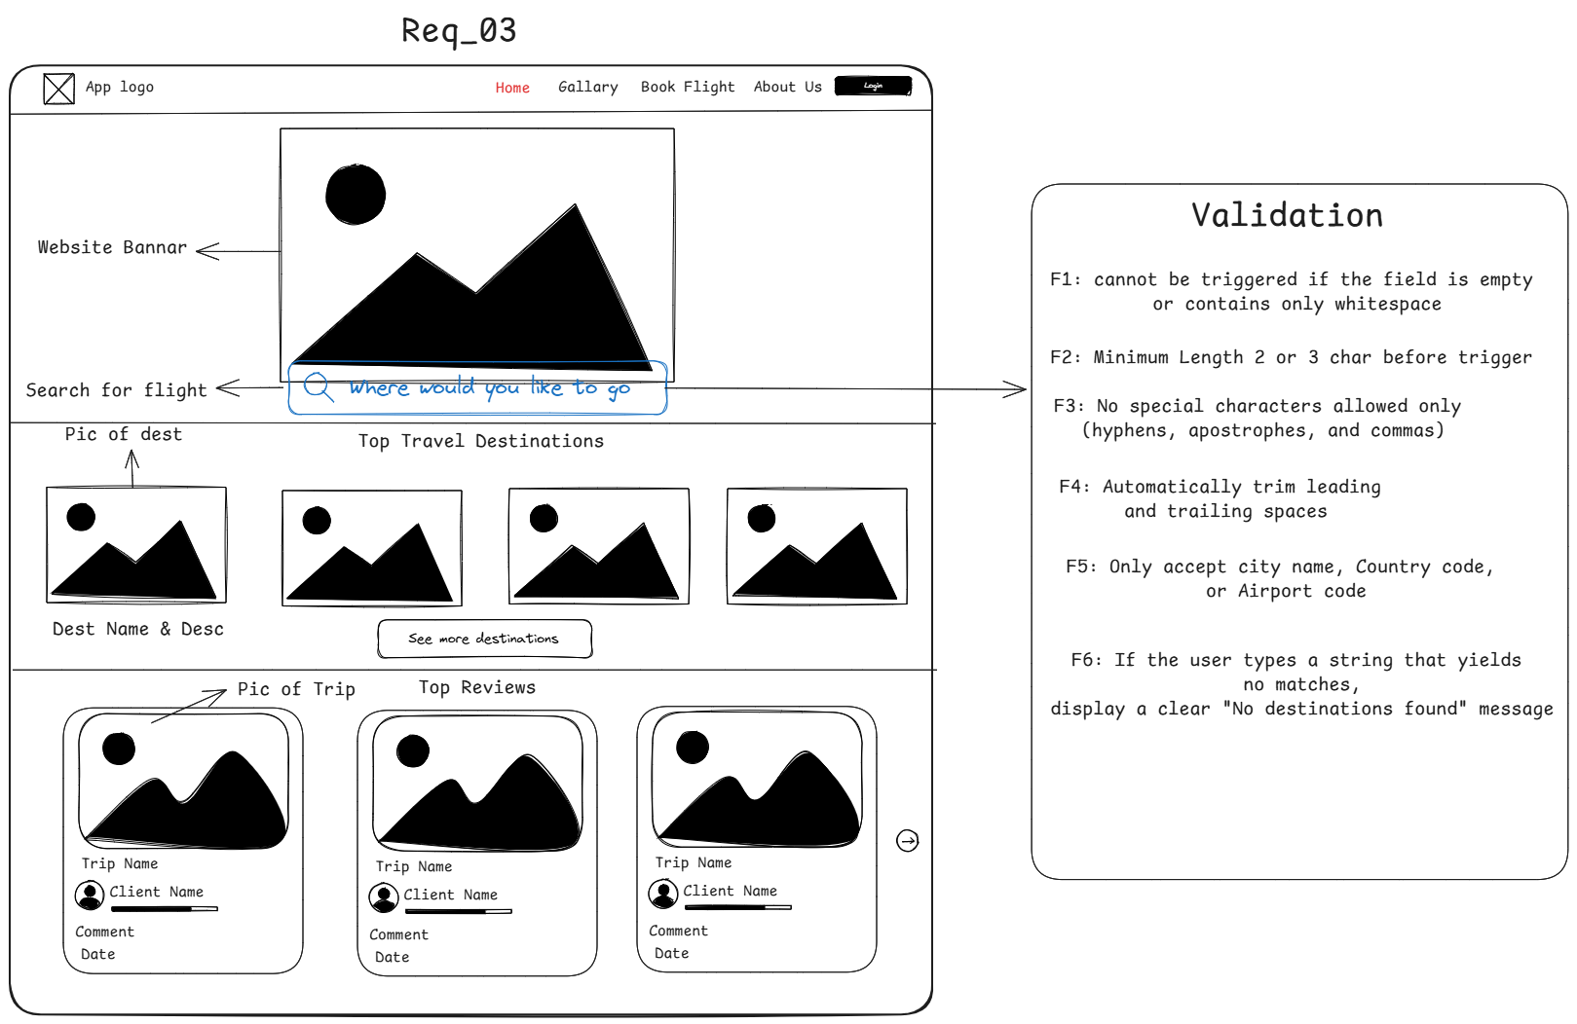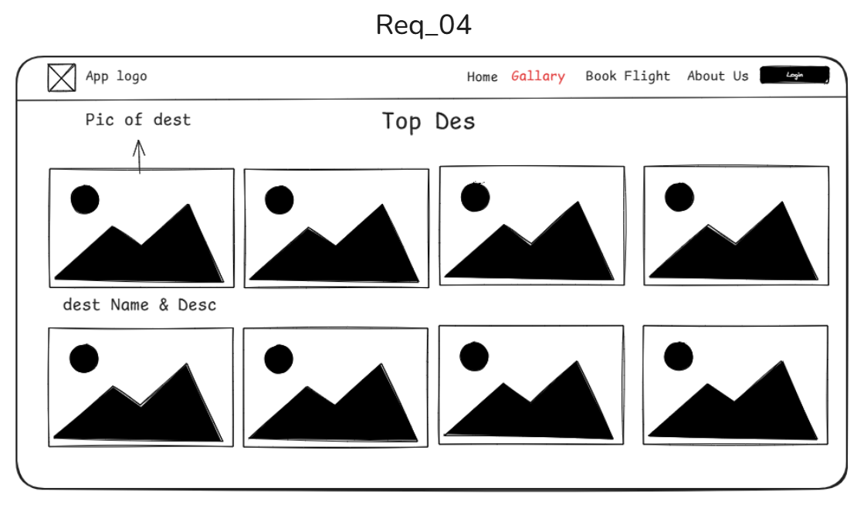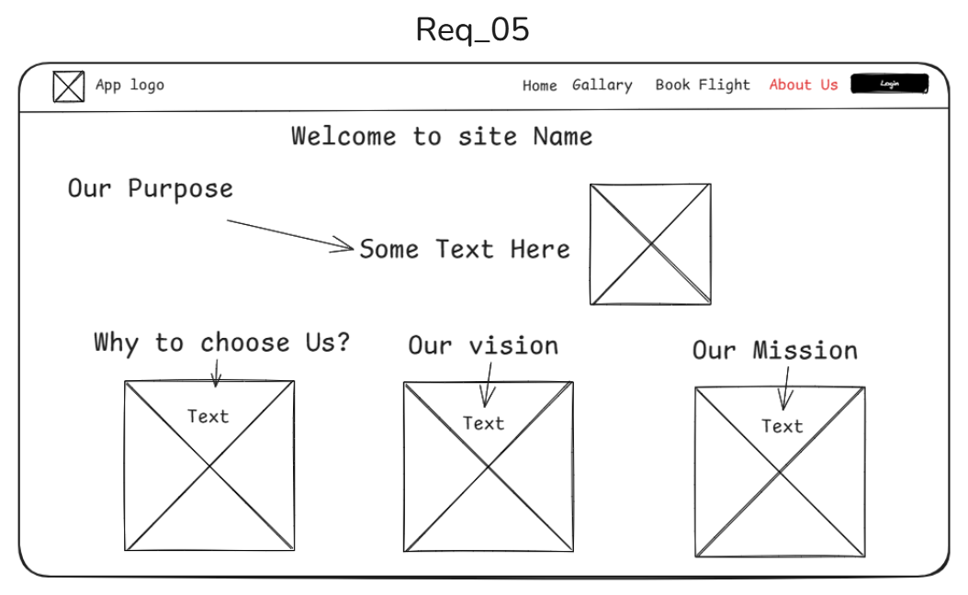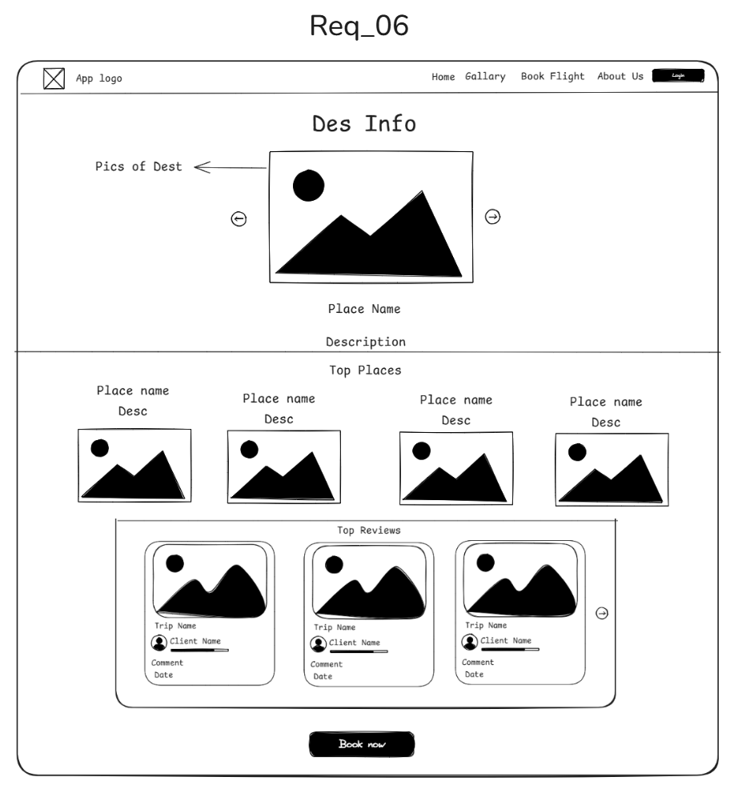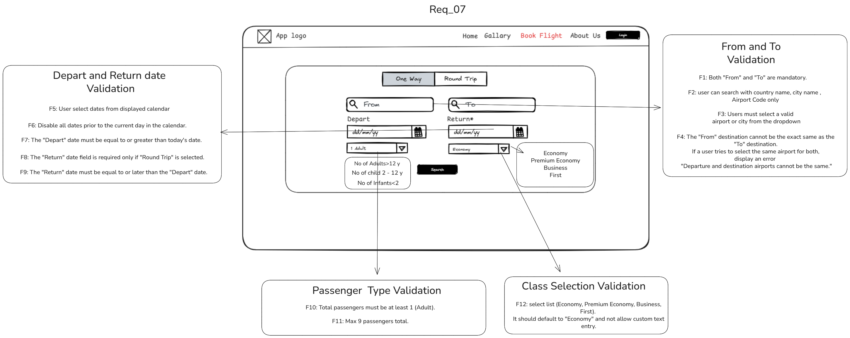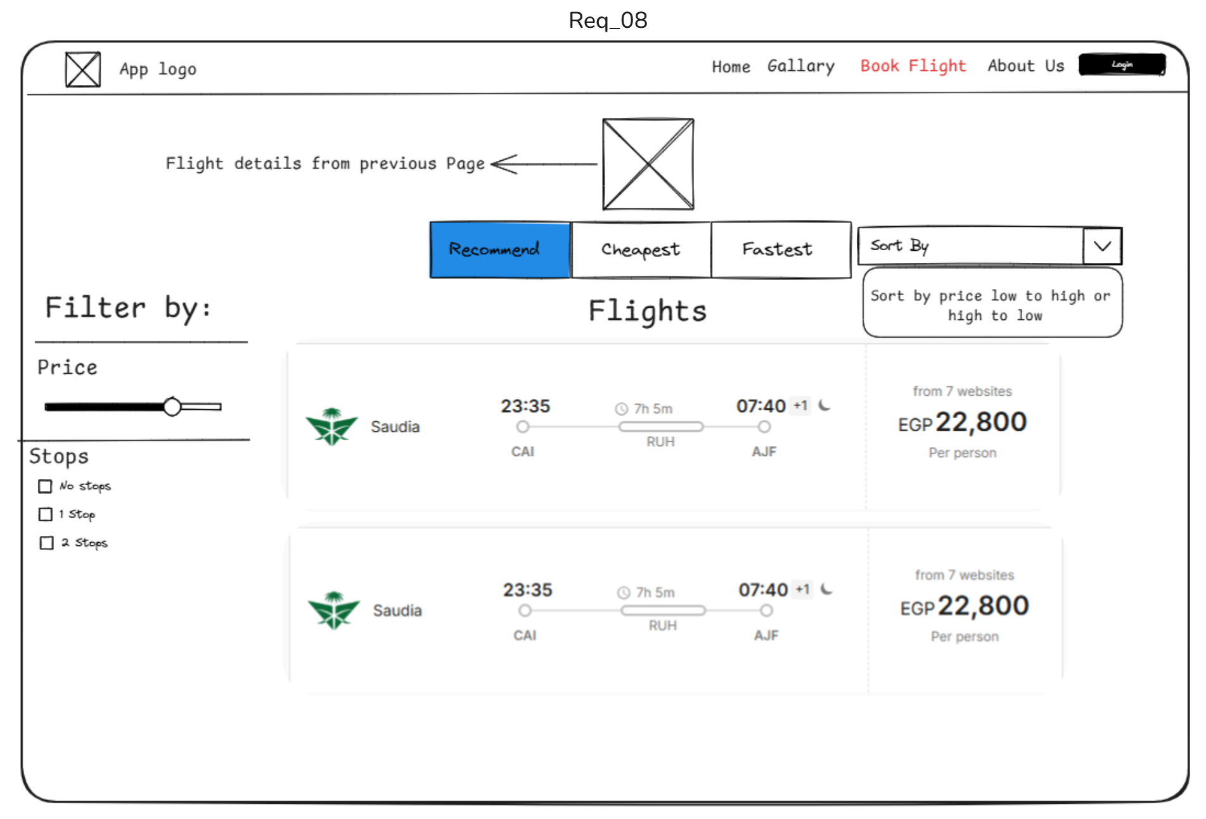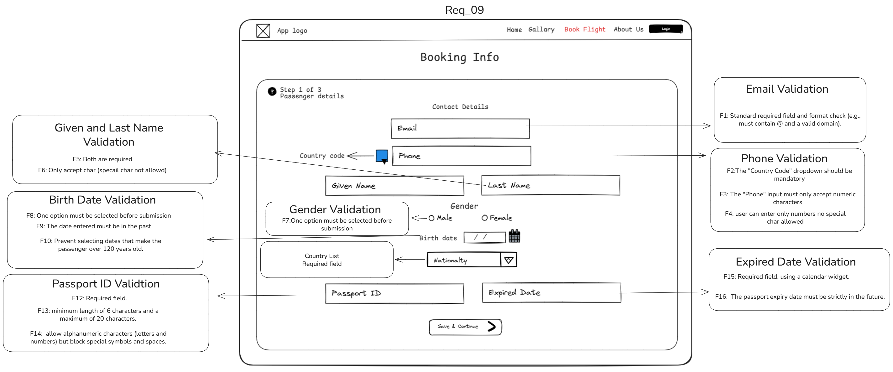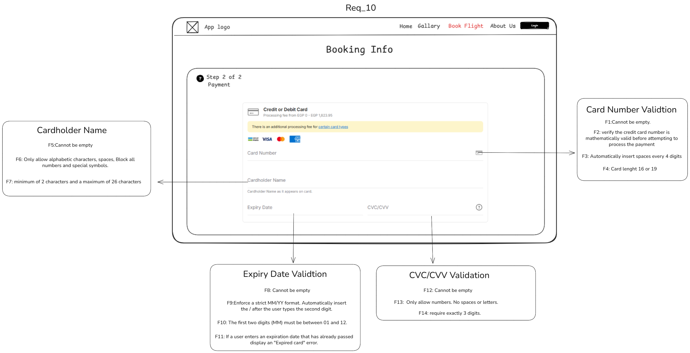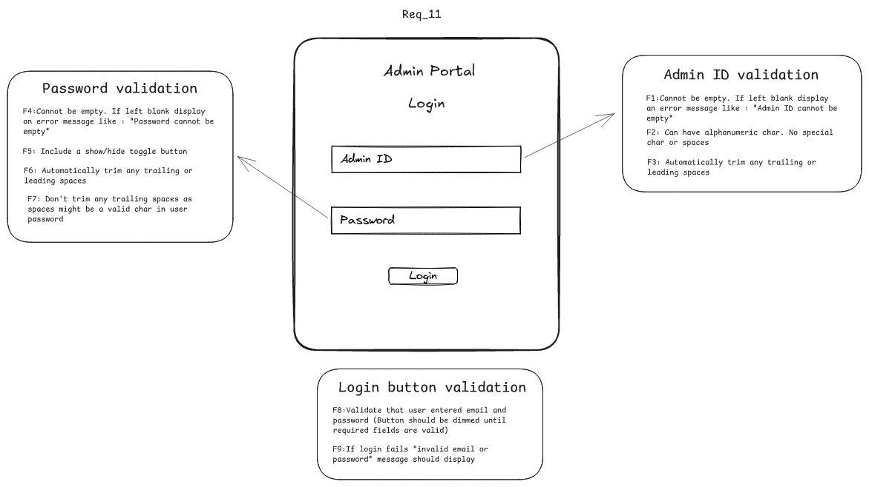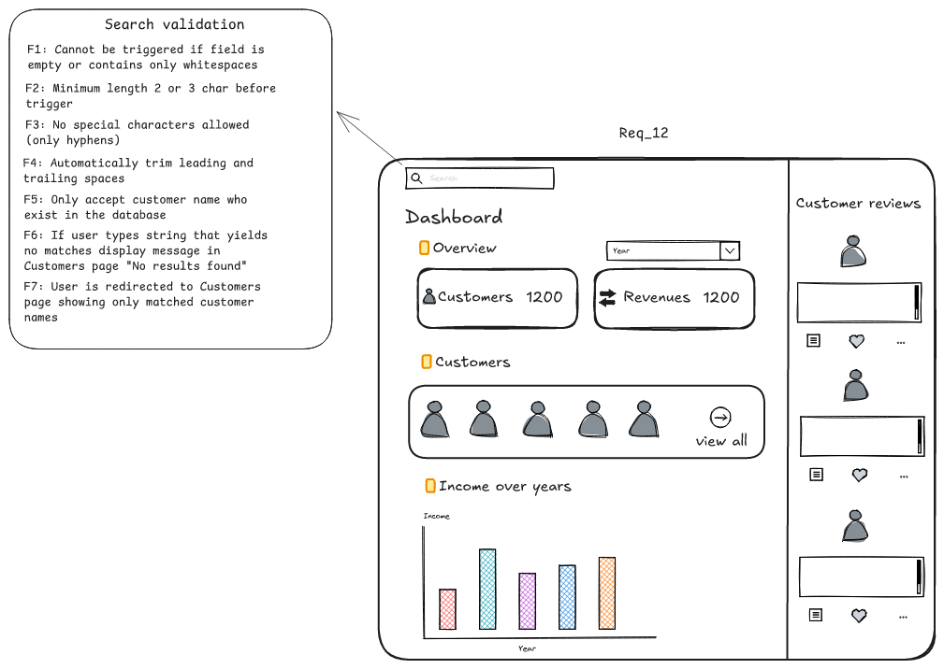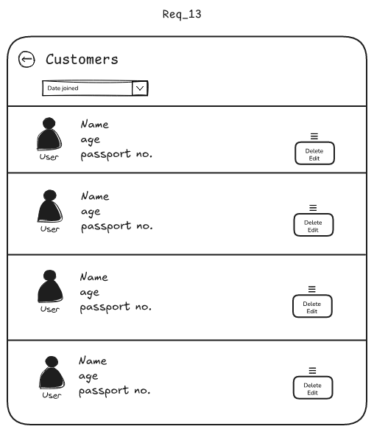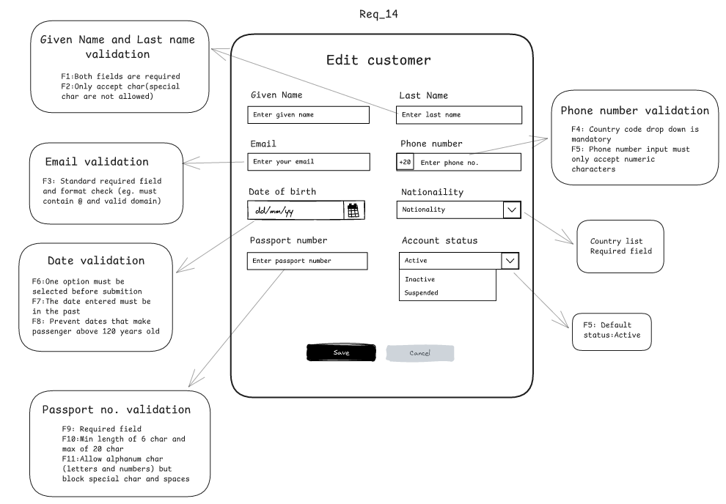

Hardware Interfaces
The Travel Advisor Website is a web-based system, so it does not need any special hardware devices to operate. Users can access the website using common devices such as desktop computers, laptops, tablets, and smartphones.

The main hardware components connected to the system are the user’s device, the web server, the database server, and the network equipment used for internet communication.
Users interact with the system through normal input and output devices such as a keyboard, mouse, touchscreen, and monitor.

Software Interfaces
- The system should work through standard web browsers such as Google Chrome, Mozilla Firefox, Microsoft Edge, and Safari, which allow users to access the website and interact with its pages.
- The website should run on a web server that receives user requests, processes system logic, and sends responses back to the browser.
- The system should connect to a database management system to store and retrieve all users’ data.
- The system may connect to an external payment gateway to process online payments securely.
- The system may connect to an email service to send booking confirmations, payment receipts, and notification messages to users.

Communications Interfaces
- The Travel Advisor Website is a web-based system, so it uses internet communication to connect users, servers, and external services. The main communication takes place between the user’s web browser and the web server that hosts the website.
- The system should use HTTPS for communication between the client and the server.
- Data exchanged between systems should follow standard web message formats such as form data, JSON, or other API response formats supported by the connected service.

System Features
This section provides the Features, requirements and validations for user and admin flows.

User Login
4.1.1 Description and Priority
This feature allows a registered user to log in to the system using email and password credentials. The system shall validate the entered data and grant access upon successful login.
Priority: High
4.1.2 Stimulus/Response Sequences
1. The user enters email and password and clicks Login.
2. The system validates the entered input.
3. If the input or credentials are invalid, the system displays the relevant error message.
4. If the credentials are valid, the system logs the user in and redirects the user to the next page.

4.1.3 Functional Requirements
Mockup Reference: REQ-01
UL-01: The system shall provide a Login page for registered users.
UL-02: The system shall provide an email input field and a password input field.
UL-03: The system shall provide a Login button to submit the entered credentials.
UL-04: The system shall authenticate the user using the submitted email and password.
UL-05: The system shall grant access when valid credentials are entered.
UL-06: The system shall display an error message when login fails due to invalid credentials.
UL-07: The system shall provide a Sign Up link for users who do not have an account.

Validations
UL-F1: The email field shall not be empty. If left blank, the system shall display an error message such as “Email is required.”
UL-F2: The email input shall follow a valid email format.
UL-F3: The system shall automatically trim leading and trailing spaces from the email value.
UL-F4: The password field shall not be empty. If left blank, the system shall display an error message such as “Password is required.”
UL-F5: The password field shall provide a Show/Hide Password toggle.
UL-F6: The password field shall allow a maximum length of 128 characters.
UL-F7: The system shall not trim password characters in a way that changes the actual password value.
UL-F8: The system shall validate that both email and password are entered before processing login.
UL-F9: If authentication fails, the system shall display an error message such as “Invalid email or password.”

User Registration
4.2.1 Description and Priority
This feature allows a new user to create an account by entering given name, last name, email, password, and confirm password. The system validates the entered data, prevents duplicate registration, and creates the account when all required conditions are met.
Priority: High

4.2.2 Stimulus/Response Sequences
1. The user enters the required registration data and clicks Register.
2. The system validates the entered input.
3. If any input is invalid, the system displays the relevant validation message.
4. If all entered data is valid, the system creates the user account.
5. The system confirms successful registration or redirects the user to the login page.
4.2.3 Functional Requirements
Mockup Reference: REQ-02

UR-01: The system shall provide a registration page for new users.
UR-02: The system shall provide input fields for first name, last name, email, password, and confirm password.
UR-03: The system shall provide a Register button to submit the entered registration data.
UR-04: The system shall allow a new user to create an account using valid registration data.
UR-05: The system shall verify that the submitted email is not already registered before creating the account.
UR-06: The system shall require the confirm password value to match the password value.
UR-07: The system shall display a validation message when any required or formatted input is invalid.
UR-08: The system shall create the account only after all validations pass.
UR-09: The system shall provide a Login link for users who already have an account.

Validations
UR-F1: Both given name and last name fields shall be mandatory. If either is left blank, the system shall display an error message such as "First name is required."
UR-F2: Given name and last name shall each have a minimum length of 2 characters and a maximum length of 50 characters.
UR-F3: Given name and last name shall not allow special characters.
UR-F4: The system shall automatically trim leading, trailing, and double spaces from given name and last name values.
UR-F5: The email field shall not be empty.
UR-F6: The email value shall pass a standard email format check.
UR-F7: After submission, the system shall check whether the entered email already exists in the database. If it already exists, the system shall display an error message such as "This email is already registered. Please log in."
UR-F8: The password field shall not be empty.
UR-F9: The password shall have a minimum length of at least 8 characters.
UR-F10: The password shall satisfy the defined complexity requirements, including at least one uppercase letter, one lowercase letter, one number, and one special character.
UR-F11: The confirm password field shall not be empty.
UR-F12: The confirm password value shall match the entered password value. If it does not match, the system shall display an error message such as "Passwords do not match."

Home Page
4.3.1 Description and Priority
This feature allows the user to view the main landing page of the website, including the navigation bar, website banner, top travel destinations, destination cards, top reviews, and access to additional destinations.
Priority: High
4.3.2 Stimulus/Response Sequences
1. The user opens the Home page.
2. The system displays the page header, navigation bar, and website banner.
3. The system displays destination cards and top reviews.
4. The user browses the displayed content.
5. The user clicks "See more destinations" to view additional destinations.
4.3.3 Functional Requirements
Mockup Reference: REQ-03
HP-01: The system shall provide a Home page.
HP-02: The system shall display the application logo on the Home page.
HP-03: The system shall display a navigation bar containing Home, Gallery, Book Flight, About Us, and Login.
HP-04: The system shall highlight the currently active page in the navigation bar.
HP-05: The system shall display a website banner on the Home page.
HP-06: The system shall display a Top Travel Destinations section.
HP-07: Each destination item in the Top Travel Destinations section shall display an image.
HP-08: Each destination item in the Top Travel Destinations section shall display a destination name and description.
HP-09: The system shall provide a "See more destinations" action.
HP-10: The system shall display a Top Reviews section on the Home page.
HP-11: Each review item shall display a trip image.
HP-12: Each review item shall display a trip name, client name, comment, and date.
HP-13: The system shall provide navigation controls for review browsing where applicable.

Destination Search
4.4.1 Description and Priority
This feature allows the user to search for a destination from the home page using the search field. The system validates the entered search text and returns matching destinations when valid input is provided.
Priority: High
4.4.2 Stimulus/Response Sequences
1. The user enters a destination value in the search field.
2. The system validates the entered value.
3. If the entered value is invalid, the system displays the related validation message or prevents search triggering.
4. If the entered value is valid, the system searches for matching destinations.
5. If matches are found, the system displays the matching destinations.
6. If no matches are found, the system displays a “No destinations found” message.
4.4.3 Functional Requirements
Mockup Reference: REQ-03
DS-01: The system shall provide a destination search field on the home page.
DS-02: The system shall allow the user to search using the destination search field.
DS-03: The system shall validate the entered search value before triggering the search.
DS-04: The system shall return matching destinations when the entered value is valid.
DS-05: The system shall display a message when no matching destinations are found.

Validations
DS-F1: The search shall not be triggered if the field is empty or contains only whitespace.
DS-F2: The system shall require a minimum length of 2 or 3 characters before triggering the search.
DS-F3: The search input shall not allow special characters except hyphens, apostrophes, and commas.
DS-F4: The system shall automatically trim leading and trailing spaces from the search value.
DS-F5: The search input shall only accept a city name, country code, or airport code.
DS-F6: If the user enters a value that yields no matches, the system shall display a clear message such as “No destinations found.”

Gallery
4.5.1 Description and Priority
This feature allows the user to browse and view the gallery page, which displays multiple destination images with their related names and descriptions.
Priority: Medium
4.5.2 Stimulus/Response Sequences
1. The user navigates to the Gallery page.
2. The system displays the gallery items.
3. The user views the displayed destination images and related information.
4.5.3 Functional Requirements
Mockup Reference: REQ-04
GAL-01: The system shall provide a Gallery page.
GAL-02: The system shall display multiple destination items on the Gallery page.
GAL-03: Each destination item shall include an image.
GAL-04: Each destination item shall display its related name and description.
GAL-05: The system shall allow the user to access the Gallery page from the navigation bar.

About Us
4.6.1 Description and Priority
This feature allows the user to view the About Us page, which presents the site introduction, purpose, vision, mission, and reasons to choose the service.
Priority: Medium

4.6.2 Stimulus/Response Sequences
1. The user navigates to the About Us page.
2. The system displays the About Us content.
3. The user views the presented text and visual sections.
4.6.3 Functional Requirements
Mockup Reference: REQ-05
AU-01: The system shall provide an About Us page.
AU-02: The system shall display the main introductory content on the About Us page.
AU-03: The system shall display a section describing the purpose of the service.
AU-04: The system shall display a section explaining why users should choose the service.
AU-05: The system shall display a section describing the vision of the service.
AU-06: The system shall display a section describing the mission of the service.
AU-07: The system shall allow the user to access the About Us page from the navigation bar.

Destination Details
4.7.1 Description and Priority
This feature allows the user to view detailed information about a selected destination, including destination images, place name, description, top places, reviews, and a booking action.
Priority: High
4.7.2 Stimulus/Response Sequences
1. The user opens a destination details page.
2. The system displays the destination image, place name, and description.
3. The user browses the destination images and related top places.
4. The user views customer reviews for the destination.
5. The user clicks the Book Now button to proceed with booking.

4.7.3 Functional Requirements
Mockup Reference: REQ-06
DD-01: The system shall provide a destination details page.
DD-02: The system shall display the selected destination image or images.
DD-03: The system shall display the place name of the selected destination.
DD-04: The system shall display the description of the selected destination.
DD-05: The system shall display a Top Places section related to the selected destination.
DD-06: Each item in the Top Places section shall display a place name, description, and image.
DD-07: The system shall display a Top Reviews section on the destination details page.
DD-08: Each review item shall display trip information, client name, comment, and date.
DD-09: The system shall provide navigation controls for browsing destination images or review items where applicable.
DD-10: The system shall provide a Book Now button on the destination details page.
DD-11: The system shall allow the user to proceed to the booking flow by clicking the Book Now button.

Flight Search
4.8.1 Description and Priority
This feature allows the user to search for available flights by selecting trip type, departure location, destination, travel dates, passenger count, and travel class.
Priority: High
4.8.2 Stimulus/Response Sequences
1. The user enters the flight search criteria and clicks Search.
2. The system validates the entered and selected values.
3. If any value is invalid, the system displays the related validation message or prevents search submission.
4. If all values are valid, the system processes the flight search request and returns matching results.

4.8.3 Functional Requirements
Mockup Reference: REQ-07
FS-01: The system shall provide a flight search page.
FS-02: The system shall allow the user to choose a trip type.
FS-03: The system shall provide From and To search fields.
FS-04: The system shall provide Depart and Return date fields.
FS-05: The system shall provide passenger selection controls.
FS-06: The system shall provide a class selection control.
FS-07: The system shall provide a Search button.
FS-08: The system shall validate the entered search criteria before processing the search request.
FS-09: The system shall process the search only when all required criteria are valid.

Validations
FS-F1: Both "From" and "To" fields shall be mandatory.
FS-F2: The user shall be able to search using country name, city name, or airport code only.
FS-F3: The user shall select a valid airport or city from the dropdown.
FS-F4: The "From" destination shall not be the same as the "To" destination. If both are the same, the system shall display an error such as "Departure and destination airports cannot be the same."
FS-F5: The user shall select dates from the displayed calendar.
FS-F6: The system shall disable all dates prior to the current day in the calendar.
FS-F7: The Depart date shall be equal to or later than today's date.
FS-F8: The Return date shall be required only if "Round Trip" is selected.
FS-F9: The Return date shall be equal to or later than the Depart date.
FS-F10: The total number of passengers shall be at least 1 adult.
FS-F11: The total number of passengers shall not exceed 9.
FS-F12: The class selection shall be limited to Economy, Premium Economy, Business, and First, shall default to Economy, and shall not allow custom text entry.

Flight Results
4.9.1 Description and Priority
This feature allows the user to view available flight results based on previously entered search criteria, compare result options, and use sorting and filtering controls to refine the displayed flights.
Priority: High
4.9.2 Stimulus/Response Sequences
1. The user opens the Flight Results page after submitting valid flight search criteria.
2. The system displays the previously selected flight details summary.
3. The system displays the available flight results.
4. The user applies filters or sorting options.
5. The system updates the displayed results accordingly.
4.9.3 Functional Requirements
Mockup Reference: REQ-08
FRS-01: The system shall provide a Flight Results page.
FRS-02: The system shall display the flight details received from the previous page.
FRS-03: The system shall display result category tabs including Recommend, Cheapest, and Fastest.
FRS-04: The system shall display a list of available flights.
FRS-05: Each flight result shall display airline information, departure time, arrival time, duration, route details, and price per person.
FRS-06: The system shall provide filter controls on the Flight Results page.
FRS-07: The system shall provide a price filter control.
FRS-08: The system shall provide stop-count filter options.
FRS-09: The system shall provide sorting controls on the Flight Results page.
FRS-10: The system shall provide a sort option for price from low to high or high to low.
FRS-11: The system shall update the displayed flight results according to the selected sorting or filtering criteria.

Passenger Details
4.10.1 Description and Priority
This feature allows the user to enter passenger and contact information required to continue the booking process, including email, phone, given name, last name, gender, birth date, nationality, passport ID, and passport expiry date.
Priority: High
4.10.2 Stimulus/Response Sequences
1. The user enters the required passenger and contact details.
2. The user clicks Save & Continue.
3. The system validates the entered and selected values.
4. If any value is invalid, the system displays the related validation message and prevents continuation.
5. If all values are valid, the system saves the passenger details and proceeds to the next booking step.
4.10.3 Functional Requirements
Mockup Reference: REQ-09
PD-01: The system shall provide a passenger details step in the booking flow.
PD-02: The system shall provide input fields for email, phone, given name, last name, birth date, nationality, passport ID, and passport expiry date.
PD-03: The system shall provide a country code selection control for phone entry.
PD-04: The system shall provide gender selection options.
PD-05: The system shall provide a nationality selection control.
PD-06: The system shall provide a Save & Continue action.
PD-07: The system shall validate all required passenger details before proceeding.
PD-08: The system shall save the entered passenger details only after all validations pass.

Validations
PD-F1: The email field shall be mandatory and shall follow a valid email format.
PD-F2: The country code dropdown shall be mandatory.
PD-F3: The phone input shall accept numeric characters only.
PD-F4: The phone input shall not allow special characters.
PD-F5: Given name and last name shall both be required.
PD-F6: Given name and last name shall accept alphabetic characters only and shall not allow special characters.
PD-F7: One gender option shall be selected before submission.
PD-F8: One birth date shall be selected before submission.
PD-F9: The entered birth date shall be in the past.
PD-F10: The system shall prevent selecting dates that make the passenger older than 120 years.
PD-F11: Nationality shall be selected from the country list and shall be required.
PD-F12: Passport ID shall be a required field.
PD-F13: Passport ID shall have a minimum length of 6 characters and a maximum length of 20 characters.
PD-F14: Passport ID shall allow alphanumeric characters only and shall block special symbols and spaces.
PD-F15: Passport expiry date shall be a required field and shall use a calendar widget.
PD-F16: The passport expiry date shall be strictly in the future.

Payment
4.11.1 Description and Priority
This feature allows the user to enter card payment details to complete the booking process, including card number, cardholder name, expiry date, and CVC/CVV.
Priority: High
4.11.2 Stimulus/Response Sequences
1. The user enters the payment details.
2. The user submits the payment information.
3. The system validates the entered values.
4. If any value is invalid, the system displays the related validation message and prevents payment processing.
5. If all values are valid, the system proceeds with payment processing.
4.11.3 Functional Requirements
Mockup Reference: REQ-10
PAY-01: The system shall provide a payment step in the booking flow.
PAY-02: The system shall provide input fields for card number, cardholder name, expiry date, and CVC/CVV.
PAY-03: The system shall validate the entered payment details before processing the payment.
PAY-04: The system shall process payment only after all validations pass.

Validations
PAY-F1: The card number field shall not be empty.
PAY-F2: The system shall verify that the credit card number is mathematically valid before attempting payment processing.
PAY-F3: The system shall automatically insert spaces after every 4 digits in the card number field.
PAY-F4: The card number shall have a length of 16 or 19 characters.
PAY-F5: The cardholder name field shall not be empty.
PAY-F6: The cardholder name field shall allow alphabetic characters and spaces only, and shall block numbers and special symbols.
PAY-F7: The cardholder name shall have a minimum length of 2 characters and a maximum length of 26 characters.
PAY-F8: The expiry date field shall not be empty.
PAY-F9: The expiry date field shall enforce a strict MM/YY format and shall automatically insert the slash after the second digit.
PAY-F10: The month value in the expiry date shall be between 01 and 12.
PAY-F11: If the entered expiry date has already passed, the system shall display an "Expired card" error.
PAY-F12: The CVC/CVV field shall not be empty.
PAY-F13: The CVC/CVV field shall allow numbers only and shall not allow spaces or letters.
PAY-F14: The CVC/CVV field shall require exactly 3 digits.

Admin Login
4.12.1 Description and Priority
This feature allows an admin user to log in to the Admin Portal using Admin ID and password.
Priority: High
4.12.2 Stimulus/Response Sequences
1. The admin enters Admin ID and password and clicks Login.
2. The system validates the entered values.
3. If any entered value is invalid, the system displays the related validation message or keeps the Login button unavailable.
4. If the entered credentials are valid, the system logs the admin in.

4.12.3 Functional Requirements
Mockup Reference: REQ-11
AL-01: The system shall provide an Admin Portal Login page.
AL-02: The system shall provide an Admin ID input field.
AL-03: The system shall provide a password input field.
AL-04: The system shall provide a Login button.
AL-05: The system shall validate the entered Admin ID and password before processing login.
AL-06: The system shall authenticate the admin using the submitted credentials.
AL-07: The system shall allow admin access only after successful authentication.
AL-08: The system shall display an authentication error message when login fails.

Validations
AL-F1: The Admin ID field shall not be empty. If left blank, the system shall display an error message such as "Admin ID cannot be empty."
AL-F2: The Admin ID field shall allow alphanumeric characters only and shall not allow special characters or spaces.
AL-F3: The system shall automatically trim leading and trailing spaces from the Admin ID value.
AL-F4: The password field shall not be empty. If left blank, the system shall display an error message such as "Password cannot be empty."
AL-F5: The password field shall provide a Show/Hide toggle button.
AL-F6: The system shall automatically trim leading or trailing spaces from the password value.
AL-F7: The system shall not trim trailing spaces if such spaces are intended to be valid password characters.
AL-F8: The system shall validate that both Admin ID and password are entered before enabling or processing the Login action.
AL-F9: If login fails, the system shall display an error message such as "Invalid email or password."

Admin Dashboard
4.13.1 Description and Priority
This feature allows the admin to view the dashboard overview, including customer count, revenues, income over years, customer reviews, and quick access to customers.
Priority: High

4.13.2 Stimulus/Response Sequences
1. The admin opens the Dashboard page.
2. The system displays the overview information and dashboard sections.
3. The admin views customers, revenues, income chart, and customer reviews.
4. The admin uses the available controls such as year selection, customer navigation, or search.
4.13.3 Functional Requirements
Mockup Reference: REQ-12
DB-01: The system shall provide a Dashboard page.
DB-02: The system shall display an Overview section on the Dashboard page.
DB-03: The system shall display a Customers summary card.
DB-04: The system shall display a Revenues summary card.
DB-05: The system shall provide a year selection control.
DB-06: The system shall display a Customers section with a view all action.
DB-07: The system shall display an Income over years chart.
DB-08: The system shall display a Customer reviews section.
DB-09: The system shall provide a search field on the Dashboard page.

Dashboard Search
4.14.1 Description and Priority
This feature allows the admin to search for customers from the Dashboard search field and navigate to the Customers page with matching results.
Priority: High
4.14.2 Stimulus/Response Sequences
1. The admin enters a customer name in the Dashboard search field.
2. The system validates the entered search value.
3. If the entered value is invalid, the system prevents the search and displays the related validation behavior.
4. If the entered value is valid, the system searches for matching customer names.
5. If matches are found, the system redirects the admin to the Customers page showing only the matched customer names.
6. If no matches are found, the system displays a “No results found” message on the Customers page.

4.14.3 Functional Requirements
Mockup Reference: REQ-12
DSR-01: The system shall provide a search field on the Dashboard page.
DSR-02: The system shall allow the admin to search for customers using the Dashboard search field.
DSR-03: The system shall validate the entered search value before triggering the search.
DSR-04: The system shall search only for customer names that exist in the database.
DSR-05: The system shall redirect the admin to the Customers page showing only matched customer names when matches are found.
DSR-06: The system shall display a “No results found” message on the Customers page when no matches are found.

Validations
DSR-F1: The search shall not be triggered if the field is empty or contains only whitespaces.
DSR-F2: The system shall require a minimum length of 2 or 3 characters before triggering the search.
DSR-F3: The search input shall not allow special characters except hyphens.
DSR-F4: The system shall automatically trim leading and trailing spaces from the search value.

Customers Management
4.15.1 Description and Priority
This feature allows the admin to view the customers list and manage each customer record through the available actions.
Priority: High
4.15.2 Stimulus/Response Sequences
1. The admin opens the Customers page.
2. The system displays the list of customers.
3. The admin views customer details shown in each row.
4. The admin uses the available action menu for a selected customer.
5. The system performs the selected management action.
4.15.3 Functional Requirements
Mockup Reference: REQ-13
CM-01: The system shall provide a Customers page.
CM-02: The system shall display a list of customers on the Customers page.
CM-03: Each customer entry shall display the customer image or avatar.
CM-04: Each customer entry shall display the customer name.
CM-05: Each customer entry shall display the customer age.
CM-06: Each customer entry shall display the customer passport number.
CM-07: The system shall provide an action control for each customer entry.
CM-08: The action control shall provide Edit and Delete actions for the selected customer.
CM-09: The system shall provide a sorting or filtering control at the top of the Customers page.

Edit Customer
4.16.1 Description and Priority
This feature allows the admin to edit an existing customer record by updating personal and account details, then saving the changes.
Priority: High
4.16.2 Stimulus/Response Sequences
1. The admin opens the Edit Customer page.
2. The system displays the editable customer fields.
3. The admin updates one or more values.
4. The admin clicks Save.
5. The system validates the entered values.
6. If any value is invalid, the system displays the related validation message and prevents saving.
7. If all values are valid, the system saves the updated customer record.
4.16.3 Functional Requirements
Mockup Reference: REQ-14
EC-01: The system shall provide an Edit Customer page.
EC-02: The system shall provide input fields for given name, last name, email, phone number, date of birth, nationality, passport number, and account status.
EC-03: The system shall provide Save and Cancel actions.
EC-04: The system shall validate the entered customer data before saving.
EC-05: The system shall save the updated customer data only after all validations pass.
EC-06: The system shall allow nationality to be selected from a country list.
EC-07: The system shall provide account status options including Active, Inactive, and Suspended.

Validations
EC-F1: Both given name and last name shall be required.
EC-F2: Given name and last name shall accept alphabetic characters only and shall not allow special characters.
EC-F3: The email field shall be required and shall follow a valid email format.
EC-F4: The country code dropdown for phone number shall be mandatory.
EC-F5: The phone number input shall accept numeric characters only.
EC-F6: One date shall be selected before submission.
EC-F7: The entered date shall be in the past.
EC-F8: The system shall prevent dates that make the passenger older than 120 years.
EC-F9: Passport number shall be a required field.
EC-F10: Passport number shall have a minimum length of 6 characters and a maximum length of 20 characters.
EC-F11: Passport number shall allow alphanumeric characters only and shall block special characters and spaces.
EC-F12: Nationality shall be selected from the country list and shall be required.
EC-F13: The default account status shall be Active.

Performance Requirements
The website should load main pages within a few seconds under normal internet conditions, and search results should be displayed quickly after the user submits a request.

Security Requirements
The system should protect user accounts and personal information by requiring secure login and using protected communication for sensitive data such as payment details.

Business Rules
- Only registered users can book flight tickets, cancel reservations, or view booking history.

- Guest users can search for flights and view flight details, but they cannot complete a booking.

- A booking shall not be confirmed until the payment process is completed successfully.

- Each confirmed booking shall have a unique booking ID.

- Only admin can manage the website, user accounts and monitor all bookings.

- The system shall not display flights as available if there are no remaining seats.

