# SETTING UP A DARK KITCHEN IN PERTH

Syed Muhammad Ahmed Zaidi

**OVERVIEW**

## Australia does not lag behind as the global trend for increased food deliveries rises. There were 5.5 million Australians who utilized food delivery services in 2020, and since then, the rate has been increasing at exponential growth. (Australian Food Delivery Statistics of 2023 – Accumulate Australia, 2023). They spent almost $2.6 billion on takeout orders with a market size of $851 million for online food delivery platforms which is a 20.6% growth for food delivery platforms like UberEats and Deliveroo (20+ Gripping Food Delivery Statistics in Australia, 2022). This may all be categorized as an impact of Covid-19; however, it paved the way for expanding a business model called Dark Kitchen (Shankar et al., 2022). With a prediction for global Ghost kitchens to almost double from 2019 to a staggering $71.4 billion industry by 2027(Ghost Kitchen Forecast: Steaming HOT!, 2021), now one in every 25 of the restaurants listed with Uber Eats in Australia is as a virtual restaurant (Ghost Kitchens and virtual restaurants, 2022). This trend has also entered the city of lights, Perth, which will be analyzed through this data management plan.

**ASSUMPTIONS**

In this report, we will be assuming a scenario of setting up a multi-brand Dark kitchen that is owned by the same mother brand but operates multiple fast food brands under it. It will be making use of aggregator platforms like UberEats, Menulog, and DoorDash to make sales but it also has its own delivery fleet that is being marketed through social media apps.

The city of Belmont was selected to be the setup location due to multiple reasons, one being the service availability of all the above-mentioned aggregator platforms. Belmont rests in the heart of Perth with only a 6 km difference from the City (Why Belmont? | City of Belmont, n.d.) and is recognized as a suburb very close to the airport. The demographics show an adequate population density that will reach up to 65,659 by 2041 (Profile and Statistics | City of Belmont, n.d.). The area also has 23% employment opportunities with a highly vibrant/diverse culture reflecting easy availability of labor (Why Belmont? | City of Belmont, n.d.).

**5V's OF DATA**

Once the dark kitchen is up and running the data will be produced internally, however, it uses POS (point of Sale) proprietary software by Deliverect called MyOrderBox that allows it to keep track of all orders coming from all delivery platforms under one system (Deliverect AUS | MyOrderBox Connected to UberEats, Deliveroo, and More, n.d.).

.

**Volume:** The volume of data is correlated with the scale of the business. It includes several categories ranging from data related to supply chain like buying, stocking, transportation, distribution among brands, and more. It will have data related to the customer base. This will continue to increase as more deliveries are made to new customers. The data would include information that allows the business to create and maintain long-term relationships, for example, customer profiles, contact information, order history, and feedback. The data relating to orders can be in high volume as it comprises the details of the order itself and all related financial aspects. Operational data would also be generated irrespective of the number of sales. This may include staff scheduling, equipment usage, and other day-to-day activities.

**Variety:** The variety of data in this field of business is also quite extensive. Apart from all the categories discussed above, the types can also be divided into structured or unstructured data. Structured data would include customer data (demographics, buying behavior), order details (order number, quantity, prices), and financial data (revenues, cost, profits). On the other hand, unstructured data would include information like reviews, feedback, social media comments, and more. This category of data also requires high-performing hardware/software solutions while digging for insights. Other types of data could be categorized as external data, including industry reports, and market trends, that can be provided by MyOrderbox software. The variety shows that a multiple-branded ghost kitchen would need high storage capacities to keep data separate for each brand hence, storing it in a cloud service like Microsoft One Drive would be an ideal choice.

**Velocity:** The velocity of data is also highly dependent on the quantity of sales. However, for any virtual kitchen, Real-Time order data is being produced. It includes the order details, status, and delivery information. All this needs high-efficiency software to provide accurate results for decision-making. At the same time, with ghost kitchens, marketing is a crucial aspect of its success, and with that, data is produced at high velocity on social media and other platforms being used.

**Veracity**: In such forms of business structures, data veracity is an essential part. Failure to produce authentic data can lead to erroneous decision-making, impacting the restaurant's success. Customers expect nothing less than perfection in their eateries; any false data production could lead to complete miss management of an order and the loss of a potential long-term customer.

**Value:** The value of this data can be very significant as it is used to produce business insights. All data relating to customers and orders can be assessed using statistical methods to find the best items that should be kept on the menu for the most sales. The external data can also add value when deciding to add or remove any cuisine from the brand portfolio.

**DATA LIFECYCLE AND ACQUISITION**

## The data lifecycle for any dark kitchen would start with generation at distinct stages of an order. Following that, the process of acquisition will take place from different sources. For example, employee data would be collected through employee management software such as Workzone or Deputy. This would include their credentials, rostering, and more. Similarly, anything about the order would be collected through the POS software setup to integrate all orders from different partners like UberEats and Menulog. This would include data about the order and also for each customer placing the order. All these data points will be processed with validation and then stored in cloud storage. They will then be retrieved at different times depending on their usage. For example, operational data would be retrieved more often for day-to-day activities, while monthly data can be more useful for making market trends. All this would be analyzed using statistical techniques to find insights that may lead to the further success of the restaurant. This will then be visualized using software like Microsft Excel and PowerBI. The management will then interpret and make decisions that could benefit each brand under the Dark Kitchen.

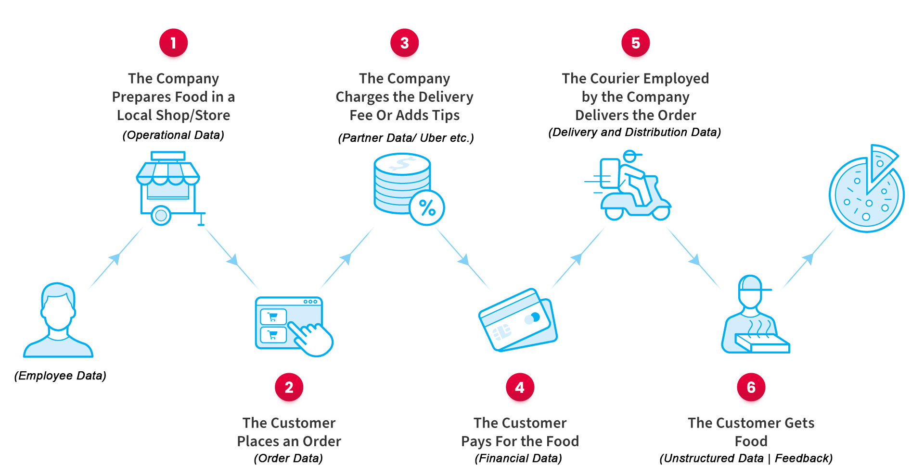

**DATA TYPES**

For a Dark Kitchen, data types would include the following

**Transaction Data:** All the records for the activities carried out for the kitchen would be included in this category. For example, customer orders, sales transactions, financial transactions, and more.

**Master Data:** All data that can remain stable and unique and be used in all brands of the mother kitchen falls under this term. Examples of this would include the primary key data example, Brand ID, customer ID, menu items ID, order ID, employee ID, and more.

**BI Data:** This would include anything that is business intelligence used for the betterment of the overall brand. Anything related to the insight analysis, for example, different types of metrics including performance (KPIs), customer satisfaction, and, operational would fall under this category.

**Reference Data:** This would provide context to other data; hence for Dark Kitchen, examples include the menu being divided into Appetizers, Main Courses, or Desserts. The food can be given context by giving it categories like different types of pizzas, including supreme, chicken Tikka, and Fajita.

**Metadata:** This includes information about the data, for example, the formats of the files produced by different systems. Another example would be that the employee data columns would show the employee name as a string while the joining date is the date format.

**DATA GOVERNANCE**

**Data Owners:** For the dark kitchen, the data owner would be the owner of the mother brand itself. Each of the managers of the fast-food brands would also be the data owner as they will have access to complete information, including confidential data, so it aids in central decision-making.

**Data Stewards:** In this scenario, the data stewards would be data analysts, and data administrators hired by the mother brand, who would ensure that data acquisition and handling are done with quality so the owners can rely on it for improved governance. There will also be data stewards of POS systems and delivery partners who would be dealing with data at their end.

**Data Users:** This category would include all the stakeholders with access to the data. Starting from the upper levels of the hierarchy till going deeper down, everyone, including managers using it for analysis, chefs for food improvement, and marketers for ad postings, will be a part of this. The data users can also be external stakeholders who have been given access through consent.

**DATA QUALITY**

In order to have quality data, the dark kitchen could set up a Data Governance Framework allowing policies and procedures to be created that would instill responsibility and accountability for anyone managing or adding to the dataset. Data Validation and verification checks could also be added within different phases of the data life cycle to minimize errors and improve the overall data quality standards. The mother brand could create a data dictionary that serves as a centralized repository of metadata and data definitions. This would help data stewards carry out metadata management through occasional audits, ensuring there are no discrepancies in formats, sources, and file management. If still found, data cleaning and management processes can be carried out to rectify inconsistencies and improve standardization.

**DATA SECURITY AND PRIVACY**

A newly established dark kitchen would need to comply with Australian Data Protection Laws for improved protection. The business could also employ vigorous access control mechanisms that only allow data access according to user roles and permissions. For example, one fast food brand cannot access the information of the other brand unless authorized. Furthermore, they could use firewalls, intrusion detection systems, and antimalware antivirus systems to mitigate potential security vulnerabilities. Partnering with big brands like UberEats and Menulog would also allow learning and incorporating their data security and privacy techniques. Lastly, having proprietary software dealing with all combined ordering would have a built-in data protection system allowing safe and smooth data usage.

**DATA ANALYSIS**

**Preliminary Exploration:** For the initial decision of location, data related to demand, demographics, traffic, rents, competition, and labor availability will be explored. Once the setup is complete and data has been acquisition starts, we can use metadata management to check for discrepancies in the early produced data to rectify them before further data collection and analysis takes place. See Appendix 1 for hypothetical data tables.

**Illustrative Visualizations**: Next step would be to create visualizations based on the current data. This would mean using software like PowerBI, Microsoft Excel, Python, or R Studio to create different charts and graphs to find interesting insights. The charts could include a scatter plot showing how many sales each brand made in the last month. Pie charts could also be created to see which menu item is most popular and can be used to make adjustments. Charts based on maps (heatmaps) could also be generated using Python to see which areas around Belmont are ordering more as this analysis could help in making marketing decisions.

**Prediction and Modeling:** Prediction Modelling and forecasting can be done to use past data and find insights into the future. For a dark kitchen, the sales data can be used to forecast trends in the future and find seasonal variations. See Appendix 4 for a hypothetical Model. This could help in inventory management to keep ingredients for the most demanded menu items. Partner companies like UberEats and DoorDash have top-notch technology to predict delivery timings. Similarly, Customer buying behaviors from past orders could also be used in a prediction model to recommend something they might be more interested in purchasing.

**REFERENCES**

*20+ Gripping Food Delivery Statistics in Australia*. (2022, May 3). Take a Tumble. https://takeatumble.com.au/insights/lifestyle/food-delivery-statistics-australia/

Ahmed Khan, T., Arman Khan, S., Haque, S., & Ayub, M. F. B. (2022, November 29). A Study on the Prospect of the Cloud Kitchen Model in Dhaka. *International Journal of Business and Management*, *18*(1), 46. https://doi.org/10.5539/ijbm.v18n1p46

*Australian Food Delivery Statistics of 2023 – Accumulate Australia*. (2023, April 15). Australian Food Delivery Statistics of 2023 – Accumulate Australia. https://accumulate.com.au/australian-food-delivery-statistics-of-2023/

B. (2022, September 7). *Ghost Kitchens and virtual restaurants*. Baking Business. https://bakingbusiness.com.au/ghost-kitchens-and-virtual-restaurants/

*Deliverect | How to start a ghost kitchen in 10 steps*. (n.d.). Deliverect | How to Start a Ghost Kitchen in 10 Steps. https://www.deliverect.com/en/blog/dark-kitchens/how-to-start-a-ghost-kitchen-in-10-steps

*Deliverect AUS | MyOrderBox connected to Uber Eats, Deliveroo, and more*. (n.d.). Deliverect AUS | MyOrderBox Connected to Uber Eats, Deliveroo, and More. https://www.deliverect.com/en-au/integrations/myorderbox

*Ghost Kitchen Forecast: Steaming HOT!* (2021, June 17). Hospitality Technology. https://hospitalitytech.com/ghost-kitchen-forecast-steaming-hot

*Perth’s foodie credentials under review*. (2019, October 8). Community News. https://www.perthnow.com.au/community-news/western-suburbs-weekly/perths-foodie-credentials-under-review-c-892024

*Profile and statistics | City of Belmont*. (n.d.). Profile and Statistics | City of Belmont. https://www.belmont.wa.gov.au/about-us/our-city/future-direction/profile-and-statistics

Shankar, A., Jebarajakirthy, C., Nayal, P., Maseeh, H. I., Kumar, A., & Sivapalan, A. (2022, July). Online food delivery: A systematic synthesis of literature and a framework development. *International Journal of Hospitality Management*, *104*, 103240. https://doi.org/10.1016/j.ijhm.2022.103240

*Shedding Light on Dark Kitchens*. (2022, July 14). Shedding Light on Dark Kitchens. https://blog.foodsafety.com.au/shedding-light-dark-kitchens

*Why Belmont? | City of Belmont*. (n.d.). Why Belmont? | City of Belmont. <https://www.belmont.wa.gov.au/business/business-in-our-city/why-belmont>

**APPENDIX**

**Appendix 1: Hypothetical Data Tables for Dark Kitchen**

**Orders Table**

|  |  |  |  |  |
| --- | --- | --- | --- | --- |
| Primary Key (Order ID) | Secondary Key (Customer ID) | Date Ordered | Address of Delivery | Total Amount |
| 1 | 1001 | 17/04/2023 | 123 Bentley Perth | $36.00 |
| 2 | 1002 | 17/04/2023 | 456 Gild street, Perth | $74.50 |
| 3 | 1003 | 18/04/2023 | 789 Cloverdale, Perth | $25.20 |
| 4 | 1004 | 18/04/2023 | 246 Victoria Park, Perth | $65.65 |

**Customers Table**

|  |  |  |  |  |
| --- | --- | --- | --- | --- |
| Primary Key (Customer ID) | First Name | Last Name | Email Address | Phone # |
| 1001 | Ahmed | Zaidi | Ahmed@gmail.com | 0426949441 |
| 1002 | Hassan | Shahid | ShahidHassan@hotmail.com | 0426678754 |
| 1003 | Adil | Khan | AdilK@Outook.com | 0426699887 |
| 1004 | Sibtain | Ali | Ali.Sib@gmail.com | 0427867865 |

**Menu Items**

|  |  |  |  |  |
| --- | --- | --- | --- | --- |
| Primary Key (Item ID) | Item Name | Category | Price ($) | Description |
| 1 | Mughlai | Pizza | $15.50 | Classic pizza with tomato and Chicken tikka |
| 2 | Thai | Noodles | $11.50 | A traditional Thai noodle dish |
| 3 | Butter Chicken | Curry | $14.00 | Creamy chicken curry |
| 4 | Chicken Burger | Burgers | $4.50 | Juicy Chicken patty with fries |

**Ingredients Table**

|  |  |  |  |
| --- | --- | --- | --- |
| Primary Key (Ingredient ID) | Ingredient Name | Supplier | Unit Price |
| 1 | Tomatoes | Freshtomato.org | $4.00 |
| 2 | Flour | Spudshed | $13.50 |
| 3 | Halal Chicken | Coles | $15.00 |
| 4 | Pizza Sauce | Hienz | $5.50 |

**Inventory Table**

|  |  |  |
| --- | --- | --- |
| Primary Key (Inventory ID) | Ingredient ID (Foreign Key) | Quantity |
| 1 | 1 | 1000 |
| 2 | 2 | 500 |
| 3 | 3 | 300 |
| 4 | 4 | 800 |

**Appendix 2 : Metadata Table**

**MetaData Table**

|  |  |  |  |
| --- | --- | --- | --- |
| Table Name | Column Name | Data Type | Description |
| Orders | Order ID | Integer | Primary key for the Orders table |
| Orders | Customer ID | Integer | Secondary key referencing Customer ID |
| Orders | Date of Order | Date | Date of the order placement |
| Orders | Address of Delivery | String | Address where the order is to be delivered |
| Orders | Total Amount | Decimal(10,2) | Total amount of the order |
| Customers | Customer ID | Integer | Primary key for the Customers table |
| Customers | First Name | string | First name of the customer |
| Customers | Last Name | String | Last name of the customer |
| Customers | Email Address | String | Email address of the customer |
| Customers | Phone # | String | Phone number of the customer |
| Menu Items | Item ID | Integer | Primary key for the Menu Items table |
| Menu Items | Item Name | String | Name of the menu item |
| Menu Items | Category | String | Category of the menu item (e.g., Pizza, Noodles) |
| Menu Items | Price ($) | Decimal(10,2) | Price of the menu item |
| Menu Items | Description | String | Description of the menu item |
| Ingredients | Ingredient ID | Integer | Primary key for the Ingredients table |
| Ingredients | Ingredient Name | String | Name of the ingredient |
| Ingredients | Supplier | String | Supplier of the ingredient |
| Ingredients | Unit Price | Decimal(10,2) | Price per unit of the ingredient |

**Appendix 3 : Relationship Model (Using PowerBI)**

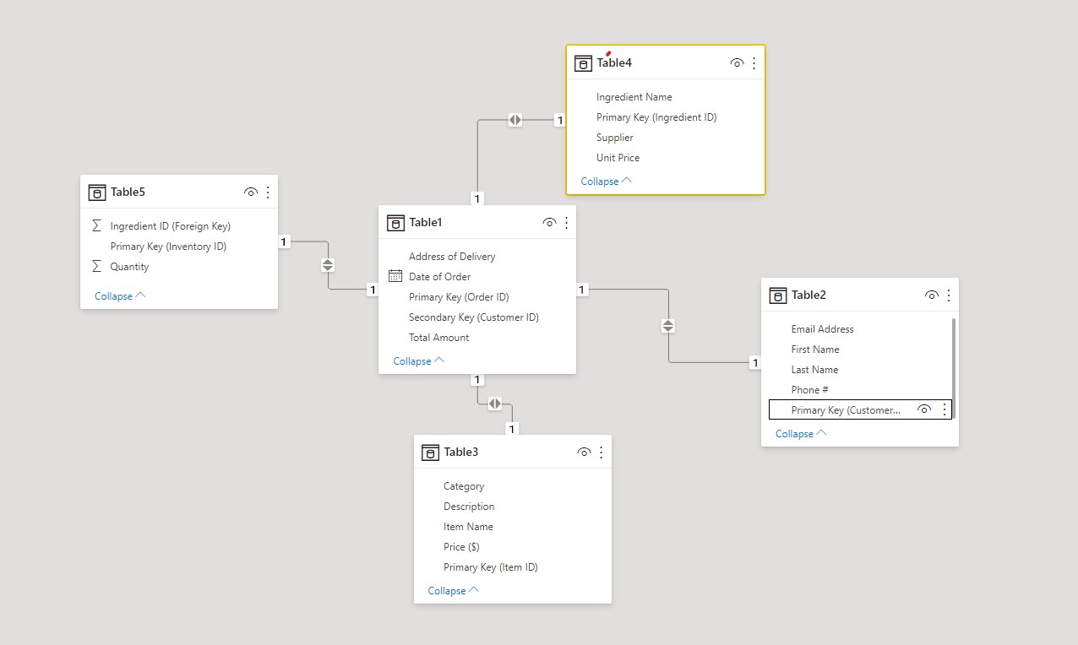

PowerBI was used to import all hypothetical tables from an Excel sheet for this relationship modeling. These relationships were then automatically detected with the identification of Primary keys turning into Foreign keys in other tables.

**Appendix 4: Pseudocode and Computer Code (Python) to create a hypothetical forecasting model for Dark Kitchen's Sales**

1. **Importing Relevant Libraries.**

First, we need to import the libraries that are required to complete this code.

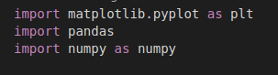

1. **Loading sales dataset**

By using Panda Library we can read the data from our csv file called ghostkitchensales.csv



1. **Resample the data into the required frequency:**

This will allow mutating the original frequency (hourly, weekly) into the required frequency (daily,

monthly. Resample is another function of the Panda Library. It allows consistency in data if data is found in different dates.



1. **Specifying the window size:**

The window size determines the quantity of data points being used to find the average. Sales data will be picked from the dataset, and then the method of Rolling will be used from Pandas library to divide the data points according to the window size and to find the mean at each interval.



1. **Ploting the Graph**

Lastly, the Matplotlib library is used in order to plot the graph that shows the forecasting. This allows setting the title, the x labels, y labels, and also adding a legend.

