MATH5007 2024 Sem 1: Assignment 3 (Bentley)

Name : Syed Muhammad Ahmed Zaidi

Student Id : 20972008

**Question 1: General (30 Marks); max 300 words**

The unit provided you with knowledge and skill sets on optimization (and later simulation) and introduced you to models implemented with AMPL.

1. Why is the knowledge of optimisation valuable with respect to providing decision support even in case you are not in charge of creating and solving optimisation models? Should managers have at least an introduction to optimisation? **8M**

Ans) With respect to providing decision support, knowledge of optimization can still be very crucial as it highly contributes to the understanding of any problem while critically thinking about the objective that needs to be achieved and the contraints limiting the solution space. I believe managers should indeed have an introduction to optimization as it helps them structure problems better. This skill sharpens the ability to reach conclusions in a systematic manner and hence aiding them make effective decisions. Understanding the problem in a clear manner can also be a key for managers to have clear communication with other departments of the business.

1. Explain IN YOUR WORDS the difference between prescriptive and predictive modelling to someone not familiar with the subject. **8M**

Ans) Predictive modelling is the use of historical data to answer questions about the future. It requires statistical techniques and machine learning algorithms to answer questions such as ‘what might happen?’. On the other hand, prescriptive models are a step ahead which actually answers the question about ‘what should be done next?’. It requires optimization and simulations to recommend the optimal strategies to solve a particular problem. A combined example of both would be to identify the demand for a product in the future using predictive modelling while finding an optimal solution for its inventory would be through a prescriptive model.

1. Why is modelling a process with Lego models a possible option? Describe a possible scenario where you could see Lego being used (at least in an early stage of planning). **8M**

Ans) Modelling a process with lego models can be a cost-effective way of visualizing a complex system. It allows quick adjustments that can be beneficial in terms of understanding the structure of the process. Initially, this easy technique of modelling can be used when restructuring a warehouse layout to optimize space. By simulating a design of the warehouse using legos, an efficient structure can be formulated keeping in mind the process of logistics. It can also help point out potential issues in the flow before a complete change is implemented in real life, saving time, cost and energy.

1. Consider removing a constraint from a model, what are the expected changes to the objective function value for the optimal solution in case of a minimisation problem? Provide a short argumentation. **6M**

Ans) In a minimization problem, removing a constraint may decrease the objective function value of optimal solution. This is because the feasible solution space will expand as a constraint is removed, which means there is a bigger possibility of finding a solution that might even have a lower optimal value than before. However, it is not guaranteed that the value will decrease further as the newly uncovered solutions may not have a value that is lower than the current optimal solution.

**Question 2: Network Flow (45 Marks)**

Answer the following questions about network flow problems.

1. We used in the MST-problem a BigM constraint. Explain the BigM constraint (**10M**) and why it was required to find the solution (**10M**). Include in your answer why solving the problem without the BigM constraint results in a wrong answer (**5M**).

Ans) BigM method is a mathematical technique used along with binary variables to enforce conditions in an optimisation problem. ‘M’ itself is a large enough numerical figure that gets multiplied with a binary condition to ‘turn off’ a constraint as required by the problem.  
When considering Minimum Spanning tree problem, we must ensure that all the nodes are connected in a structure that does now allow a cycle to be formed. It requires a path from one node to the other, however there must not be a loop formed which may allow it to reach a node from another direction. In this context, the BigM is used to ensure that the characteristics of a MST network are not violated and hence, no cycles are being formed with complete connection of all nodes. Here, the bigM constraint is required to conditionally activate or deactivate other constraints considering the values of binary decision variables indicating whether a connection should be created or not. With this the solution is reached while keeping the characteristics of a Minimum Spanning Tree intact.   
Solving an MST problem without bigM method may result in connections being made between nodes that would allow a cycle to be formed. It may also mean that any other method, in search of minimizing the connections may remove connections between nodes that would make the whole structure as not being fully connected. Both these reasons will violate the characteristics of a Minimum Spanning Tree model, which would result in the solution not being optimal and any feasible solution being considered as the best one.

1. You are starting an internship in an **Operations Management** department. At the moment, the department is just beginning to consider optimisation as part of their planning and decision support. They understand the typical scenarios of network flow models (like the one introduced in the classroom). However, they ask you to research other problem scenarios/cases that can be modelled as network flow models. Use provided documentation, references and **online sources** to **briefly** describe 2 scenarios and how these are modelled (very short, maybe referring back to the models from the class). Use appropriate visualisations if needed; however, an implementation in AMPL is not required. **20M**

**Ans)** As per the question requirements, I have assumed to have taken the role of a intern in the Operations Management department of the health care industry. Based on the scenario, the first case I will be presenting is related to the network flow model for an ambulance service. It will be using the Routing subsection of the problems to optimize the flow of ambulance to reach a destination in the quickest way possible. The reason to do so is because of the extensive traffic found in rush hours, making it hard for such vehicles to reach their destination in time.

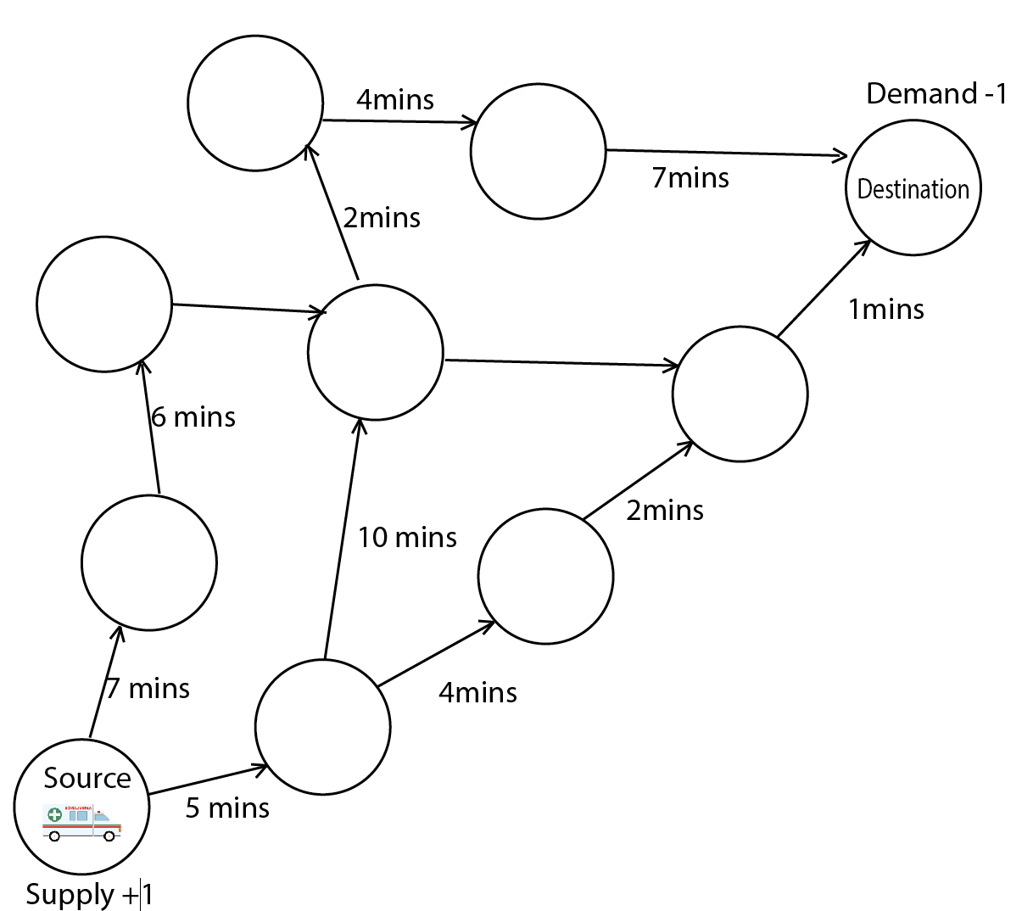

Under this flow, the start of the destination will be represented by a node with a positive supply of +1 while the end the destination location will represented with another node representing the demand with -1. All the intersections and key points that come between would also be represented with a node with a supply/demand of being 0. The connections between the nodes will be represented with arrows called the edges. Above them displays the time it will take when taking that particular route. The objective of the model would be to minimize the time taken to reach from source to the destination. To check which path is taken, binary variables will be used to show which decision was taken at the intersection (1) and which was not taken (0). The constraint in the model will ensures that the amount of supply is conserved at each node of the network supply and in the context of this scenario it means that ambulance leaves the station goes through the route and fulfills the demand by reaching the destination.

Another scenario for the health care sector would be related to how the medical supplies need to reach multiple destinations while keeping the costs as low as possible. This can be categorized as the general transhipment problem. In this model we will be having multiple nodes which may include suppliers, warehouses and hospitals. These could be shown on a diagram with multiple nodes spread out as a network. The edges connecting each one could show us the cost associated with transferring the equipment. The objective function of this model will be to minimize the total cost of moving all the supplies (Supply) to the destinations like warehouse or hospitals (demand). Within the model we can have multiple constraints like having a demand that needs to be fullfiled. Also we may have a limited amount of supply due to the limitations in production of medical equipment.

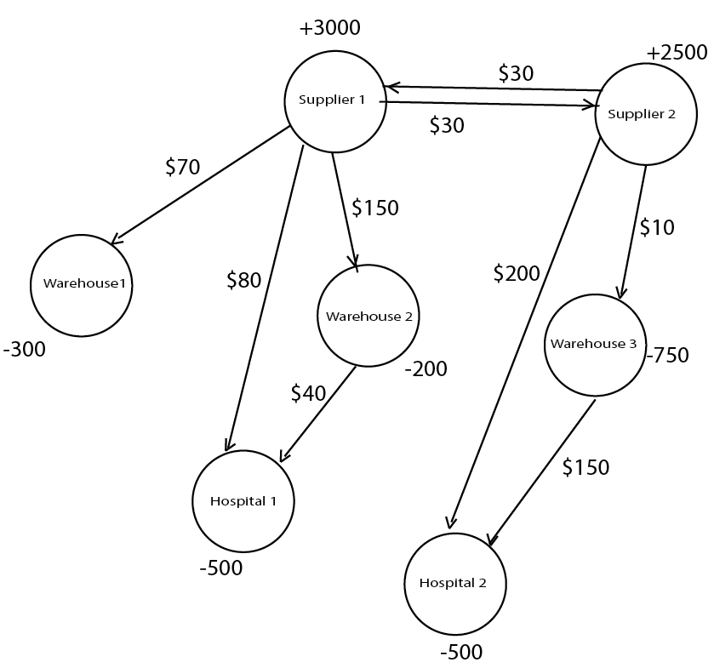

**Question 3: Multi-Objective Optimisation (25 Marks)**

Given is the *shopping_moo.mod* model. The model itself describes a knapsack problem, where items with a value and a weight have to be packed in a given number of bags. The optimisation target here is either the maximisation of value (zv) or the maximisation of the number of items in the bags (zi).

The problem has two constraints.

1. Weight constraint ensures that the bags' weight restrictions are kept.
2. The number of items of each product in all bags is restricted.

Running the model, you get a value of 328 with 15 items (zv) or 307 with 19 items (zi).

Use Multi-Objective Optimisation to see if a solution maximises both objectives. In the data file, there is already a declaration of targets and weights. Your task is to

1. Write the MOO-Objective function z **(5M)**

**Ans)** #combined objective function

**maximize** z_combined {k **in** OBJ}: **sum** {j **in** 1..nrbags , i **in** OBJECTS} values [i,k] * x[j,i];

#To minimize the deviation

**minimize** z : Q;

1. Write the constraint for restricting the deviation to Q **(7M)**

**Ans)** **s.t.** c_dev {k **in** OBJ}:

weights[k] * ((targets[k] - **sum** {j **in** 1..nrbags, i **in** OBJECTS} values [i, k] * x[j,i]) /targets[k]) <= Q;

1. Find the weights (param weights) for the deviation constraint that results in a solution with 16 items. How do you approach a solution for the weights? **(7M)**

ANS) There were two possibilities of doing this which include to change the weights of Value or the Items. I let the items stay the same and changed the weight of the values. The weights of the value that allow the solution of items being 16 range from 13 till 34. I did a manual increase starting from 10 where the items were given more importance hence they turned out to be 17. I manuualy increased it to 12 where the item importance was just enough to make it 16. Then I went up higher till 50 and moved my way down till reaching 34 which was the last weight that allows 16 items as 35 would would give too much importance to value making the items to become 15.

1. Explain the idea of Multi-Objective Optimisation **(6M)**

Ans) Multi-Objective Optimisation is when models are created to solve problems that have more than one objective solution. For example at the same time we can have one objective minimizing the total cost while the other trying to maximize the efficiency. We can give each objective a different name and require ampl to solve the answer while considering one goal over the other. AMPL also allows us to give a weights to the objectives through which we can decide which goal to give more importance to in order to get the desired solution.

*Files: shopping_moo.xxx*

**Total: 100 Marks (representing 10% of the final mark)**

The final submission is via email attachments to the lecturer (Torsten). Use your Curtin email account. Attached to the submission should be a Word document with all your answers to the questions (You can use this file and insert your answer in a different colour) and .mod and .dat files based on the questions. You can use a compressed folder or zip file. Use for the filenames the following structure: a3_YOURID_answers.docx for the answer to the questions, a3_YOURID_answers.zip in case you submit all in a compressed file, and a3_YOURID_Q[number of question this file relates to].mod/.dat. As using given formats and naming conventions is crucial in organisations, we **deduct up to 5M** if the filenames are not as specified.