[Document subtitle]

Ahmed Zakaria

**Stopwatch project**



**عمل الطلاب: -**

**احمد زكريا عبد العال يوسف**

**احمد محمد محمود**

**اسلام محمود توفيق**

**احمد فتحي عواد**

**رمزي احمد رمزي**

**اشرف محمد إبراهيم**

**عبد الله حسن**

**مادة القياسات الكهربية**

**د: طارق الكمار**

**م:معتصم قطب**

**Equipment: -**

**1-two 7 SEG COM CATHODE**

**2- 4033 IC**

**3-RESISTOR 150 OHM**

**4-wires**

**5-10UF CAP**

**6-RESISTOR 33K OHM**

**7-DC SOURCE 5V**

**8-resistor 56k ohm**

**9-TIMER 555 IC**

**10-TWO push buttons**

**11-100k OHM RESISTOR**

**12-LED**

**Circuit connection: -**

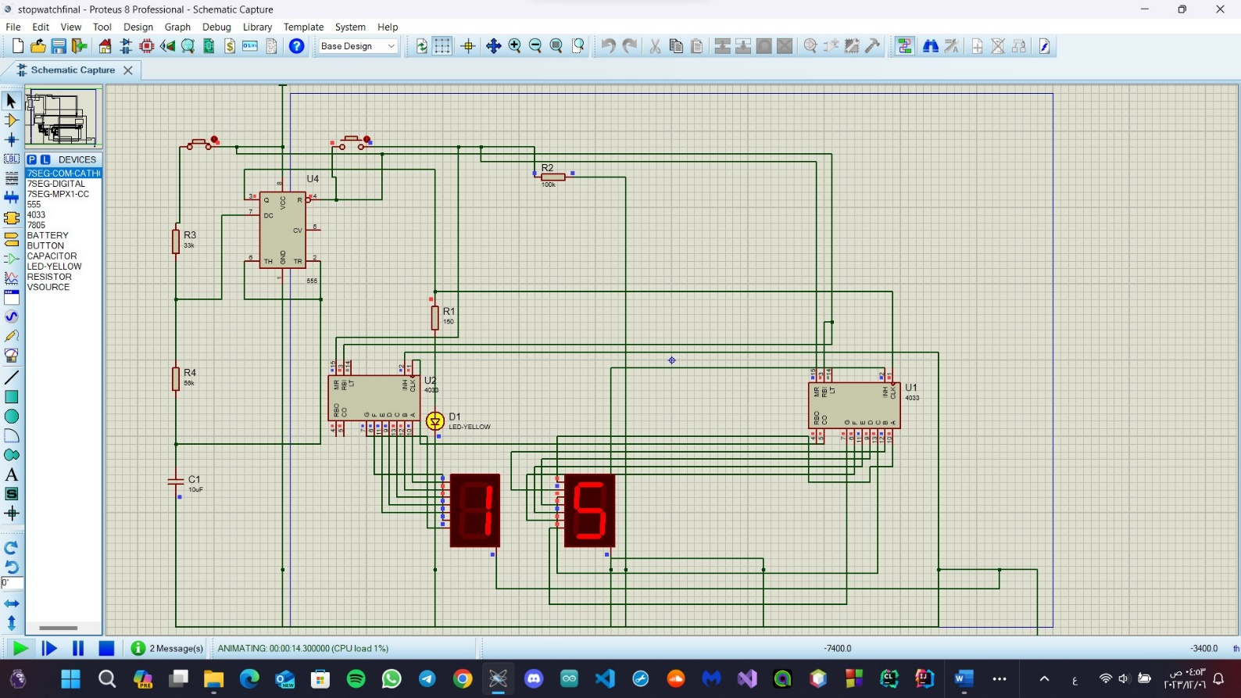

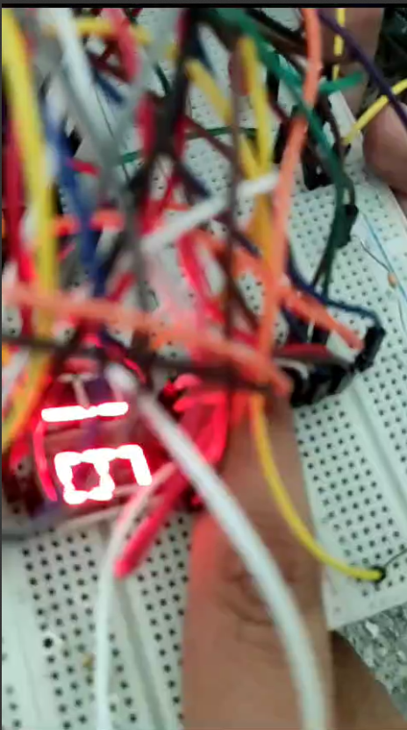

**IC 4033 specifications**

**Electrical Characteristics**

* Supply voltage range: 3V to 18V
* Input voltage range:
* Clock input: 0V to VDD
* Display enable input: 0V to VDD
* Ripple-blanking input: 0V to VDD
* Operating temperature range: -40°C to +85°C
* Quiescent current: up to 100 nA at VDD = 18V and T = +25°C
* Maximum clock frequency: 8MHz (typical) at VDD = 10V
* Input capacitance:
* Clock input: 10pF (typical)
* Display enable input: 5pF (typical)
* Ripple-blanking input: 5pF (typical)
* Output drive capability:
* Sink current: 5mA (minimum)
* Source current: 0.4mA (minimum)
* Propagation delay:
* Clock input to any output: 45ns (typical)
* Ripple-blanking input to any output: 45ns (typical)
* Power dissipation:
* Quiescent power: up to 1.8mW at VDD = 18V and T = +25°C
* Maximum power dissipation: 500mW
* ESD protection: 2000V (minimum)

**Pinout connections**

## How IC 4033 Works

° CD4033 is a Johnson counter IC commonly used in digital

display.

It has a 5 stage Johnson decade counter with decoder

which convert the Johnson code to a 7 segment decoded output.

Means it will convert the input into numeric display which can be

seen on 7 segment display or with the help of LED's.

° Advantage of this IC is it can be operated at high voltage of 20V.

But is highly sensitive, can detect emf present in the atmosphere

and is sensitive to static charge also. When you touch your

finger at its input terminal its counter get started therefore care

should be taken while using it. It can be used in various

application like in 7 segment decimal display circuit, in clocks,

timer etc. To understand its working first have a look on its pin

diagram.

There are two seven segments, so this stopwatch circuit can count 00-99 seconds time.

**7SEG COM CATHODE PINOUT**

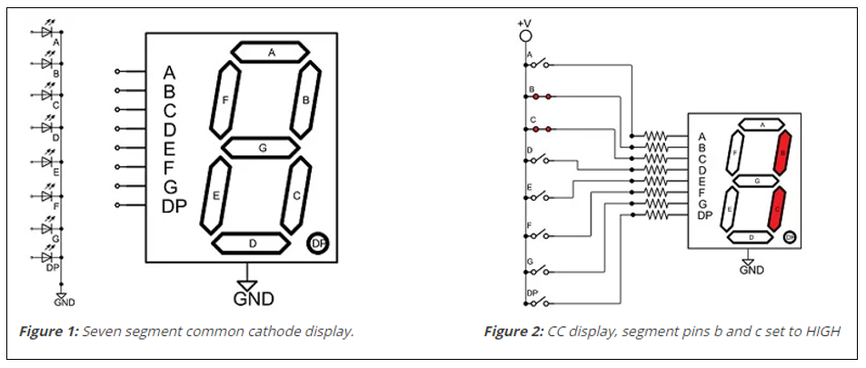

**PCB LAYOUT: -**

**How the circuit work: -**

**1-When we press the start button, we see the screen start counting with a time delay of one second, and the pulse time is controlled by the values of the resistors and capacitors connected to the timer.**

**2-When we press the reset button, we see that the timer has zeroed**

**3-When we press the start button again, the counting starts from the beginning until it reaches the number ninety-nine, then it returns to zero again and starts counting again**

