[Document subtitle]

DELL

**Bluetooth Password Lock Door**

**عمل الطلاب: -**

**احمد زكريا عبد العال**

**احمد محمد محمود**

**يحيي محمد محي محمد**

**إسلام محمود توفيق**

**رمزي احمد رمزي**

**احمد فتحي عواد**

**اشرف محمد ابراهيم**

**ممدوح السيد احمد**

**اسلام أسامة فاروق**

**بهاء أحمد عزب**

**مادة اختبارات 2**

**م: ايناس مصطفى**

**د: مصطفى الطوخي**

**Equipment: -**

**1-ESP-32 MODULE**

**2-resistor 2k**

**3-TIP 122 Darlington transistor**

**4-Diode**

**5-Micro USB Cable**

**6-Wires**

**7-DC Source 12V**

**8-Mobile phone**

**9-Project phone Application**

**10-Solonoied (JF-0630B)**

**Circuit connection: -**

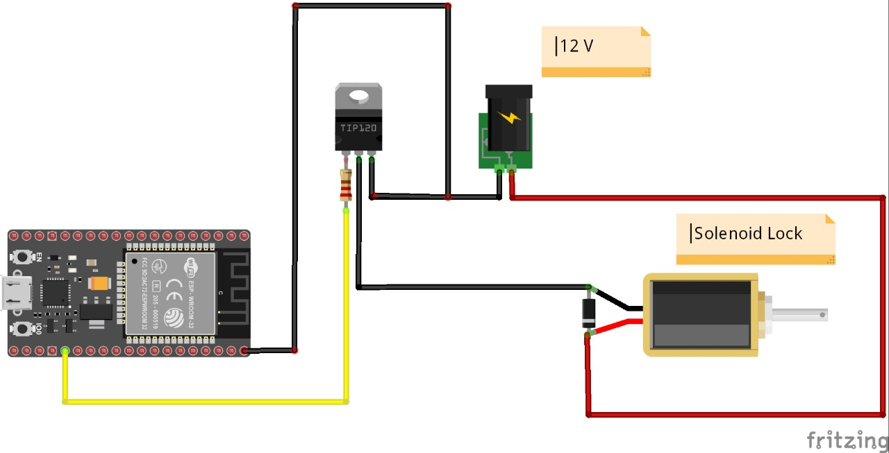

**TIP 122 Transistor Data Sheet:-**

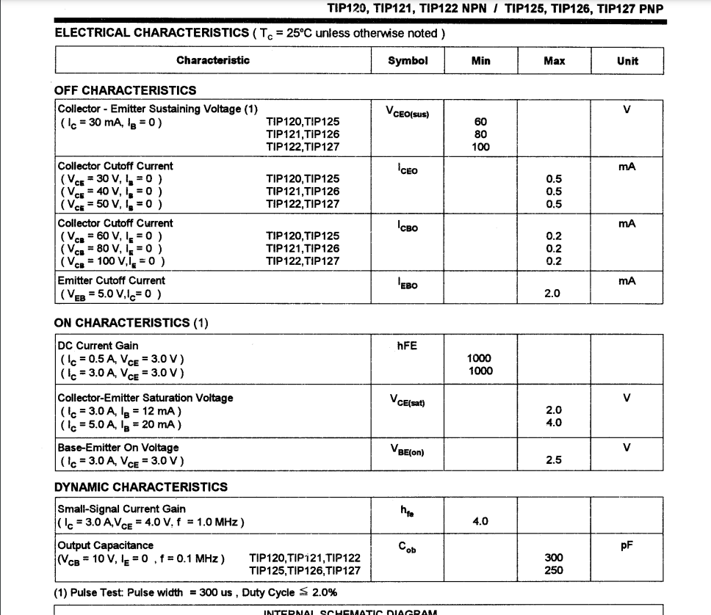

**ESP-WROOM 32E Data Sheet: -**

**CPU and On Chip Memory**

• ESP32-D0WD-V3 or ESP32-D0WDR2-V3 embedded, Xtensa dual-core 32-bit LX6 microprocessor, up to 240 MHz

• 448 KB ROM

• 520 KB SRAM

• 16 KB SRAM in RTC

• ESP32-D0WDR2-V3 also provides 2 MB PSRAM

**Wi­Fi**

• 802.11b/g/n

• Bit rate: 802.11n up to 150 Mbps

• A-MPDU and A-MSDU aggregation

• 0.4 µs guard interval support

• Center frequency range of operating channel: 2412 ~ 2484 MHz

**Bluetooth**

• Bluetooth V4.2 BR/EDR and Bluetooth LE specification

• Class-1, class-2 and class-3 transmitter

• AFH

• CVSD and SBC

**Integrated Components on Module**

• 40 MHz crystal oscillator

• 4/8/16 MB SPI flash

**Operating Conditions**

• Operating voltage/Power supply: 3.0 ~ 3.6 V

• Operating ambient temperature: – 85 °C version: –40 ~ 85 °C – 105 °C version: –40 ~ 105 °C. Note that only the modules embedded with a 4/8 MB flash support this version.

**Code:-**

**How the circuit work: -**

**This circuit simply works like this.**

**After supplying the circuit with the required voltage, and when connecting the mobile phone to the ESP 32 via Bluetooth, we enter the password. If we type an incorrect password, the phrase Wrong password will appear in the program**

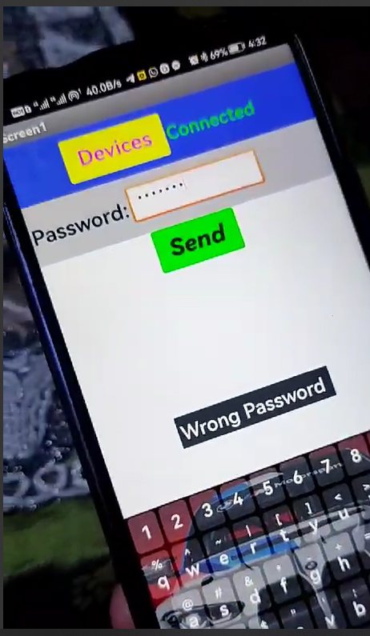**.**

**When it is written correctly, the ESP receives the signal and transmits it to the transistor, which acts as an electronic switch, giving a signal to the solenoid and it opens.**

**In this circuit, the diode works to protect the solenoid from reverse current, so it is connected in reverse to it.**