**Computer Programming II Project**

**THE QUEENS**

**What is the game**

It is a cards game composed of 52 cards (13 spades, 13 diamonds, 13 hearts, and 13 clubs) and four players, each of them will have 13 cards randomly.

***********

**How to play the game**

The player who has the “two club card” will start first by throwing it.

Every round the players will throw one card from his hand(All the cards that the player hold them in his hand) should be the same type that the first player had thrown, but if you do not have any, you are allowed to throw any card you want, and the player who thrown the biggest card of that type will add the cards to his deck(every player has a deck which contains the cards which he collected them from the playground) independently of his hand, and he will start the next round by throwing any card from his hand so on until the players run out of card, which is after 13 rounds.

**Score calculating**

The score will be calculated at the end of the 13 rounds by adding 25 points on every queen you had collected in your deck so that the game ends when one of the players reach 150 points and the player with the minimum score will be considered as a winner.

***********

**Interacting with the game**

While the game is running there will be a bar at the top side of the interface which contains two menus the first one is game (contains: restart or quit) the second one will be help which contains the game instructions and how to play it

The game is a single player game which means that the other three players will be automatically run and generated by the computer

The interface between the player the game will be handled by the screen and the mouse by choosing the card he will throw in the field, the cards in the field will go to the player who thrown the biggest card of the same type of the first thrown card in that round but we will not show the cards that every player has in his deck which will give the winner at the end of each game.

At the end of every game we will show a table that shows the name of the player and their scores and the winner.

While you are playing you will hear classic music that will help the player to concentrate on the game .

We will write the program taking into account all these rules with one player and three computers also we will create a graphical interface similar to this one

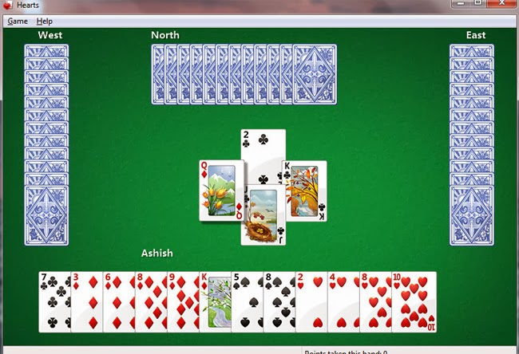

**Functionalities of the game**

* Class Card (value /type)

We have 4 types (spade, diamond, heart, club)

And 13 value for each from 1 to 13.

* Player (name /score/deck/hand)

The name will be taken from the player at the start of the game.

Deck: an array of cards that you had collected them in the game.

Hand: an array of cards that you got them at the beginning of the game.

In the player class the user will take the decision about the card to throw.

* Computer player (name /score/deck/hand)

In the computer player class the computer will decide which card to play with taking in considers the intelligence (not randomly).

And this class will be a child class of the class player

* Driver class: one player objects and 3 computer player objects .

***********

**Introduction to the Game**

The aim of this game is to get rid of the queen and by that it will make the way easy to win.

After finishing the game the player will get 25 for every queen.

For the first player who reaches 150 the game will be over and that player will lose.

**Some Use Case Examples**

1) If the player throws the ace card and it is the computer’s turn to play the computer should throw his queen by doing that the other player will get himself 25 so he will be closer to 150(losing).

2) If any other player throws a card type which the computer doesn’t have it the computer should throw the queen and by that the player will get rid of the queen.

3) If the computer was last in turn to throw and on the playground there were three cards and they don’t contain the queen the player should throw the king or the ace card.

4) The computer shouldn’t throw the king or ace if it’s not the last in turn because there may be a possibility that the next player may has the queen that will cause the computer 25in its score and will be closer to 150.