Golden Collection – Approval Cycle Policy (Marketing & Operations)
Oct 13, 2026 · @ahmed hossam

Purpose, scope and principles
Every Marketing and Operations commitment above EGP 5K is approved by the Department Manager (L2) first and then gets a second approval from FP&A before any commitment, with Accounting running invoices and payments, and approval authority rises with value across five EGP bands. This policy covers four request types: spend and purchase requests, payments and invoices, campaigns and promotions, and operational changes including hiring.
Principles:
- No commitment before approval. No PO, vendor confirmation or offer letter is issued until the final approver signs.
- Segregation of duties. The requester never approves their own request; the person who approves a purchase does not release its payment.
- Budget linkage. Every request carries a budget line; FP&A confirms remaining budget as part of its second approval.
- Lowest sufficient level. A request goes only as high as its value band requires, keeping cycle times short.
- Works without ERP. The cycle runs on a standard request form, email sign-off and a shared approval log, so it can start immediately.

Approval roles
Seven roles carry the cycle; titles can be mapped to Golden Collection's actual org chart.
Role | Who (Marketing) | Who (Operations) | Responsibility in the cycle
Requester | Media buyer, marketing executive or designer | CX or live ops agent / team member | Raises the request with quotes, budget line and business case
Senior / Lead (L1) | Senior media buyer, senior marketing executive or lead designer | Senior agent or team lead, logistics / live ops | Confirms need, scope and priority
Department Manager (L2) | Marketing Manager | CX / Live Ops Manager | First approval; owns the department budget
FP&A (second approver) | FP&A | FP&A | Second sign-off after L2 on every request: budget availability, cost coding, ROI or cost-per-contact impact; co-approves Band C and out-of-budget items
Procurement | Procurement Officer | Procurement Officer | Confirms vendor, 3 quotes above EGP 100K, contract terms
Accounting | Accounting | Accounting | Runs all financial operations: receives invoices (AP inbox), 3-way match, ad account top-ups, advances and payment runs; does not approve spend
Strategy Analysts | Strategy Analyst – Marketing | Strategy Analyst – Ops | Reviews every request above EGP 500K from their department for fit with company strategy and priorities; sends a recommendation to the CEO through the EA; does not approve. Each analyst covers the other's department when absent
CEO | CEO | CEO | Final authority above EGP 500K and for new headcount outside plan
CEO Executive Assistant | CEO Executive Assistant | CEO Executive Assistant | Copied at every stage; can pull any request to the CEO's attention at any point; manages the CEO approval queue and its SLA; does not approve
logistics
HR joins every hiring request after L1 to confirm grade, salary band and headcount plan.
CEO Executive Assistant at every stage. The EA is copied on every request from submission to payment through the approval log. At any stage the EA can flag a request for CEO attention, put it on hold pending a CEO question, or fast-track it, and is the single channel through which Strategy-reviewed requests reach the CEO.

Delegation of Authority matrix
The final approver is set by request type and value band; every request first passes Requester → L1 → L2 → FP&A (second approval) → Procurement where relevant; Strategy and the CEO sign only above EGP 500K, and Accounting processes the payment; the CEO Executive Assistant is copied at every step. Values are per request, EGP incl. VAT; splitting one need into smaller requests to stay under a band is a policy breach.
Request type | Band A: ≤ 25K | Band B: 25K–100K | Band C: 100K–500K | Band D: 500K–1.5M | Band E: > 1.5M
Opex purchase, in budget | L1 Senior / Lead | L2 Dept Manager | L2 Dept Manager | L2 + FP&A (2nd) | Strategy → CEO
Capex purchase, in budget | L2 Dept Manager | L2 Dept Manager | L2 + FP&A (2nd) | Strategy → CEO | Strategy → CEO
Marketing campaign / activation | L1 Senior / Lead | L2 Dept Manager | L2 + FP&A (2nd) | Strategy → CEO | Strategy → CEO
Trade promotion / discount | L2 Dept Manager | L2 Dept Manager | L2 + FP&A (2nd) | Strategy → CEO | Strategy → CEO
Ops change: CX tools, BPO / outsourced agents, shift or workforce changes | L1 Senior / Lead | L2 Dept Manager | L2 + FP&A (2nd) | Strategy → CEO | Strategy → CEO
Out-of-budget item (any type) | L2 + FP&A (2nd) | L2 + FP&A (2nd) | L2 + FP&A (2nd) | Strategy → CEO | Strategy → CEO
Payment processing (Accounting, after approval) | Accounting | Accounting | Accounting | Accounting | Accounting + CEO (dual)
Fixed rules regardless of value:
- Hiring within approved headcount plan: L2 Dept Manager + HR. Hiring outside plan or above salary band: Strategy review, then CEO.
- Contracts over 12 months or with auto-renewal: L2 + FP&A second approval minimum.
- Discounts deeper than the approved price-list corridor: L2 + FP&A second approval, with a margin impact (bps) from FP&A.
- Procurement: 1 quote ≤ 25K, 2 quotes 25K–100K, 3 quotes > 100K or a documented single-source justification.

Marketing approval cycle
Marketing requests come from three roles — media buyers, marketing executives and designers — and all follow the same nine steps: L2 approves first and FP&A gives the second approval, Procurement is skipped for Band A, Strategy and the CEO sign only above EGP 500K, and Accounting handles invoices and payments.
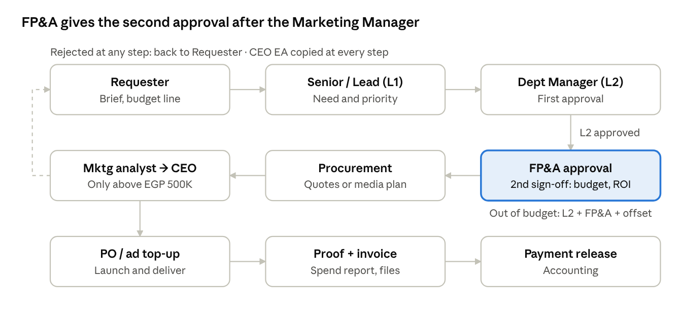
Marketing approval flow · 8 steps
Proof of execution (ad platform spend reports, media log, delivered design files or print proofs) replaces the goods received note, and campaigns in Band C and above get a post-campaign ROI review within 30 days of closing.
How each Marketing role uses the cycle:
Role | Typical requests | What approval covers | Specific rules
Media buyer | Paid media on ad platforms (Meta, Google, TikTok), influencers, media agency fees | A monthly media plan by platform and campaign, approved per DoA band on its total value | Ad platforms are single-source, so no 3 quotes; Accounting tops up prepaid ad accounts only against the approved plan; the Senior media buyer may shift up to 15% between platforms or campaigns within the plan total; anything above needs re-approval
Marketing executive | Campaigns, activations, events, sponsorships, promotional giveaways | Each campaign as one request with brief, budget and expected ROI | All costs of one campaign go on one request (no splitting); post-campaign ROI review for Band C and above
Designer | Freelancers, printing and production, stock assets, design software licences | Per job, or an annual request for recurring licences | Freelancers on an approved rate card can be engaged by the Lead designer within Band A; software licences are opex and renew only with L2 approval

Operations (CX & Live Ops) approval cycle
Ops requests follow the same nine steps, with L2 approving first and FP&A giving the second approval; FP&A tests cost per contact and CX service-level impact instead of campaign ROI, and HR replacing Procurement for hiring.
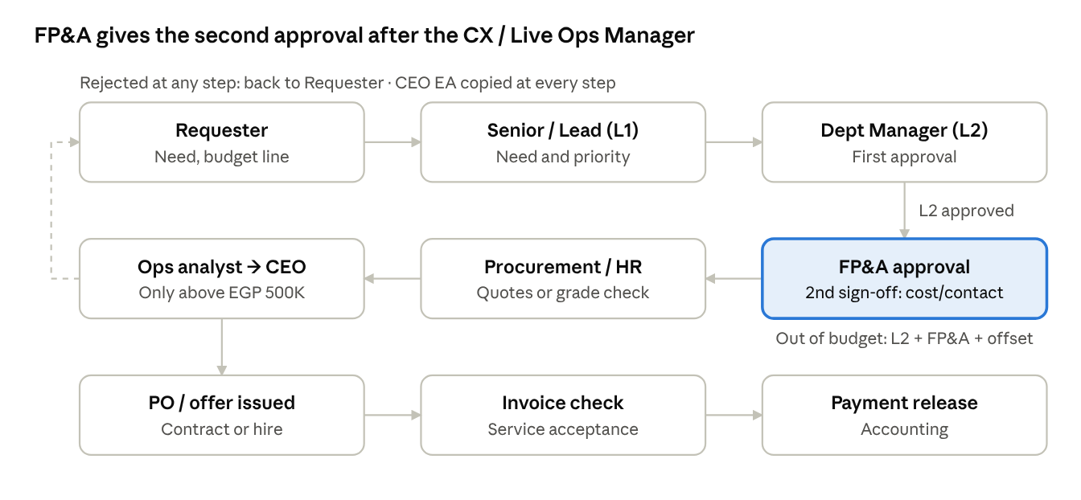
Operations approval flow · 8 steps
For CX tools, BPO contracts and workforce changes (new shifts, overtime, temporary agents), FP&A shows the cost per contact and cost per agent before and after, alongside the expected effect on SLA, first response time and CSAT. Emergency Ops requests (platform outages, backlog spikes) use the fast track in the SLA section.

Payments and invoices
An invoice is paid only when it matches an approved request (PO), a receipt confirmation and the invoice itself — the 3-way match.
- Vendor submits invoice to Accounting (one shared AP inbox), never directly to Marketing or Ops.
- Receipt confirmation by the requesting department: service acceptance for Ops (vendor SLA report, licence activation or BPO timesheets), proof of execution for Marketing (ad platform spend reports, media log, delivered design files or print proofs).
- Accounting 3-way match: approved request ↔ receipt ↔ invoice. Variance tolerance: ±2% or EGP 5K, whichever is lower.
- Variance above tolerance goes back to the original approver for re-approval of the difference; above 10%, it follows the DoA band of the new total.
- Payment release by Accounting once the request carries all approvals in the matrix, on the next weekly payment run (proposed: Thursday).
Advance payments above EGP 100K need L2 + FP&A second approval and a signed contract; advances to agencies are capped at 50% of contract value.

SLAs, escalation and exceptions
Each approval step has a 1–2 working-day clock, so a Band C request should close within 7 working days end to end.
Step | SLA (working days) | If missed
L1 Senior / Lead | 1 | Auto-escalates to L2 Dept Manager
L2 Dept Manager | 2 | Reminder, then CEO Executive Assistant informed
FP&A second approval | 2 | Reminder, then CEO Executive Assistant informed
Procurement (quotes) | 3 | Escalates to FP&A
Strategy Analyst review (Marketing or Ops) | 2 | CEO Executive Assistant escalates to CEO
CEO | 3 | CEO Executive Assistant raises it in the weekly management meeting
Accounting (match and payment) | Next weekly payment run | Escalates to FP&A
Rejected or returned requests go back to the Requester with a written reason; resubmission restarts at the rejecting step, not at the beginning.
Emergency requests (e.g. CX platform or telephony outage, sudden ticket or call backlog needing overtime or temporary agents): the L2 Dept Manager may give verbal or WhatsApp approval up to Band C, with the full form and FP&A second approval completed within 2 working days. Emergency use is reported monthly; more than 3 per department per month triggers a review.
Out-of-budget requests must name the offset: a saving elsewhere in the department budget, a reallocation, or an incremental ask approved by L2 + FP&A (Strategy and CEO above EGP 500K).

Documentation, approval log and controls
Every request lives as one row in a shared approval log (Excel or Google Sheet) with a unique ID, and each sign-off is an email reply quoting that ID.
Request form — minimum fields: request ID (e.g. MKT-2026-041 / OPS-2026-112), department, request type, description, vendor, value excl. and incl. VAT, budget line and remaining budget, business case (expected ROI for Marketing; cost per contact and impact on CX KPIs (SLA, first response time, CSAT) for Ops), attachments (quotes, brief, contract draft).
Approval log columns:
Request ID | Date raised | Dept | Type | Value (EGP) | Band | Budget line | In budget? | Current step | Approver | Approval date | Status | PO / payment ref
MKT-2026-041 | 13 Oct 2026 | Marketing | Campaign | 180,000 | C | Trade activation Q4 | Yes | FP&A (2nd) | FP&A (2nd) | — | Pending | —
Monthly controls run by FP&A, with Accounting data:
- Spend without an approved request ID (target: 0)
- Split requests: same vendor, same department, within 30 days, combined value crossing a band
- Cycle time per step versus SLA, by department
- Emergency approvals count and value
- Approved versus actual spend per campaign (post-campaign ROI review for Band C and above)

Assumptions
The EGP bands are a starting proposal sized for a mid-size Egyptian FMCG distributor and should be calibrated to Golden Collection's actual spend profile before sign-off.
Key assumptions
- Each department has Seniors / Leads (L1) reporting to a Department Manager (L2), who reports to the CEO; there is no CFO, so FP&A acts as second approver, Accounting runs invoices and payments, a Strategy team reviews CEO-level items, and the CEO Executive Assistant coordinates CEO approvals.
- An approved annual budget exists by department and cost line; FP&A can report remaining budget weekly.
- Bands assume roughly 70–80% of request count falls in Bands A–B, so most requests close at department level.
- Values include VAT; recurring contracts are valued at their total contract value, not the monthly amount.

