**Spring Boot 101 - Lab Start notes**

This document describes what to do to get started with the labs for the AMIS SIG Spring Boot 101.

1. Install the VirtualBox machine
2. Start and log in
3. Update the labs
4. Install a PDF viewer (optional)

Requirements:

* VirtualBox version 5.2.8 is installed
* Free Disk space: image (3 GB) + installed image (6 GB) = 9 GB
* Memory: 4 GB (preferred 8GB)
* CPU: modern cpu with 4+ cores

An important remark up front: all passwords are set to welcome01 … except the one for PostgreSQL.

# Install the VirtualBox machine

First, obtain the VirtualBox machine image. There are 2 options:

1. Download the file course.ova from <https://bit.ly/2uvq9z9>   
   (or <https://lgorissen.stackstorage.com/s/pUu8f0Bt43f0v9k> )
2. Copy the file from one of the disks provided

Next, start VirtualBox and go to ‘Bestand – Appliance importeren’:

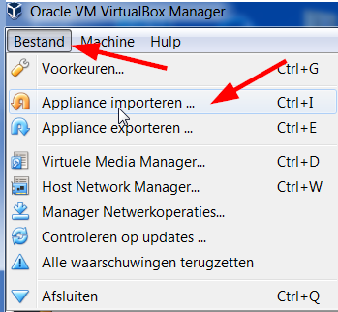

Select the downloaded VirtualBox image:

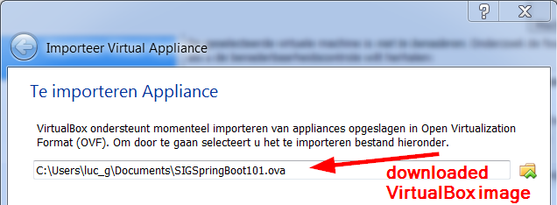

Click Volgende and check the settings. Mind the memory and cpu settings:

* Memory allocated: 4GB. It may run with less, but …
* On a multicore CPU, allocate at least half of the cores, e.g. 4 cores

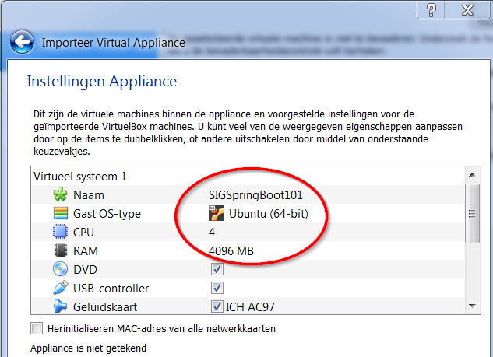

Click Importeren.

When imported, the machine will appear in the list of available machines:



Right-click the machine:

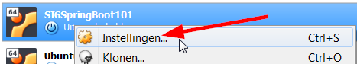

And select Instellingen.

Next, go to the Netwerk tab and verify that Adapter 1 has the settings:

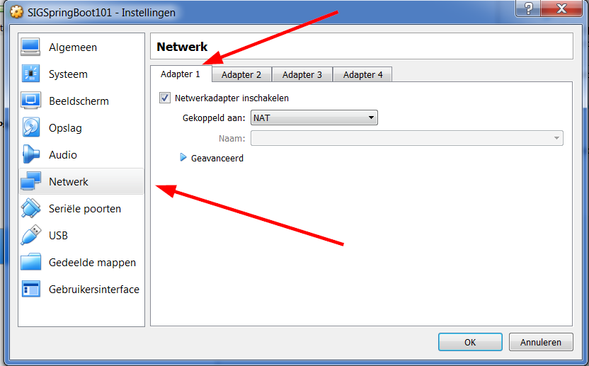

The other adapters do not need to be activated.

# Start and log in

With VirtualBox still opened, select the SIGSpringBoot101 image and then start the machine:  


The user named Developer is shown:



Click the user and log in with the password welcome01

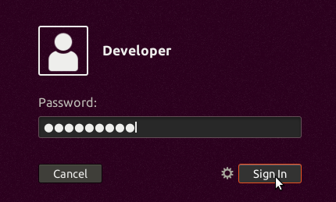

You should now end up in a Desktop that looks like:

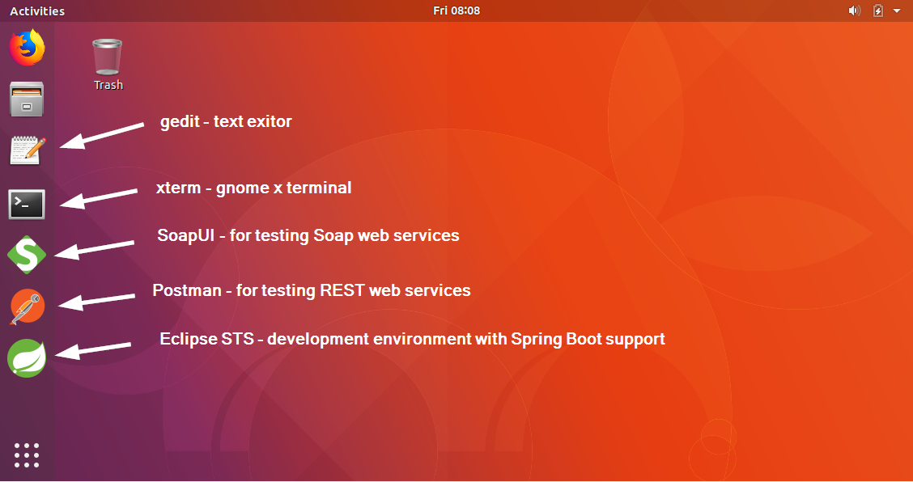

# Update the labs

The labs – as well as all the required tooling - are already installed in the machine. However, you should update the labs to have the latest version.

Open a terminal by clicking:



In the terminal go to the ~/projects/SIGSpringBoot101 directory where the labs are created. There, give the ‘git pull’ command:

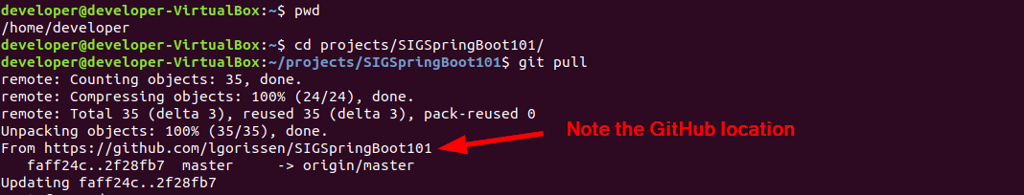

# Install a PDF viewer - optional

The lab manuals are in GitHub in Word and PDF format. If you want to work with the lab manuals from within you Virtual Machine, you will first need to install a PDF view. You can do that using the command  
sudo apt-get install evince:

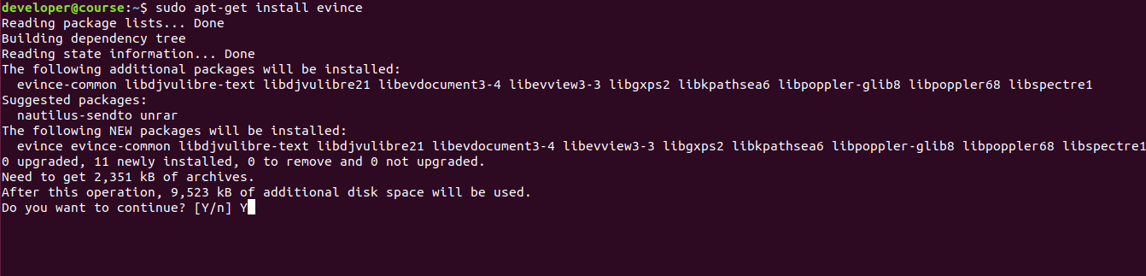

Click Y to continue and then evince should be visible in your applications:

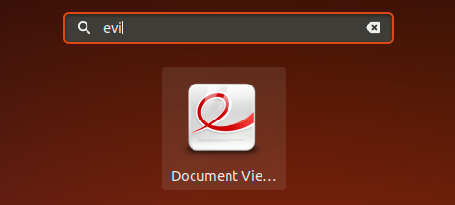

Now, you’re ready to start the labs…