Q1

1-

WITH customer_sales_cte AS (

SELECT DISTINCT CUSTOMER_ID, COUNTRY ,ROUND(SUM(QUANTITY * PRICE) OVER

(PARTITION BY CUSTOMER_ID)) AS TOTAL_SALES

FROM tableRetail

),

customer_ranks_cte AS (

SELECT CUSTOMER_ID,COUNTRY ,TOTAL_SALES, RANK() OVER (ORDER BY TOTAL_SALES DESC)

AS TOP10

FROM customer_sales_cte

)

SELECT CUSTOMER_ID, TOTAL_SALES , TOP10 ,COUNTRY

FROM customer_ranks_cte

WHERE TOP10 <= 10;

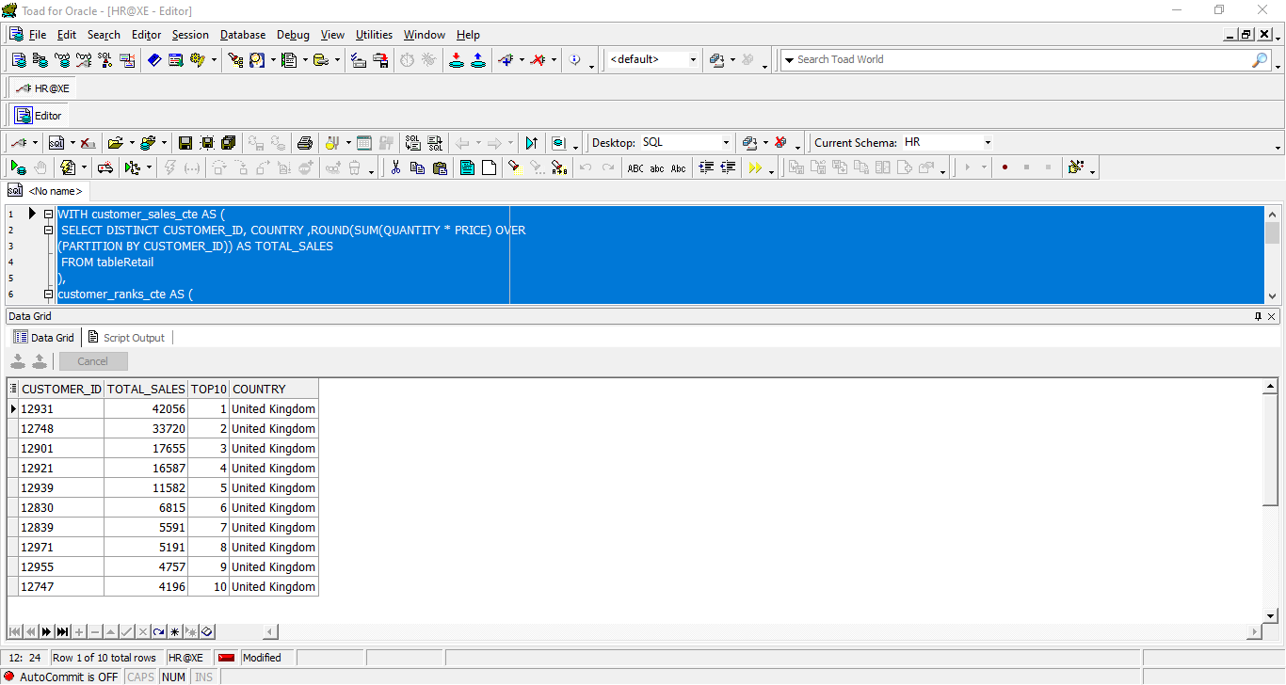

**Here I want to determine the top 10 customers' sales to give them some vouchers.**

2-

SELECT *

FROM

(SELECT DISTINCT StockCode,

TotalSales,

row_number() OVER (

ORDER BY TotalSales DESC) Ranked

FROM

(SELECT DISTINCT StockCode,

sum(Quantity * price) OVER (PARTITION BY StockCode) AS TotalSales

FROM tableRetail))

WHERE Ranked <= 10

ORDER BY Ranked;

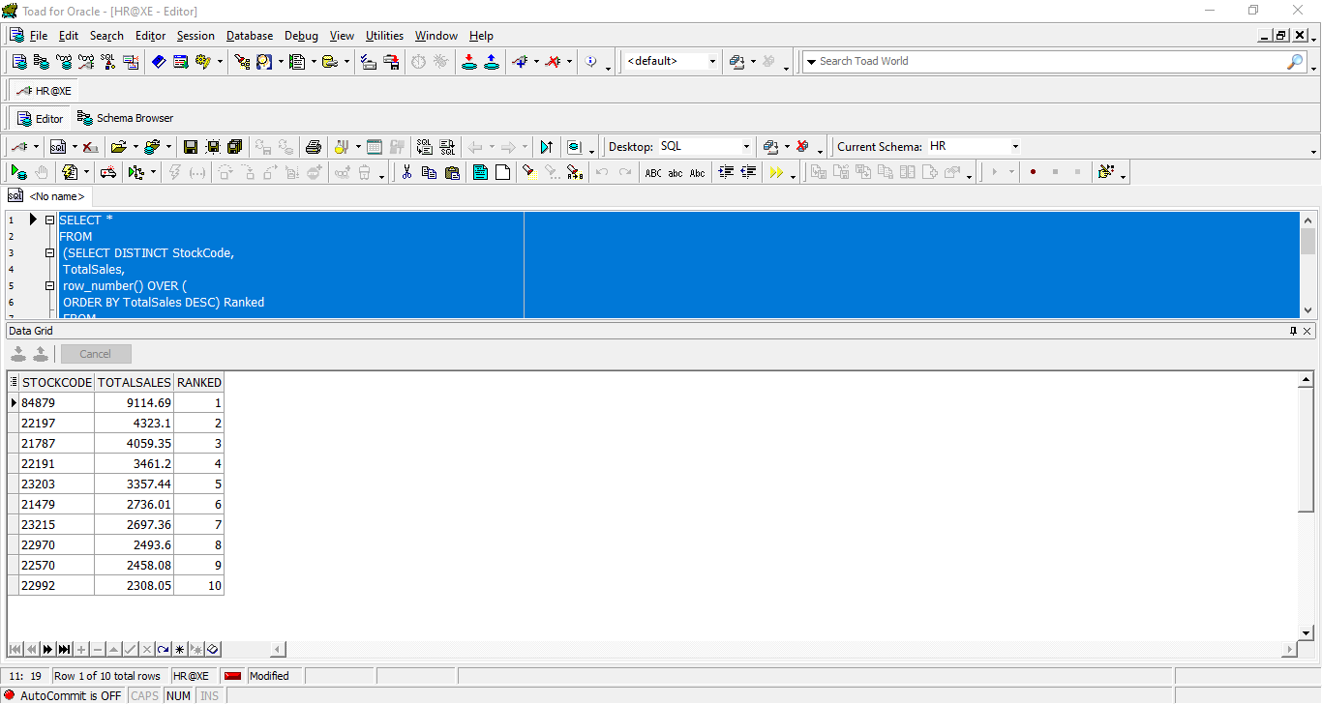

**Here I want to determine the top 10 products' sales as they're high in demand.**

3-

SELECT Product1, Product2, TimesSoldTogether

FROM (

SELECT Product1, Product2, TimesSoldTogether,

DENSE_RANK() OVER (ORDER BY TimesSoldTogether DESC) AS rn

FROM (

SELECT DISTINCT t1.StockCode AS Product1,

t2.StockCode AS Product2,

COUNT(*) OVER (PARTITION BY t1.StockCode, t2.StockCode) AS TimesSoldTogether

FROM tableRetail t1

JOIN tableRetail t2 ON t1.Invoice = t2.Invoice

AND t1.StockCode < t2.StockCode

)

)

WHERE rn <= 5;

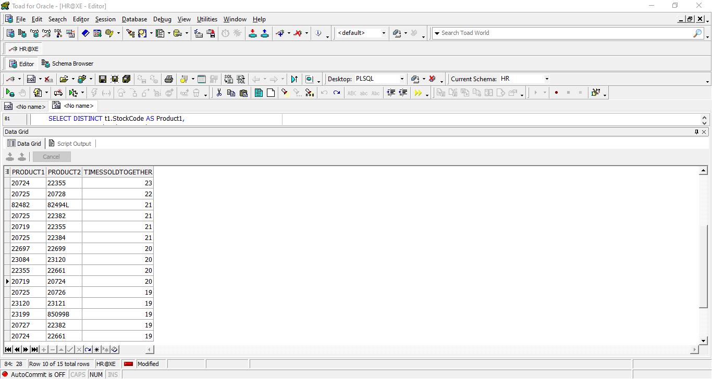

**Here I want to determine the top 5 products' sales as they're sold together, which could help me taking** **business decisions.**

4-

SELECT HOUR , round(SUM(Quantity * Price), 0) AS Sales

from (

SELECT TO_CHAR(TO_DATE(InvoiceDate, 'MM/DD/YYYY HH24:MI'), 'HH24') AS HOUR ,

Quantity , Price

FROM tableRetail )

GROUP BY HOUR

ORDER BY sales DESC ;

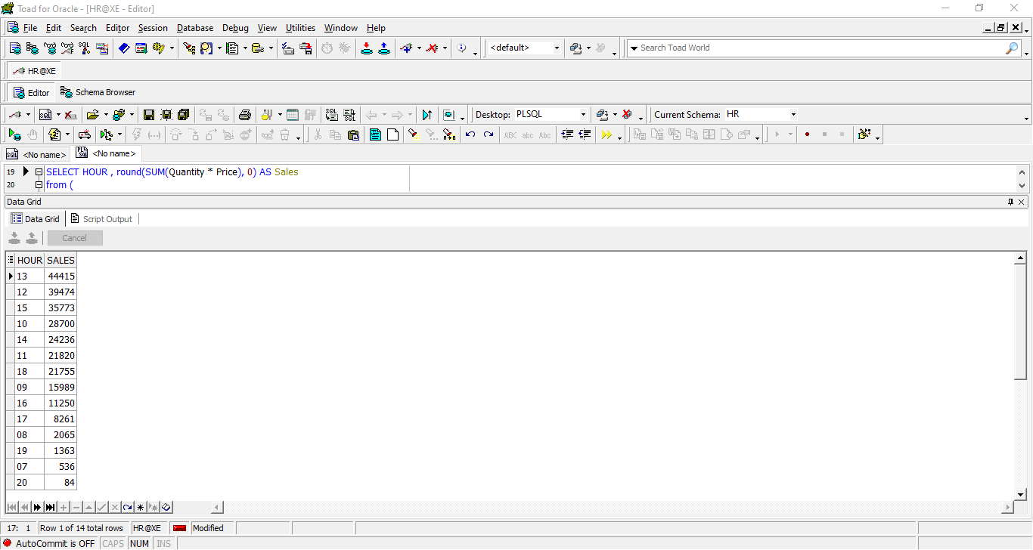

**Here I want to know the total sales per hour to determine the lowest and highest sales time which benefits me in taking** **business decisions.**

5-

SELECT

EXTRACT(YEAR FROM TO_DATE(INVOICEDATE, 'MM/DD/YYYY HH24:MI')) AS Year,

ROUND(SUM(QUANTITY * PRICE)) AS Total_Sales,

ROUND(SUM(QUANTITY * PRICE) - LAG(SUM(QUANTITY * PRICE)) OVER (ORDER BY EXTRACT(YEAR

FROM TO_DATE(INVOICEDATE, 'MM/DD/YYYY HH24:MI')))) AS "Total Sales Diff"

FROM

tableRetail

GROUP BY

EXTRACT(YEAR FROM TO_DATE(INVOICEDATE, 'MM/DD/YYYY HH24:MI'))

ORDER BY

EXTRACT(YEAR FROM TO_DATE(INVOICEDATE, 'MM/DD/YYYY HH24:MI'));

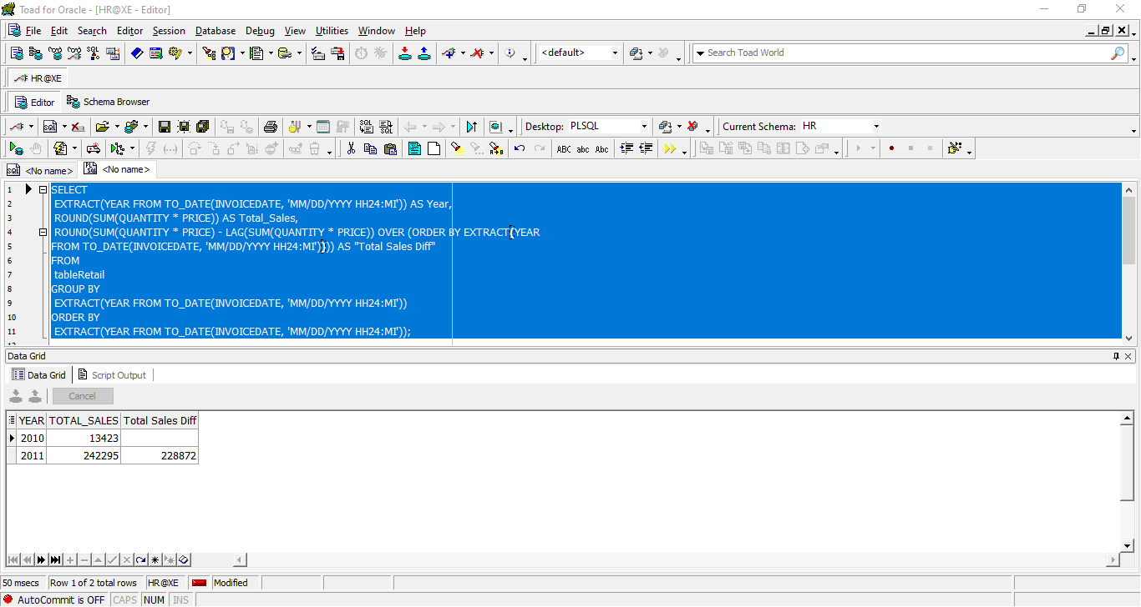

**Here I want to know the total sales per Year and the sales difference between every year and the recent year to know if we're growing or the sales have decreased.**

Q2

select CUSTOMER_ID,

recency,

frequency,

monetary,

fm_score ,

r_score

, Case

when r_score >= 5 and fm_score >= 5

or r_score >= 5 and fm_score =4

or r_score = 4 and fm_score >= 5 then 'Champions'

when r_score >= 5 and fm_score = 2

or r_score = 4 and fm_score = 2

or r_score = 3 and fm_score = 3

or r_score = 4 and fm_score >= 3 then 'Potential Loyalists'

when r_score >= 5 and fm_score = 3

or r_score = 4 and fm_score = 4

or r_score = 3 and fm_score >= 5

or r_score = 3 and fm_score >= 4 then 'Loyal Customers'

when r_score >= 5 and fm_score = 1 then 'Recent Customers'

when r_score = 4 and fm_score = 1

or r_score = 3 and fm_score = 1 then 'Promising'

when r_score = 3 and fm_score = 2

or r_score = 2 and fm_score = 3

or r_score = 2 and fm_score = 2 then 'Customers Needing Attention'

when r_score = 2 and fm_score >= 5

or r_score = 2 and fm_score = 4

or r_score = 1 and fm_score = 3 then 'At Risk'

when r_score = 1 and fm_score >= 5

or r_score = 1 and fm_score = 4 then 'Cant Lose Them'

when r_score = 1 and fm_score = 2

or r_score = 2 and fm_score = 1 then 'Hibernating'

when r_score = 1 and fm_score <= 1 then 'Lost'

End cust_segment

from

(

SELECT CUSTOMER_ID , recency , frequency,

monetary,

NTILE(5) OVER (ORDER BY recency desc) AS r_score ,

NTILE(5) OVER (ORDER BY (frequency + monetary)/2 ) AS fm_score

from (

SELECT DISTINCT

CUSTOMER_ID,

FIRST_VALUE(DAYS_BETWEEN_INVOICES IGNORE NULLS) OVER (PARTITION BY CUSTOMER_ID ORDER

BY DAYS_BETWEEN_INVOICES ASC) AS recency,

frequency,

monetary

FROM

(

SELECT DISTINCT

CUSTOMER_ID,

CEIL(FIRST_VALUE(TO_DATE(INVOICEDATE, 'MM/DD/YYYY HH24:MI')) OVER (ORDER BY

TO_DATE(INVOICEDATE, 'MM/DD/YYYY HH24:MI') DESC) - TO_DATE(INVOICEDATE, 'MM/DD/YYYY

HH24:MI')) AS DAYS_BETWEEN_INVOICES,

SUM(price *quantity) OVER (PARTITION BY CUSTOMER_ID) AS monetary,

COUNT(DISTINCT INVOICE) OVER (PARTITION BY CUSTOMER_ID ) AS frequency

FROM

tableRetail

ORDER BY

CUSTOMER_ID )

)

ORDER BY

CUSTOMER_ID );

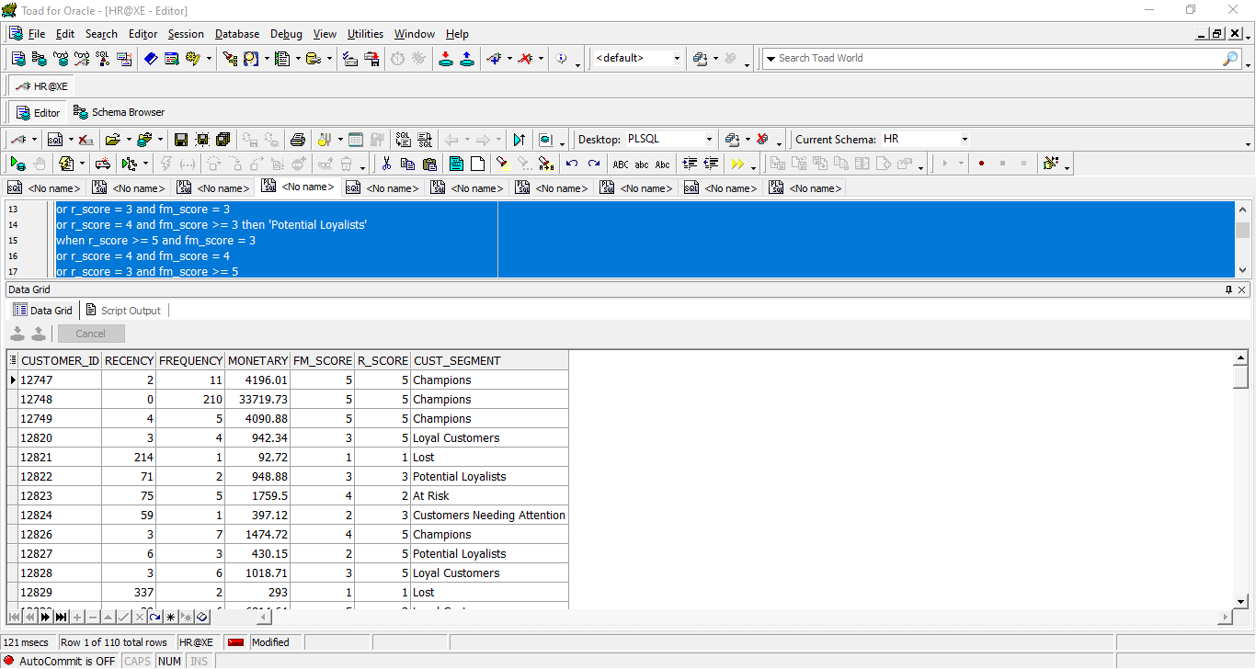

-------------------------------------------------------------------------------------------------

Q3

1-

SELECT CUST_ID, MAX(cons_days) as max_consecutive_days

FROM (

SELECT CUST_ID, COUNT(*) AS cons_days

FROM (

SELECT

CUST_ID,

order_date,

ROW_NUMBER() OVER (PARTITION BY CUST_ID, grp ORDER BY order_date) AS rn

, grp

FROM (

SELECT

CUST_ID,

CALENDAR_DT AS order_date,

SUM(reset_flag) OVER (PARTITION BY CUST_ID ORDER BY CALENDAR_DT) AS grp

FROM (

SELECT

CUST_ID,

CALENDAR_DT,

CASE

WHEN CALENDAR_DT - LAG(CALENDAR_DT) OVER (PARTITION BY CUST_ID ORDER BY CALENDAR_DT) > 1 THEN 1

ELSE 0

END AS reset_flag

FROM

CUSTOMERS

)

)

)

GROUP BY CUST_ID , grp

)

GROUP BY CUST_ID

order by CUST_ID;

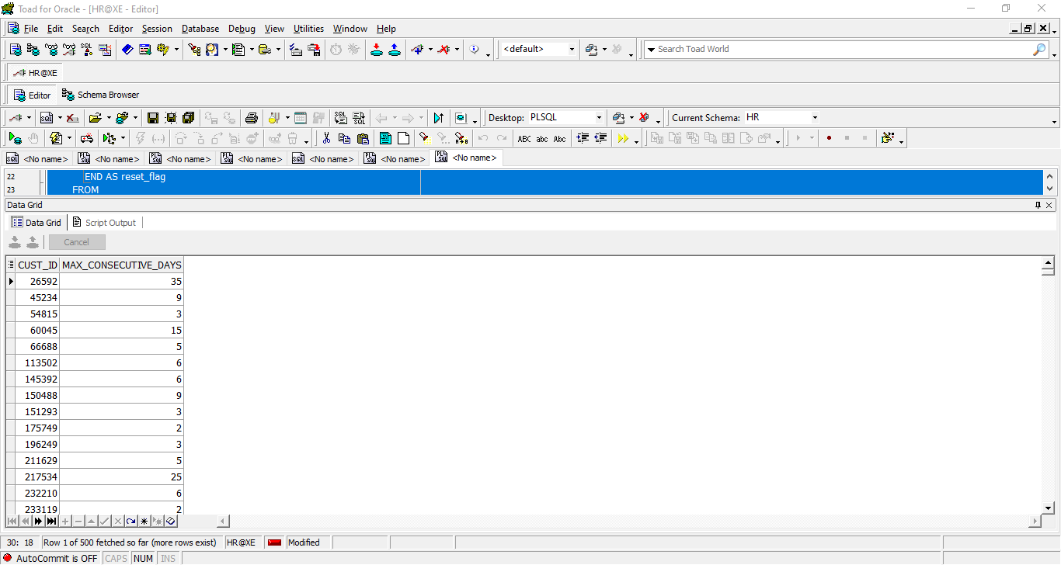

2-

WITH daily_spending AS (

SELECT

CUST_ID,

CALENDAR_DT,

SUM(AMT_LE) OVER (PARTITION BY CUST_ID ORDER BY CALENDAR_DT) AS total_spending

FROM

CUSTOMERS

),

threshold_unreached AS (

SELECT

CUST_ID,

CALENDAR_DT,

total_spending

FROM

daily_spending

WHERE

total_spending < 250

),

threshold_reached AS (

SELECT

CUST_ID,

CALENDAR_DT,

total_spending

FROM

daily_spending

WHERE

total_spending >= 250

),

avg_days as (SELECT

CUST_ID,

COUNT( CALENDAR_DT) +1 AS days_to_reach_threshold

FROM

threshold_unreached

where CUST_ID in (select CUST_ID from threshold_reached )

GROUP BY

CUST_ID

order by CUST_ID )

SELECT round (avg(days_to_reach_threshold),2) as average_days from avg_days ;

