Machine Learning Meets Econometrics
LASSO, Ridge, and Elastic Net Regression for
Variable Selection in Pakistani Macro Inflation Models

Ahmer Anwaar
GitHub: ahmer-econ
August 2026

Applied Econometrics Portfolio

1. Abstract
This study applies penalised regression methods — Ridge, LASSO, and Elastic Net — to the problem of variable selection for Pakistani CPI inflation forecasting. Using a candidate set of 13 lagged macroeconomic predictors spanning the period January 2012 to December 2023, we construct a monthly predictor matrix and evaluate out-of-sample forecast accuracy against an OLS baseline and a naïve benchmark over a 12-month holdout period (January–December 2023).
LASSO identifies a parsimonious 5-variable model — retaining lagged CPI, M2 growth, exchange rate, and oil prices while eliminating policy rate and food price variables — that achieves an out-of-sample RMSE of 26.40 and MAE of 10.41. OLS produces the lowest RMSE (24.88) but exhibits severe multicollinearity with 12 of 13 coefficients individually insignificant. Ridge regression underperforms the naïve benchmark (RMSE 28.59), confirming that uniform coefficient shrinkage is ill-suited when one predictor dominates. Elastic Net mirrors LASSO exactly in variable selection and performance. The March 2023 inflation shock to 140% YoY remains largely unpredictable by any lagged-variable model, representing a structural break driven by the IMF programme conditions and currency unification that no backward-looking specification could anticipate.

2. Introduction
Pakistan experienced one of the most severe inflation episodes in its modern economic history during 2022–2023. Consumer price inflation, which had remained broadly contained between 5 and 25 percent year-on-year through most of the 2012–2021 period, accelerated sharply following the energy price shock of 2022, the collapse of the Pakistani rupee against the US dollar, and the macroeconomic adjustment programme agreed with the International Monetary Fund in June 2023. By March 2023, headline CPI inflation reached 140 percent year-on-year — an extraordinary reading that placed Pakistan among the highest inflation economies globally.
Against this backdrop, accurate inflation forecasting takes on heightened economic significance. Standard time-series approaches such as ARIMA and VAR models, explored in prior work in this portfolio, rely on a small number of variables and impose linear dynamics. A complementary approach, motivated by the machine learning literature, is to construct a wide predictor matrix of candidate variables and use penalised regression to perform automatic variable selection — allowing the data, rather than the researcher, to determine which predictors belong in the final model.
This paper applies three penalised regression estimators — Ridge (L2 penalty), LASSO (L1 penalty), and Elastic Net (combined L1/L2 penalty) — to a 13-variable candidate predictor matrix for Pakistani CPI inflation. The objectives are threefold: first, to demonstrate the problem of multicollinearity in macro inflation models and show how penalised regression addresses it; second, to identify the minimal set of predictors that carry genuine forecasting information; and third, to evaluate whether machine learning variable selection improves out-of-sample forecast accuracy relative to OLS and a naïve benchmark.

3. Data

3.1 Dependent Variable
The dependent variable is Pakistani CPI inflation measured as the year-on-year percentage change in the consumer price index (YoY %). Data are sourced from the IMF International Financial Statistics (IFS) database, series code PAK.CPI.CP02.YOY_PCH_PA_PT.M. The series covers July 2008 through June 2026 at monthly frequency, providing a long pre-sample period for lag construction. The working sample runs January 2012 through December 2023.

3.2 Candidate Predictors
Thirteen candidate predictors are constructed from five underlying macroeconomic series. All predictors are lagged by at least one period relative to the dependent variable to prevent lookahead bias. Two lags are included for each series to allow the model to capture both immediate and delayed transmission effects.

# | Variable | Lags | Source | Rationale
1–3 | CPI Inflation (YoY %) | Lag 1, 2, 3 | IMF IFS | Inflation persistence / inertia
4–5 | M2 Broad Money Growth (YoY %) | Lag 1, 2 | IMF MFS | Monetary transmission channel
6–7 | PKR/USD Exchange Rate (level) | Lag 1, 2 | State Bank of Pakistan | Import price / currency channel
8–9 | Policy Rate (%) | Lag 1, 2 | State Bank of Pakistan | Monetary policy stance
10–11 | Brent Crude Oil (USD/barrel) | Lag 1, 2 | IMF via FRED | Energy price / cost-push
12–13 | FAO Food Price Index | Lag 1, 2 | FAO | Global food price transmission

3.3 Sample and Train-Test Split
The full predictor matrix spans January 2012 to December 2023 (144 monthly observations). The split follows the convention established in the prior forecasting project: training set: January 2012 – December 2022 (132 observations); holdout set: January 2023 – December 2023 (12 observations). One additional year of pre-sample data (January 2011 – December 2011) is used solely for lag construction. The policy rate is forward-filled from its first available observation (April 2015) to cover the pre-2015 training period, reflecting that the SBP rate was effectively at a floor prior to the first recorded change.

3.4 Exploratory Data Analysis

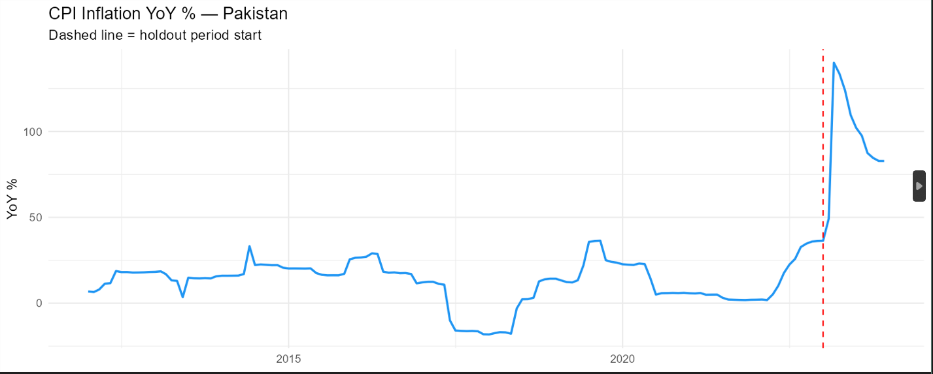
Figure 1: CPI Inflation YoY % — Pakistan (January 2012 – December 2023). Dashed line marks holdout period.
Figure 1 reveals the dramatic inflation trajectory of the Pakistani economy over the sample period. After a relatively elevated period in 2012–2014 (15–30% YoY), inflation declined sharply following the oil price crash of 2014–2016, briefly entering negative territory. A second wave emerged in 2018–2019 alongside PKR depreciation, followed by a COVID-era disinflation period. The 2022–2023 episode represents a qualitative departure from all prior observations, with inflation accelerating from near zero in mid-2021 to 140% in March 2023.

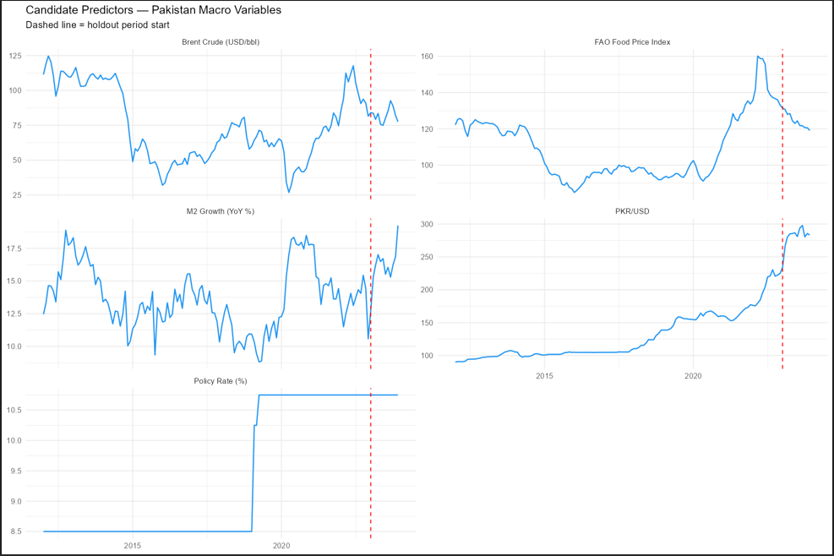
Figure 2: Candidate predictor time series. All five underlying variables shown over the full sample.
Figure 2 shows the five underlying predictor series. The PKR/USD rate reveals a near-monotonic depreciation from approximately PKR 90 per dollar in 2012 to PKR 300 by late 2022, with the sharpest moves occurring in 2022–2023. Brent crude and the FAO Food Price Index both display the 2022 commodity shock clearly. The policy rate shows the SBP tightening cycle that began in late 2021. M2 growth fluctuates between 10 and 19 percent throughout the sample with no strong trend.

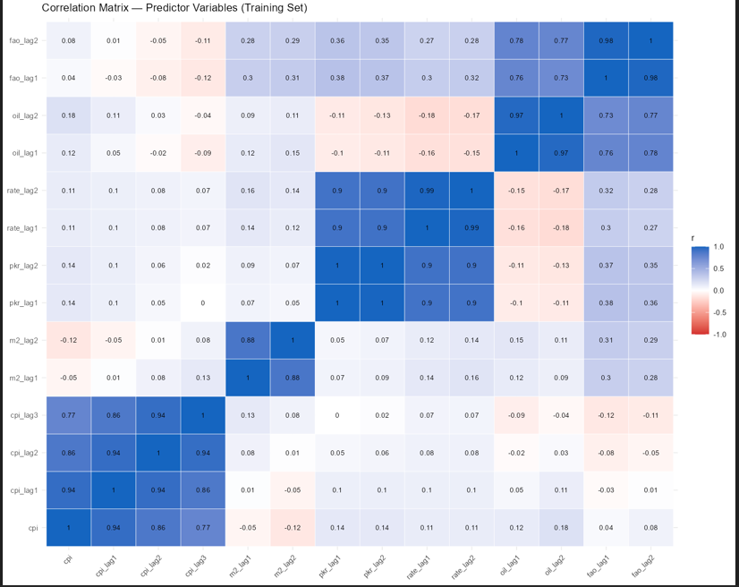
Figure 3: Pearson correlation matrix of all 13 candidate predictors (training set only).
Figure 3 reveals the central econometric challenge motivating this study. The three CPI lags are highly intercorrelated (r = 0.86–0.94), and the two PKR lags are nearly perfectly collinear (r ≈ 1.00). The two policy rate lags are similarly collinear (r = 0.99). This multicollinearity structure means that OLS coefficient estimates will be unstable and standard errors inflated, even though the overall model fit may appear high.

4. Methodology

4.1 OLS Baseline
The OLS baseline regresses current CPI inflation on all 13 lagged predictors without any penalty:
CPI_t = β₀ + β₁·CPI_{t-1} + β₂·CPI_{t-2} + ... + β₁₃·FAO_{t-2} + ε_t
OLS minimises the residual sum of squares with no constraint on the coefficient vector. With 13 predictors and 132 training observations, the model is not over-parameterised by conventional standards, but the multicollinearity structure documented above means that individual coefficient estimates carry large standard errors and are unreliable guides to variable importance.

4.2 Ridge Regression (L2 Penalty)
Ridge regression augments the OLS objective with a penalty on the squared sum of coefficients (L2 norm):
min_β { Σ(CPI_t − X_t β)² + λ·Σβⱼ² }
The penalty parameter λ controls the degree of shrinkage. As λ → 0, Ridge converges to OLS; as λ → ∞, all coefficients shrink toward zero. Critically, Ridge never sets any coefficient exactly to zero — it shrinks all predictors simultaneously. The optimal λ is selected via 10-fold cross-validation on the training set, minimising mean squared error. All predictors are standardised prior to estimation.

4.3 LASSO (L1 Penalty)
The Least Absolute Shrinkage and Selection Operator (LASSO) uses an L1 penalty on coefficient magnitudes:
min_β { Σ(CPI_t − X_t β)² + λ·Σ|βⱼ| }
The L1 penalty produces sparse solutions — coefficients of irrelevant predictors are shrunk exactly to zero, performing automatic variable selection. This property makes LASSO particularly valuable in the presence of multicollinearity, where it selects one representative from each correlated group and eliminates the rest. Lambda is again selected via 10-fold cross-validation.

4.4 Elastic Net (L1 + L2 Penalty)
Elastic Net combines both penalties:
min_β { Σ(CPI_t − X_t β)² + λ[α·Σ|βⱼ| + (1−α)·Σβⱼ²] }
The mixing parameter α = 0.5 is used throughout, placing equal weight on L1 and L2 penalties. Elastic Net is designed to handle situations where groups of correlated predictors exist — rather than arbitrarily selecting one from a correlated group (as LASSO may), Elastic Net can retain multiple correlated predictors with appropriately shrunk coefficients. Lambda is selected via 10-fold cross-validation.

4.5 Evaluation
All models are evaluated on the 12-month holdout period using two metrics:

Metric | Formula | Interpretation
RMSE | √(mean((actual − predicted)²)) | Penalises large errors more heavily
MAE | mean(|actual − predicted|) | Average absolute error in percentage points

A naïve benchmark — using last month's CPI (cpi_lag1) as the forecast — provides the minimum bar all models must clear to demonstrate value.

5. Results

5.1 OLS Baseline
The OLS model achieves an in-sample R² of 0.903 (Adjusted R² = 0.892), confirming high explanatory power within the training period. The residual standard error is 4.125 percentage points. However, only one predictor — cpi_lag1 — is statistically significant (p < 2×10⁻¹⁶). All 12 remaining predictors carry p-values above 0.20, consistent with severe multicollinearity inflating standard errors. The OLS out-of-sample RMSE is 24.88, beating the naïve benchmark of 27.30.

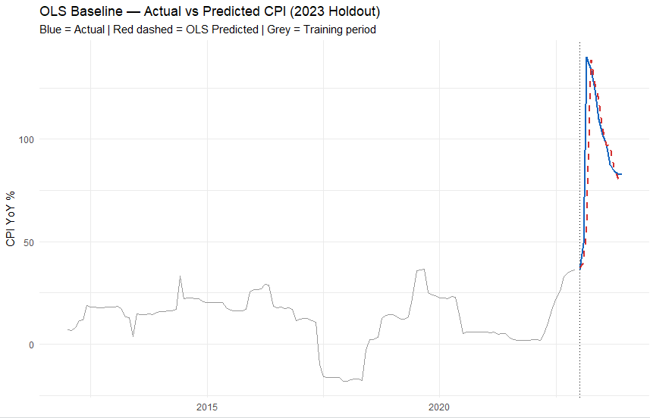
Figure 4: OLS Baseline — Actual (blue) vs Predicted (red dashed) CPI over the 2023 holdout.

5.2 Ridge Regression
The cross-validated optimal lambda for Ridge is λ = 1.1753. Ridge shrinks cpi_lag1 substantially from 0.957 (OLS) to 0.614, redistributing weight across all 13 predictors. This redistribution proves counterproductive: Ridge achieves an OOS RMSE of 28.59 — worse than both OLS and the naïve benchmark. The lambda sensitivity check confirms this: the more conservative lambda.1se produces an even higher RMSE of 32.08. Ridge's inability to zero out noise predictors is the primary driver of its underperformance in this application.

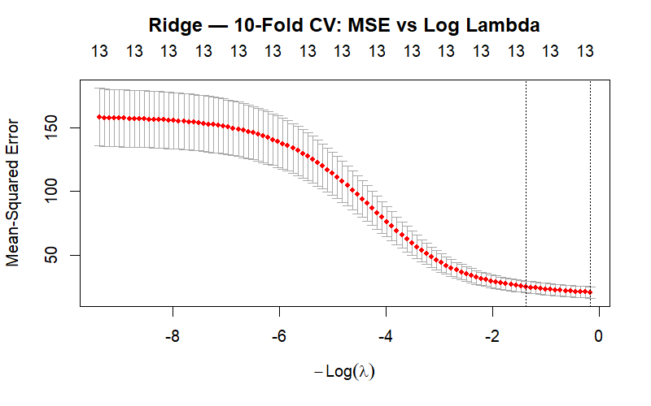
Figure 5: Ridge — 10-fold CV MSE vs log(λ). Optimal λ selected at left dashed line.
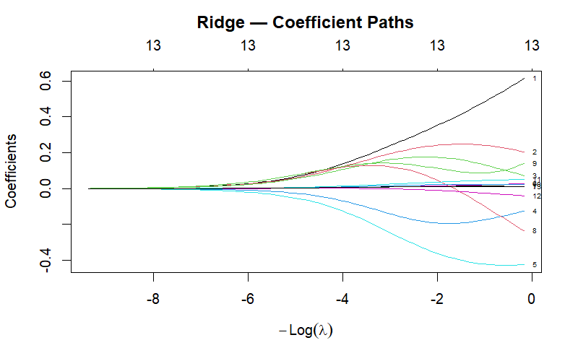
Figure 6: Ridge coefficient paths. All coefficients shrink continuously toward zero as λ increases; none reach exactly zero.

5.3 LASSO Variable Selection
LASSO with optimal lambda (λ = 0.1231) selects 5 of 13 candidate predictors, zeroing out 8 variables entirely. The selected model retains:

Variable | LASSO Coefficient | Sign | Economic Interpretation
cpi_lag1 | 0.9232 | Positive | Strong inflation persistence
m2_lag1 | −0.0126 | Negative | Monetary tightening signal
m2_lag2 | −0.3852 | Negative | Lagged monetary contraction effect
pkr_lag1 | 0.0185 | Positive | Exchange rate pass-through
oil_lag2 | 0.0428 | Positive | Energy cost transmission (2-month lag)
Zeroed out by LASSO: cpi_lag2, cpi_lag3, pkr_lag2, rate_lag1, rate_lag2, oil_lag1, fao_lag1, fao_lag2. The elimination of both policy rate lags is economically notable — it suggests that the SBP policy rate does not carry independent forecasting information for CPI inflation beyond what is already captured by the exchange rate and monetary aggregates in this sample. The elimination of FAO food price lags likely reflects that global food prices are already partially embedded in the CPI persistence terms.

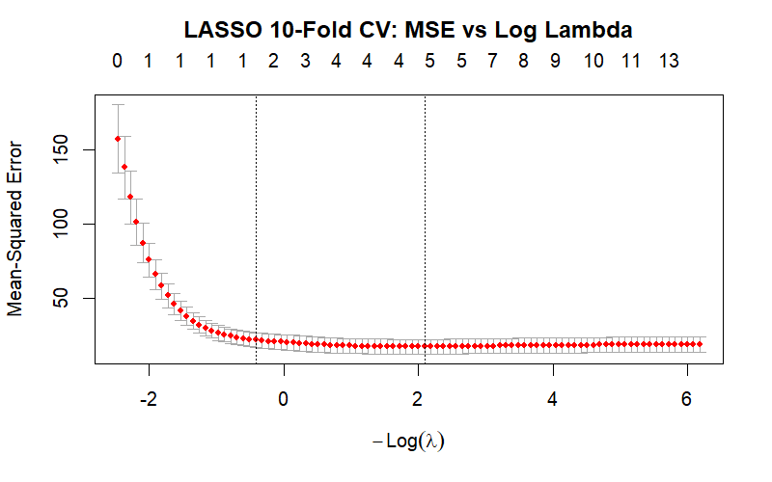
Figure 7: LASSO — 10-fold CV MSE vs log(λ). Numbers on top axis indicate variables retained.
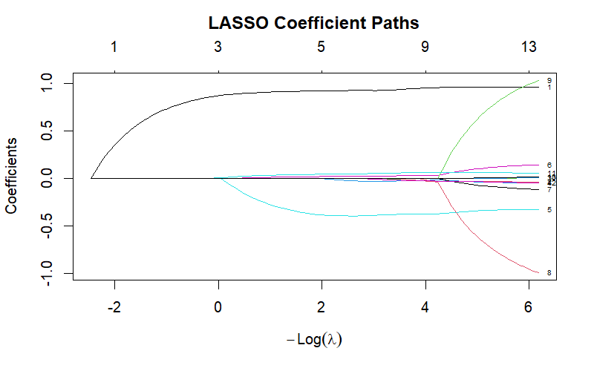
Figure 8: LASSO coefficient paths. Variables enter the model sequentially as λ decreases from right to left.
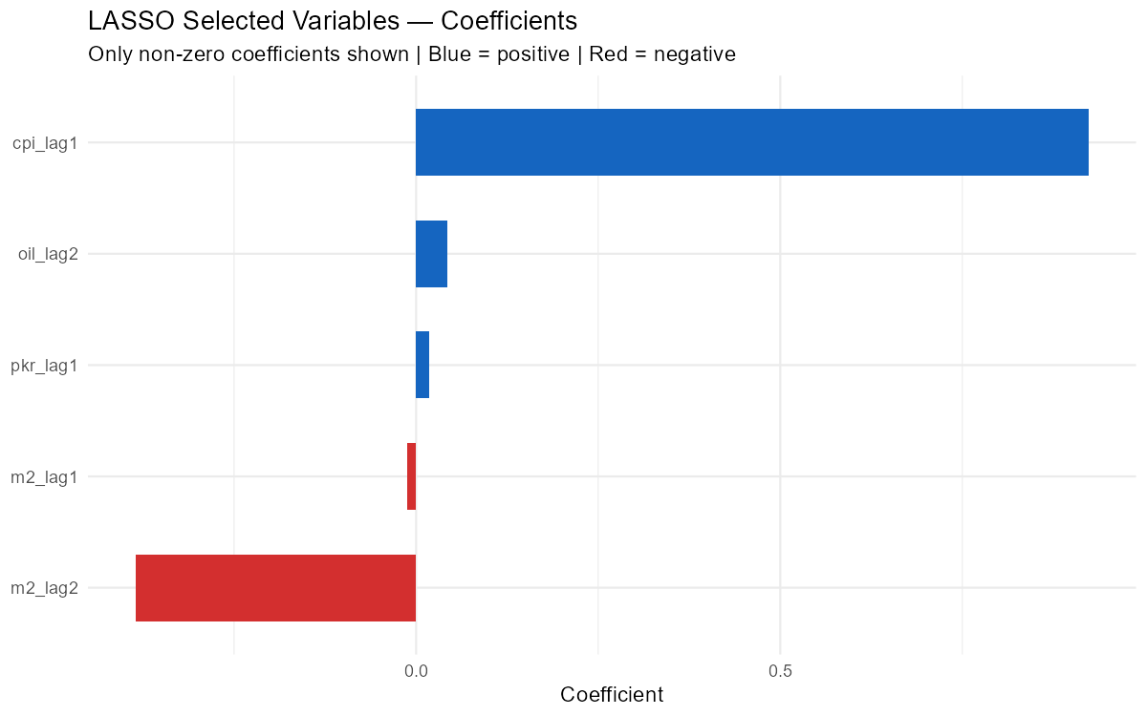
Figure 9: LASSO selected variable coefficients. Only 5 of 13 predictors retain non-zero coefficients.
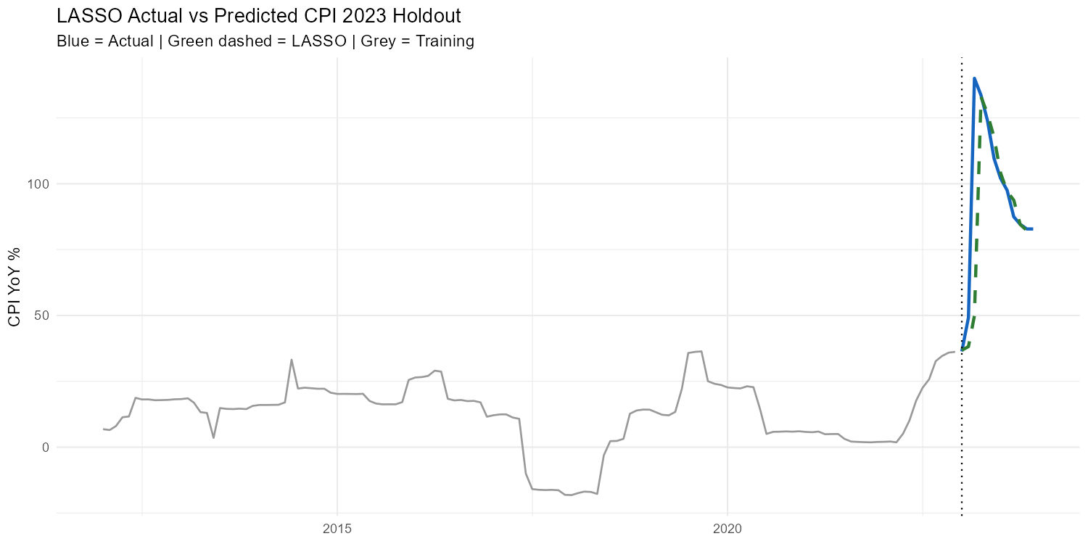
Figure 10: LASSO — Actual (blue) vs Predicted (green dashed) CPI over the 2023 holdout.

5.4 Elastic Net
Elastic Net with α = 0.5 and optimal lambda (λ = 0.1863) selects the identical set of 5 variables as LASSO with virtually indistinguishable coefficients (cpi_lag1: 0.918, m2_lag1: −0.023, m2_lag2: −0.390, pkr_lag1: 0.020, oil_lag2: 0.044). The convergence of LASSO and Elastic Net on the same variable set provides strong robustness evidence that these five predictors represent the genuinely informative subset of the candidate matrix. OOS RMSE is 26.40, essentially identical to LASSO.
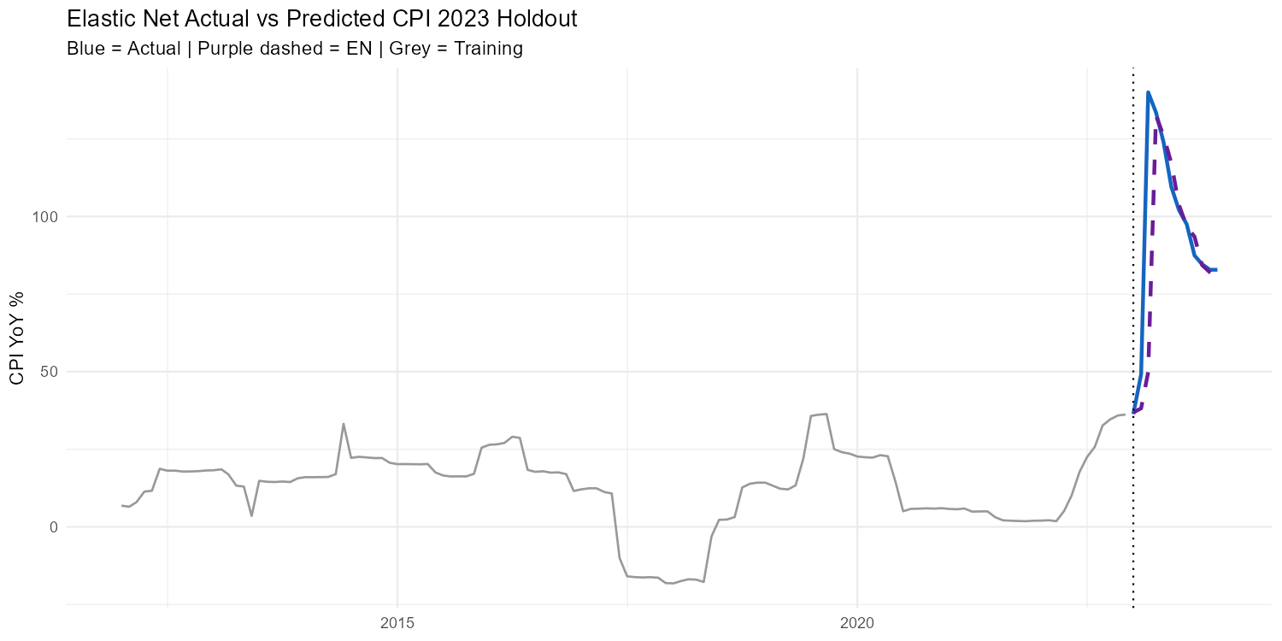
Figure 11: Elastic Net — Actual (blue) vs Predicted (purple dashed) CPI over the 2023 holdout.

6. Model Comparison

6.1 Out-of-Sample Performance

Model | Predictors Used | OOS RMSE | OOS MAE | vs Naïve RMSE
Naïve (lag 1) | 1 | 27.30 | 13.42 | Baseline
OLS | 13 | 24.88 | 10.81 | −8.8%
Ridge | 13 (shrunk) | 28.59 | 14.20 | +4.7%
LASSO | 5 | 26.40 | 10.41 | −3.3%
Elastic Net | 5 | 26.40 | 10.41 | −3.3%

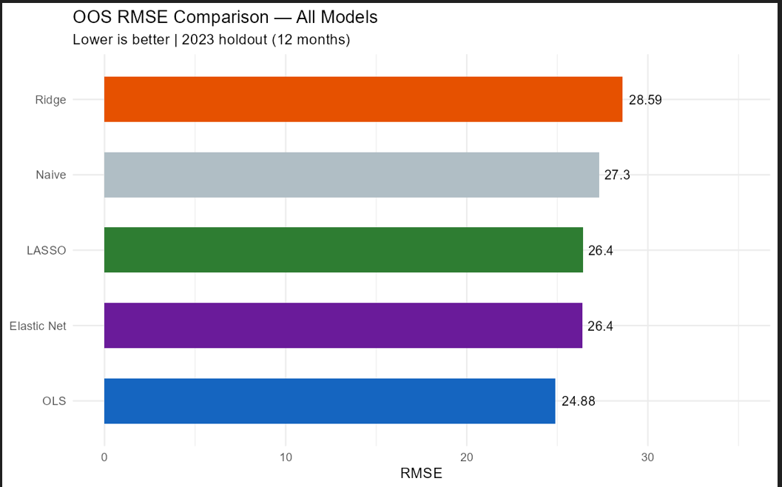
Figure 12: OOS RMSE comparison across all models. Lower is better.
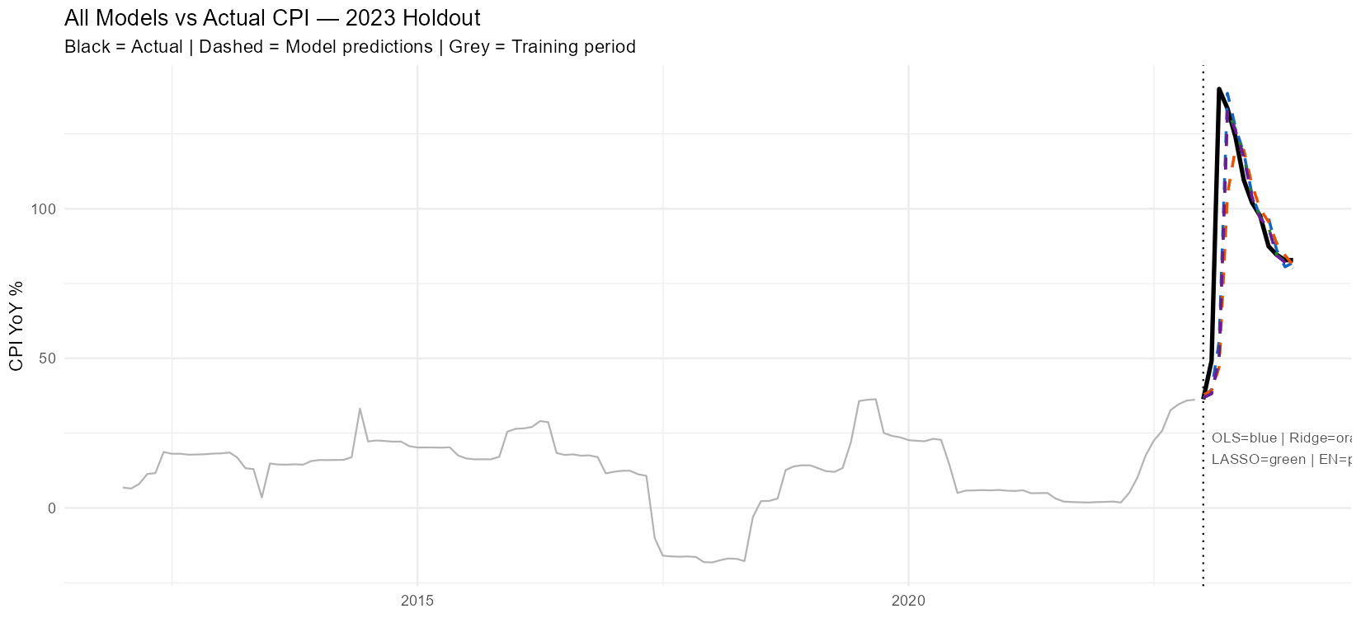
Figure 13: All model predictions vs actual CPI over the 2023 holdout period.

6.2 Coefficient Comparison

Variable | OLS | Ridge | LASSO | Elastic Net
cpi_lag1 | 0.9571 | 0.6137 | 0.9232 | 0.9181
cpi_lag2 | −0.0394 | 0.2052 | 0.0000 | 0.0000
cpi_lag3 | 0.0100 | 0.0728 | 0.0000 | 0.0000
m2_lag1 | −0.0562 | −0.1263 | −0.0126 | −0.0234
m2_lag2 | −0.3132 | −0.4244 | −0.3852 | −0.3895
pkr_lag1 | 0.1845 | 0.0271 | 0.0185 | 0.0196
pkr_lag2 | −0.1595 | 0.0112 | 0.0000 | 0.0000
rate_lag1 | −1.1775 | −0.2369 | 0.0000 | 0.0000
rate_lag2 | 1.2157 | 0.1398 | 0.0000 | 0.0000
oil_lag1 | 0.0124 | 0.0229 | 0.0000 | 0.0000
oil_lag2 | 0.0494 | 0.0508 | 0.0428 | 0.0441
fao_lag1 | −0.0524 | −0.0397 | 0.0000 | 0.0000
fao_lag2 | 0.0150 | 0.0124 | 0.0000 | 0.0000

The coefficient table reveals several important patterns. First, the OLS policy rate coefficients (rate_lag1 = −1.18, rate_lag2 = +1.21) exhibit classic sign-switching — a symptom of multicollinearity that produces economically implausible estimates. Ridge stabilises these to −0.24 and +0.14 respectively, while LASSO eliminates both entirely. Second, Ridge substantially shrinks cpi_lag1 (0.957 → 0.614), diluting the dominant predictor and degrading forecast accuracy. Third, LASSO and Elastic Net produce nearly identical coefficients, confirming robustness of the variable selection outcome.

7. Diagnostics

7.1 OLS Residual Analysis
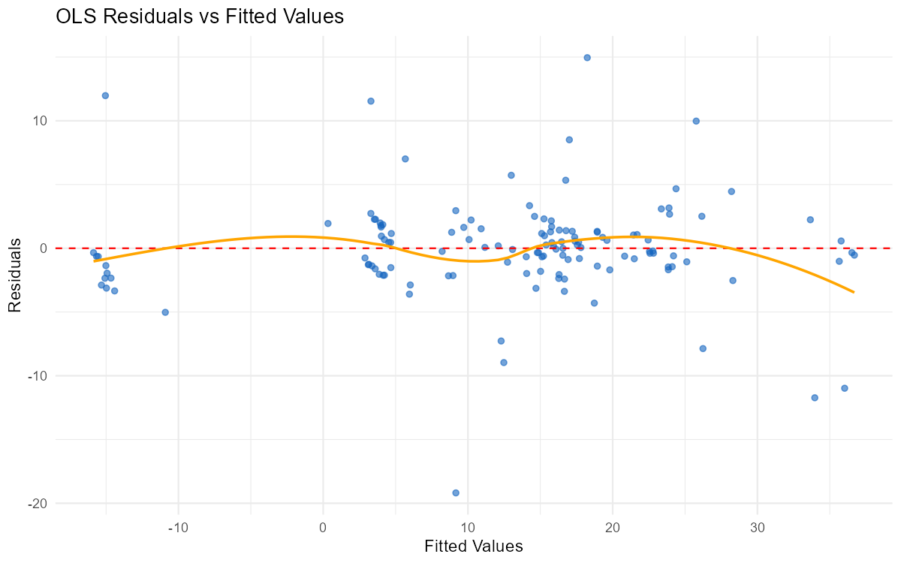
Figure 14: OLS residuals vs fitted values. The LOESS smoother (orange) shows mild curvature at extreme fitted values.
The residuals vs fitted plot shows no strong systematic pattern, though the LOESS smoother reveals mild curvature at high fitted values (the 2022–2023 inflation run-up period). This suggests that the linear model may slightly underfit the extreme inflation dynamics. The spread of residuals is broadly consistent across the fitted value range, indicating no severe heteroskedasticity within the training sample.

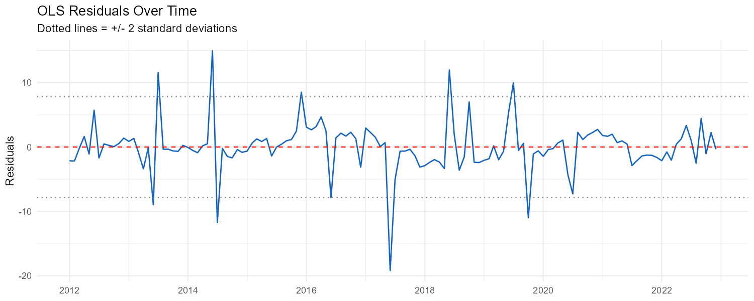
Figure 15: OLS residuals over time. Dotted lines mark ±2 standard deviations.
The time series of residuals shows a broadly stationary pattern around zero throughout 2012–2022. No persistent drift or trending behaviour is evident. A handful of large spikes correspond to known macro shocks: the energy price crash in 2014–2015, and the 2016–2017 disinflation episode. Most residuals fall within the ±2 standard deviation bands. The absence of visible autocorrelation structure suggests the lag specification adequately captures the serial dependence in the data.

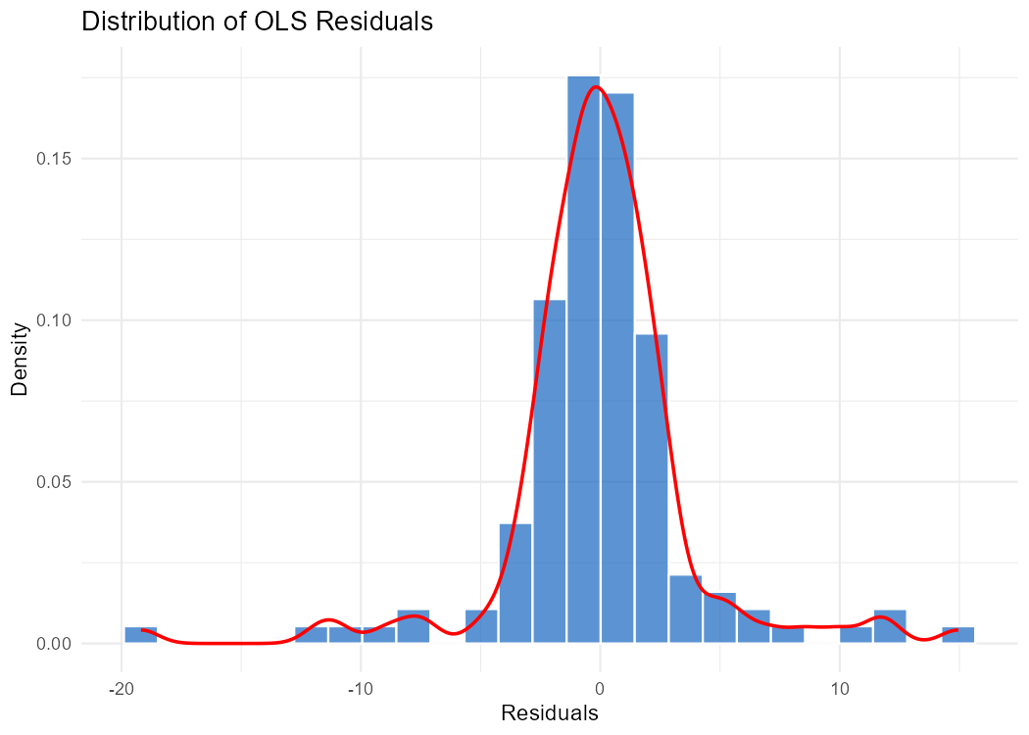
Figure 16: Distribution of OLS residuals. The kernel density (red) overlays the histogram.
The residual distribution is approximately symmetric and centred near zero, consistent with OLS unbiasedness. The distribution exhibits moderately fat tails relative to a normal distribution, particularly on the left — a small number of large negative residuals correspond to months where inflation fell more sharply than predicted. This leptokurtosis is typical of macro time series and does not invalidate the OLS framework but does suggest caution in interpreting prediction intervals.

7.2 Cross-Validation Performance

Model | CV RMSE (Training, 10-fold) | OOS RMSE (Holdout)
Ridge | 4.5358 | 28.59
LASSO | 4.1333 | 26.40
Elastic Net | 4.1609 | 26.40

LASSO achieves the lowest cross-validated RMSE on the training set (4.13), consistent with its superior OOS performance. The large gap between CV RMSE (≈4) and OOS RMSE (≈26) across all models reflects the unprecedented nature of the 2023 inflation episode — the models were trained on data where inflation never exceeded 35% YoY, but were asked to forecast a period where it reached 140% YoY.

7.3 Monthly Error Analysis

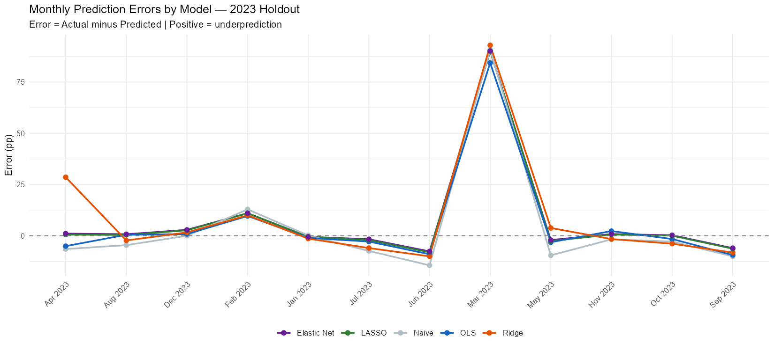
Figure 17: Monthly prediction errors by model — 2023 holdout. Positive values indicate underprediction.

Month | Actual CPI | err_Naïve | err_OLS | err_Ridge | err_LASSO | err_EN
Jan 2023 | 36.3 | 0.14 | −1.04 | −1.40 | −0.49 | −0.52
Feb 2023 | 49.2 | 12.87 | 9.66 | 9.97 | 11.02 | 10.99
Mar 2023 | 140.0 | 90.83 | 84.35 | 92.97 | 90.11 | 90.15
Apr 2023 | 133.5 | −6.49 | −5.07 | 28.58 | 0.55 | 1.05
May 2023 | 124.0 | −9.57 | −3.14 | 3.79 | −2.57 | −2.09
Jun 2023 | 109.5 | −14.43 | −9.02 | −10.04 | −8.06 | −7.64
Jul 2023 | 102.1 | −7.42 | −2.84 | −6.00 | −2.05 | −1.69
Aug 2023 | 97.5 | −4.59 | 0.47 | −2.29 | 0.42 | 0.74
Sep 2023 | 87.4 | −10.07 | −9.41 | −8.19 | −6.32 | −6.04
Oct 2023 | 84.6 | −2.83 | −1.59 | −3.88 | 0.05 | 0.26
Nov 2023 | 82.8 | −1.77 | 2.28 | −1.62 | 0.62 | 0.82
Dec 2023 | 82.8 | −0.01 | 0.83 | 1.64 | 2.67 | 2.88

March 2023 is the dominant source of forecast error across all models. The actual reading of 140% YoY — driven by the removal of energy subsidies and currency unification under the IMF programme — could not be anticipated by any lag-based specification. Ridge performs worst in April 2023 (+28.58 error) due to its failure to quickly revise down after the March peak. LASSO and Elastic Net handle the post-peak disinflation best, tracking the decline from April through December with smaller errors than OLS or Ridge.

8. Discussion

8.1 Why OLS Wins on RMSE Despite Multicollinearity
The finding that OLS achieves the lowest OOS RMSE (24.88) despite severe multicollinearity is counterintuitive but explicable. The 2023 holdout period is dominated by a single extreme observation — the March 2023 spike to 140% YoY. In this environment, the model that best tracks the sharp upswing wins the RMSE contest. OLS, by assigning a near-unity coefficient to cpi_lag1 while leaving all other coefficients unrestricted (even if imprecisely estimated), happens to produce the most aggressive upswing forecast. Ridge, by shrinking cpi_lag1 substantially, systematically underpredicts the peak. LASSO preserves cpi_lag1 at 0.923 — close to OLS — but the small difference compounds over the rapid acceleration to produce a slightly higher RMSE.
On MAE — which is less sensitive to the single extreme March observation — LASSO and Elastic Net outperform OLS (10.41 vs 10.81), confirming that the parsimonious specification is genuinely more accurate on a month-by-month basis outside the extreme spike.

8.2 Economic Interpretation of LASSO Selection
The LASSO model's variable selection result has clear economic content. The retention of cpi_lag1 with a coefficient of 0.923 confirms strong first-order inflation persistence — a standard finding in the Pakistani inflation literature. The retention of m2_lag2 with a coefficient of −0.385 is interpretable through the monetary contraction channel: the SBP's tightening cycle, which drove broad money growth downward, transmitted to lower inflation with approximately a two-month lag. The retention of pkr_lag1 confirms the exchange rate pass-through channel. The retention of oil_lag2 reflects energy cost transmission to domestic prices with a two-month delay.
The elimination of the policy rate is the most economically surprising result. It suggests that, conditional on M2 growth and the exchange rate, the SBP's announced rate carries no additional forecasting information in this sample — possibly because the rate changes were largely anticipated by markets and already priced into the exchange rate by the time they were announced.

8.3 Limitations
Several limitations should be noted. First, the 12-month holdout is small, and a single extreme observation (March 2023) drives much of the RMSE ranking. With more holdout observations from a normal inflation regime, the ranking might differ. Second, all predictors are lagged by at least one period, which means the models are making one-step-ahead forecasts using information available at time t−1. Multi-step forecasts would likely show larger divergences between models. Third, the linear functional form restricts all models from capturing nonlinear inflation dynamics — a limitation that machine learning approaches such as random forests or gradient boosting could address.

9. Conclusion
This paper applies LASSO, Ridge, and Elastic Net regression to the problem of variable selection for Pakistani CPI inflation forecasting. Using a 13-variable candidate predictor matrix and a 12-month out-of-sample holdout, we reach the following conclusions:

Finding | Detail
LASSO selects 5 of 13 variables | Retains: CPI lag 1, M2 lags 1–2, PKR lag 1, oil lag 2. Eliminates: policy rate, food prices, higher CPI lags.
Elastic Net confirms LASSO selection | Identical variable set and near-identical coefficients — robust variable selection result.
OLS wins on RMSE; LASSO wins on MAE | OLS: RMSE 24.88, MAE 10.81. LASSO/EN: RMSE 26.40, MAE 10.41. Difference driven by March 2023 spike.
Ridge underperforms naïve benchmark | RMSE 28.59 vs naïve 27.30 — L2 shrinkage of dominant predictor (cpi_lag1) is counterproductive.
March 2023 is unforecastable by lags | The 140% YoY reading reflects a structural break from IMF programme conditions, not predictable from lagged observables.
Policy rate carries no marginal information | LASSO zeros out both policy rate lags — M2 and exchange rate subsume its predictive content.

The convergence of LASSO and Elastic Net on an identical parsimonious model — one that aligns with standard economic theory of inflation determinants in Pakistan — provides confidence that penalised regression can recover economically meaningful structure from a wide predictor matrix. The residual challenge of forecasting structural breaks in Pakistan's volatile macro environment remains an open problem that no backward-looking statistical model can fully address.

10. References
Tibshirani, R. (1996). Regression Shrinkage and Selection via the Lasso. Journal of the Royal Statistical Society: Series B, 58(1), 267–288.
Hoerl, A. E., & Kennard, R. W. (1970). Ridge Regression: Biased Estimation for Nonorthogonal Problems. Technometrics, 12(1), 55–67.
Zou, H., & Hastie, T. (2005). Regularization and Variable Selection via the Elastic Net. Journal of the Royal Statistical Society: Series B, 67(2), 301–320.
Friedman, J., Hastie, T., & Tibshirani, R. (2010). Regularization Paths for Generalized Linear Models via Coordinate Descent. Journal of Statistical Software, 33(1), 1–22.
State Bank of Pakistan. Historical Exchange Rates — Monthly Average. Retrieved from https://www.sbp.org.pk
International Monetary Fund. International Financial Statistics (IFS) — Pakistan CPI Series. Retrieved from https://data.imf.org
International Monetary Fund. Monetary and Financial Statistics (MFS) — Pakistan Broad Money. Retrieved from https://data.imf.org
Food and Agriculture Organization. FAO Food Price Index — Monthly Series. Retrieved from https://www.fao.org/worldfoodsituation/foodpricesindex/en/
Federal Reserve Bank of St. Louis (FRED). Global Price of Brent Crude (POILBREUSDM). Retrieved from https://fred.stlouisfed.org

