TAIL RISK IN PAKISTANI FINANCIAL MARKETS

Value at Risk and Expected Shortfall
for KSE-100 Equities and COMEX Gold

Ahmer Anwaar| GitHub: ahmer-econ | August 2026
Sample Period: January 2010 – August 2024 | 3,487 Daily Observations

Abstract
This report estimates and compares three methodologically distinct approaches to market risk measurement — Historical Simulation (HS), Parametric Variance-Covariance, and GARCH-Based Filtered Historical Simulation (FHS) — applied to daily return series for the KSE-100 Index and COMEX Gold over the period January 2010 to August 2024. Value at Risk (VaR) and Expected Shortfall (ES) are computed at the 95% and 99% confidence levels for each asset under each method. Formal backtesting is conducted using the Kupiec Proportion of Failures test and the Christoffersen Conditional Coverage test. Results demonstrate that both return series exhibit significant excess kurtosis and negative skewness — decisively rejecting normality — and that the Parametric method systematically underestimates tail risk at the 99% confidence level. Historical Simulation produces the most reliable breach counts across both assets. The Christoffersen test reveals persistent breach clustering in KSE-100 across all methods, pointing to the limitations of static VaR in the presence of volatility regime shifts. GARCH-FHS performs competitively at 99% but exhibits over-conservatism for COMEX Gold at 95% due to regime-sensitive volatility scaling.

1. Introduction

1.1 Motivation
Market risk quantification is a foundational requirement of modern financial risk management. Whether applied to equity portfolios, commodity exposures, or regulatory capital calculations, risk managers rely on statistical models to estimate the probability and magnitude of extreme losses. The two most widely used measures — Value at Risk and Expected Shortfall — form the backbone of the Basel III and Basel IV regulatory frameworks governing international banking.
Pakistan's financial markets present a particularly interesting empirical setting. The KSE-100 Index, the benchmark equity index of the Pakistan Stock Exchange, operates in an emerging market environment characterised by episodic macro-financial crises, currency pressures, political uncertainty, and periodic liquidity shocks. COMEX Gold, by contrast, is a globally traded safe-haven commodity with a well-documented countercyclical relationship to equity markets. Comparing tail risk across these two assets allows us to examine whether risk models calibrated on global markets translate appropriately to a volatile emerging market context.
This project contributes to the applied econometrics literature on Pakistani financial markets by rigorously estimating and backtesting VaR and ES using three methods of increasing sophistication, covering approximately 14.5 years of daily data spanning multiple stress episodes including the 2015 KSE correction, the 2018-2019 Pakistan balance of payments crisis, and the March 2020 COVID-19 market shock.

1.2 Research Objectives
This report addresses four primary objectives:
First, to characterise the distributional properties of daily returns for KSE-100 and COMEX Gold, with particular attention to fat tails and non-normality.
Second, to estimate VaR and ES at 95% and 99% confidence levels using Historical Simulation, Parametric, and GARCH-FHS methods.
Third, to formally validate each model's accuracy through Kupiec POF and Christoffersen Conditional Coverage backtesting.
Fourth, to identify which method best captures tail risk in Pakistani equity and global commodity markets, and to articulate the practical implications for risk managers.

1.3 Data
KSE-100 daily closing prices were sourced from the Kaggle dataset 'Pakistan Stock Exchange KSE100 20 Years' (aleemaher, CC0 Public Domain licence), covering January 2004 to August 2024. COMEX Gold futures daily closing prices (ticker: GC=F) were retrieved from Yahoo Finance via the quantmod package in R, covering the same period. After inner-joining on common trading dates and restricting to January 2010 – August 2024, the final aligned sample contains 3,488 observations, yielding 3,487 daily log returns after first-differencing.

1.4 Software
All analysis was conducted in R 4.6.0. Key packages used include quantmod for data retrieval, rugarch for GARCH estimation, ggplot2 for visualisation, moments and tseries for distributional diagnostics, and dplyr and readr for data management. All scripts are available at github.com/ahmer-econ.

2. Methodology

2.1 Return Computation
Daily log returns are computed as r_t = 100 × ln(P_t / P_{t-1}), where P_t is the closing price on day t. Expressing returns in percentage form facilitates direct comparison with VaR and ES estimates reported in the same units.

2.2 Distributional Diagnostics
Prior to model estimation, the empirical return distributions are characterised through descriptive statistics (mean, standard deviation, skewness, excess kurtosis) and formally tested for normality using the Jarque-Bera test. The null hypothesis of the Jarque-Bera test is that skewness equals zero and excess kurtosis equals zero simultaneously. Rejection of this null is the formal justification for preferring non-parametric or semi-parametric VaR methods over the parametric normal assumption.

2.3 Value at Risk and Expected Shortfall
Value at Risk at confidence level α is defined as the loss threshold exceeded with probability (1 − α). Formally, VaR_α is the α-quantile of the return distribution: P(r_t < VaR_α) = 1 − α. A 99% VaR of −3% means losses exceed 3% on only 1% of trading days.
Expected Shortfall at confidence level α is defined as the conditional expected loss given that the loss exceeds VaR_α: ES_α = E[r_t | r_t < VaR_α]. ES is always more negative than VaR at the same confidence level, and is considered a superior risk measure because it is coherent in the sense of Artzner et al. (1999) and captures the shape of the tail beyond the VaR threshold.

2.4 Historical Simulation
Historical Simulation (HS) estimates VaR and ES directly from the empirical distribution of past returns, without imposing any parametric distributional assumption. The 95% VaR is the 5th percentile of the observed return series; the 99% VaR is the 1st percentile. ES is the mean of all returns falling below the VaR threshold. HS's principal advantage is its non-parametric nature; its limitation is that it assumes the future distribution will resemble the past and is sensitive to the length and composition of the historical window.

2.5 Parametric (Variance-Covariance) Method
The Parametric method assumes that returns are normally distributed with mean μ and standard deviation σ estimated from the data. VaR is computed analytically as VaR_α = μ + σ × z_{1−α}, where z_{1−α} is the standard normal quantile. ES is computed as ES_α = μ − σ × φ(z_{1−α}) / (1 − α), where φ(·) is the standard normal density function. This method is computationally simple but imposes the normality assumption that the Jarque-Bera test will decisively reject for our data.

2.6 GARCH(1,1) Filtered Historical Simulation
The GARCH(1,1) Filtered Historical Simulation method addresses two limitations of pure HS: it does not account for time-varying volatility (volatility clustering), and it uses the full historical distribution rather than adapting to the current volatility regime.
Step one estimates a GARCH(1,1) model for each asset: r_t = μ + ε_t, where ε_t = σ_t × z_t and σ_t² = ω + α₁ε_{t−1}² + β₁σ_{t−1}². The parameter α₁ captures the ARCH effect (sensitivity to recent shocks) and β₁ captures the GARCH effect (persistence of volatility). The sum α₁ + β₁ measures volatility persistence.
Step two extracts standardised residuals z_t = ε_t / σ_t. If the GARCH model is correctly specified, these residuals should be approximately i.i.d. with mean zero and unit variance.
Step three constructs simulated returns using the last conditional volatility estimate σ_T and the empirical distribution of standardised residuals: r_sim = μ + σ_T × z_t. VaR and ES are then computed from this simulated distribution. This combines GARCH's forward-looking volatility estimate with the empirical fat-tailed innovation distribution, avoiding the normality assumption.

2.7 Backtesting
Kupiec Proportion of Failures (POF) Test: This test evaluates whether the observed breach rate equals the theoretical breach rate (1 − α). The test statistic LR_UC = −2[log L₀ − log L₁] follows a chi-squared distribution with one degree of freedom under the null hypothesis of correct unconditional coverage. A p-value below 0.05 indicates rejection — the model produces too many or too few breaches.
Christoffersen Conditional Coverage Test: This test extends Kupiec by additionally testing whether breaches are independent over time. Clustered breaches — multiple violations occurring close together — indicate that the model fails to capture volatility dynamics. The conditional coverage statistic LR_CC = LR_UC + LR_IND follows a chi-squared distribution with two degrees of freedom. Passing the Christoffersen test is a stricter requirement than passing Kupiec alone.

3. Distributional Properties of Returns

3.1 Return Series
Figures 1 and 2 plot the daily log return series for KSE-100 and COMEX Gold respectively over the full sample period. Both series display the hallmark features of financial return data: volatility clustering (periods of high volatility are followed by further high volatility), and occasional extreme observations that substantially exceed the typical daily range.
For KSE-100, the dominant stress episode is clearly visible around March 2020, when the COVID-19 pandemic triggered the largest single-day loss in the sample (−7.10%). Secondary elevated volatility episodes are visible around 2015 (market correction) and 2018-2019 (Pakistan macro-financial stress). For COMEX Gold, COVID-19 produced an extreme positive return exceeding +11% in a single day — reflecting gold's safe-haven demand surge — alongside a sharp negative spike of approximately −9% in April 2013 (the gold flash crash).
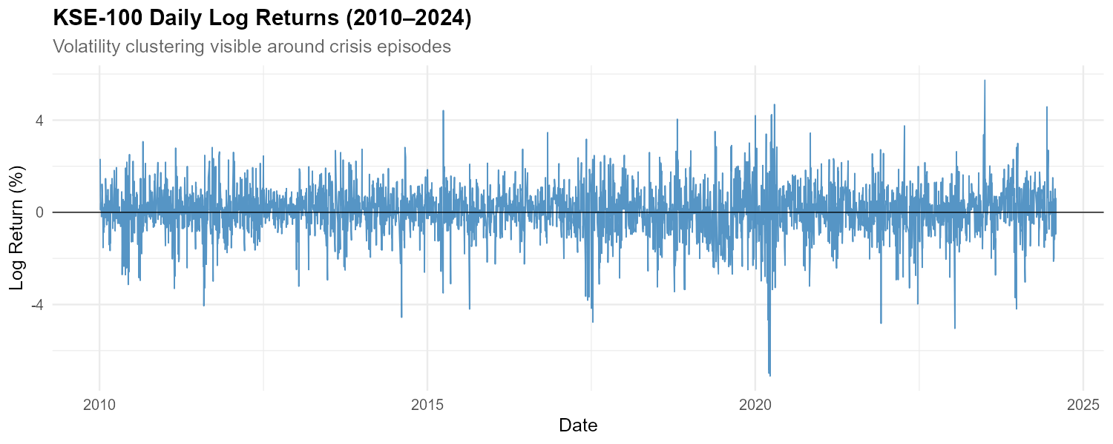
Figure 1: KSE-100 Daily Log Returns (2010–2024)
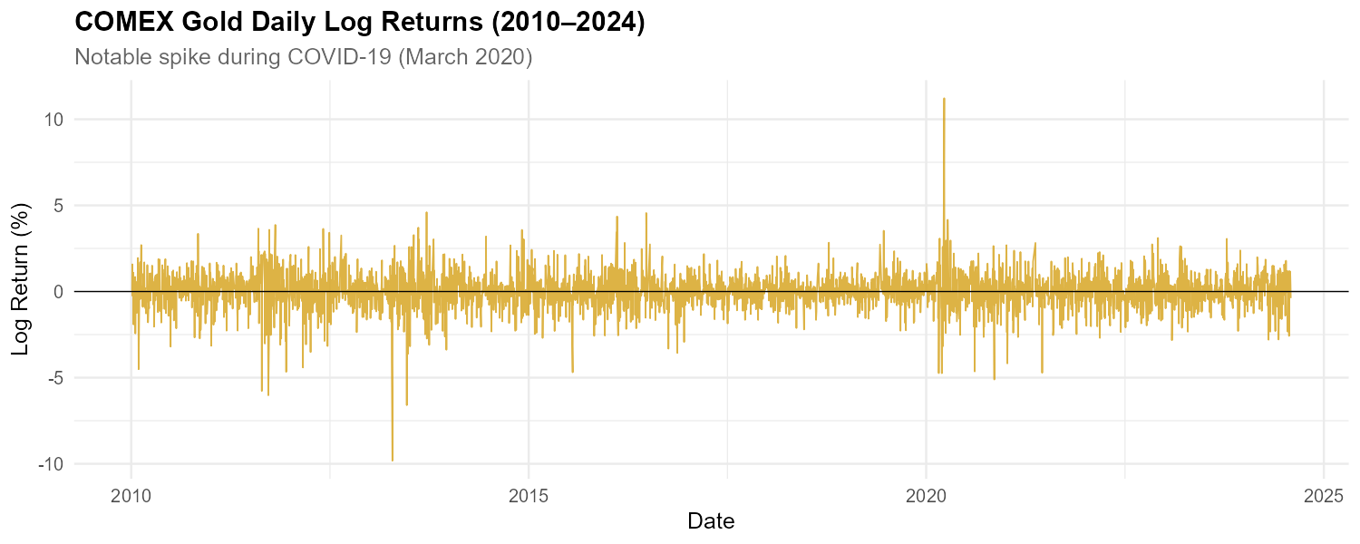
Figure 2: COMEX Gold Daily Log Returns (2010–2024)

3.2 Descriptive Statistics and Normality Tests
Table 1 presents the full set of descriptive statistics and Jarque-Bera normality test results for both return series.
Statistic | KSE-100 | COMEX Gold
Observations | 3,487 | 3,487
Mean (%) | 0.0607 | 0.0222
Std Dev (%) | 1.0449 | 1.0416
Minimum (%) | −7.1024 | −9.8206
Maximum (%) | 5.7339 | 11.2197
Skewness | −0.4755 | −0.2645
Excess Kurtosis | 3.9849 | 8.8652
Jarque-Bera Statistic | 2,438.57 | 11,459.46
Jarque-Bera p-value | < 0.0001 | < 0.0001
Table 1: Descriptive Statistics and Jarque-Bera Normality Tests
Both series are negatively skewed, indicating that large negative returns are more extreme than large positive returns — consistent with the general finding that equity and commodity markets crash faster than they rally. Excess kurtosis is strongly positive for both assets: 3.98 for KSE-100 and 8.87 for COMEX Gold. These values substantially exceed the normal distribution's excess kurtosis of zero, confirming the presence of fat tails — extreme events occur far more frequently than the normal distribution would predict.
The Jarque-Bera test decisively rejects normality for both series (p < 0.0001). Gold's kurtosis of 8.87 — more than double KSE-100's 3.98 — reflects the asset's susceptibility to sudden safe-haven demand shocks and the April 2013 flash crash. This empirical fact has direct methodological implications: any VaR model that assumes normality will systematically underestimate tail risk, particularly at high confidence levels.
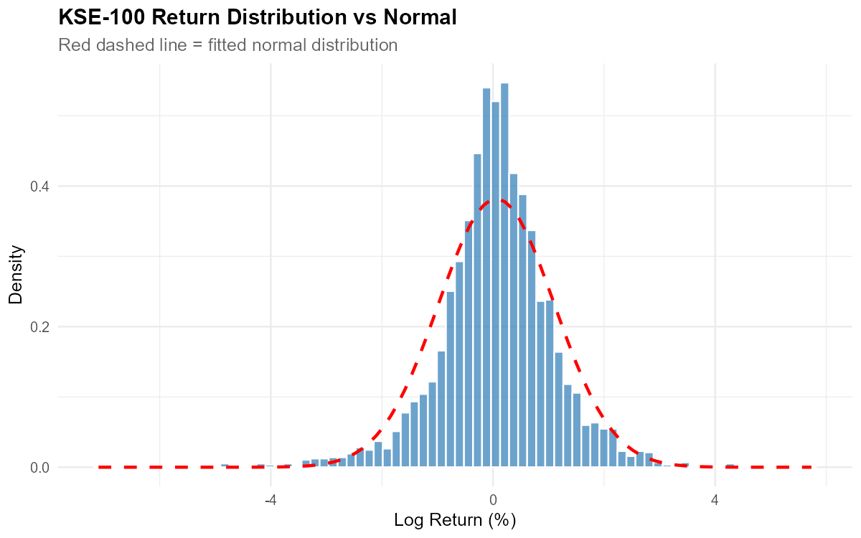
Figure 3: KSE-100 Return Distribution vs Normal (red dashed)
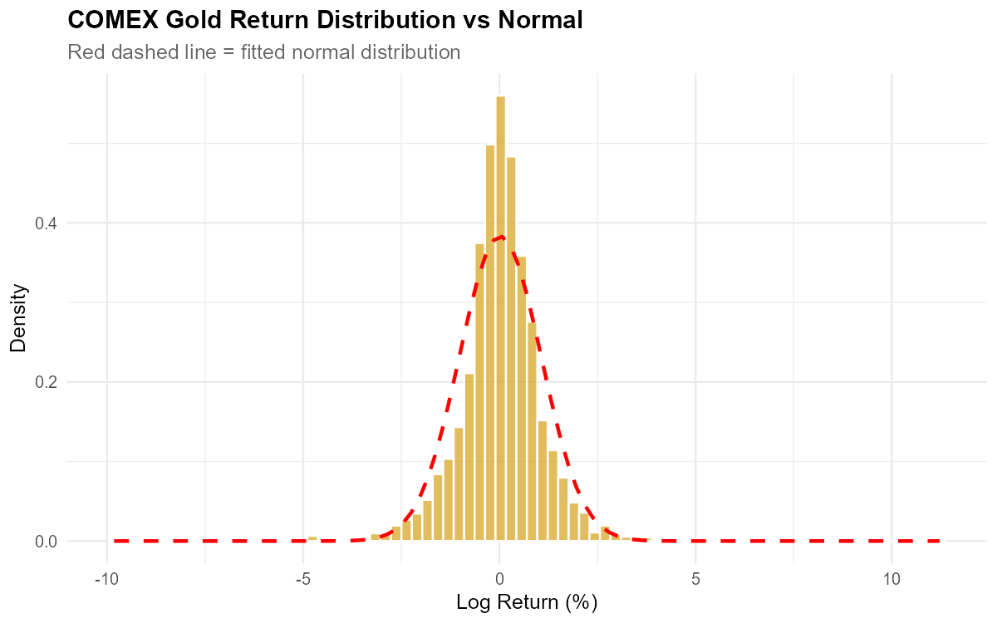
Figure 4: COMEX Gold Return Distribution vs Normal (red dashed)
Figures 3 and 4 display the empirical return distributions overlaid with fitted normal curves. The visual evidence is striking: the empirical histograms are taller and narrower at the centre than the normal curve (leptokurtosis), and exhibit heavier tails — the histogram bars extend well beyond the range where the normal curve has effectively reached zero. This visual evidence complements the Jarque-Bera test results and directly motivates the use of non-parametric and semi-parametric VaR methods.

4. GARCH(1,1) Estimation

4.1 Model Specification and Rationale
The return series plots (Figures 1 and 2) clearly exhibit volatility clustering — large returns (positive or negative) tend to be followed by further large returns, and calm periods cluster similarly. This violates the constant-variance assumption underlying both HS and the Parametric method and motivates the use of a GARCH model to capture time-varying volatility dynamics.
A GARCH(1,1) model is specified for each asset with a constant mean (ARFIMA(0,0,0)) and normal innovation distribution. The GARCH(1,1) specification is the standard parsimonious choice for daily financial returns and is sufficient to capture the autocorrelation structure in squared returns identified in the data.

4.2 Estimated Coefficients
Parameter | KSE-100 | COMEX Gold | Interpretation
μ (mean) | 0.1025*** | 0.0194 | Daily mean return
ω (intercept) | 0.0711*** | 0.0188*** | Baseline variance
α₁ (ARCH) | 0.1252*** | 0.0440* | Shock sensitivity
β₁ (GARCH) | 0.8108*** | 0.9391*** | Volatility persistence
α₁ + β₁ (Persistence) | 0.9361 | 0.9831 | Shock half-life
Table 2: GARCH(1,1) Coefficients. *** p<0.01, * p<0.10 (robust standard errors).
All parameters are precisely estimated and statistically significant at conventional levels, with the exception of gold's mean return (μ = 0.019, p = 0.238) — consistent with the descriptive statistics showing gold's near-zero daily mean. The α₁ parameter for gold is borderline significant under robust standard errors (p = 0.055) but significant under standard errors, and is retained given the economic importance of the ARCH effect.
Volatility persistence is extremely high for both assets: 0.936 for KSE-100 and 0.983 for COMEX Gold. This means that a volatility shock today retains 93.6% and 98.3% of its impact tomorrow, respectively. Gold's near-unit-root persistence is well documented in the empirical finance literature and reflects the asset's tendency to remain in elevated volatility regimes for extended periods following major shocks.
The substantially higher α₁ for KSE-100 (0.125 vs 0.044) indicates that the Pakistani equity market is more sensitive to individual day shocks — new bad news hits KSE-100 volatility harder than it hits gold, consistent with the thinner liquidity and higher idiosyncratic risk of an emerging market equity index.

4.3 Conditional Volatility
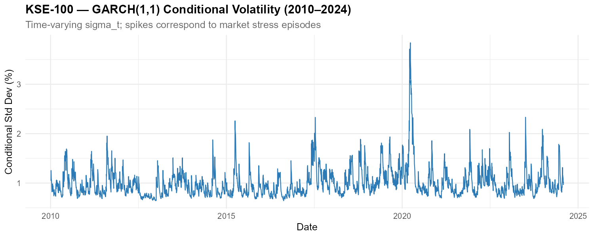
Figure 5: KSE-100 GARCH(1,1) Conditional Volatility (2010–2024)
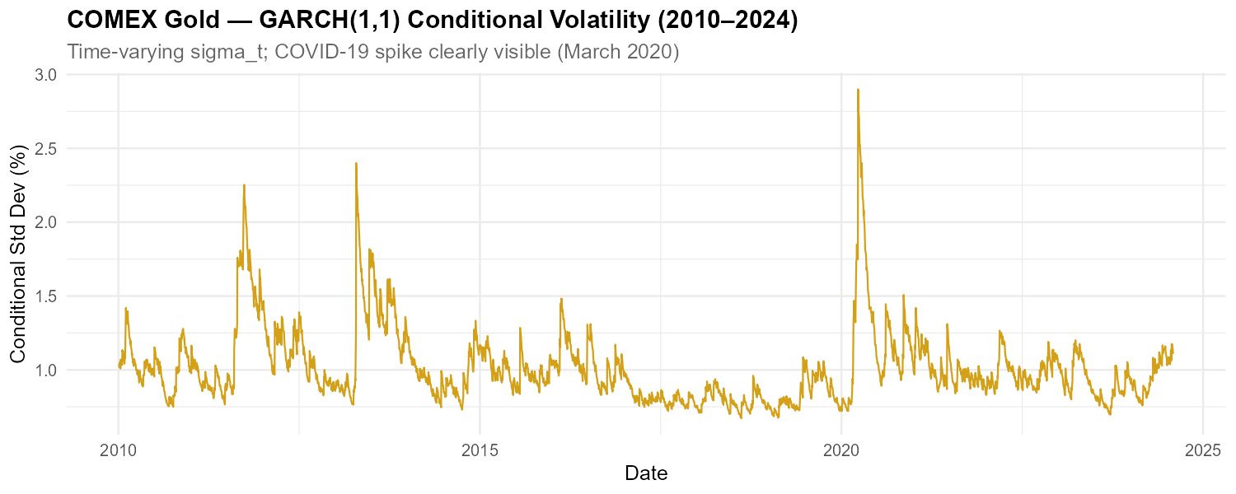
Figure 6: COMEX Gold GARCH(1,1) Conditional Volatility (2010–2024)
Figures 5 and 6 plot the estimated conditional volatility series σ_t for each asset. Both series clearly identify the COVID-19 episode as the dominant stress event of the sample, with KSE-100 conditional volatility reaching approximately 3.7% and gold reaching approximately 2.9% in March-April 2020. KSE-100 also shows elevated volatility in 2015 and 2018-2019, corresponding to domestic macro-financial stress. Gold shows elevated volatility in 2011-2012 during the post-GFC safe-haven demand surge.
The GARCH diagnostic tests confirm model adequacy. The weighted Ljung-Box test on squared standardised residuals yields p-values well above 0.10 for both assets, indicating no remaining ARCH effects in the residuals — the GARCH(1,1) has successfully captured the volatility clustering. The ARCH LM tests confirm this finding.

4.4 Standardised Residuals
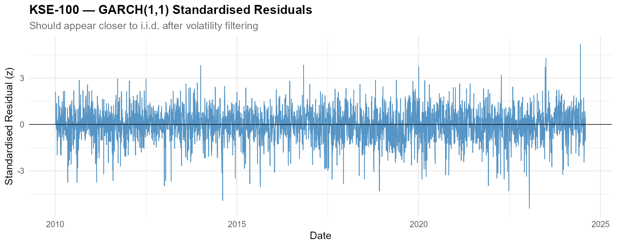
Figure 7: KSE-100 GARCH(1,1) Standardised Residuals
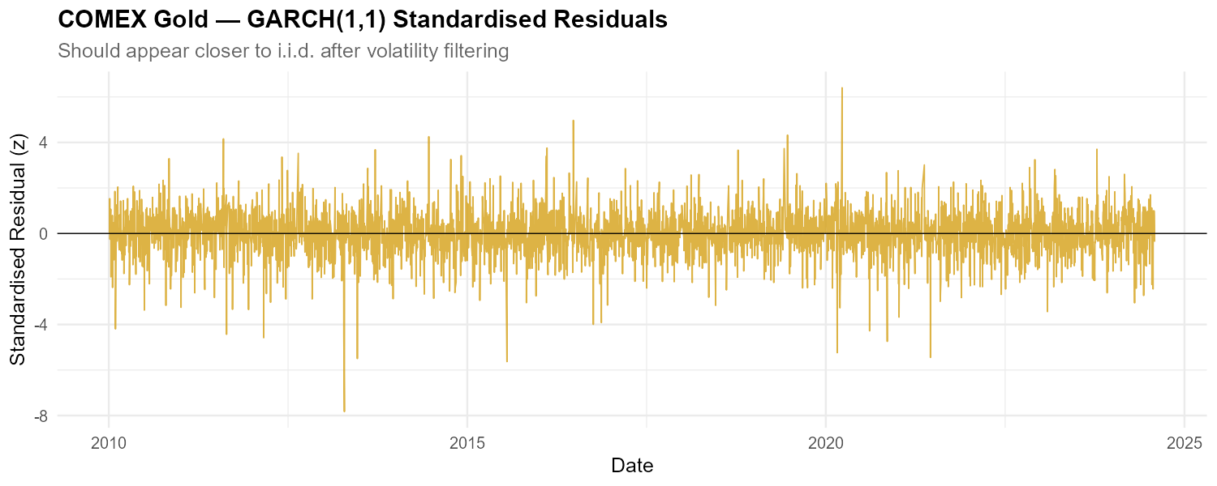
Figure 8: COMEX Gold GARCH(1,1) Standardised Residuals
The standardised residuals z_t = ε_t / σ_t have mean −0.052 and standard deviation 0.999 for KSE-100, and mean 0.004 and standard deviation 1.001 for COMEX Gold — very close to the expected mean zero and unit variance. Figures 7 and 8 show that volatility clustering has been largely removed from the residuals, though extreme outliers persist — most notably a z-score of approximately −8 for gold around April 2013 (the flash crash), which exceeds what any GARCH model can absorb in a single period. These standardised residuals form the empirical innovation distribution resampled in the FHS VaR computation.

5. VaR and ES Estimation Results

5.1 Summary of All Estimates
Asset / Conf. | HS VaR | HS ES | Param VaR | Param ES | FHS VaR | FHS ES
KSE-100 — 95% | −1.61% | −2.51% | −1.66% | −2.09% | −1.59% | −2.31%
KSE-100 — 99% | −3.04% | −4.01% | −2.37% | −2.72% | −2.80% | −3.43%
COMEX Gold — 95% | −1.65% | −2.48% | −1.69% | −2.13% | −1.80% | −2.64%
COMEX Gold — 99% | −2.80% | −4.08% | −2.40% | −2.75% | −3.03% | −4.16%
Table 3: VaR and ES Estimates — All Methods and Confidence Levels. Red = systematic underestimation confirmed by backtesting.

5.2 Method Comparison — KSE-100
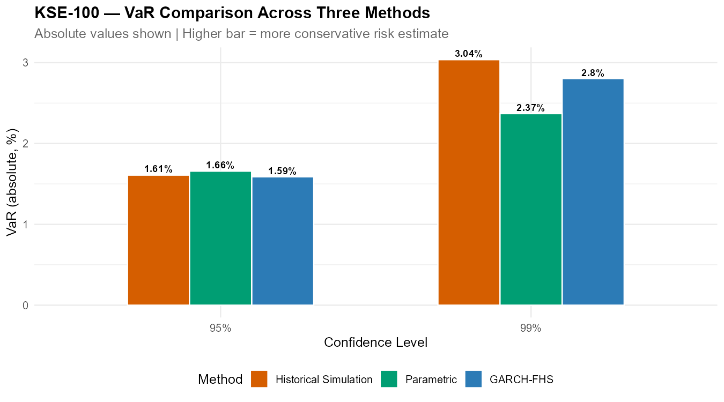
Figure 9: KSE-100 VaR Comparison Across Three Methods
At the 95% confidence level, all three methods produce nearly identical VaR estimates for KSE-100 (−1.59% to −1.66%). This convergence is expected: near the centre of the distribution, the normal approximation is relatively accurate, and all three methods draw on similar parts of the empirical distribution.
At the 99% confidence level, the methods diverge sharply. Historical Simulation produces the most conservative estimate at −3.04%, GARCH-FHS produces −2.80%, and the Parametric method produces −2.37% — 67 basis points less conservative than HS. At the ES level, the gap is even more pronounced: Parametric ES of −2.72% vs HS ES of −4.01%, a difference of 129 basis points. A risk manager relying on the Parametric method at the 99% level would hold approximately one-third less capital against extreme KSE-100 losses than the empirical distribution warrants.

5.3 Method Comparison — COMEX Gold
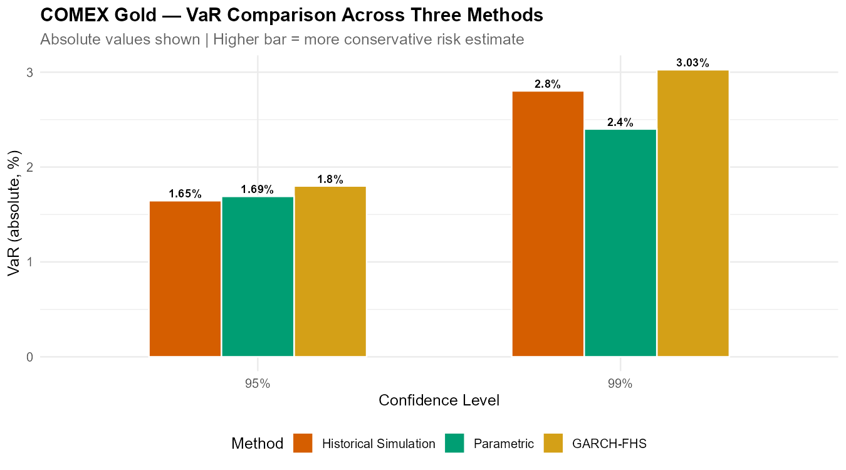
Figure 10: COMEX Gold VaR Comparison Across Three Methods
Gold exhibits a different pattern. At 95%, GARCH-FHS produces the most conservative estimate (−1.80%), exceeding even HS (−1.65%). This occurs because gold's last conditional volatility σ_T = 1.107% is above the historical average — GARCH correctly identifies that gold was in an elevated volatility regime at the end of the sample period, and scales the risk estimate upward accordingly. This is the key advantage of GARCH-FHS over static methods: it is forward-looking.
At 99%, the ordering shifts: HS produces −2.80%, GARCH-FHS produces −3.03% (most conservative), and Parametric produces −2.40% (least conservative). The Parametric method again underestimates tail risk most severely, consistent with gold's extreme excess kurtosis of 8.87.

5.4 Historical Simulation VaR — Distributions
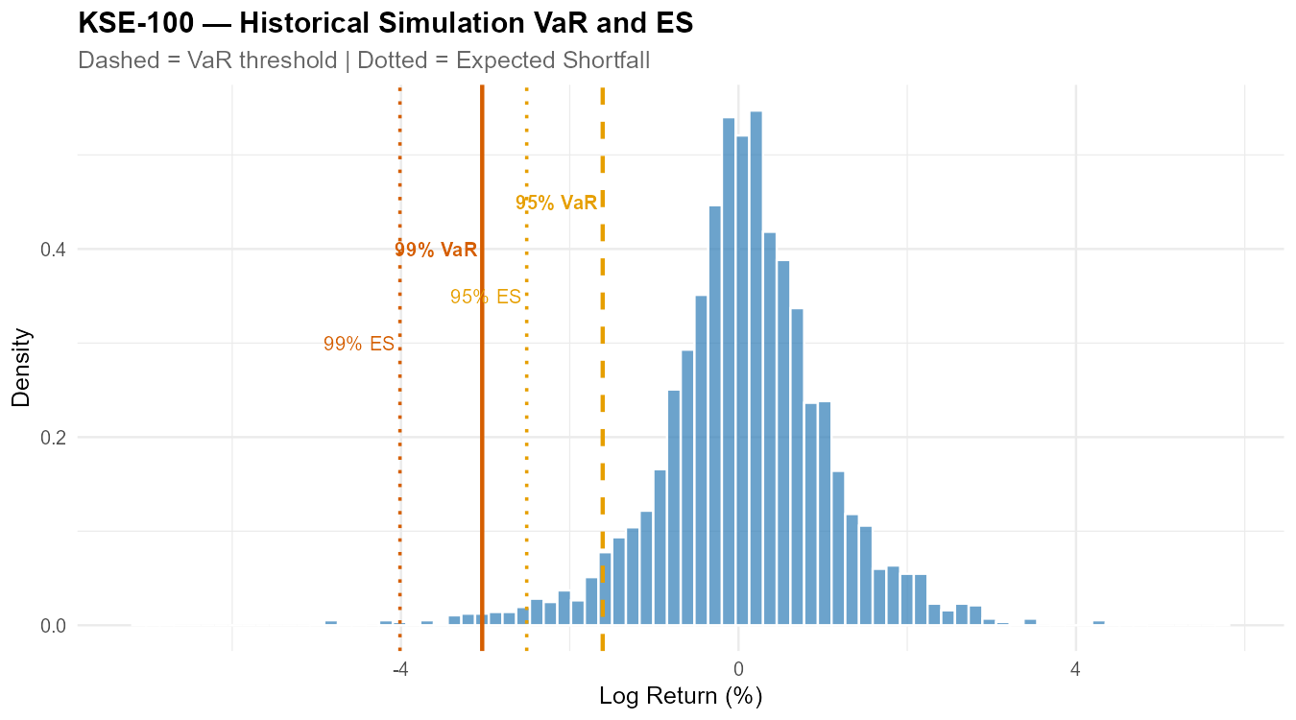
Figure 11: KSE-100 Historical Simulation VaR and ES
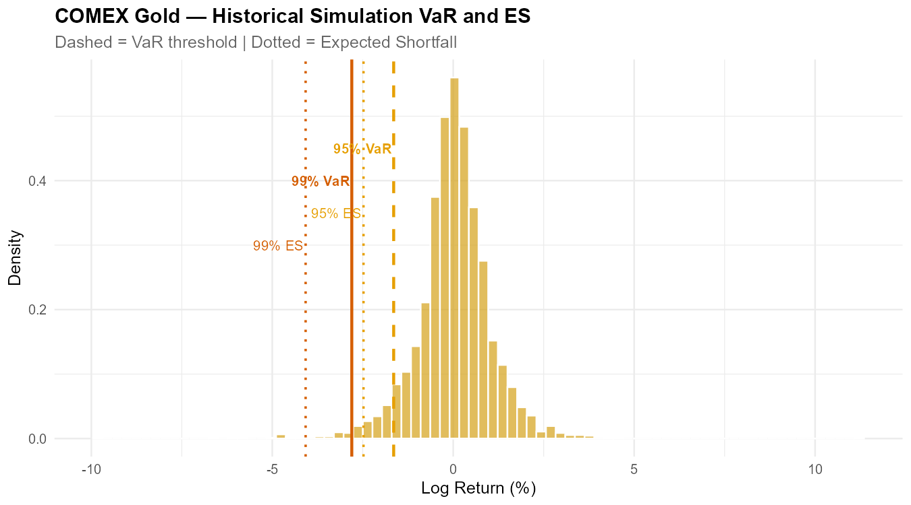
Figure 12: COMEX Gold Historical Simulation VaR and ES

5.5 Parametric vs Historical Simulation
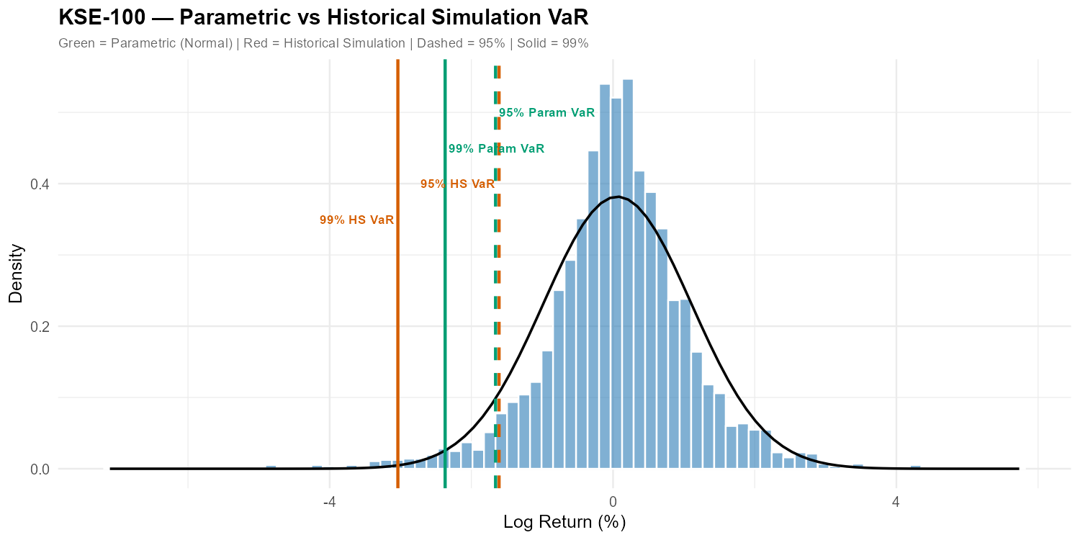
Figure 13: KSE-100 — Parametric vs HS VaR
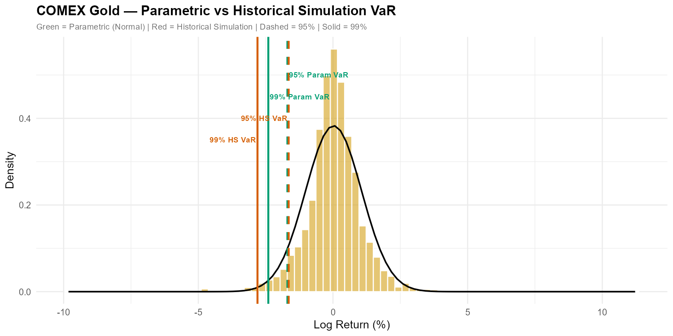
Figure 14: COMEX Gold — Parametric vs HS VaR
Figures 13 and 14 overlay the Parametric and HS VaR lines on the empirical return histograms, together with the fitted normal curve. The visual evidence is clear: the normal curve is too thin in both tails, and the Parametric 99% VaR line sits noticeably to the right of the HS 99% VaR line — confirming that the normal assumption systematically underestimates the depth of the true tail.

6. Backtesting Results

6.1 Rolling VaR
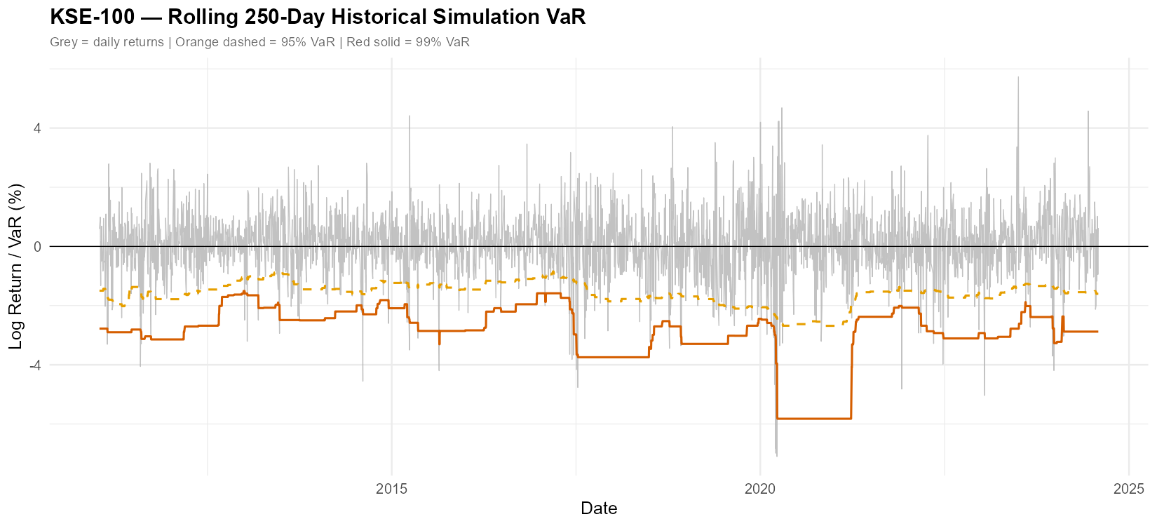
Figure 15: KSE-100 Rolling 250-Day Historical Simulation VaR
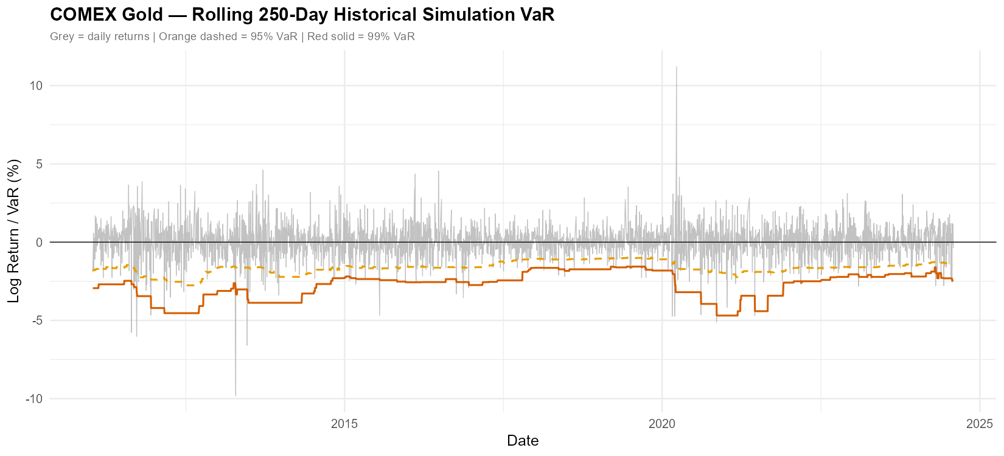
Figure 16: COMEX Gold Rolling 250-Day Historical Simulation VaR
Figures 15 and 16 show the 250-day rolling Historical Simulation VaR overlaid on the return series. The rolling VaR responds to the changing risk environment but with a characteristic lag — it drops sharply after COVID-19 as extreme losses enter the rolling window, then gradually recovers as those observations age out. This illustrates the fundamental limitation of backward-looking risk models: they adapt to new volatility regimes slowly and symmetrically.

6.2 VaR Breach Plots
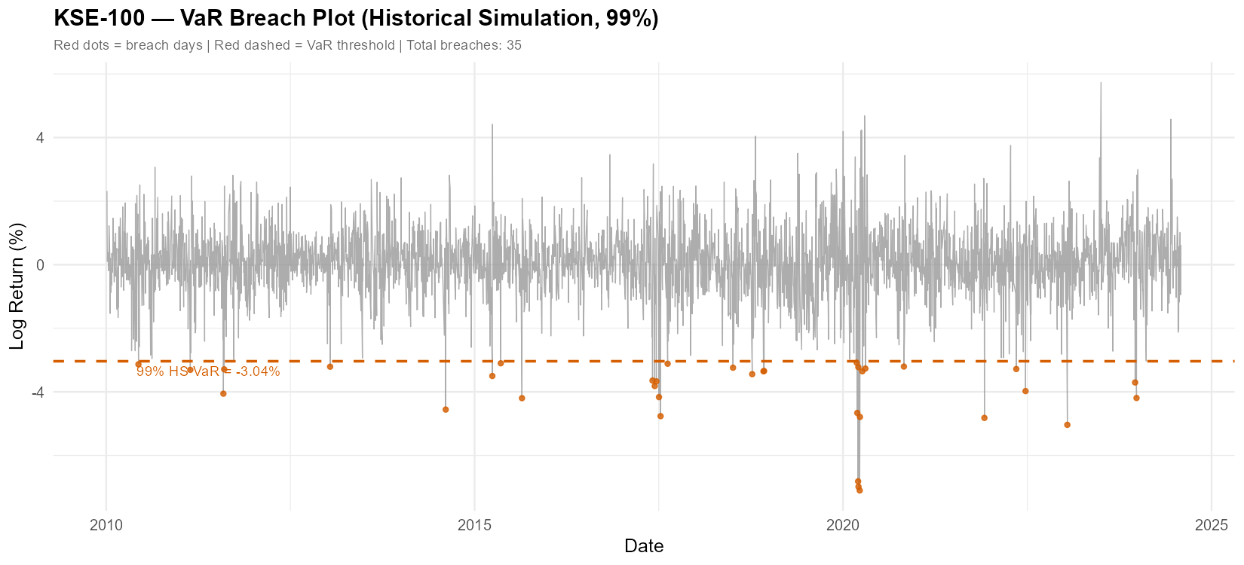
Figure 17: KSE-100 VaR Breach Plot (HS 99%)
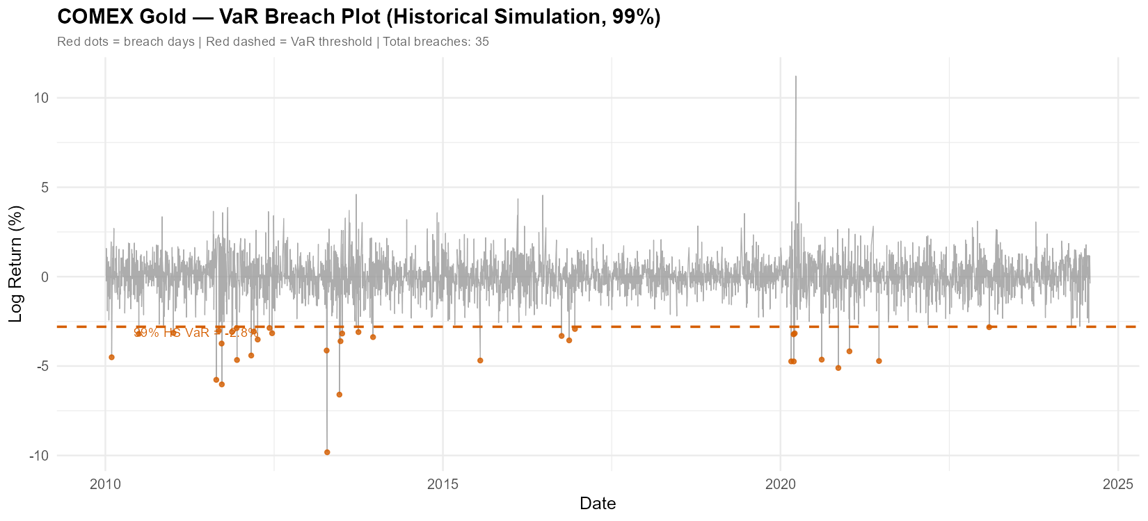
Figure 18: COMEX Gold VaR Breach Plot (HS 99%)
Figures 17 and 18 mark each VaR breach day (red dots) against the return series and the 99% HS VaR threshold. For KSE-100, 35 breach days are visible, and even visual inspection reveals that breaches are not uniformly distributed over time — they concentrate around 2015, 2018, and 2020. For COMEX Gold, 35 breach days are also recorded, with notable clusters in 2010-2011, 2013, and 2020. This visual breach clustering is precisely what the Christoffersen independence test formalises.

6.3 Kupiec POF Results
Method | Asset | Conf. | Breaches | Expected | Fail Rate | p-value | Result
Historical Simulation | KSE-100 | 95% | 175 | 174.4 | 5.02% | 0.9597 | PASS
Historical Simulation | KSE-100 | 99% | 35 | 34.9 | 1.00% | 0.9824 | PASS
Parametric | KSE-100 | 95% | 161 | 174.4 | 4.62% | 0.2936 | PASS
Parametric | KSE-100 | 99% | 75 | 34.9 | 2.15% | 0.0000 | FAIL
GARCH-FHS | KSE-100 | 95% | 180 | 174.4 | 5.16% | 0.6623 | PASS
GARCH-FHS | KSE-100 | 99% | 47 | 34.9 | 1.35% | 0.0499 | FAIL
Historical Simulation | COMEX Gold | 95% | 175 | 174.4 | 5.02% | 0.9597 | PASS
Historical Simulation | COMEX Gold | 99% | 35 | 34.9 | 1.00% | 0.9824 | PASS
Parametric | COMEX Gold | 95% | 163 | 174.4 | 4.67% | 0.3728 | PASS
Parametric | COMEX Gold | 99% | 61 | 34.9 | 1.75% | 0.0001 | FAIL
GARCH-FHS | COMEX Gold | 95% | 142 | 174.4 | 4.07% | 0.0095 | FAIL
GARCH-FHS | COMEX Gold | 99% | 30 | 34.9 | 0.86% | 0.3958 | PASS
Table 4: Kupiec POF Backtesting Results. Green = PASS (p ≥ 0.05), Red = FAIL (p < 0.05).
Historical Simulation passes all four Kupiec tests across both assets with p-values near 1.0 — breach counts match expected almost exactly (175 vs 174.4 at 95%; 35 vs 34.9 at 99%). This represents near-perfect calibration of the unconditional breach frequency.
The Parametric method passes at 95% for both assets but fails decisively at 99%. For KSE-100 at 99%, the Parametric method produces 75 breaches against 34.9 expected — more than double the theoretical frequency. For COMEX Gold at 99%, it produces 61 breaches against 34.9 expected. This is the formal statistical confirmation that the normal distribution assumption is inadequate for deep tail risk measurement in these markets.
GARCH-FHS shows mixed performance. It passes KSE-100 at 95% (180 breaches vs 174.4 expected) but fails at 99% (47 vs 34.9 expected, p = 0.0499 — exactly on the boundary). For COMEX Gold it fails at 95% (142 vs 174.4 expected — too few breaches, indicating over-conservatism) but passes cleanly at 99% (30 vs 34.9 expected). The over-conservatism at 95% for gold is explained by the elevated current conditional volatility σ_T = 1.107%, which scales the risk estimate upward beyond what the empirical 95% threshold requires.
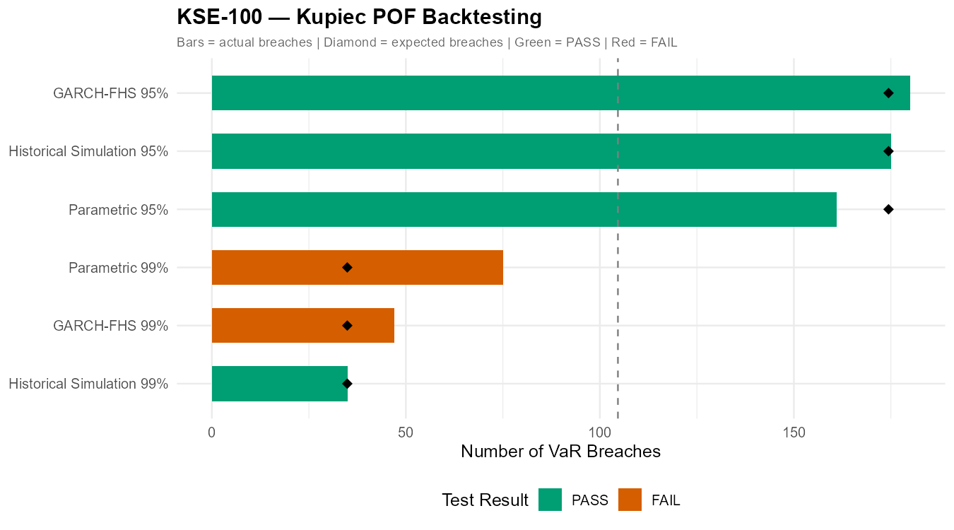
Figure 19: KSE-100 Kupiec POF Backtesting
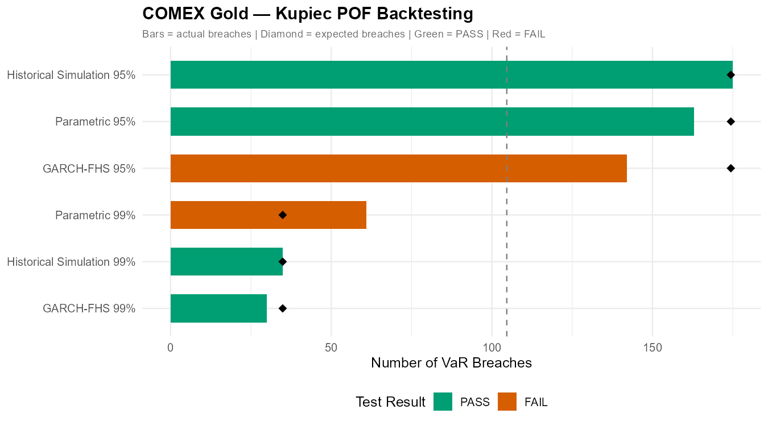
Figure 20: COMEX Gold Kupiec POF Backtesting

6.4 Christoffersen Conditional Coverage Results
Method | Asset | Conf. | P_UC | P_IND | P_CC | n11 | Result
Historical Simulation | KSE-100 | 95% | 0.9597 | 0.0000 | 0.0000 | 24 | FAIL
Historical Simulation | KSE-100 | 99% | 0.9824 | 0.0047 | 0.0184 | 3 | FAIL
Parametric | KSE-100 | 95% | 0.2936 | 0.0000 | 0.0000 | 23 | FAIL
Parametric | KSE-100 | 99% | 0.0000 | 0.0275 | 0.0000 | 5 | FAIL
GARCH-FHS | KSE-100 | 95% | 0.6623 | 0.0000 | 0.0000 | 27 | FAIL
GARCH-FHS | KSE-100 | 99% | 0.0499 | 0.0035 | 0.0021 | 4 | FAIL
Historical Simulation | COMEX Gold | 95% | 0.9597 | 0.4473 | 0.7483 | 11 | PASS
Historical Simulation | COMEX Gold | 99% | 0.9824 | 0.0047 | 0.0184 | 3 | FAIL
Parametric | COMEX Gold | 95% | 0.3728 | 0.6097 | 0.5901 | 9 | PASS
Parametric | COMEX Gold | 99% | 0.0001 | 0.0254 | 0.0000 | 4 | FAIL
GARCH-FHS | COMEX Gold | 95% | 0.0095 | 0.1946 | 0.0149 | 9 | FAIL
GARCH-FHS | COMEX Gold | 99% | 0.7211 | 0.0018 | 0.0053 | 3 | FAIL
Table 5: Christoffersen Conditional Coverage Results. P_UC = unconditional coverage p-value; P_IND = independence p-value; P_CC = joint conditional coverage p-value; n11 = consecutive breach pairs.
The Christoffersen test reveals a critical finding that Kupiec alone missed entirely. Even for Historical Simulation on KSE-100 — which passed Kupiec with near-perfect p-values — the independence test fails decisively (P_IND < 0.0001 at 95%). This means that VaR breaches in KSE-100 are significantly clustered in time: when the index breaches its VaR threshold on one day, it is significantly more likely to breach again on subsequent days.
The n11 column (consecutive breach pairs) quantifies this clustering: KSE-100 shows 24-27 consecutive breach pairs at 95% depending on the method, far more than would be expected under independence. The breach plots (Figures 17-18) make this clustering visually clear.
Only two method-asset-confidence combinations pass the full Christoffersen test: Historical Simulation on COMEX Gold at 95% (P_CC = 0.748) and Parametric on COMEX Gold at 95% (P_CC = 0.590). This suggests that gold's breach dynamics at the 95% level are more consistent with independence — a reasonable finding given gold's different liquidity structure and global market depth compared to KSE-100.
The systematic failure of the independence test for KSE-100 is an important result: it indicates that no static, single-regime VaR model can fully eliminate breach clustering in Pakistani equities. Volatility regimes persist — when one bad day occurs in the KSE-100, more tend to follow. Addressing this limitation would require a regime-switching VaR model, dynamic conditional correlation structure, or intraday volatility updating, all of which are beyond the scope of this project and noted as avenues for future research.

7. Discussion and Conclusion

7.1 Summary of Key Findings
This report has demonstrated five principal findings across the KSE-100 and COMEX Gold return series for the period 2010-2024.
First, both return series decisively reject normality. Excess kurtosis of 3.98 (KSE-100) and 8.87 (COMEX Gold), combined with negative skewness and Jarque-Bera statistics in the thousands, confirm that fat tails and asymmetry are dominant features of both markets. Any risk model that assumes normality will systematically underestimate extreme losses.
Second, the Parametric method fails at the 99% confidence level for both assets. The Kupiec test confirms that it produces more than double the theoretical breach frequency — 75 breaches vs 34.9 expected for KSE-100. The 99% ES gap of 129 basis points relative to Historical Simulation has direct capital adequacy implications for institutions using the normal assumption.
Third, Historical Simulation is the most reliable method across both assets, passing all Kupiec tests with near-perfect calibration. Its non-parametric nature allows it to capture fat tails without imposing distributional assumptions.
Fourth, GARCH-FHS performs competitively at 99% for gold and demonstrates the key advantage of time-varying volatility estimation: it correctly identified that gold's risk was elevated at the end of the sample period. However, its performance at 95% is inconsistent, and it fails Kupiec at KSE-100's 99% level.
Fifth, the Christoffersen test reveals systematic breach clustering in KSE-100 that no static model resolves. This is a structural feature of the market — volatility regimes persist — and represents the binding constraint on VaR model performance in Pakistani equities.

7.2 Practical Implications
For Pakistani financial institutions and fund managers with KSE-100 exposure: Historical Simulation at 99% is the most defensible risk measure for capital adequacy purposes. The Parametric method should not be used for tail risk measurement given its systematic failure at high confidence levels. GARCH-based approaches are valuable for detecting current volatility regime, particularly for anticipating periods of elevated risk.
For commodity risk managers with gold exposure: all three methods perform acceptably at 95%, but the Parametric method again fails at 99%. GARCH-FHS provides the most forward-looking estimate when gold is in an elevated volatility regime.
The breach clustering finding implies that risk managers should apply volatility multipliers or stress buffers on top of standard VaR estimates during episodes of market turbulence, particularly for KSE-100 positions.

7.3 Limitations and Future Research
Several limitations of this analysis warrant acknowledgment. The Filtered Historical Simulation uses the last single observation's conditional sigma as the forward-looking volatility estimate — a more robust approach would use a multi-step forecast. The Christoffersen test finds that breach clustering is not resolved by any method studied here; future work could examine regime-switching models (Markov-switching GARCH) or intraday volatility proxies.
The KSE-100 dataset from Kaggle carries a caveat that its methodology for handling non-trading days may differ from official PSX data. Future work using directly sourced PSX historical data would eliminate this uncertainty. Additionally, the analysis covers a single bull market cycle for gold (2010-2024); extending to include the 1990s and 2000s would provide a richer test of tail risk models across full commodity cycles.
Finally, this analysis treats the two assets independently. A natural extension would estimate portfolio VaR accounting for the diversification benefit (or lack thereof during crises) of combining KSE-100 and gold positions, using Dynamic Conditional Correlation or copula-based dependence models.

References
Artzner, P., Delbaen, F., Eber, J.-M., and Heath, D. (1999). Coherent measures of risk. Mathematical Finance, 9(3), 203-228.
Basel Committee on Banking Supervision (2019). Minimum capital requirements for market risk. Bank for International Settlements.
Bollerslev, T. (1986). Generalized autoregressive conditional heteroskedasticity. Journal of Econometrics, 31(3), 307-327.
Christoffersen, P. (1998). Evaluating interval forecasts. International Economic Review, 39(4), 841-862.
Engle, R. (1982). Autoregressive conditional heteroscedasticity with estimates of the variance of United Kingdom inflation. Econometrica, 50(4), 987-1007.
Glosten, L. R., Jagannathan, R., and Runkle, D. E. (1993). On the relation between the expected value and the volatility of the nominal excess return on stocks. Journal of Finance, 48(5), 1779-1801.
Kupiec, P. (1995). Techniques for verifying the accuracy of risk measurement models. Journal of Derivatives, 3(2), 73-84.
McNeil, A. J., Frey, R., and Embrechts, P. (2015). Quantitative risk management: Concepts, techniques and tools (Revised ed.). Princeton University Press.
Pakistan Stock Exchange (2024). KSE-100 Index. Retrieved via Kaggle dataset: aleemaher/psx-kse100-20-years (CC0 Public Domain).
Yahoo Finance (2024). COMEX Gold Futures (GC=F). Retrieved via quantmod package in R.

Appendix: Complete Script List
All R scripts are available at github.com/ahmer-econ. The following scripts were used in this analysis:
01_data_download_cleaning.R — KSE-100 CSV loading, COMEX Gold download via quantmod, date alignment, clean CSV export.
02_returns_descriptive_stats.R — Log return computation, descriptive statistics, Jarque-Bera tests, return series and histogram plots.
03_historical_simulation_var_es.R — HS VaR and ES estimation at 95% and 99%, distribution plots with threshold lines.
04_parametric_var_es.R — Parametric VaR and ES estimation, comparison plots against HS.
05_garch_estimation_residuals.R — GARCH(1,1) specification and estimation for both assets, diagnostic tests, conditional volatility and standardised residual plots.
06_garch_fhs_var_es.R — Filtered Historical Simulation VaR and ES computation, master comparison table, three-method bar charts.
07_kupiec_backtesting.R — Kupiec POF test implementation, full backtest results table, breach count visualisation.
08_rolling_var_breach_christoffersen.R — 250-day rolling VaR, VaR breach plots, Christoffersen Conditional Coverage test.

