Tail Risk in Pakistani Financial Markets
Value at Risk and Expected Shortfall in Python
KSE-100 Index · COMEX Gold Futures
Historical Simulation · Parametric · GARCH-FHS
Kupiec POF · Christoffersen Independence Backtesting
Ahmer Anwaar | GitHub: ahmer-econ | Sep 2026

1. Introduction
Accurate measurement of downside risk is a central concern for portfolio managers, risk officers, and regulators. Value at Risk (VaR) and Expected Shortfall (ES) are the two dominant metrics used to quantify potential losses at a given confidence level. This report applies three VaR and ES estimation methods to daily returns on two assets: the KSE-100 equity index, Pakistan's benchmark stock market index, and COMEX Gold front-month futures, a globally traded safe-haven commodity.
The sample covers approximately 2,288 daily observations from January 2015 to August 2024. The three methods compared are Historical Simulation (HS), the Parametric Normal method, and GARCH(1,1) Filtered Historical Simulation (GARCH-FHS). Estimates are evaluated at the 95% and 99% confidence levels using Kupiec (1995) and Christoffersen (1998) backtests. All estimation is implemented in Python using pandas, NumPy, SciPy, and the arch library.

2. Data
KSE-100 daily closing prices were sourced from a Kaggle historical dataset covering 2004–2024. COMEX Gold front-month futures prices (ticker: GC=F) were downloaded via the yfinance Python library. Both series were trimmed to a common sample of January 2015 to August 2024. After an inner join on trading dates, 2,289 price observations were retained. Daily log returns were computed as r_t = ln(P_t / P_{t−1}), yielding 2,288 return observations with no missing values.

2.1 Descriptive Statistics

Statistic | KSE-100 | COMEX Gold
Observations | 2,288 | 2,288
Mean daily return | 0.038% | 0.031%
Std deviation | 1.104% | 0.961%
Skewness | −0.477 | +0.399
Excess kurtosis | 4.254 | 10.478
Minimum | −7.10% | −5.11%
Maximum | +5.73% | +11.22%

Table 1. Descriptive statistics of daily log returns, January 2015 – August 2024.
Both series display pronounced leptokurtosis — excess kurtosis of 4.25 for KSE-100 and 10.48 for Gold — indicating fat-tailed distributions inconsistent with the normal assumption. KSE-100 returns are negatively skewed (−0.477), implying large negative returns are more frequent than large positive ones. Gold's extreme kurtosis is driven primarily by a single +11.2% return observed during the March 2020 COVID-19 market shock.

2.2 Return Distributions

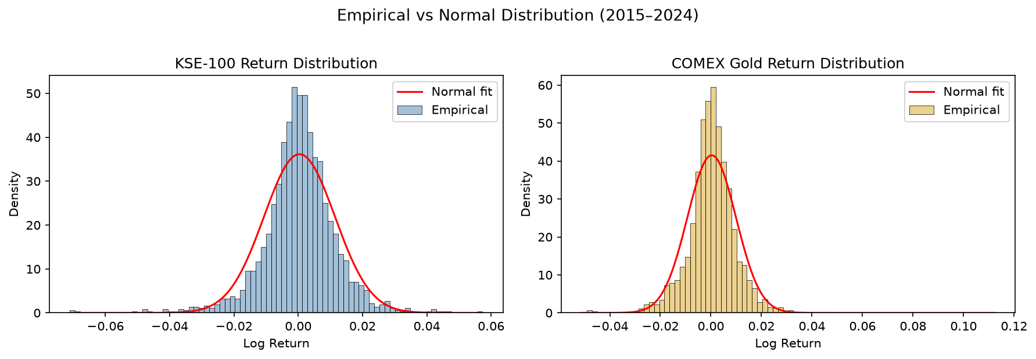
Figure 1. Empirical return distributions vs normal fit. Both assets display taller peaks and fatter tails than the normal distribution.

2.3 ARCH Effects

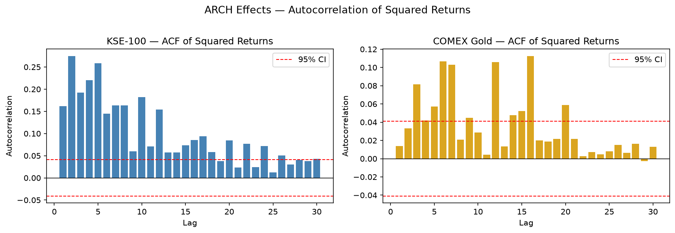
Figure 2. Autocorrelation of squared returns. KSE-100 shows strong, persistent ARCH effects across 30 lags. Gold shows moderate clustering.
The autocorrelation function of squared returns confirms significant volatility clustering in both series. KSE-100 autocorrelations remain well above the 95% confidence band across all 30 lags, providing strong justification for GARCH modelling. Gold shows weaker but statistically significant clustering at several lags.

3. Methodology

3.1 Historical Simulation
Historical Simulation (HS) estimates VaR at confidence level α as the empirical quantile of the return distribution at the (1−α) percentile. No distributional assumption is imposed. ES is computed as the average of all returns below the VaR threshold. A rolling window of 250 trading days is used for backtesting, re-estimating VaR each day using only the prior 250 observations.

3.2 Parametric (Normal) Method
The Parametric method assumes returns follow a normal distribution. VaR is estimated as VaR = μ − z_α · σ, where μ and σ are the sample mean and standard deviation, and z_α is the standard normal quantile. ES is derived analytically from the normal density. This method is computationally efficient but imposes a distributional assumption that the EDA results suggest is violated.

3.3 GARCH-FHS
GARCH(1,1) Filtered Historical Simulation combines the flexibility of HS with the time-varying volatility of a GARCH model. A GARCH(1,1) model with normal innovations is fitted to the return series. Standardised residuals ε_t = r_t / σ_t are extracted, where σ_t is the GARCH conditional volatility. Historical Simulation is applied to the standardised residuals, and the resulting quantile is scaled by the one-step-ahead conditional volatility forecast σ_{t+1}. This method adapts to current volatility conditions while retaining the empirical tail distribution.

3.4 Backtesting
Both tests use a rolling window of 250 days, producing 2,038 out-of-sample VaR forecasts per asset. A violation occurs when the realised return falls below the VaR estimate on a given day.
Kupiec (1995) POF test: Tests whether the observed violation rate equals the expected rate (1−α). The test statistic is likelihood-ratio distributed as χ²(1) under the null.
Christoffersen (1998) Independence test: Tests whether violations are independently distributed over time. Clustered violations — where a breach today predicts a breach tomorrow — indicate model failure during crisis periods. The test statistic is also χ²(1) distributed.

4. GARCH(1,1) Parameter Estimates

Parameter | KSE-100 | COMEX Gold
ω (omega) | 0.000713 | 0.000139
α (alpha[1]) | 0.1352 | 0.0340
β (beta[1]) | 0.8088 | 0.9509
Persistence (α+β) | 0.9440 | 0.9850
One-step σ forecast | 0.9352% | 1.0572%

Table 2. GARCH(1,1) parameter estimates. All returns expressed in percentage scale for estimation.
Both series show high volatility persistence. KSE-100 has a persistence of 0.944, indicating that volatility shocks decay gradually but do eventually dissipate. Gold's persistence of 0.985 is near-integrated, meaning volatility shocks are extremely long-lasting. The alpha coefficient for KSE-100 (0.135) is notably higher than Gold's (0.034), indicating that the KSE-100 reacts more strongly to new daily shocks. Both models are stationary (persistence < 1).

5. VaR and ES Estimation Results

Asset | Level | Method | VaR | ES
KSE-100 | 95% | Historical Simulation | −1.69% | −2.67%
KSE-100 | 95% | Parametric | −1.78% | −2.24%
KSE-100 | 95% | GARCH-FHS | −1.52% | −2.21%
KSE-100 | 99% | Historical Simulation | −3.24% | −4.34%
KSE-100 | 99% | Parametric | −2.53% | −2.90%
KSE-100 | 99% | GARCH-FHS | −2.71% | −3.23%
Gold | 95% | Historical Simulation | −1.55% | −2.20%
Gold | 95% | Parametric | −1.55% | −1.95%
Gold | 95% | GARCH-FHS | −1.70% | −2.46%
Gold | 99% | Historical Simulation | −2.53% | −3.41%
Gold | 99% | Parametric | −2.20% | −2.53%
Gold | 99% | GARCH-FHS | −2.65% | −3.77%

Table 3. Full-sample VaR and ES estimates at 95% and 99% confidence levels.
At the 99% level, the Parametric method produces the most conservative (smallest magnitude) VaR estimates for both assets — KSE-100: −2.53% vs −3.24% for HS — reflecting the normal distribution's inability to capture fat-tailed losses. ES estimates are consistently larger in magnitude than VaR at the same level, as expected by construction. GARCH-FHS VaR at 99% falls between HS and Parametric for both assets, benefiting from the adaptive volatility forecast while retaining empirical tail behaviour.

6. Backtesting Results
Rolling 250-day VaR forecasts were generated for 2,038 out-of-sample dates. Results are reported for both the Kupiec POF test and the Christoffersen Independence test. p-values below 0.05 indicate rejection of the null hypothesis at the 5% level.

6.1 KSE-100

Method | Level | Violations | Expected | Rate | Kupiec p | Christ. p | Verdict
HS | 95% | 119 | 102 | 5.84% | 0.090 | 0.000 | Fail
Parametric | 95% | 106 | 102 | 5.20% | 0.679 | 0.001 | Fail
GARCH-FHS | 95% | 119 | 102 | 5.84% | 0.090 | 0.000 | Fail
HS | 99% | 34 | 20 | 1.67% | 0.006 | 0.019 | Fail
Parametric | 99% | 37 | 20 | 1.82% | 0.001 | 0.179 | Fail
GARCH-FHS | 99% | 34 | 20 | 1.67% | 0.006 | 0.019 | Fail

Table 4. KSE-100 backtesting results. N = 2,038 out-of-sample observations. Window = 250 days.

6.2 COMEX Gold

Method | Level | Violations | Expected | Rate | Kupiec p | Christ. p | Verdict
HS | 95% | 109 | 102 | 5.35% | 0.475 | 0.710 | Pass
Parametric | 95% | 107 | 102 | 5.25% | 0.607 | 0.867 | Pass
GARCH-FHS | 95% | 109 | 102 | 5.35% | 0.475 | 0.710 | Pass
HS | 99% | 28 | 20 | 1.37% | 0.108 | 0.400 | Pass
Parametric | 99% | 37 | 20 | 1.82% | 0.001 | 0.703 | Fail
GARCH-FHS | 99% | 28 | 20 | 1.37% | 0.108 | 0.400 | Pass

Table 5. COMEX Gold backtesting results. N = 2,038 out-of-sample observations. Window = 250 days.

6.3 Violations Plots

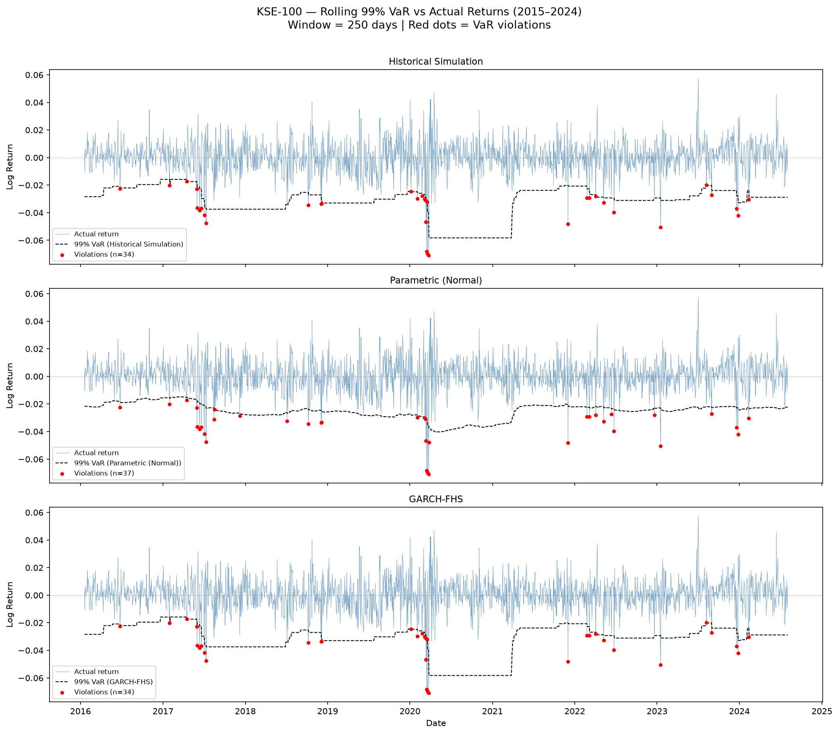
Figure 3. KSE-100 — rolling 99% VaR vs actual returns. Red dots indicate violations. Clustering around 2017 and 2020 is visible across all methods.

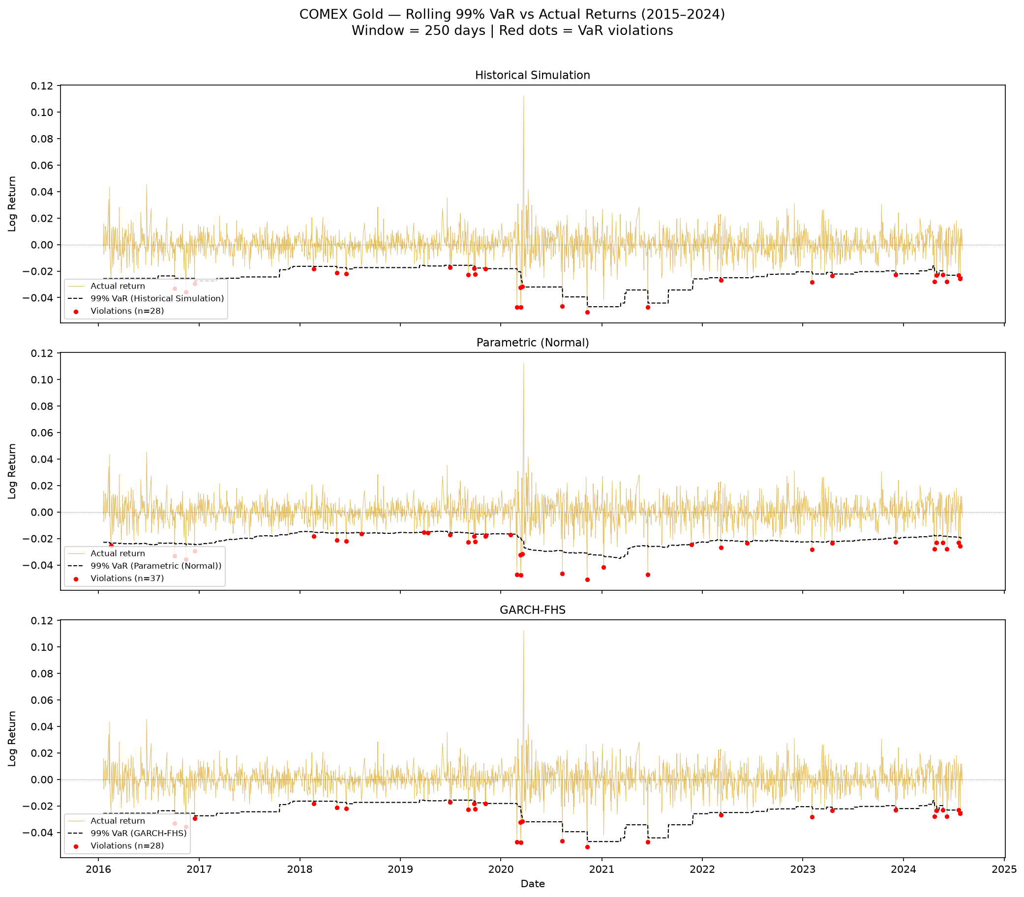
Figure 4. COMEX Gold — rolling 99% VaR vs actual returns. Violations are more randomly distributed, consistent with the Christoffersen independence test passing.

7. Discussion

7.1 KSE-100 — All methods fail
All three methods fail backtesting for KSE-100 at one or both confidence levels. At 95%, all methods pass the Kupiec frequency test but fail the Christoffersen independence test, indicating that violations cluster in time rather than arriving randomly. This clustering is visible in Figure 3 — violations bunch around 2017 and the COVID-19 shock of early 2020. At 99%, all methods fail the Kupiec test, generating roughly 34–37 violations against an expected 20.
These failures reflect structural features of Pakistan's frontier equity market: sharp volatility regime shifts driven by political instability, currency crises, and external shocks are not adequately captured by a 250-day rolling window. When volatility transitions abruptly, all backward-looking methods lag behind, producing clustered violations precisely when risk protection is most needed.

7.2 COMEX Gold — HS and GARCH-FHS pass cleanly
For Gold, Historical Simulation and GARCH-FHS pass all Kupiec and Christoffersen tests at both confidence levels. Violations are well-calibrated in frequency and arrive independently over time. The Parametric method passes at 95% but fails the Kupiec test at 99% (p = 0.001), confirming that the normality assumption breaks down at the extreme tail — expected given the excess kurtosis of 10.48.

7.3 Parametric VaR — worst performer
The Parametric Normal method is the weakest performer across both assets. It produces the most violations at 99% for Gold (37 vs 28 for HS and GARCH-FHS) and fails the Kupiec test for both assets at 99%. The normal distribution systematically underestimates tail risk when returns are fat-tailed, making it unsuitable for risk management in these markets without a distributional correction such as the Student-t or Cornish-Fisher adjustment.

8. Conclusion
This report estimated VaR and ES for the KSE-100 index and COMEX Gold futures using three methods and evaluated their performance using formal backtests over 2,038 out-of-sample days. The main findings are as follows.
- For COMEX Gold, Historical Simulation and GARCH-FHS produce well-calibrated VaR estimates that pass both frequency and independence tests at the 95% and 99% levels.
- For KSE-100, all methods fail backtesting — a result attributable to sharp volatility regime shifts characteristic of Pakistan's frontier equity market rather than a deficiency of the methods themselves.
- The Parametric Normal method is the worst performer at the 99% confidence level for both assets, confirming that the normality assumption is inappropriate for fat-tailed return distributions.
- GARCH-FHS matches HS in violation counts but adds the benefit of a time-varying volatility forecast, making it more theoretically sound for real-time risk management applications.

All estimation was implemented in Python (pandas, NumPy, SciPy, arch). Code and data are available at github.com/ahmer-econ.

References
Christoffersen, P. (1998). Evaluating interval forecasts. International Economic Review, 39(4), 841–862.
Engle, R. F. (1982). Autoregressive conditional heteroscedasticity with estimates of the variance of United Kingdom inflation. Econometrica, 50(4), 987–1007.
Kupiec, P. (1995). Techniques for verifying the accuracy of risk measurement models. Journal of Derivatives, 3(2), 73–84.
McNeil, A. J., Frey, R., & Embrechts, P. (2015). Quantitative Risk Management: Concepts, Techniques and Tools (Revised ed.). Princeton University Press.
Sheppard, K. (2024). arch: Autoregressive Conditional Heteroskedasticity (ARCH) and Other Tools for Financial Econometrics. Python package. https://github.com/bashtage/arch

