Looker-Studio

<https://lookerstudio.google.com/reporting/1c8a8e0f-85b4-4a79-9898-b8cf14d08dd0>

Power-BI

*Activity 1:*

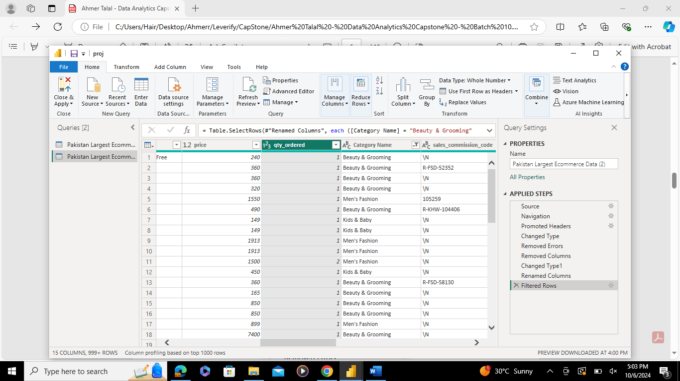

**Calendar Table:**

1st method:

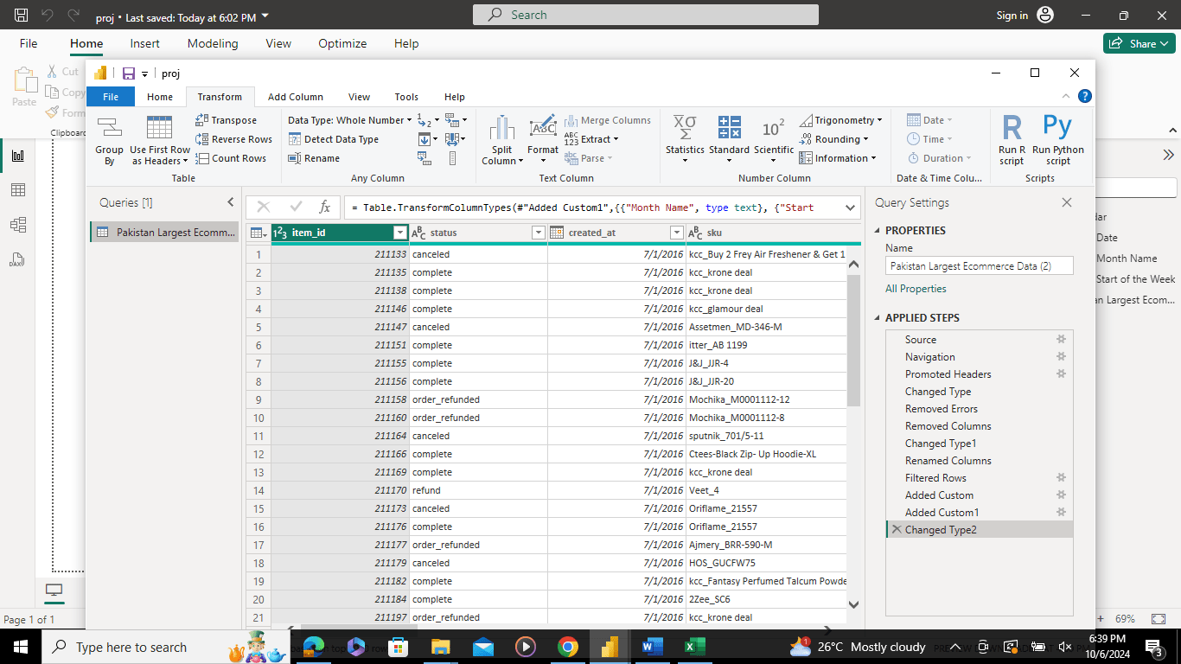

**SECOND METHOD:**

At start, first method is not working then I tried second one. After restarting the Laptop 1st method also works meanwhile I put screenshots of both methods.

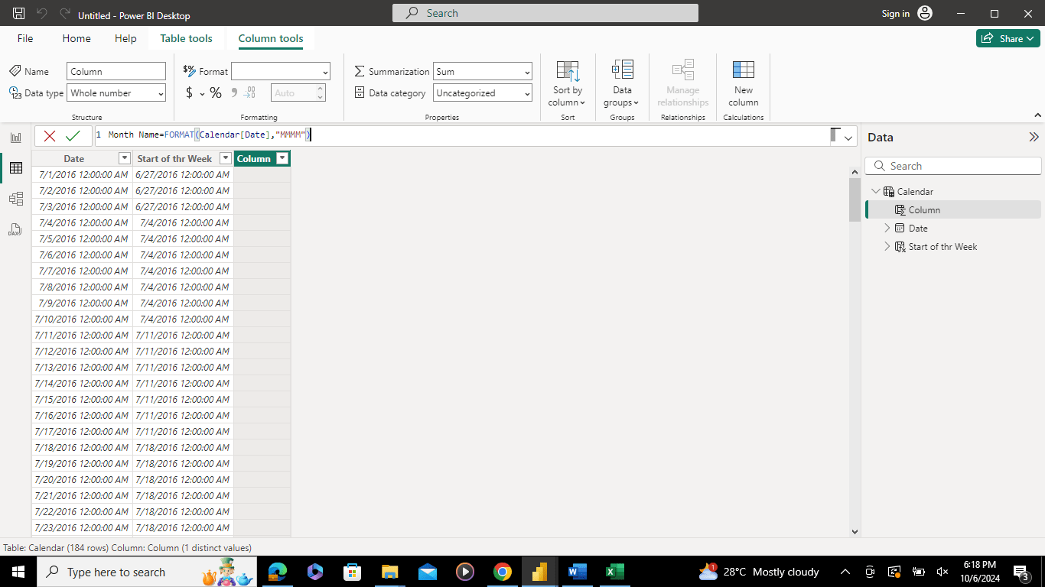

Now for Start of the Week Column:

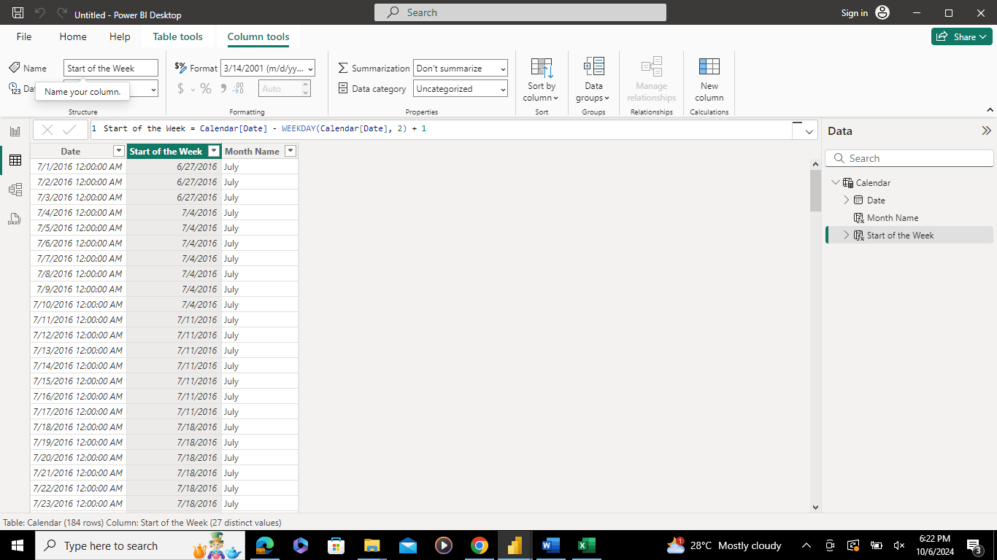

Whole OVERVIEW:

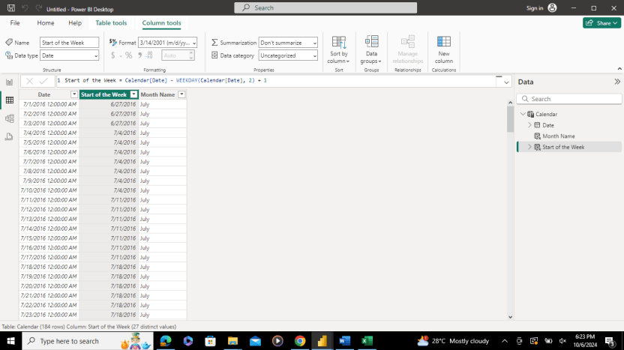

*Relationship between Calendar and Ecommerce dataset:*

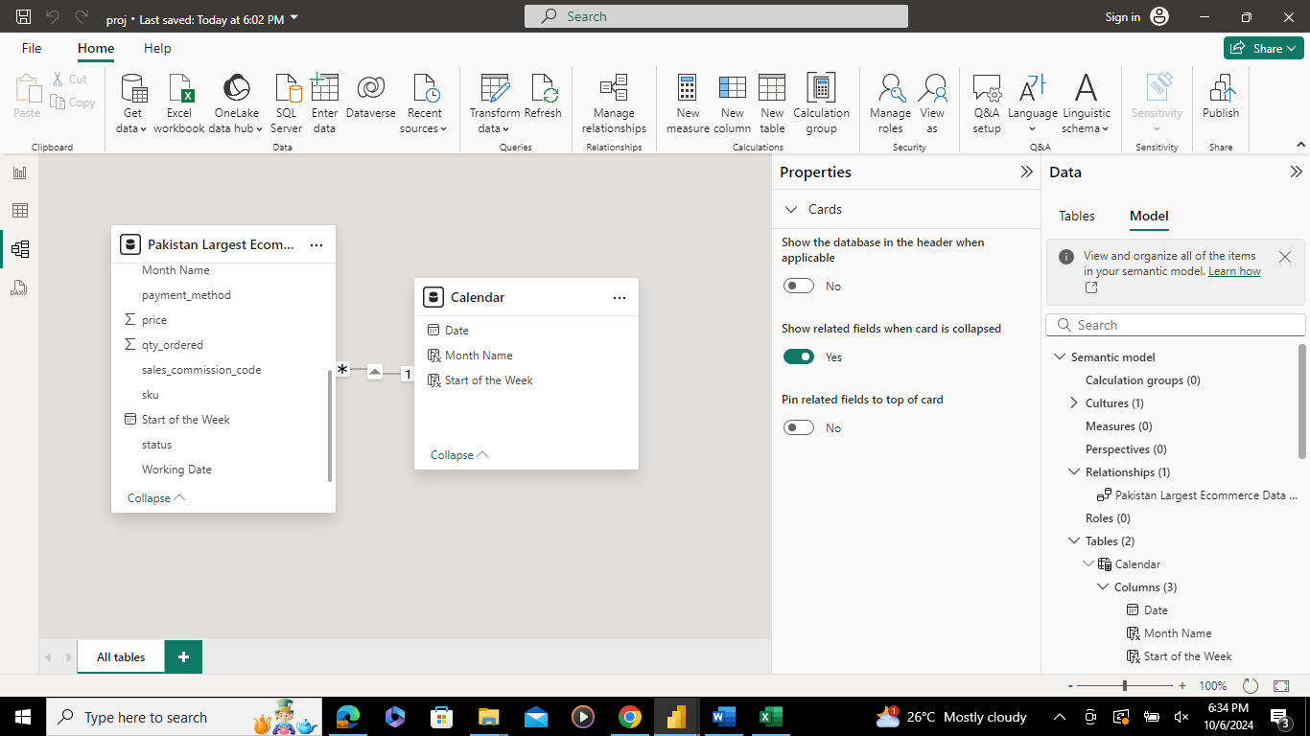

*Activity 2:*

Bill Total Formula:

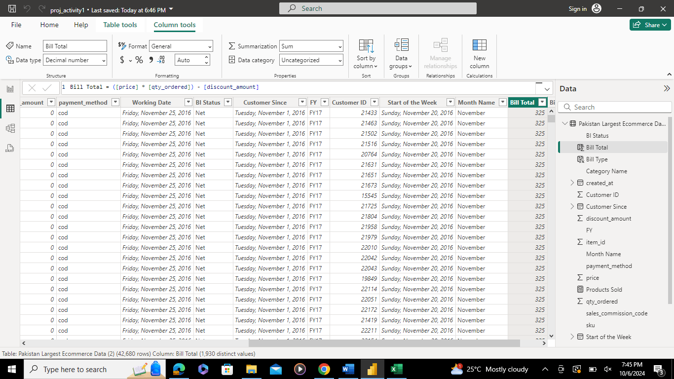

Bill Type Formula:

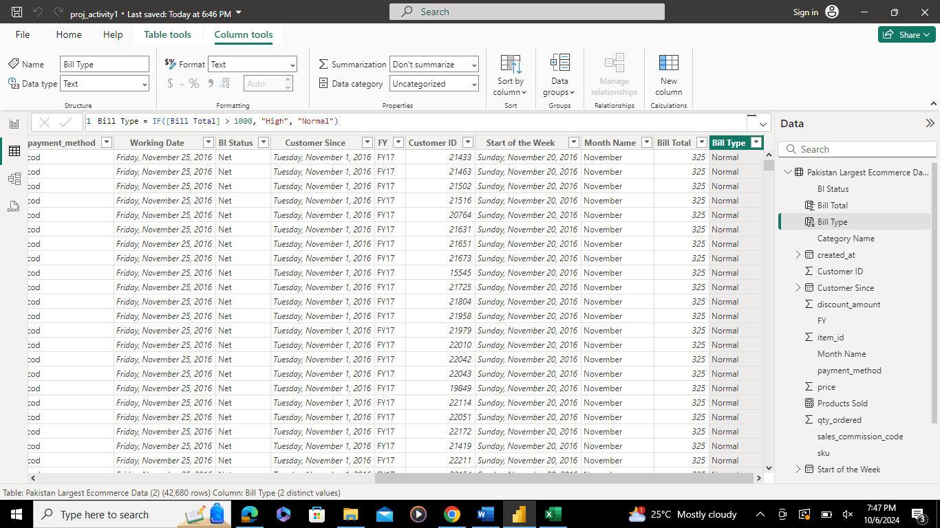

Total Sales Formula:

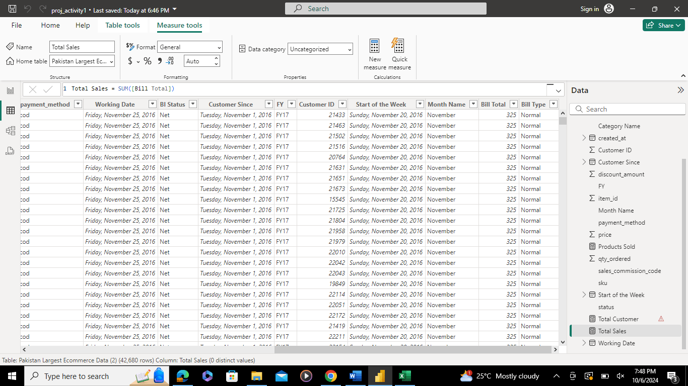

Product Sold Formula:

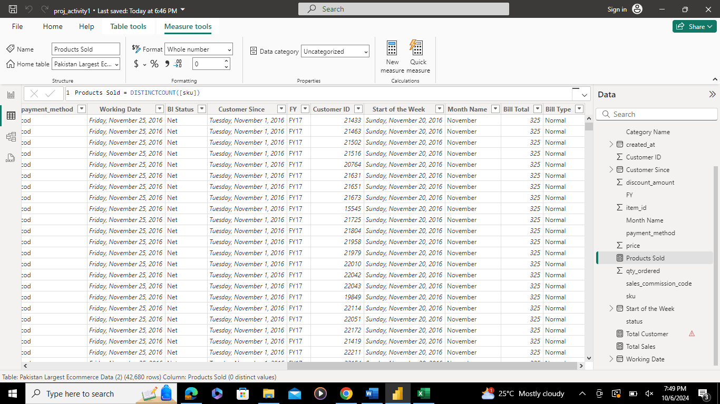

Total Customer Formula:

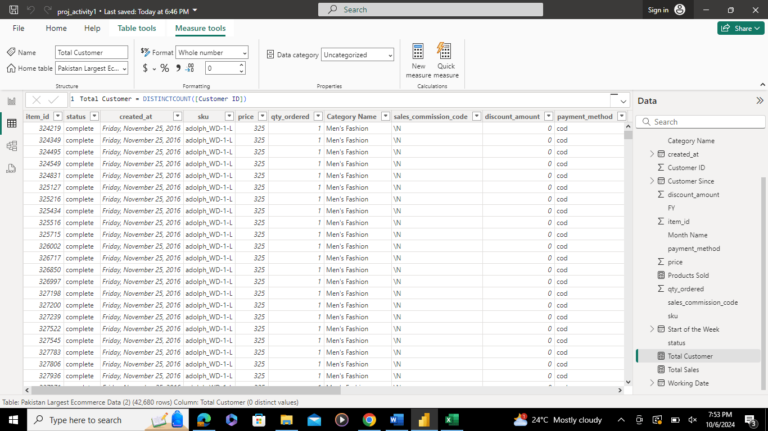

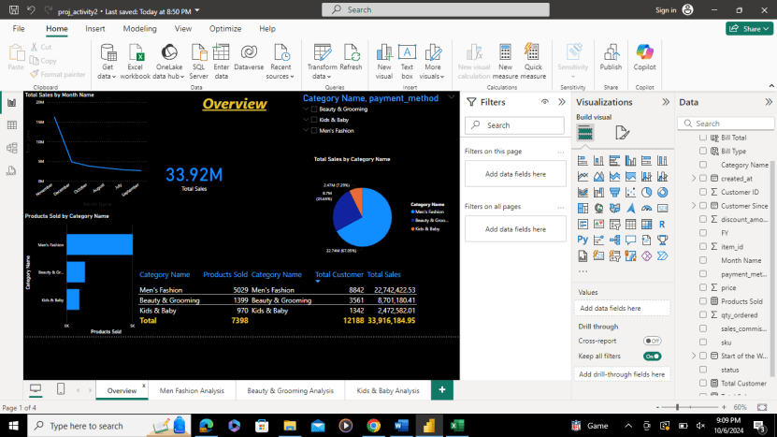

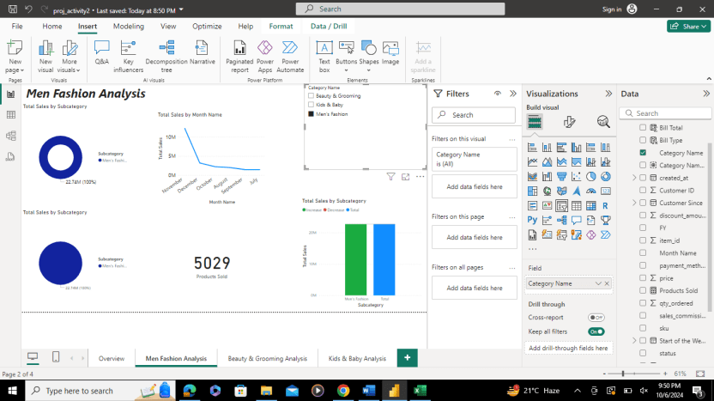

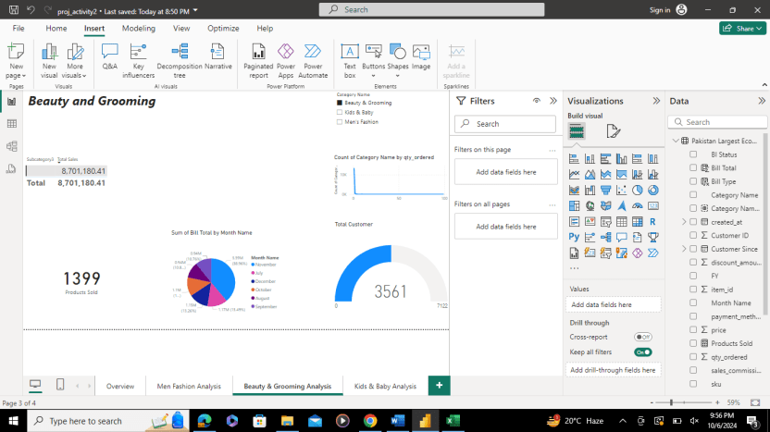

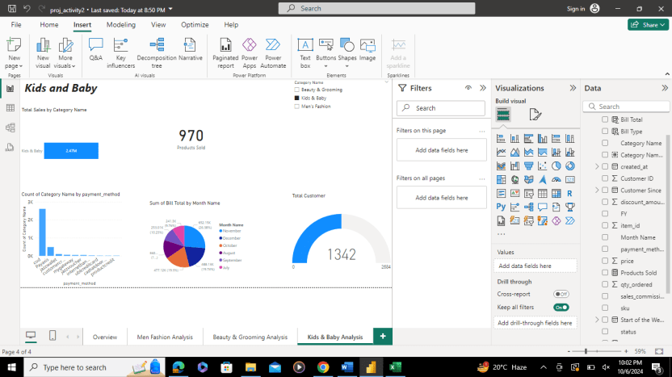

*Activity 3:*

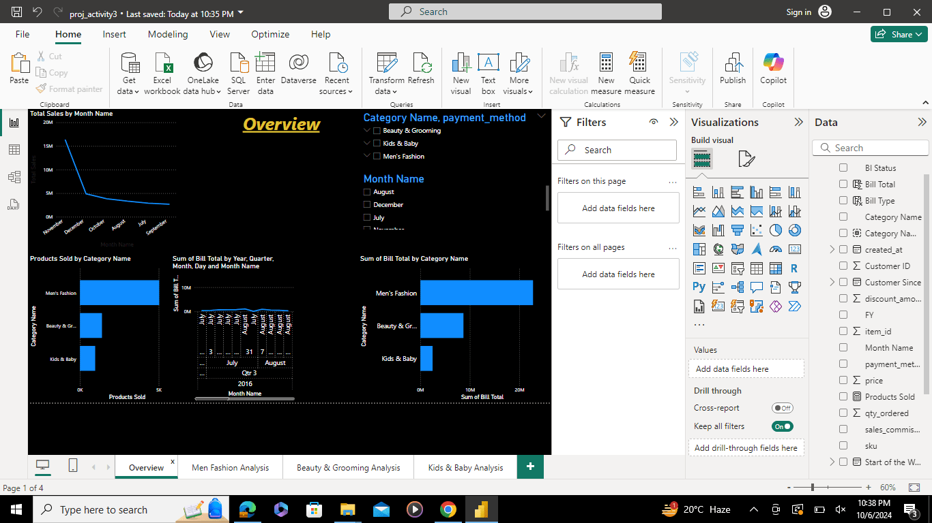

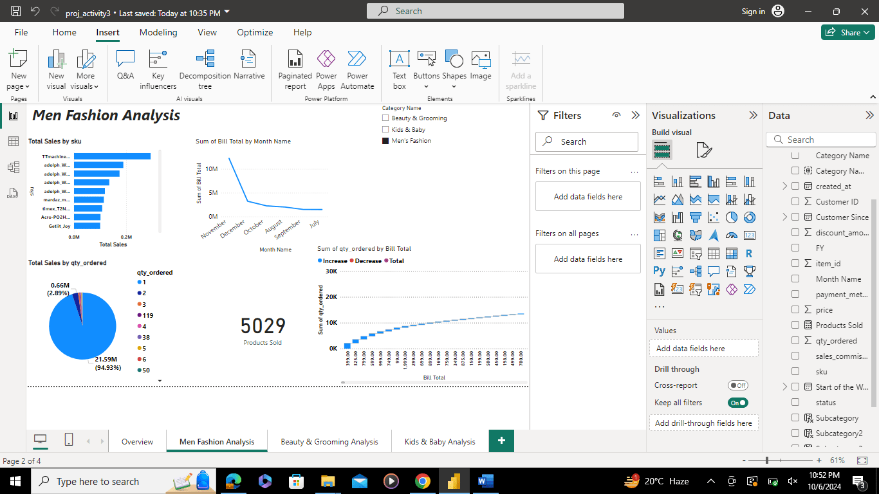

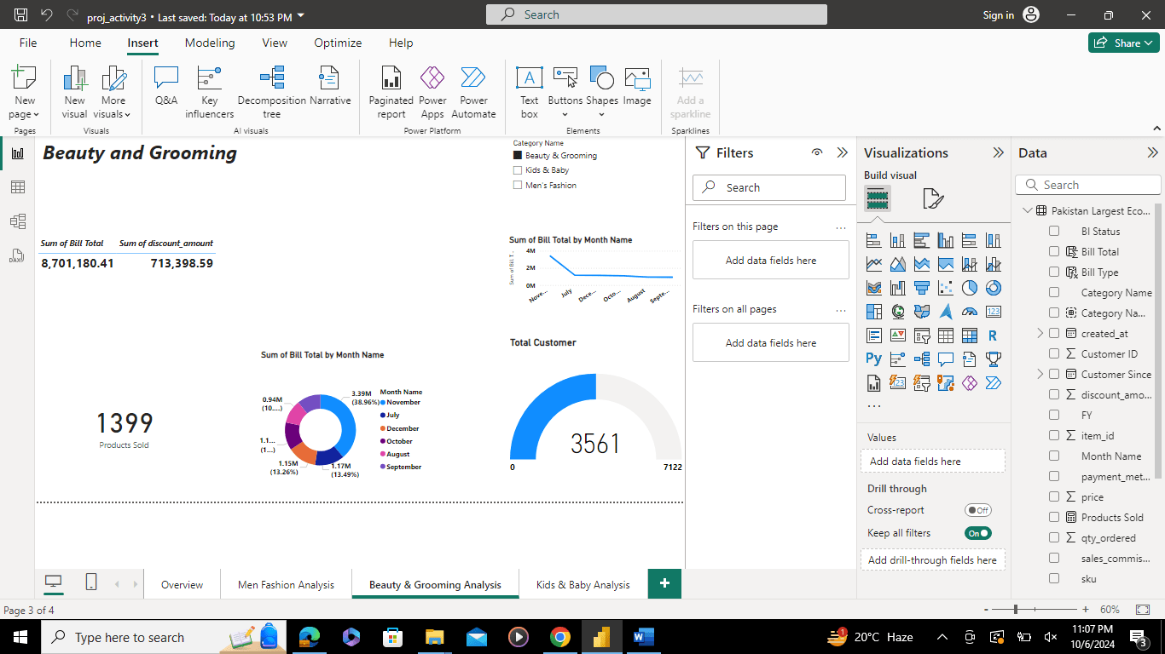

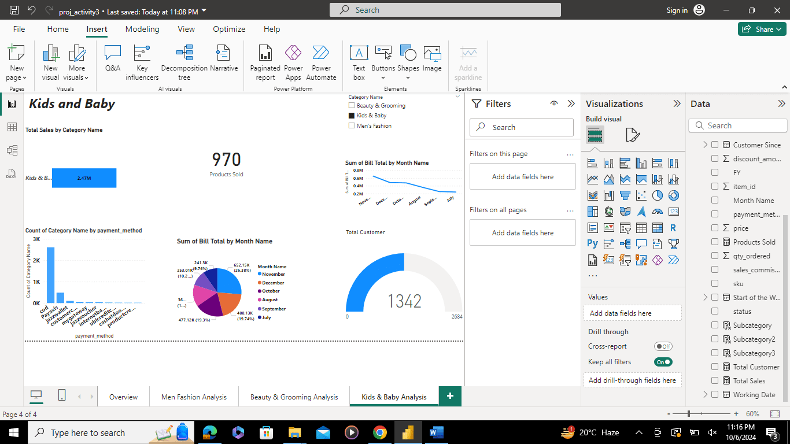

SQL

First of all, Create Database “OFFICE” and add 2 tables named “Departments” & “Employees” in it.

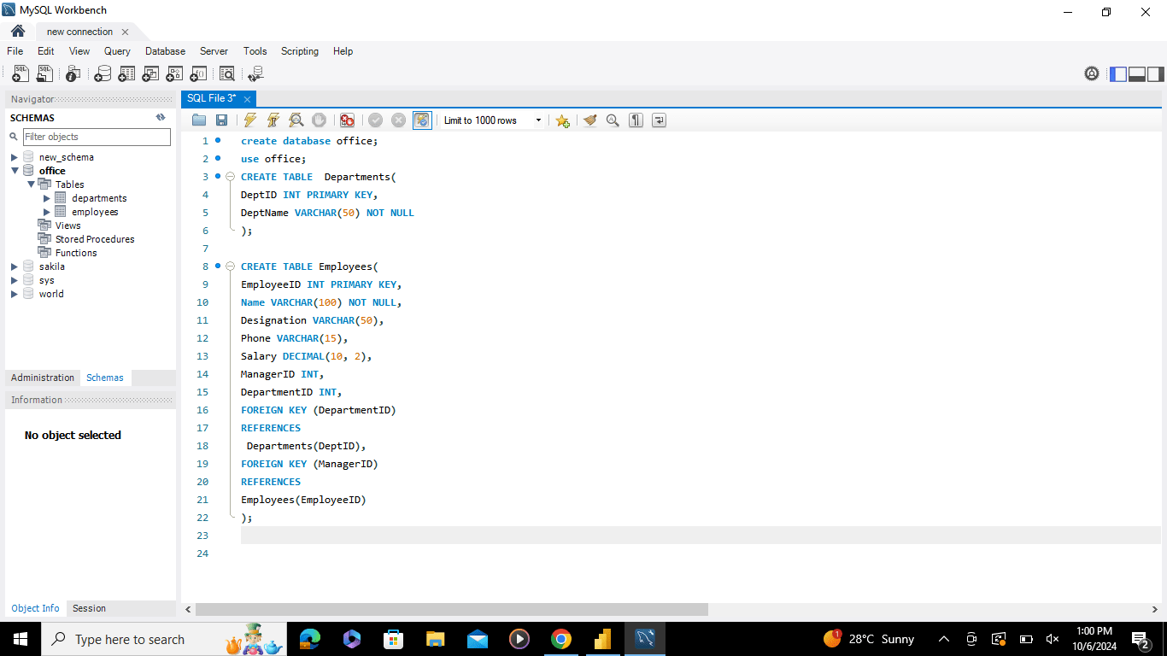

Then insert the data into Departments like Department ID and Department Name.

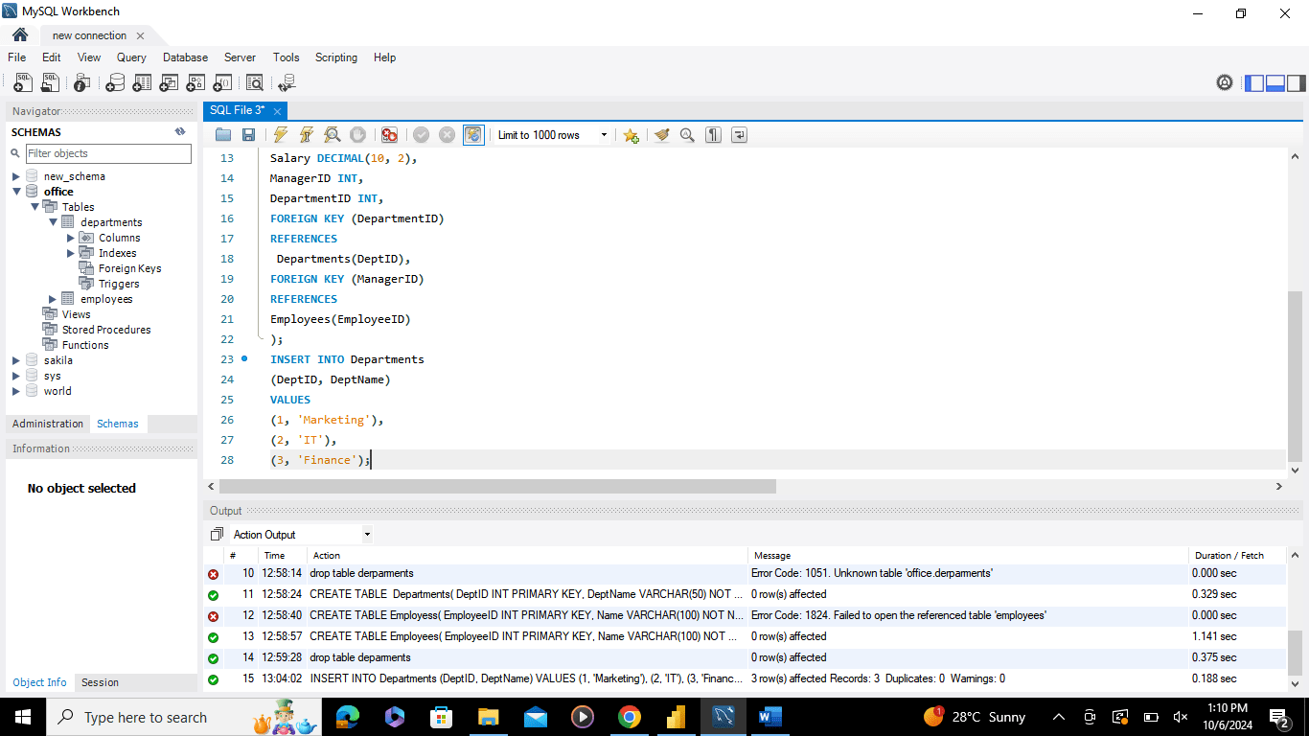

**Questions:**

1. **Write SQL statements to create the Employee and Department table.**

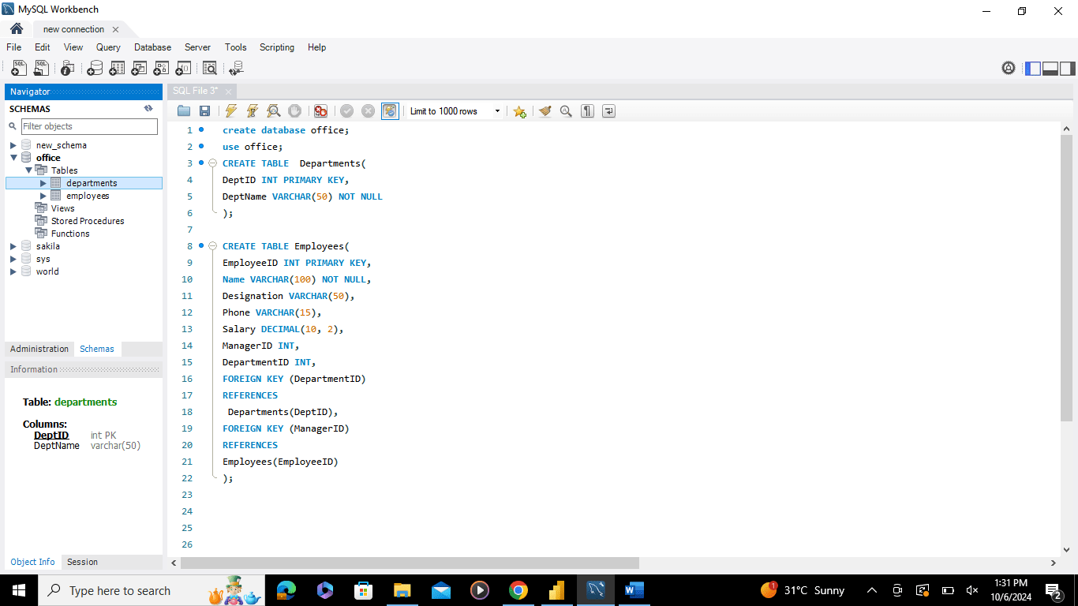

1. **Insert the sample data at least 5-Employees and 3- Departments in the relevant tables. Make sure the data of the employees is about your instructors in the Data Analytics batch and include yourself also as a ‘Student’. As for the managerID, use any instructor as your manager and all instructors must have Sir Zeeshan as Manager. While Sir Zeeshan has no Manager.**

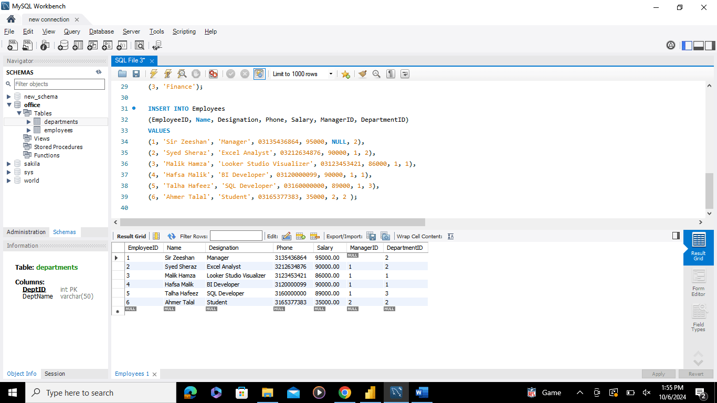

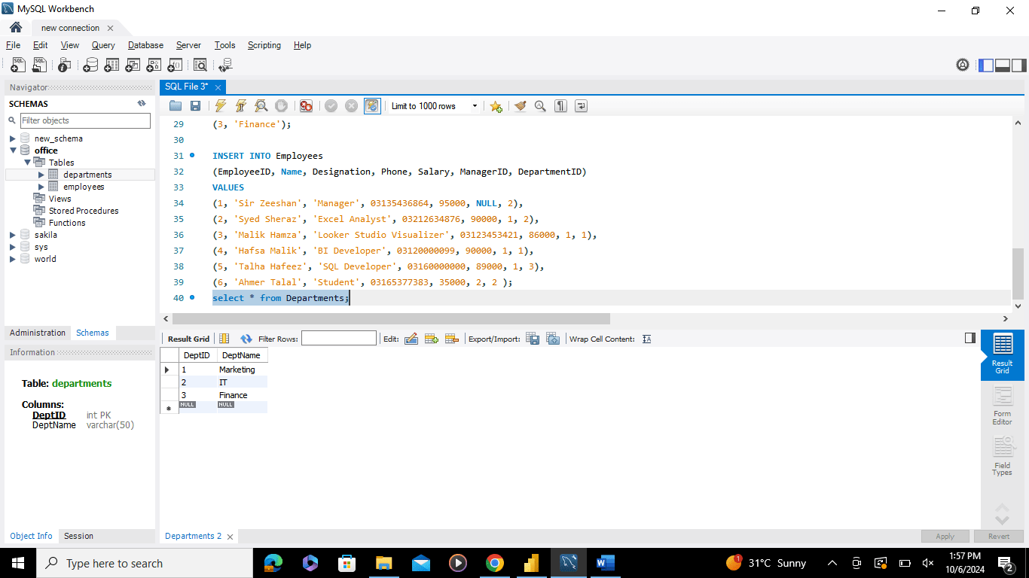

1. **Write an SQL query to display all Employees along with their Department names using a LEFT JOIN.**

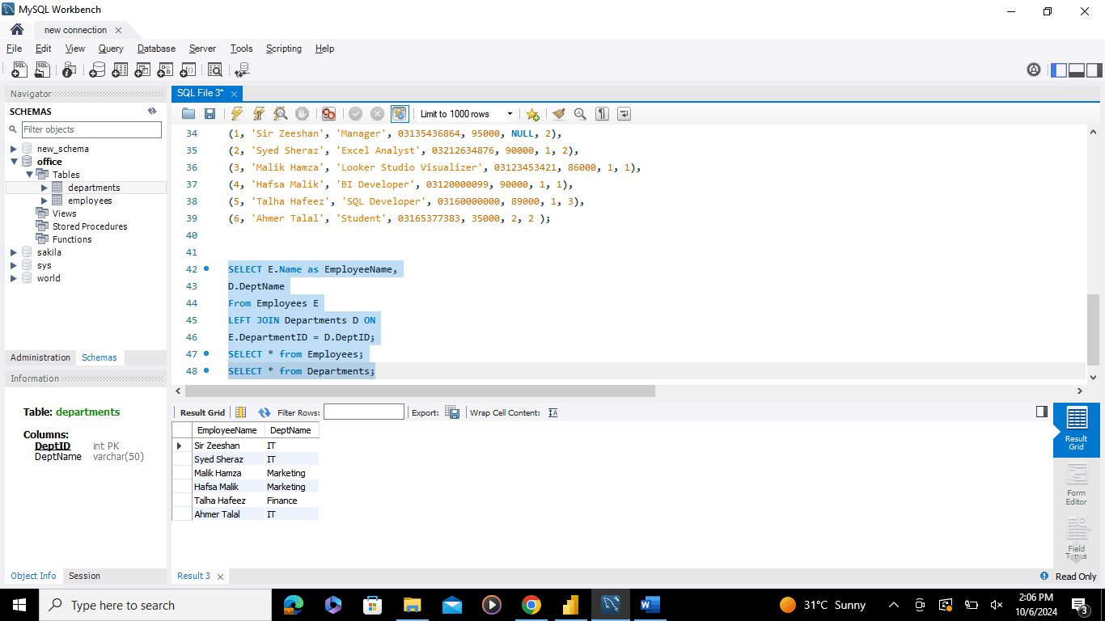

1. **Write a SQL query to get Employee name, DepartmentID (Bonus if fetched name), Manager name using Join.**

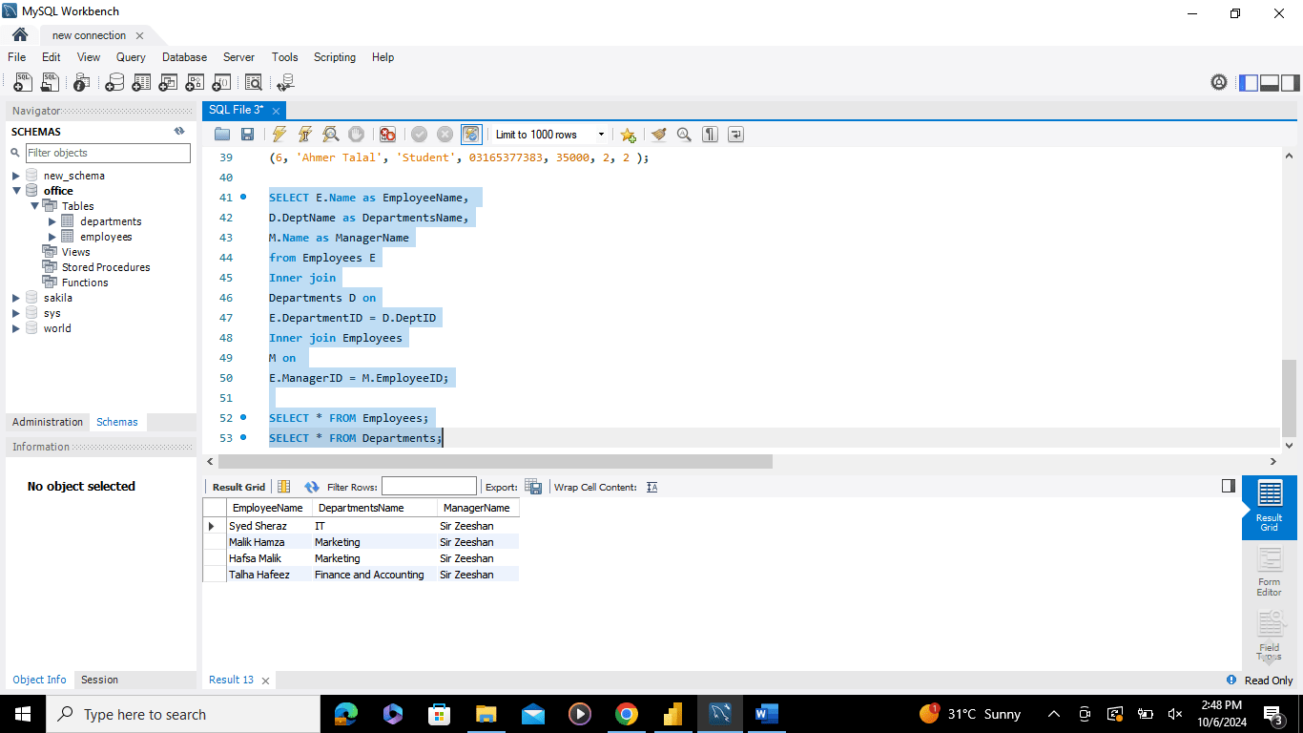

1. **Update the Department Name of ‘Finance’ to ‘Finance and Accounting’ in the department table.**

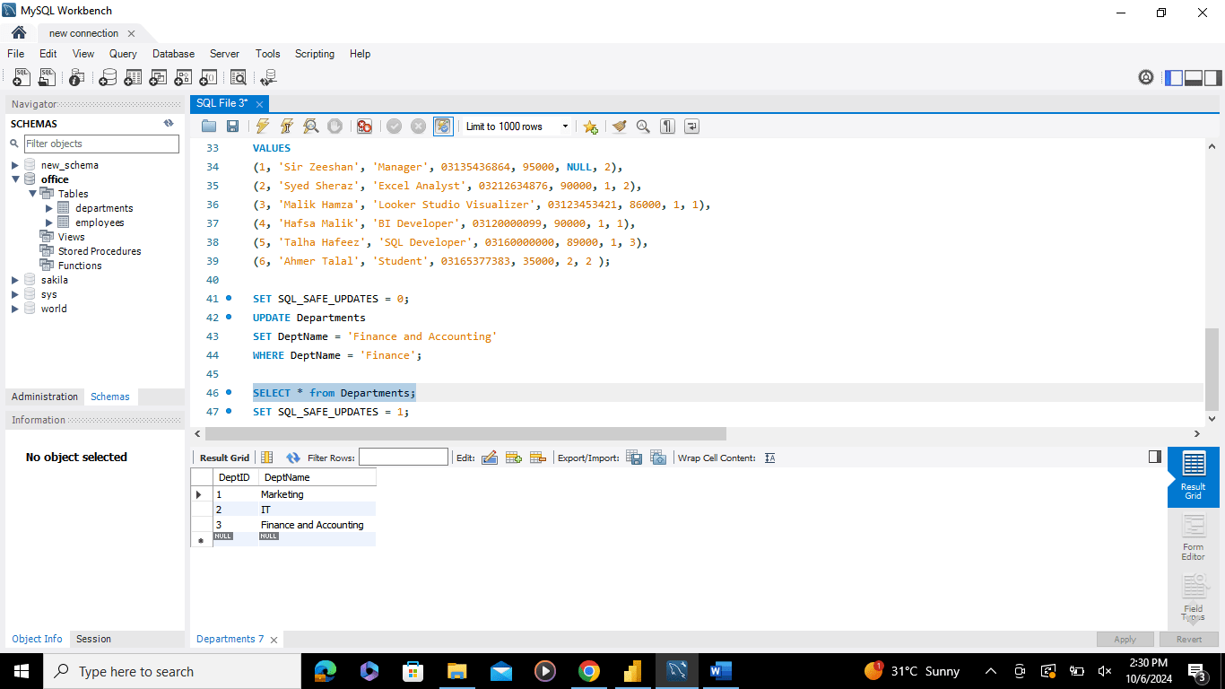

1. **Delete the Employee with the rank of Student from the Employees table.**

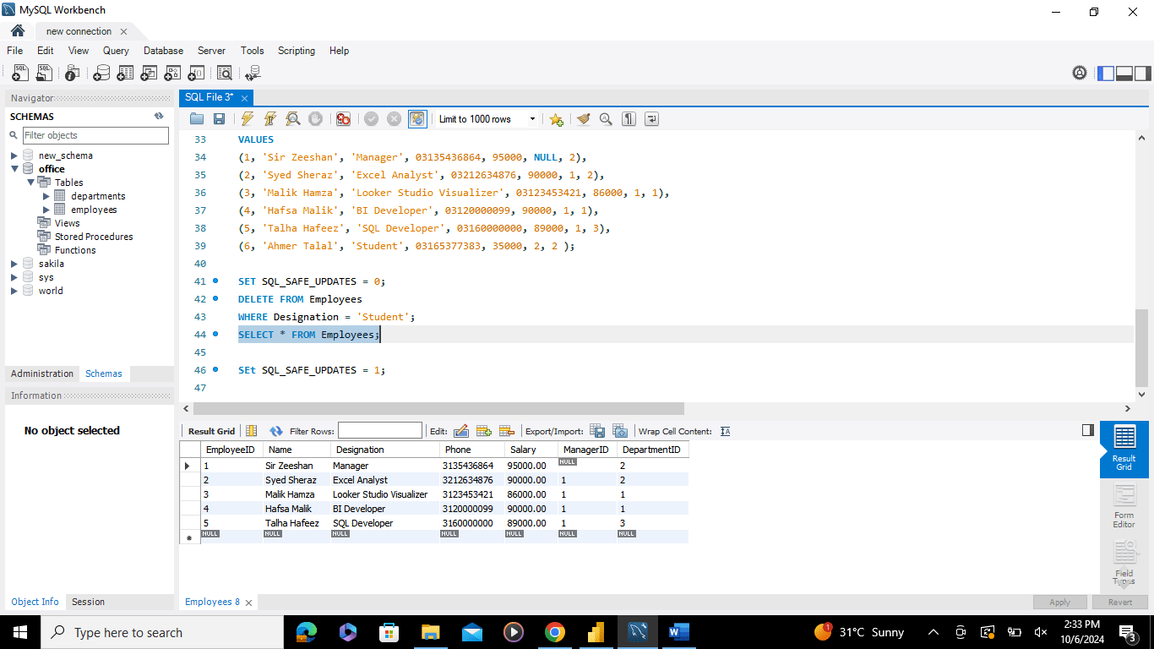

1. **Write an SQL query to sum the salary for each department using the SUM function and GROUP BY clause.**

