DevOps Fundamentals

Assignment 04 – CI/CD Pipeline Integration

GROUP DETAILS
Table 1: Group Details , Each student must fill their own row (including Assigned Page) in the versioned copy inside the repo
Sr # | Student Name | GitHub Username | Role (Lead/Member) | Assigned Page | Branch Worked On | Screenshots Added (Yes/No)
1 | Muhammad Ahmer Asghar | ahmer1289 | Team Lead | index.html | feature/home-page | Yes
2 | Asfaan Nasir | asfaannasir49 | member | Contact.html | feature/contact | Yes
3 | Zohaib ul hussnain | zohaib-source | member | task-details | Teacher/task-details | yes
4 | Memouna Shamshad | Memouna00 | member | about | feature/about | Yes
5

Group Repository URL:
https://github.com/ahmer1289/TaskFlow/
Deployed Application URL:
https://taskflow-64se.onrender.com/

SCENARIO

Sr # | Page File | Page Name | Page Responsibility
1 | index.html | Home / Dashboard | Overview of all tasks: summary counts (total, pending, completed), a welcome message, and navigation links to all other pages.
2 | add-task.html | Add Task | An HTML form allowing the user to enter a new task , fields for task title, description, due date, and priority (High / Medium / Low).
3 | task-list.html | Task List | A table listing all tasks with columns for title, due date, priority, and status. Includes basic filter buttons (All / Pending / Completed).
4 | task-detail.html | Task Detail | A page displaying the full details of a single selected task, with an option to mark it as complete or delete it.
5 | about.html | About / Help | A page describing the TaskFlow application, its purpose, and a simple usage guide explaining how to navigate and use the app.

Required repository structure:
Table 2: Expected Repository Structure
File / Folder | Purpose
index.html | Home / Dashboard page , created by Member 1
add-task.html | Add Task page , created by Member 2
task-list.html | Task List page , created by Member 3
task-detail.html | Task Detail page , created by Member 4
about.html | About / Help page , created by Member 5
style.css | Shared stylesheet , consistent look across all pages
Dockerfile | Dockerfile to containerize the application (nginx-based)
.github/workflows/ci.yml | CI workflow – triggered on Pull Request to “develop”
.github/workflows/cd.yml | CD workflow – triggered on push (merge) to “develop”
Assignment_04_Spring2026.docx | This assignment question paper (versioned in repo)

SUBMISSION REQUIREMENTS
The Team Lead must submit the following on LMS:
- Completed Assignment 04 document with all group details filled in (including each member's Assigned Page).
- GitHub repository URL (must be public or shared with the instructor).
- Render live application URL.
- Screenshot 1: GitHub “development” Environment showing all three secrets configured.
- Screenshot 2: Each member's CI workflow run triggered by their individual PR , all steps green (one screenshot per member, or a combined view).
- Screenshot 3: Docker Hub repository page showing the pushed image with correct tags.
- Screenshot 4: CD workflow run triggered by a push to “develop” , deploy step completed.
- Screenshot 5: Live TaskFlow application on Render showing all five pages are accessible.
- Screenshot 6: The Assignment 04 .docx file visible in the GitHub repository file listing.
- Individual reflection: Each team member must write 4–5 lines on what they learnt and any challenges they faced.

VERIFICATION SCREENSHOTS
GitHub Environment & All Secrets
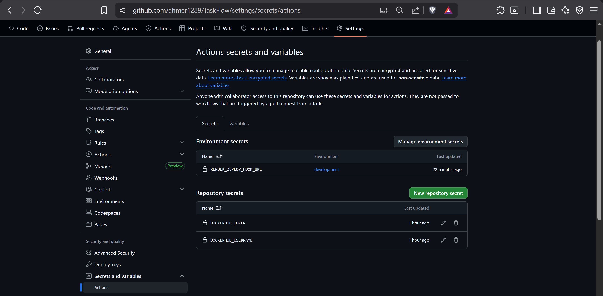

CI Workflow Runs – Triggered by each member's PR (all steps green)

Docker Hub Pushed Image with Tags

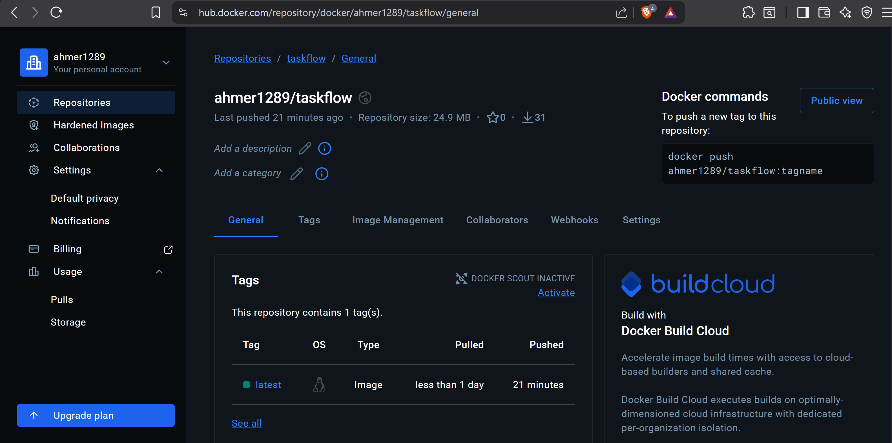

CD Workflow Run – Triggered by Push to “develop”

Ahmer

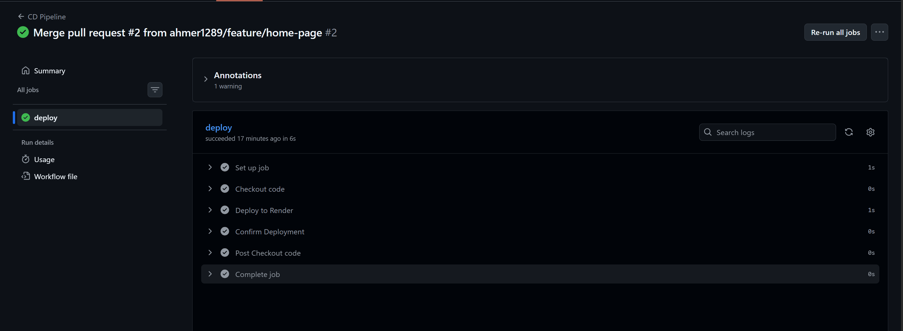

Live TaskFlow on Render – All 5 Pages Accessible

Assignment 04 .docx Visible in GitHub Repo
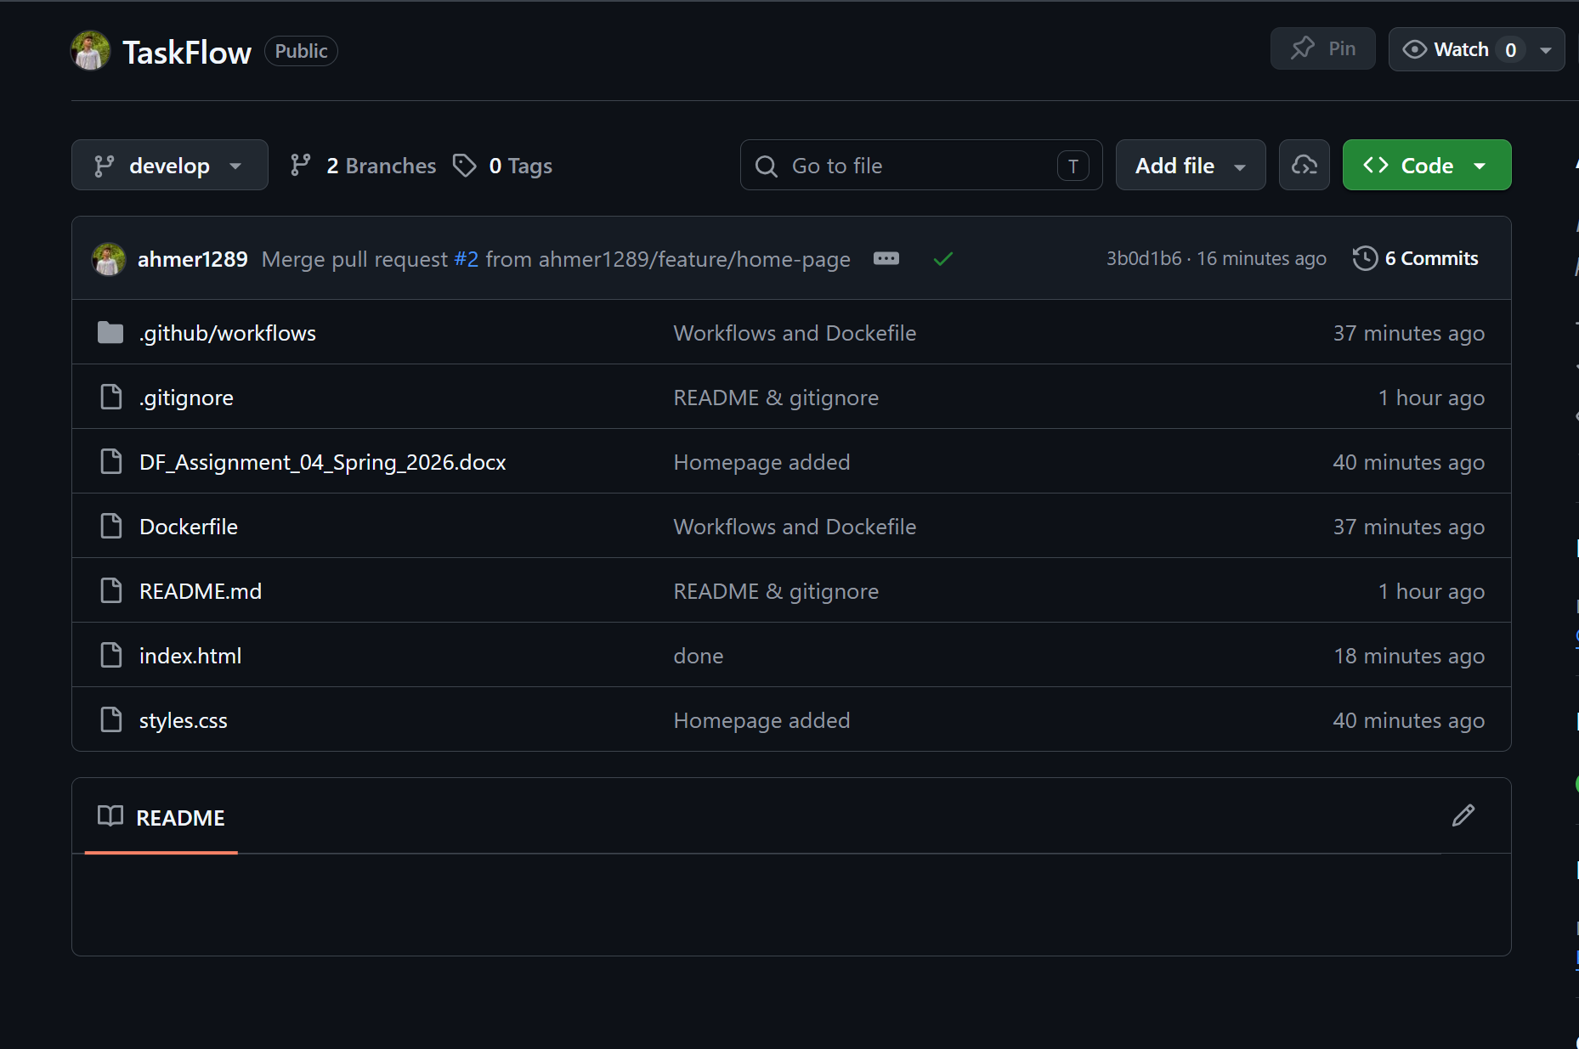

TEAM REFLECTION
Each team member must individually write 4–5 lines covering: what was learnt, the most challenging part of the assignment, and how the team resolved it.

Member 1 (Name: Muhammad Ahmer Asghar)
Leading this project, I mastered orchestrating CI/CD pipelines by integrating GitHub Actions, Docker Hub, and Render. The greatest challenge was resolving authentication conflicts between our private Docker registry and the deployment environment, which I solved by standardizing our Dockerfile and configuring secure environment secrets. I also implemented branch protection rules to ensure our develop branch remained stable. This experience solidified my understanding of DevOps workflows and effective team coordination

Member 2 (Name: Asfaan Nasir )
Watching our lead build the CI/CD pipeline from scratch showed me the power of automated testing and deployment workflows in action. Seeing my changes seamlessly integrated and deployed without a single hitch highlighted how robust automation minimizes human error. It was an invaluable lesson in how modern DevOps practices streamline the release cycle and ensure system stability.

Member 3 (Zohaib ul hussnain: )
For this assignment, I developed the task-details page from scratch and experienced the power of our pre-configured CI/CD workflows firsthand. The most challenging part was ensuring my code changes integrated smoothly without breaking the existing pipeline, as any error could halt the deployment process. We resolved this by relying heavily on the automated tests triggered the moment I opened my pull request, which immediately highlighted any integration issues. Seeing my commits automatically tested and seamlessly deployed upon PR approval taught me how crucial robust automation is for maintaining code stability and accelerating teamwork

Member 4 (Name: Memouna Shamshad)
The about page was simple to implement also the workflow was setup compeletely fine so I easily saw the changes live as soon as I pushed my changes to github. No issues from my side the only learning factor was that workflow makes the whole job too easy as compared to normal flow.

Member 5 (Name: )

