PIPILINED MULTIPLIER
COMPILE
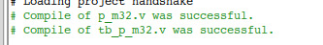
DESIGN FILE
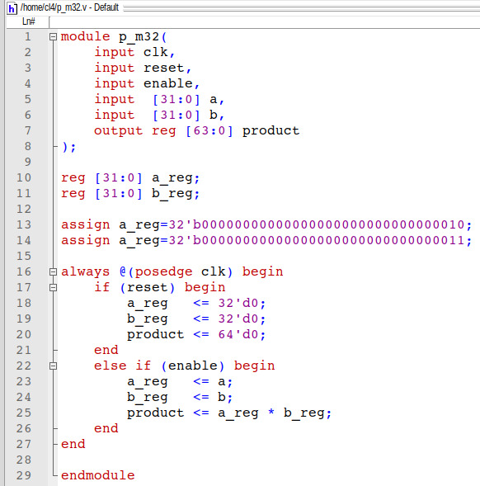

TEST BENCH FILE
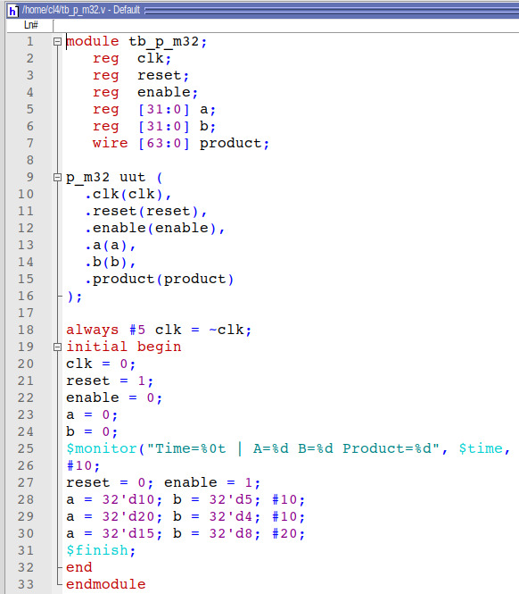
WAVE
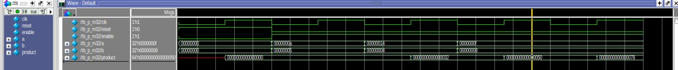

COMMAND RUN
