SOLVING TSP

Ahmet Çelik

Contents:

1. Problem Description
2. Problem Solution
3. User Manual
4. Conclusion

1. Problem Description

In this project , I developed some solutions to well-known Travelling Salesman Problem. I used different four methods to solve this(2opt and 3opt are similar to each other). Only the first exact enumeration guarantees solution is correct others are just to guess a good solution, since exact enumeration lasts long for even for 16 cities.

2. Problem Solution
Class 0: Main Class:
This class reads input.txt file from default directory(in eclipse it is directory of Project,near src and bin folders) and holds it in the distances array. All other class reads distances between cities from this array. (Main.distances ) So, all TSPSolvers should be used with my Main.
Please use my Main class to test or use a main class it has name Main and a public static double[][] distances field.
Class I: Exact Enumeration:
This class finds all possible paths and tries all of them and finds the best one. I tried this method until 14 city. It is lasted approximately 470 sn. So, for 16 city it may last more than 24 hour. Results for 6-8-10-12-14 cities are in the txt files that are in zip file. Complexity of my find() method is O(n!) n is city number. perm(int[] arr,int k) basicly finds all possible permutations. But, since our path is always closed , there is at least two path that has same length, 1-5-3-4-2-1 and 1-2-4-3-5-1. But since our code complexity O(n!), to divide 2 permutation does not help much(24 hour vs 12 hour,they are too long). This class use its own computeTotalCost method.
Numbers of  City | Run Time *  (in miliseconds) | Run Time *  (in nanoseconds)
6 | 0 | 99529
8 | 1 | 798142
10 | 26 | 25303620
12 | 3109 | 3133682245
14 | 468735 | -

Class II: Greedy:
This class implements Greedy Method. Simply I hold two different list. One for path one for unconnected cities. Each time I add closest one to the last added city to the path. So, it runs O(n²) complexity. Much much faster than first method. But, this method does not guarentee correct solution. You can find results in the txt files that are in zip folder.
Numbers of  City | Run Time *  (in miliseconds) | Run Time *  (in nanoseconds)
6 | 0 | 27178
8 | 0 | 41342
10 | 0 | 53976
12 | 0 | 64693
14 | 0 | 84982
40 | 0 | 242314
60 | 0 | 295523
80 | 0 | 754504
101 | 0 | 826087

Class III: Minimum Spanning Tree Method:
To implement this solution I created MSTNodes that holds all children in a LinkedList in adding order to tree and a ID for the city. I basicly for each step travel both connected and unconnected list and makes in total O(n²) comparison. Then travelling tree is O(n), so this program has O(n²) complexity, it is faster than again first method,but slightly slower than second method. But, since we are applying DFT to a minimum spanning tree, in jumps to other nodes there will be extra length. So, this method also does not guarantee anything, even sometimes it can be worse than Greedy Method. I used Prim’s algorithm to construct MST.
Numbers of  City | Run Time *  (in miliseconds) | Run Time *  (in nanoseconds)
6 | 0 | 28711
8 | 0 | 90724
10 | 0 | 105270
12 | 0 | 213221
14 | 0 | 332272
40 | 0 | 242697
60 | 1 | 684068
80 | 4 | 3309326
101 | 8 | 8200392

Class IV: Opt Solutions(2opt and 3opt):
To implement this solutions I used only one class, since they only differ in creating new solutions.
Just, use true in constructor to construct 2Opt, false to construct 3Opt. I holds randomPaths, bestPath , bestResult and Random object.
If we analyze 2opt and 3opt to create a new solution we need first two indices, that defines region that will change. For 2opt this enough. Then reverse that region and calculate length. There is no need to calculate all length, but since the longest region can be in size 97, it will not worth it. For 2opt a reverse method will enough for that region. For example:
A | B | C | X | K | L | M | N | O | P | Q | R | Y | E | F | G | H | I | J | A
For this path, valid random big and small indices should statisfy: big-small>= 3(to have 2 different edge) and big-small can not number of cities since big and small will be same city in this situation. Lets choose X and Y as big and small borders. So, new solution will be:
A | B | C | X | R | Q | P | O | N | M | L | K | Y | E | F | G | H | I | J | A

For 3opt there is four possibilities: (S:small , B:big, B1:block1 , B2:block2, -B1:reverse of block1, -B2:reverse of block2)
Initial: S-B1-B2-B So, there is important things. B-S>=5 and size of B1 can be >=2 and <(B-S-3) this same for size of B2. So while randomly generating B,S,and B1 size we should becareful about them. We need extra method for swapping blocks in additional to reverse.
Same in code:
Case 1: S,B2,B1,B Case 2: S,-B2,B1,B Case 3: S,B2,-B1,B Case 4: S,-B1,-B2,B
For example lets do Case 3,
Initial:
A | B | C | X | R | Q | P | O | N | M | L | K | Y | E | F | G | H | I | J | A
Then:
A | B | C | X | O | N | M | L | K | P | Q | R | Y | E | F | G | H | I | J | A

To improve solution I choose best of this four cases in each step. I randomly chose Big,Small and Block1 size ,so to try more possibilities I run program many many times,with different seeds. Run Time for these:

Numbers of  City | Run Time *  (in miliseconds) |  | Run Time *  (in nanoseconds)
Numbers of  City | 2 Opt | 3 Opt | 2 Opt | 3 Opt
6 | 1 | 0 | 1049262 | 567696
8 | 1 | 0 | 1376940 | 651147
10 | 2 | 1 | 1636480 | 744550
12 | 2 | 2 | 1670167 | 1572170
14 | 2 | 2 | 2175848 | 2330884
40 | 2 | 7 | 7184052 | 6962793
60 | 2 | 15 | 2667750 | 15152849
80 | 3 | 20 | 2215277 | 20270917
101 | 7 | 25 | 1935831 | 25369462

Class V: Triangle(Bonus):

An intuitive approach to the TSP is to start with a subtour, i.e. a tour on small subsets of cities, and then extend this tour by inserting the remaining cities one after the other until all cities have been inserted.
The starting tour is usually some tour on three cities, e.g. those cities that form the largest triangle. It can be chosen as convex hull.But, in my implementation I used largest triangle that results from first n cities. Then, I should choose an insertion scheme to this largest triangle. I have chosen;
cheapest insertion: Among all cities not inserted so far, choose a city whose insertion causes the lowest increase in the length of the tour. The idea behind this strategy is greediness. But this is very different from Greedy Method, and gives better solutions than it.

Numbers of  City | Run Time *  (in miliseconds) | Run Time *  (in nanoseconds)
6 | 0 | 54358
8 | 0 | 41725
10 | 0 | 75029
12 | 0 | 102592
14 | 0 | 133216
40 | 1 | 1423265
60 | 1 | 1363547
80 | 3 | 3702096
101 | 8 | 8259758

*These results are from x86 eclipse and java32bit and 2.66 ghz quad core cpu(Cache L1 :4 x 64 KB -- Cache L2 :4 x 256 KB-- Cache L3 :8192 KB) and 4gb ram (if you use 64bit java results may be better)

TABLES

Now let see all five method speeds in one table:
As you can see all methods runs very fast except for Exact Enumeration. For 16 city it will took calculate total length approximately 24 hours. It grows factorially. But others methods grows quadratic or cubic depends algorithm.

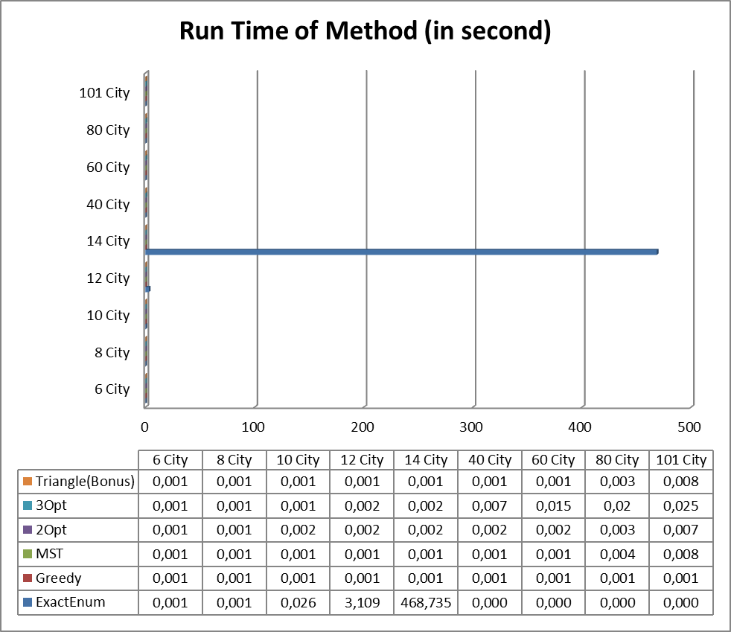
Table 1: Run times.( 0,000 values for ExactEnum means they were not calculated)

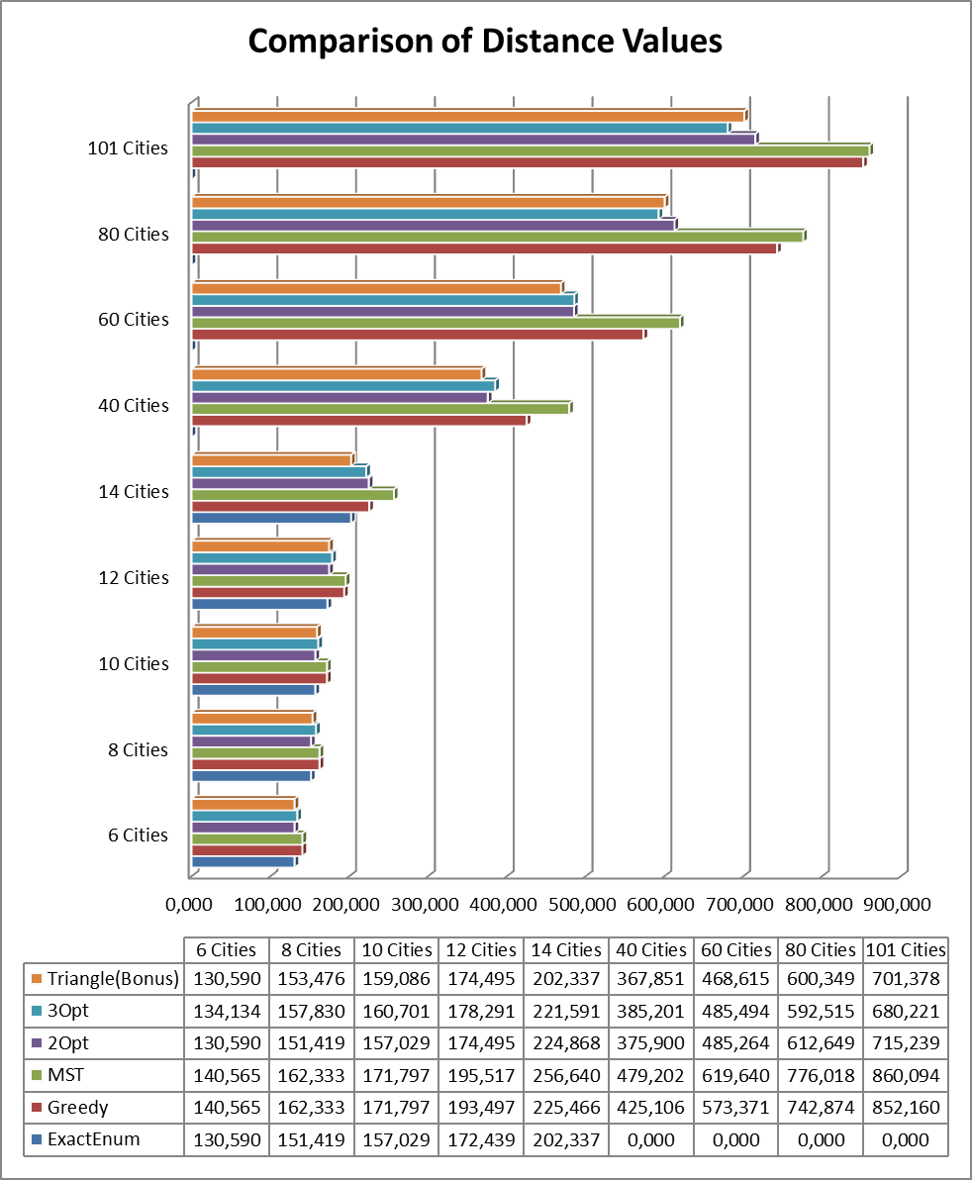
Table 2: Results of Methods ( 0,000 values for ExactEnum means they were not calculated)

You can find paths of these results in “paths.zip” zip archive.

Class Relationships
Main class is responsible for creating distance array of all cities from input.txt . Other classes use Main class static field for their calculations. Results are being writing into their txt files that are appendable.
There is a abstract TSPSolvers class that is parent of all solving methods. It includes usefull stuff for solving methods, such as printing pretty(except for ExactEnum) ,calculating total length of path(except for ExactEnum). All children of this should implement a void find() method.
ExactEnumetion is different from others since it used an array to hold path, it is array because it is faster. But,since other methods is not too complex i used LinkedList for them.
There is a MSTNode class for Minimum Spanning Tree method, because this nodes are used in this to constitute a tree. MSTNode has a child field that is a LinkedList. So, it can multiple children(more than two).
OptSolver class holds two methods. While constructing it, if you use true in constructor it will be 2opt method, otherwise will be 3opt method.
Triangle class implements my bonus method.

3. User Manual

Please use my Main class to test or use a main class that has name Main and has a public static double[][] distances field and properly add distances to this array. Because my Main class creates distances array.

4. Conclusion
I deduced that from this project. Some problems can not solved with exact enumeration. For those, we can use heuristic methods. That can be very different approaches, even one can try to solve this problem with genetic idea, taking cities as genes. And crossing-over cities. Applying Natural Selection to cities that are higher lengths. But, in my implementions I used basic approaches. Some of them can give better results with huge number of iterations that are 2-3OptSolutions(Iterative Solutions). But, minimum spanning tree gives one solution. If changed order of children in child LinkedList there can be different valid solutions,even they can be lower. Greedy method is basic approach and it works great,even sometimes better than complex MST solution. My bonus method gives great results and it works as fast as others. I tried also using convex hull, but its results are not much different from this triangle version. So, I said simple is better and I have chosen this one. Because in the other I also need Point class,it was very complex and uses logic of cross product of vectors.

