**STORE PROCEDURES:**

**1-AddInstructor:**

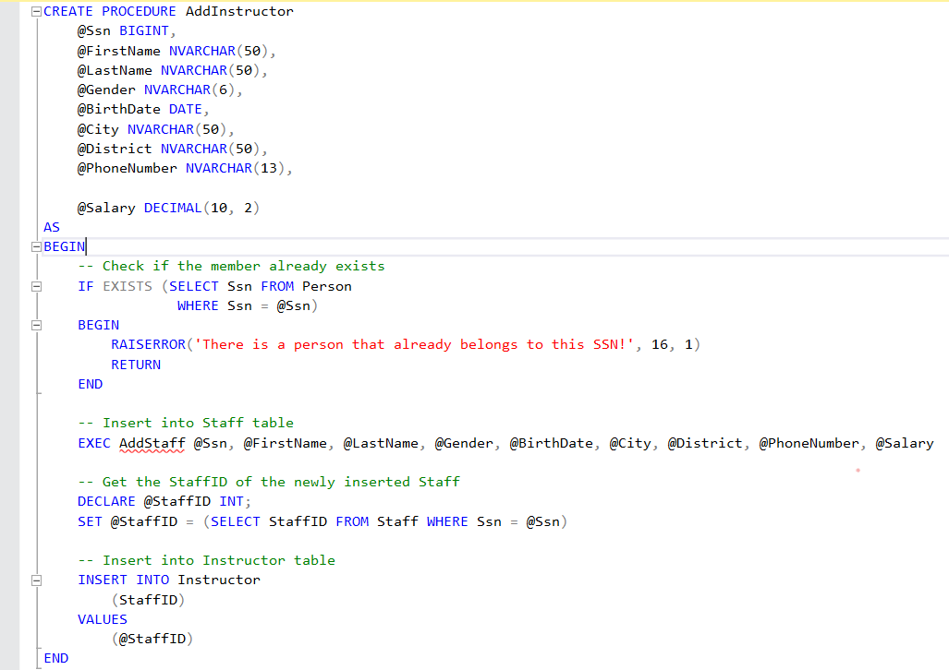

In this store procedure, we aim adding the instructor to the database. We have 9 parameters for this store procedure. Firstly, we control the records. If there is a ınstructor which has an Ssn that is same with @Ssn, system returns the error message. If there is no error, The another store procedure(AddStaff) is called. We should add that record as a staff too. Because an instructor is a staff.

Finally, the record are saved via INSERT INTO command.

**2-AddMember:**

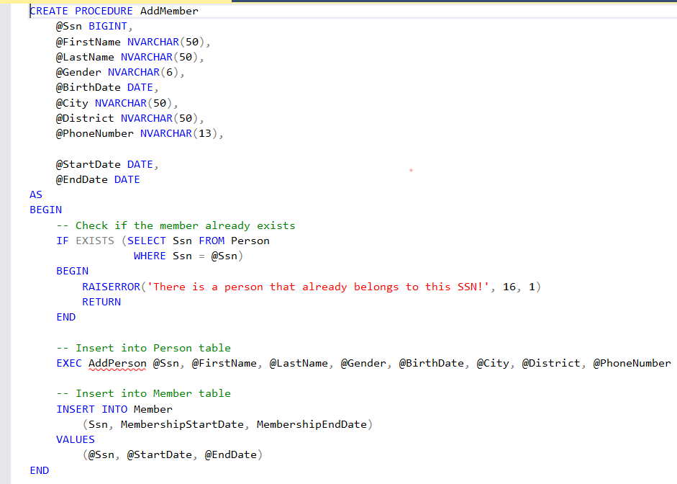

In this store procedure, we aim adding the member to the database. We have 10 parameters for this store procedure. Firstly, we control the records. If there is a member which has an Ssn that is same with @Ssn, system returns the error message. If there is no error, The another store procedure(AddPerson) is called. We should add that record as a person too. Because an member is a person.

Finally, the record are saved via INSERT INTO command.

**3-AddOrDeleteProduct:**

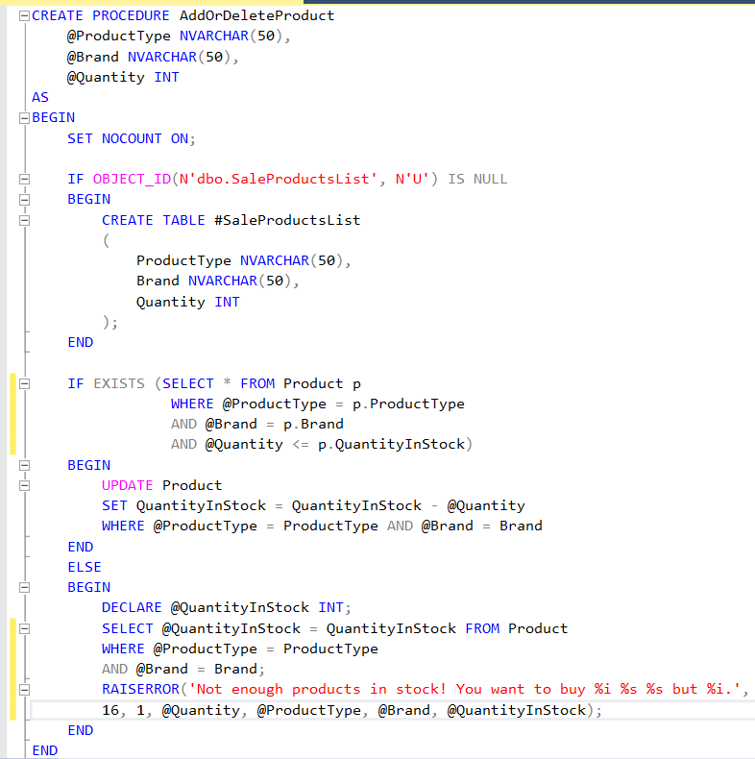

In this store procedure, we aim add or delete product. We have 3 parameters for this sp. If there is a sale on this products, the Quantity stock will be updated, will be decreased by @Quantity. If there is no more product in the stock system returns the error message.

**4-AddPerson:**

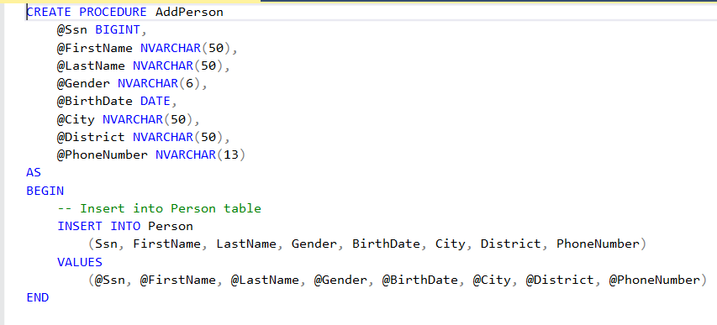

In this store procedure, we aim adding the person to the database. We have 8 parameters for this store procedure. If there is no error, the record are saved via INSERT INTO command.

**5-AddPersonalTrainer:**

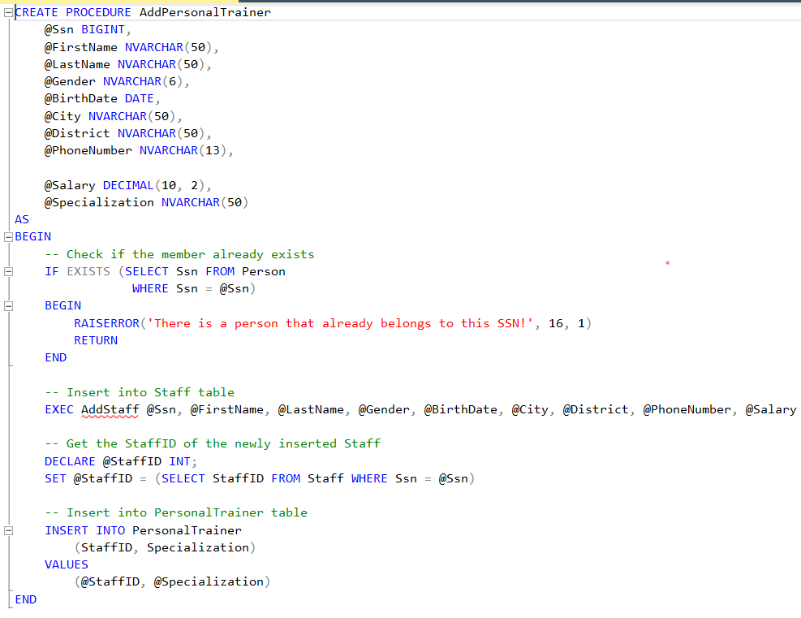

In this store procedure, we aim adding the personal trainer to the database. We have 10 parameters for this store procedure. Firstly, we control the records. If there is a PT which has an Ssn that is same with @Ssn, system returns the error message. If there is no error, The another store procedure(AddStaff) is called. We should add that record as a staff too. Because an PT is a staff.

Finally, the record are saved via INSERT INTO command.

**6-AddStaff:**

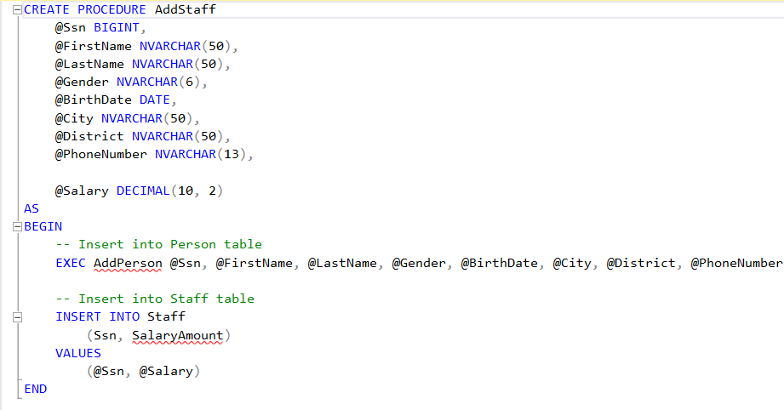

In this store procedure, we aim adding the staff to the database. We have 9 parameters for this store procedure. Firstly, we control the records. If there is a staff which has an Ssn that is same with @Ssn, system returns the error message. If there is no error, The another store procedure(AddPerson) is called. We should add that record as a person too. Because an staff is a person.

Finally, the record are saved via INSERT INTO command.

**7-BuyProduct:**

**metin, yazılım, yazı tipi, çizgi içeren bir resim

Açıklama otomatik olarak oluşturuldu**

In this store procedure, we aim the calculate the total amount of sale and insert into tha sale table. Firstly, we check the SaleProductList table. If there is no such as this table, system returns the error message. If there is no error, total amount is calculated and ınserted into the Sale table.

**8-GenerateTransaction:**

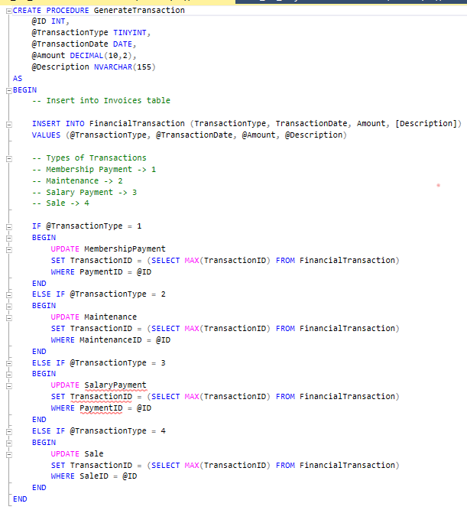

In this store procedure, we aim generating the transaction. We have 5 parameters. Firstly, we insert into invoices table. Then, we have 4 types of transactions:

-- Membership Payment -> 1

-- Maintenance -> 2

-- Salary Payment -> 3

-- Sale -> 4

If transaction type is Membership payment, The membership Payment Table is updated with new TransactionID

If transaction type is Maintenance, The Maintenance Table is updated with new TransactionID

If transaction type is Salary Payment, The Salary Payment Table is updated with new TransactionID

If transaction type is Sale, The Sale Table is updated with new TransactionID

**9-GetWorkoutsByMember:**

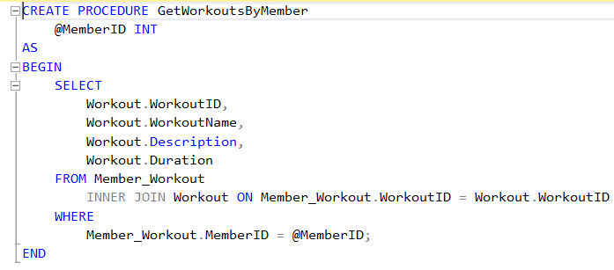

In this store procedure, we aim check the workout of member which has @MemberID. We have 1 parameter. We can select the workout information via INNER JOIN.

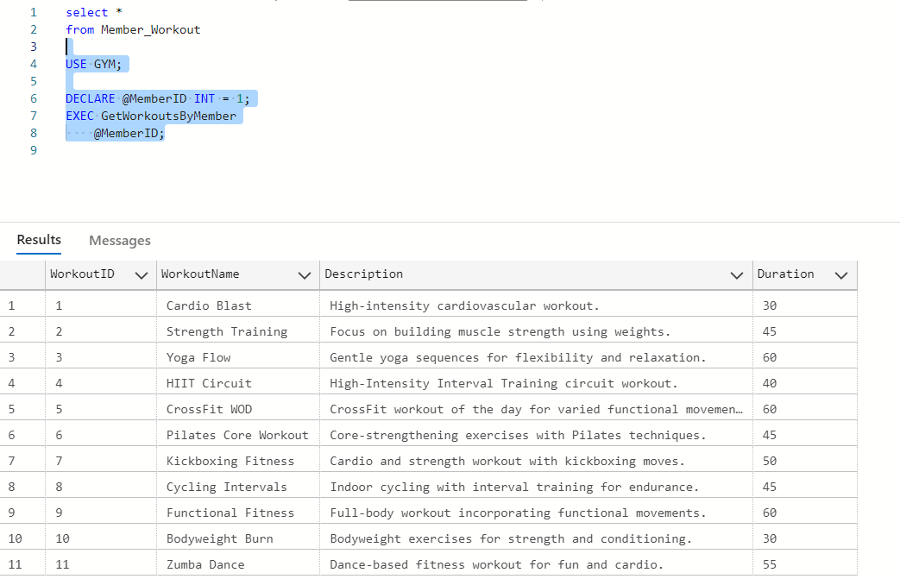

**10-UpdateMemberShip:**

**metin, ekran görüntüsü, yazı tipi, sayı, numara içeren bir resim

Açıklama otomatik olarak oluşturuldu**

In this store proceure we aim update the member ship of a member. We have 2 parameters. @MemberID is ID of member that we wnat to evaluate. @NewPlanID is new plan of the this member. Firstly, we check if the member is in database or not. If member is in database, we update the membership of this member. After updating we check if the update was successful. If no rows are affected, meaning the member with provided ID was not found.

