**TRIGGERS:**

**1- trg_AfterInsertMembershipPayment:**

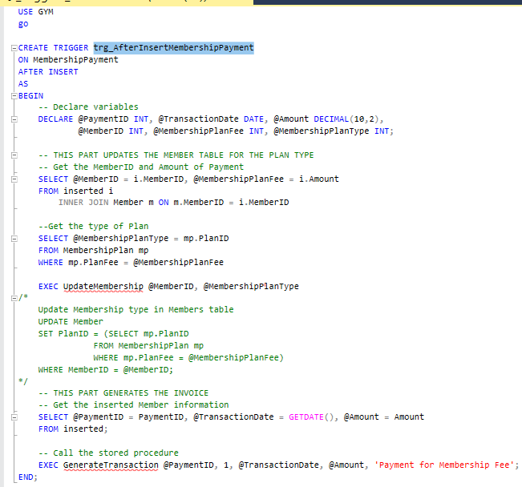

The trigger is set to execute AFTER INSERT operation on the Membership Payment table. It updates the membership type of the corresponding member in the Member table based on the membership fee and generates a transaction for the payment using the GenerateTransaction stored procedure.

**2-trg_AfterInsertMaintenance:**

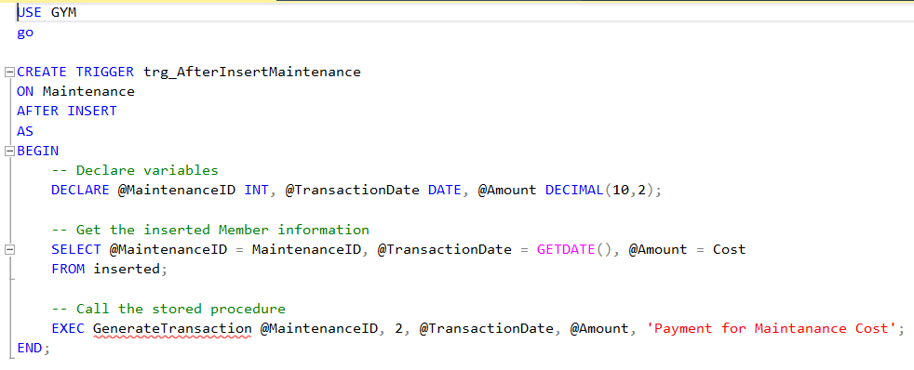

The trigger is set to execute AFTER INSERTION operation on the Maintenance table. It retrieves information about the inserted maintenance, such as the maintenance ID and cost, and then generates a transaction fort he maintenance cost using the GenerateTransaction stored procedure.

**3-trg_AfterInsertSalaryPayment:**

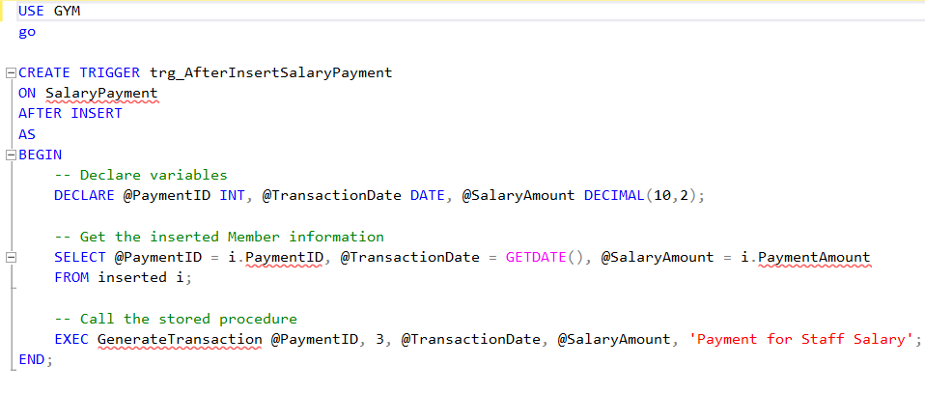

This trigger is designed to execute after an INSERT operation on the SalaryPayment table. Variables are declared to store information retrieved from the inserted. The GenerateTransaction stored procedure is called to generate a transaction (invoice) for the staff salary payment. It passes the PaymentID as the transaction identifier, 3 as the transaction type (indicating staff salary payment), @TransactionDate as the date of the transaction, @SalaryAmount as the payment amount, and a description for the transaction.

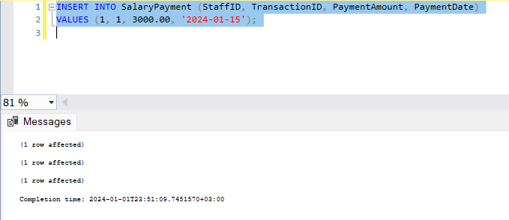

**4-trg_AfterInsertSale:**

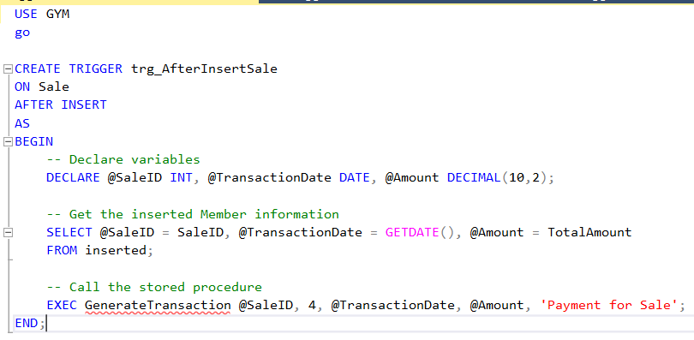

The trigger is set to execute AFTER INSERT operation. Variables are declared to store information retrieved from the inserted table. It fetches information about the inserted sale from the inserted table. It retrieves SaleID, sets the TransactionDate to the current date and time, and stores the total amount of the sale in the @Amount variable. The GenerateTransaction stored procedure is called to generate a transaction (invoice) for the sale. It passes the SaleID as the transaction identifier, 4 as the transaction type (indicating a sale), @TransactionDate as the date of the transaction, @Amount as the total amount of the sale, and a description for the transaction.

In summary, this trigger is designed to execute after an INSERT operation on the Sale table. It retrieves information about the inserted sale, such as the sale ID and total amount, and then generates a transaction (invoice) for the sale using the GenerateTransaction stored procedure. The generated transaction includes information such as the sale ID, transaction date, sale amount, and a description indicating it's a payment for a sale.

