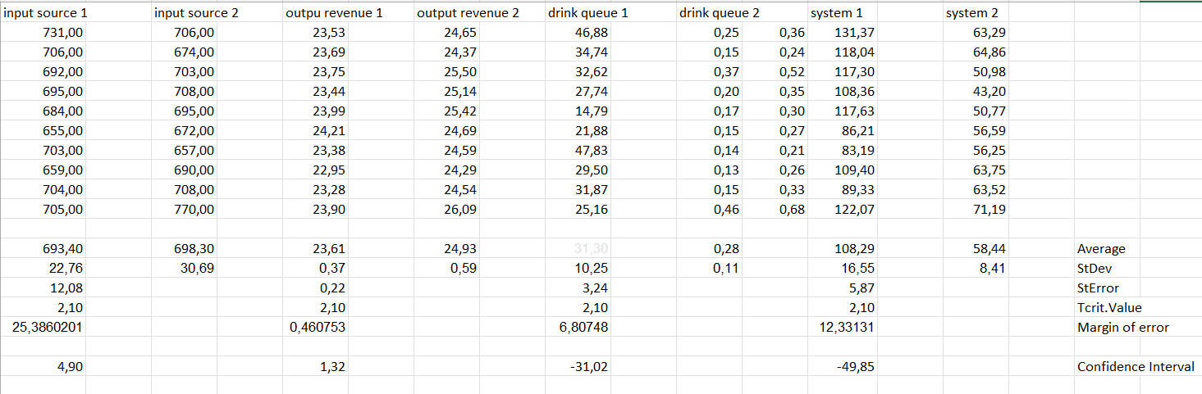IE3081-MODELING AND DISCRETE SIMULATION COURSE

150121025 Ahmet Abdullah Gültekin

150120035 Ömer Deligöz

150120063 Hamza Ali İslamoğlu

150120005 Ayşe Gülsüm Eren

150120004 Melik Özdemir

In this project we are expected to determine a system that is dynamic stochastic system and we want to model and simulate. This project consists of 4 steps.

**STEP 1:**

In this step, we are expected to determine system components, relations between system components.

**System:** Refectory Business:

**Entities:**

1. Customer: Person that use the refectory
2. Meal: Food items provided by the refectory:

**Attributes:**

1. Customer: Meal Preference, Entry Time.
2. Meal: Type

**Activities:**

1. Queueing: The area where customers wait in line to get their meals.
2. Meal Service: The area where meals are served to customers.
3. Payment: The process where customers pay for their meals.

**Events:**

1. Customer Entry: A new customer enters the cafeteria.
2. Order Placement: The customer specifies their meal preference.
3. Meal Pickup: After waiting in line, the customer moves to the meal service area and picks up their meal.
4. Payment Transaction: The customer pays for their meal.
5. Customer Exit: The customer leaves the cafeteria.

**State Variables:**

1. Customer Count: The total number of customers in the cafeteria.
2. Queue Status: The number of customers waiting in line and the status of the queue (e.g., busy, idle).
3. Meal Service Status: The number of customers in the meal service area and its status.
4. Revenue: The total revenue generated from meal sales.

**Relations:**

1. **Customer Queue Relation:**

-Description: Customers form a queue to wait for their turn to get meals.

-Key Components: Queueing Activity,Customer Entities

1. **Meal Service Relation:**

-Description: Meals are served to customers who have waited in line.

-Key Components: Meal Service Activity, Customer Entities

1. **Order Placement Relation:**

-Description: Customers place orders before moving to the meal service area.

-Key Components: Order Placement Event, Customer Entities, Meal Entities

1. **Payment Transaction Relation:**

-Description: Customers complete the payment process after receiving their meals.

-Key Components: Payment Activity, Customer Entities

1. **Customer Exit Relation:**

-Description: Customers leave the cafeteria after completing the entire process.

-Key Components: Customer Exit Event, Customer Entities

1. **Revenue Generation Relation:**

-Description: Revenue is generated when customers make payments for their meals.

-Key Components: Payment Activity, Revenue State Variable

**Queue:** The customers create a queue.

**STEP 2:**

In this step, we are expected to define the objectives, re-determine system components, determine the performance metrics and alternative system design(s).

**Objectives:**

**Efficiency**: Minimize customer waiting time and optimize meal service to increase the throughput of customers.

**Revenue Maximization**: Maximize revenue generation through efficient meal sales.

**Customer Satisfaction:** Enhance the overall experience for customers, considering factors like wait times and service quality.

**Refined System Components:**

**Entities:**

**Attributes:** Include additional attributes such as customer satisfaction scores, service completion times, and meal waiting times.

**Activities:**

**Refinement:** Further detail the activities to include specific steps in the queueing, meal service, and payment processes.

**Events:**

**Refinement:** Specify additional events related to customer feedback, unexpected events (e.g., service disruptions), and special promotions.

**State Variables:**

**Refinement:** Enhance state variables to include detailed counts, such as the number of satisfied customers, the number of incomplete transactions, etc.

**Performance Metrics and Other Outputs:**

**Customer Waiting Time**: Measure the average time customers spend waiting in the queue and meal service areas.

**Revenue Generation Rate**: Track the rate at which revenue is generated per unit of time.

**Service Completion Rate**: Monitor the percentage of completed transactions compared to the total attempted transactions.

**Customer Satisfaction Score**: Collect and analyze customer satisfaction scores through feedback surveys or direct observations.

**Alternative System Designs:**

**Multi-Queue System:** Implement multiple queues for different types of meals or services to reduce waiting times.

**STEP 3**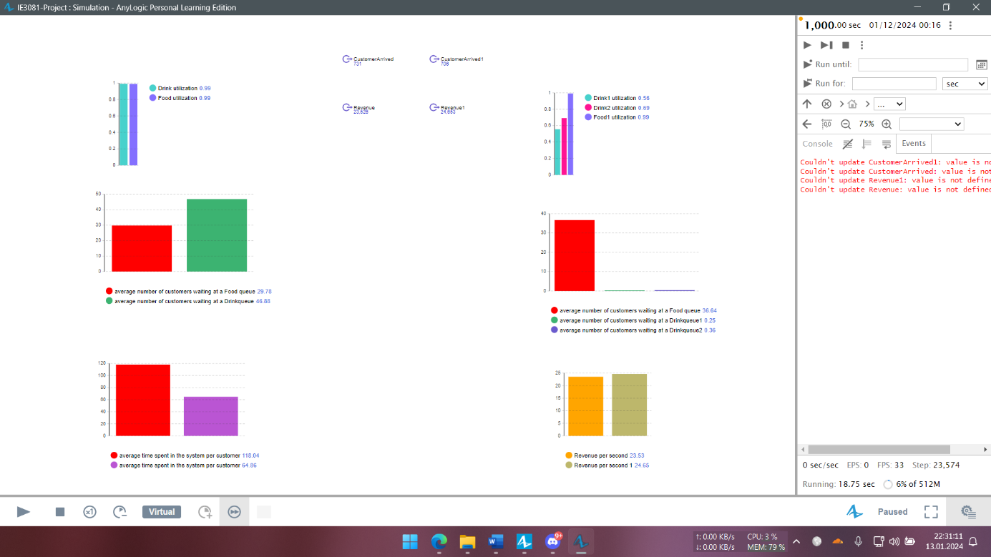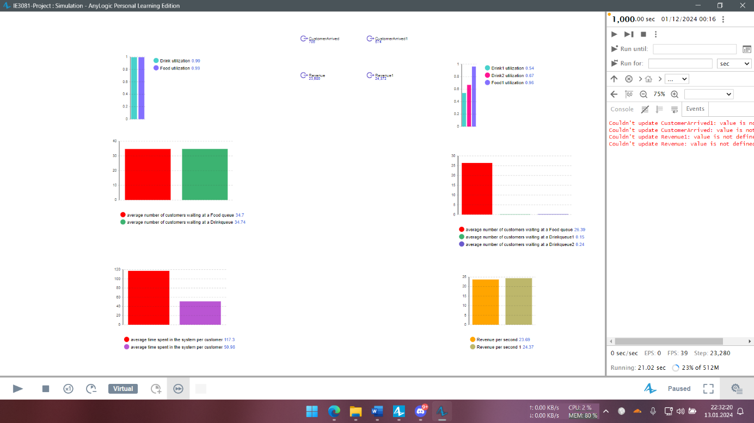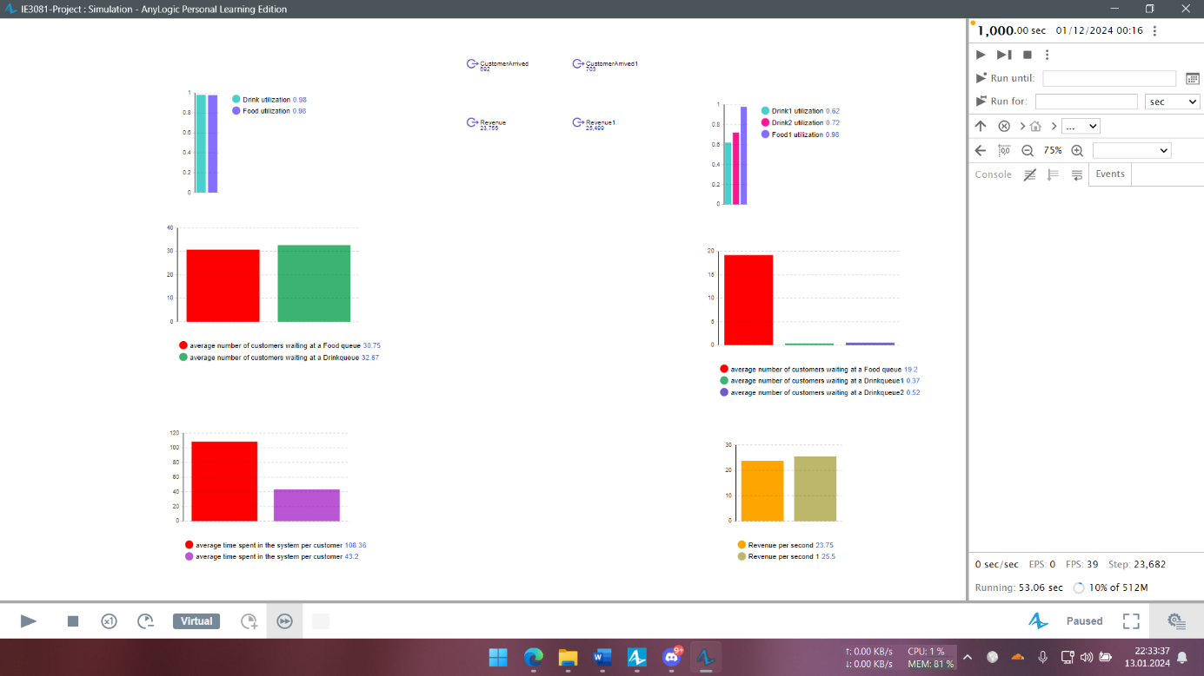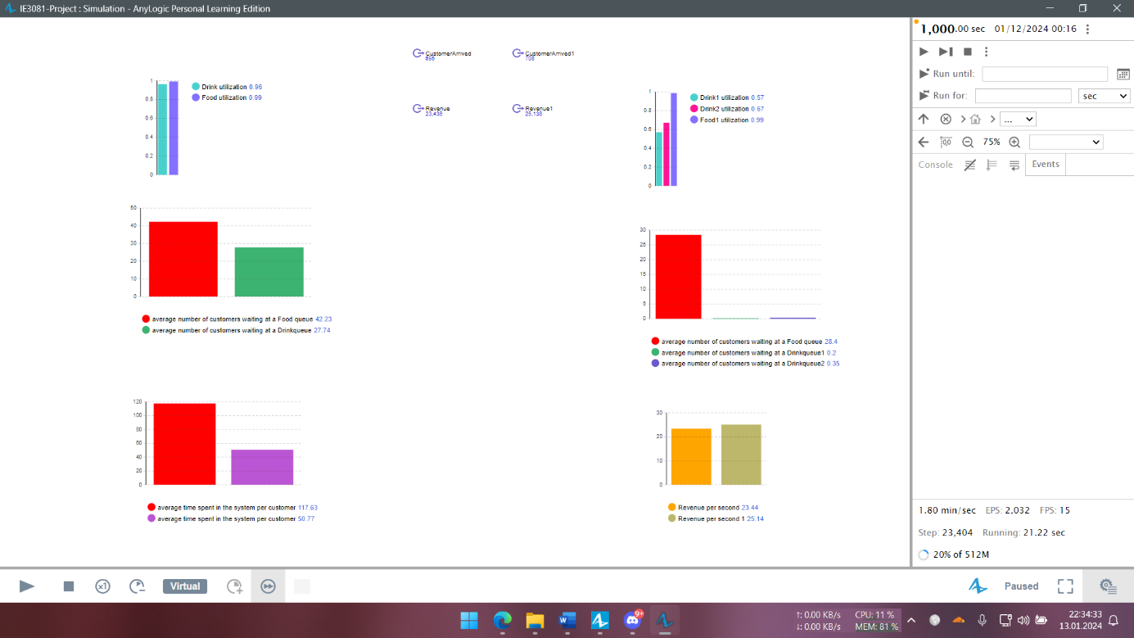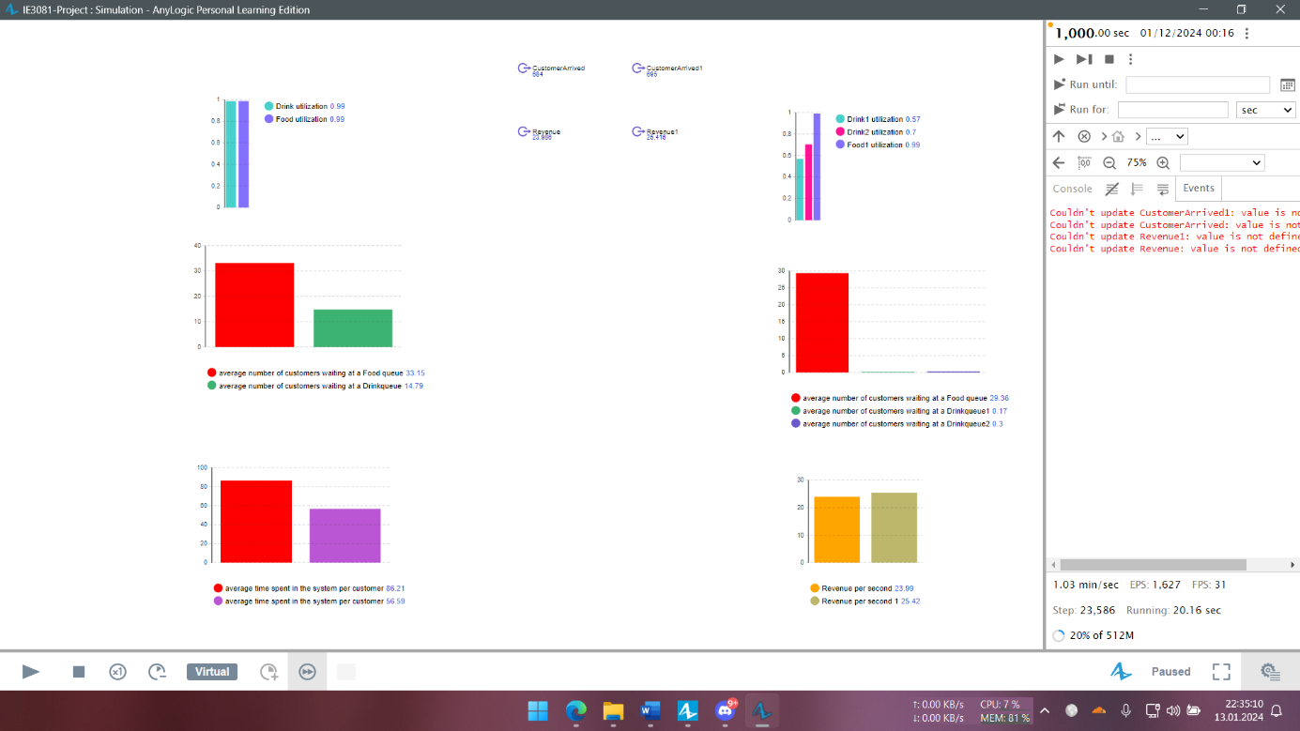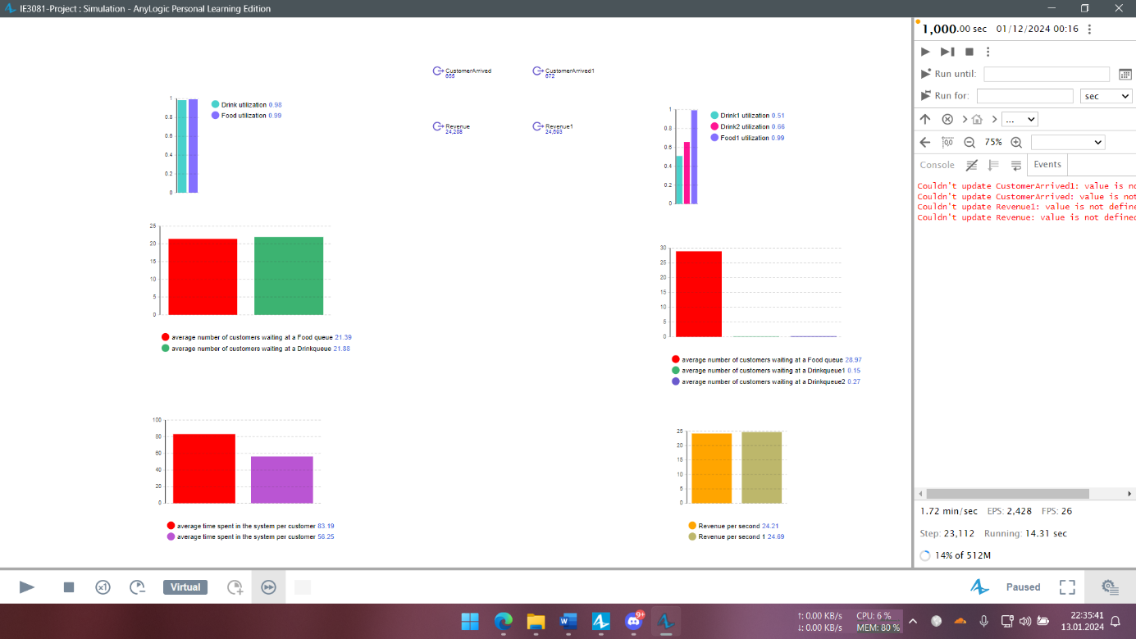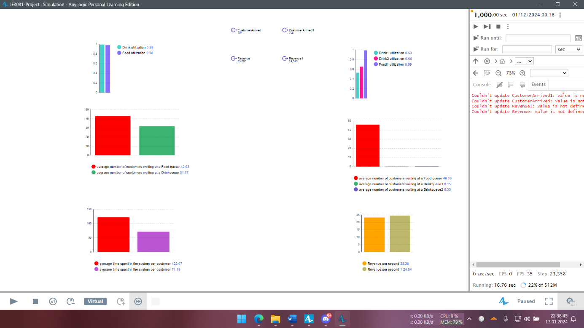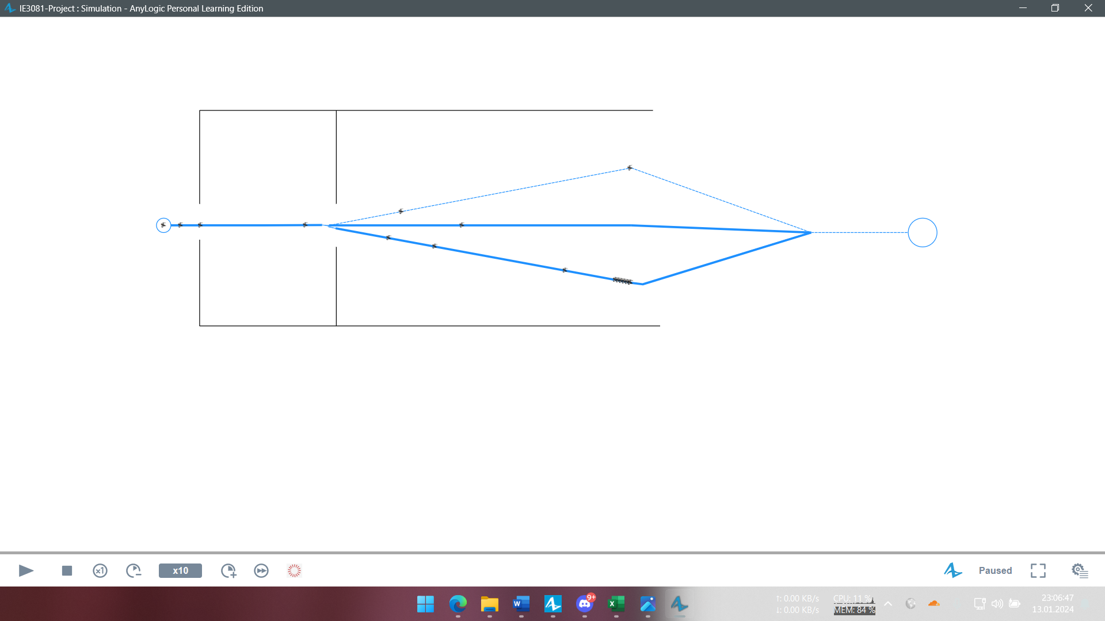

Step 4:

