MMÜ 497 - DESIGN PROJECT II
ROBOTIC GRIPPER

FINAL REPORT

Submitted by
AHMET AKÇAY
EREN ÖZDİL
GÖKHAN EYÜBOĞLU
GÖKTAN GÜNDEŞLİOĞLU

Supervisor: Prof.Dr.Volkan Parlaktaş

HACETTEPE UNIVERSITY
MECHANICAL ENGINEERING DEPARTMENT
May 2026

ABSTRACT
The following report discusses the whole design process starting from concept generation,
manipulator manufacturing and assembly, up to its functionality and operation. This project
endeavors to construct an affordable, manufacturable, and reliable robotic gripper capable of
gripping objects of various basic geometries. The finished prototype consists of PLA parts
printed using the FFF method, bolts, nuts, washers, and a hobby servo motor.
The design process consisted of defining real-life engineering constraints, examining
mechanisms used in existing robotic grippers, comparing the alternatives based on the
decision matrices, making kinematic and mechanical calculations, designing in the CAD
software, conducting stress analysis, performing fatigue analysis, and preparing technical
drawings. The construction of the robotic manipulator included manufacturing, assembling,
and testing. When assembling the prototype, some problems related to manufacturing
processes like 3D printing tolerance, hole clearance, gear interaction, selecting bolts of
correct length, tightening the nuts, and installing the servo motor were assessed.
The developed prototype was capable of moving fingers synchronously using a one-
servo-gear drive mechanism and showed acceptable performance as a light-duty gripper. As
a result of the study, it is confirmed that the developed prototype is a viable alternative to
simple, readily available, and quickly manufacturable robotic grippers, although there are
some limitations concerning PLA plasticity, mechanical play, mounting the servo motor with
the help of adhesive substances, and lack of force sensing feedback.

Table of Contents
ABSTRACT 2
LIST OF FIGURES 7
LIST OF TABLES 8
LIST OF SYMBOLS 8
1. INTRODUCTION 10
1.1. Problem Statement 11
1.2. Motivation 11
1.3. Realistic Design Constraints and Engineering Codes/Standards 13
1.3.1. Realistic Design Constraints 13
1.3.2.Engineering Codes/Standards 14
1.4. Work Packages and Work-time Schedules 15
2. LITERATURE REVIEW AND PRELIMINARY DESIGN 20
2.1 Literature Review 20
2.1.1 Robotic Grippers: Overview and Importance 20
2.1.2 Classification of Grippers 20
2.1.3 Current Technological Trends 20
2.1.4 Mechanical Design Considerations 21
2.1.5 Actuation Mechanisms 21
2.1.6 Sensing and Feedback 21
2.1.7 Engineering Standards and Compliance 21
2.1.8 Applications and Benchmarking 21
2.1.9 Summary 22
2.2. Identification of the Components Using Pugh Chart 23
2.3 Design Approach 24
2.3.1 Force and Torque Relations 24
2.3.2 Friction Limited Payload (Max weight carried) 25
2.3.3 Finger Strength and Deflection 27
2.3.4 Size of the object 28
3. DESIGN APPROACH AND PROCESS 30
3.1 Design Philosophy and Objectives 30
3.2 Alternative Concept Evaluation 31
3.3 Selection of Final Mechanism 32
3.4 Working Principle of the Gear–Linkage System 33
3.5 Iterative Refinement and Prototyping Process 33
3.6 Final Design Advantages 35
4. KINEMATIC AND MECHANICAL ANALYSIS 35
4.1 Mechanism Description, Modeling Assumptions and Structural Simulation 36
4.2 Degree of Freedom (DOF) Analysis 38
4.3 Gear Ratio and Angular Transmission 38
4.4 Linkage Kinematics and Finger Motion Behavior 39
4.5 Range of Motion and Gripping Envelope 40
4.6 Torque Transmission and Fingertip Force Estimation 40
4.7 Structural Integrity: Stress and Deflection Estimates 42
4.8 Fatigue Calculations 43
4.8.1 Fatigue Related Equations 43
4.8.2 Fatigue Calculations 46
4.9 Discussion of Practical Factors (Backlash, Tolerances, and Load Sharing) 47
4.10 Summary 47
5. MATERIAL SELECTION AND MANUFACTURING METHOD 48
5.1 Finger Links 48
5.2 Gear Mechanism 49
5.3 Servo Housing and Mounting Structure 49
5.4 Joints, Pins, and Spacers 49
5.5 Servo Motor and Fasteners 50
5.6 Manufacturing Process 50
5.7 Summary 51
6. CAD MODEL, TECHNICAL DRAWINGS, AND ASSEMBLY 52
6.1 CAD Development Overview 52
6.2 CAD File Structure and Main Parts 53
6.3 Subsystem-Level CAD Design Description 53
6.3.1 Base Plate and Structural Alignment 53
6.3.2 Gear Train and Servo Interface 54
6.3.3 Finger Links and Contact Geometry 54
6.3.4 Linkage Arms and Motion Transmission 55
6.3.5 Pins, Spacers, and Fastener Interfaces 55
6.4 Assembly Mates, Constraints, and Motion Verification 56
6.5 Interference, Clearance, and Design-for-Assembly Considerations 56
6.6 Tolerances 57
6.7 Technical Drawings and Documentation Strategy 59
6.8 Exploded View and Bill of Materials Integration 60
6.9 Assembly Procedure (Practical Steps) 61
6.10 Summary 62
7. ANALYSIS AND SIMULATIONS 62
7.1 Dynamic Analysis and System Evaluation 62
7.2 Fatigue Analysis 66
7.2.1 Fatigue Analysis Setup and Assumptions 66
7.2.2 Fatigue Analysis Methodology 66
7.2.3 Equivalent Stress Results 67
7.2.4 Fatigue Life Results 67
7.2.5 Fatigue Safety Factor at 10,000 Cycles 68
7.2.6 Effect of Load Magnitude on Fatigue Safety 69
7.2.7 Conclusion and Maintenance Decision 69
8. PROTOTYPING, TESTING, AND RESULTS 70
8.1 Prototype Manufacturing 70
8.2 Post-Processing and Dimensional Adjustment 71
8.3 Assembly Validation and Initial Functional Check 71
8.4 Assembly of the Manufactured Parts 72
8.5 Bolt and Nut Dimensions 73
8.6 Contact Between the Gears 74
8.7 Servo Motor and Servo Base Plate 76
8.8 Test Methodology 79
8.9 Grasping Performance and Object Handling Results 79
8.10 Repeatability and Reliability Observations 80
8.11 Limitations Identified During Testing 80
8.12 Summary 81
9. COST ANALYSIS AND BILL OF MATERIALS 81
9.1 Cost Categories and Estimation Method 81
9.2 Bill of Materials (BOM) 82
9.3 Additive Manufacturing Cost of Printed Parts 82
9.4 Consumables and Assembly-Related Costs 83
9.5 Discussion: Key Cost Drivers and Cost-Effectiveness 83
9.6 Summary 83
10. CONCLUSION AND FUTURE WORK 84
10.1 Conclusion 84
10.2 Assessment of Realistic Design Constraints 84
10.3 Limitations 85
10.4 Future Work 86
10.5 Final Remarks 87
REFERENCES 88
APPENDIX A – Technical Drawings 88

LIST OF FIGURES
Figure 1. Robotic gripper STP model 11
Figure 2. 3D CAD model of the gripper 24
Figure 3. Schematic of torque and normal force 25
Figure 4. Schematic of friction forces on a gripper 26
Figure 5. Finger opening angle of a generic gripper 29
Figure 6. Von Mises stress distribution of the robotic gripper 37
Figure 7. ISO tolerance grade tables for hole shaft contacts 57
Figure 8. Hole diameter illustrations of the 3D link and finger models 58
Figure 9. Hole diameter illustrations of the 3D link and base plate models 59
Figure 10. Assembly view and exploded view of the gripper 60
Figure 11. Von Mises equivalent stress analysis on fingers 67
Figure 12. Life cycle analysis on fingers 68
Figure 13. Fatigue safety factor analysis on fingers for 10,000 life cycles 68
Figure 14. Difference in fatigue safety factor depending on load change 69
Figure 15. Final manufactured gripper design 72
Figure 16. Illustration of difference between rough surfaces and finished surfaces 73
Figure 17. Side view of the gripper showing the connection elements 74
Figure 18. Teeth contact between Gear Link 1 and Gear Link 2 75
Figure 19. First location of the base gear, slightly on the left 76
Figure 20. Second location of the base gear, slightly on the right 76
Figure 21. Contact between the servo motor and the base gear 77
Figure 22. Assembly model of servo motor and servo base plate 78
Figure 23. Connections between the servo motor, servo base plate and the main body 79
Figure A.1 Technical Drawing of the Base Plate 88
Figure A.2 Technical Drawing of the Mounting Brackets 89
Figure A.3 Technical Drawing of the Finger 89
Figure A.4 Technical Drawing of the Base Gear 90
Figure A.5 Technical Drawing of the Gear Link-1 91
Figure A.6 Technical Drawing of the Gear Link-2 92
Figure A.7 Technical Drawing of the Link 92
Figure A.8 Technical Drawing of the Servo Base Plate 93

LIST OF TABLES
Table 1. Work Package for Robotic Gripper Project 16
Table 2. Pugh Chart for Solutions 23
Table 3. Pugh Chart for Materials 24
Table 4. Material Selection and Manufacturing Method for Each Subsystem 48
Table 5. Bill of Materials 82

LIST OF SYMBOLS
$τ_{finger}$ : Output torque at the finger pivot point (N·m)
$τ_{s}$ : Servo torque at its shaft (N·m)
G : Transmission ratio (–)
η : Mechanical efficiency (–)
F : Normal force at the fingertip (N)
d : Distance between finger pivot point and contact line / lever arm (m)
$F_{friction}$ : Total friction force (N)
$μ_{s}$ : Static coefficient of friction (–)
$m_{o}$: Mass of the object (kg)
$m_{o,max}$ : Maximum mass of the object that can be carried (kg)
g : Gravitational acceleration (9.81 m/s²)
a : Acceleration along slip direction (m/s²)
M : Bending moment (N·m)
σ : Bending stress (Pa)
$σ_{allowable}$: Allowable stress for the material (Pa)
c : Distance between neutral axis and outer fiber (m)
I : Second moment of area / moment of inertia (m⁴)
δ : Fingertip deflection (m)
r : Lever arm for deflection (m)
E : Young’s modulus of material (Pa)
w(θ) : Instant distance between inner fingers (m)
$w_{min}$ : Minimum gap between the fingers (m)
L : Finger length (m)
θ : Finger rotation angle (rad)
$θ_{max}$ : Maximum finger rotation angle (rad)
$w_{max}$ : Maximum distance between the fingers (m)
$t_{pad}$ : Pad thickness (m)
$w_{o}$: Maximum object width that fits between pads (m)
$D_{cyl}$ : Diameter of grasped cylindrical object (m)
$B_{rectangle}$ : Width of rectangular object along pinch direction (m)

1. INTRODUCTION
Robotic grippers are vital components of robotic systems capable of handling, holding, moving, and interacting with objects in a mechanical fashion. In parallel to growing trends in automation, Industry 4.0, and collaborative robotics, there is an increased need for low-weight, low-cost, high-reliability robotic grippers capable of being manufactured rapidly. Servo-driven mechanical grippers constructed using additive manufacturing techniques, with gear mechanisms and linkages, are promising candidates that satisfy these needs well.
This design project entails the development of a robotic gripper equipped with gear linkages that ensure the synchronous operation of the gripper fingers. The gripper comprises two symmetrically located finger links, which perform simultaneous opening and closing motions thanks to spur gears and parallel linkages. This type of gripper allows achieving a simple design that requires minimum effort to build and maintain, as well as inexpensive manufacture.
The reasons to choose this particular type of robotic gripper design are related to its mechanical nature, as well as to the fact that such designs have good mechanical properties and their functioning is easier to comprehend, model, and enhance. In comparison with multi-actuator designs, this design involves using one servo as the driving element, with a motion transmitting through gear linkage to the fingers, which allows reducing weight, minimizing costs, and simplifying the control logic.
The main objective of this design project is the application of knowledge about engineering fundamental mechanisms and design methods to produce a useful design. Besides, it will serve as an example of the engineering design cycle process.
This paper presents the process of designing the presented robotic gripper, including its motivation, realistic design constraints, engineering standards, state-of-the-art review, design approaches, kinematic modeling, CAD development, material choice, manufacturing process, and performance estimation.

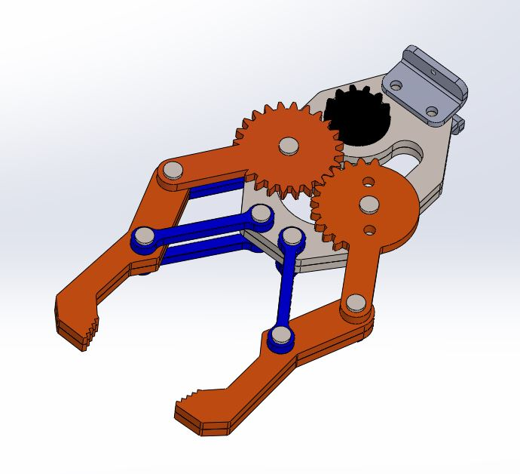
Figure 1. Robotic gripper STP model

1.1. Problem Statement
Modern robotic applications increasingly require end-effectors that are lightweight, scalable, cost-effective, and easy to prototype. Many commercial grippers rely on multiple actuators or complex multi-joint mechanisms, which significantly increase cost and manufacturing difficulty.
The goal of this project is to design and fabricate a simple yet functional robotic gripper that meets the following objectives:
- Operates with a single actuator while producing symmetric finger motion
- Provides sufficient gripping force for lightweight objects
- Uses additive manufacturing techniques for rapid production
- Minimizes backlash and friction for smooth, repeatable motion
- Maintains structural integrity through appropriate material selection
- Offers an accessible and low-cost solution for robotics laboratories and student projects
The primary challenge is achieving stable and synchronized motion of the two fingers through a compact gear-linkage mechanism, while ensuring manufacturability and mechanical robustness.

1.2. Motivation
The motivation behind this project is driven by several factors:
Educational Value
The gripper is intentionally designed to be fully transparent from a mechanical standpoint, allowing engineering students to observe:
- Gear interaction
- Linkage kinematics
- Servo-driven actuation
- Stress distribution
- Material behavior in 3D-printed parts
This makes the device an ideal demonstration tool for robotics, mechanisms, and manufacturing courses.
Cost and Manufacturability
A major motivation is designing a robotic gripper that can be reproduced by anyone with access to a low-cost 3D printer and standard components such as hobby servos and steel pins. This supports:
- Rapid prototyping
- Affordable replacement parts
- Open-source sharing of designs
Lightweight Applications
Many educational robots, desktop robotic arms, and manipulators require lightweight end-effectors. This project focuses on a gripper optimized for:
- Low-load tasks
- Fast actuation
- Minimal inertia
Research Potential
The modularity of the design allows further academic research on:
- Force optimization
- Compliance control
- Grip stability
- Soft fingertip integration
- Sensor feedback

1.3. Realistic Design Constraints and Engineering Codes/Standards
All engineering design projects are subjected to several constraints, due to the fact that projects are to be implemented in real life. The robotic gripper in development should be optimized to achieve the most desirable specifications and features under the identified design constraints, while complying with the relevant codes and standards.

1.3.1. Realistic Design Constraints
Mechanical Constraints
The gripper must operate reliably under repeated loading conditions. Mechanical constraints include:
- Sufficient grip force to hold small laboratory objects
- Symmetric finger motion achieved through the gear–linkage mechanism
- Material stiffness high enough to prevent excessive deflection
- Minimal backlash in joints and gear train
- Structural integrity maintained during repeated open-close cycles
Geometric Constraints
The gripper dimensions must remain compact to be compatible with small robotic arms or tabletop manipulators:
- Finger length and linkage proportions must allow a usable gripping range
- Base plate geometry must accommodate the servo motor and gear assembly
- Joints must maintain alignment throughout the operating cycle
Manufacturing Constraints
Additive manufacturing (Fused Filament Fabrication, FFF) was selected as the primary process. Constraints include:
- Layer orientation affecting strength
- Tolerances and hole accuracy requiring small post-processing
- Maximum part size determined by printer build volume
- Material availability (PLA filament for FFF printing)
Economic Constraints
A low total cost is critical for accessibility and reproducibility:
- Use of hobby-grade servo motor instead of industrial actuators
- Selection of 3D printing polymers instead of machined metals
- Avoiding specialized or hard-to-source components
Safety and Reliability Constraints
- Moving parts must operate without risk of detachment
- Adequate clearance must be kept around gears and linkages
- Joints must not fail under normal loading cycles
- Materials must be durable and fatigue-resistant for repeated operation
Sustainability Constraints
- PLA is recyclable, satisfying environmental considerations
- Additive manufacturing minimizes waste material
- Low energy consumption due to single servo motor

1.3.2.Engineering Codes/Standards
Safety
ISO 31101:2023 determines safety guidelines and proper safety management systems for
service robots. Even though the robotic gripper is not a “hazardous” project, the safety and
the integrity of the operator and the system is crucial to project success and general health.
Material
ISO/ASTM 52901:2016: provides general principles and guidelines for the qualification of additive manufacturing processes and parts. This is especially relevant to the robotic gripper project, as most components will be fabricated using 3D-printed polymers.
Mechanics
ISO 9409-1:2004 defines dimensioning and markings for plates in industrial robots.
ISO 9409-2:2002 is used for dimensioning and marking cylindrical shafts in robots, which is
also useful for the robotic gripper project, even though this project is fairly simple.

Testing
ISO 18646-3:2021 explains several performance criteria for service robots, specifically
manipulators. This standard also refers to methods of manipulative movements such as
grasping, opening, moving, etc.
ISO 17296-3:2014 introduces basic concepts and methods for the testing for additive
manufactured parts.
Terminology and Basic Principles
ISO 8373:2021 defines some fundamental terminology used in robotics.
Material Selection and Manufacturing
ISO/ASTM 52901:2016 establishes a guide for additive manufacturing methods.

1.4. Work Packages and Work-time Schedules
In order to work more efficiently in our project, the work department and the weekly work calendar were created before which is given below.
Table 1. Work Package for Robotic Gripper Project
Tasks | Ahmet Akçay | Eren Özdil | Göktan Gündeşlioğlu | Gökhan
Identifying requirements
Weekly general evaluation of what has been done
Report I
Writing the introduction
Description of project
Starting our motivation for the project
Determination of realistic design constrains
Determination of tasks and distribution to group members
Creating time schedule
Report I - Submission
Report II
Literature review
Discussing different solution possibilities, considering technical and realistic design limitations
Determination and presentation of our design approach and process
Determination of design side and selection of tools to be used
Report II - Submission
Report III
Describing all the components required to produce the
project idea and explaining why they are preferred over
other options
Calculations
Indicate and list why the selected mechanism elements, materials and sensors are preferred over other options.
3D Drawings
Part list and cost analysis table
Reporting assembly techniques and other information required for project production
Manufacturing procedure for each subsystem
Summary of the results
Discussion about the results
Discussion of future works
Report III-Submission

Task / Date | July |  |  |  | Agust |  |  |  | September |  |  |  |  | October
 | Week 1 | Week 2 | Week 3 | Week 4 | Week 5 | Week 6 | Week 7 | Week 8 | Week 9 | Week 10 | Week 11 | Week 12 | Week 13 |  | Week 14
Weekly general evaluation of what has been done
Report I
Writing the introduction
Description of project
Starting our motivation for the project
Determination of realistic design constrains
Determination of tasks and distribution to group members
Creating time schedule
Report I - Submission
Report II
Literature review
Discussing different solution possibilities, considering technical and realistic design limitations
Determination and presentation of our design approach and process
Determination of design side and selection of tools to be used
Report II - Submission
Report III
Describing all the components required to produce the
project idea and explaining why they are preferred over
other options
Calculations
Indicate and list why the selected mechanism elements, materials and sensors are preferred over other options.
3D Drawings
Part list and cost analysis table
Reporting assembly techniques and other information required for project production
Manufacturing procedure for each subsystem
Summary of the results
Discussion about the results
Discussion of future works
Report III-Submission

2. LITERATURE REVIEW AND PRELIMINARY DESIGN
The robotic gripper project requires a design scheme that should be simple and cheap, effective enough for laboratory work, and fulfilling relevant engineering standards. In this section, an in-depth literature review is carried out followed by an evaluation of actuation systems, gripping mechanisms, and material selections, considering basic engineering principles.

2.1 Literature Review

2.1.1 Robotic Grippers: Overview and Importance
Robotic grippers serve as the robot's hand and the interface between the manipulator and the objects being manipulated. They are utilized in pick-and-place tasks, assembly operations, material handling, and precision manipulation in medical and service robotics. As discussed by Siciliano et al. [10], the end-effector is a key factor in determining how effectively a robot can interact with real-world objects.

2.1.2 Classification of Grippers
Grippers can be broadly classified based on their mechanism of action:
Mechanical (Friction) Grippers
Vacuum (Suction) Grippers
Magnetic Grippers
Flexible/Soft Grippers
Anthropomorphic Grippers

Our project focuses on mechanical grippers, particularly the parallel-jaw configuration.

2.1.3 Current Technological Trends
Adaptability, little to no slippage, appropriate force distribution, and modularity are often expected from modern robotic grippers. Additive manufacturing is a popular way of fabrication for these robotic grippers, allowing for rapid prototyping and keeping the manufacturing costs low.

2.1.4 Mechanical Design Considerations
An effective robotic gripper must have gripping force, repeatability, weight, payload capacity, and durability.

2.1.5 Actuation Mechanisms
Common actuation mechanisms include:
- Electric Servo Motors
- Pneumatic Systems
- Shape Memory Alloys
Servo motors are chosen due to control precision and integration ease.

2.1.6 Sensing and Feedback
Future iterations may include tactile sensors, force-sensitive resistors, or infrared proximity sensors.

2.1.7 Engineering Standards and Compliance
Standard Code | Title / Scope
ISO 31101:2023 | Robotics — Functional safety requirements for service robots
ISO 9409-1 | Robots — Mechanical interfaces — Part 1: General requirements
ISO 9409-2 | Robots — Mechanical interfaces — Part 2: Location pins and mounting details
ISO/ASTM 52901:2016 | Additive manufacturing — General principles for quality assurance
ISO 18646-3:2021 | Robots — Performance criteria and related test methods — Part 3
ISO 8373:2021 | Robots and robotic devices — Vocabulary

2.1.8 Applications and Benchmarking
Robotic grippers are used in manufacturing, healthcare, agriculture, and assistive robotics. Our design benchmarks commercial systems like Robotiq. Robotiq’s robotic grippers are widely used in industrial automation because they’re versatile, faring well in tough applications and easy to integrate. The mechanical systems of the 2F and 3F gripper are very simple and therefore they can handle various object sizes and shapes. Production facilities can use these grippers for they provide reliable and repetitive results. The expansion of robotic applications in medical, agriculture and assisting technologies requires advanced gripper systems and their flexibility and intelligent actuation.

2.1.9 Summary
The literature supports the use of a parallel-jaw mechanical gripper actuated by a servo motor, fabricated by additive manufacturing, and developed in compliance with relevant ISO standards. Based on these findings and the project's cost and manufacturability priorities, PLA was selected as the primary printed material for the prototype.

2.2. Identification of the Components Using Pugh Chart
As the project progressed, alternative solutions were evaluated, and a Pugh chart was prepared to illustrate the advantages and disadvantages of other solutions.
During the solution selection process, the chart was created by scoring the criteria in order of importance, with the most important factors being 5 and decreasingly 1. This resulted in critical issues like security receiving higher scores than others.
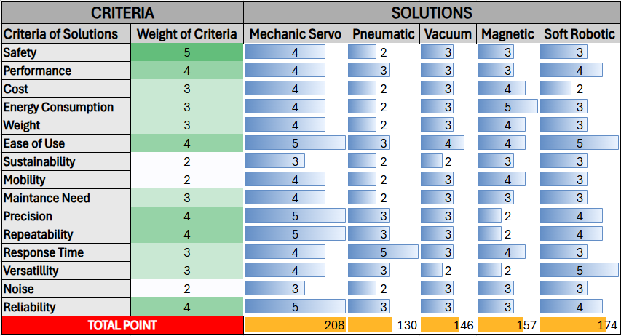
Table 2. Pugh Chart for Solutions

As can be seen from the chart, our project is in an advantageous position for us compared to others.
A Pugh chart was created to assess the constraints and requirements we would encounter during project production. The chart compares production materials.
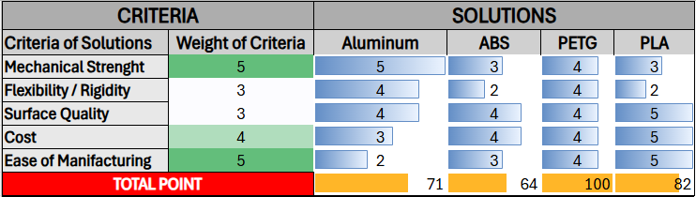
Table 3. Pugh Chart for Materials
It was decided to use PLA, which made sense given the production requirements and ease of use while keeping the price/performance value at an optimum level.

2.3 Design Approach
The gripper we designed is a symmetric mechanism that consists of two fingers. Single servo motor actuates and drives both fingers through a transmission, making the operation of holding an object possible. Its degree of freedom is one and for this reason, we won’t be dealing with degree of freedom calculations. In our design calculations we will be looking at the relation between force and the mass of the object, maximum stress the finger can endure without deflection and the dimension constraints of the object.

Figure 2. 3D CAD model of the gripper

2.3.1 Force and Torque Relations
Torque applied at the finger of the gripper is dependant on the torque generated by the servo motor:
$$τ_{finger}=τ_{s} G η (1)$$

$$τ_{finger}:Output torque at the finger pivot point \left(N.m\right)$$
$$τ_{s}:Servo torque at its shaft \left(N.m\right)$$
$$G:Transmission ratio (unitless)$$
$$η:Mechanical efficiency (unitless)$$
Force applied on the fingers are dependant on torque output at the finger pivot point:
$$τ_{finger}=F d (2)$$

$$τ_{finger}:Output torque at the finger pivot point (N.m)$$
$$F:Normal force at the fingertip (N)$$
$$d:Distance between finger pivot point and contact line (m)$$

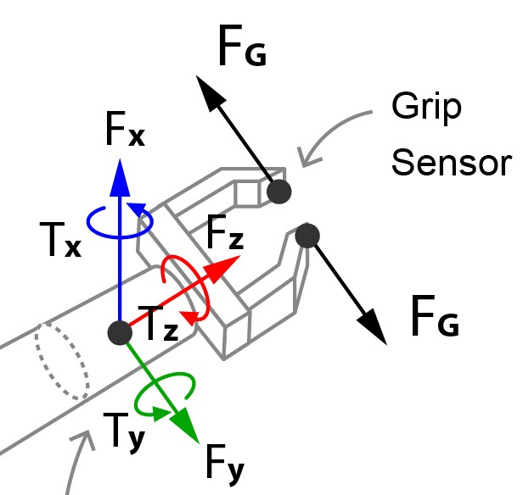
Figure 3. Schematic of torque and normal force

When we combine equations 1 and 2, we get the equation for the force applied from the finger pivot point of the gripper:
$$F=\frac{τ_{s} G η}{d} (3)$$

2.3.2 Friction Limited Payload (Max weight carried)
With two contact surfaces, the total available friction force against the slip is:
$$F_{friction}=2 μ_{s} F (4)$$

$$F_{friction}:Total friction (N)$$
$$μ_{s}:Static coefficient of friction between the gripper and the object (unitless)$$
$$F:Normal force per finger surface \left(N\right)$$

Figure 4. Schematic of friction forces on a gripper

For gripper to securely hold an object, no-slip conditions should be met to prevent the object from falling during the operation:
$$2 μ_{s} F ≥m_{o}\left(g+a\right) (5)$$

$$m_{o}:Mass of the object (kg)$$
$$g:Gravitational acceleration \left(\frac{m}{s^{2}}\right)$$
$$a:Acceleration along the slip direction due to motion or disturbance \left(\frac{m}{s^{2}}\right)$$

Combining the equations 3 and 5 gives us the final equation that calculates the maximum mass of the object that can be carried with no-slip condition:
$$2 μ_{s} F=m_{o,max} \left(g+a\right) (6)$$
$$m_{o,max}=\frac{2μ_{s}}{g+a}\frac{τ_{s} G η}{d} (7)$$
$$m_{o,max}:Maximum mass of the object that can be carried (kg)$$
$$μ_{s}:Static coefficient of friction between the gripper and the object (unitless)$$
$$g:Gravitational acceleration \left(\frac{m}{s^{2}}\right)$$
$$a:Acceleration along the slip direction due to motion or disturbance \left(\frac{m}{s^{2}}\right)$$
$$τ_{s}:Servo torque at its shaft \left(N.m\right)$$
$$G:Transmission ratio (unitless)$$
$$η:Mechanical efficiency (unitless)$$
$$d:Distance between finger pivot point and contact line (m)$$

2.3.3 Finger Strength and Deflection
The normal force at the fingertip creates a bending about the finger cross section. Bending moment at the critical section:
$$M=F d (8)$$

$$M:Bending moment \left(N.m\right)$$
$$F:Normal force per finger (N)$$
$$d:Lever arm$$

Maximum allowable bending stress can be calculated:
$$σ=\frac{M c}{I} ≤σ_{allowable} (9)$$

$$σ:Bending stress at the outer fiber \left(\frac{N}{m^{2}}\right)$$
$$M:Bending moment (N.m)$$
$$c:Distance between neutral axis and outer fiber (m)$$
$$I:Second moment area of the finger cross section (m^{4})$$
$$σ_{allowable}:Allowable stress for the finger material\left(\frac{N}{m^{2}}\right)$$
For gripper to work without deformation, bending stress should be less than maximum allowable stress. This depends on the material of the finger. Generated bending stress depends on force applied, as well as the geometry of the gripper.
Deflection occurring on the fingertip:
$$δ=\frac{F r^{3}}{3 E I} (10)$$

$$δ:Fingertip deflection under load (m)$$
$$F:Normal force (N)$$
$$r:Lever arm (m)$$
$$E:Young^{'}s modulus (GPa)$$
$$I:Second moment of area \left(m^{4}\right)$$
Equations 9 and 10 should be used in determining the amount of deflection occurring during the process.

2.3.4 Size of the object
Dimensions of the object determines if it can be operated by our gripper design mainly due to maximum distance between fingers.
$$w\left(θ\right)=w_{min}+2 L sin\left(θ\right) (11)$$

$$w\left(θ\right):Instant distance between inner fingers (m)$$
$$w_{min}:Minimum gap between the fingers (m)$$
$$L:Finger length (m)$$
$$θ:Finger rotation angle from the closed position (radians)$$
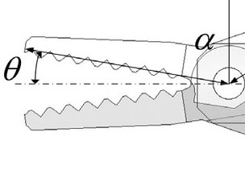
Figure 5. Finger opening angle of a generic gripper
Minimum gap between the fingers is constant. Only variable affecting the distance between fingers is the rotation angle. Rotation angle is only located inside of a sin function. Value of the sin function is inside the range of $-1≤sin⁡(θ)≤1$ . Theoretically if we take sin(θ) = 1, we get the maximum gap between the fingers. But the fingers don’t open at a 90° angle in our design. When we take that into consideration:
$$w_{max}=w_{min}+2 L sin\left(θ_{max} \right) (12)$$

$$w_{max}:Maximum distance between the fingers (m)$$
$$w_{min}:Minimum gap between the fingers (m)$$
$$L:Finger length (m)$$
$$θ_{max}:Maximum rotation angle of the fingers (radians)$$

Maximum gap between fingers is not the maximum distance that object can fit. We should take pad thickness into consideration:
$$w_{o}=w_{max}-2 t_{pad} (13)$$

$$w_{o}:Maximum object width that fits between pads (m)$$
$$w_{max}:Maximum distance between the fingers (m)$$
$$t_{pad}:Pad thickness \left(m\right)$$

If we show size limitations for rectangular and cylindrical objects separately:
$$D_{cyl}≤w_{o} and B_{rectangle}≤w_{o} (14)$$

$$D_{cyl}:Grasped cylinder diameter (m)$$
$$B_{rectangle}:Rectangular objects width along the pinch direction (m)$$
$$w_{o}:Maximum object width (m)$$

3. DESIGN APPROACH AND PROCESS
The development of the robotic gripper followed a structured engineering design process, beginning with the identification of functional requirements and progressing through concept generation, mechanism selection, analytical evaluations, and iterative refinement. This chapter outlines the design philosophy and explains how the final gear–linkage hybrid mechanism was conceived.

3.1 Design Philosophy and Objectives
The primary goal of the project was to design a lightweight, low-cost, single-actuator robotic gripper that provides synchronized motion of two fingers through a mechanically efficient transmission system. To achieve this, the following design objectives guided the process:
- Simplicity: Minimize actuator count and reduce electronic complexity
- Mechanical transparency: Prefer deterministic mechanical linkages over elastic or tendon systems
- Modularity: Ensure every component can be manufactured separately and replaced easily
- Low cost: Rely on additive manufacturing using PLA instead of metal machining
- Compactness: Fit the mechanism onto a small robotic arm or test fixture
- Repeatability: Guarantee similar grasping performance across repeated cycles
These objectives formed the baseline for concept development and constrained all subsequent decisions.

3.2 Alternative Concept Evaluation
During the ideation stage, several gripper mechanisms were considered:
Concept 1 — Parallel Jaw Gripper (Rack & Pinion)
Pros:
- Highly precise
- Strong linear gripping force
Cons:
- Requires linear guides
- Larger footprint
- More components
Concept 2 — Tendon-Driven Underactuated Gripper
Pros:
- Very lightweight
- Adaptive to object shapes
Cons:
- Low positional accuracy
- Tendons stretch over time
- Not ideal for rigid motion requirement
Concept 3 — Scissor Mechanism Gripper
Pros:
- Simple geometry
- Large opening span
Cons:
- Non-uniform force distribution
- Requires careful alignment
Concept 4 — Gear–Linkage Hybrid Gripper (Chosen Design)
Pros:
- Single servo controls two fingers symmetrically
- High repeatability
- Mechanically efficient motion transmission
- Very compact design
- Easy to prototype via 3D printing
Cons:
- Requires precise gear alignment
- Backlash must be minimized
A Pugh Chart comparison showed that Concept 4 scored highest, meeting almost all constraints in manufacturability, user safety, cost, and performance.

3.3 Selection of Final Mechanism
The chosen mechanism consists of:
- A central servo motor with a small driving gear
- Two larger spur gears on each side meshing symmetrically
- Link arms attached to each gear, converting rotation into angular finger motion
- Finger links connected through pivot joints
- A mounting plate that holds all components rigidly
This arrangement enables:
- Perfectly mirrored finger movement
- High transmission efficiency
- Smooth torque flow from servo to fingers
- Compact arrangement
- Underactuated 1-DOF behavior
The mechanism ensures that the gripper remains structurally simple while delivering reliable performance.

3.4 Working Principle of the Gear–Linkage System
The servo rotates the small pinion gear.
That gear meshes with two identical larger gears.
As the servo rotates clockwise or counterclockwise:
- The two large gears rotate in opposite directions
- Their link arms push or pull the finger links
- Finger links rotate around their base pivots
- The two fingers open or close simultaneously
This allows synchronized grasping motion without requiring two actuators or complex control algorithms.
Advantages of this mechanism include:
- Symmetry: Fingers always move identically
- Precision: Gear teeth eliminate slip or stretch
- Predictable kinematics: Finger motion can be modeled analytically
- Servo efficiency: Mechanical advantage comes from gear ratio
- Scalability: The mechanism can be resized easily

3.5 Iterative Refinement and Prototyping Process
After selecting the mechanism, the following iterative steps were performed:
Step 1 — Initial CAD Modeling
- Finger geometry defined
- Gear dimensions chosen (module, teeth count)
- Mounting plate and servo slot designed
Step 2 — Motion Simulation
Using CAD motion analysis:
- Check for interference between parts
- Validate finger range of motion
- Confirm smooth rotation of gears
Step 3 — Structural Adjustments
Issues discovered included:
- Link thickness insufficient → increased
- Gear clearance too tight → tooth profile updated
- Finger pivot friction → tolerances adjusted
Step 4 — Prototype Fabrication
Using PLA:
- Gears printed with high infill
- Fingers printed with thicker walls
- Pins prepared from steel rods
Step 5 — Assembly & Testing
The prototype was assembled and tested for:
- Smoothness of motion
- Grip force
- Repeatability
- Servo load under different object weights
All results informed iterative improvements until the final stable configuration was achieved.

3.6 Final Design Advantages
The final mechanism provides several key advantages:
- Single-actuator simplicity
- High reliability due to rigid mechanical coupling
- Ease of repair and replacement
- Excellent performance-to-cost ratio
- Suitable for educational and research environments
This completes the design approach and sets the stage for the kinematic and mechanical analysis detailed in the next chapter.

4. KINEMATIC AND MECHANICAL ANALYSIS
This chapter presents the kinematic and mechanical analysis of the proposed robotic gripper. The mechanism is a planar, single-actuator architecture in which a servo-driven pinion gear synchronizes two follower gears, and each follower gear drives a finger through a linkage connection. The objective of this chapter is to confirm the degree of freedom (DOF) of the system, derive the angular transmission through the gear train, characterize the finger range of motion, and establish a transparent analytical relationship between servo torque and fingertip gripping force. Since the final actuator and gear set were selected during the prototyping stage, the numerical evaluations in this chapter are based on conservative preliminary design assumptions that can be updated without altering the analysis structure.

4.1 Mechanism Description, Modeling Assumptions and Structural Simulation
The robotic gripper starts with a stiff base - this anchors everything else. A servo spins a small gear up front, setting things in motion. That movement rolls through to twin gears on either side, mirror copies turning in opposite directions. Each gear connects to a slender arm, one per side, forming what becomes the fingers. Linkages bridge from gear to fingertip, translating spin into curling action around pivot points. Motion stays flat across a single plane, never twisting out of alignment. Because both sides move in sync, just half needs full attention when mapping it out.
In analyzing and simulating structures, each part and connection behaves like a solid unit - no flexing allowed. Instead of wrestling with complex frictions, hinges here spin perfectly free on their axes, at least when keeping things simple. Teeth between gears lock together by rule, syncing rotation exactly as needed, one turning this way, the other that. Think of it as choreography without slack or slip. Engineers often start with these stripped-down rules to track how movement flows and forces shift through moving systems.
A 1 kg wooden block had to be lifted, so realistic load scenarios took shape around that goal. Friction-based grip set the stage for how forces would play out. To pin down the needed grip strength, this equation came into use instead
Fgrip equals mass times gravity times safety margin divided by friction grip. Mass stands for the item's weight. Gravity pulls it downward constantly. Safety buffer covers unexpected hiccups like rough patches on surfaces. Friction value set at 0.4 fits wood contact zones. Real-world imperfections influenced that number. Manufacturing quirks matter when things don't align perfectly. Grip strength adjusts because nothing works flawlessly every time.
A pair of 25 N lateral pulls acted on every fingertip, directed across the x-plane, building up to a combined clasp strength of 50 N. Meanwhile, each finger faced a 10 N push upward along the y-direction, summing to 20 N overall - capturing minor stresses that pop up when shifting objects around.
The simulation used finite element methods to test how the gripper handles stress during operation. Where forces move through gears and joints, peak stress shows up - around 30 MPa by the readings. This concentration appears because those zones carry most of the load transfer. Elsewhere, stress stays minimal across the frame. Material limits aren't approached, since yield strength sits higher than the highest recorded value. So, under these specific loads, the structure holds without risk of deformation or failure.

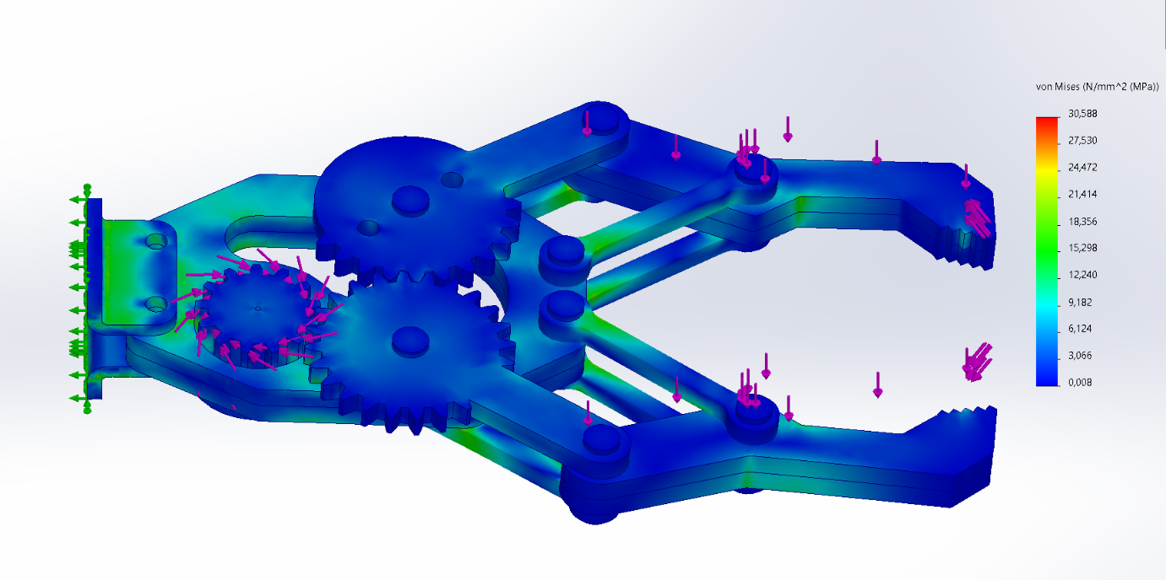
Figure 6. Von Mises stress distribution of the robotic gripper
Von Mises stress distribution of the robotic gripper obtained from finite element analysis under operational loading conditions. Horizontal forces of 25 N were applied to each finger along the x-axis (total 50 N), while vertical forces of 10 N were applied to each finger along the y-axis (total 20 N), corresponding to lifting a 1 kg wooden block with a friction coefficient of μ = 0.4.

4.2 Degree of Freedom (DOF) Analysis
A primary design goal is synchronized two-finger motion with a single actuator. The mobility of the planar mechanism is evaluated using the Gruebler–Kutzbach criterion:
$$M=3(N-1)-2J_{1}-J_{2}$$
where $M$is mobility, $N$is number of links (including ground), $J_{1}$is number of lower pairs (revolute joints), and $J_{2}$is number of higher pairs (gear contacts). The mechanism can be represented using the following link/joint count:
- Number of links (including ground): $N=10$
(ground, servo pinion, two follower gears, two finger links, and four linkage/connector links)
- Lower pairs (revolute joints): $J_{1}=12$
(finger pivots, linkage joints, gear axle joints, servo pinion joint)
- Higher pairs (gear meshes): $J_{2}=2$
(pinion–left follower and pinion–right follower meshes)
Substituting:
$$M=3(10-1)-2(12)-2=27-24-2=1$$
Therefore, the gripper is a 1-DOF system, meaning the complete motion is fully determined by the servo input angle $θ_{s}$. This mechanically enforced synchronization improves repeatability and reduces control complexity.

4.3 Gear Ratio and Angular Transmission
The servo drives a pinion gear with tooth count $N_{s}$, which meshes with each follower gear of tooth count $N_{f}$. The angular displacement relationship is:
$$θ_{f}=-\frac{N_{s}}{N_{f}}θ_{s}$$
and the angular velocity relationship is:
$$ω_{f}=-\frac{N_{s}}{N_{f}}ω_{s}$$
For preliminary evaluation, the following conservative gear set is assumed:
- Pinion teeth: $N_{s}=12$
- Follower gear teeth: $N_{f}=36$
Thus, the transmission ratio is $N_{s}/N_{f}=1/3$, and:
$$θ_{f}=-\frac{1}{3}θ_{s}$$
This ratio intentionally increases torque available at the follower gears while reducing their speed, which is beneficial for grasping tasks.

4.4 Linkage Kinematics and Finger Motion Behavior
Each follower gear transmits motion to a finger through a linkage. Because of linkage geometry, the finger angle $θ_{finger}$is a nonlinear function of follower gear angle $θ_{f}$. For engineering analysis, it is sufficient to express this mapping as:
$$θ_{finger}=f(θ_{f})$$
and since $θ_{f}$depends on $θ_{s}$:
$$θ_{finger}=f\text{ ⁣}\left( − \frac{N_{s}}{N_{f}}θ_{s}\right)$$
To fully specify the behavior numerically for this report, a typical linkage amplification is assumed based on common crank–rocker style gripper geometries. In the operating region, the finger rotation is approximated as:
$$θ_{finger}≈5 ∣θ_{f}∣$$
This yields a practical range where modest follower rotation produces a significantly larger finger opening, consistent with compact gripper designs.

4.5 Range of Motion and Gripping Envelope
A realistic servo rotation range is assumed as:
- Servo stroke: $θ_{s}=±{30}^{∘}$(total 60° stroke)
Using the gear ratio, the follower gear rotation becomes:
$$θ_{f}=-\frac{1}{3}θ_{s}⇒θ_{f}=±{10}^{∘}$$
With the linkage amplification assumption:
$$θ_{finger}≈5∣θ_{f}∣⇒θ_{finger}≈{50}^{∘}$$
Therefore, the finger motion range is defined as:
- Near-closed finger angle: $θ_{min}≈5^{∘}$
- Fully open finger angle: $θ_{max}≈{55}^{∘}$
To estimate jaw opening, the finger length (pivot-to-tip) is assumed:
- Finger effective length: $L=60\text{ mm}$
The maximum tip-to-tip opening can be approximated geometrically as:
$$W_{max}≈2Lsin⁡(θ_{max}) \\ W_{max}≈2(60)sin⁡({55}^{∘})=120(0.819)≈98.3\text{ mm}$$
For the near-closed configuration, a realistic residual gap is taken as:
- Minimum gap: $W_{min}≈3\text{ mm}$
Thus, the gripper envelope is approximately:
- Jaw opening range: $W≈3\text{ mm}→98\text{ mm}$

4.6 Torque Transmission and Fingertip Force Estimation
The gripping capability is determined by how servo torque is transmitted through gears and linkages to the fingertips. The torque at each follower gear is approximately:
$$T_{f}≈\frac{N_{f}}{N_{s}}T_{s}$$
A common, conservative servo capability for a prototype gripper is assumed as:
- Servo stall torque (6 V class): $T_{s}=1.0\text{ N\backslash cdotpm}$
Then:
$$T_{f}≈\frac{36}{12}(1.0)=3.0\text{ N\backslash cdotpm}$$
The torque at the finger pivot translates into fingertip force through an effective lever arm. The effective pivot-to-tip moment arm is assumed:
- $l_{eff}=75\text{ mm}=0.075\text{ m}$
Linkage geometry provides a mechanical advantage that increases near closure. A conservative near-closure mechanical advantage factor is assumed:
- $η=1.2$(dimensionless)
Then the estimated normal force per finger at the tip is:
$$F_{tip}≈η\frac{T_{f}}{l_{eff}}=1.2⋅\frac{3.0}{0.075}=1.2⋅40=48\text{ N}$$
Since two fingers apply force symmetrically, the approximate pinch force (sum of opposing normal forces) is:
$$F_{pinch}≈2F_{tip}≈96\text{ N}$$
This value represents an upper-bound estimate under ideal transmission (losses neglected). To remain conservative and realistic for a printed prototype, a transmission efficiency factor can be applied to account for friction and compliance. Taking an efficiency of $η=0.7$:
$$F_{pinch,realistic}≈0.7⋅96≈67\text{ N}$$
Therefore, the realistic expected pinch force is on the order of 60–70 N, which is adequate for typical lightweight objects (small tools, bottles, boxes, laboratory items) within the scope of an educational prototype.

4.7 Structural Integrity: Stress and Deflection Estimates
Because the gripper is additively manufactured, it is important to check whether finger links can withstand the estimated gripping loads without excessive deflection or yielding. The finger is approximated as a cantilever beam of length $L=60\text{ mm}$subjected to tip load $F_{tip}$. A conservative realistic per-finger load is selected as:
- Design load per finger: $F=30\text{ N}$
The bending moment at the finger root:
$$M=FL=30(0.06)=1.8\text{ N\backslash cdotpm}$$
Assume finger cross-section is rectangular with:
- Width $b=15\text{ mm}=0.015\text{ m}$
- Thickness $h=8\text{ mm}=0.008\text{ m}$
Second moment of area:
$$I=\frac{bh^{3}}{12}=\frac{0.015(0.008)^{3}}{12}=\frac{0.015(5.12×{10}^{-7})}{12}=6.4×{10}^{-10} {\text{m}}^{4}$$
Maximum bending stress:
$$σ_{max}=\frac{Mc}{I},c=\frac{h}{2}=0.004 \\ σ_{max}=\frac{1.8(0.004)}{6.4×{10}^{-10}}=\frac{0.0072}{6.4×{10}^{-10}}=1.125×{10}^{7}\text{ Pa}≈11.3\text{ MPa}$$
For PLA, a conservative printed-part tensile strength can be taken as approximately 30 MPa (depending on print orientation and settings). The resulting safety factor:
$$n≈\frac{30}{11.3}≈2.65$$
This indicates acceptable strength for prototype use.
Deflection at the tip:
$$δ=\frac{FL^{3}}{3EI}$$
Assume PLA elastic modulus $E=2.1\text{ GPa}=2.1×{10}^{9}\text{ Pa}$, then:
$$δ=\frac{30(0.06)^{3}}{3(2.1×{10}^{9})(6.4×{10}^{-10})}=\frac{30(2.16×{10}^{-4})}{3(1.344)}=\frac{0.00648}{4.032}=0.00161\text{ m}≈1.6\text{ mm}$$
A tip deflection of approximately 1–2 mm is acceptable for an educational prototype and explains why polymer grippers typically show slight compliance under load.

4.8 Fatigue Calculations

4.8.1 Fatigue Related Equations
The finger of the gripper is exposed to repeated loading during each gripping operation. Because this action is repeated a lot, fatigue is a critical design consideration. Even when stress levels remain below the material’s yield strength, cyclic loading can lead to progressive damage and fatigue failure. Therefore, fatigue life and fatigue safety factor must be evaluated to ensure reliable long term operation.
In this study, fatigue behavior is evaluated using the stress–life (S–N) approach, which is suitable for high cycle fatigue problems with elastic deformation. Due to the lack of reliable fatigue data for PLA, the S–N curve was approximated using a linearized stress–life relationship. Also, the fatigue strength reduction factor was assumed as 1 ($k_{f})$.
Because the loading is not fully reversed, the mean stress is non zero. For this reason, the Goodman mean stress correction method was used. This method is widely used in engineering practice and provides conservative fatigue life estimation.

Stress ratio:
$$R=\frac{σ_{min}}{σ_{max}}$$
$$R:Stress ratio$$
$$σ_{min}:Minimum stress during one load cycle (MPa)$$
$$σ_{max}:Maximum stress during one load cycle (MPa)$$

Alternating and mean stress:
$$σ_{a}=\frac{σ_{max}-σ_{min}}{2}$$

$$σ_{m}=\frac{σ_{max}+σ_{min}}{2}$$

$$σ_{a}:Alternating stress amplitude (MPa)$$
$$σ_{m}:Mean stress (MPa)$$
$$σ_{min}:Minimum stress during one load cycle (MPa)$$
$$σ_{max}:Maximum stress during one load cycle (MPa)$$

Goodman mean-stress correction:
$$σ_{a,eq}=\frac{σ_{a}}{1-\frac{σ_{m}}{S_{ut}}}$$
$$σ_{a,eq}:Equivalent fully reversed alternating stress (MPa)$$
$$σ_{a}:Alternating stress amplitude (MPa)$$
$$σ_{m}:Mean stress (MPa)$$
$$S_{ut}:Ultimate tensile strength of the material (MPa)$$

Stress-life S-N relationship:
$$S=aN^{b}$$
$$S:Fatigue stress amplitude correspongind to life N (MPa)$$
$$N:Number of load cycles to fatigue failure$$
$$a:Fatigue strength coefficient$$
$$b:Fatigue strength exponent$$

Determination of S-N curve parameters:
$$b=\frac{\ln\left(S_{2}\right)-ln⁡(S_{1})}{\ln\left(N_{2}\right)-\ln\left(N_{1}\right)}$$

$$a=\frac{S_{1}}{N_{1}^{b}}$$
$$\left(N_{1},S_{1}\right):First reference fatigue data point$$
$$\left(N_{2}, S_{2}\right):Second reference fatigue data point$$
$$a:Fatigue strength coefficient$$
$$b:Fatigue strength exponent$$

Fatigue life calculation:
$$σ_{a,eq}=aN^{b}→N={\left(\frac{σ_{a,eq}}{a}\right)}^{\frac{1}{b}}$$
$$N:Predicted fatigue life$$
$$σ_{a,eq}:Equivalent alternating stress after mean stress correction (MPa)$$
$$a:Fatigue strength coefficient$$
$$b:Fatigue strength exponent$$

Allowable stress at target life of $N_{d}$:
$$S_{allow}\left(N_{d}\right)=aN_{d}^{b}$$
$$S_{allow}:Allowable fatigue stress at design life (MPa)$$
$$N_{d}:Design life$$
$$a:Fatigue strength coefficient$$
$$b:Fatigue strength exponent$$

Inverse goodman:
$$σ_{a,allow}=S_{allow}\left(N_{d}\right)\left(1-\frac{σ_{m}}{S_{ut}}\right)$$

$$σ_{a,allow}:Allowable alternating stress under mean stress (MPa)$$
$$S_{allow}:Allowable fatigue stress at design life (MPa)$$
$$N_{d}:Target life cycle$$
$$σ_{m}:Mean stress (MPa)$$
$$S_{ut}:Ultimate tensile strength of the material (MPa)$$

Fatigue safety factor at $N_{d}$:
$$n_{f}\left(N_{d}\right)=\frac{σ_{a,allow }}{σ_{a}}$$
$$n_{f}:Fatigue safety factor$$
$$N_{d}:Target life cycle$$
$$σ_{a,allow}:Allowable alternating stress (MPa)$$
$$σ_{a}:Applied stress amplitude (MPa)$$

4.8.2 Fatigue Calculations
Given data:
$$σ_{max}=19.77 MPa$$
$$σ_{min}=0 MPa$$
$$S_{ut}=57 MPa$$

Alternating and mean stress:
$$σ_{a}=\frac{19.77-0}{2}=9.88 MPa$$
$$σ_{a}=\frac{19.77+0}{2}=9.88 MPa$$

Goodman equivalent stress:
$$σ_{a,eq}=\frac{9.88}{1-\frac{9.88}{57}}=11.96 MPa$$

S-N Curve parameters:
$$\left(N_{1},S_{1}\right)=\left({10}^{3},30 MPa\right), \left(N_{2},S_{2}\right)=\left({10}^{6},4 MPa\right),$$
$$b=-0.292 , a=225$$
Final S-N equation:
$$S=225N^{-0.292}$$
$$For S=σ_{a,eq}→N={\left(\frac{11.96}{225}\right)}^{-\frac{1}{0.292}}→N=23,000$$

Fatigue safety factor at 10,000 cycles:
$$S_{allow}\left({10}^{4}\right)=225{\left({10}^{4}\right)}^{-0.292}=15.33 MPa$$
$$σ_{a,allow}=15.33\left(1-\frac{9.88}{57}\right)=12.67 MPa$$
$$n_{f}=\frac{12.67}{9.88}→n_{f}=1.28$$

4.9 Discussion of Practical Factors (Backlash, Tolerances, and Load Sharing)
However, in reality, backlash and tolerances on gear and hole sizes affect repeatability and distribution of the forces between both sides. In order to get symmetric behavior while grasping, the base plate needs to keep its initial gear centers distance and proper pivot alignment. Also, post-process printing is required to get smooth rotation without unnecessary backlash and addition of spacers for not allowing axial contact of rotating parts with each other. Furthermore, choosing suitable gear material decreases friction, thus providing more efficient force transmission.

4.10 Summary
Kinematics and mechanics were confirmed in this chapter as viable for use in the design of the robotic gripper. Movement analysis showed that the mechanism is a one-DOF system driven by just one input, namely the servo. Ratios between gears were established, and the rotation of the follower gear from the servo rotation was calculated. A realistic amplification relationship between movement in the mechanism was determined, resulting in the estimation of the finger movement between 5° and 55° while the jaw opens up to a maximum of 98 mm with finger length being at 60 mm. Torque to force analysis was undertaken, resulting in an estimated expected force in the order of 60-70 N for the gripper pinched object. Finally, simplified force analysis suggested a safety factor of around 2.5-3 for a PLA finger geometry..

5. MATERIAL SELECTION AND MANUFACTURING METHOD
The robotic gripper prototype has been separated into five major subsystems which include finger links, gear mechanism, servo casing & mount, servo motor & fasteners, and joints & spacers. All the subsystems have been designed considering factors such as materials properties, manufacturing capabilities, weight, sturdiness, price, and easy assembly. For the production of the final prototype, primarily PLA materials along with FFF 3D printing technology has been utilized to produce parts, while commercially available bolts, nuts, washers, and servo motors were used for construction of the prototype.

5.1 Finger Links
The finger links are the main moving parts in the gripper that make contact with the object to be grasped. The finger links were made using FFF 3D printing of PLA plastic. The selection of PLA plastic was based on cost, availability, ease of printing, and stiffness enough for lightweight applications such as the current prototype. While PLA is less tough compared to other plastics, it can handle the loads within its specified limit in a prototyping application and is good enough for demonstration projects like this one. The finger design was printed to sufficient wall thickness and infill to increase stiffness, and the holes for pivoting were corrected later to enhance smooth movement.

5.2 Gear Mechanism
The gear mechanism becomes the primary method of transmitting the power necessary to move the fingers in tandem. For the final prototype model, the gear parts were also printed using PLA material by FFF printing method. Gears made out of polymer materials were selected to decrease the cost, manufacturing complexity, and weight compared to metal gears. Because PLA gears are highly affected by backlash and the quality of the teeth surface, high infill and post-printing processing were needed to enhance the tooth structure of the gear mechanism. The drawback of using PLA gears is that they have relatively low wear resistance compared to metal or engineered plastic gears; nevertheless, this problem is negligible.

5.3 Servo Housing and Mounting Structure
The key support structures of the mechanism’s actuators include the servo housing and mounting plate. For the finalized prototype, these were produced via 3D printing in PLA material. The servo housing design ensured that the alignment of the motor, base gear, gears, and finger pivots is maintained while operating. Due to the effect misalignment would have on the amount of friction generated, sufficient walls were incorporated around the mounting areas to enhance stability. While the use of metal for the mounting structure may increase the rigidity of the device in the future, a PLA structure sufficed for the purpose.

5.4 Joints, Pins, and Spacers
The joints, bolts, nuts, washers, and spacers form the basis for the mechanical joint points that connect finger segments, gear segments, base plate segments, and servo holder segments. Regular M6 bolts and nuts were employed for most major joints, while other small joints were to be made of small metallic fasteners for use with servo parts. The holes made for these fasteners on printed PLA parts were sized carefully to ensure the proper level of torque transmission and friction. Washers were placed in between the moving layers of the segments where needed.

5.5 Servo Motor and Fasteners
The servo is one of those devices which are easily obtainable on the market and are easy to include into the mechanism without having to make any changes at all. The metal-geared servo motor was chosen specifically because it had high torque, sharp positioning, and well-designed internal parts that would ensure reliability when being continuously operated. Small size and internal controller of the servo motor make this part perfect for lightweight robotic applications. Screws made out of M3 material which have heat-set brass threaded inserts create durable vibration-resistant joint between motor's case and 3D-printed part. Central screw together with a washer holds the servo horn firmly attached to the driving gear, thus providing precise transmission of torque without any possibility of slippage. When assembling the gripper, only stainless steel fasteners such as bolts, nuts, and washers are employed. Stainless steel was chosen because of its corrosion resistance, high strength, and ability to withstand preload for an extended period of time. Thread lock compound was used for the most critical connections in order to ensure that there will be no looseness because of vibration. Standardized fasteners were used in the assembly for simplicity of further maintenance.

5.6 Manufacturing Process
The finger links, gears, base plates, and servo base plate of the gripper were 3D printed using FFF technique by using PLA filament. The reason for using additive manufacturing is that it allows the fabrication of complex geometries economically, which is important as we can easily change our design if there are any problems with the design. Standard bolts, nuts, washer, and the servo motor were ordered from the market, and they were incorporated into the 3D printed parts. Some post-processing operations were also done after printing the parts, such as sanding, drilling holes, and adjusting the holes to achieve a smooth motion of the joints.

5.7 Summary
In summary, PLA was selected as the main manufacturing material because it provides low cost, good dimensional stability, and easy printability for prototype production. Standard metallic fasteners were used in the joints to improve assembly strength and repeatability. This material combination allowed the robotic gripper to be manufactured, assembled, and tested with accessible resources while keeping the design lightweight and suitable for educational applications.
Subsystem / Part | Material | Manufacturing Method | Remarks
Finger Links | PLA | 3D Printing (Fused Filament Fabrication) | Printed using PLA filament for toughness and durability. Post-processed by sanding and reaming holes to achieve smooth motion.
Gear Mechanism | PLA | 3D Printing (FFF) | Gears printed with high infill for strength. Gear contact and surface finish were checked during assembly.
Servo Housing and Mounting Plate | PLA | 3D Printing (Fused Filament Fabrication) | Housing and servo base plate printed from PLA. Fastening support was used to maintain alignment.
Joints and Spacers | Stainless Steel (pins), PLA (spacers) | Cutting (pins), 3D Printing (spacers) | Steel pins cut to length and used as pivots. PLA spacers printed to maintain clearance and reduce vibration.
Servo Motor & Fasteners | Standard purchased part | Direct Assembly | Servo motor integrated with the printed servo base plate. Adhesive was used temporarily where suitable small screws were not available.

Table 4: Material Selection and Manufacturing Method for Each Subsystem

6. CAD MODEL, TECHNICAL DRAWINGS, AND ASSEMBLY

6.1 CAD Development Overview
The robotic gripper was developed as a parametric 3D CAD model for manufacturability, accurate assembly, and range of motion. The focus of the CAD process was on establishing the gear contacts, the finger motions based on linkages and the rigid structure which keeps the rotating pieces still. Each part was designed individually and then combined into one assembly file to verify fit, clearance, and total motion.
The mechanical CAD model is separated into a set of subsystems:
- Base and structural components
- Gear train and servo interface
- Finger links and linkages
- Pins, spacers, and fasteners
- Complete gripper assembly

6.2 CAD File Structure and Main Parts
The CAD design consists of the following primary part files (naming based on the project CAD models):
- Base Plate.SLDPRT — main structural plate, supports servo and gear shafts
- Gripper.SLDPRT — full assembly model
- Gear Link 1.SLDPRT — left follower gear / gear arm component
- Gear Link 2.SLDPRT — right follower gear / gear arm component
- Link.SLDPRT — finger link geometry (mirrored in assembly)
- pin.SLDPRT — pivot pin / shaft element used as joints and gear axles
This file organization supports quick prototyping, and easy replacement of individual parts. It’s also useful when a part is redesigned.

6.3 Subsystem-Level CAD Design Description

6.3.1 Base Plate and Structural Alignment
The base plate acts as the ground link of the mechanism. It defines the reference coordinate system and ensures fixed distances between:
- servo shaft axis
- follower gear axes
- finger pivot axes
The plate includes:
- mounting holes for the servo housing/mount
- holes/bosses for gear shafts (pins)
- holes/bosses for finger pivots
- clearance regions to prevent interference with rotating gears and links
The base plate geometry was designed to be stiff enough to prevent misalignment, because even small axis offsets can cause:
- increased gear noise
- higher friction
- uneven finger motion
- premature wear

6.3.2 Gear Train and Servo Interface
The gripper utilizes a pinion gear to ensure both the left and right fingers move symmetrically in opposite direction during the operation. Therefore, both fingers will open/close simultaneously. Motor rotates the pinion gear, powering the whole mechanism.
CAD Model focus points:
- Center distance accuracy: gears need to be spaced exactly like the gear pitch dimensions
- Tooth clearance/backlash: ensure free rotation without binding
- Servo horn connection: central screw/hub interface must be rigid to prevent slip
To reduce backlash and ensure smooth meshing:
- gear profiles were modeled with correct module/teeth count (based on selected design)
- hub regions were reinforced to avoid cracking at the shaft interface
- gear thickness was chosen to prevent tooth bending under load

6.3.3 Finger Links and Contact Geometry
The finger links are the main end-effector components that physically contact the object. The CAD design of the fingers considered:
- sufficient length for gripping range
- thickness for stiffness against bending
- smooth contours to avoid stress concentrations
- a pivot interface with adequate bearing area
- a linkage connection point aligned with intended motion path
A symmetric design was used so that one finger model can be mirrored for the opposite side, ensuring identical kinematic behavior and simplifying manufacturing.

6.3.4 Linkage Arms and Motion Transmission
The link components connect the gears to the fingers. This way, gear rotation is converted into finger rotation. The CAD model was designed so that:
- linkage holes align precisely with gear-arm joints and finger joints
- linkage lengths maintain symmetric motion
- the mechanism avoids singular positions in the normal operation region
- sufficient clearance exists throughout the full opening/closing cycle
Linkage joints are modeled as revolute joints around steel pins. Hole tolerances and spacer thickness were considered to achieve smooth motion.

6.3.5 Pins, Spacers, and Fastener Interfaces
Pins represent rotating joints and gear shafts. The CAD model includes:
- pin diameters matched to printed hole dimensions (with post-processing allowance)
- spacer thickness to prevent axial rubbing between rotating parts
- washers/nuts to prevent loosening and maintain alignment
Fastener locations were designed with:
- minimum edge distance (to prevent cracking of printed parts)
- accessible tool paths (assembly practicality)
- optional insert locations (heat-set brass inserts if used)

6.4 Assembly Mates, Constraints, and Motion Verification
The full gripper assembly was created by inserting all parts into a single CAD assembly and defining constraints. The constraints include:
- Concentric constraint between pins and holes (gear shafts, finger pivots, linkage joints)
- Coincident constraint between base plate and servo housing surfaces
- Gear mate (or equivalent rotational relationship) between pinion and follower gears (if available in CAD tool)
- Limit constraint (mechanical stops) to prevent unrealistic rotation beyond physical constraints
After assembly, the mechanism was tested and observed:
- manual rotation of the servo gear/pinion in CAD
- checking symmetric finger movement (left and right)
- ensuring no interference between fingers, gears, and base plate
- validating that joint rotations are possible throughout the full cycle

6.5 Interference, Clearance, and Design-for-Assembly Considerations
To ensure manufacturability and smooth operation, the CAD model was reviewed for:
- interference detection (no collisions in motion range)
- minimum clearances between rotating parts (gears, linkage arms, fingers)
- assembly accessibility (ability to insert pins, tighten screws, mount servo)
- tolerance stack-up effects (especially around gear axes and finger pivots)
Practical adjustments included:
- adding small chamfers/fillets to reduce stress concentration and ease assembly
- providing clearance pockets around gear rotation envelopes
- reinforcing areas near screw holes and pivot holes
- ensuring spacers/washers prevent axial rubbing

6.6 Tolerances
Initially, we tried to follow the ISO tolerance standards. In ideal conditions, somewhere between transition and clearance fit was targeted. However, due to the additional tolerance from the 3D printing aspect, we had to give more generous clearance for every hole diameter. Main fastening element was selected as M6. Apart from minor connections related to the servo motor, 6 mm fastener is used to connect every major component.
Tolerance parameters for different hole diameters are shown in Figure 7 below where tolerance grade of 10 or higher is preferred for our design.
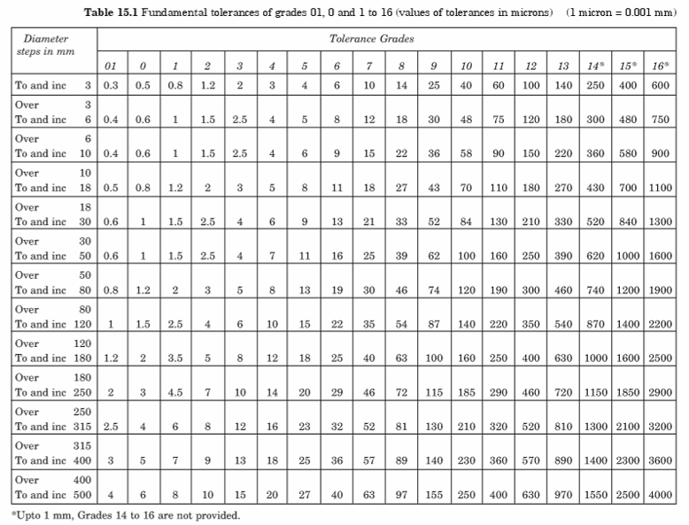
Figure 7. ISO tolerance grade tables for hole shaft contacts

Most of the hole diameters modeled in CAD software are 6.5 mm or 6.3 mm depending on the wanted clearance. For hole diameter of 6 mm, tolerances between 300 and 500 micron meters are achieved. For very accurate 3D printing production results we will achieve tolerance grade of around 14 and 15. This is theoretically not accurate but our prototypes and previous attempts steered towards this direction.
We didn’t want to use bearings for every joint but we also didn’t want tight fastener usage in the joints. This would increase the friction on the joints and require more servo motor power for the same grip force. Due to the limitation of our servo motor torque output, we wanted to minimize this friction. Similar issue exists with loose joints as well. If all the links at a joint is loosely connected, rotational force is not fully transferred between the links. To prevent both scenarios, we chose different hole sizes for different parts of the gripper. There are two main instances for our mechanism and both of them will be explained separately. These change in hole diameters can also be observed from the technical drawings from Appendix A.
Most important torque transfer occurs at the finger - link and finger - gear link joints. To ensure that torque is transferred to the fingers, finger holes have less clearance. Hole diameter of 6.3 mm is selected for the fingers. With the expected tolerance resulted from 3D printing, this diameter gives close to transition fit. Using this hole size on every component would result in unnecessary friction. For this reason, hole size of 6.5 mm is selected for gear link and links. More rigid connection of fingers and nuts results in sufficient torque transfer to the fingers.
More understandable presentation of the said hole diameters is shown in Figure 8 below. Blue lines indicate a diameter of 6.5 mm while red lines indicate a diameter of 6.3 mm in respected components.

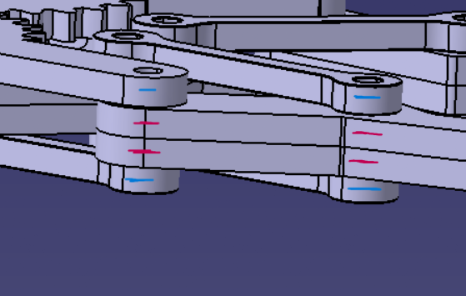
Figure 8. Hole diameter illustrations of the 3D link and finger models
Similar difference in tolerances exists on the base plate as well. Middle front holes of the base plate have hole diameter of 6.3 mm, similar to the fingers. This part of the base plate shares a joint with two links. As previously said, all holes of the links have a diameter of 6.5 mm. Same way as before, this 6.5-6.3-6.5 change between the diameter creates different clearance for the links on a certain joint and optimizes torque transfer to friction ratio.
More understandable presentation of the said hole diameters is shown in Figure 9 below. Blue lines indicate a diameter of 6.5 mm while red lines indicate a diameter of 6.3 mm in respected components.

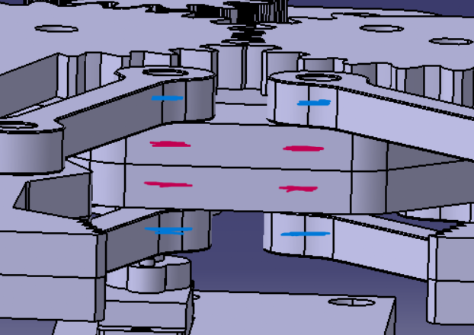
Figure 9. Hole diameter illustrations of the 3D link and base plate models

Overall, tolerances we applied in our 3D models gave very accurate results. From a pure standard perspective, tolerance grade above 8 is not very acceptable but this mostly depends on the material and the usage of the component. Materials used in 3D printing such as PLA have much higher friction coefficients compared to steel or aluminum. Even if 3D printer manufactures results with little to no error, similar tolerance grades used for steel assemblies can’t be applied for our mechanism.

6.7 Technical Drawings and Documentation Strategy
Fully dimensioned technical drawings of the manufactured parts are provided in Appendix A. These drawings enable reproducibility and support manufacturing and inspection. The set of technical drawings includes the following:
- Base Plate drawing: all hole coordinates, thickness, mounting pattern
- Gear drawings: bore diameter, gear thickness, teeth parameters (module / teeth count)
- Finger link drawings: pivot hole diameter, linkage hole positions, overall length
- Linkage drawings: hole-to-hole distances, thickness
- Pin/spacer drawings: diameters and lengths (or standard part references)
- Assembly drawing: orthographic views and exploded view
- BOM table: item numbers matching exploded view

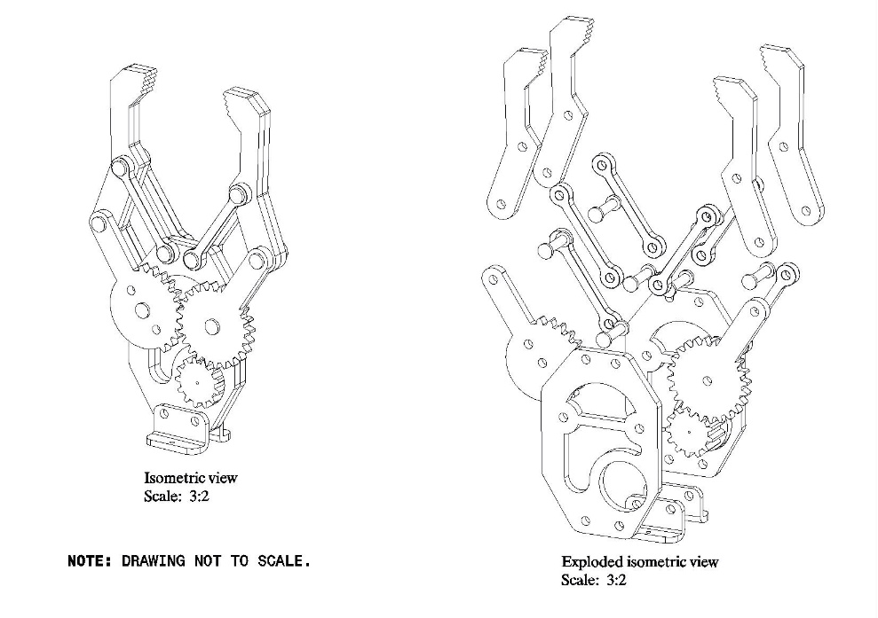
Figure 10. Assembly view and exploded view of the gripper

6.8 Exploded View and Bill of Materials Integration
An exploded assembly view is provided to clearly show how the gripper is assembled and how each part interfaces. Each component is labeled with an item number corresponding to the BOM in Chapter 9.
The BOM is grouped as follows:
- Structural components (base, servo mount)
- Gear train components (pinion, follower gears)
- Finger components (left/right fingers)
- Linkage components
- Pins/spacers/fasteners

6.9 Assembly Procedure (Practical Steps)
A practical assembly process is as follows:
Step 1 — Prepare printed parts
- Remove supports (if any), clean surfaces
- Check hole quality; lightly ream/drill if required
Step 2 — Install servo and pinion
- Mount servo to base plate / housing using screws
- Attach pinion gear to servo horn securely
Step 3 — Install follower gears
- Insert gear shafts (pins) into base plate
- Mount left and right gears
- Add spacers/washers to prevent axial contact
Step 4 — Install linkage arms
- Connect linkage arms to gear connection points
- Insert pins and verify free rotation
Step 5 — Install finger links
- Mount finger links onto finger pivots
- Connect finger links to linkage endpoints
Step 6 — Alignment and functional check
- Rotate servo/pinion manually (or by low-speed actuation)
- Confirm symmetric opening/closing
- Ensure no binding or collision
- Tighten fasteners with appropriate preload

6.10 Summary
This chapter completed the full development of the robotic gripper in CAD including subsystem modeling, assembly constraints and clearance verification as well as documentation planning for technical. The modular structure of the CAD supports rapid prototyping and future iterations. The assembly model validates that the gear-linkage mechanism is feasible and provides a manufacturing ready foundation to build the prototype.

7. ANALYSIS AND SIMULATIONS

7.1 Dynamic Analysis and System Evaluation
Dynamic evaluation is necessary to understand how a robotic gripper behaves during operation, especially during rapid opening and closing movements. While static calculations provide an estimate of gripping force and torque requirements, real-life conditions include inertial effects and friction caused by accelerating, decelerating, and rotating parts such as gears, linkages, and moving parts. The aim is to estimate the movement speed of the robotic gripper, the acceleration required for the target cycle time, and the corresponding torque demand on the servo motor, while also discussing practical stability issues such as structural flexibility.
To determine systemic predictions, the mechanism is considered as a planar system operating under rigid body motion. Rotary joints are primarily assumed to be in an ideal state, and friction losses are treated as secondary effects that can be discussed qualitatively and evaluated accordingly. The servo motor is assumed to rotate at approximately constant average speed. The accelerations at the beginning and end of the actual servo motion are ignored. It is assumed that the gear transitions are correctly aligned to prevent tooth skipping. These simplifications are suitable for evaluating the system and allow for the assessment of dynamic demand and the attainment of a result very close to reality without the need for additional information.
The dynamic behavior begins with the servo rotation, which is usually specified in servo datasheets as a time value required for a 60-degree rotation. If the servo time for 60° is denoted by $t_{60}$, the approximate servo angular speed can be estimated as
$$ω_{s}≈\frac{{60}^{∘}}{t_{60}}⋅\frac{π}{180}.$$
The servo drives a pinion gear with $N_{s}$teeth, which meshes with follower gears of $N_{f}$teeth. The follower gear angular displacement and speed are therefore related to the servo rotation through the gear ratio as
$$θ_{f}=-\frac{N_{s}}{N_{f}}θ_{s},\text{and}ω_{f}=-\frac{N_{s}}{N_{f}}ω_{s}.$$
The negative sign indicates opposite rotation direction, which is the mechanism that ensures symmetric finger motion. The finger links are not directly mounted to the gear shafts; instead, a linkage transmits gear rotation to finger rotation. As a consequence, the finger angular speed is not strictly constant and depends on the instantaneous configuration of the linkage. For report-level performance estimation, the relationship can be expressed using an average geometric transmission factor $k_{avg}$such that
$$ω_{finger}≈k_{avg} ω_{f},$$
where $k_{avg}$represents the effective conversion from gear rotation to finger rotation over the working stroke. Based on this chain, the open–close cycle time can be approximated using the commanded servo angle range $Δθ_{s}$as
$$t_{cycle}≈\frac{Δθ_{s}}{ω_{s}}.$$
These relations demonstrate that the primary determinants of operational speed are the servo speed and the selected gear ratio, while the linkage geometry shapes the detailed velocity profile of the fingers.
Acceleration is particularly important because it generates additional inertial torque demand. Even if the servo is approximated to have a constant average speed in mid-stroke, acceleration occurs during startup, braking, and especially at direction reversal. A simplified approach assumes that the servo reaches its average angular speed $ω_{s}$within a ramp time $t_{r}$. Under this assumption, the order-of-magnitude angular acceleration can be estimated as
$$α_{s}≈\frac{ω_{s}}{t_{r}}.$$
The follower gear acceleration follows the same gear ratio relationship,
$$α_{f}=-\frac{N_{s}}{N_{f}}α_{s},$$
and the finger acceleration can again be related to follower gear acceleration through the configuration-dependent linkage factor. Although these estimates are approximate, they are valuable for checking whether inertial loading could become significant relative to static gripping torque, especially if the gripper is commanded to move rapidly.
The servo motor must provide torque not only for gripping (load torque) but also for accelerating the moving parts (inertial torque), in addition to mechanical losses. A common representation is
$$T_{total}=T_{load}+T_{inertia}+T_{loss}.$$
Inertial torque can be estimated by reducing the rotating components to an equivalent inertia seen at the servo shaft. In a simplified form,
$$T_{inertia}=I_{eq}α_{s},$$
where $I_{eq}$includes contributions from the servo pinion, follower gears, and the linkage–finger subsystem reflected through the gear ratio.

This formulation highlights the benefit of using lightweight connections and parts in the system: reducing mass and inertia directly reduces I_{eq}, which in turn lowers the dynamic torque demand and increases the system's response speed. In practice, this means that the prototype is more likely to operate more smoothly within the range where standard servo motors would be safe.
The dynamic stability of the gripper is primarily affected by the clearance in the gear set, the joint clearances, the structural flexibility of the printed components, and the servo control behavior. The clearance created by the interlocking of gears can create a small dead zone during direction change, leading to a slight delay and potential "clicking" behavior that reduces position repeatability. Furthermore, while PLA raw material provides sufficient stiffness for production, it has limited ductility and impact resistance; printed components may exhibit small elastic deflections under dynamic loading; and due to the low precision of the system used during 3D printing, the desired dimensions may not be precisely achieved, manifesting as slight oscillation at high speeds. Stability issues related to the servo can lead to inconsistent movement if the servo is operated aggressively or if voltage drops occur in the power supply. For these reasons, maintaining the correct gear center distance (i.e., manufacturing according to the reference drawing), creating robust assemblies with appropriate spacers, reinforcing high-stress areas near pivots, and improving operational stability are important practical measures.
In summary, the dynamic performance of the gripper can be effectively evaluated using analytical predictions derived from assumptions of servo speed, gear ratio, and simplified acceleration. The results show that the finger movement speed is primarily determined by the actuator speed and transmission ratio, while acceleration during initiation and return introduces additional inertial torque requirements. By utilizing lightweight components and a mechanically optimized gear-linkage mechanism, the design is expected to deliver the intended smooth and repeatable operation.

7.2 Fatigue Analysis

7.2.1 Fatigue Analysis Setup and Assumptions
In this analysis, the gripper is assumed to hold a cubic workpiece with a mass of 1 kg. The fingers do not move during the gripping action. During this moment, joints on the finger act as fixed points. Therefore, these pin locations were modelled as fixed to represent the constraint. This simplifies the analysis while making the results more conservative.
Each finger is primarily subjected to bending loads, with a lateral force of 25 N and an additional vertical force of 5 N applied at the serrated contact region. Only the fingers were analysed to achieve higher mesh resolution and improved stress accuracy without increasing computational limitations.
The finger was selected for the fatigue analysis because it is the most important part of the mechanism. It is one of the parts that is exposed to high stress concentration. Out of the parts that is experiencing high stress, the fingers have the most complex geometry. They are also the only part of the gripper that interacts with the workpiece. That’s why their analysis is crucial.

7.2.2 Fatigue Analysis Methodology
Fatigue evaluation was performed using the stress–life (S–N) approach. This approach is appropriate for high-cycle fatigue problems where stresses remain within the elastic range. The Goodman mean stress correction method was used because its results provide a conservative fatigue life. This method underestimates life and for that reason, it is suitable for our simulations. Not having fatigue failure before expected time cycle is very important.
The gripper finger is made of PLA, which is a polymer material commonly used in FFF 3D printing. Although PLA is relatively brittle compared with some engineering polymers, the von Mises equivalent stress was used as a practical engineering approximation to represent the multiaxial stress state in the finger during gripping. This is a conservative simplification, since it combines the multiaxial stress components into a single equivalent value that can be compared directly against the material strength data used in the fatigue model.
Due to the lack of reliable and standardized fatigue data for PLA, some modelling decisions were made for the calculations. Because reliable fatigue strength reduction factors are not available for PLA, it was taken as 1 to avoid adding unnecessary conservatism. Also, a linearized S–N curve was used in the solution due to same reason. Linearized curve is acceptable because the analysis is between the range of 1,000 and 1,000,000 life cycles.

7.2.3 Equivalent Stress Results
The von Mises equivalent stress distribution obtained from the finger analysis is shown in Figure 11. This result is presented to verify consistency with the previously discussed system stress analysis. The reduced model shows stress magnitudes and distributions that closely match the previous system analysis results. This confirms the accuracy of our simulation setup.
As shown in Figure 11, the maximum equivalent stress occurs near the finger root and geometric transition regions. These regions have high stress concentration and they are affected by bending stress the most. The location and magnitude of the maximum stress are consistent with those observed in the full assembly analysis.
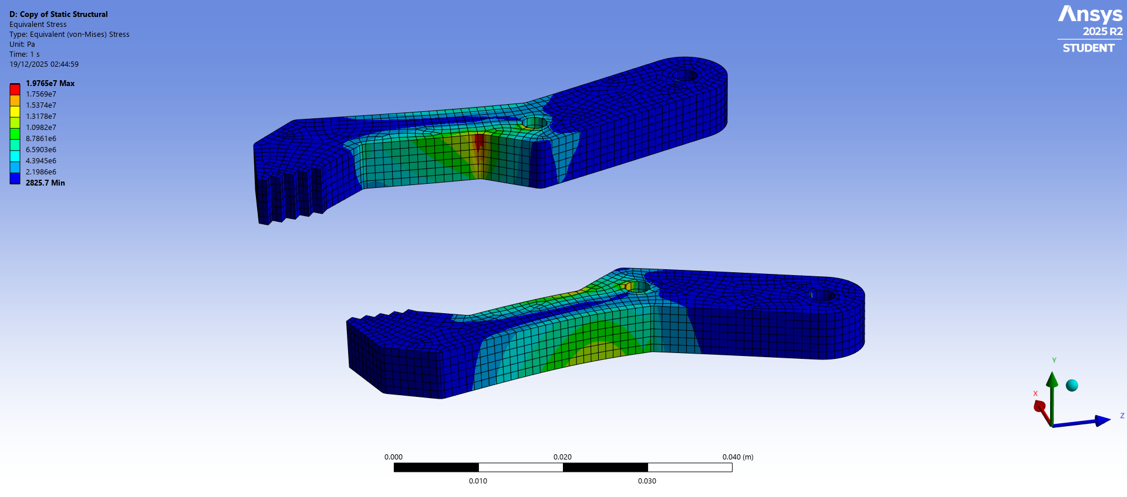
Figure 11. Von Mises equivalent stress analysis on fingers

7.2.4 Fatigue Life Results
The fatigue life analysis predicts a minimum life of approximately 17,474 cycles, as illustrated in Figure 12. Based on this result, a conservative fatigue life of 10,000 cycles was selected as the design maintenance interval to account for modelling assumptions and material uncertainties.
The small region corresponding to the minimum fatigue life is highly localized near a geometric stress concentration. As shown in Figure 12, this small region is located on the outer surface of the finger, making it accessible for visual inspection. Because this critical region is exposed on the outer surface, any developing cracks or surface damage can be detected during routine visual inspection before they propagate to a level that would compromise the finger, which supports the chosen maintenance interval.
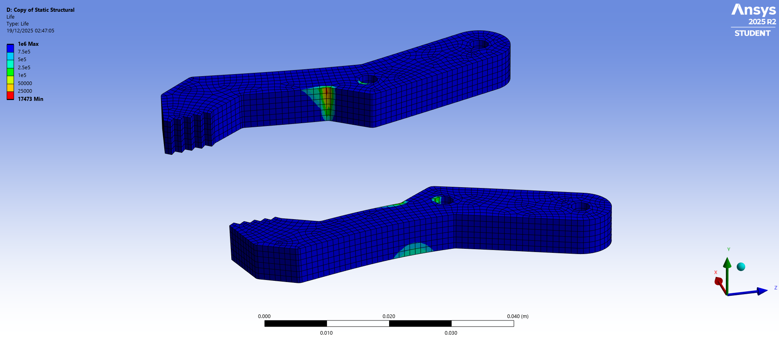
Figure 12. Life cycle analysis on fingers

7.2.5 Fatigue Safety Factor at 10,000 Cycles
The fatigue safety factor distribution for a design life of 10,000 cycles is shown in Figure 13. Apart from that previously discussed small region, the fatigue safety factor is above 1.5 and approaches values close to 2 in areas close to that region. This indicates a generally safe operating condition under the selected design life.
The minimum fatigue safety factor is approximately 1.08 and occurs in a highly localized region. This value is calculated for worst operating conditions. Maximum design load is applied while jaw opening is at maximum, resulting in highest bending moment possible. This process is repeated 10,000 times which is not realistic operating conditions.

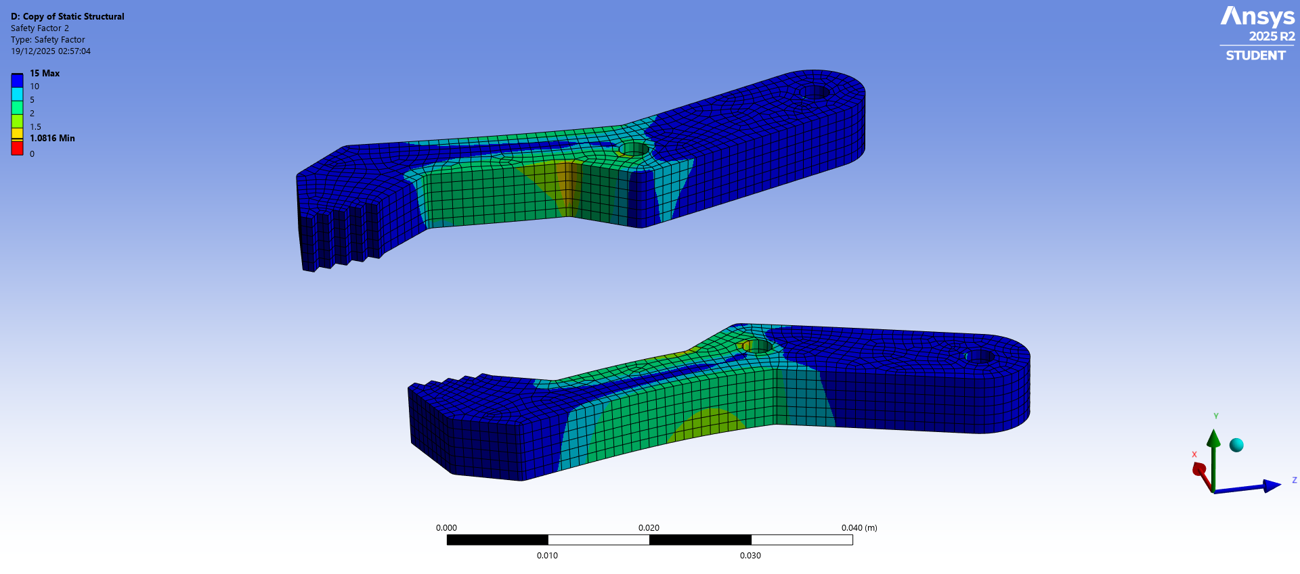
Figure 13. Fatigue safety factor analysis on fingers for 10,000 life cycles

7.2.6 Effect of Load Magnitude on Fatigue Safety
The effect of load magnitude on the fatigue safety factor is shown in Figure 14. While the previous fatigue analysis was conducted under maximum design load conditions, reducing the applied load greatly improves fatigue performance. This gives a better idea on fatigue safety factor under realistic operation conditions.
For loads below 500 g, the fatigue safety factor exceeds 2, which is very reliable. At approximately 750 g loads, and ideal safety factor of 1.5 is achieved. These results confirm that the presented simulations represent worst case conditions. Under normal circumstances the selected fatigue life of 10,000 cycles is acceptable.
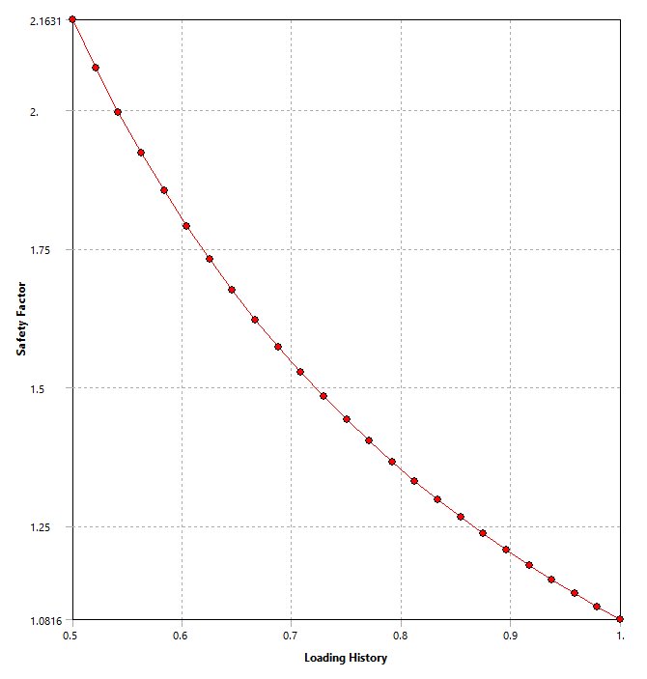
Figure 14. Difference in fatigue safety factor depending on load change

7.2.7 Conclusion and Maintenance Decision
Based on the fatigue life and fatigue safety factor analyses, a service life of 10,000 operation cycles was selected for the gripper finger. Although the minimum predicted fatigue life exceeds this value, the selected limit provides a safety margin that accounts for uncertainties such as surface roughness.
Chosen life cycle of 10,000 provides a balance between reliability and operability. This life cycle ensures that fatigue failure does not happen while maintaining a practical maintenance interval.

8. PROTOTYPING, TESTING, AND RESULTS
The activities presented in this chapter include the prototyping process, assembly validation and experimental testing to validate the operational functionality of the developed robotic gripper. In addition to demonstrating that the produced prototype functions as planned and fulfills all major specifications defined during previous stages (chapters), the activities are also aimed at determining potential areas for improvements and/or limitations in terms of manufacturability, repeatability of motion, basic grasp ability and qualitative behavior of the device when subjected to typical load conditions. Since most of the gripper's components were produced by additive manufacturing and assembled with conventional mechanical fasteners or pins, the focus was placed upon these specific aspects.

8.1 Prototype Manufacturing
We made a prototype after we finished the design and decided on the materials. We used a printer to make it. This kind of printing is good because we can make changes quickly we do not waste a lot of material. It is great for making lightweight parts with complicated shapes.
The parts we printed include the base plate, links, gears and fingers and the extra servo base plate we needed to connect the servo motor to the system. When we made these parts we made sure they fit together nicely during the practical assembly and most importantly that the gears are turning smoothly.
We chose the optimum settings for the printer so that the parts would be strong but wouldn’t take too long to manufacture. We used the same settings for all the parts. After they were printed we looked at all the parts to make sure they did not have any problems, such as dented or very rough surfaces. We especially paid attention to the gears and the parts that transfer the gripping motion. Small inaccuracies are expected but anything that would result in faulty operation of the mechanism is not acceptable.

8.2 Post-Processing and Dimensional Adjustment
Post processing was done to make the parts fit better and move smoothly at the joints. We specifically checked the holes for pins to make sure they were the right size and had a smooth surface. If needed, we adjusted the holes so that they rotated smoothly without too much extra space. We also lightly sanded areas where there was contact and motion between the two parts.. These adjustments were made carefully to avoid adding much looseness, while reducing the unnecessary friction caused by the movements of the parts. The gear system was inspected too to ensure the teeth fit together properly. Small problems with the surface from printing can cause resistance so we checked the gear teeth and turned them manually before controlling them with the servo motor. We also removed small imperfections such as burr from printed parts.

8.3 Assembly Validation and Initial Functional Check
Assembly was done following the instructions from the Chapter 6. Assembly process was done with attention and care to ensure that the servo pinion gear aligned with the gear links. Misalignment of an axis would cause increase friction and can even cause the mechanism to not work properly. Once the gears, linkages and finger were installed, function of the mechanism was tested. The gripper was cycled through its range of motion while being controlled very slowly so that it could be confirmed that both fingers operated symmetrically throughout its travel.
Manual testing of all moving parts to validate functionality occurred when the servo motor was rotated manually and the finger motions were observed. Confirmation of successful completion of the assembly was accomplished based on the following criteria:
1. Absence of jamming or collision of either finger at any point of motion.
2. Smooth engagement and disengagement of each gear pair during meshing, without skipping or slippage.
3. Consistent left-right symmetry of the fingers throughout their respective ranges of motion.
4. Secure fastening and retention of all pins and other fasteners.
Once confirmation was obtained of the manual tests, powered operation at slow speeds was implemented to further test the mechanisms ability to operate dependably.

8.4 Assembly of the Manufactured Parts
The size of our first prototype was not sufficient enough for our purposes. For this reason all the models were scaled by 2. Newly designed mechanism had enough reach and size but downside was the required power. Our previous design could be operated with a much smaller servo motor and because we already purchased it, we would first try the servo in our new design. In a case where the motor is not powerful enough, design changes and adjustments can be made. Current final design of the gripper mechanism is shown in Figure 15 below.

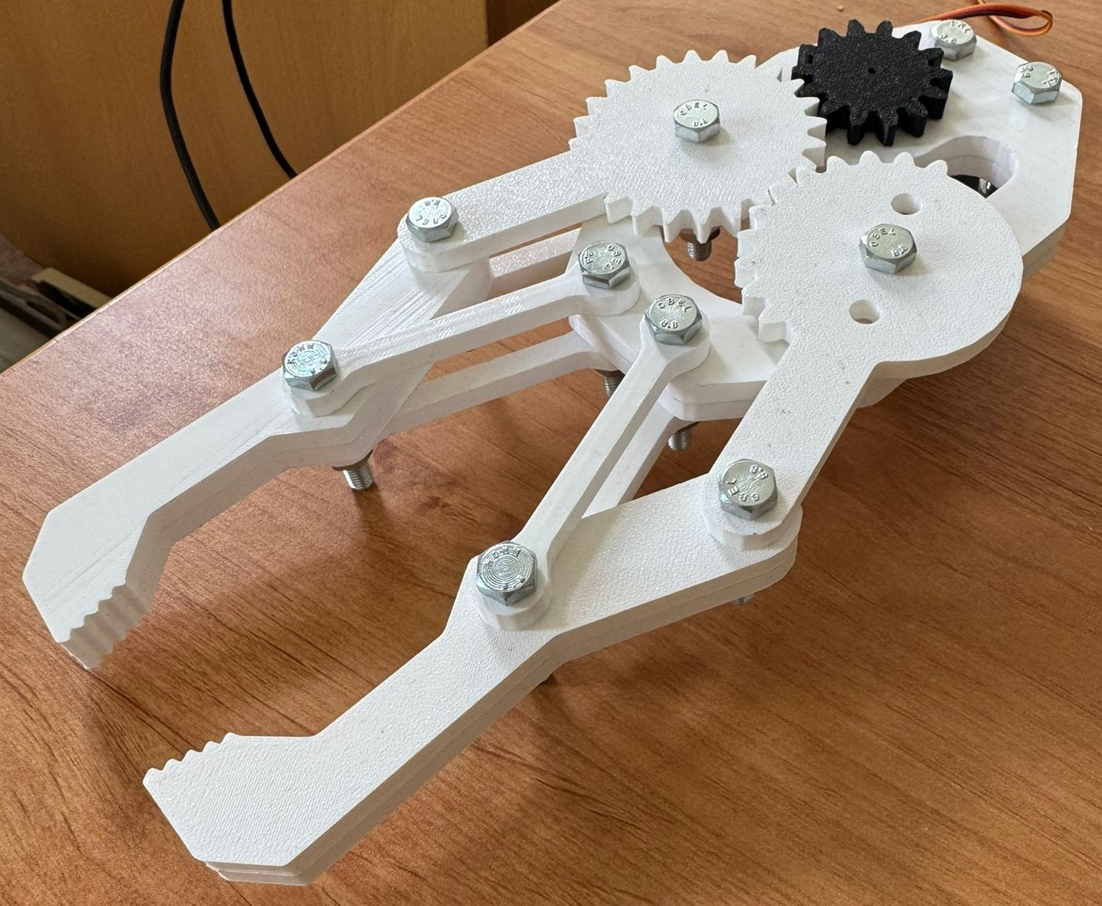
Figure 15. Final manufactured gripper design

During the assembly of the mechanism, 3D models and assembly designs we have created were followed. Some surfaces of the parts had surface finish, causing them to have less coefficient of friction. This surfaces are placed to contact other moving parts. For example outer surfaces of the fingers have less coefficient of friction, compared to their other surface. This rough surface doesn’t matter in the mechanism because they are connected from two joints and they don’t move separately.
This surface distinction is shown in Figure 16 below. It’s a picture from the initial assembly where a different base gear is used. Seen surfaces of the gears are rough while seen base plate surface is smooth. Contact surfaces of the parts are smooth in this configuration.
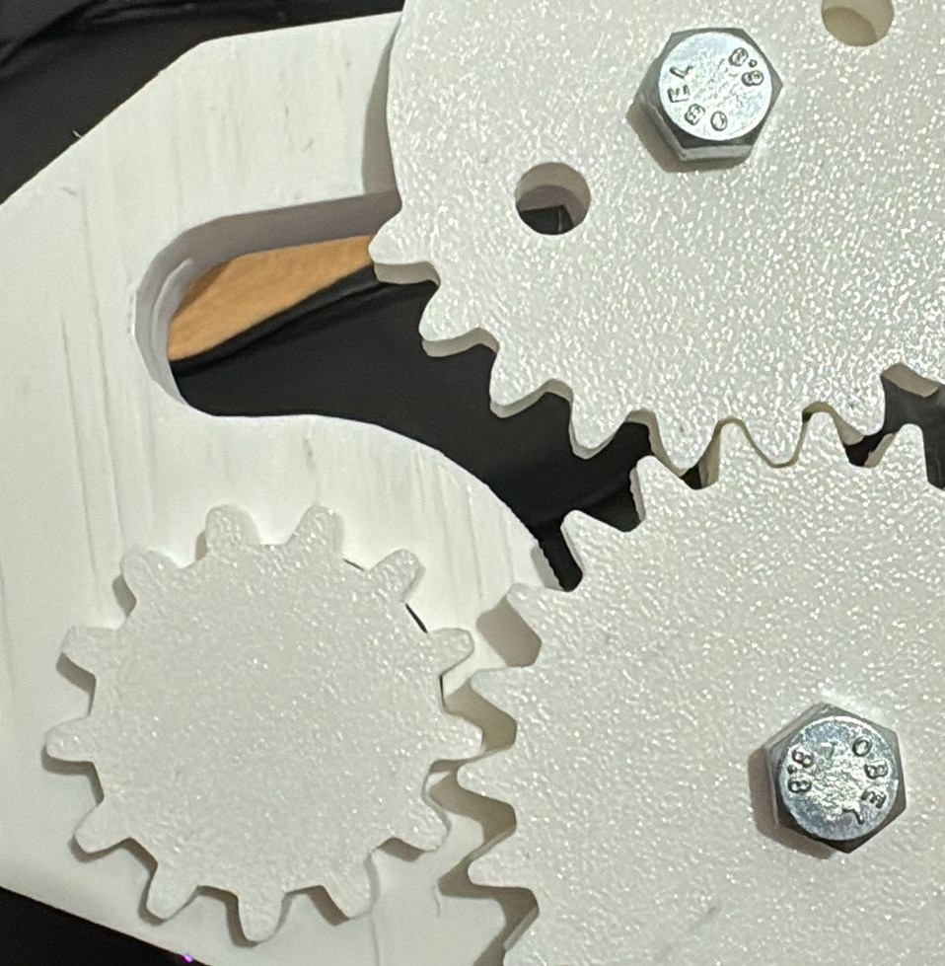
Figure 16. Illustration of difference between rough surfaces and finished surfaces

8.5 Bolt and Nut Dimensions
New design consists of 6 mm holes in the joints. Necessary tolerances was given to the joints and slight adjustments were done for assembly to be possible. Most of the joints are 6 mm holes with 4 different components connected. Thickness of the joint is 24 mm for most holes. This requires minimum bolt length of 30 mm for proper use. When we also factor the fact that we will be using nuts on the opposite sides, longer bolt length might be necessary.
Also gear link 1 and gear link 2 parts are placed on top of the main body. To reduce friction, washers have been placed between the gear links and the base plates. This slightly increases the thickness of the body. In our assembly attempts, we understood that 30 mm bolt length is not sufficient. Washer exceeds the thickness limit and although nut can be placed at the tip of the bolt, it can’t be properly adjusted. Almost half of the nut is not standing on the thread of the bolt. For this reason, 35 mm bolt length is selected. M6X35 mm bolts ensure full thread contact and secure the mechanism properly. It’s important to note that this bolt size is standard throughout the whole assembly. This bolt size is used in most of the joints, and it is specified when a different size bolt is used.
Different size bolts are used mainly in parts related to the servo motor. The side view of the manufactured mechanism is given below in Figure 17 to better show the bolts, nuts and other connection elements.
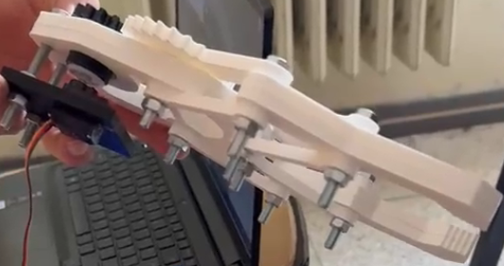
Figure 17. Side view of the gripper showing the connection elements

As mentioned before, nuts are placed on the opposite sides of the bolts to secure the joints of the assembly. These nuts should be tightened properly. Making them loose would cause the mechanism to be unsteady. Long term operations would result in nuts falling off and unusable mechanism. However if we tighten the nuts too much, unnecessary friction will occur. A balanced choice is the most optimal where mechanism stay compact while friction is minimal. During our assembly trials, we tried to tighten the nuts with our fingers. This would cause minimal friction but after 10-20 minutes of operation nuts would become loose. Our decided opinion is to tighten the nuts as much as we can with our fingers, then tightening them with a wrench ever so slightly. This is the simplest, most practical solution we could find that both secured the mechanism and didn’t cause unnecessary friction.

8.6 Contact Between the Gears
Gear Link 1 and Gear Link 2 are the two most important parts affecting the movement of the fingers. They need to be positioned symmetrically and synchronized during the operation of the mechanism. The base gear transmits the torque to only Gear Link 1. Gear Link 1 than moves the Gear Link 2 to create symmetrical gripping motion. Since both sides of the mechanism must move equally, torque should be transmitted equally. Problem might occur if enough torque is not transmitted to Gear Link 2.
After manufacturing, it was observed that gear teeth of Gear Link 1 and 2 almost perfectly fit each other. This would cause problems if they were made from metal. However the material we use is much more flexible and doesn’t cause any problems other than increase friction. This is a trade off we prefer when we also take the possible tolerance problems related to 3D printing manufacturing. Even the most optimal designs will slightly change during the manufacturing. Contact between Gear Link 1 and Gear Link 2 is shown in Figure 18 below.
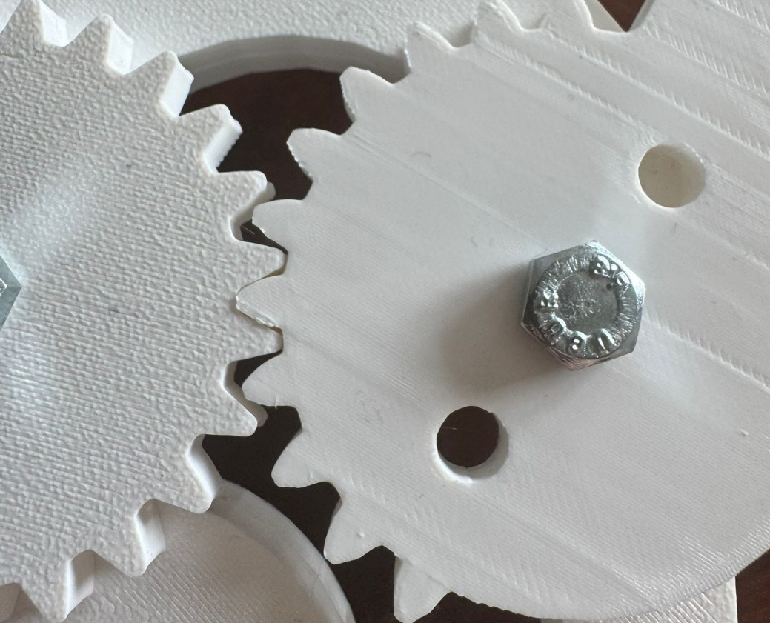
Figure 18. Teeth contact between Gear Link 1 and Gear Link 2

Base gear was one of the parts where redesign was required. Slight adjustments to the diameter and the thread angle was done for better torque transmission to the gear link 1. This redesign was decided after the first manufacturing of the parts. Initial Base Gear had less contact with Gear Link 1. This insufficient contact surface between the two gears was not predicted due to the small movement of the Base Gear. This movement was noticed during the first assembly.
Base Gear is not directly fixed onto the main body of the gripper. It’s attached to the servo motor. Servo motor is placed and fixed onto a Servo Base Plate, and this plate is attached to the Base Plate. This indirect attachment caused slight movement between the parts. If all of the said connections were done very tightly, the structure would be rigid and Base Gear would turn on a fixed axis. However the structure is not completely rigid due to the not too tight connections of the nuts and bolts, and the flexibility of the material. This causes slight movement of the Base Gear during the operation of the mechanism.
Base Gear is placed onto a slightly small hole. This causes only the outer parts of the gear to contact main body, thus reducing friction. This was designed this way because the Base Gear is a cylinder that passes through the whole body. Thickness of 12 mm of the Base Plates would cause too much friction to efficiently operate the mechanism. It was designed so that sides of the cylinder would never touch the inner surface of the base plate hole. However, this was not the case during our operations. Slight looseness causes Base Gear to move inside the hole. At the beginning or closing motion, the base gear shift slightly inside the hole in direction of the rotation. Once it reaches the limit of the clearance, it starts to rotate the Gear Link 1. Because the opening and closing actions are opposite direction, this occurs every time a different command is given to the gripper. This clearance causes only a slight delay at the start of the operation. When open or close command is given, Base Gear starts turning but Gear Link 1 starts turning after approximately 0.5 seconds. Two different locations of the Base Gear are shown in Figure 19 and Figure 20 below. Movement of the base gear is very small but looking at the gap between the base gear and the end points of the base plate can give an idea.
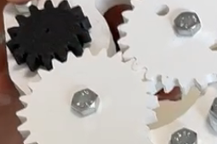
Figure 19. First location of the base gear, slightly on the left

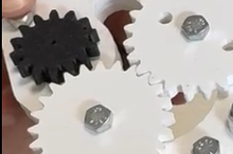
Figure 20. Second location of the base gear, slightly on the right

8.7 Servo Motor and Servo Base Plate
EMAX ES08MAII servo was selected to be used in our mechanism. Initially, the gripper was designed smaller, half the size of the current design. But due to the tolerance complications during the 3D printing, we scaled the entire design by 2. Nevertheless, previously purchased servo was selected. Also, 3D model of the servo motor was obtained and was used during the assembly design. This way, accuracy of the further assembly is checked and alignment and dimension errors are prevented. Model of the gripper with servo attached is given in Figure 21 below.

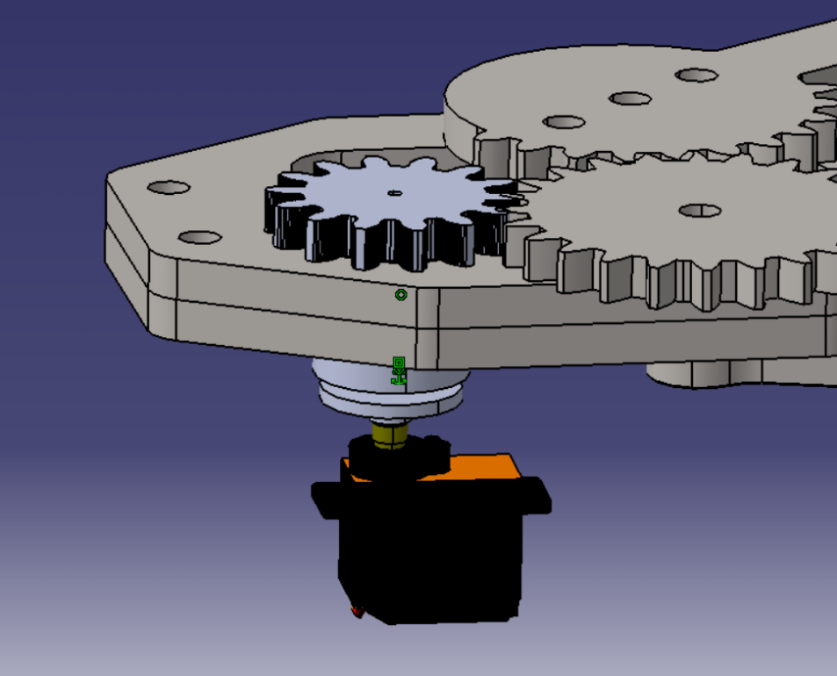
Figure 21. Contact between the servo motor and the base gear

Addition to the main parts of the gripper, a servo base plate was also designed and manufactured for the complete system. This plate is designed to hold the servo motor in a fixed place. Servo motor is mounted to the plate, and the plate is attached to the base plates of the gripper with the help of nuts and bolts. Dimensions of the plate are selected according to our previously purchased servo motor and the geometry of the gripper. Model of the gripper with servo and servo base plate attached is given in Figure 22 below.
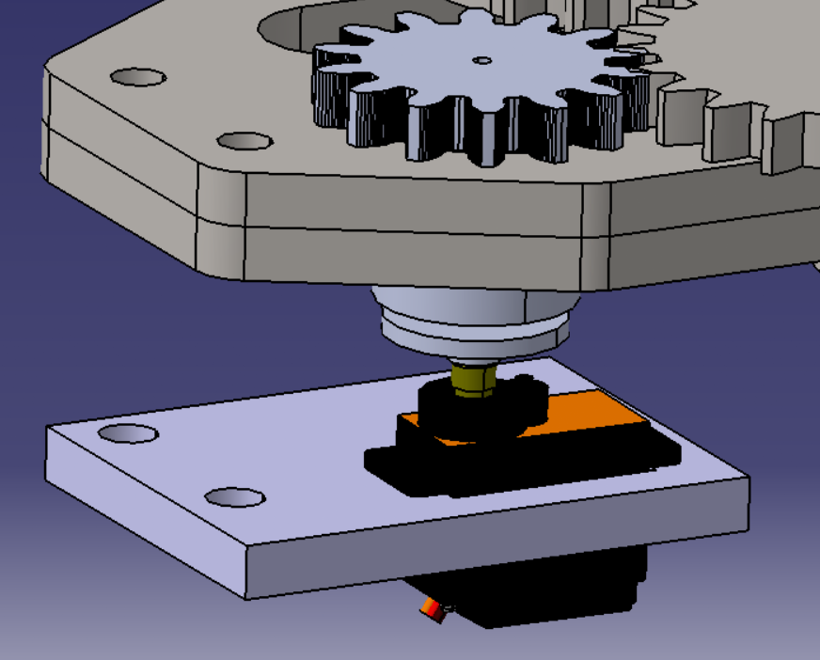
Figure 22. Assembly model of servo motor and servo base plate
Servo plate is attached to the main body with two 6MX50 bolts with 2 nuts on both sides of the plate. This ensures that plate stays steady during the operation of the gripper. 6mm diameter bolt and nuts are standard within the gripper but the length of 50 mm is selected to ensure that the distance between servo motor and the base gear is controlled. For optimized assembly, shorter bolts can be used. To attach the servo motor onto the servo base plate, two 2MX10 bolts were thought initially. Also similar size screws were considered. However due to the supply issues with small bolts and screws, we used CA Glue to fix the servo onto the servo base plate. Similar issues occurred during the assembly of the servo horn. To attach the servo horn to the base gear, several self tapping screws with diameter of 2 mm were intended to use. However, CA Glue was used again to attach the horn of the servo to the base gear. Servo horn used in the assembly is also gathered from the servo motor model and already exists in the servo motor package. Because of this they are compatible and, connection between the servo motor and the servo horn doesn’t require additional components.
Figure 23 shows the manufactured servo base plate, as well as the servo motor mounted on the plate. Connections between the servo base plate and the base plate of the gripper with a bolt and two nuts setup is also shown.

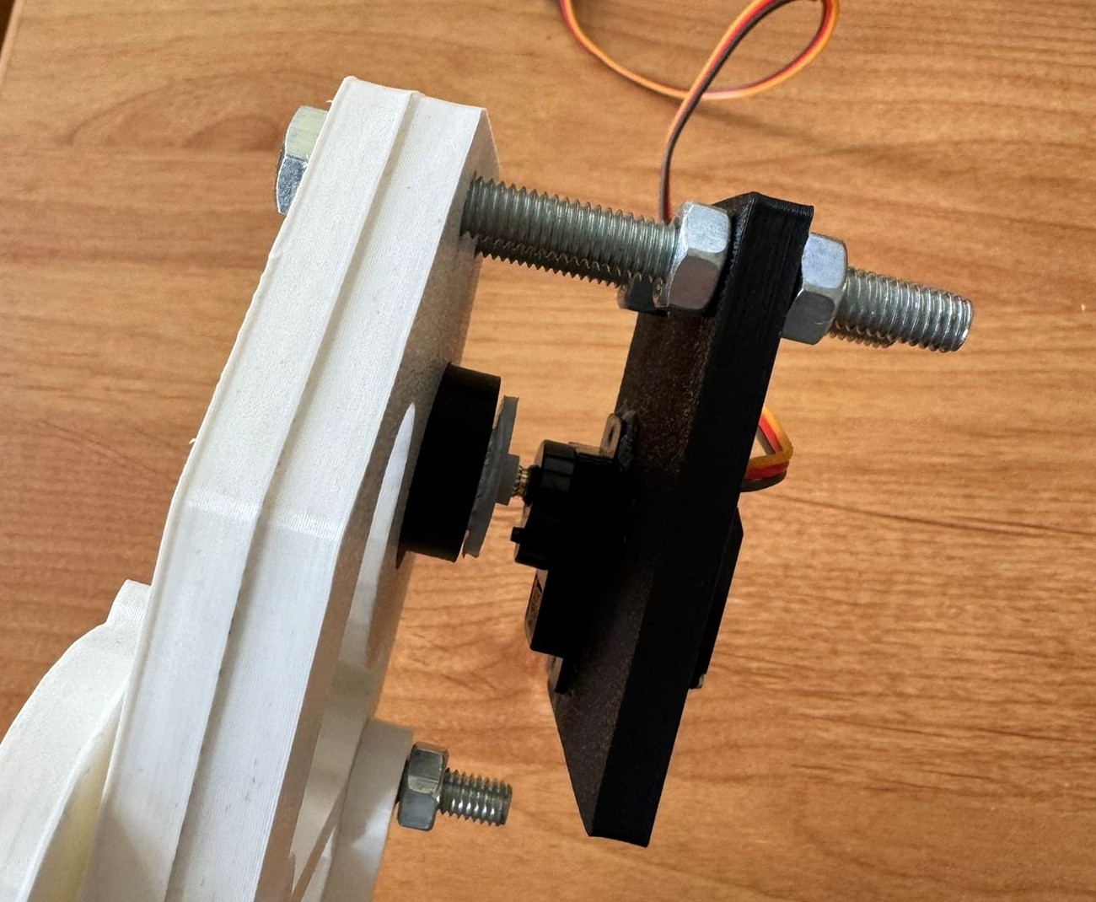
Figure 23. Connections between the servo motor, servo base plate and the main body

8.8 Test Methodology
Testing was used in order to determine if the gripper would work properly for both academic/educational applications, as well as real-world laboratory applications. The testing strategy was based upon three primary goals. These include (1) determining how repeatable the gripper's motion could be, (2) determining the ability of the gripper to successfully grasp various types of geometrically different objects, and (3) evaluating basic load handling characteristics. These tests utilized a variety of representative object styles including but not limited to cylindrical objects (for example, markers), prismatic objects (small boxes), and irregularly shaped household items that fall within the gripper's expected payload size. In addition to the fact that the gripper design is intended to be an economical educational tool, testing was done primarily through observational methods or simple load-based demonstrations (not utilizing calibrated force sensors).

8.9 Grasping Performance and Object Handling Results
The gripper was evaluated using several objects to assess the effectiveness of the finger design and closing trajectory to maintain a stable contact. Synchronized finger closure provided by the gear linkages allowed for central grasps of symmetrical objects. Stable two point contacts were made to both cylindrical and prismatic objects. No slippage occurred during static testing. The fingers made enough surface contact in prismatic objects that they would hold the item as long as it was held close to its center of mass. It was found that the object handling performance improved towards the last part of the closure because the mechanical advantage of the linkage configuration increased. This behavior has been previously reported with mechanisms that are based upon linkages (e.g. robotic grippers), and that provide more force at end-of-stroke. As a result, the prototype demonstrated satisfactory capability for grasping small, light weight items.

8.10 Repeatability and Reliability Observations
The repeatability of the gripper's operation was assessed by repeating an open-close cycle. The gripper performed symmetrical motions during each repetition of opening and closing with no apparent gear "skip" or loss of engagement with pivot pins or fasteners. No degradation in operational performance was seen across the number of test cycles. Minor variability in friction may be present from printing surface finish quality and/or hole finishing quality; however, the general trend demonstrated stable behavior. A qualitative assessment suggests that this design will function satisfactorily for multiple actuations typically associated with demonstration in a classroom environment or other short-duration project settings. High-cycle fatigue (long duration), or repeated exposure testing, is recommended to provide a more thorough characterization of reliability.

8.11 Limitations Identified During Testing
The testing also identified a number of limits common to three-dimensional printing of mechanical prototypes. Polymer parts will have small elastic deflections when subjected to high load conditions. This could result in lower stiffness of grip as well as some positional error in the fingers due to the deflections. Additionally, no force feedback or closed loop control exists. Therefore, the gripping forces would be largely dependent on the position of the servo commands and mechanical advantage and less dependent on actual force control. In addition, tolerances present in the printed holes and surface geometry of gear teeth could lead to back lash and variable friction unless controlled through careful post processing and assembly. These limitations do allow for successful application of this type of component within the limited range of lightweight applications. However, these limitations identify the limitations of the existing prototype and provide motivation for future enhancements.

8.12 Summary
In conclusion, an industrial robotic gripper prototype has been made and successfully built from a design created in SolidWorks using Additive Manufacturing processes to create the body. The prototype is also completely functional as it will move smoothly and symmetrical on each side due to the gear linkage mechanism. Trials have shown that the gripper is able to pick up and support small objects of different shapes and sizes with good stability and repeatability for educational or laboratory use. The prototype supports the realism of the proposed design and provide a clear direction for further improvements such as stiffness, tolerance control, and sense based grip regulation.

9. COST ANALYSIS AND BILL OF MATERIALS
In this chapter we present the cost structure of the robotic gripper prototype in detail, with an entire Bill of Materials (BOM) and estimations for the costs associated with the additive manufacturing process, followed by a breakdown of all the costs involved in building the final prototype. One primary goal of our cost analysis was to determine if the design of the robotic gripper meets the project's affordability and manufacturability goals while meeting its requirements for mechanical performance. Because our gripper will be used as an educational tool for students working on small scale projects within a lab setting, the cost model has been based on commercially available parts and additive manufacturing processes that allow us to quickly build prototypes and replace parts easily.

9.1 Cost Categories and Estimation Method
There are four primary cost categories in this project. These categories include "purchased components" where servo motors and other metallic parts generally make up most of the costs associated with inexpensive prototype builds. "3D-printed components," can be a very variable cost depending on how much filament you use or buy. "Assembly consumable's" are items that may be necessary to build your product with high reliability, such as using inserts, or thread locker. A "contingency fund," will allow for an amount of money to account for potential over head (reprinting, small breakage, etc.) of a prototype. This method allows for a more realistic view of the cost analysis, and a way to reproduce it.

9.2 Bill of Materials (BOM)

Table 5 lists the bill of materials for the robotic gripper. The table is listed to match the assembly and exploded view numbering used in Chapter 6. Unit costs and totals should be filled based on actual purchase receipts and supplier quotations once finalized.
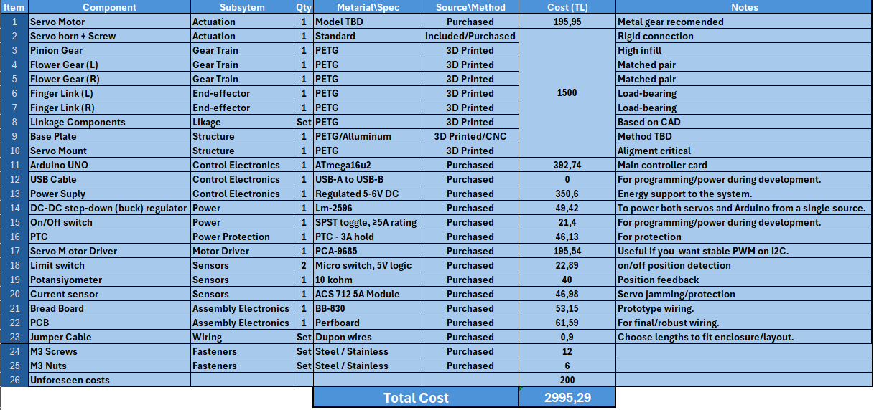
Table 5: Bill of Materials

9.3 Additive Manufacturing Cost of Printed Parts

The cost of additively manufactured parts is estimated from filament consumption. For each printed part $i$, the cost is computed using the mass extracted from the slicer output and the unit cost of filament per gram. The printing cost model is:
$$C_{printed}=\sum_{i=1}^{n}{(}m_{i}⋅c_{filament})$$
where $m_{i}$is the printed mass in grams and $c_{filament}$is the unit cost in TRY/g. The unit cost is obtained from spool price and spool net weight:
$$c_{filament}=\frac{Price_{spool}}{Weight_{spool}}$$
The pricing we've done for the project is based on mass production and is unrealistic. While the quantity of filament needed is fixed, it cannot be purchased in parts, and since we don't own a 3D printer, we would have to pay rental fees. Based on our calculations, we estimate the cost of filament and printing will be around 1500 TL under current conditions.

9.4 Consumables and Assembly-Related Costs
In addition to primary components and filament, minor consumables may also be required. These may include sandpaper for finishing, the use of drill bits/reamers, heat-curing inserts, adhesives, and screw fastener. We have included these unforeseen costs, and more, in our table to account for them in our total cost.

9.5 Discussion: Key Cost Drivers and Cost-Effectiveness
The main cost drivers of the prototype are the servo motor, 3D printing service, PLA filament consumption, and standard mechanical fasteners. Using a single actuator reduced both cost and assembly complexity compared with multi-actuator alternatives. Since most components were manufactured by 3D printing, damaged or revised parts can be reproduced individually instead of remanufacturing the entire assembly. This modular structure improves cost effectiveness during prototyping and future design iterations.

9.6 Summary
In this chapter we provided an open and replicable cost analysis for the robotic gripper prototype. We took into account the Bill of Materials (BOM), filament based cost estimation for printing, consumable costs and costs related to assembly. As the team does not have access to their own 3D printer, the practical production cost will include both the cost of the 3D printing service as well as filament usage. The total cost for printing and filament is expected to be approximately 1,500 TL. However, the final budget could be updated with receipt from purchases made by suppliers.

10. CONCLUSION AND FUTURE WORK

10.1 Conclusion
The goal for this project has been to develop a lightweight robotic gripper that uses a
single servo-driven pinion gear and a synchronized gear-linkage mechanism. The main
goal of developing this robot is to get reliable and symmetric motion from both fingers,
and to have it manufactured in a low-cost, high-manufacturability manner by utilizing
additive manufacturing processes. Ultimately the design of the gripper was able to combine
a servo-driven pinion gear, two follower gears and a planar linkage system, as well as
two finger links so that one input can be used to open or close both fingers together.
This also simplifies the control process since there is only one actuator required.

Throughout this project, we applied an Engineering Design methodology to include: Requirements Identification; Concept Evaluation; Realistic Design Constraints; Literature Review; Mechanism Selection; Kinematic/Mechanical Analysis; Material Selection/Manufacturing Planning; CAD Development; Functional Testing at the Prototype Level. In addition, our CAD model and assembly are developed to enable easy assembly and replaceability of individual components with off-the-shelf parts and hardware. Further, our analytical kinematics/mechanics analysis demonstrates that the selected transmission system enables a reliable and predictable motion as well as efficient transfer of torque from the Servo motor to the grippers' Fingers. Finally, our manufacturing of prototypes, along with functional testing thereof, indicates that the mechanism operates properly, it has adequate repeatibility for Educational/Laboratory scale use, and is able to grasp and hold small objects in accordance with the defined operational range.

Overall, our results show that the proposed design can be considered feasible for use as an affordable and easily available robotic gripper. The project also demonstrates how a mechanically synchronized gear-linkage system may represent a viable alternative to more sophisticated multi-actuator grippers when the primary focus in the targeted application area lies with keeping the design simple; maintaining high levels of reproducibility; and minimizing time requirements for prototyping.

10.2 Assessment of Realistic Design Constraints
This section discusses how the constraints described in Section 1.3.1 were met by the completed prototype. The categories of mechanical, geometric, manufacturing constraints are examined based on the results of the design, analysis and testing provided in the previous sections.
Mechanical Constraints:
These constraints have been generally met. During functional testing and assembly validation it has been demonstrated that the gear-linkage system produces synchronized and symmetrical movement of all the fingers using one servo motor. The structural analyses indicated a bending safety margin of 2.5-3 at representative loading conditions. Fatigue analysis has shown that the calculated minimum service life will be greater than the chosen 10,000 cycle maintenance interval showing that the fingers can withstand multiple open-close cycles without failure. The largest deviation from these mechanical constraints is backlash/joint play which resulted in a small initial opening time. Although some improvement was made through tolerance control, this problem cannot be completely solved due to the nature of the design.
Geometric Constraints:
The constraints geometric have been entirely met. The final configuration is still compact and suitable for use with a small robot arm or tabletop fixture. The base plate provides sufficient space to accommodate the servo motor, the base gear, and the gear links while providing proper pivot alignment. Kinematics have also verified that there will be a useful jaw-open range of about 3mm to 98mm, sufficient for accommodating most lightweight objects. The only modification to meet geometric constraints involved reducing the size of the model by half (scaling) when it became apparent that the first prototype would be too large to print reliably due to printing tolerances.
Manufacturing Constraints:
As expected with other types of constraints, manufacturing constraints were also met with compromise. All structural components were successfully manufactured via FFF 3D printing inside typical printer build envelopes. Post processing techniques such as sanding and reaming enabled the creation of smooth joints. As expected, however, FFF 3D printing tolerances were far less precise than those specified by ISO standards for mating surfaces, and therefore larger hole diameters (6.3 – 6.5 mm) were used in addition to a tolerance grade similar to 14-15 instead of transitioning fit sizes.

Economic Constraints:
The design met all economic constraints. A single, "hobby" grade servo motor, three dimensional (3d) printed polymer parts and common fasteners were all that was required to meet these economic constraints. Hobby grade servos are much cheaper than the "industrial grade" versions. Also, it is easier and much less expensive to create custom parts using 3d printers than by machine cutting metal. The total cost of 3d printer filament for this project will likely be in excess of 1,500.00 turkish lira. If only one part fails or wears out, it can easily be replaced without having to remake an entire assembly. This makes the design amenable to low cost maintenance and re-design.
Safety and Reliability Constraints:
No parts came loose during testing. None of the gear teeth skipped their teeth during operation. The design provided sufficient clearance between the various moving parts so as to avoid contact and possible damage during repeated cycles. Even when subjected to its maximum expected load (i.e., the worst case), the fatigue safety factor remained above unity. The most serious reliability problem identified with this design relates to the use of CA adhesive to attach the servo horn to the shaft of the servo motor. There were no available small diameter screws that could have been used to securely fasten these two parts together. Although CA adhesives provide good temporary attachment of parts until they are cured, they do not possess anywhere near the strength or durability of mechanical fasteners. Therefore, it is intended that future designs will include mechanical means for attaching these two parts instead of relying upon CA adhesive.
Sustainability Constraints:
The use of additive manufacturing techniques resulted in significant reductions in material usage when compared to traditional subtractive machining methods. The single-servo architecture employed in this design also results in lower power consumption than would be experienced in a multi-servo system. Additionally, the recyclable nature of the materials used to fabricate the 3d printed polymer parts provides additional environmental advantages.

10.3 Limitations
Although the prototype met all of the main objectives in the project, there are still many ways that it could have been improved. The first major limitation comes from the fact that all parts of the robot's body were printed with 3D printing technology using polymers. These polymer parts can introduce tolerancing issues and surface finish problems (i.e., surface roughness) into the design of the robot's joints and gears. If these issues are not resolved through post processing, they can also increase friction at the interface between the gears and the joints of the robot. Second, although the links made from polymer are generally quite stiff, they will often deform elastically when subjected to high loads. This elastic deformation limits the ability of the links to provide stiff support for heavy payloads and severely restricts the types of manipulative tasks that can be accomplished by the robot. Third, since no sensors or closed loop feedback mechanisms were employed in this study, the gripping force produced by the gripper was controlled almost entirely by commands sent to the servos, along with mechanical advantage provided by the gripper's linkage configuration. While this arrangement worked reasonably well for manipulating relatively light and rigid objects, its inability to actively regulate gripping force makes it much less reliable when attempting to manipulate delicate objects or objects whose mass properties vary widely. Fourth, while analysis of dynamic behavior allowed us to understand general trends in performance characteristics, we would need to employ motion simulation and instrumented force measurement techniques to accurately quantify the dynamic behavior of the gripper. Additionally, because appropriate-sized small screws were unavailable for assembly purposes, CA glue was applied to temporarily hold together some servo related connections. Therefore, long term reliability of those adhesive assisted joints is considerably worse than those assembled using conventional mechanical fasteners.

10.4 Future Work
Many opportunities exist to implement various enhancements and improvements on future versions to increase reliability, performance and usability. Mechanically, we can increase structural rigidity with optimal dimensions of fingers, add some localized stiffeners and reinforce areas where pivots occur. We can also make an improvement to the gear train by tightening up the center distances of the gears, use high quality gear material, introduce bushings or bearings to minimize wear and improve repeatable accuracy over longer periods of time. We can also improve backlash by adjusting tooth profile and better print resolution especially when nylon gears are involved. Also the design of the servo horn and attachments to servos need to be revised with standard fastener designs rather than adhesives for increased reliability, serviceability, and long term reliability. Manufacturing-wise, repeatability will greatly improve with introduction of tolerances and inspections, as well as fixture based post processing for holes. Some parts could transition from polymer to metal (Aluminum base plate & Metal Gears) depending upon how much payload is needed at that point for either long life or high payloads. Hybrid manufacturing methods allow you to still utilize Rapid Prototyping Advantages but also increase your Mechanical Robustness. Adding Feedback will open up many possibilities. Possible additions are Force Sensing Resistors (FSR) or Small Load Cells embedded into Fingers, Current Sensing of Servo to Estimate Loads, and Closed Loop Control Strategies to Regulate Grip Force. This will allow adaptation to variable objects whether they are stiff or delicate. Last but certainly not least, A Full Motion Simulation Study (SolidWorks Motion) and Experimental Validation with Instrumentation Testing (Force and Displacement Measurement) will provide more accurate results for torque, acceleration effect and cycle life.

10.5 Final Remarks
In conclusion, the robotic gripper built within this project is an example where a single actuator gear system could develop synchronized, repeatable gripping functionality using low cost manufacturing methods. Further improvements to the project can be made including increased stiffness and better accuracy. Improved sensor based control for the grippers is the main area where improvements and optimizations can be made.

REFERENCES
[1] ISO 12100:2010, Safety of machinery — General principles for design — Risk assessment and risk reduction. International Organization for Standardization, 2010.
[2] ISO 9283:1998, Manipulating industrial robots — Performance criteria and related test methods. International Organization for Standardization, 1998.
[3] ISO 2768-1:1989, General tolerances — Part 1: Tolerances for linear and angular dimensions without individual tolerance indications. International Organization for Standardization, 1989.
[4] ISO 2768-2:1989, General tolerances — Part 2: Geometrical tolerances for features without individual tolerance indications. International Organization for Standardization, 1989.
[5] ISO 527-1:2019, Plastics — Determination of tensile properties — Part 1: General principles. International Organization for Standardization, 2019.
[6] ISO 178:2019, Plastics — Determination of flexural properties. International Organization for Standardization, 2019.
[7] ISO/ASTM 52900:2021, Additive manufacturing — General principles — Fundamentals and vocabulary. International Organization for Standardization / ASTM International, 2021.
[8] I. Gibson, D. Rosen, and B. Stucker, Additive Manufacturing Technologies: 3D Printing, Rapid Prototyping, and Direct Digital Manufacturing, 2nd ed. New York, NY, USA: Springer, 2015.
[9] J. J. Craig, Introduction to Robotics: Mechanics and Control, 4th ed. Boston, MA, USA: Pearson, 2018.
[10] B. Siciliano, L. Sciavicco, L. Villani, and G. Oriolo, Robotics: Modelling, Planning and Control. London, U.K.: Springer, 2009.
[11] M. T. Mason, Mechanics of Robotic Manipulation. Cambridge, MA, USA: MIT Press, 2001.
[12] A. M. Dollar and R. D. Howe, “The Highly Adaptive SDM Hand: Design and Performance Evaluation,” The International Journal of Robotics Research, vol. 29, no. 5, pp. 585–597, 2010.
[13] ISO 31101:2023, Robotics — Application of ISO 13482 — Safety-related test methods. International Organization for Standardization, 2023.
[14] ISO 9409-1:2004, Manipulating industrial robots — Mechanical interfaces — Part 1: Plates. International Organization for Standardization, 2004.
[15] ISO 9409-2:2002, Manipulating industrial robots — Mechanical interfaces — Part 2: Shafts. International Organization for Standardization, 2002.
[16] ISO/ASTM 52901:2016, Additive manufacturing — General principles — Requirements for purchased AM parts. International Organization for Standardization / ASTM International, 2016.
[17] ISO 18646-3:2021, Robotics — Performance criteria and related test methods for service robots — Part 3: Manipulation. International Organization for Standardization, 2021.
[18] ISO 8373:2021, Robotics — Vocabulary. International Organization for Standardization, 2021.

APPENDIX A – Technical Drawings
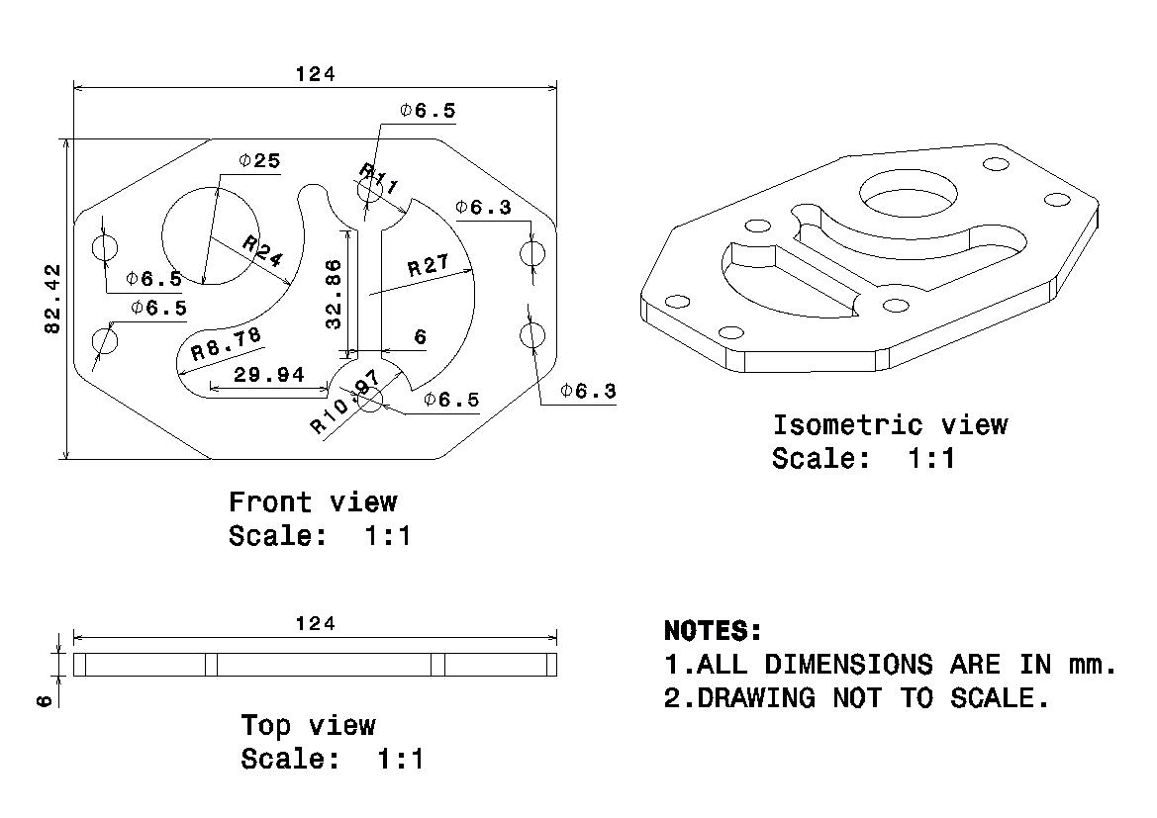
Figure A.1 Technical Drawing of the Base Plate

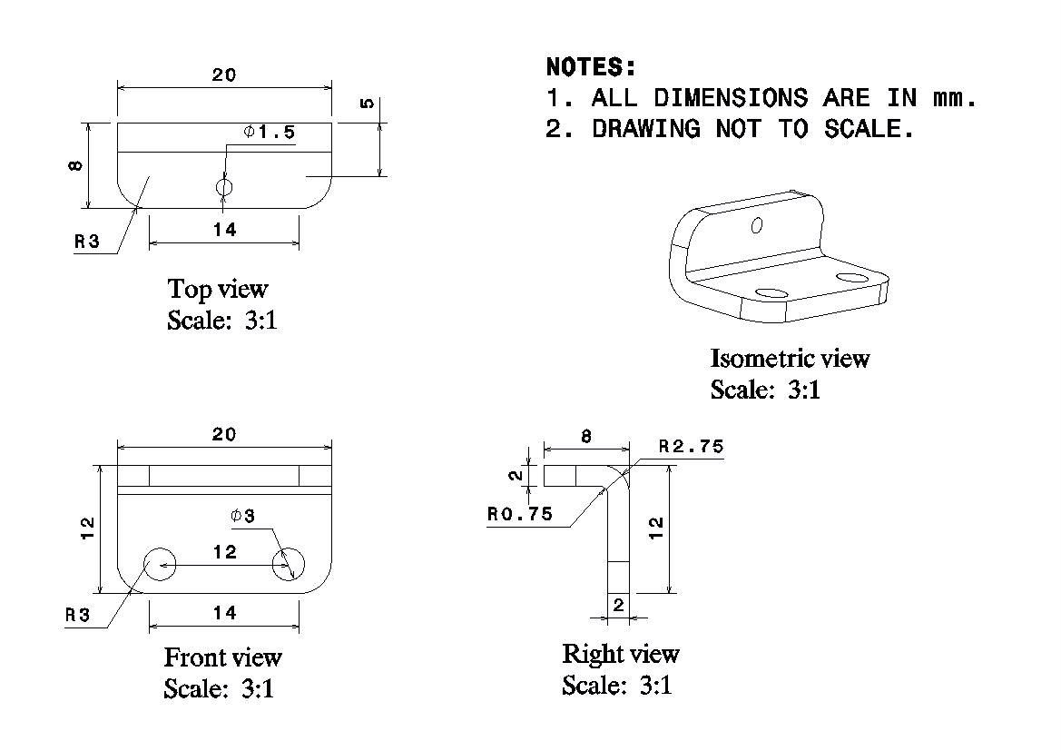
Figure A.2 Technical Drawing of the Mounting Brackets
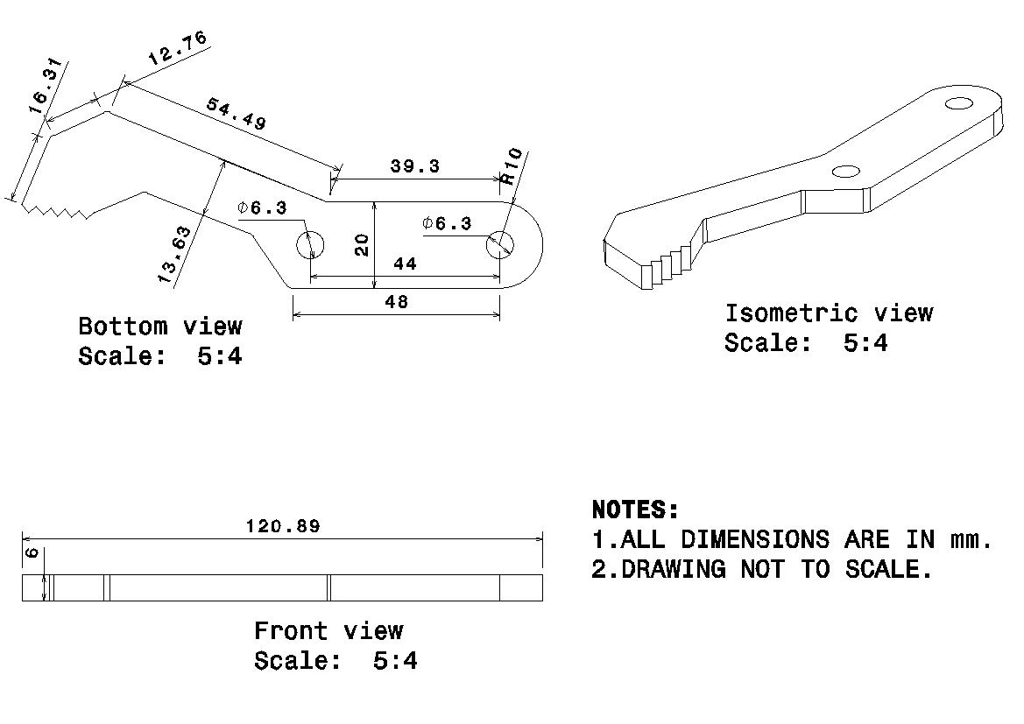
Figure A.3 Technical Drawing of the Finger

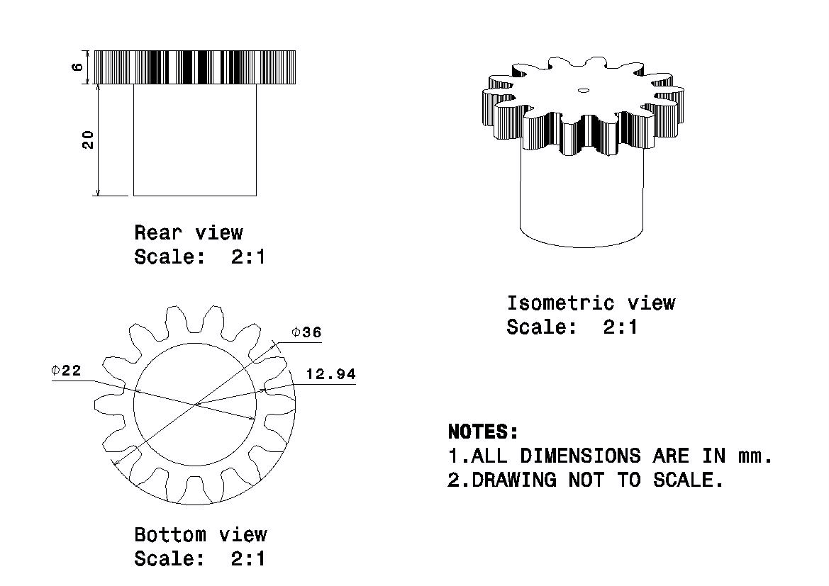
Figure A.4 Technical Drawing of the Base Gear
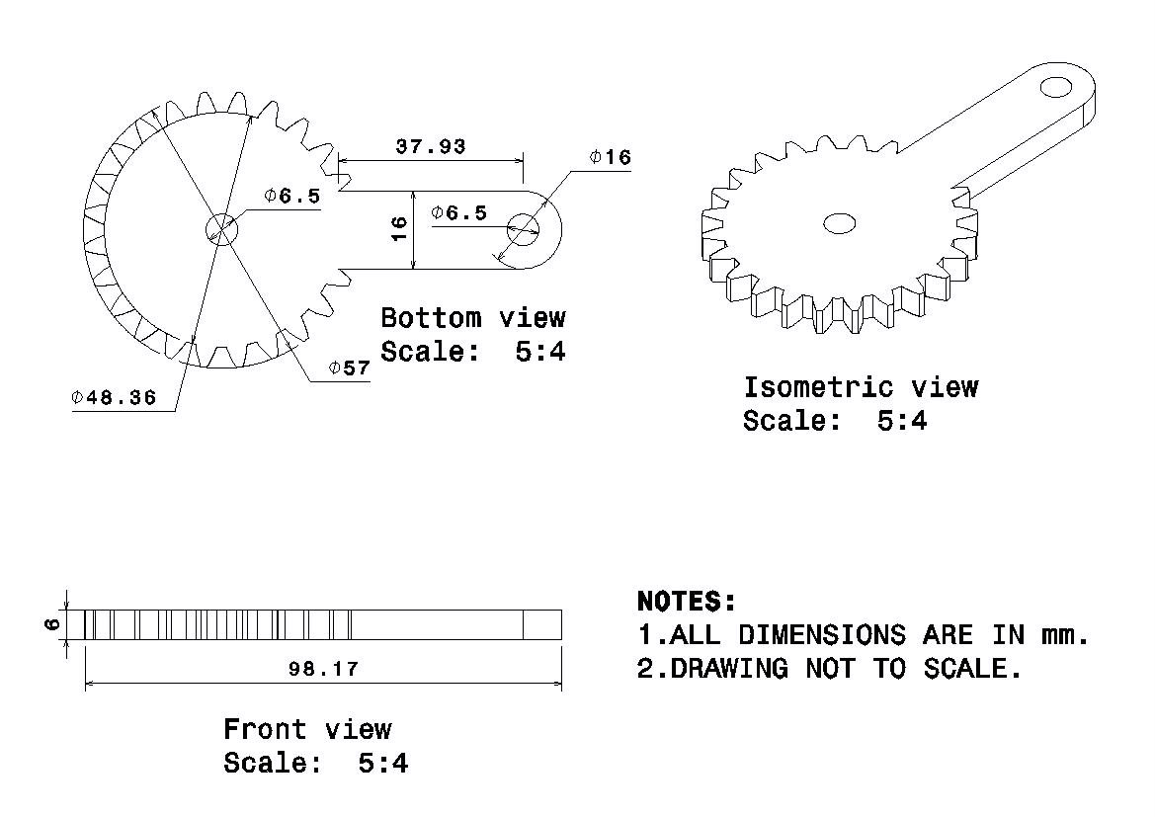
Figure A.5 Technical Drawing of the Gear Link-1

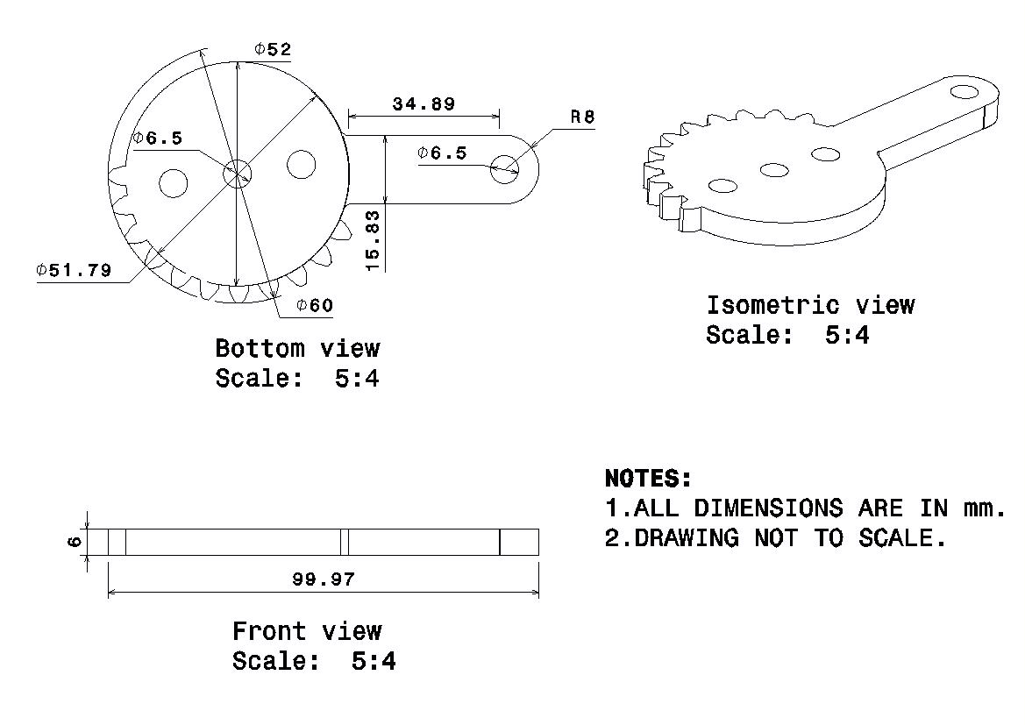
Figure A.6 Technical Drawing of the Gear Link-2
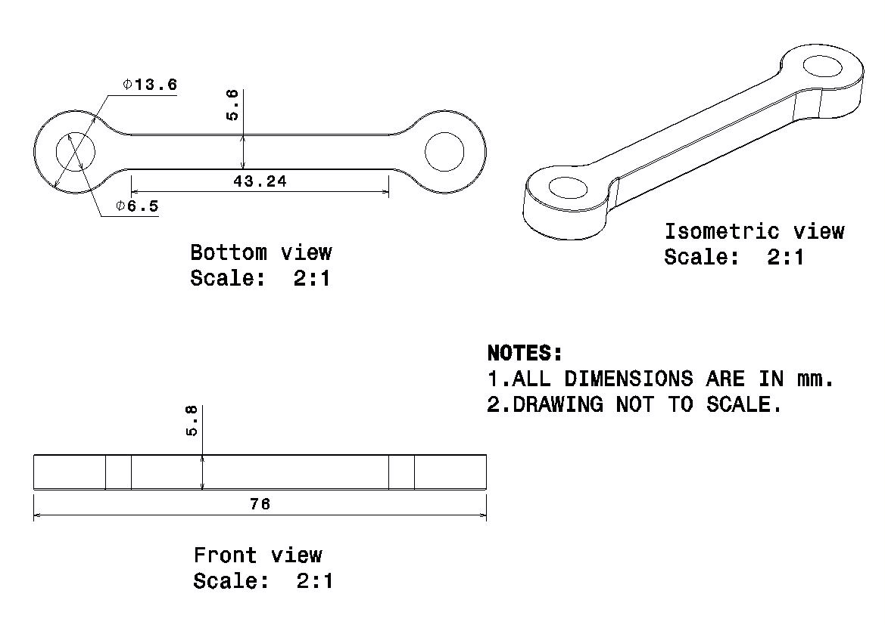
Figure A.7 Technical Drawing of the Link

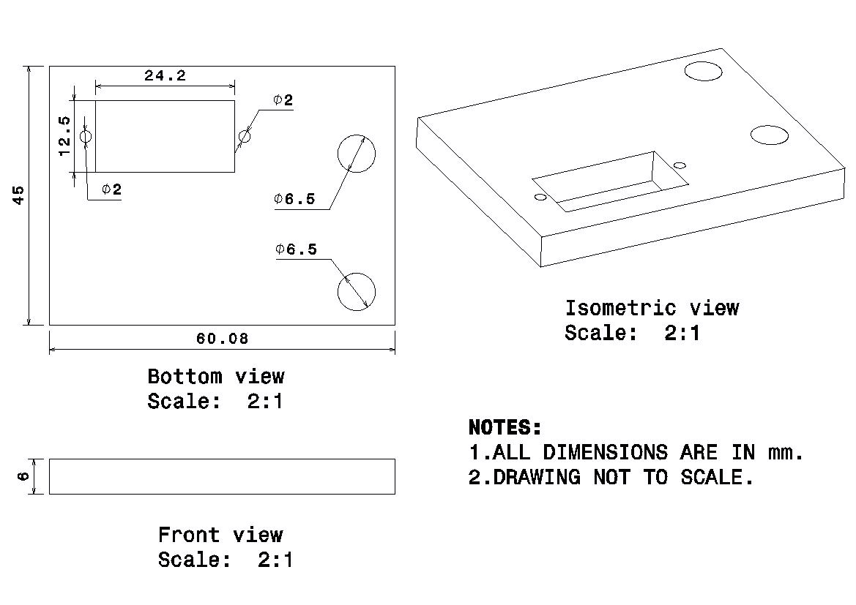
Figure A.8 Technical Drawing of the Servo Base Plate

