Library Book Loan System

System-Wide Requirements Specification

# Introduction

This file refers to the purpose ,contents and features of the Library Book Loan. Various diagrams were used to explain the requirements and usage characteristics. The expected program interface at the end of the project was tried to be shown with GUI Prototype.

# System-Wide Functional Requirements

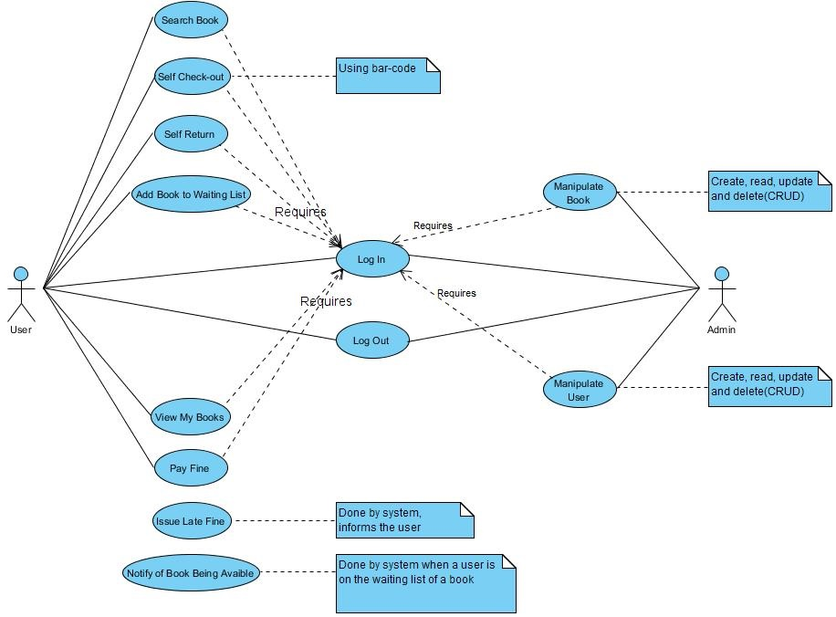

Figure 1 : Use-case Diagram

# System Qualities

## Usability

System users do not come from a specific kit. When we were doing our design, we worked with people from all walks of life. So, to make the system easier to use, we made our interface design as simple as possible. We tried to stay away from complicated operations.

## Reliability

Reliability is important because our system is a library system. The result you get when a user searches for any book should be true. Books that are in the user's hand must be kept correctly in the system. In our design, we paid attention to all of these factors.

## Performance

We mentioned that our system can be used by all kinds of users. Besides this, we think that the amount of users may be higher. When these two conditions come together, the system must be able to operate without difficulty. The system should respond quickly to search results, update the database in case of borrowing and returning of books.

## Supportability

The system must be tested by the users in order to optimize the interface. Therefore, after using the system, it may be necessary to change the interface.

Some problems or new requirements may arise in the background of the system. In this case it is necessary to solve these problems and to fulfill the requirements.

These two factors make the system constantly need technical support. We will continue to provide this support as a team.

# System Interfaces

## User Interfaces

When defining the user interface, we made sure that it is easy to use. We tried to create a GUI Prototype that is as intuitive as possible, understandable at first glance. We used the Axure RP 8 program when creating the GUI Prototype.

### Look & Feel

We have not colored the interface yet. The GUI Prototype we designed was just to show the components on the screen and their locations. However, when creating the interface we will make a simple design using unobtrusive and harmonious colors.

### Layout and Navigation Requirements

The overall design of the pages should be the same. Thus, the buttons are placed in easily accessible positions, which are uncompromising to the user.

### Consistency

We took care to set the papers on a certain standard. So users can predict what they will see on the next page and find out intuitively what they are looking for. We especially noticed that the location of the buttons did not change from page to page. We tried to keep the menus very clear and easily accessible.

### User Personalization & Customization Requirements

We have already told you that we have not done the coloring of the interface yet. For this reason, we have not taken a step to personalize the interface. However, when the system is complete, features such as color, position, and font switching will be in the system.

## Interfaces to External Systems or Devices

### Software Interfaces

Since the features we want to emphasize in our software are that the program responds quickly and accurately, it is important that the software can run in any environment. The C # language, known for its ability to easily adapt to changing environments, has been found suitable for this program. We also need to use a database to manage the users and books on the system, and we decided on Microsoft SQL Server, which is C # compatible. In the web site of Program, PHP was decided because of database support and easy of writing.

### Hardware Interfaces

There is no hardware interface in our system.

### Communications Interfaces

There is no communication interface in our system.

# Business Rules

## Borrowing Books

### Maximum number of borrowings

### In our system, up to 3 books can be found on one user at the same time. If you want to get more books, you should first return the books that have been saved on the system.

### Book return time

The user can keep books he or she has on the system for up to 30 days. Users who fail to comply with this rule will be placed on the system blacklist, and in the event of a reversal, the user's book purchase limit may be reduced or banned from the system.

## Penalties

The user will have to pay a penalty on his / her own book, if he / she does not return it within 30 days, in accordance with the terms of the user agreement that he / she accepted beforehand. This penalty increases per day the user delays the matter.

# System Constraints

• The program will initially run in the Windows environment and will expand to work on other systems in the future.

• Initially our program will only be the desktop application

• PHP will be used next to C # or Java.

• The most important part of the program, the database, will be Microsoft SQL Server

# System Compliance

## Licensing Requirements

All documents and codes related to the project will be shared publicly.

## Legal, Copyright, and Other Notices

The use of documents and codes is personally free, provided that it is not commercial.

## Applicable Standards

This project "Library Book Loan System" follow C# coding standards.

# System Documentation

When this system is completed, a user manual will also be completed. This manual will explain the interface usage and the logic of the system in a simple and understandable way for users. The manual will be prepared by the people in charge of the project. In this way, we will try to prevent incomplete or incorrect information. It also contributes to the simplicity of the guide in the presence of different perspectives.

Also in this manual will be contact information of the project team and the support unit.

**APPENDIX A (Activity Diagrams)**

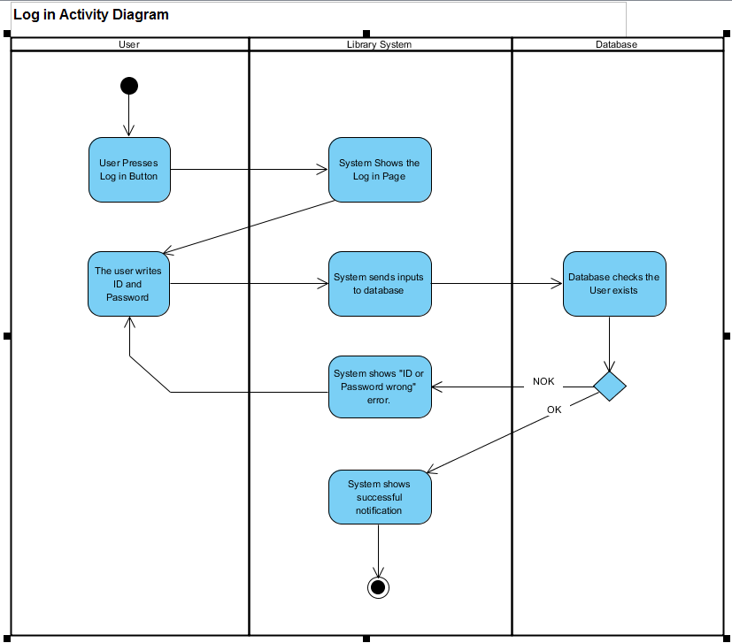

Figure 2 : Log In Activity Diagram

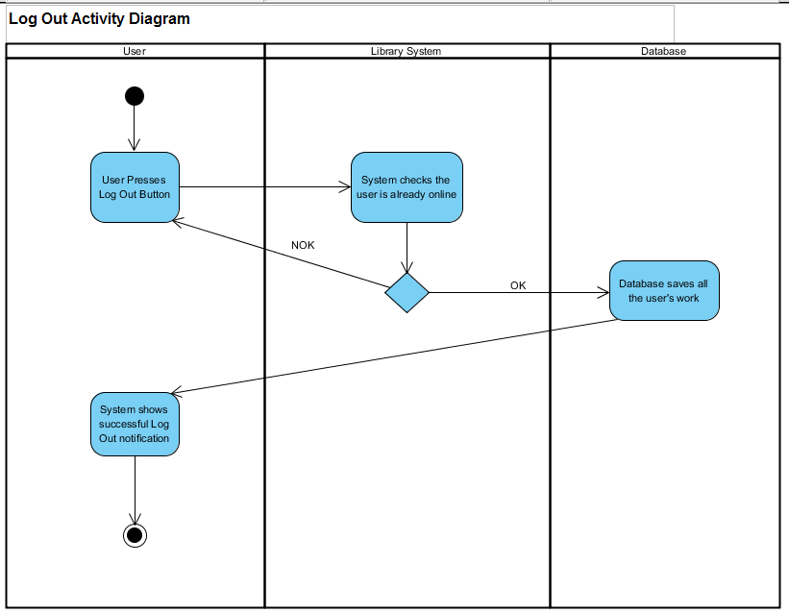

Figure 3 : Log Out Activity Diagram

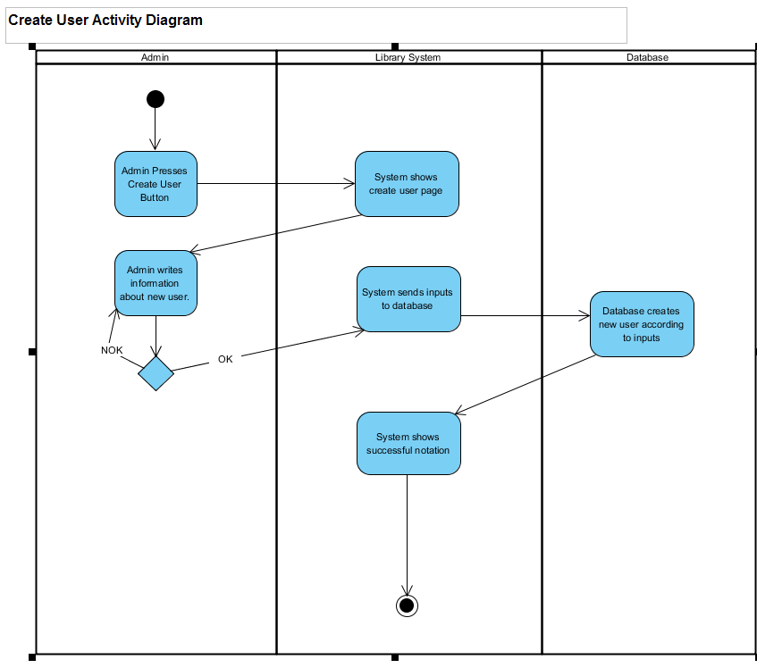

Figure 4 : Create User Activity Diagram

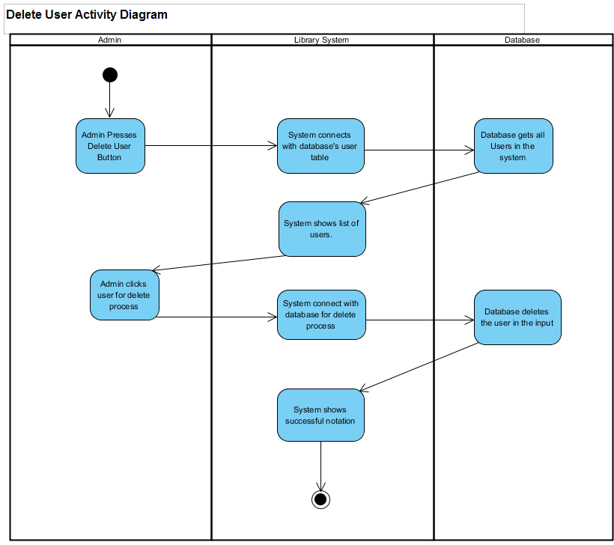

Figure 5 : Delete User Activity Diagram

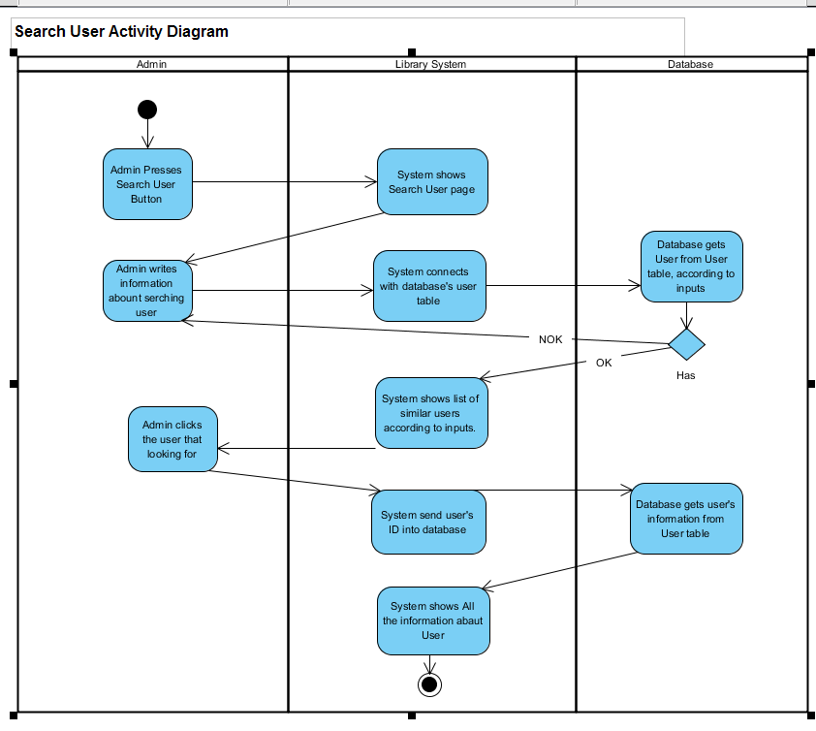

Figure 6 : Search User Activity Diagram

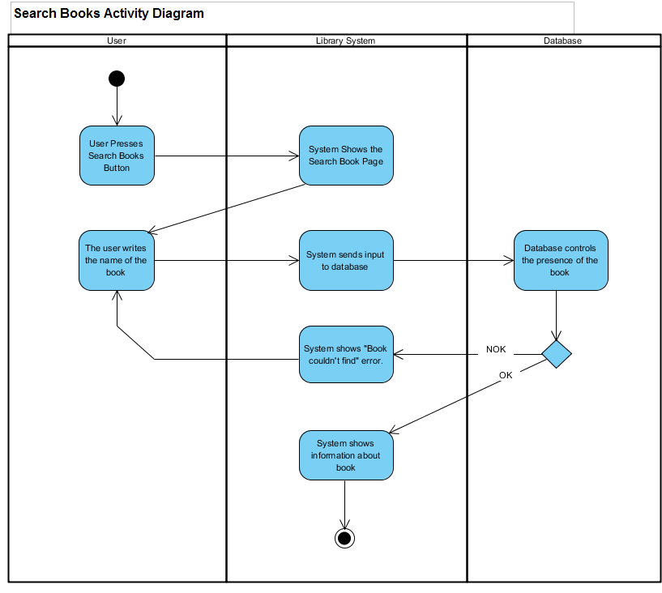

Figure 7 : Search Book Activity Diagram

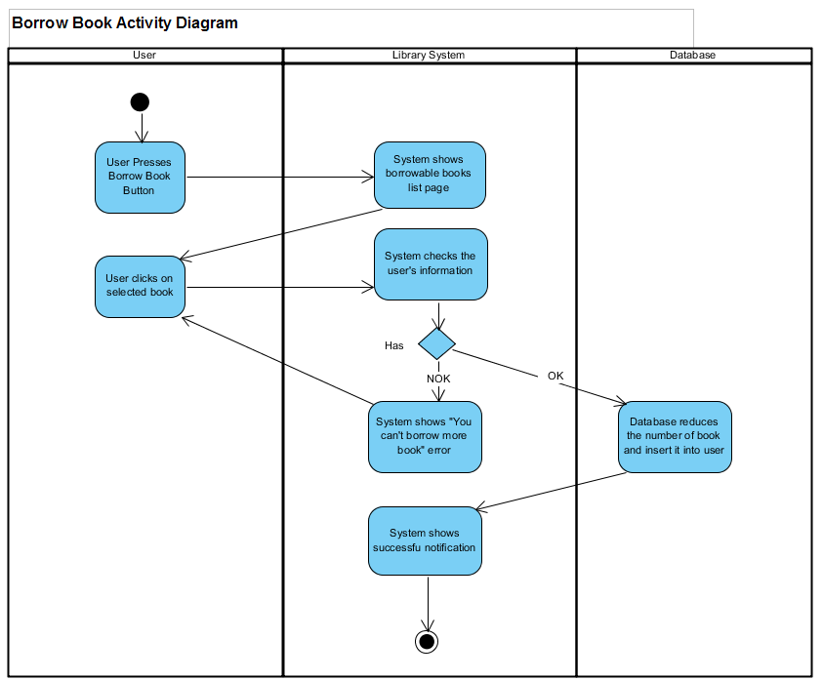

Figure 8 : Borrow Book Activity Diagram

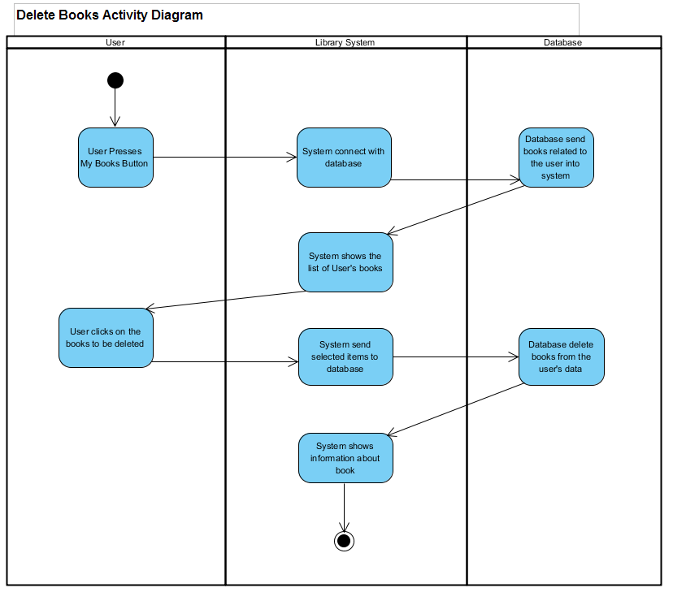

Figure 9 : Delete Book Activity Diagram

**APPENDIX B (GUI Prototype)**

**- User Interface**

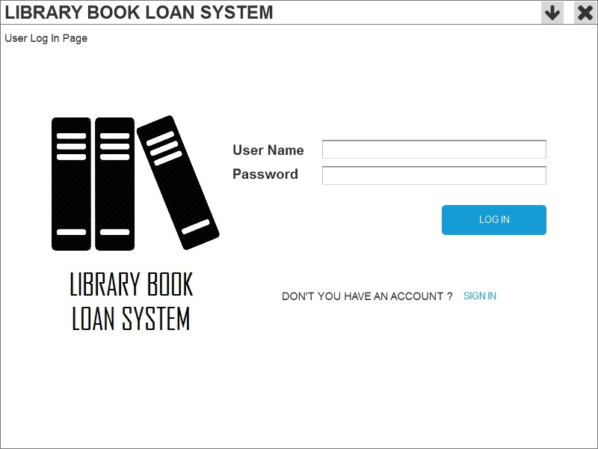

Figure 10 : User Log In Page

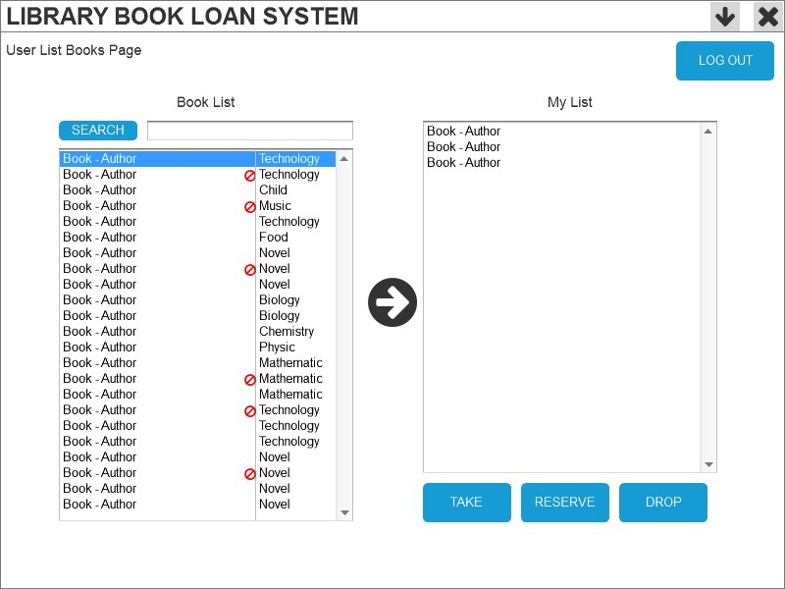

Figure 11 : User List Books Page

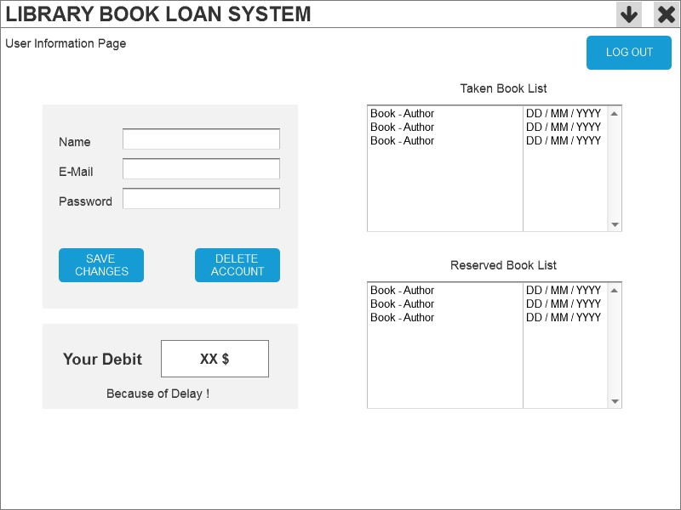

Figure 12 : User Information Page

**- Admin Interface**

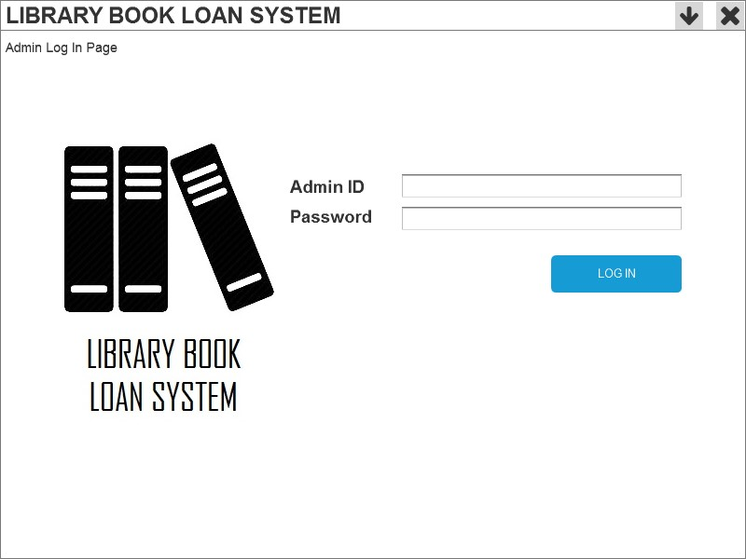

Figure 13 : Admin Log In Page

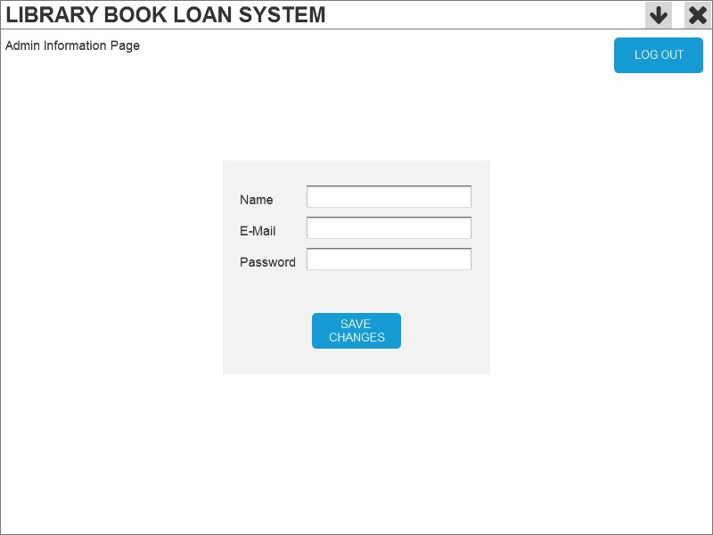

Figure 14 : Admin Information Page

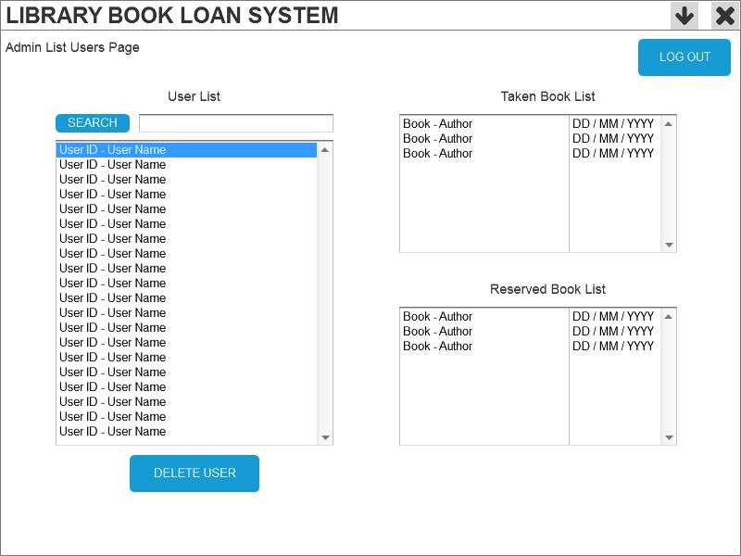

Figure 15 : Admin List Users Page

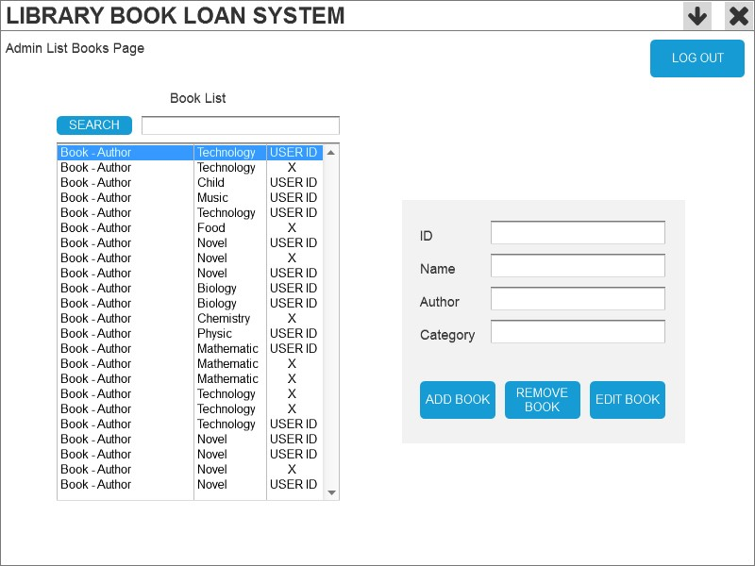

Figure 16 : Admin List Books Page

**APPENDIX C (ER Diagram)**

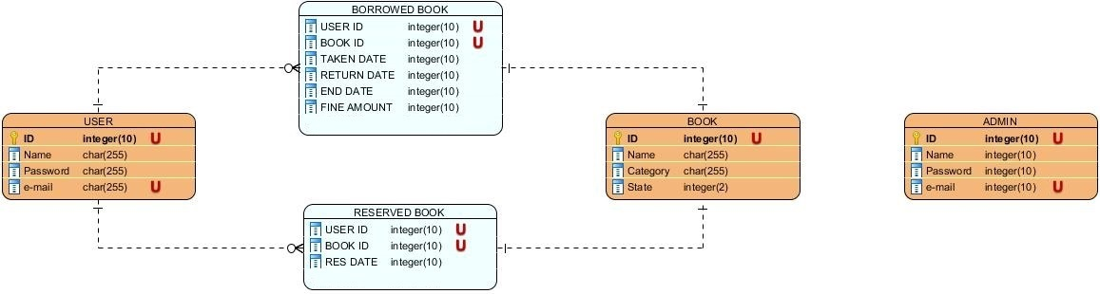

Figure 17 : Entity-Relationship Diagram