## CSE142 – Spring 2016

## Homework #1

**Due: April 21st, 2016, 23:55**

1. Suppose that you wonder the instantaneous height and distance values of an object thrown to air from earth with an angle θ (see the figure below).

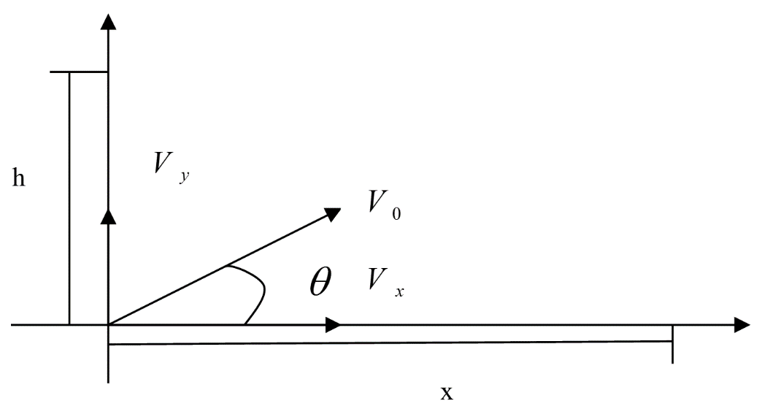

Write a program that calculates and lists on screen the instant height (h) and distance (x) values of the object where the user is able to adjust time intervals.

The program gets the V0, θ and time interval from the user and prints the height and distance values at each time interval. Note that you have to calculate the total flying time.

The program should also give the highest point that it captures and the distance along x axis at highest point.

Relevant formulas are as follows:

Sample runs of the program are as follows:

Enter the V0 value : 20

Enter the theta value : 45

Enter the time step value : 0.5

Vy is : 14.1421

Vx is : 14.1421

Total flying time is : 2.884193

h =

0.00000 5.84524 9.23881 10.18072 8.67097 4.70956

x =

0.00000 7.07107 14.14214 21.21320 28.28427 35.35534

Highest point is : 10.1807

Distance at highest point is : 21.2132

Bye...

========================================

Enter the V0 value : 20

Enter the theta value : 37

Enter the time step value : 0.5

Vy is : 12.0363

Vx is : 15.9727

Total flying time is : 2.454722

h =

0.00000 4.79232 7.13298 7.02197 4.45930

x =

0.00000 7.98636 15.97271 23.95907 31.94542

Highest point is : 7.13298

Distance at highest point is : 15.9727

Bye...

========================================

Enter the V0 value : 20

Enter the theta value : 37

Enter the time step value : 0.2

Vy is : 12.036300

Vx is : 15.972710

Total flying time is : 2.454722

h =

0.00000 2.21113 4.02999 5.45658 6.49091 7.13298 7.38277

7.24030 6.70557 5.77857 4.45930 2.74777 0.64397

x =

0.00000 3.19454 6.38908 9.58363 12.77817 15.97271

19.16725 22.36179 25.55634 28.75088 31.94542 35.13996

38.33450

Highest point is : 7.38277

Distance at highest point is : 19.1673

Bye...

1. Write a program using random function that plays the lottery game “Sayisal Loto” with the user. The input to the program will be number row consisting of 6 numbers. Output of the program will be 5 number rows that are generated by the computer and after them number of truly guessed values.

An example may be as follows:

4 17 25 32 33 48 (Input)

38 45 23 12 34 6 0

49 31 27 33 45 2 1

39 18 17 25 4 48 3

34 22 32 42 25 5 2

15 17 32 4 48 24 4 (Output)

Rules are ;

* No number repetition is allowed.
* Numbers are from 1 to 49.

Notes:

* Write your name, id and at the top line of each submitted file in a commented manner. Ex: // Özgür Yurtsever, 123456789, HW1Q1.
* WARNING: This homework is an individual assignment. Your programs are checked and compared against each other using automated tools. Any act of cheating will be punished. DO NOT GIVE/TAKE YOUR HOMEWORK TO/FROM OTHERS.