10.04.2016

COMPUTER SCIENCE ENGINEERING

COMPUTER PROGRAMMING II

TEACHER: ALİ FUAT ALKAYA

CSE 142

JAVA PROGRAMMING PROJECT

PROJECT NAME: SAVE THE FROGS

PROJECT DESIGNER: OĞUZHAN BÖLÜKBAŞ

PROJECT CODER: OĞUZHAN BÖLÜKBAŞ

FOUNDER OF THE PROJECT’S IDEA: HASAN ŞAŞMAZ

**INTRODUCTION**

In this project, I have designed and coded a basic game with java language and it’s properties. Our hero in this game is a little frog which is on the rock in the waterfall’s near side. It waits to rescue from this dangerous place with helps of us.

**GAMEPLAY AND DESIGN**

Playing this game is very easy. In order to jump the frog, player must press the space key and to pause, he/she must press the “P” key on the key board.

This game has two windows. First of them is entry window. It has 3 buttons that’s names are “Play”, “How to play” and “Scores”. After pressing play button, the input screen opens. After that the main screen are opens.

The entry screen:

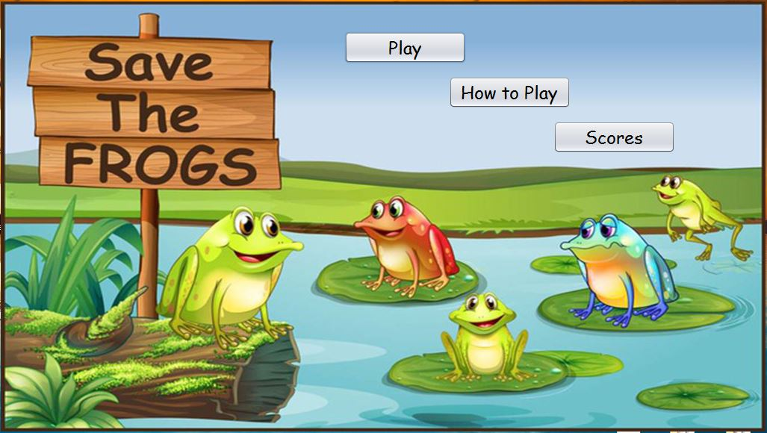

After pressing “Scores” button, this screen are opened:

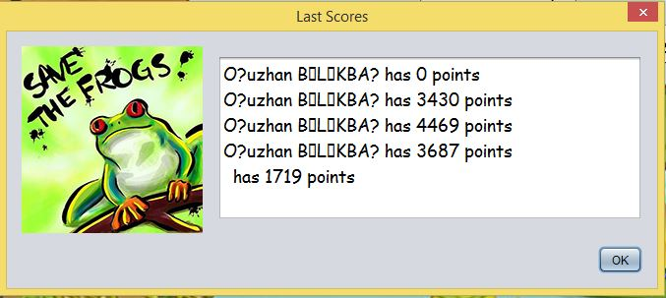

It shows information which stores in “scores.txt” file in the same path with game’s executable file.

Pressing the “How to Play” button opens this window:

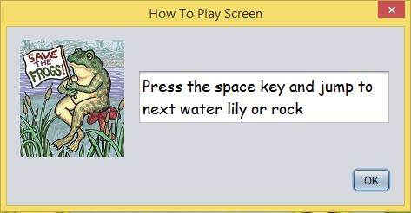

After pressing “Play” button, input screen opens before the game starting:

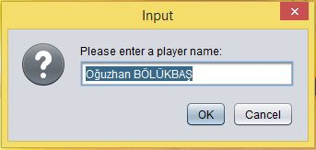

The main screen of the game:

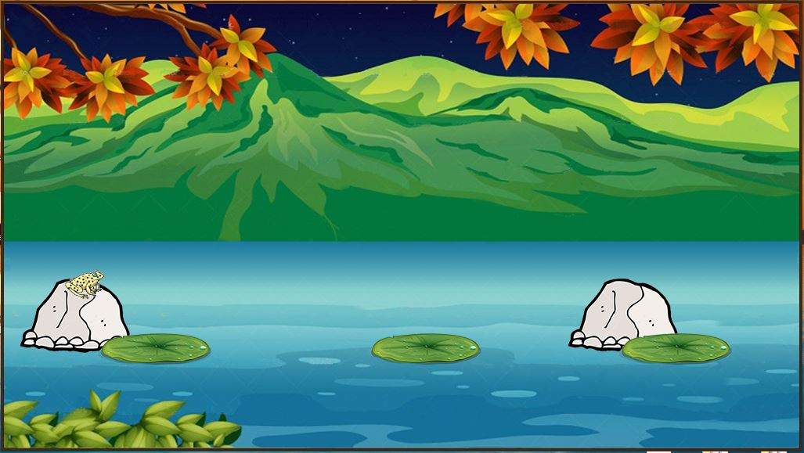

Three possible dies are defined. If we jump to too forward, the frog dies. If we stay too long on the water lilies, the frog and water lily are to be dragged and falls down to the waterfall. The third possible death happens when we jump to the water between water lilies. After the frog death, the scores screen are opens:

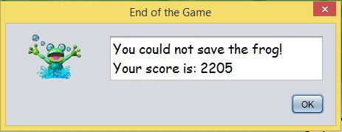

**CODING**

This program contains 4 class, the main JFrame class and the three object class for each frog, lily and rock objects. Every object classes have their own coordinate values and draw methods. The main class creates one frog object with specified coordinates for the beginning of the game, two movable and one unmovable rock object and four movable water lily objects. After reaching the frog to the first movable rock, the first rock does not draw. Other seven objects draws every time with helps of time listeners. Each time listeners triggers their own action listeners. The action listeners changes the coordinates of the seven objects, so we see like the objects moves.

Space key on boards starts frogs time listeners and this listeners triggers its action listeners. The action listeners calls jump methods at every 31 milliseconds. This methods changes the coordinates of the frog like a real jumping frog’s coordinates. After reaching the frog the water lily or rock, the timer stops and variables of the methods are reseted.

“P” key is also used in order to stop to moving every objects. In fact, it stops the two timer. After pressing the p key again or pressing space key, the timers begins to work.