1-) localhost:8080/save/saveairport Method:POST
RequestBody:
airportcode,
airportname

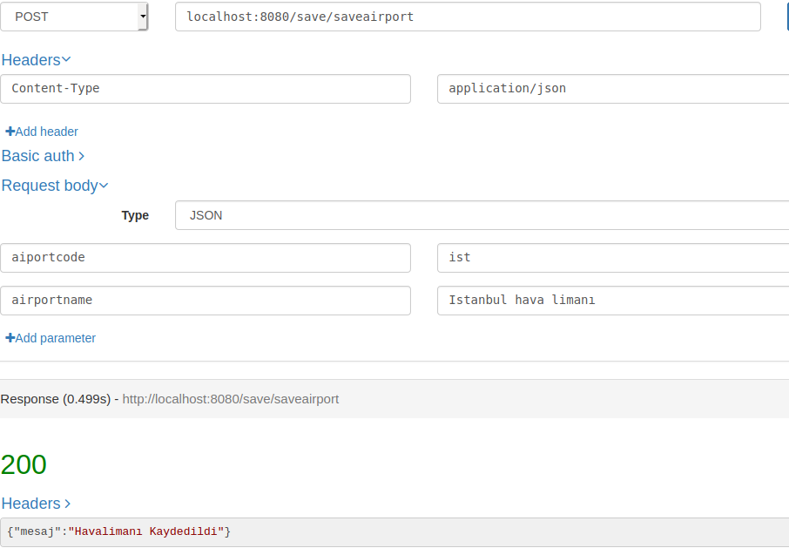

2-) localhost:8080/save/saveairport Method:POST
RequestBody: companyname, headquarter

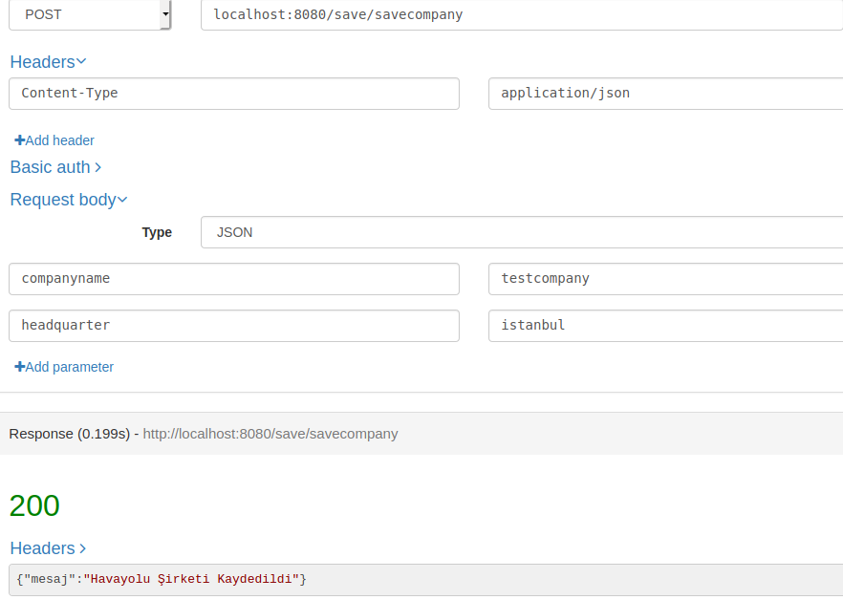
3-) localhost:8080/save/saveroute Method:POST

RequestBody : routeId, departure, arrival

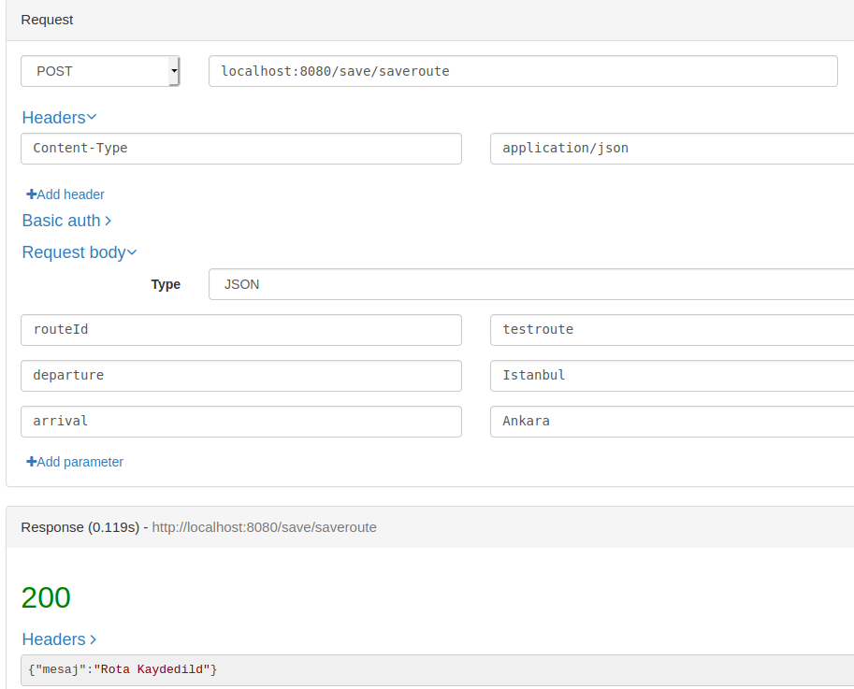

4-) localhost:8080/save/taketicket Method:POST

RequestBody : ticketnumber, departure, arrival, passangername, seatnumber,
flightno
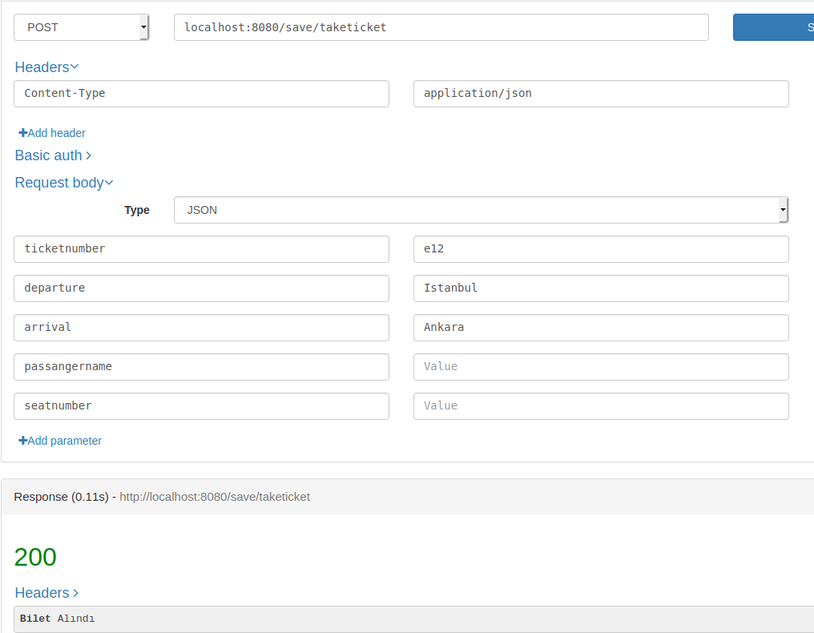

5-) localhost:8080/save/cancelticket/{ticketno} →path param Method:POST

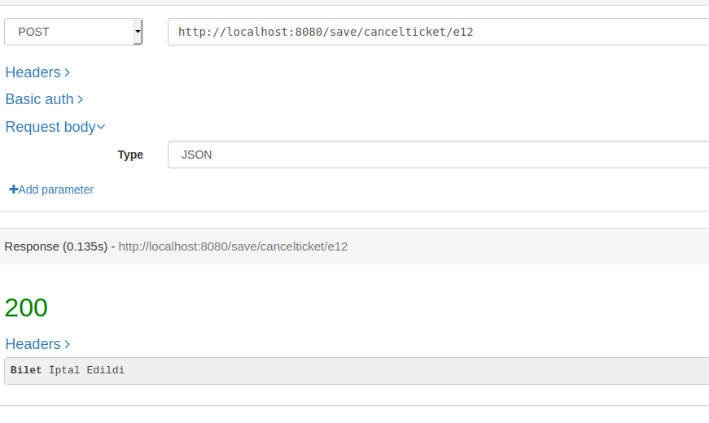
6-) localhost:8080/save/saveflight Method:POST

Request Body : flightnumber, departure, arrival, companyname, headquarter
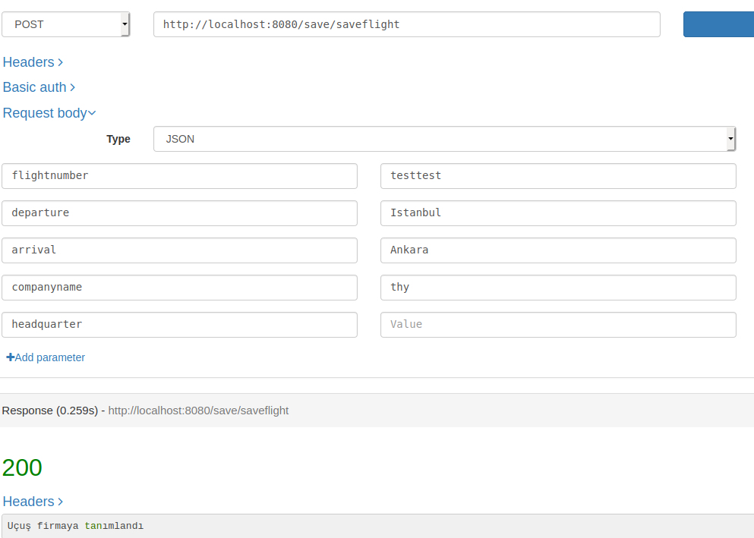

7-)localhost:8080/search/companysearch Method:GET
RequestParam: key
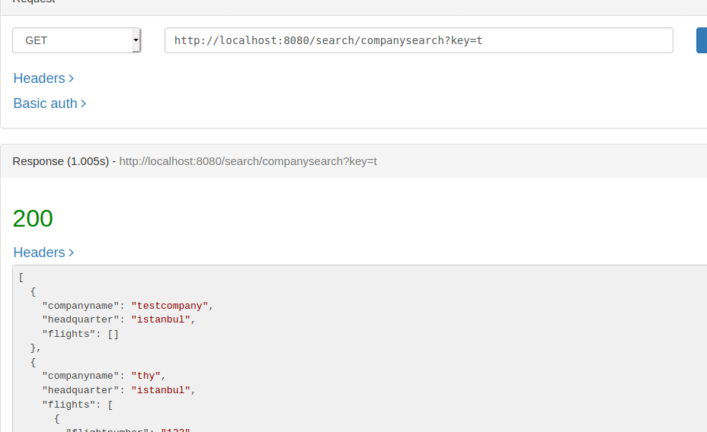

8-)localhost:8080/search/companysearch Method:GET
RequestParam: companyname, flightkey

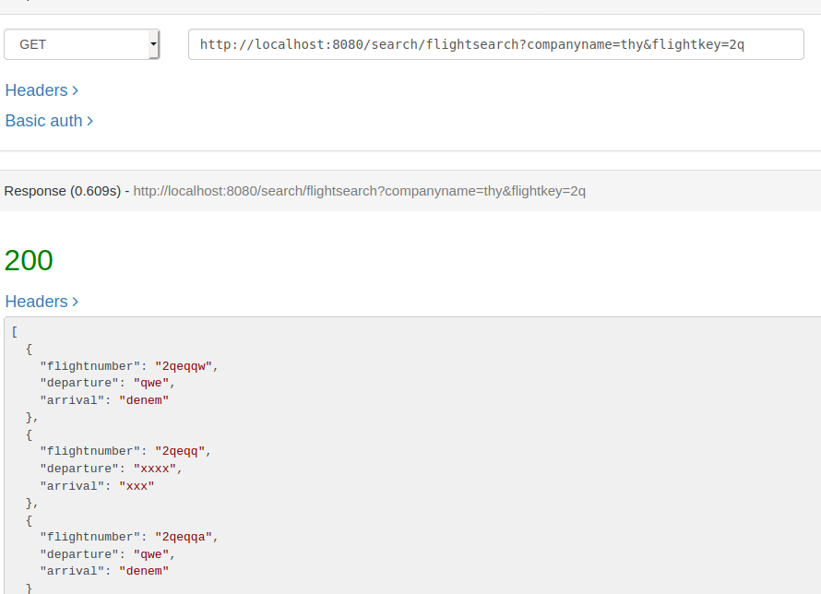

9-)localhost:8080/search/routesearch Method:GET
RequestParam: routeid

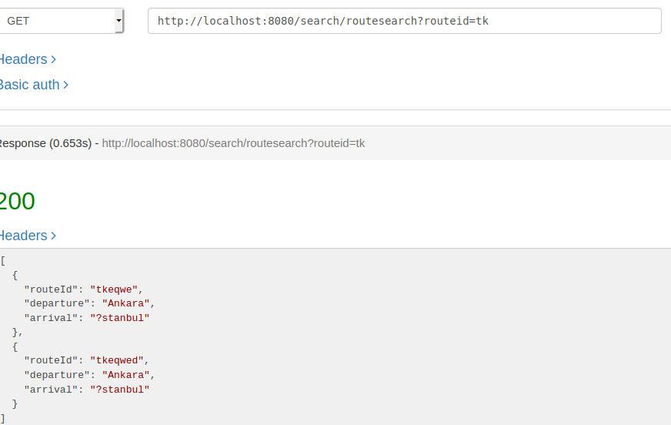

10-)localhost:8080/search/airportsearch Method:GET
RequestParam: key

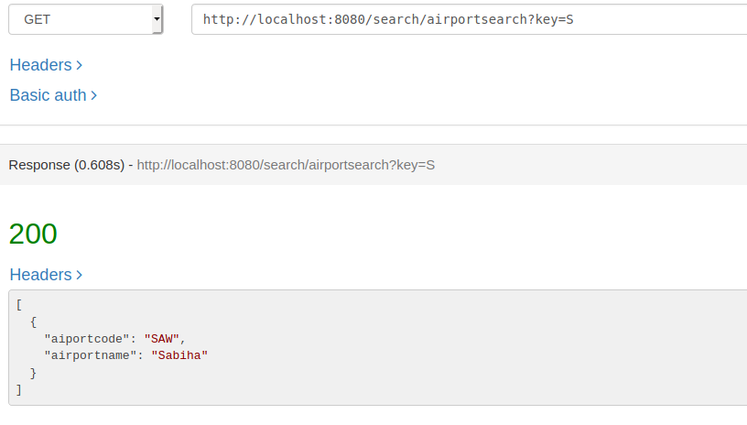

11-)localhost:8080/search/ticketsearch Method:GET
RequestParam: key

