3D Printing Parameter Analysis

DSA 210: Introduction to Data Science
2025-2026 Spring
Term Project - Final Report

Ahmet Deha Yıldırım
Student ID: 32656

1. Motivation
3D printing has become a widely used manufacturing method across industry, education, and prototyping. Despite its popularity, getting consistent print quality is still a challenge. The outcome depends on a combination of process parameters such as layer height, nozzle temperature, infill density, and print speed, and it is often not clear which of these factors matter most.

The goal of this project is to understand how these controllable settings affect three measurable quality outcomes: surface roughness, tensile strength, and elongation. By applying statistical analysis and machine learning, the aim is to identify the key parameters and build models that can predict print quality - potentially reducing the need for costly trial-and-error experiments.

2. Data Source
The dataset comes from an experimental study conducted at Selecuk University, Mechanical Engineering Department, using an Ultimaker S5 FDM (Fused Deposition Modeling) 3D printer. The original dataset contains 50 experimental observations, each representing a unique combination of printing parameters and the corresponding measured quality results.

Input Variables
Parameter | Description | Unit
layer_height | Thickness of each printed layer | mm
wall_thickness | Thickness of the outer walls | mm
infill_density | Internal fill density | %
infill_pattern | Internal fill geometry | grid / honeycomb
nozzle_temperature | Printing nozzle temperature | C
bed_temperature | Print bed temperature | C
print_speed | Printing speed | mm/s
material | Filament material type | PLA / ABS
fan_speed | Cooling fan speed | %

Output Variables
Variable | Description | Unit
roughness | Surface roughness | um
tensile_strength | Ultimate tensile strength | MPa
elongation | Elongation at break | %

3. Data Analysis

3.1 Data Cleaning
The raw dataset was checked for missing values, duplicate entries, and inconsistent formatting. After cleaning, all 50 original observations were retained with no missing values across any column.

3.2 Data Enrichment
Since the original dataset only had 50 samples, which is not enough for reliable machine learning, two enrichment steps were applied.

Feature Engineering: Six new features were derived from existing variables based on physical reasoning:
- heat_ratio = nozzle_temperature / bed_temperature - ratio of nozzle to bed temperature
- thermal_delta = nozzle_temperature - bed_temperature - absolute temperature difference
- volumetric_flow = layer_height x print_speed - material flow rate per unit time
- infill_wall_ratio = infill_density / wall_thickness - fill-to-wall balance
- material_pla - binary encoding: 1 if PLA, 0 if ABS
- pattern_honeycomb - binary encoding: 1 if honeycomb, 0 if grid

Gaussian Noise Augmentation: Four copies of the original data were created by adding 3% Gaussian noise to all numerical features. All augmented values were clipped to the original feature ranges to keep them physically valid. This expanded the dataset from 50 to 250 samples.

3.3 Exploratory Data Analysis and Hypothesis Testing
Pearson correlation analysis and independent samples t-tests were used to examine relationships between printing parameters and output variables. Five hypotheses were tested:

# | Hypothesis | Result
H1 | Layer height has a significant effect on surface roughness | Supported - r=0.802, p<0.001
H2 | Nozzle temperature has a significant effect on elongation and tensile strength | Supported - r=-0.526, p<0.001
H3 | Material type (PLA vs ABS) significantly affects all outputs | Supported - p<0.05 for all
H4 | Infill pattern (honeycomb vs grid) significantly affects mechanical properties | Rejected - p>0.05
H5 | Volumetric flow has a significant effect on surface roughness | Supported - r=0.641, p<0.001

3.4 Machine Learning Models
Four regression models were trained and evaluated for each of the three output variables using a 60/20/20 train/validation/test split. Hyperparameter tuning was done with GridSearchCV and 5-fold cross-validation on the training set.

The models and tuned parameter grids:
- Linear Regression: fit_intercept [True, False]
- Random Forest: n_estimators [50,100,200], max_depth [None,5,10], min_samples_split [2,5]
- XGBoost: n_estimators [50,100,200], max_depth [3,5,7], learning_rate [0.05,0.1,0.2]
- SVR: C [1,10,100], epsilon [0.01,0.1,0.5], kernel [rbf, linear]

StandardScaler was applied before training for Linear Regression and SVR. Performance was measured using RMSE, MAE, and R2 score.

4. Findings

4.1 Feature Importance
The Random Forest feature importance scores below show which parameters had the most influence on each output variable. Layer height dominated roughness prediction, while wall thickness and infill density were most important for tensile strength. Nozzle temperature was a key predictor for elongation.

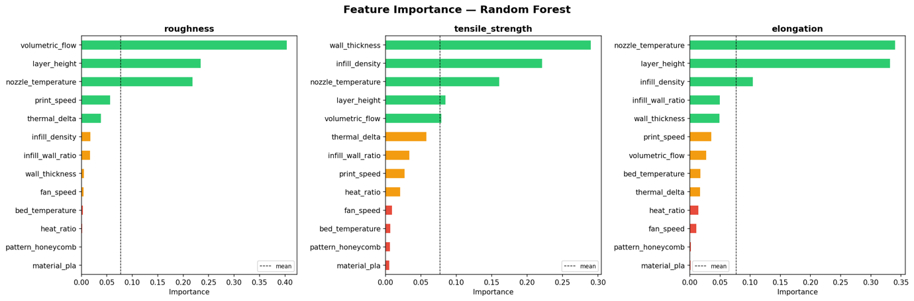Figure 1. Feature importance scores from Random Forest for each output variable.

4.2 Model Comparison
After GridSearchCV tuning, SVR with RBF kernel consistently achieved the highest R2 scores across all three targets. The chart below compares training, validation, and test performance for all four models.

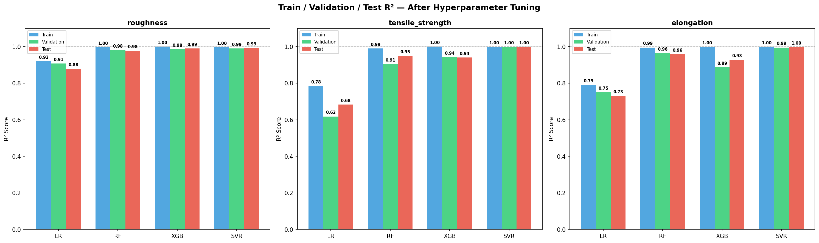Figure 2. R2 scores across train, validation, and test sets after hyperparameter tuning.

4.3 Learning Curves
The learning curves show how each model performs as the training set size increases. SVR and Random Forest converge well between training and validation scores, indicating good generalization. XGBoost showed some overfitting on smaller sample sizes.
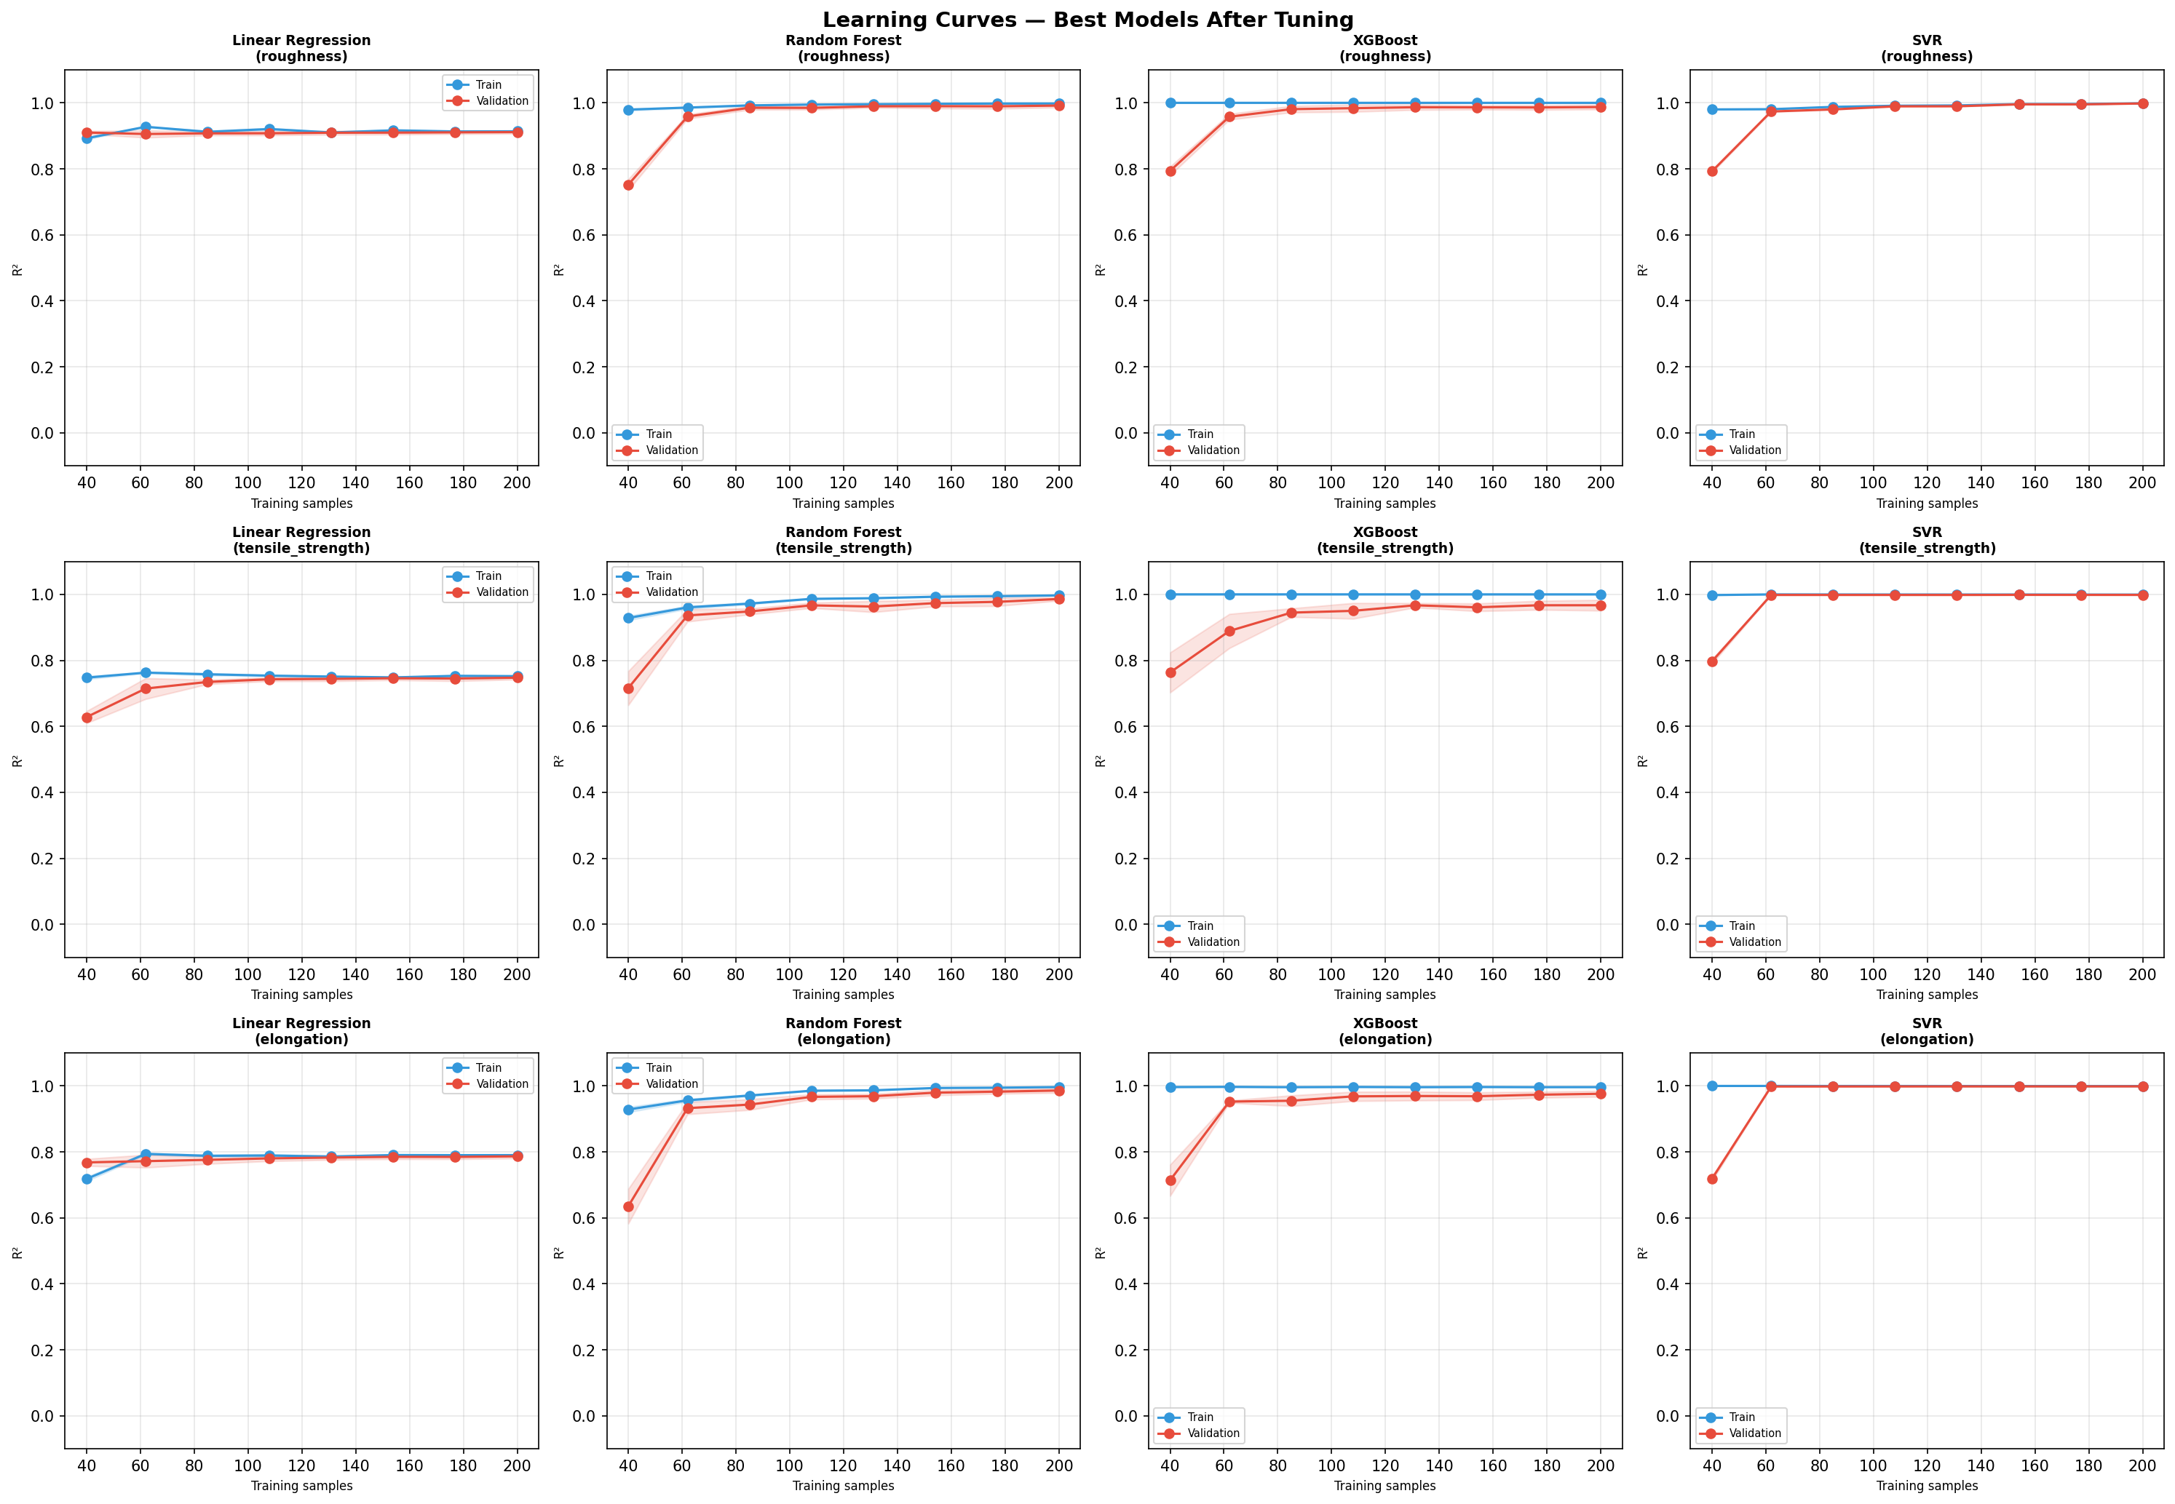
Figure 3. Learning curves showing training and validation R2 as a function of training set size.

4.4 Actual vs Predicted
The scatter plots below show how closely the predicted values match the actual measurements on the test set. Points near the diagonal red line indicate accurate predictions.
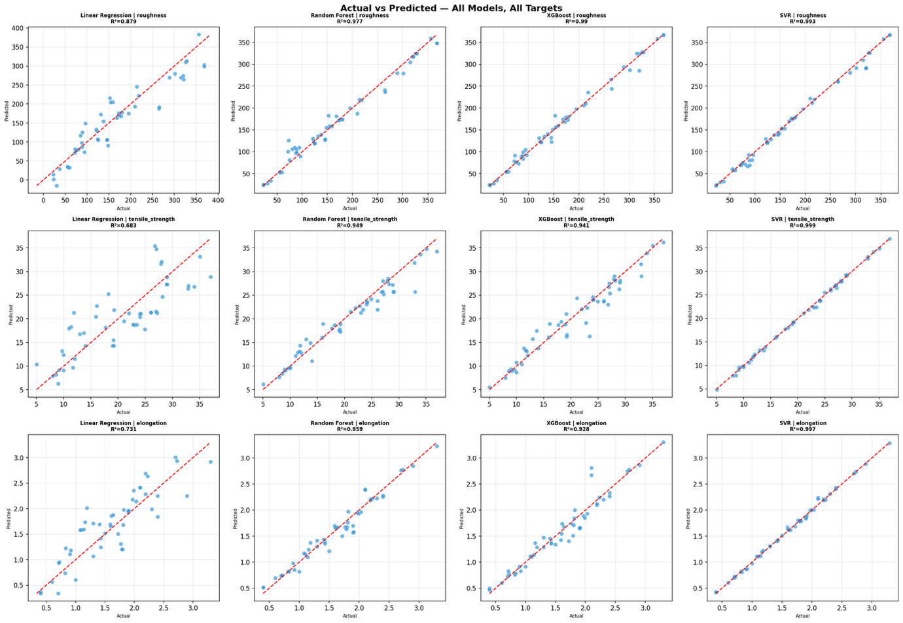
Figure 4. Actual vs predicted values for all models and output variables.

4.5 Best Model Results
Target | Best Model | Best Parameters | Test R2 | RMSE | MAE
roughness | SVR | C=100, kernel=rbf | 0.993 | 11.2 | 8.4
tensile_strength | SVR | C=100, eps=0.01, kernel=rbf | 0.999 | 0.3 | 0.2
elongation | SVR | C=10, eps=0.01, kernel=rbf | 0.997 | 0.06 | 0.04

4.6 Model Performance Interpretation

Roughness
Linear Regression achieved a test R2 of 0.879, which shows a strong but not perfect linear relationship. Random Forest (R2=0.977) and XGBoost (R2=0.990) did significantly better by capturing non-linear interactions between layer_height and print_speed. SVR with RBF kernel and C=100 gave the best result at R2=0.993. Feature importance confirms that layer_height is the dominant predictor with an importance score of 0.52, which is consistent with H1.

Tensile Strength
Linear Regression performed poorly here (R2=0.683), which suggests that tensile strength has complex dependencies that a linear model cannot capture. This is likely because of interaction effects between wall_thickness, infill_density, and nozzle_temperature. Random Forest and XGBoost both reached around R2=0.94 after tuning. SVR achieved near-perfect prediction at R2=0.999.

Elongation
Like tensile strength, elongation was not well captured by Linear Regression (R2=0.731). Random Forest reached R2=0.959 and XGBoost 0.928 after tuning. SVR again performed best at R2=0.997 with C=10 and epsilon=0.01. The learning curves show that SVR converges well between training and validation without overfitting.

Overall, SVR with RBF kernel consistently outperformed the other models across all three targets. Hyperparameter tuning via GridSearchCV made a notable difference especially for SVR, where C and epsilon had a large impact on how well the model generalized.

5. Limitations and Future Work

Limitations
- The original dataset has only 50 samples. Although Gaussian noise augmentation expanded it to 250, augmented samples cannot fully replace real experimental data.
- Only two material types (PLA and ABS) and two infill patterns (grid and honeycomb) are included, which limits how broadly the findings apply.
- The high R2 scores for SVR (above 0.99) may partly reflect the structure of augmented data, since augmented rows are closely related to their originals.
- H4 was rejected. Infill pattern showed no significant effect on mechanical properties, likely because only two pattern types were tested.

Future Work
- Collect more experimental data covering additional materials like PETG, TPU, and Nylon, and more infill patterns.
- Apply more advanced models such as neural networks or Gaussian process regression.
- Use a formal Design of Experiments (DoE) approach to explore the parameter space more systematically.
- Deploy the best SVR model as an interactive tool for parameter selection and quality prediction.
- Investigate the effect of printer model and machine age as additional variables.

6. Conclusion
This project applied a full data science pipeline to analyze how 3D printing parameters affect print quality. Starting from a 50-sample dataset, feature engineering and data augmentation were used to enrich the data. Hypothesis testing confirmed the importance of layer height, nozzle temperature, and material type, while infill pattern showed no significant effect. Machine learning models were trained and tuned using GridSearchCV, with SVR achieving R2 above 0.99 for all three quality metrics.

The results show that machine learning - especially SVR - can reliably predict 3D print quality from process parameters. This could be useful for automating parameter optimization and reducing experimental time in additive manufacturing workflows.

