

Ahmet Furkan Teke – 150120202

**IT Systems Analysis and Design**

**HOMEWORK #2**

* Write a class called **Polygon** that has two fields: an int for the **number of sides** and a double for the **area**. Add a method called **getNumberOfSides()** that prints out and returns the number of sides.

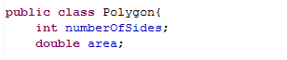

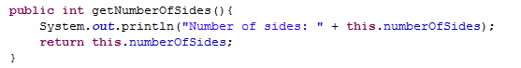

* Override the **toString()** method in Polygon to return a nice string representation of your Polygon class.



* Add a constructor to **Polygon** that takes in an int to represent the number of **sides** and prints out the message “Inside Polygon constructor.”

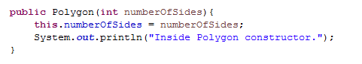

* Write a class called **Triangle** that extends **Polygon**. Add two int fields: one for the **base** and one for the **height**. (Triangles have a base and a height.)



* Add a constructor to **Triangle** that takes in two int’s for the **base** and **height**. The constructor needs to use **super()** to invoke the constructor in Polygon, passing in 3 for the number of sides. Print out the message “Inside Triangle constructor.”

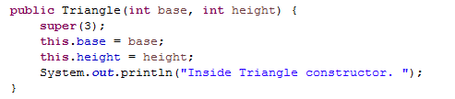

* Add a **toString()** method to Triangle that prints out the triangle’s base and height.



* Add a **getArea()** method to Triangle that computes and returns the area. The formula for the area of a triangle is:

area = 1/2 (base * height)

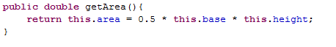

* Write a class called **RightTriangle** that extends your **Triangle** class.

Add a field of type double called **hypotenuse** to represent the longest side of a right triangle.



* Add a constructor that takes in two int’s to represent the base and height. Pass these two values up to the Triangle constructor and then use these two values in the constructor to compute the hypotenuse field. The formula is:

hypotenuse = sqrt(base*base + height*height)

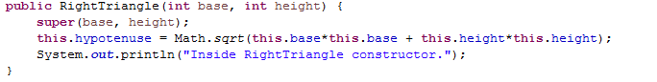

* Use the Math.sqrt() function to compute the square root. Math.sqrt() takes in a double and returns a double. Also, print out a message stating “Inside RightTriangle constructor.”
* Add the **toString()** method to **RightTriangle**. Use **super** to invoke **toString()** in the parent and concatenate the result with the hypotenuse.

