**ISE307 IT Systems Analysis and Design Homework 3**

Implement a class Robot that simulates a robot wandering on an infinite plane. The robot is located at a point with integer (x,y) coordinates and faces north, east, south, or west. Supply following methods

public void turnLeft()

public void turnRight()

public void move()

public Point getLocation()

public String getDirection()

The turnLeft and turnRight methods change the direction but not the location.

The move method moves the robot by one unit in the direction it is facing.

The getDirection method returns a string “N”, “E”, “S”, or “W”.

Supply a Point class to represent the location of the robot on the plane. Use this class as the return value of the getLocation method.

Implement a GridRobot class that inherits from the Robot class. GridRobot class has the

following features:

* Each GridRobot instance has a name. Override toString() method of the Object class so that the name of the GridRobot instance is written to the screen. The name must be set as a constructor parameter.

* Instances of the GridRobot class move on a FINITE plane which is a grid of size GRID_WIDTH x GRID_HEIGHT.

* Override the move() method of the Robot class so that GridRobot instances only move inside the grid. When they are on the edges, they respond the move requests with error messages (e.g, “The Robot X can't move in the NORTH direction since it is outside the grid”)

Use your GridRobot class to the user by means of the following GUI:

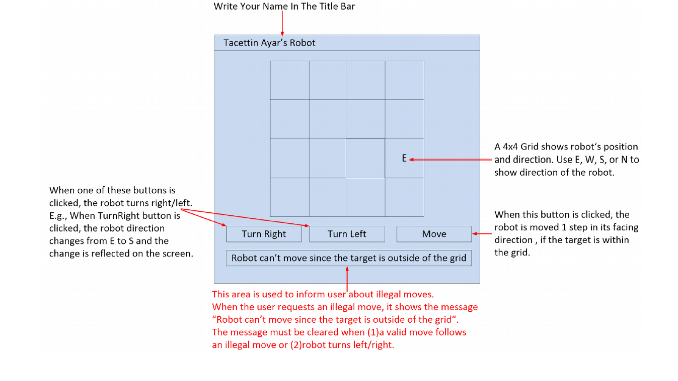

Note that your grid length must be at least 20x20 and initial position and direction of the robot can be arbitrary.

In your report you should add the screenshots of your running codes!!!!