**ISE307 IT Systems Analysis and Design Homework 3**

Ahmet Furkan TEKE - 150120202

Point Class

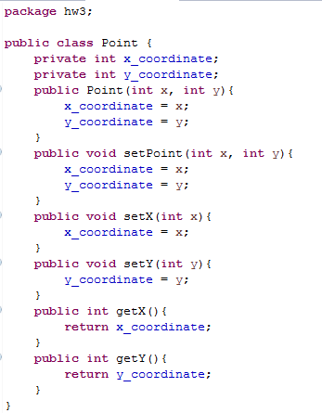

Robot Class

Direction keeps direction desired to go, N = North, W = West, S = South, E = East

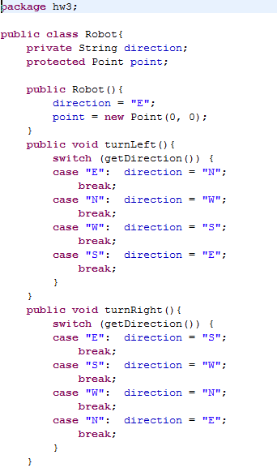

Move is on infinitive space, no checking

Returned string is going to use by label

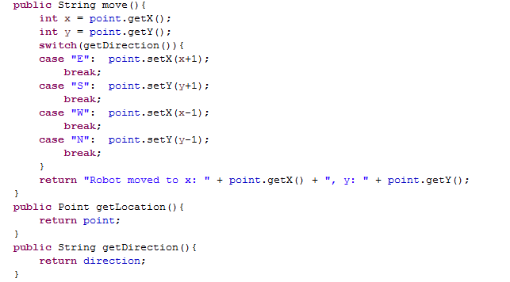

GridRobot Class

Uses super class constructor

Move checks the desired move is legal or not

Returns message to use by label

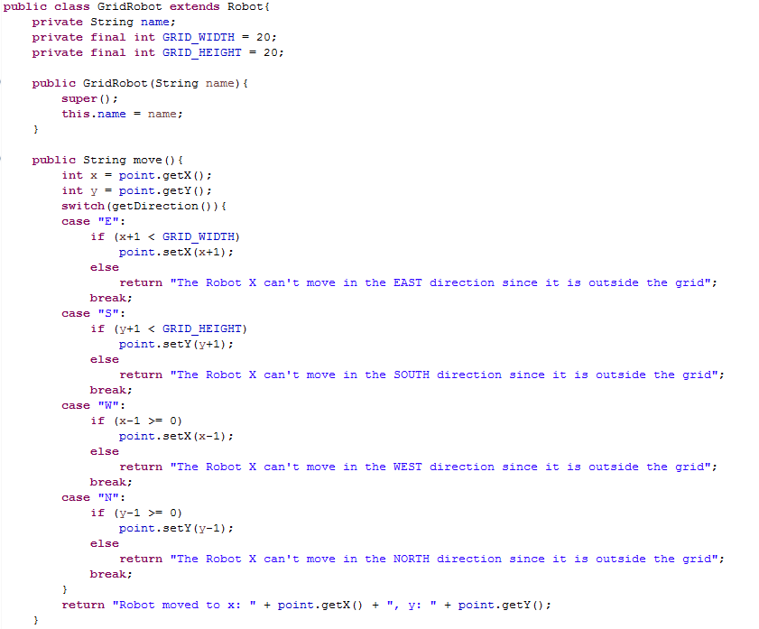

To string is overrided

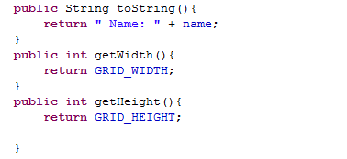

Panel Class (Main & GUI)

I used images to represent directions

EAST NORTH SOUTH WEST



INITIAL PAGE

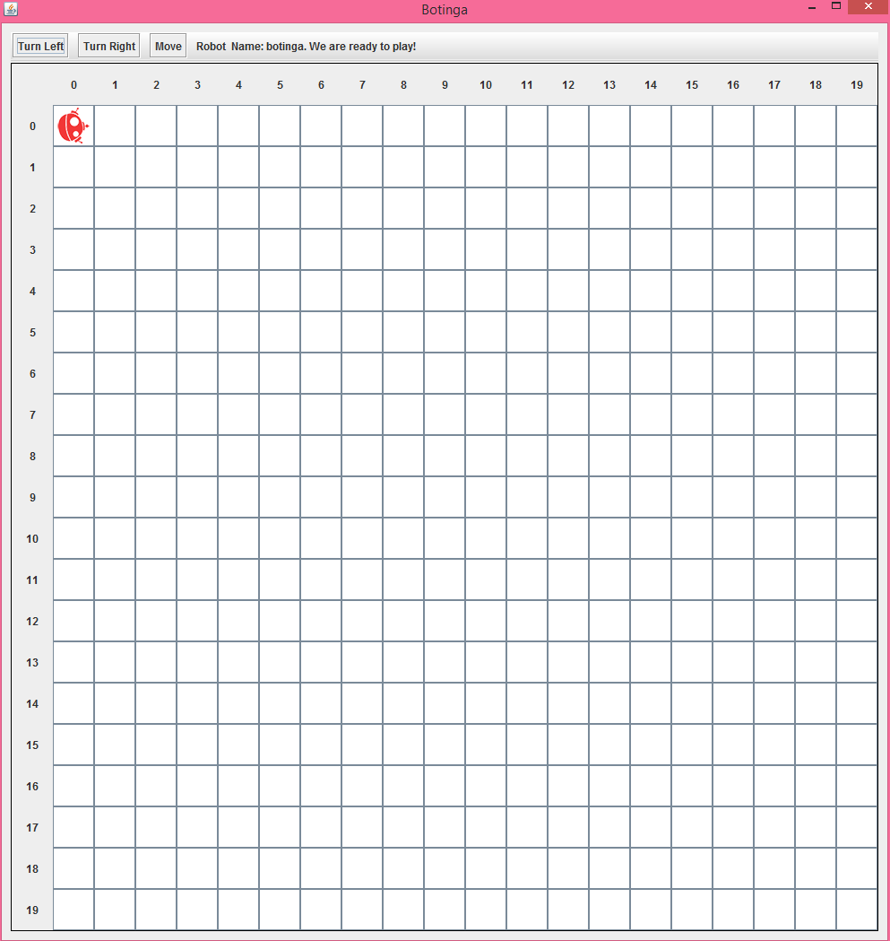

Turn Right

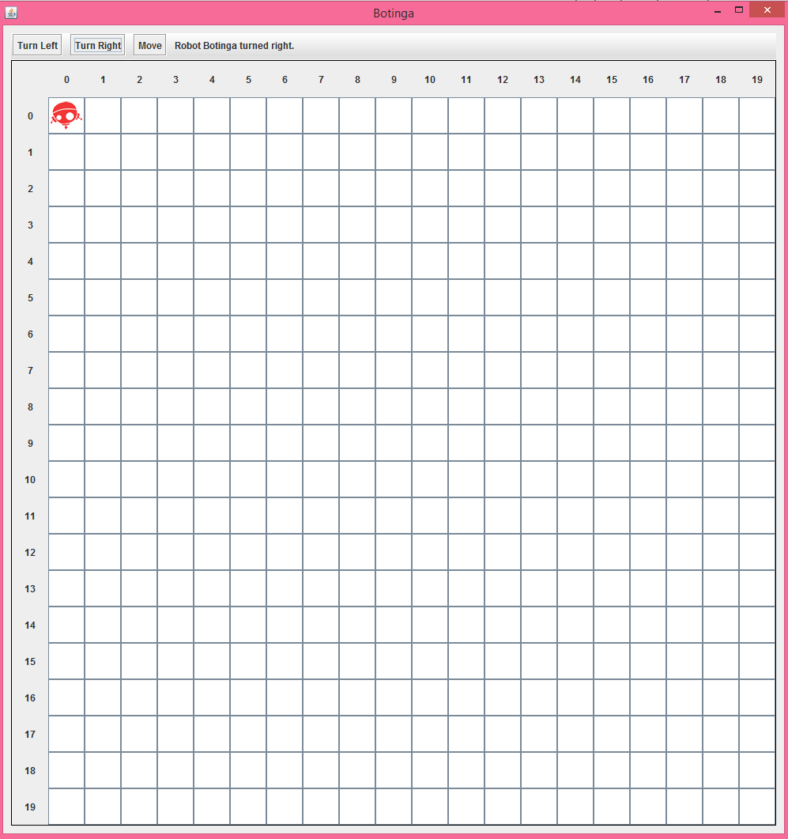

Move (Legal Move)

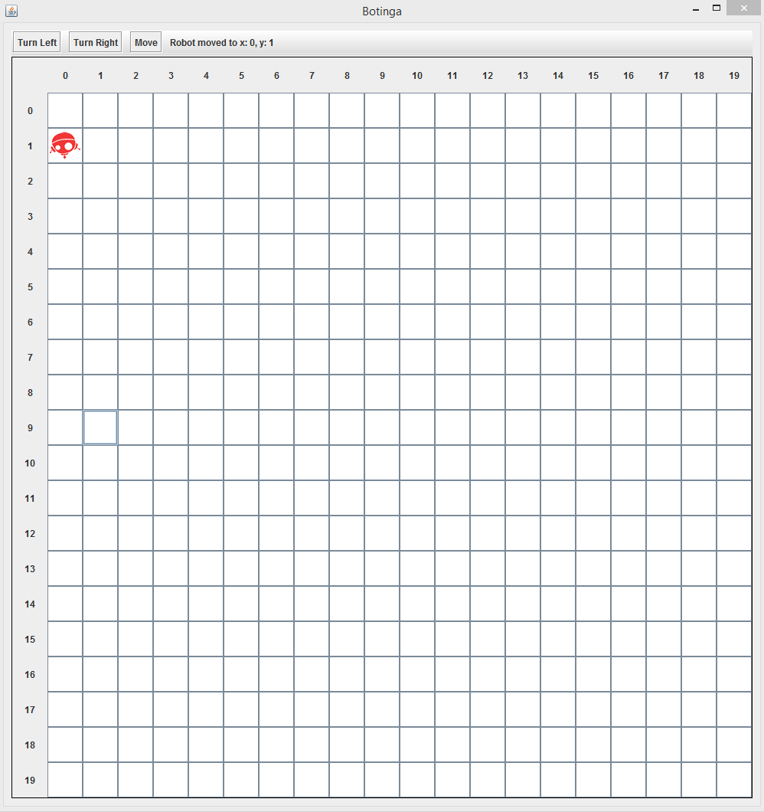

Illegal Move