## 1 Error analysis (20 pts)

**Consider the function sin(x) and the following Taylor series:**

**(a) Use MATLAB/OCTAVE to plot :**

* **The real sin(x) function,**
* **The sum of the first 7 terms of the series,**
* **The sum of the first 8 terms of the series**

**on the same graph. What change do you observe as you use more terms from the series?**

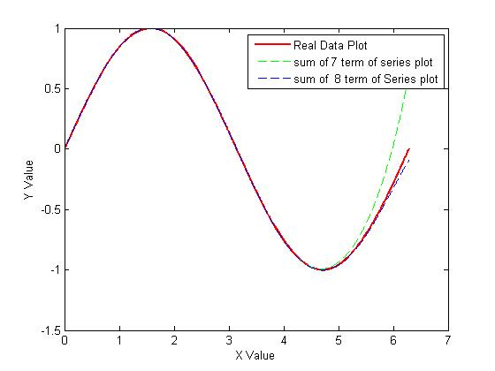

**(b) Use MATLAB/OCTAVE to sum the first 7 terms of the series for x = 1.4 π. What is the relative true error?**

y = -0.9511 = sin(1.4 π)

When using this formula to sum the first 7 terms of the series for x = 1.4 π is

When x=1.4 π

* True Error = True Value – Approximate Value :

= |-0.9511-0.9479| = 0.0032

* Relative true error
* Percent error : 0.0033x100 = 0.33%

**(c) How many terms do you need to include in the sum for the relative true error to become less than 1%?**

The terms do you need to include in the sum for the relative true error to become less than 1% is 2 .

**(d) How many terms do you need to include in the sum for the relative approximation error to become less than 1%?**

The terms do you need to include in the sum for the relative approximation error to become less than 1% is 4.

## 2 Error measurement on floating point number (15 pts)

**Consider a computer that uses 16 bits to represent floating-point numbers (Table 1). 1 bit for sign of number, 1 bit for sign of exponent, 4 bit for exponent, 10 bit for mantissa**

**Table 1: 16 bits to represent floating-point numbers**

1. **What is the machine epsilon for this computer?**

**The machine epsilon is as follow.**

1. **How would (571, 632) 10 be represented in this system? What is the relative true error in this representation?**

(571, 632) 10=(10001011100011110000) 2

In this system: (10001011100000000000) 2=571392

Thus, the relative true error=

## 3 Linear Equations (10 pts)

**Solve the system below using LU decomposition**

**x1+ 2x2 + x3 = 0**

**8x2+ 6x3= 10**

**2x1+ 5x3 = 11**

The linear equation can be written as follow.



Step 1: finding the U matrix

Row3-Row1*2= 

Row3-Row2*(-1/2)= 

Thus, [U]=

Step 2: finding the L matrix



 : =

 : =

Thus, [L]=

Set [L][Z]=[C]

Z1=0

Z2=10

Z1*2+z2*(-1/2)+z3=11

z3=16

[Z]=

Set [U][X]=[Z]

X3=8/3

X2*8+x3*6=10

X2=-3/4

X1+x2*2+x3=0

X1=-7/6

Thus, the solution vector

## 4 Interpolation (30 pts)

**Scientists try to understand following observation data and come with a formulation to determine the relationship between x and y in Table 2.**

**Table 2: Observation data.**

**X(cm) y(cm)**

**2.00 7.2**

**4.25 7.1**

**5.25 6.0**

**(a) Using quadratic Lagrange (second order Lagrange polynomial) method what is the value of y at x = 4.00**

**(b) Plot the resulting functions in MATLAB/OCTAVE**

**(a) Using quadratic Lagrange (second order Lagrange polynomial) method what is the value of y at x = 4.00**

Solving the above three equations gives

Thus,

The value of y at x=4.00

**(b) Plot the resulting functions in MATLAB/OCTAVE**

The plot of resulting function is as follow.

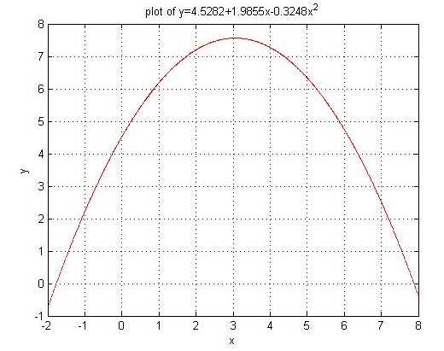

**5. Root calculation (25 pts)**

**Write a MATLAB/OCTAVE code that calculates the root of the function:**

**f(x) = x*cos(x)-sin(x)**

**using the Newton-Raphson method. Conduct three iterations to estimate the root of the above equation. Calculate and plot the absolute relative approximate error at the end of each iteration using initial condition x0 = 1.**

Iteration 1:

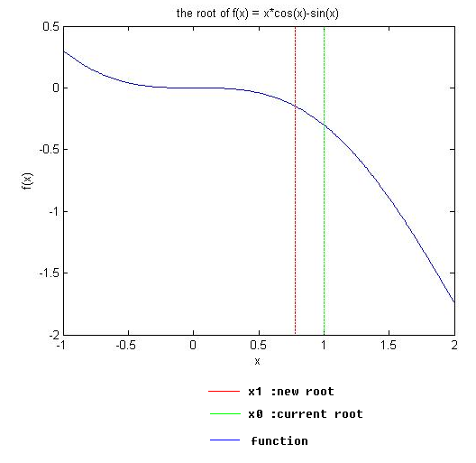

Iteration 2:

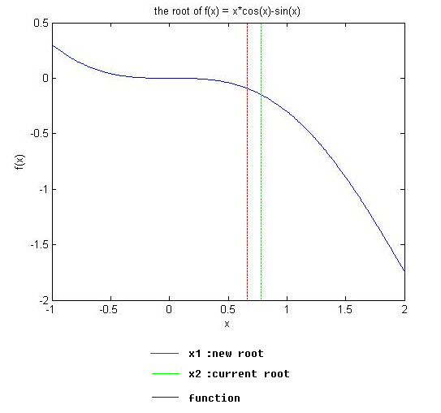

Iteration 3:

