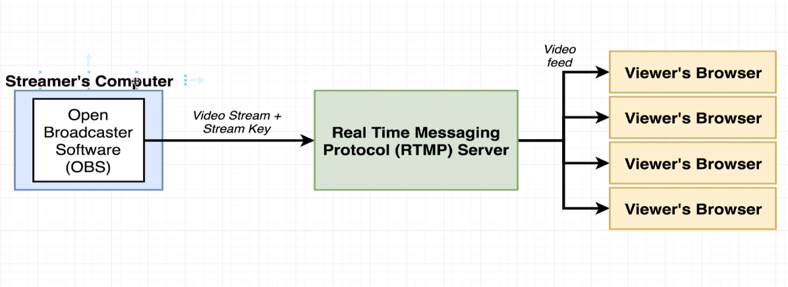

**HOW TO INSTALL DEPENDENCIES OF REACT-ROUTER**

npm install --save react-router-dom

196-1:47 <insert diagram here>

197-2:07 <insert diagram here>

198-3:07 <path property diagram>

199-2:10 <bad navigation diagram>

200-2:57 <Link tag diagram>

