CTIS 365-1 Applied Data Analysis HW1 + HW2

Ahmet Oğuz Ergin 21903070

Emre Karaçal 21903232

**Summary**

**Analysis of Climate Change and Its Impacts on Nature**

Climate change is one of the most pressing global challenges of our time, with far-reaching implications for nature and the environment. This study will analyze climate change and its various effects on nature using various types of sources and visualization techniques, which will be combined to derive both descriptive and inferential statistical conclusions.

Climate change refers to long-term shifts in temperature and weather patterns caused primarily by human activities, such as the burning of fossil fuels and deforestation. These activities release greenhouse gasses into the atmosphere, trapping heat and leading to a rise in global temperatures. As a result, the Earth's ecosystems are experiencing significant changes, which can have profound consequences for biodiversity, ecosystem services, and human well-being. This analysis will focus on several key parameters to assess the impacts of climate change on nature.

Table 1. Descriptive Statistics Carbox Dioxide PPM Values Between Years 1958 and 2017 [1].

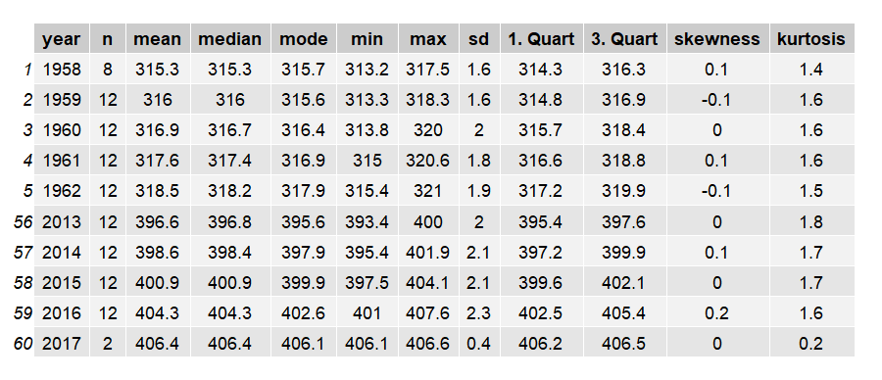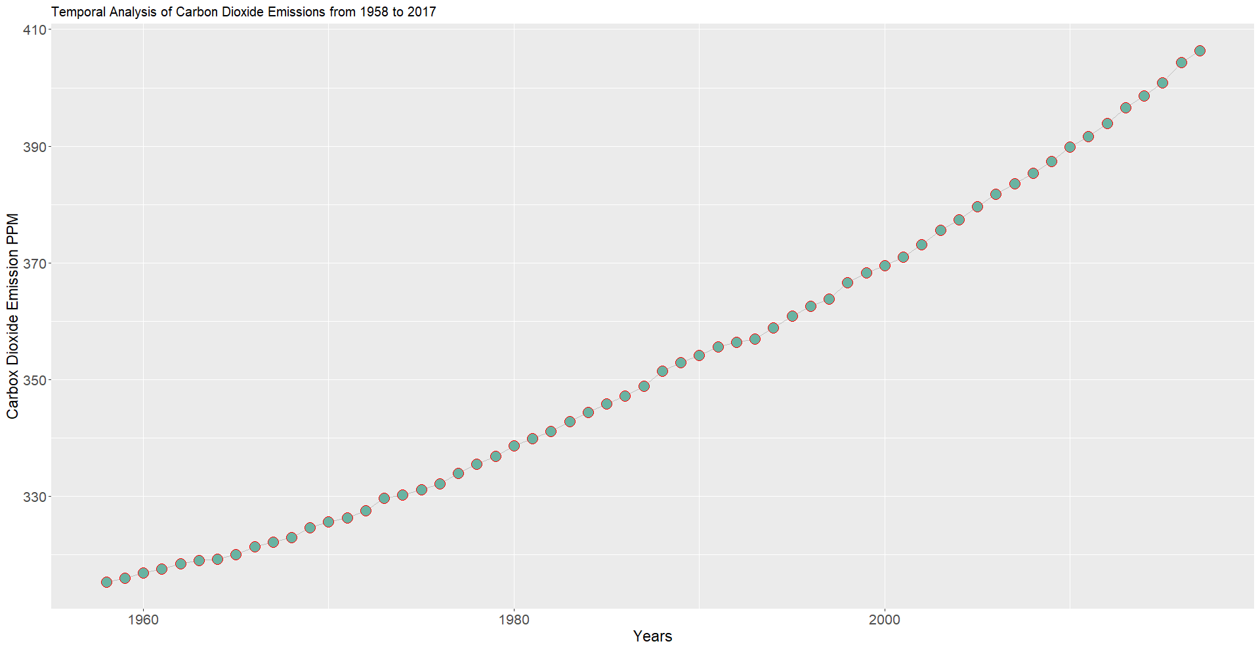

Figure 1. Carbox Dioxide PPM Values Between Years 1958 and 2017.

Firstly, temperature changes will be examined to understand the extent of warming and its effects on ecosystems and species adaptation. Rising temperatures can alter growing seasons, shift species' ranges, and disrupt critical ecological processes.

Secondly, precipitation patterns will be analyzed, including changes in rainfall intensity, frequency, and distribution. Alterations in precipitation can affect water availability, vegetation growth, and wildlife habitats. Changes in precipitation can lead to droughts in some regions, while causing increased rainfall and flooding in others.

Sea-level rise, another important parameter, will be investigated to understand its implications for coastal areas and associated ecosystems. Rising sea levels result from the melting of glaciers and ice sheets, as well as the expansion of seawater due to warming. Coastal regions face increased risks of erosion, loss of habitat, and heightened vulnerability to storm surges and flooding.

Lastly, the analysis will explore the impact of climate change on biodiversity. Changes in temperature and precipitation patterns can disrupt ecosystems and lead to the loss of species, changes in species composition, and disruptions to critical ecological interactions. Biodiversity loss not only threatens the survival of individual species but also affects the overall functioning and resilience of ecosystems.

To conduct this analysis, reliable data sources such as climate monitoring stations, satellite observations, and scientific reports will be utilized. Statistical techniques, and modeling approaches will be employed to analyze the data and identify observed impacts.

Key Parameters and Data Sources

To analyze the impacts of climate change on nature, it is essential to focus on key parameters and utilize reliable data sources. There are some important parameters that will be explored in this analysis, along with the selection of appropriate data sources.

Temperature Changes

Temperature is a fundamental parameter in assessing climate change impacts. Historical temperature records from meteorological stations, satellite data, and climate models provide valuable insights into long-term trends and variations. Data sources provided by the Food and Agriculture Organization Corporate Statistical Database (FAOSTAT) and is based on publicly available GISTEMP data from the National Aeronautics and Space Administration Goddard Institute for Space Studies (NASA GISS) will be used to examine the changes over the years.

Precipitation Patterns

Changes in precipitation patterns have significant implications for ecosystems, agriculture, and water resources. Precipitation data from rain gauges, weather stations, and remote sensing can be analyzed to identify shifts in rainfall intensity, duration, and spatial distribution. Global datasets like the Climate Prediction Center's Global Precipitation Climatology Project (GPCP) are reliable to use, but grid system is not in the coverage of that analysis. Rain pattern of the Istanbul will be analized.

Sea-Level Rise

Sea-level rise is a critical parameter for assessing the impacts of climate change on coastal regions. Tide gauge measurements, satellite altimetry data, and long-term coastal monitoring programs offer valuable insights into sea-level changes over time. Data sources such as the US Environmental Protection Agency (EPA), National Oceanic and Atmospheric Administration (NOAA) can provide reliable information for the analysis.

Biodiversity Loss

The impact of climate change on biodiversity is multifaceted, requiring a comprehensive analysis of species distribution, habitat loss, and ecological interactions. Biodiversity data sources, such as the International Union for Conservation of Nature (IUCN) Red List of Threatened Species, Global Biodiversity Information Facility (GBIF), and regional biodiversity databases, provide information on species richness, range shifts, and conservation status. Additionally, scientific literature, research articles, and ecological studies can contribute valuable insights into the effects of climate change on specific ecosystems and species.

**Conclusion**

In conclusion, this analysis aims to provide a comprehensive understanding of the impacts of climate change on nature. By examining temperature changes, precipitation patterns, sea-level rise, and biodiversity loss, we can gain insights into the profound effects of climate change on ecosystems and their resilience. This knowledge will guide us in developing informed policies and actions to address climate change and protect the precious natural resources upon which our planet relies.

**Graphical Abstract**

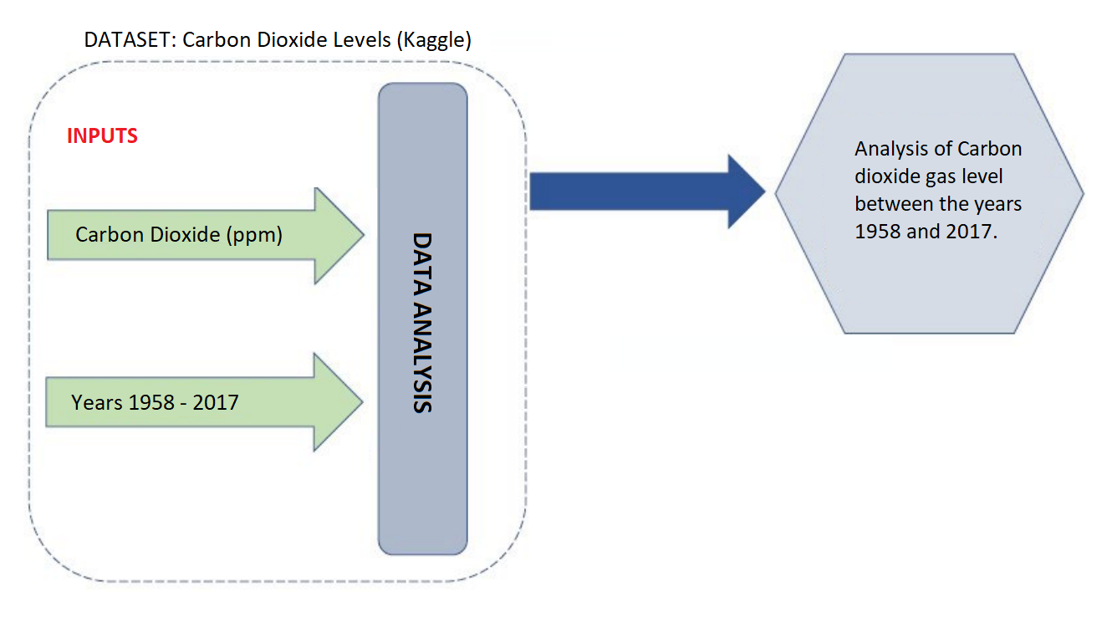

**Sources**

Articles

* M. Kappelle, M. M. I. Van Vuuren, and P. Baas, "Effects of climate change on biodiversity: a review and identification of key research issues," Biodiversity & Conservation, vol. 8, pp. 1383-1397, 1999. https://link.springer.com/article/10.1023/A:1008934324223
* Franklin-Cheung. “Climate change”. BBC. https://www.sciencefocus.com/climate-change (Accessed: May 22, 2023).

Videos

* Science ABC. Climate Change and Global Warming: Explained in Simple Words for Beginners | Science ABC. (16 January 2023). Accessed: May 22, 2023. [Online Video]. Available: https://youtu.be/G9t__9Tmwv4

Books

* J. Bennett, “The Expected Consequences,” in Global Warming Premier, USA: 2016, pp. 53–75. [Online]. Available: https://www.globalwarmingprimer.com/primer/primer3/

Datasets

* [1] Carbon Dioxide Levels in Atmosphere, Kaggle, 1958 to 2017, 2017. [Online]. Available: https://www.kaggle.com/datasets/ucsandiego/carbon-dioxide
* Annual Surface Temperature Change, Climatedata, 1961 to 2023, 2021. [Online]. Available: https://climatedata.imf.org/pages/climatechange-data
* World Monthly Atmospheric Carbon Dioxide Concentrations, Climatedata, 2000 to 2023, 2023. [Online]. Available: https://climatedata.imf.org/pages/climatechange-data
* Weather Istanbul Data 2009-2019, Kaggle, 1901to 2019, 2019. [Online]. Available: https://www.kaggle.com/datasets/vonline9/weather-istanbul-data-20092019
* Change in Mean Sea Levels, Climatedata, 1992 to 2023, 2023. [Online]. Available: https://climatedata.imf.org/pages/climatechange-data
* Global Average Absolute Sea Level Change, Datopian, 1970 to 2010, 2018. [Online]. Available:
* https://www.cbs.nl/en-gb/society/nature-and-environment/green-growth/natural-resources/living-planet-index
* Living Planet Index, Statistics Netherlands, 1970 to 2010, 2023. [Online]. Available: https://www.cbs.nl/en-gb/society/nature-and-environment/green-growth/natural-resources/living-planet-index