Analysis of Climate Change and Its Impact on Nature

Ahmet Oğuz Ergin  
Department of Information Systems and Technologies

University of Bilkent  
Ankara, Turkey  
oguz.ergin@ug.bilkent.edu.tr

Emre Karaçal  
Department of Information Systems and Technologies  
University of Bilkent

Ankara,Turkey

emre.karacal@ug.bilkent.edu.tr

*Abstract*— Climate change has emerged as one of the most important issues confronting our planet, with substantial ramifications for different areas of the natural world. This study delves into the connection between climate change and its enormous consequences on nature, including ecosystems, biodiversity, and ecological processes. This study seeks to offer a complete overview of the effects of climate change on the environment and the implications for the planet's future by reviewing scientific research and empirical data.

Keywords—climate, ecosystem, nature

# Introduction

Climate change is one of the most pressing global challenges of our time, with far-reaching implications for nature and the environment. This study will analyze climate change and its various effects on nature using various types of sources and visualization techniques, which will be combined to derive both descriptive and inferential statistical conclusions. Climate change refers to long-term shifts in temperature and weather patterns caused primarily by human activities, such as the burning of fossil fuels and deforestation [1]. These activities release greenhouse gasses into the atmosphere, trapping heat and leading to a rise in global temperatures [2]. As a result, the Earth's ecosystems are experiencing significant changes, which can have profound consequences for biodiversity, ecosystem services, and human well-being. This analysis will focus on several key parameters to assess the impacts of climate change on nature.

# HYPOTHESES

H1: Increased carbon dioxide (CO2) levels in the atmosphere affect climate change by trapping heat and causing global warming.

H2: Increased surface temperatures are a negative result of climate change.

H3: Decreasing precipitation amounts are a negative consequence of climate change.

H4: The decrease in sea levels is a negative consequence of climate change.

H5: The decrease in biodiversity is a negative consequence of climate change.

# METHODOLOGY

As emphasized before, this paper focuses on analysis of climate change and its impacts on nature. Technically speaking, to evaluate the complex link between climate change and its effects on numerous facets of the natural world, this research combines observational data analysis, climate modeling, and ecological modeling methodologies. This study attempts to give a rigorous and thorough knowledge of how climate change affects ecosystems, species dynamics, and ecological processes by combining numerous lines of evidence. The technique described here makes it possible to look at long-term trends, geographic patterns, and probable future scenarios, enabling a more detailed investigation of the intricate relationships between climate change and nature. By using this methodical approach, we want to add to the body of information on the effects of climate change, ultimately assisting in the creation of well-informed plans for biodiversity conservation and ecosystem management.

The datasets used from Kaggle.com cover a wide range of quantitative and qualitative data sources, giving a thorough investigation of climate change and its effects on the environment. Measurements of climatic variables, such as temperature, precipitation, sea-level rise, and atmospheric CO2 concentrations, taken by meteorological stations, satellites, or climate models, are included in the quantitative data [3-8]. For analyzing patterns and changes over time, these data provide exact and unbiased information. Comparatively, qualitative data sources include ecological surveys, biodiversity evaluations, field observations, and expert views, which offer insightful information on the intricate ecological responses to climate change.

This study can reflect the multifaceted features of climate change consequences by integrating scientific information with contextual understanding and subject-matter expertise by using both types of data. This all-encompassing strategy enables a more thorough and rigorous investigation, allowing researchers to understand the complex connections between climate change and the natural world.

The datasets downloaded from different sources, such as /www.cbs.nl, climatedata.imf.org, and kaggle.com, were subjected to diverse sampling techniques and measurement units. Prior to the analytical step, the datasets were cleansed to remove missing data and outliers. R codes were then implemented in RStudio to analyze the data and generate graphs for visualization purposes.

# DESCRIPTIVE ANALYSIS OF CARBON DIOXIDE LEVELS IN ATHMOSPHERE

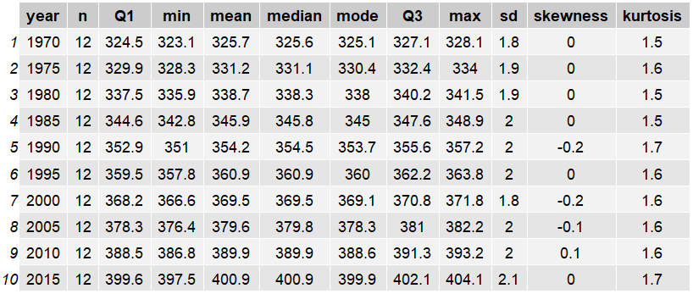This section is created for providing a descriptive analysis of the data that we have used for this study. Table 1 demonstrates the Descriptive Statistics Carbon Dioxide PPM Values Between in 1970-2015. The data is derived from kaggle.com [2]. When examining the table 1 data that covers every month of the year, a notable difference can be observed, particularly among the minimum values. In 1970, the minimum recorded CO2 level in the atmosphere was measured at 323.1 PPM, while in 2015, this value increased to 397.5 PPM. This significant increase in minimum CO2 levels over the years indicates a notable change and rise in atmospheric carbon dioxide concentrations.

Figure 1 depicts the mean values of carbon dioxide (CO2) concentrations between 1958 and 2017. The graph illustrates a clear increasing trend over the years, indicating a rise in atmospheric CO2 levels. This sustained increase in CO2 levels can be attributed to air pollution and other contributing factors. It is important to note that this upward trend in CO2 concentrations has potential implications for human health in the long term, potentially posing risks over the course of the next decades.

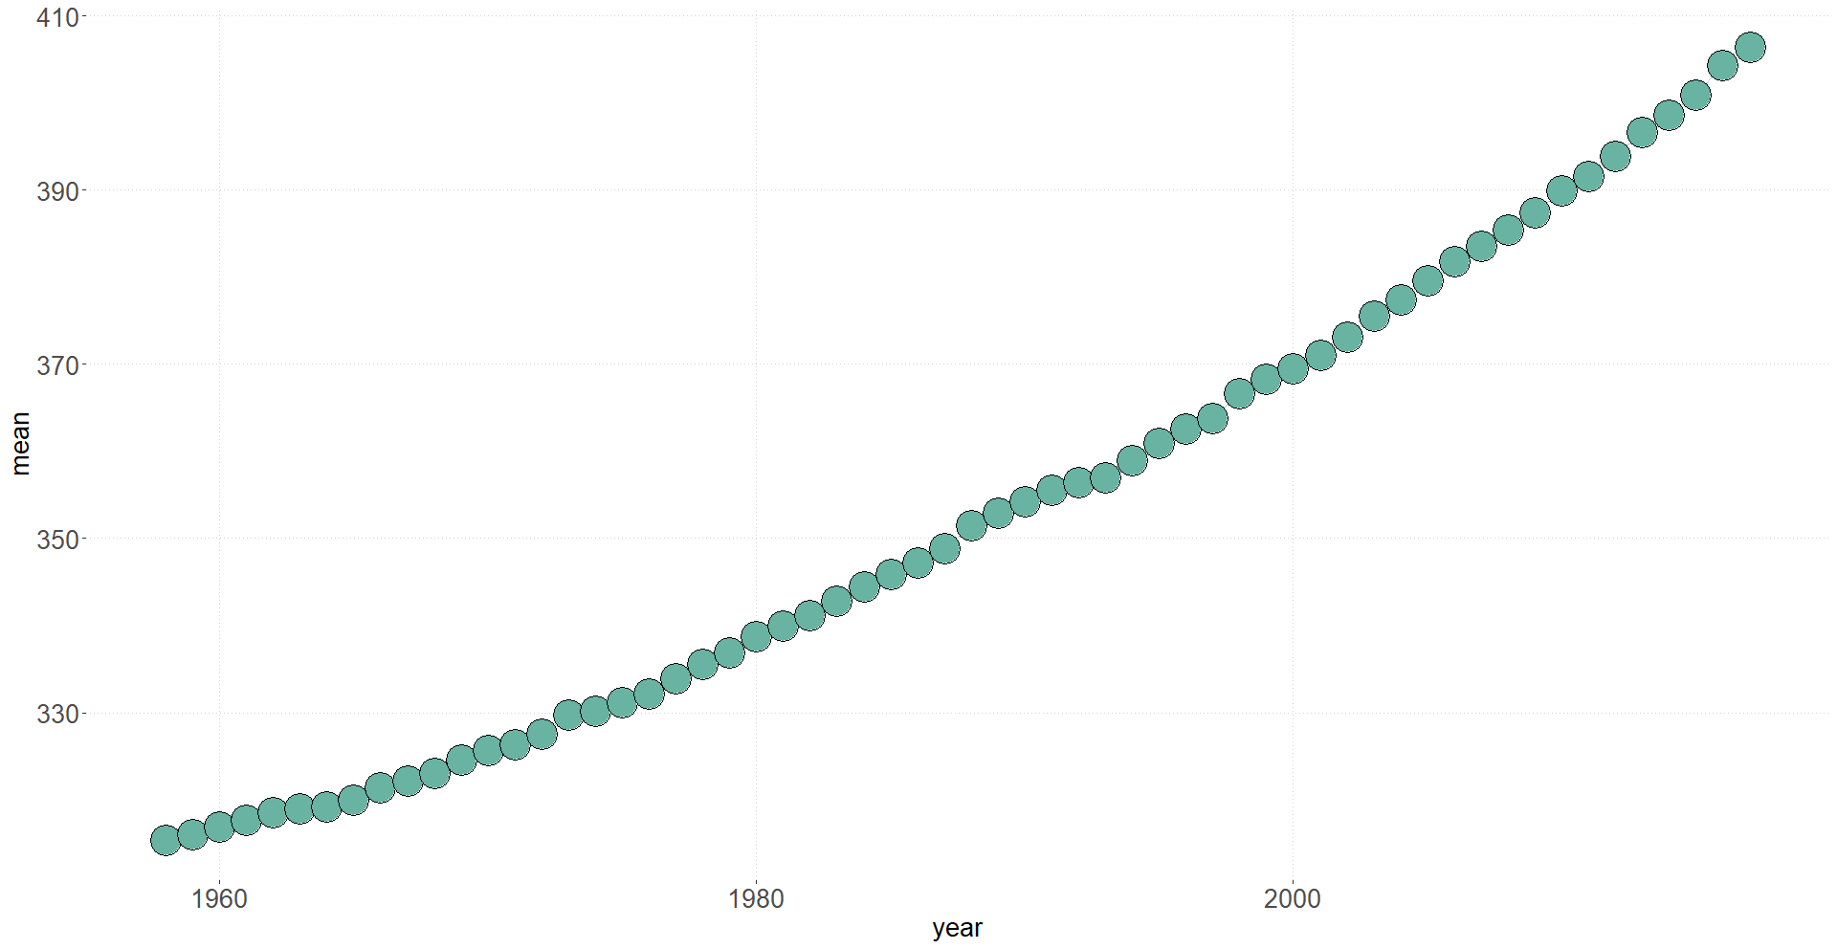*Table 1. Descriptive Statistics Carbox Dioxide PPM Values Between in 1970-2015 [3].*

*Figure 1. Carbox Dioxide PPM Values Between in 1958-2017 [3].*

# ANNUAL SURFACE TEMPERATURE CHANGE

In figure 2, as we can see the annual surface temperature change in the UK and the United States has exhibited distinct patterns and trends over the years.

Over the past few decades, the United Kingdom has experienced a significant warming trend. Data from the UK Met Office reveals that the yearly average temperature has increased by approximately 1 degree Celsius compared to the pre-industrial period. This upward trend in temperatures is indicative of the broader phenomenon of global warming, which is primarily driven by human activities and the emission of greenhouse gases.

In recent years, the UK has witnessed some of the hottest years on record, with rising temperatures posing various challenges. Heatwaves, for instance, have become more frequent and intense, leading to adverse impacts on human health and well-being. These extreme heat events can result in increased rates of heat-related illnesses, heat exhaustion, and even fatalities, particularly among vulnerable populations such as the elderly and those with pre-existing health conditions.

The effects of rising temperatures are not limited to human health. The natural environment and ecosystems in the UK are also experiencing significant impacts. Changes in temperature patterns can disrupt the delicate balance of ecosystems, affecting the distribution and behavior of plant and animal species. Some species may struggle to adapt to the changing climate, which can lead to shifts in their habitats and potential loss of biodiversity.

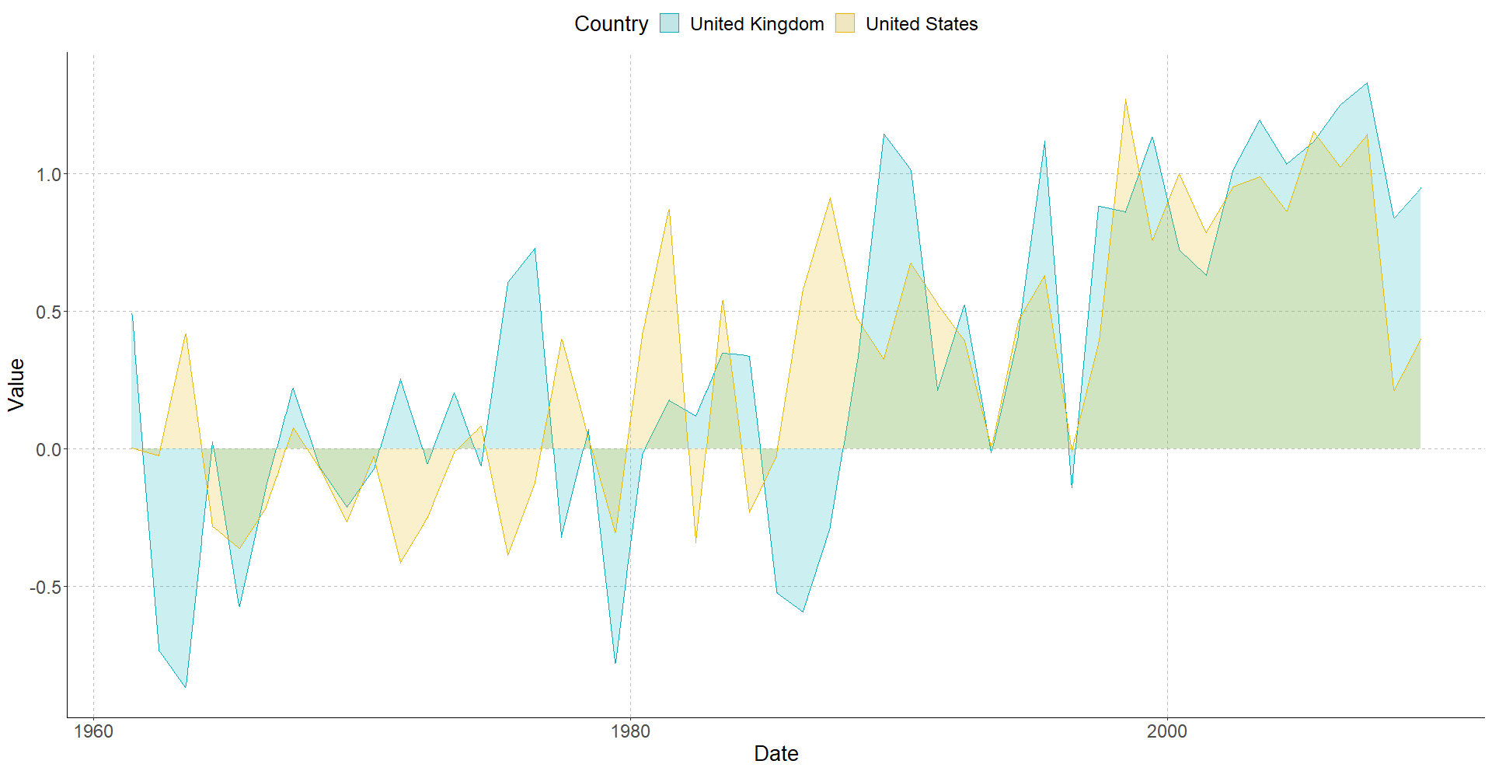

Additionally, the UK's water resources are affected by temperature fluctuations. Higher temperatures can result in increased evaporation rates, leading to water scarcity in certain regions. This can have implications for water supply, both for domestic use and for sustaining ecosystems, such as rivers and wetlands, which rely on adequate water levels to support their biodiversity.

The United States has also seen a noticeable warming trend, albeit there have been regional variances. Since the late 19th century, the nation's yearly temperature has increased by around 1.8 degrees Fahrenheit (1 degree Celsius) on average. In contrast to the national average, other areas, including the Arctic and Alaska, have experienced more dramatic temperature rises. Additionally, the United States has seen an increase in extreme weather phenomena, such as heatwaves, wildfires, and hurricanes, which have had a major effect on various regions of the nation. Planning for infrastructure and other fields like agriculture and public health are impacted by these temperature fluctuations. Especially after 2000, there is a serious temperature increase in both countries.

In figure 3, we can see the temperature changes in Austria, Canada, Finland, Sweden, the UK, and the United States, The enormous nation of Canada, which has several different climate zones, saw temperature variations that differed greatly among its provinces and territories. Similar to Finland, Sweden too experienced temperature variations that were unique to their various regions due to their diverse climates from north to south. Additionally, temperature fluctuations were seen in Austria, the UK, and the US, with local variations determined by local weather patterns and geographic location. However, if we look at the table in general, it is not difficult to see the ratio of temperature changes in Finland.

*Figure 2. The temperature changes in the UK and US, with respect to a baseline climatology, for the years between 1961 and 2009, is measured in degrees Celsius. [4].*

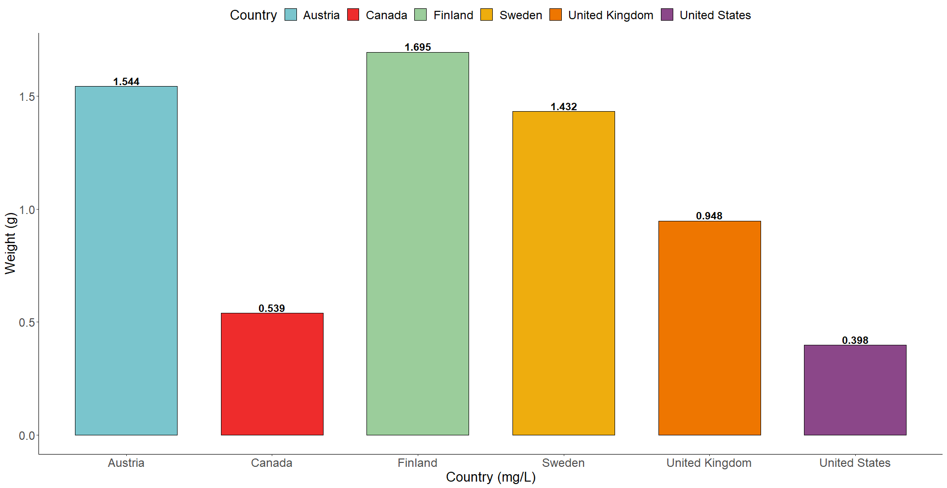

*Figure 3. The temperature changes in the specified countries in the year 2009, with respect to a baseline climatology, is measured in degrees Celsius [4].*

# PRECIPITATION RATE

In figure 4, we can display the weather conditons in Istanbul, between the years 2009-2019, Throughout the year, Istanbul receives a reasonable amount of precipitation, with the winter and late autumn months often being the wettest. Istanbul receives an average of 844 millimeters (33 inches) of precipitation per year. The distribution and intensity of precipitation can change from year to year, and certain weather patterns might affect these factors.

The wettest months are typically December, January, and February, with irregular periods of heavy rain and increased storm danger. In the spring (March to May) and fall (September to November), there is a fair amount of rain, including both small showers and prolonged rainstorms. The summer months (June to August) are frequently drier than the rest of the year since there is less chance of significant rainfall. That’s how we understand more then 58% of the 10 years, Istanbul is Sunny and dry.

Figure 5 presents the precipitation ratio in Istanbul for the period between 2009 and 2019. The data reveals a consistent decreasing trend in precipitation over the course of the ten-year period. The highest precipitation ratio occurred in 2010, while the lowest was recorded in 2013. This declining trend highlights the reduction in rainfall amounts over this specific timeframe, indicating a potential shift in the city's precipitation patterns.

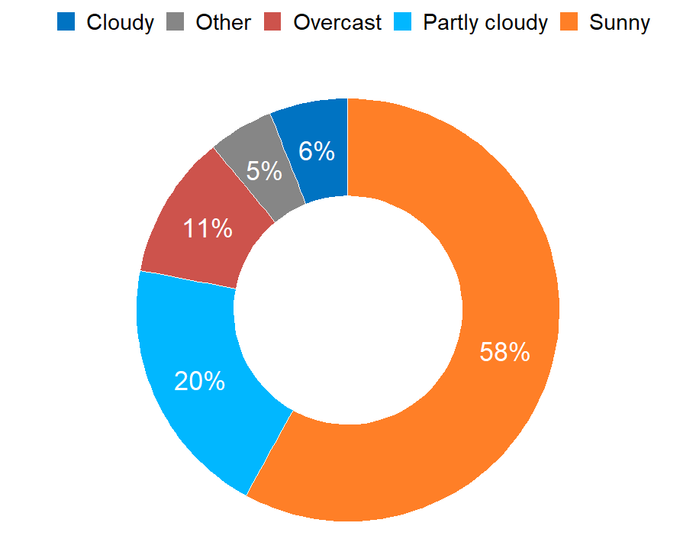

*Figure 4. The weather conditions in Istanbul from 2009 to 2019 [5].*

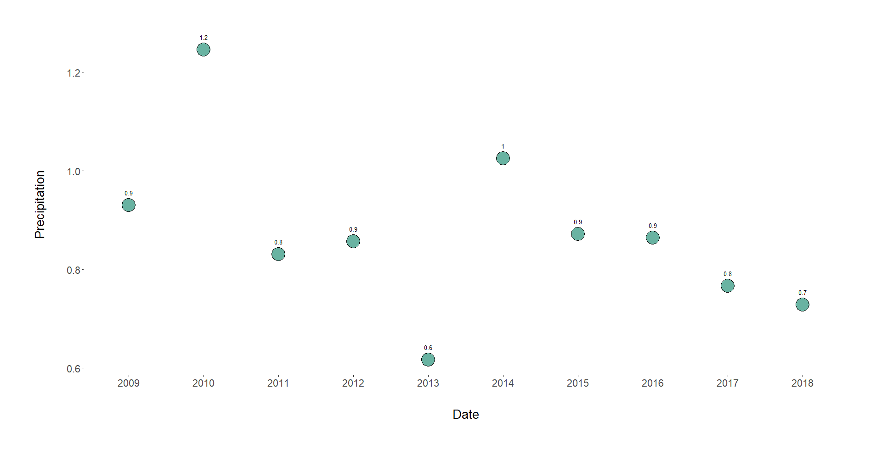*Figure 5. Precipitation ratio in Istanbul between the years 2009 - 2019 [5].*

# CHANGE IN MEAN SEA LEVELS

The change in mean sea level in the Pacific Ocean and Atlantic Ocean has been subject to extensive monitoring and scientific study over the years. Figure 6 and Figure 7 illustrate the trends observed in mean sea level for both oceans between 1992 and 2022. These figures clearly indicate a consistent and notable increase in sea levels over the examined time frame, which can be attributed to the phenomenon of climate change.

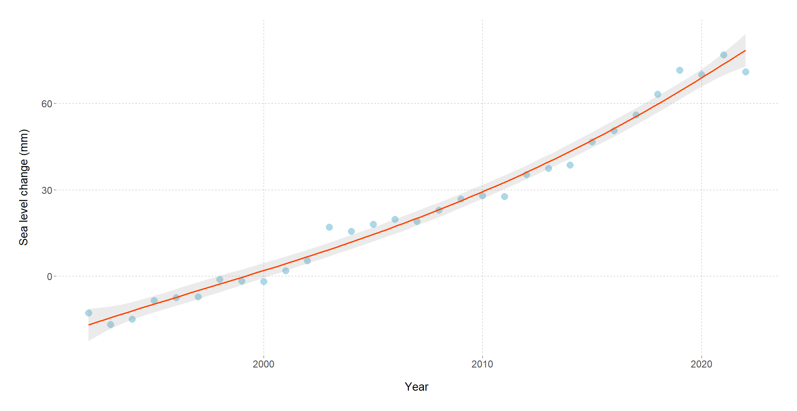The data presented in these charts provide evidence of a rising trend in mean sea level, indicating that the increase is likely to continue in the coming years. This underscores the long-term implications of climate change on our oceans and suggests that without significant mitigation efforts, the trend of rising sea levels is expected to persist for at least the next two decades.

Understanding the patterns and magnitude of sea level rise is crucial for coastal communities and policymakers to adequately plan and prepare for the associated impacts. These impacts include coastal erosion, increased vulnerability to storm surges and flooding, and potential displacement of populations residing in low-lying areas. Addressing climate change and implementing adaptive measures to mitigate the consequences of rising sea levels are paramount to minimizing the risks and ensuring the long-term resilience of coastal regions.

Figure 6. Change in mean sea level in the Pacific Ocean from 1992 to 2022 [6].

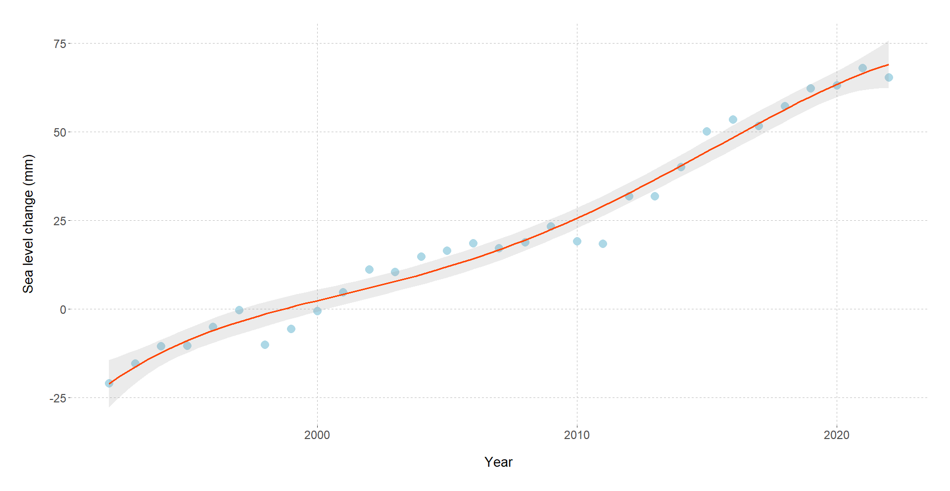

*Figure 7. Change in mean sea level in the Atlantic Ocean from 1992 to 2022 [6].*

# Using the Template

After the text edit has been completed, the paper is ready for the template. Duplicate the template file by using the Save

# Using the Template

After the text edit has been completed, the paper is ready for the template. Duplicate the template file by using the Save

# Using the Template

After the text edit has been completed, the paper is ready for the template. Duplicate the template file by using the Save

# Using the Template

After the text edit has been completed, the paper is ready for the template. Duplicate the template file by using the Save

# Using the Template

After the text edit has been completed, the paper is ready for the template. Duplicate the template file by using the Save

# Using the Template

After the text edit has been completed, the paper is ready for the template. Duplicate the template file by using the Save

# Using the Template

After the text edit has been completed, the paper is ready for the template. Duplicate the template file by using the Save

##### References

1. Science ABC. Climate Change and Global Warming: Explained in Simple Words for Beginners | Science ABC. (16 January 2023). Accessed: May 22, 2023. [Online Video]. Available: https://youtu.be/G9t__9Tmwv4.
2. J. Bennett, “The Expected Consequences,” in Global Warming Premier, USA: 2016, pp. 53–75. [Online]. Available: <https://www.globalwarmingprimer.com/primer/primer3/>.
3. World Monthly Atmospheric Carbon Dioxide Concentrations, Climatedata, 2000 to 2023, 2023. [Online]. Available: <https://climatedata.imf.org/pages/climatechange-data>.
4. Annual Surface Temperature Change, Climatedata, 1961 to 2023, 2021. [Online]. Available: <https://climatedata.imf.org/pages/climatechange-data>
5. Weather Istanbul Data 2009-2019, Kaggle, 1901to 2019, 2019. [Online]. Available: <https://www.kaggle.com/datasets/vonline9/weather-istanbul-data-20092019>.
6. Change in Mean Sea Levels, Climatedata, 1992 to 2023, 2023. [Online]. Available: <https://climatedata.imf.org/pages/climatechange-data>
7. Global Average Absolute Sea Level Change, Datopian, 1970 to 2010, 2018. [Online]. Available: <https://www.cbs.nl/en-gb/society/nature-and-environment/green-growth/natural-resources/living-planet-index>
8. Living Planet Index, Statistics Netherlands, 1970 to 2010, 2023. [Online]. Available: <https://www.cbs.nl/en-gb/society/nature-and-environment/green-growth/natural-resources/living-planet-index>