Network confıguratıon

Ahmet Oğuz Ergin

# Network Device Types

## NAT

* VMs can communicate with outer network over host machine.
* VMs cannot communicate with each other.
* Host machine cannot communicate with VM with its ip address.
* Host machine can communicate with VM with localhost and port.
* Outer network machine cannot communicate with VM?

## Host Only

* VMs cannot communicate with outer networks.
* Host machine and VMs can communicate with each other

## Bridged

* VMs act like an any other physical machine on the network and get ip address.

# Which Network Device Type I Choose

With these information when I consider to which network device should I use, I choose **NAT** and **Host Only** with together.

**Why not NAT adapter only:** VMs cannot communicate with each other.

**Why not Host Only adapter only:** VMs cannot cummunicate with outer network which I need to reach github and k3s installation.

**Why not Bridged:** Network changes of host machine affect all the VMs ip adresses.

# NAT Device

## Installation on VM

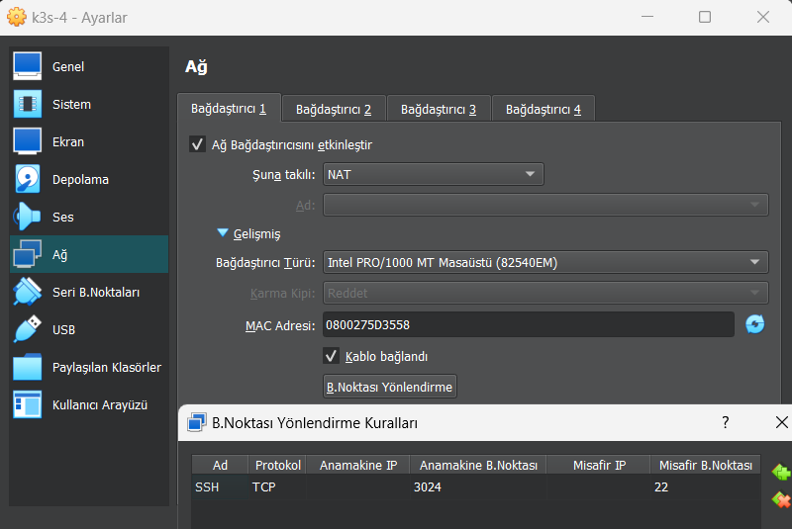

1 NAT Device Configuration

## Connection From Host Machine

ssh -p 3024 root@localhost

# Adding Host Only Device

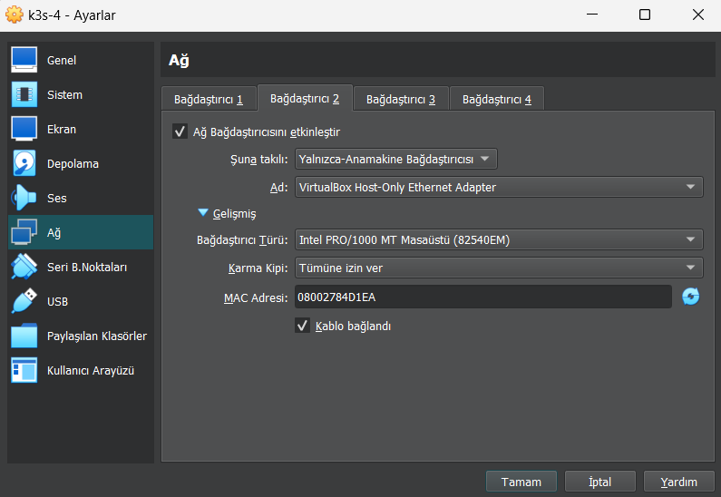

2 Host Only Configuration

## Checking The Device Ip

Check information of the device. enp0s8 is added without ip address.

root@k3s-4:~# ip link show

# Set static ip address

## Determine Ip Address

You may set dhcp as primary network interface and check the host portion of the ip address then change it according to subnet. Another solution is checking the host machine. Get host portion from that.

Determine Gateway

Default gateway is 10.0.2.2 so I will use that.

root@k3s-1:~# ip route

default via 10.0.2.2 dev enp0s3

10.0.2.0/24 dev enp0s3 proto kernel scope link src 10.0.2.15

169.254.0.0/16 dev enp0s3 scope link metric 1000

172.17.0.0/16 dev docker0 proto kernel scope link src 172.17.0.1 linkdown

192.168.56.0/24 dev enp0s8 proto kernel scope link src 192.168.56.103

## Interface Configuration

Configure **interfaces** file and add last block.

nano /etc/network/interfaces

**# This file describes the network interfaces available on your system**

**# and how to activate them. For more information, see interfaces(5).**

source /etc/network/interfaces.d/*

**# The loopback network interface**

auto lo

iface lo inet loopback

**# The primary network interface**

allow-hotplug enp0s3

iface enp0s3 inet dhcp

**# My secondary static network interface**

auto enp0s8

iface enp0s8 inet static

    address 192.168.56.31

    netmask 255.255.255.0

    gateway 10.0.2.2

    dns-nameservers 8.8.8.8 8.8.4.4

Restart Service

systemctl restart networking

If its giving error try:

Remove gateway option and

ip addr flush dev enp0s8

systemctl restart networking

Check Ip Address

root@k3s-1:~# ip addr show enp0s8

3: enp0s8: <BROADCAST,MULTICAST,UP,LOWER_UP> mtu 1500 qdisc fq_codel state UP group default qlen 1000

    link/ether 08:00:27:a3:26:8d brd ff:ff:ff:ff:ff:ff

    inet 192.168.56.31/24 brd 192.168.56.255 scope global enp0s8

       valid_lft forever preferred_lft forever

    inet6 fe80::a00:27ff:fea3:268d/64 scope link

       valid_lft forever preferred_lft forever

# Bridge Device

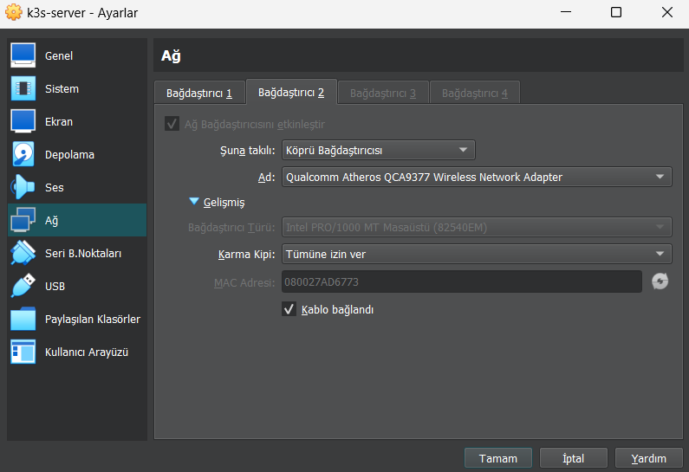

Without any configuration done check ips

ip a

It will display new device ips empty.

Lets add dhcp configuration for that device so that we will get ip address for that device.

Edit file

nano /etc/network/interfaces

Add that lines at the end

**# My secondary network interface**

allow-hotplug enp0s8

iface enp0s8 inet dhcp

Restart service

systemctl restart networking

Check ip address again. It will be assigned. Keep that ip and set it static as specified above.