statıc ıp confıguratıon

Ahmet Oğuz Ergin

# Add New Network Device to VM

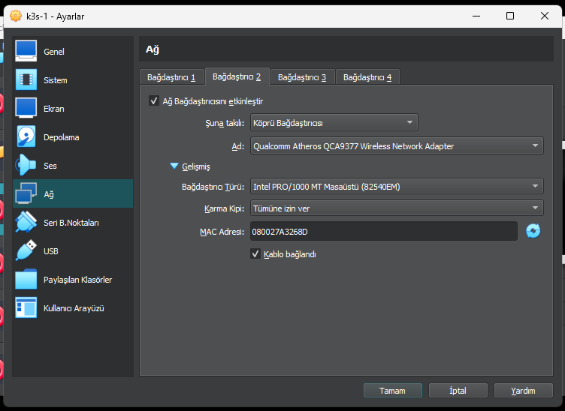

Check information of the device. enp0s8 is added without ip address.

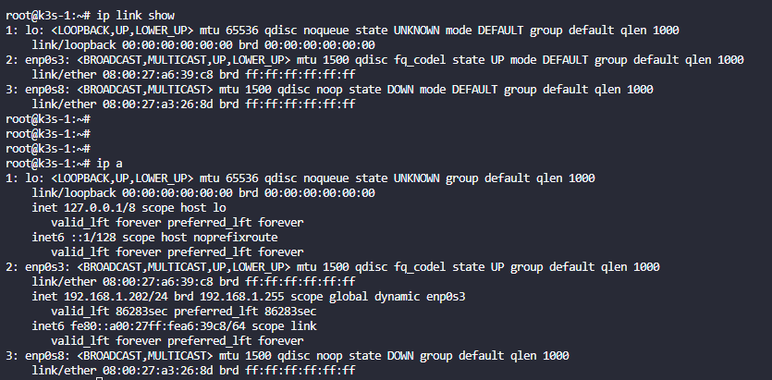

# Set static ip address

Configure file and add last block.

nano /etc/network/interfaces

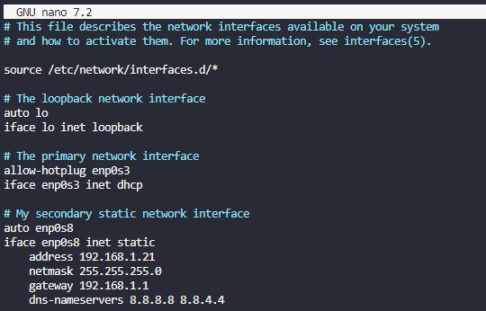

Restart service with:

systemctl restart networking

check service again

