SWAP

Ahmet Oğuz Ergin

# Why I swap?

In real life scenarios, cloud providers, provide limited CPU and RAM on vm. But they provide enough space (volume) and we can use that volume to swap memory.

# Swap With New Block Device

## Installing New Block Device on VM

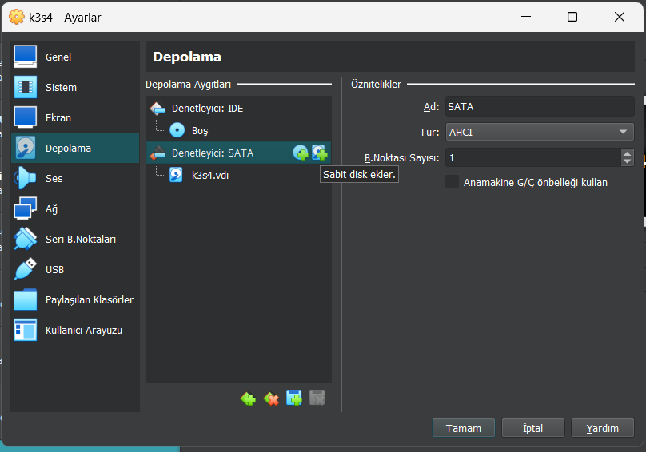

1 Block Device Installation

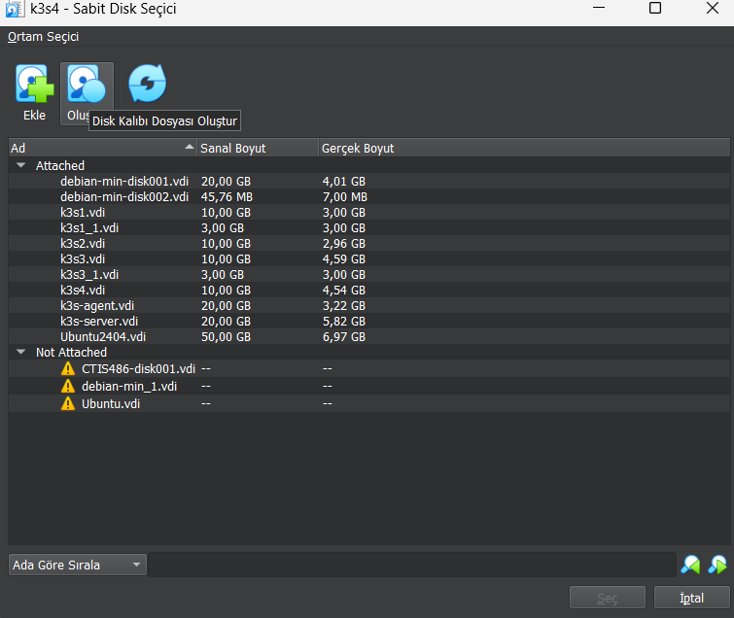

2 Block Device Installation

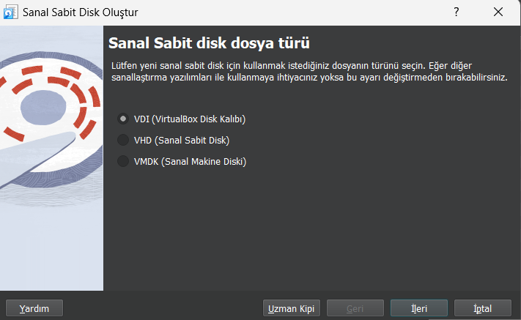

3 Block Device Installation

## Partition Disk

Run **lsbk** command todisplay current block devices. /dev/sdb will be added.

lsblk

fdisk /dev/sdb

n

p

1

w

lsblk

## Format Partiton and Save as Persistent

swapon --show

mkswap /dev/sdb1

swapon /dev/sdb1

echo '/dev/sdb1 none swap sw 0 0' | tee -a /etc/fstab

reboot

swapon --show

free -h

# Swap Without New Block Device

First Check initial sizes. 15G

root@st-vm:~# df -h

Filesystem      Size  Used Avail Use% Mounted on

udev            474M     0  474M   0% /dev

tmpfs            97M  456K   97M   1% /run

/dev/sda1        15G  2.2G   12G  16% /

tmpfs           485M     0  485M   0% /dev/shm

tmpfs           5.0M     0  5.0M   0% /run/lock

/dev/sda15      124M   12M  113M  10% /boot/efi

tmpfs            97M     0   97M   0% /run/user/1002

root@st-vm:~# free -h

               total        used        free      shared  buff/cache   available

Mem:           969Mi       716Mi       160Mi       488Ki       263Mi       253Mi

Swap:             0B          0B          0B

Run commands to create swap.

fallocate -l 3G /swapfile

chmod 600 /swapfile

mkswap /swapfile

swapon /swapfile

Check size again.

root@st-vm:~# df -h

Filesystem      Size  Used Avail Use% Mounted on

udev            474M     0  474M   0% /dev

tmpfs            97M  456K   97M   1% /run

/dev/sda1        15G  5.2G  8.7G  38% /

tmpfs           485M     0  485M   0% /dev/shm

tmpfs           5.0M     0  5.0M   0% /run/lock

/dev/sda15      124M   12M  113M  10% /boot/efi

tmpfs            97M     0   97M   0% /run/user/1002

root@st-vm:~# free -h

               total        used        free      shared  buff/cache   available

Mem:           969Mi       420Mi       225Mi       420Ki       500Mi       549Mi

Swap:          3.0Gi       768Ki       3.0Gi

Make it persistent.

echo '/swapfile none swap sw 0 0' | sudo tee -a /etc/fstab