Date of this meeting: **04-04-2018**

Time of this meeting: **15:00 CET**

***The following is to be filled in before the meeting.***

Attendees per university:

|  |  |  |  |  |  |  |  |
| --- | --- | --- | --- | --- | --- | --- | --- |
| **Saxion** | | **AAU** | | **UTP** | | **AGU** | |
| **Name:** | **Present?:** | **Name:** | **Present?:** | **Name:** | **Present?:** | **Name:** | **Present?:** |
| Morcel | Yes | Magnus | yes | Anna | No – Jens | Ahmet | yes |
| Alex | No (doctor) | Daniel | Yes ish |  |  |  |  |
|  |  | Robert | yes |  |  |  |  |
|  |  | Peter | yes |  |  |  |  |
|  |  | Jacob | yes |  |  |  |  |

|  |  |  |
| --- | --- | --- |
| **Subject to discuss** | **Estimated time needed (In minutes)** | **University** |
| Start-up | 15 | Saxion |
| Barcelona plan | 10 | AAU |
| Feedback to AAU doc | ? | AAU |
| Anna update | ? | UTP |
|  |  |  |
|  |  |  |
| **Actual times** |  |  |
| Anna |  | Jens |
| Start-up |  |  |
| Barcelonaplan |  |  |
| PR stuff |  |  |
|  |  |  |
|  |  |  |
|  |  |  |
|  |  |  |
|  |  |  |

**Notes and agreements from this meeting as well as progress on previously made agreements below ↓**

Robert is on note duty:

Started 5 min late, waiting for Jens

Anna was told not to join by Jens,

Jens have talked to the polish guys, Anna is sorry. Misunderstood the way of communicating

Anna will be working separate from the rest but still on the HoneyPot. There will be feedback both ways, 1 or 2 meetings. One of those meetings could be in Barcelona.

Anna think this the best way too.

Anna will decide if she will go to Barcelona

AAU:

Worked on feedback from supervisors.

Morcel liked the problem analysis

Worked on designing the GUI

Server is shit….

SAX:

Finished some subquestions, and will get feedback form the supervisor

Will finish more subquestions and do some mock-ups of a GUI, GUI should be ready for Barcelona

Jacob suggest a meeting next week talking about what It should look like. It will be held after next weeks meeting.

AGU:

Ahmet talked to Valentin, and is looking in to the feedback.

Very helpful feedback from Valentin.

Ahmet had a “fight” with his bike but have solved the conflict

Ahmet will use Jens if there is any problems

Barcelona plan:

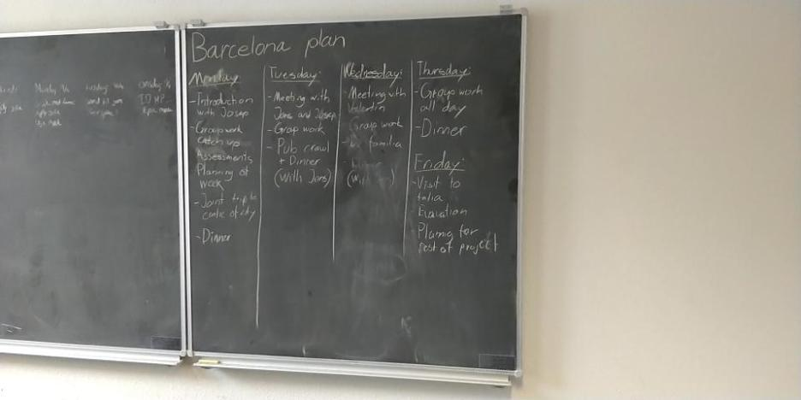Feedback from jens Tuesday and Valentin Wednsday

Magnus will make a nice plan with atleast 8 hours of work.

Alex and morcel will talk to jens if tickets is not booked on Friday morning.

Rest is okay

Feedback for Doc will be next week.

Danish guys will do a post for facebook