COMP201- Object Oriented Programming

Spring 2017

**HOMEWORK4**

In this homework, you are asked to write an application to draw shapes for tetris game.

**Required Classes:**

The class diagram is given below:

**JPanel**

**Shape**

**<abstract>**

-x: int

-y:int

-w:int

-h: int

Shape(x,y,w,h)

draw(Graphics g)

**DrawPanel**

Shape[] shapes;

DrawPanel()

paintComponent(Graphics g)

**TShape**

**Square**

**IShape**

**LShape**

* JPanel class exist in Java. You should not implement it again. You only need to inherit it.
* Shape is an abstract class.
* void draw(Graphics g) is an abstract method in the Shape class.
* paintComponent(Graphics g) is a special method inherited from the JPanel class. You need to override it.
* The attributes of Shape class means below:
  + x: the X coordinate of the left up corner of the shape
  + y: the Y coordinate of the left up corner of the shape
  + w: width of each square in the shape (note that each shape consists of 4 squares)
  + h: height of each square in the shape.
* In the Shape class, there is only one constructor with four integer parameters to set x, y, w, h values.
* The size of the shapes array is 10.

**Program Output:**

The application produces 10 tetris shapes. The first one is drawn to the up left corner. Following ones are drawn a couple of millimeter left and down.

Here is an example for the program output. Note that you do not have to use exactly same colors.

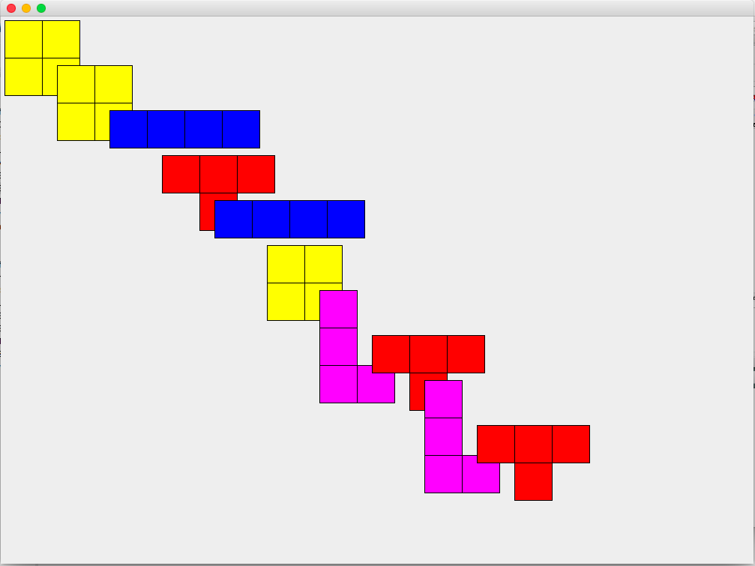

**Programming Tips**

- The following code generate random integer numbers between 0 and 5:

SecureRandom randomNumbers = new SecureRandom();

int randomValue= randomNumbers.nextInt(6);

In the constructor of the DrawPanel class, you need to create instances of Shapes to the Shape array. You need to decide the shape type randomly.

- In the paintComponent method, you need to call the draw method of each shape in the array.